Rapid Response

Procedural Manual

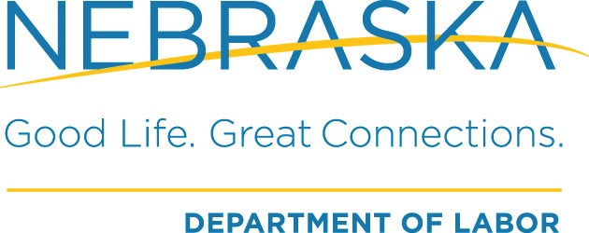

Revised

12/2/2019

Contents

NDOL’s Rapid Response Services 4

Layoff Aversion 4

Receipt of Notification 5

Assignment of Companies 5

OnBase Entries 5

Opening an Employer File in OnBase 5

Accuracy of Information in OnBase and NEworks 6

Employer Outreach – RR Services 6

When a Company has Already Closed or Declines RR Services 7

Rapid Response Information Sessions (RRIS) 8

Providing On-Site Rapid Response Information Session(s) 8

Securing Attendance at a Rapid Response Information Session 9

Employee List 9

Registering for NEworks and the RRIS Prior to Event 9

Preparing for a Rapid Response Information Session 9

Requesting a Rapid Response Event Number 9

RR Packets 10

Contact Sheet 10

Rapid Response Folder Contents List 10

Left side: Back to Front 10

Right Side: Back to Front 10

Presenting the Rapid Response Information Session 11

Rapid Response Attendance by RRWCs and Local Area Staff 11

Equipment 11

Rapid Response Laptops 11

Set Up 11

Sign In Sheets 12

Presentations 12

Demographic and Assistance Surveys 12

Closing the Session 13

Post Rapid Response Information Session - Updating OnBase and NEworks 13

The Service Plan 13

Additional Resource Events 14

Responsibilities 14

State level Rapid Response Program Coordinator (RRPC) 14

Program Quality Assurance 15

Rapid Response Workforce Coordinators (RRWCs) 15

Local Area Staff 15

Natural Disasters 17

WARNs 19

What is a WARN? 19

NDOL Rapid Response Notification & Referral Process 21

Rapid Response Information Session (RRIS) Notification 21

Rapid Response Referrals 22

Entering a Company into OnBase 23

Entering an Event in OnBase 27

Running Reports on OnBase 30

Entering Activity Codes for Employer Services in NEworks 32

(If the Employer has an NEworks Account) 32

Sending a Referral to Virtual Services Unit (VSU) 34

# NDOL’s Rapid Response Services

Nebraska’s Rapid Response (RR) program provides employers facing a layoff or closure with immediate and rapid services aimed at connecting affected employees to the workforce system with the goal of rapid reemployment. Nebraska’s Rapid Response (RR) team provides customized activities onsite at the affected company or alternate location while accommodating work schedules, and any other specific needs or requests of the employer (e.g. job fair, mental health, financial resources). Onsite responses will be offered to all companies facing a downsizing or closing, regardless of number of affected workers.

RR activities are coordinated at the state level through the Rapid Response Program Coordinator (RRPC). The RRPC then assigns a Rapid Response Workforce Coordinator (RRWC) to the event and the RRWC then coordinates with the local area. Delivery of a Rapid Response Information Session (RRIS) is completed in conjunction with the assigned RRWC, local area Wagner Peyser and WIOA staff, and applicable workforce partners.

At its core, RR is an employer focused service; RRWC are not responsible for any one on one services provided to affected employees. The RR team’s focus will be on serving employers and connecting affected employees to services and resources, with the intent of minimizing the effects of a layoff on the employer, employees and the community.

# Layoff Aversion

Layoff aversion strategies and activities are designed to prevent, or minimize the duration of unemployment resulting from layoffs. Layoff aversion is a comprehensive approach requiring the integration of data, partnerships, and policies and procedures to allow an assessment of the economic situation that exists within a given area.

Layoff aversion strategies and activities are customized to specific needs, quickly deployable, informed by economic data, and designed and coordinated with partners as necessary. State and local RR operators should design innovative solutions for both businesses and workers in training. Such solutions should include, but are not limited to:

* Ongoing engagement, partnership, and relationship-building activities with businesses in the community in order to create an environment for successful layoff aversion efforts and to enable the provision of assistance to Dislocated Workers (DW) in obtaining reemployment as soon as possible;
* Providing assistance to employers in managing reductions in force, which may include early identification of firms at risk of layoffs, assessment of the needs of and options for at-risk firms, and the delivery of services to address these needs;
* Funding feasibility studies to determine if a company’s operations may be sustained through a buyout or other means to avoid or minimize layoffs;
* Developing, funding, and managing incumbent worker training programs or other worker upskilling approaches as part of a layoff aversion strategy or activity;
* Connecting companies to state Short-Time Compensation (STC) or other programs designed to prevent layoffs or to quickly reemploy dislocated workers, employer loan programs for employee skill upgrading; and other Federal, State and local resources as necessary to address other business needs;
* Establishing linkages with economic development activities at the Federal, State and local levels, including Federal Department of Commerce programs and available State and local business retention and expansion activities;
* Partnering or contracting with business-focused organizations to assess risks to companies, propose strategies to address those risks, implement services, and measure impacts of services delivered;
* Conducting analyses of the suppliers of an affected company to assess their risks and vulnerabilities from a potential closing or shift in production of their major customer;
* Engaging in proactive measures to identify opportunities for potential economic transition and training needs in growing industry sectors or expanding businesses; and
* Connecting businesses and workers to short-term, on-the-job, or customized training programs and apprenticeships before or after layoff to help facilitate rapid reemployment.

# Receipt of Notification

Information on potential layoffs, closures or disaster impacted companies comes from many sources, including local area staff, unemployment, news outlets, social media, affected employees, etc. Generally, the local area staff are made aware of any potential situations first and this information must be immediately relayed to the Rapid Response email address: [NDOL.RapidResponse@Nebraska.gov](mailto:NDOL.RapidResponse@Nebraska.gov).

# Assignment of Companies

RRWCs will have assigned regions that they will cover and, typically, they will assume responsibility for any needs in their assigned regions. However, due to varying workloads in the various areas across the state, RRWCs may be asked to assist in other areas, as needed.

RRWCs will be responsible for taking any incoming notifications from their assigned regions and following up as they come into the RR inbox. They will record any companies they are working on in the case tracker and ensure it is updated as they provide services.

Case Tracker Excel File: L Drive > Employment and Training > WIOA Rapid Response > Program Management > Rapid Response Case Tracker.

# OnBase Entries

## Opening an Employer File in OnBase

When a notification is received, RRWCs should immediately open an employer file in OnBase to track their work process. OnBase is the official document retention system for NDOL and will be utilized, along with NEworks, by users across the workforce system to view progress and information on any closures or layoffs. See “Entering a Company in OnBase” section, beginning on page 22, for screen shots and step by step instructions.

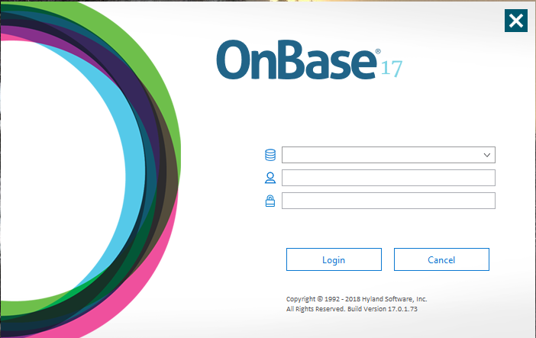

RRWCs will record their progress with an employer via the Case Tracker Excel file on the L drive. Once services are completed, RRWCs should complete OnBase entries for all of the events for that company (e.g. WARN’s, notification date of potential layoff/closure, actual date of layoff/closure, date of RRIS, etc.). RRWCs will also record employer services in NEworks if the employer has a NEworks account. See “NEworks Employer Activity Codes” section, beginning on page 31, for screen shots and step by step instructions.

## Accuracy of Information in OnBase and NEworks

OnBase and NEworks will track the events and services provided to employers and their affected employees. When entering the information for a company and an event, it is imperative that the information be accurately entered, as NDOL receives requests from many system partners and stakeholders across the state for data on closures, layoffs and dislocated worker numbers and these reports are run through OnBase and NEworks.

**A note about public and confidential information:** If an entry goes into OnBase as a verified closure or verified layoff, it will populate this information to the NDOL public website. For this reason, RRWCs should always utilize “potential closure” and “potential layoff” entries until the information is verified and is determined to be public information. If the company requests that the information they provide remain confidential, you MUST enter the information as “confidential” under the publicity section of an event record and all emails with system partners must identify the information in the subject line as CONFIDENTIAL. The only exception to this is if NDOL receives a WARN notice by request of the Commissioner of Labor. ALL WARNS will be treated as public and immediately posted to OnBase (and thus, the NDOL public website). RRWCs must ensure employers are aware of this.

# Employer Outreach – RR Services

RRWCs should conduct employer outreach on every notification they are assigned within two (2) working days and document that outreach in OnBase and NEworks under the appropriate event type and activity code. RRWCs should utilize the initial employer outreach to gain information on the potential closure or layoff and provide information on the services we can provide to their affected employees via a RRIS. RRWCs should utilize the Details page to gather information on potential services we can provide and will utilize this form to provide information to the local area partners. This is the opportunity for the RRWC to make determinations of what an employer may need. It is also an opportunity for the RRWCs to inform the employer of potential services that can be provided and to provide support and assistance to the employer during a difficult transitional time.

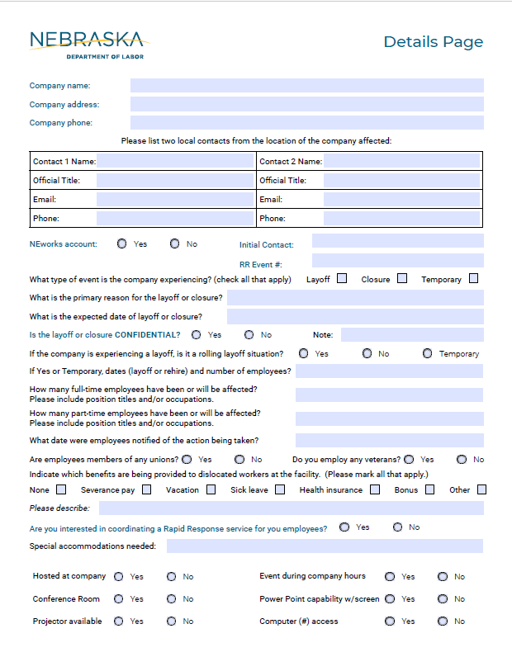

Once the RRWC has completed the Details page, they will email the form as an attachment to the affected areas shared Inbox (the local area of the affected employer). Regional Managers and Supervisors are responsible for providing the information to their appropriate team staff (e.g. Wagner Peyser, WIOA, Business Services) to begin coordinated service delivery. Please see Notification Processes on pages 20 & 21.

## When a Company has Already Closed or Declines RR Services

Unfortunately, scheduling a RRIS is not always feasible. Employees may be laid off prior to the Rapid Response team being notified, the employer declines to host a RRIS, or the timing of events does not allow for the process to occur.

Because information and data are always helpful in determining strategy for delivery of services, the appropriate RRWC should attempt to obtain the information on the Details page to be shared with the local area staff. RRWCs will arrange for workforce centers, American Job Centers and partner services contact information to be distributed to the impacted employees. The RRWCs will provide information electronically, by mail or personal delivery to each employer who indicates an interest in the information but does not wish to host an onsite information session. If an employer does not respond to calls, emails or provide an employee list or indicate a date to expect an employee list, the RRWCs will, within seven (7) business days of the initial request, send a notification to local area staff (via Local Area Shared Inbox) that the employer has declined services, did not provide an employee list and that the case will be closed.

When the employer provides an employee list, but has declined to host an information session, the RRWCs will immediately email the list to the appropriate local area shared Inbox. Regional Managers will be responsible for ensuring that the information is disseminated to the appropriate DW staff from the local area for follow up.

# Rapid Response Information Sessions (RRIS)

The RRIS is an opportunity for the assigned RRWC and local area staff to meet with the affected employees and make them aware of benefits, services, and resources available to assist them during their layoff and transition to new employment. Employees will receive information during these sessions and will be able to ask questions about available benefits and services.

Any worker who loses their job through no fault of their own, are by WIOA definition, a dislocated worker (DW) and the RRIS brings these dislocated workers together in one location to provide early services to assist in rapid re-employment. Local area staff for Wagner Peyser (WP) and WIOA will present information on their program/area of expertise at the RRIS and will be available to assist with registrations on NEworks as well as schedule appointments with DWs for possible WIOA enrollment.

Contact information and methods to access benefits, resources, and services will be provided to the employees during the session in order for the employee to be able to individually follow-up with the appropriate entities after the session has been completed. It is imperative that the local area provide the RRWC with contact information prior to the RRIS of the local area staff assigned with presenting and assisting those at the RRIS. The RRWCs will ensure that the contact information for the services and resources, including any additional services being coordinated by the local area offices, are identified for the employees.

## Providing On-Site Rapid Response Information Session(s)

When an employer has requested an on-site RRIS, ideally, the RRIS would be conducted as far in advance of the projected layoff or closure as possible. This allows employees time to absorb information presented and make informed decisions for their individual circumstances, interests and needs. The RRWCs will coordinate with the employer to determine session dates and times that work for the RRWC and Unemployment Insurance staff (UI). However, RRWCs must keep in mind that the employer will make the final determination on preferred date(s) and time(s) of a RRIS.

RRWCs will not be required to check with potential presenting team members prior to scheduling a RRIS as the employer has final decision making authority of the date and time of the RRIS. The RRWCs are capable of presenting WIOA and WP information at the sessions if local area staff cannot attend the information session. However, attendance is highly encouraged.

For remote and rural situations, if feasible, these services may be offered via technology such as Skype or WebEx meetings. A representative of Unemployment Insurance must be available to present UI information and answer questions for remote RRIS per Federal regulations. The RRWC will need to work in coordination with the RRPC in determining when this alternative would be appropriate.

## Securing Attendance at a Rapid Response Information Session

In order to maximize worker attendance at the RR information sessions, it is highly recommended that the meeting be held on-site, and while the employees are “on the clock”, if possible. This requires the cooperation of the employer and should be discussed during the initial employer meeting(s). Because many of the information sessions are conducted on company time, additional workforce and community partners may be in attendance at the information session, if space allows, but will not be allowed to present information at the session itself, with the exception of UI, WIOA and WP representatives. If additional partners are present, RRWCs should introduce these individuals in their presentation, and employees may meet with these additional resources following the RRIS. If additional services have been arranged for another date/time RRWCs will ensure that they are presenting information on upcoming opportunities for additional assistance to the employees.

If a layoff or closure will affect multiple shifts, each shift may need a separate information session scheduled. If the sessions are to be held “off the clock”, it is recommended that they be scheduled immediately before or after shift changes in order to give all of the affected employees an opportunity to attend.

## Employee List

The RRWCs should encourage the employer to provide information concerning the affected employees, and their current positions and skill sets prior the RR session by providing a separate employee list. However, this information is not required and the decision to supply any information is at the employer’s discretion.

## Registering for NEworks Prior to Event

RRWCs should encourage employers to request that their employees register on NEworks as soon as possible, and prior to a RRIS, when possible. Early registration will assist in providing timely and effective services to the affected employees.

# Preparing for a Rapid Response Information Session

## Requesting a Rapid Response Event Number

RRWCs will need to request one event number for each company. Separate sessions will be recorded under the same RR event number for that company. If the RR will occur at separate locations for different divisions within the same company, each location/division will need its own event number.

To request an event number, send an email to [ndol.neworkshelp@nebraska.gov](mailto:ndol.neworkshelp@nebraska.gov)

* Include the Employer Details page in the request; also include the following:
  + If a WARN was issued;
  + If there is a Trade petition or certification
    - If there is no Trade connection, note that on the request.

## RR Packets

Once the RR information session has been determined, RRWCs will assemble information packets for attendees.

## Contact Sheet

The contact sheet will identify the presenters for the event and contain contact information for each local area office or American Job Center and any additional resource contacts for the employers and the affected employees following the event. Local area staff contact information must be provided to the RRWC prior to the RRIS.

## Rapid Response Folder Contents List

Folder contents should not be changed on a state level without prior approval of the RRPC.

Local areas may add additional appropriate content to the folders with approval of the RRWCs.

## Left side: Back to Front

* Position Yourself for Success brochure (PIO for reorders)
* Labor Market Information brochure (PIO for reorders)
* NEworks Mobile App postcard (PIO for reorders)
* FINRA booklet on financial choices (Obtained online from FINRA organization (301) 590-6500
* Economic Transition Dislocated Worker Program – ET-DWG page (reprint locally)
* “Know your Healthcare Options” book (printed locally)

## Right Side: Back to Front

* Contact List
* Demographic Survey (printed locally)
* Assistance Survey (printed locally)
* UI Handbook (reorder from UI)
* “Surviving a Layoff” booklet (purchase request needed for reorders)

RRWCs will be responsible for monitoring supply levels for RR packets and ensuring timely reorders of supplies. All PIO and local print orders can be completed by the RRWCs. Any reorders requiring purchase orders will need to be signed off on by the RRPC.

# Presenting the Rapid Response Information Session

## Rapid Response Attendance by RRWCs and Local Area Staff

All RRIS’s with an anticipated attendance lower than 25 will be attended by one RRWC. If numbers are anticipated to be over 25, two RRWCs will attend. This is a guideline only - if staff determine that more help will be needed, based on the circumstances, adjustments will be made accordingly. When multiple staff are in attendance, they will support each other in fulfilling their RR duties and assignments for all sessions and should work as a cohesive team: One RRWC will facilitate the session and the other staff will assist with coordinating sign-in sheets, information packets, NEworks registrations, etc.

Local area Wagner Peyser staff and WIOA staff are encouraged to attend the RRIS to present their services to the affected employees. However, if staff schedules do not allow for this, RRWCs will present Wagner Peyser and WIOA service information at the RRIS and share staff contact information with the affected employees.

## Equipment

RRWCs will be supplied with the appropriate and necessary equipment to conduct all RRIS events. This equipment will include laptops to assist with registrations on NEworks, a projector, a large screen and a small screen for the projector, an individual cell phone with hot spot service for internet connections, carts to load and carry equipment, etc. Wherever possible, RRWCs will need a secure (locked) location to store laptops where they can be left plugged in and connected to receive periodic updates. If there are equipment needs, please contact the RRPC for assistance.

## Rapid Response Laptops

The RR laptops are an important part of the RR event. They should all be open and displaying the NEworks site where participants can register for NEworks. All NDOL staff who are in attendance at the RRIS, should be manning the laptops and registering affected employees on NEworks and scheduling appointments for one on one services.

The laptops are public facing. If the laptops require a login, staff will need to enter the following information to log into the system:

User Name: Public.RapidResponse

Password: Password1’

If you have to log in to access the RR laptops, notify the RRPC when you return as the laptops will need serviced.

## Set Up

RRWCs are responsible for setting up the RRIS and ensuring that the proper technology is working effectively. It is recommended that RRWCs maintain a thumb drive with the RR Power Point presentations which must be updated periodically as changes are made. Power Point presentations will remain generic, however, local staff are encouraged to provide RRWCs with information specific to their local area to be placed in the RR packets. The RR Power Point content will be reviewed annually (or more often, as needed) and will not be changed without prior approval of the RRPC. The Power Point presentations can be found at: L > Employment and Training > WIOA Rapid Response > RRWC_Resources > RR Information Session > Rapid Response Power Point.

## Sign In Sheets

RRWCs will be responsible for providing a sign-in sheet for attendees, collecting the sign in sheet following the session, scanning the sign in sheet into the appropriate company folder on the L drive, emailing a copy to the local area (via the Local Area Shared Inbox) and providing the original sign in sheet to the RRPC for filing in NDOL Administration. If a RRWCs home office is outside of NDOL Administration, the RRWC is responsible for maintaining the original sign-in sheet. In accordance with state policy, all RR documents shall have a three (3) year retention rate from date of event.

Sign in sheets can be found at: L > Employment and Training> WIOA Rapid Response > RRWC_Resources >Templates > Sign-In Sheet.

## Presentations

RRWCs will begin the RRIS with a “Welcome” and make introductions of any partners who will be available for follow up after the session. The RRWC will present the session information and the local area staff, if in attendance, will present Wagner Peyser and WIOA services. UI staff will present on Unemployment Insurance benefits that are available. All presenters should keep their presentations as concise as possible, out of respect for the employer and the employee’s time.

## Demographic and Assistance Surveys

Nebraska’s RR program utilizes surveys to gather necessary data to track dislocated worker trends across the state; these surveys also provide the RRWCs and local area staff with a snapshot of the needs and interests of the affected employees. RRWCs are responsible for ensuring that both the assistance survey and the demographic surveys are included in the packets and *ensuring that employees are directed to remove and complete the surveys at the RRIS.* Once the assistance surveys are gathered, RRWCs should scan them into the appropriate folder on the L drive and send a copy of the surveys to the Local Area Shared Inbox. Paper copies of the assistance surveys should be maintained in a central file by the RRWC for three (3) years from event date. Copies of the demographic surveys can be recycled after being converted to the demographic results spreadsheet.

Assistance surveys can be found at L > Employment and Training > WIOA Rapid Response > RRWC_Resources > RR Information Session > RR packets > RR Assistance Survey.

*Under no circumstances is information about participants to be shared with non-workforce system partners without their prior approval. If a referral must be made to a partner program outside of the AJC or NDOL, you may provide that partner’s contact information to the participants, but a participant’s contact information should never be shared with other service providers without their expressed permission.

The demographic survey is a one page document that gathers general demographic information on the dislocated employees as a group. RRWCs are responsible for retrieving the demographic surveys after a session. The demographic survey should be entered into the demographic results spreadsheet for an overall result for use in the service plan.

The demographic survey can be found at: L > Employment and Training > WIOA Rapid Response > RRWC_Resources > RR Information Session > RR Packets > RR Demographic Survey;

The demographics spreadsheet can be found at: L > Employment and Training > WIOA Rapid Response; > RRWC_Resources > Templates > RR Demographic Results Spreadsheet.

## Closing the Session

RRWCs will be responsible for closing the event and ensuring that all equipment is packed up and checked back in as soon as possible.

Following the session, RRWCs should maintain contact with the local area office to ensure no further assistance is needed from the RRWC as they move forward with additional services.

# Post Rapid Response Information Session - Updating OnBase and NEworks

Following a RR information session, the RRWCs will be responsible for ensuring that the information about the event is updated and completed in the company’s file on the L drive (should contain the service plan), and that all major contact/events with the company, employer and affected employees is documented in OnBase and NEworks. Each company should have contact information, address, an identified layoff or closure with a complete date and number of affected employees (if known), a date that a RR session was provided, if WARNs were received for that company and whether the company is Trade certified or not, if known.

# The Service Plan

The service plan is a comprehensive document that identifies the company, the demographics of the affected community, the layoff/closure details, available workforce and community services, the local labor market information for the community and identifies any growing and in demand jobs in the area.

The service plan should serve as a resource for both the employer and the affected employees in moving forward from the layoff or closure. The plan is developed by the RRWCs *prior to a RR event, when possible*, so that it can be provided to the employer and the affected employees at the event. The service plan will also be utilized by local area offices as a resource in strategizing and planning for additional services for affected employees in the area. RRWCs will email a copy of the service plan to the Local Area Shared Inbox to be disseminated to the appropriate staff as soon as it is available.

A Service Plan template can be found at: L > Employment and Training > WIOA Rapid Response > RRWC_Resources > Templates > Service Plan.

# Additional Resource Events

The service plan will identify important local market area information that local staff can utilize in determining needs for additional DW services in the local area. Regional Managers or Supervisors will disseminate this information immediately to their DW staff and the local area staff will quickly arrange any additional services.

Any additional employer services (for the affected employer and potential hiring employers in the area) will be driven by the local Business Services Workforce Professional. Services for DW’s will be driven by local area staff. The RRWCs will work closely with local areas to assist in coordinating any additional services *if they are going to occur in conjunction with the RRIS*. If additional services will occur at a later date/time or at a different location, local area staff are responsible for providing this information to the RRWCs as far in advance of a RRIS as possible. RRWCs will include this information in the RRIS packets for employees and work to promote the additional resource events and services at the RRIS.

* RRWCs will not be tasked with organizing or providing additional services such as job fairs, workshops, collecting paystubs, verifying employment, etc., however, they may provide appropriate referrals to local area staff and assist in scheduling additional services *if they will occur in conjunction with the planned information session*.

# Responsibilities

## State level Rapid Response Program Coordinator (RRPC)

It is the responsibility of the RRPC to monitor any federal directives and changes to the program issued via Training and Employment Notices (TENS) and Training and Employment Guidance Letters (TEGL’s) and to update the manual to reflect these changes and to disseminate that information to staff. Program development, monitoring and reporting are the responsibility of the RRPC, in conjunction with the RR Administrator, along with development and dissemination of training curriculum, standard operating procedures, quality control measures, and RR policies from the federal and state levels. The RRPC will conduct bi-annual quality assurance of all RRIS, notifications, and referrals. The RRPC will approve any changes to the RR information Power Points and state level information in the RR folders, maintain current and updated information for program delivery for RR staff, maintain current, accurate and organized documents on the L drive, and communicate any changes or updates to all RRWCs.

The RRPC will be responsible for monitoring layoff and closure notifications, and work of the RRWCs, and, in conjunction with RRWCs, overseeing and ordering RR supplies and maintaining accurate lists of RR partners, workforce partners and community partners in the local areas. The RRPC will assist with ensuring new state level staff receive full training on their duties and responsibilities, assist with presentations for state level information, etc. and will ensure that the program is running efficiently and effectively on a daily basis.

## Program Quality Assurance

The RRPC will be responsible for conducting quality control checks for RR services across the state and for maintaining accurate and current program forms and making updates when required. The RRPC will be responsible for tracking outcomes for DW referrals across the state and reporting these outcomes to NDOL Administration. The RRPC will be responsible for checking that OnBase and NEworks entries are entered accurately and completely and determining that correct activity codes are being utilized in NEworks by RRWC’s.

## Rapid Response Workforce Coordinators (RRWCs)

RRWC’s will facilitate working relationships with the local area offices and staff, RRWCs will be assigned regions on an annual basis and will be responsible for any events that occur within that region. This will provide consistent partnerships and effective and efficient support from RRWCs for each region. Additional or alternative RRWCs will assist across regions, if needed and requested by another RRWC or the RRPC.

The RRWCs are tasked with facilitating Rapid Response activities and ensuring there are consistent and cohesive RRIS’s across the state. They will act as the primary point of contact for employers to ensure consistency, efficiency, and accountability and will determine employer needs. RRWCs will be responsible for swiftly coordinating a response from start to finish by working with employers, local area staff, and local community partners to ensure an effective, efficient and flexible response. RRWCs are tasked with communicating the needs of the company to the appropriate RR system partners, scheduling and presenting RRIS’s, maintaining the appropriate information packets (including maintaining supply levels of packet information) for employees, delivering information to employers and employees, as needed, recording, sharing and storing the data from layoff or closure events, and creating a service plan which is utilized to provide a snapshot picture of the current labor market information for the local area and the affected employees.

RRWC will make referrals to local area staff for one on one services via NEworks. See page 21 for complete details of the referral process.

## Local Area Staff

Local area Wagner Peyser and WIOA staff are invited to attend RRIS’s in their respective areas. Attendance at the RR session is not mandatory, but is highly encouraged to ensure rapid service to affected employees. Local area staff are responsible for providing one on one employment assistance to all affected workers who request such services. RRWCs will provide a formal referral via NEworks documenting such requests. See pages 20 and 21 for the referral process that local area stuff must follow. The RRPC will monitor outcomes of referrals to local areas and will address concerns with local area NDOL Administrators.

Local area staff are responsible for providing the RRWC with any information on upcoming local events and services that would be beneficial to the affected employees for inclusion at RRIS’s and the RR packet. This information should be shared as far in advance of the event as possible. RRWCs will coordinate the sharing of information and promotion of local workforce development events with the affected employees.

Additional duties of local area staff *may* include:

* Targeted employer connections to the affected employees and their skill sets;
* On-site job fairs or reverse job fairs; may occur in conjunction with RRIS;
* Additional workshops on resumes, job interviews, job search;
* Educational opportunities on utilizing and maximizing use of NEworks for job seekers;
* Assistance with registration and setting of appointments for affected employees;
* Local job openings in the region; and
* Any other pertinent information requested by the RRWC that will assist in providing the affected employees with employment opportunities.

# Natural Disasters

In response to a layoff or closure as the result of a natural disaster, the RR program will be able and available to host an event addressing reemployment needs of the affected employees in the area. The RRPC will work closely with UI, as the majority of assistance to employers and employees will come through the unemployment office. Generally, in a disaster scenario, employees are considered “attached” and planning to return to work with their company, once recovery is complete. So each disaster scenario will be unique and needs and services will need to be assessed for each situation.

The RRPC may contact the Federal Emergency Management Agency (FEMA) office and the Nebraska Emergency Management Agency (NEMA) office, when appropriate.

FEMA: Region VII contact is 816-283-7061 or [FEMARegion7info@fema.dhs.gov](mailto:FEMARegion7info@fema.dhs.gov)

NEMA: Emergency Management program specialist at (402) 471-7426

Through this contact, the RRPC will determine the following information:

FEMA (following a Federal disaster declaration only): Will a disaster recovery center (DRC) be available in the area to all impacted employees? What services are available through your organization and how can employees access them? It will be pertinent to discuss logistics of internet availability, space restrictions, and capacity limitations.

NEMA: Has an individual assistance declaration been requested/approved? Was a request for disaster unemployment also requested? Are there local area offices that will be opened and if so, what are their locations, hours and contact information? What services are available through your organization and how can employees access them?

The RRWCs will coordinate any responses with Unemployment Insurance (UI) during this time. When coordinating with UI, the RRWCs will make sure that UI knows the event is being planned as a response to a natural disaster; this information will be provided in the notification. If there is a Presidential declaration for Disaster Unemployment Assistance (DUA), it may impact the information UI provides at a RR session, so RRPC and RRWCs will need to monitor this information.

Options for meeting places across the state will depend on the type and severity of the natural disaster along with the location of the affected employees. If the President declares an Individual Assistance (IA), FEMA will open Disaster Recovery Centers (DRC’s). These centers may not be ideal for holding a formal presentation but will likely be a gathering place for those affected by the natural disaster. Other location options where the RR information session may take place include Red Cross stations, community buildings not affected by the disaster, and the nearest NDOL career center.

A RR session for a natural disaster will include more than the traditional RR team partners in order to coordinate and inform local and national disaster relief efforts and includes services above and beyond a traditional RR session. Information will be exchanged with agencies and contacts that can meet the needs of the impacted individuals, based on the type and severity of the natural disaster, to include emergency housing, clothing and nutritional needs. The list of invited partners may include, but is not limited to:

* Nebraska Emergency Management Agency (NEMA);
* DHHS;
* UI;
* Red Cross;
* Faith-based organizations; and
* Community-based organizations.

RRWCs will send individual and group referrals for dislocated employees immediately following a Rapid Response Information session via NEworks (individual referrals) and local area shared inboxes (assistance surveys and sign-in sheets). Local area staff should send an email to the RR team to verify receipt of the sign in sheet and assistance surveys. Local area staff will utilize NEworks and their local area shared email boxes to receive and follow up on dislocated worker referrals from the RR team within 24 hours of receipt. Local area staff will log the result of the referral via NEworks as successful or unsuccessful and record appropriate case notes on the referral follow up.

# WARNs

## What is a WARN?

Certain larger scale dislocation events are governed by the Worker Adjustment and Retraining Notification (WARN) Act of 1988. The Federal WARN Act provides protection to employees, their families, and communities by requiring certain businesses with 100 or more full-time employees to provide notification at least 60 calendar days in advance of business closings or dislocation events of at least 50 employees. Advance notice of larger scale dislocation events provides employees and their families’ time to transition and adjust to the prospect of loss of employment, to seek and obtain alternative jobs, and if necessary, to enter skill training or retraining that will allow them to successfully compete in the job market. WARN also requires qualifying employers to provide notice to state dislocated worker units and local government. This notice allows the state’s RR team to effectively provide timely transitional assistance to affected employees as they seek new jobs or enter relevant skills training programs.

Affected employees include:

* Employees who are terminated or laid off for more than 6 months or who have their hours reduced more than 50 percent in any 6-month period as a result of the business closing or dislocation event;
* Employees who may reasonably be expected to experience an employment loss as a result of a proposed business closing or mass lay-off;
* Employees who are on temporary layoff but have a reasonable expectation of recall, including employees on worker’s compensation, medical, maternity, or other leave; and
* Part-time employees.

WARN covers employment losses that occur over a 90-day period. An employer is required to give advance notice if it has a series of small terminations or layoffs, none of which would individually be covered under WARN but adds up to the number that would require a WARN notice.

Based on federal requirements, a business’ WARN to affected employees must contain:

1. The name and address of the employment site where the business closing or dislocation event will occur, and the name and telephone number of a company official to contact for further information;
2. A statement as to whether a planned action is expected to be permanent or temporary and if the entire business is to be closed, a statement to that affect;
3. The expected date of the first separation from employment and the anticipated schedule for making separations;
4. The job titles of position to be affected and the names of the employees currently holding affected jobs;
5. A statement of bumping rights, if any exist; and
6. The name of each union/employee representative and the name and address of the chief elected officer of each union, when applicable.

Businesses are encouraged to provide additional information that may be useful to affected employees, such as information on available dislocated worker assistance and outplacement services.

Per United States Department of Labor (USDOL) guidance, an employer who violates WARN is liable to each affected employee for an amount equal to back pay and benefits for the period of violation, up to 60 days. An employer who fails to provide notice as required to a unit of local or state government is subject to a civil penalty not to exceed $500 for each day of violation. WARN violations are enforced through actions brought by an affected employee in the U.S. District Courts.

More information on federal WARN requirements can be found at:

<https://doleta.gov/layoff/warn.cfm>

# NDOL Rapid Response Notification & Referral Process

## Rapid Response Information Session (RRIS) Notification

1. The assigned Rapid Response Workforce Coordinator (RRWC) will notify the local area Regional Manager, designee and/or service provider (if applicable), local area Administrator, Rapid Response Program Coordinator (RRPC), and Rapid Response Administrator of an upcoming Rapid Response event in the area. This notification will be made via email and will include the Details page for the event.
   1. Notifications will be sent to the following inboxes:
      1. American Job Center, Beatrice: [ndol.beatricewfd@nebraska.gov](mailto:ndol.beatricewfd@nebraska.gov)
      2. American Job Center, Grand Island: [ndol.grandislandwfd@nebraska.gov](mailto:ndol.grandislandwfd@nebraska.gov)
      3. American Job Center, Lincoln, Wagner Peyser Job Seeker Services ONLY: [ndol.lincolnwfd@nebraska.gov](mailto:ndol.lincolnwfd@nebraska.gov)
      4. Lincoln Rescare, WIOA Title I Services ONLY: [LNWIOA@rescare.com](mailto:LNWIOA@rescare.com) and Kroll, Jay: [jeremiahkroll@rescare.com](mailto:jeremiahkroll@rescare.com)
      5. American Job Center, Omaha, Wagner Peyser Job Seeker Services ONLY: [ndol.omahawfd@nebraska.gov](mailto:ndol.omahawfd@nebraska.gov)
      6. Omaha National Able, WIOA Title 1 Services ONLY: [shassan@nationalable.org](mailto:shassan@nationalable.org)
      7. Alliance: [ndol.alliancewfd@nebraska.gov](mailto:ndol.alliancewfd@nebraska.gov)
      8. Columbus: [ndol.columbuswfd@nebraska.gov](mailto:ndol.columbuswfd@nebraska.gov)
      9. Hastings: [ndol.hastingswfd@nebraska.gov](mailto:ndol.hastingswfd@nebraska.gov)
      10. Lexington: [ndol.lexingtonwfd@nebraska.gov](mailto:ndol.lexingtonwfd@nebraska.gov)
      11. McCook: [ndol.mccookwfd@nebraska.gov](mailto:ndol.mccookwfd@nebraska.gov)
      12. Nebraska City: [ndol.nebraskacitywfd@nebraska.gov](mailto:ndol.nebraskacitywfd@nebraska.gov)
      13. Norfolk: [ndol.norfolkwfd@nebraska.gov](mailto:ndol.norfolkwfd@nebraska.gov)
      14. North Platte: [ndol.northplattewfd@nebraska.gov](mailto:ndol.northplattewfd@nebraska.gov)
      15. Scottsbluff: [ndol.scottsbluffwfd@nebraska.gov](mailto:ndol.scottsbluffwfd@nebraska.gov)
      16. Sidney: [ndol.sidneywfd@nebraska.gov](mailto:ndol.sidenywfd@nebraska.gov)
      17. York: [ndol.yorkwfd@nebraska.gov](mailto:ndol.yorkwfd@nebraska.gov)
   2. An employee list will be provided to the local area via the local area shared inbox, along with any additional information, as it becomes available.
2. The local area has one (1) working day to respond to the RRWC with the contact information of the local area staff who will be attending the event and what programs they serve, assisting job seekers and the employer.
   1. The local area staff are responsible for gathering all local resources to provide at the RRIS or to provide to the RRWC should they not be able to attend the RRIS. The local area staff are also responsible for coordinating and providing any additional services requested by the employer such as a job fair, resume assistance, etc.
3. Upon completion of the RRIS, the RRWC will provide the local area with a Service Plan within 14 days of the RRIS if one was not provided prior at the event.

## Rapid Response Referrals

1. The RRWC assigned to the RRIS will provide RR attendees with a customer assistance survey during the RRIS to determine any re-employment assistance needs. This survey is used by the RRWC to make appropriate referrals to the local office via NEworks. The customer assistance surveys will be provided to the local area via the local area shared inbox within two (2) working days.
2. Within two (2) working days of the RRIS, the RRWC will utilize NEworks to provide formal referrals to the local areas based upon the customers’ requested needs.
   1. Referrals will be sent to the following inboxes from NEworks:
      1. American Job Center, Beatrice: [ndol.beatricewfd@nebraska.gov](mailto:ndol.beatricewfd@nebraska.gov)
      2. American Job Center, Grand Island: [ndol.grandislandwfd@nebraska.gov](mailto:ndol.grandislandwfd@nebraska.gov)
      3. American Job Center, Lincoln, Wagner Peyser Job Seeker Services ONLY: [ndol.lincolnwfd@nebraska.gov](mailto:ndol.lincolnwfd@nebraska.gov)
      4. Lincoln Rescare, WIOA Title I Services ONLY: [LNWIOA@rescare.com](mailto:LNWIOA@rescare.com) and Kroll, Jay: [jeremiahkroll@rescare.com](mailto:jeremiahkroll@rescare.com)
      5. American Job Center, Omaha, Wagner Peyser Job Seeker Services ONLY: [ndol.omahawfd@nebraska.gov](mailto:ndol.omahawfd@nebraska.gov)
      6. Omaha National Able, WIOA Title 1 Services ONLY: [shassan@nationalable.org](mailto:shassan@nationalable.org)
      7. Alliance: [ndol.alliancewfd@nebraska.gov](mailto:ndol.alliancewfd@nebraska.gov)
      8. Columbus: [ndol.columbuswfd@nebraska.gov](mailto:ndol.columbuswfd@nebraska.gov)
      9. Hastings: [ndol.hastingswfd@nebraska.gov](mailto:ndol.hastingswfd@nebraska.gov)
      10. Lexington: [ndol.lexingtonwfd@nebraska.gov](mailto:ndol.lexingtonwfd@nebraska.gov)
      11. McCook: [ndol.mccookwfd@nebraska.gov](mailto:ndol.mccookwfd@nebraska.gov)
      12. Nebraska City: [ndol.nebraskacitywfd@nebraska.gov](mailto:ndol.nebraskacitywfd@nebraska.gov)
      13. Norfolk: [ndol.norfolkwfd@nebraska.gov](mailto:ndol.norfolkwfd@nebraska.gov)
      14. North Platte: [ndol.northplattewfd@nebraska.gov](mailto:ndol.northplattewfd@nebraska.gov)
      15. Scottsbluff: [ndol.scottsbluffwfd@nebraska.gov](mailto:ndol.scottsbluffwfd@nebraska.gov)
      16. Sidney: [ndol.sidneywfd@nebraska.gov](mailto:ndol.sidneywfd@nebraska.gov)
      17. York: [ndol.yorkwfd@nebraska.gov](mailto:ndol.yorkwfd@nebraska.gov)
3. The local area will disseminate the referral to the appropriate local area staff within one (1) working day of receipt of the referral.
4. The assigned local area staff will initiate contact with the customer within one (1) working day of receipt of referral from supervisor/Regional Manager. Initial contact must be made via phone call. Email is to be utilized as a secondary form of contact unless the customer requests otherwise.
   1. The local area staff will case note every contact and interaction with the customer, whether contact was made or not.
   2. When the customer is contacted and the referral is addressed, the referral must be resulted as successful in NEworks.
   3. If the customer cannot be reached after a minimum of three contact attempts, the referral can be resulted as unsuccessful in NEworks.

# Entering a Company into OnBase

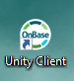

If your computer has an icon for OnBase, it will look like this. Double click on the icon to open OnBase. If your computer does not have an OnBase icon on the desktop, you can find it in your start-up menu under “unity client”.

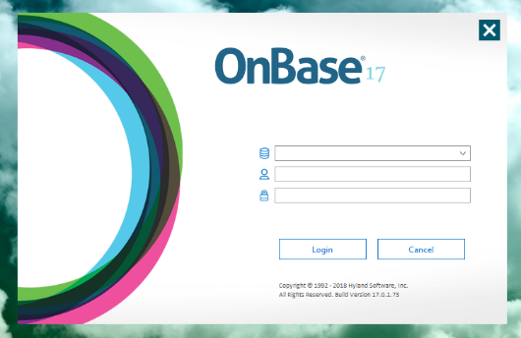

Clicking on the unity client will open the following window:

****Click on the drop down menu at the top

It will give you two options to choose from:

01 Production or 02 (two)CAT

****Choose 01 Production

The user name should populate, if it does not,

contact your supervisor for direction.

Enter your password and hit return or click “Login”

The top of your window should look like this:

****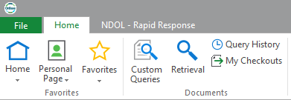

Click on NDOL – Rapid Response

The top of your screen should now look like this:

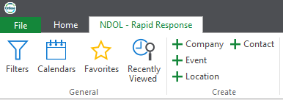

**Initial Employer Outreach**

Click on “Filters”

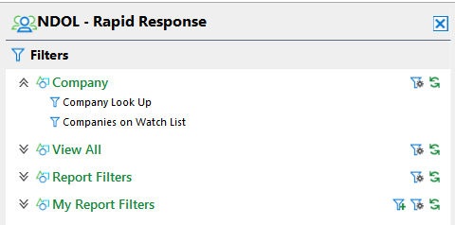



Click on “Company Look Up

Enter the company name in the box. **You may need to try variations of the name to ensure the company does not already exist in the system.**

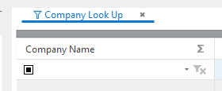

Look through the list for the company you are working with. If the company exists, ensure the location is the correct location and select that listing to open the file.

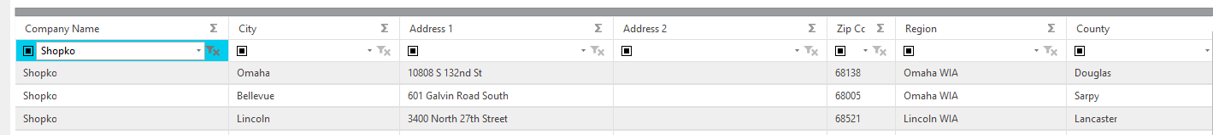



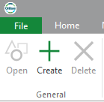

If the company does not already exist, you will need to enter it into the system.

To enter a new company in the system, click on “create” in the top menu:

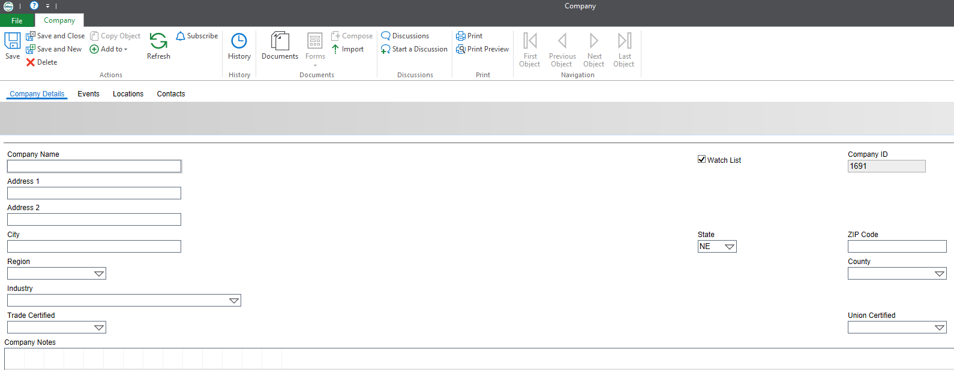

It’s easier if you start with the “location” of the company, otherwise, you will need to enter it twice. Click on “locations” at the top of the menu:



Click on the + sign on the right of the window:

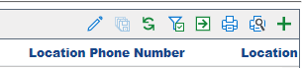

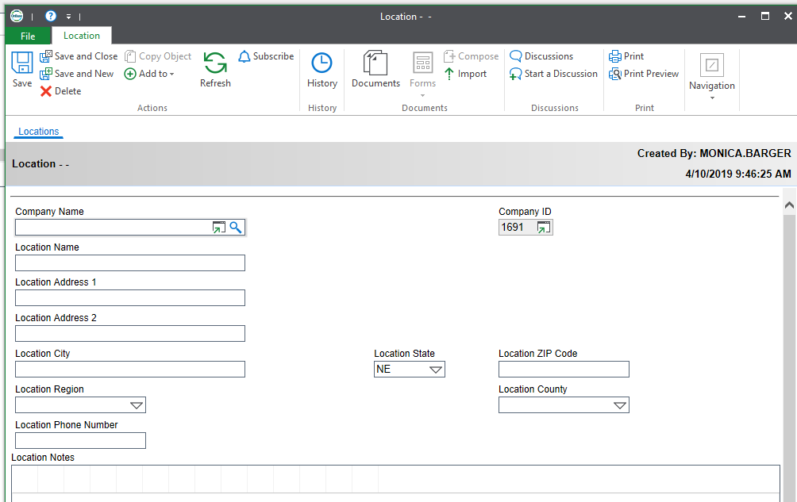



Enter the information for the company name. On location name, enter the city is located in, or, if there are multiple stores in one city, enter an easily recognizable piece of the location to differentiate between stores.

Once you have entered the information, click on “save and close” at the top of the screen.

Next, enter the contact person and information on the “Contacts” screen at the top of the page:





Click the + Sign to enter a new contact

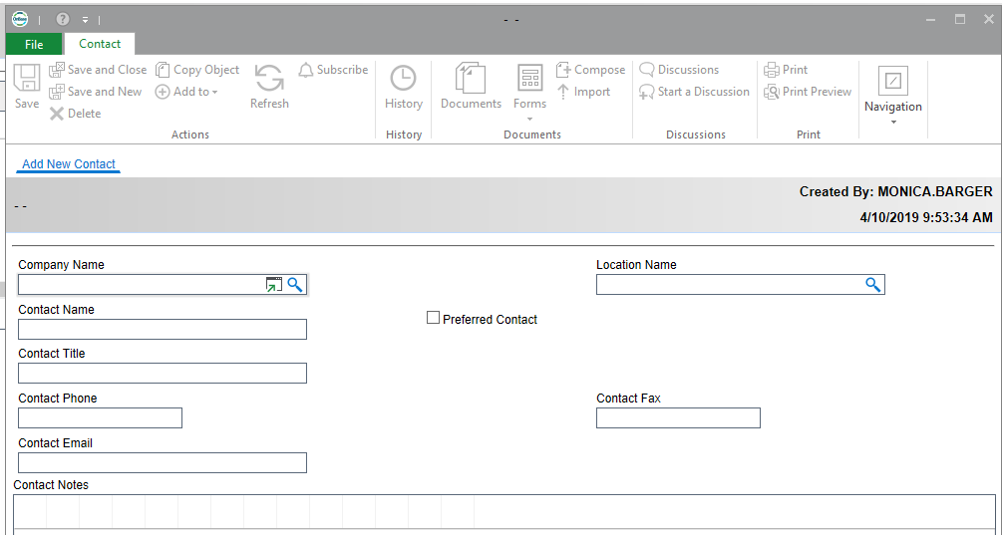Enter the contact information and click “save and close” at the top of the page.



Once the contact information is entered, return to the “Company Details” tab and complete the information:

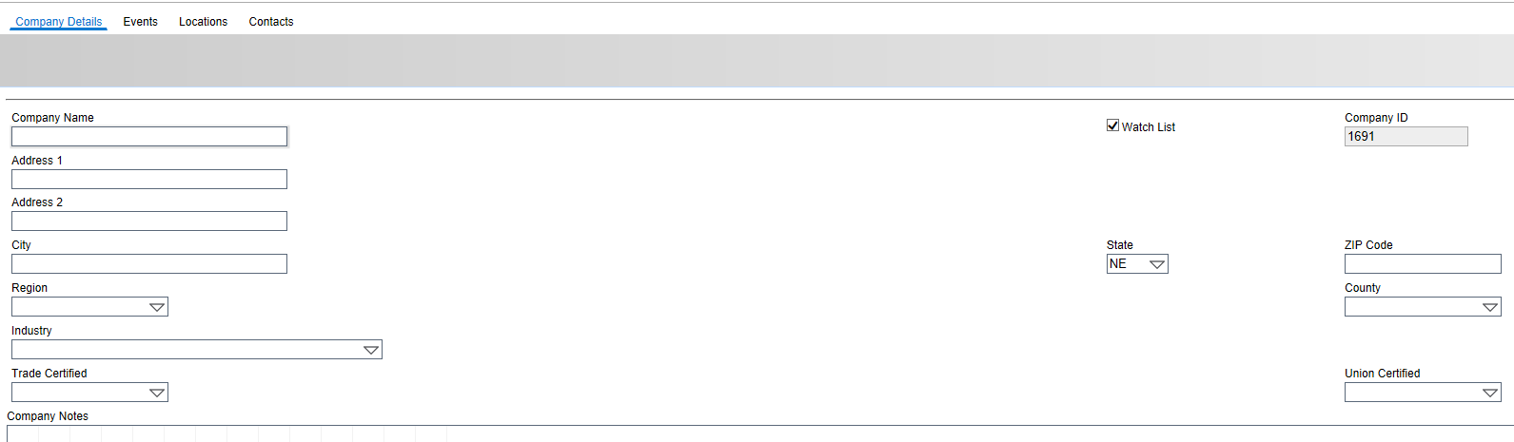

If you have entered the location information already, the system will provide you with an option to select the locations you’ve already entered in the address box. Select the correct location by double clicking on it.

# Entering an Event in OnBase

To enter an event in OnBase, first use the company look up filter to find the company you wish to enter events for. Select that company. Once you are at the company screen, select “Events” at the top of the page:





Select the + sign in the top right of the screen to enter a new event.

The “Event Date” box will automatically populate with the current date. Ensure you are entering the correct date for when the event actually occurred!

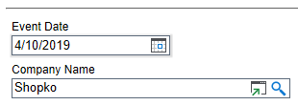



On the location name and contact name, if that information has already been entered, you can select the magnifying glass and double click on the correct location and contact name:

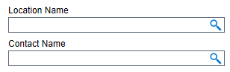



Event Type is an important piece of information:

The drop down menu for Event types include: (the highlighted ones are the ones you will use most often)

* **Closure –** this should only be entered if the closure is VERIFIED AND PUBLIC. This populates to the public NDOL website
* Contact by Other Source – used to track how the information came into us about potential clousre/layoff
* Furlough
* Initial contact (letter)
* **Initial contact (phone) –** used to track when initial contact was made to employer by phone
* **Initial onsite –** used to track when initial contact is made with employer by onsite meeting (layoff aversion)
* **Layoff –** this should only be entered if the layoff is VERIFIED AND PUBLIC
* LMI/Layoff – would be used if layoff aversion is involved and we are providing labor market information
* NEG
* Other Mailing – used to track correspondence by mail
* Other meeting – to track any meetings concerning an event
* Phone call – to track any phone calls placed while working on a notification/event
* **Possible Layoff** **–** this should be used when the layoff has NOT BEEN VERIFIED YET. This will keep the information from populating to the public website. Utilize this entry until a layoff has been verified.
* **Possible Layoff/Closure** – this should be used when the closure has NOT BEEN VERIFIED YET. This will keep the information from populating to the public website. Utilize this entry until you verify the closure.
* **Rapid Response** – tracks any Rapid Responses (onsite only!). Enter one RR for each session you provide. For example: you go to one company and provide two session, one at 9 am and one at 2 (two)pm, you will enter two rapid responses.
* RR Folder
* Survey
* **Temporary Layoff –** this entry will be utilized in situations in which the layoff is temporary, such as in a disaster where the company plans to reopen but has to layoff employees during repairs.
* **WARN** **–** this entry is utilized whenever we receive a WARN notice from a company. This will automatically populate to the NDOL public website. Per the commissioner of labor, ALL WARNS will immediately be entered in the OnBase system when they are received.
* Other
* <None>

Select the most appropriate occupation code from the drop down menu.

Enter the number of affected employees in the Number of Jobs window. This information will pull for reports on affected dislocated employees across the state, so it’s important that this information is accurate.

In the publicity window, you can select public knowledge or confidential. If you select PUBLIC KNOWLEDGE, the information will automatically publish the NDOL public website.

When you are done entering the event information, be sure to click “Save” if you want to save your work and continue working with that company. Click “Save and Close” if you are done working with that company.

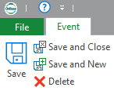

For information on how to send a referral to a service provider in NEworks, and how to result referrals in NEworks, please see the pdf. “How to Create and Result Service Provider Referrals in NEworks”, created and delivered via NEworks team. A recorded session of how to create and result service provider referrals can be located at:

|  |  |  |  |
| --- | --- | --- | --- |
| **Streaming recording link:** |  | |  | | --- | | <https://nvcn-cio.webex.com/nvcn-cio/ldr.php?RCID=6de5dc557207eaad4771b74b5f142993> | |
| **Download recording link:** |  | |  | | --- | | <https://nvcn-cio.webex.com/nvcn-cio/lsr.php?RCID=1e56f1daa8f9175d0e1f966faf8f9a31> | |

For Rapid Response team members

When selecting the recipient of a referral for dislocated employees, select the appropriate group email inbox for the area. RR staff will utilize a WIOA services referral, a job seeker services referral or a supportive service referral only. Do not use the “other” services from the drop down menu. If the provider is an outside agency or individual, select supportive service.

# Running Reports on OnBase

To run closure/layoff or WARN reports on OnBase:

Open OnBase; navigate to the NDOL-Rapid Response tab at the top



Select Filters

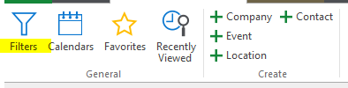

Select “Layoff, Closure, WARN’s & Rapid Response under Report Filters:

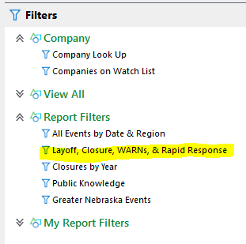

Enter a Date range

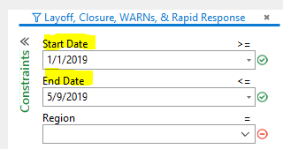

If you want to run a report for a specific region, enter the region in the drop down menu or Region box. If you want to run a state wide report, leave Region box blank.

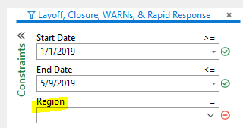

To sort by event type (closure/Layoff/WARN), click on the down arrow in the screen over the column you wish to sort by and then select the appropriate selection in the drop down menu.

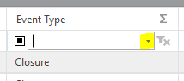

# Entering Activity Codes for Employer Services in NEworks

# (If the Employer has an NEworks Account)

There are basically three activities that the Rapid Response team will utilize and enter in NEworks to track services to employers. They are:

**E09 – Rapid Response/Business Downsizing Assistance**

Initial on-site visit or contact to either (a) discuss the range of rapid response services and other assistance available to employees and employers affected by layoff, plant closures, or natural disasters, or (b) as required by WIOA Section 3(51)(A), plan a layoff response following notification of a current or projected permanent closure or mass layoff, including natural or other disasters

Staff should enter an E09 activity anytime they conduct initial outreach to an employer to discuss RR services or other assistance. Staff should utilize the E30 activity to record planning of RR services for an employer.

**E22 (two) – Referral to Community Resources**

Providing information on proactive linkage and referral of establishments to community resources that support their workforce needs.

Staff should enter an E22 (two) activity anytime they make a referral for the employer to a community resource.

**E30 – Planning Layoff Response**

Initial on-site visit or contact, as required by WIOA Section 3(51)(A), to plan a layoff response following notification of a current or projected permanent closure or mass layoff, including natural or other disasters.

Staff should enter an E30 when planning RR services for an employer.

Select manage activities and from the menu select employer services.

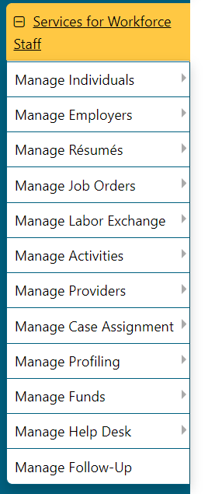

Input the employers name and select search at the bottom of the page.

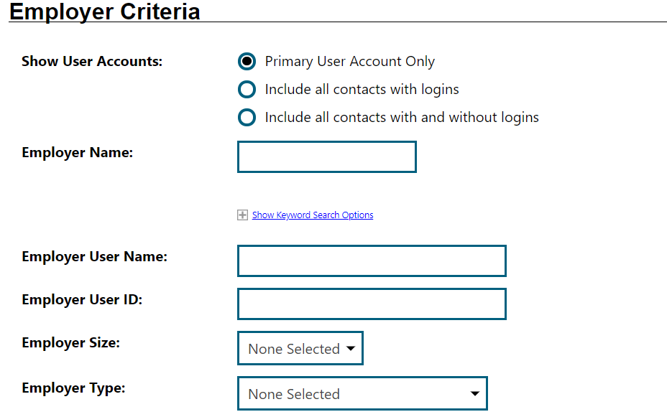

Select the activities.

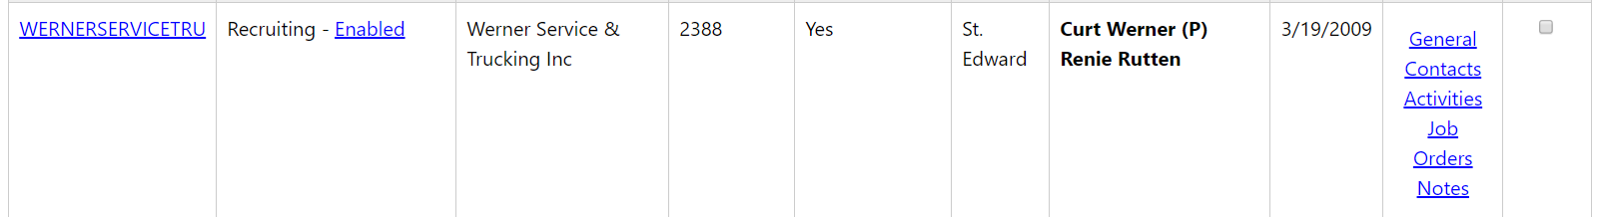

Select service plan.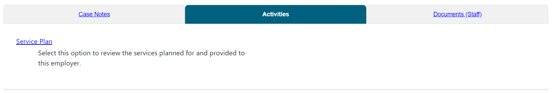

Select Add Multiple Services.

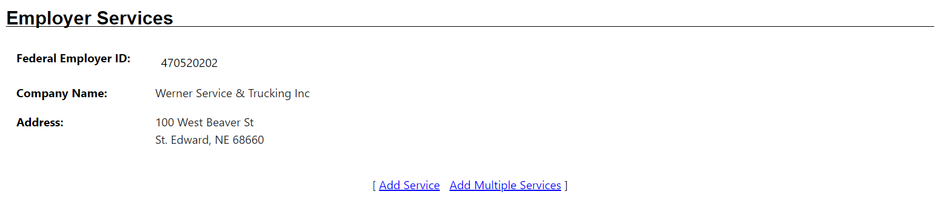

Input your region, office location and position. Then select find worksite location to select the employer’s specific address.

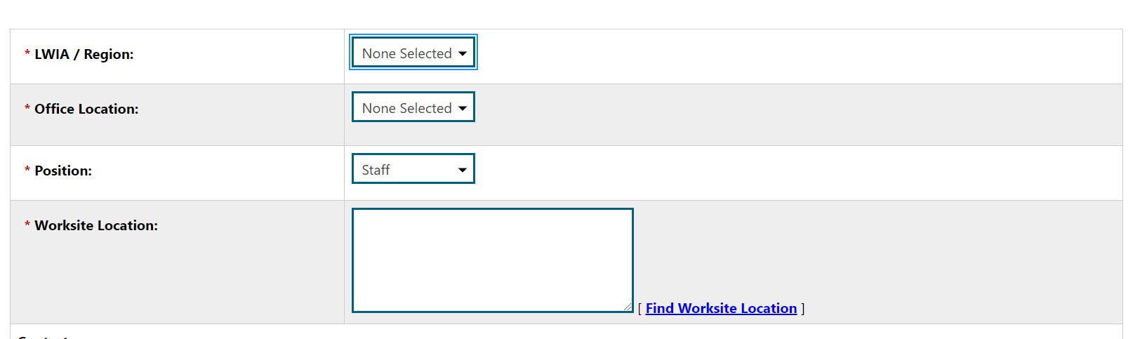

Select any of the applicable activity codes (see above for the appropriate activity codes). Be sure to input the associated rapid response event number. Select save at the bottom of the screen when complete.

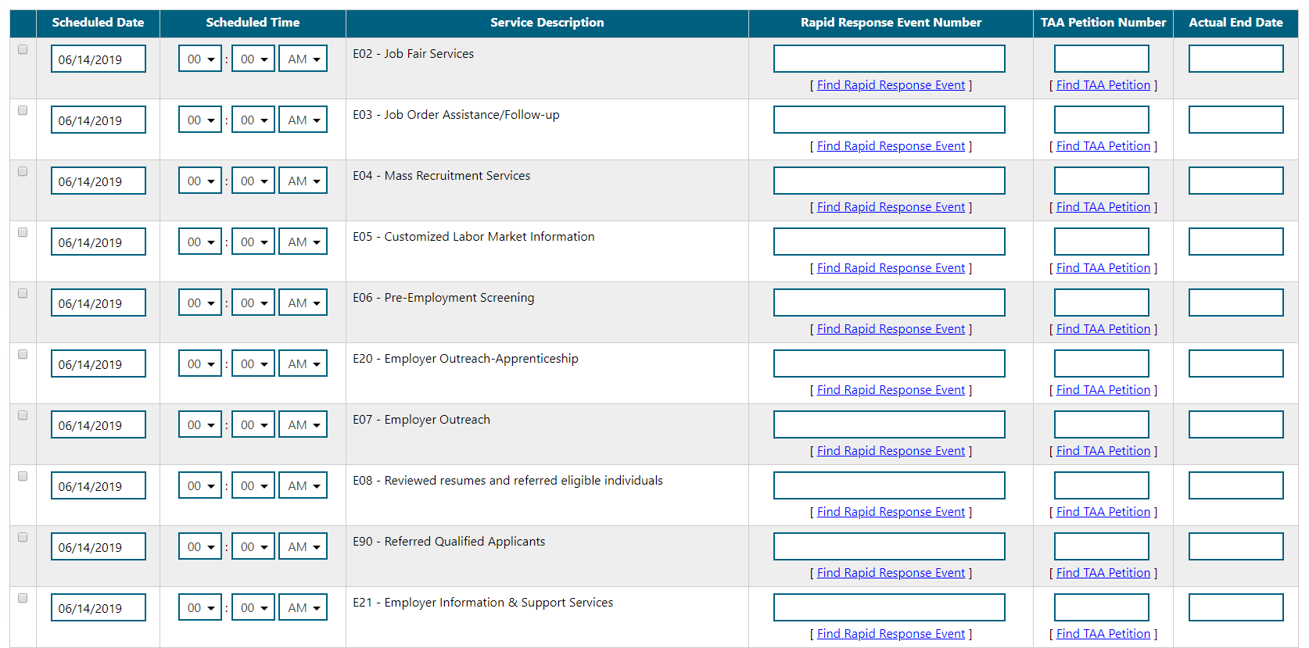

# Sending a Referral to Virtual Services Unit (VSU)

When assisting an individual, Staff Profiles > General Profile > Activities > Staff Referrals to Providers > Add Referral > Fill in LWIA/Region, Office Location of Referral, Date of Referral, and Program Making Referral > Scroll down and fill in detailed reason for referral and additional information regarding referral > **Scroll down and select “Search for Provider” link**



Type “Neb” in provider search box, with “begin with” selected for search type, then click submit

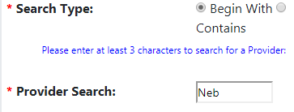

Scroll down and select “Nebraska Department of Labor”

Use drop down menu next to “location” and select “VSU Lincoln”

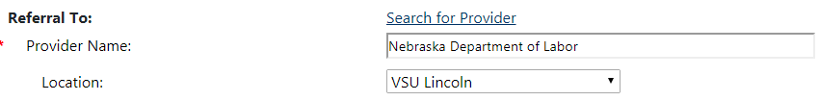

Use drop down menu next to “Contact” and select “Wagner Peyser Services”. Contact info will prefill.

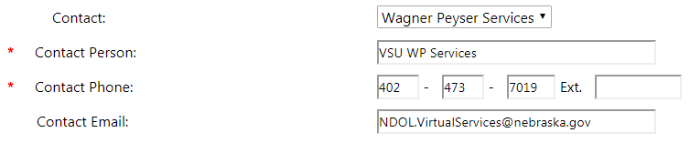

It is important for the contact email box to say [NDOL.VirtualServices@Nebraska.gov](mailto:NDOL.VirtualServices@Nebraska.gov) or the VSU will not receive the referral. Click Save.