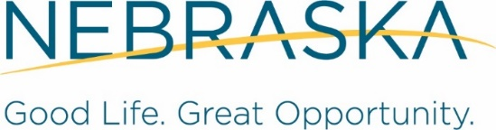

Combined State Plan for Nebraska’s Workforce System

Program Years 2024 through 2027

(July 1, 2024 – June 30, 2028)

2026 Modification (effective July 1, 2026 – June 30, 2028

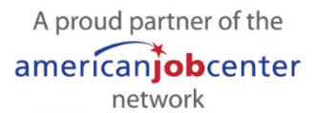

Contents
Message to readers 7
I. WIOA State Plan Type and Executive Summary 8
a. WIOA State Plan Type 8
b. Plan Introduction or Executive Summary 8
II. Strategic Elements 8
a. Economic, Workforce, and Workforce Development Activities Analysis 8
1. Economic and Workforce Analysis 8
2. Workforce Development, Education and Training Activities Analysis 47
b. State Strategic Vision and Goals 61
Vision 62
Goals 62
Performance goals 63
Assessment 63
c. State Strategy 63
Selecting and prioritizing development of career pathways 63
Strategies for alignment 69
III. Operational Planning Elements 72
a. State Strategy Implementation 72
1. State Board Functions 72
2. Implementation of State Strategy 73
b. State Operating Systems and Policies 80
1. The State operating systems that support coordinated implementation of State strategies (for example labor market information systems, data systems, communication systems, case management systems, job banks, etc.). 80
2. The State policies that will support the implementation of the State’s strategies (for example, co-enrollment policies and universal intake processes where appropriate). In addition, provide the State’s guidelines for State-administered one-stop partner programs’ contributions to a one-stop delivery system and any additional guidance for one-stop partner contributions. 81
3. State Program and State Board Overview 86
4. Assessment and Evaluation of Programs and One-Stop Program Partners 88
5. Distribution of Funds for Core Programs 92
6. Program Data 95
7. Priority of Service for Veterans. 97
8. Addressing the Accessibility of the One-Stop Delivery System for Individuals with Disabilities 101
9. Addressing the Accessibility of the One-Stop Delivery System for Individuals who are English Language Learners 110
IV. Coordination with State Plan Programs 113
V. Common Assurances (For All Core Programs) 114
VI. Program-Specific Requirements for Core Programs 115
Program-Specific Requirements For Adult, Dislocated Worker, And Youth Activities Under Title I-B 115
a. General requirements 115
b. Adult and Dislocated Workers Program Requirements 124
c. Youth Program Requirements. 138
d. Single-area State Requirements 146
e. Waiver Requests (optional) 146
Title I-B Assurances 149
Performance Goals for Adult, Dislocated Worker, and Youth Programs 150
Program-Specific Requirements for Wagner-Peyser Program (Employment Services) 151
a. Employment Service Staff 151
b. Explain how the State will provide information and meaningful assistance to individuals requesting assistance in filing a claim for unemployment compensation through one-stop centers, as required by WIOA as a career service 152
c. Describe the State’s strategy for providing reemployment assistance to UI claimants and other unemployed individuals 153
d. Describe how the State will use W-P funds to support UI claimants, and the communication between W-P and UI, as appropriate including the following: 153
e. Agricultural Outreach Plan (AOP). Each State agency must develop an AOP every four years as part of the Unified or Combined State Plan required under sections 102 or 103 of WIOA. The AOP must include: 155
Wagner-Peyser Assurances 162
Performance Goals for Wagner-Peyser Program 162
Program-specific Requirements for Adult Education and Family Literacy Act Programs 163
a. Aligning of Content Standards 163
b. Local Activities 163
c. Corrections Education and other Education of Institutionalized Individuals 166
d. Integrated English Literacy and Civics Education Program 166
e. State Leadership 167
f. Assessing Quality 169
Adult Education and Family Literacy Act Program Certifications 170
Adult Education and Family Literacy Act Program Assurances 170
Authorizing or Certifying Representative 170
Section 427 of the General Education Provisions Act (GEPA) 171
Adult Education and Literacy Program Performance Indicators 172
Program-Specific Requirements for State Vocational Rehabilitation (Combined or General) 173
a. State Rehabilitation Council. 173
b. Comprehensive Statewide Needs Assessment (CSNA). 176
c. Goals, Priorities, and Strategies 179
d. Evaluation and Reports of Progress: VR and Supported Employment Goals 184
e. Supported Employment Services, Distribution of Title VI Funds, and Arrangements and Cooperative Agreements for the Provision of Supported Employment Services. 194
f. Annual Estimates 197
g. Order of Selection 197
h. Waiver of Statewideness. 198
i. Comprehensive System of Personnel Development. 198
j. Coordination with Education Officials. 204
k. Coordination with Employers 210
l. Interagency Cooperation with Other Agencies 211
Assurances 215
Vocational Rehabilitation (Combined or General) Certifications 217
Vocational Rehabilitation Program Performance Indicators 218
GEPA 427 Form Instructions for Application Package - Vocational Rehabilitation 218
GEPA 427 Form Instructions for Application Package - Supported Employment 219
Program-Specific Requirements for State Vocational Rehabilitation (Blind) 220
a. State Rehabilitation Council. 220
b. Comprehensive Statewide Needs Assessment (CSNA). 221
c. Goals, Priorities, and Strategies 223
d. Evaluation and Reports of Progress: VR and Supported Employment Goals 225
e. Supported Employment Services, Distribution of Title VI Funds, and Arrangements and Cooperative Agreements for the Provision of Supported Employment Services. 227
f. Annual Estimates 229
g. Order of Selection 230
h. Waiver of Statewideness. 230
i. Comprehensive System of Personnel Development. 231
j. Coordination with Education Officials. 235
k. Coordination with Employers 239
l. Interagency Cooperation with Other Agencies 240
Assurances 242
Vocational Rehabilitation (Blind) Certifications 244
Vocational Rehabilitation Program Performance Indicators 246
GEPA 427 Form Instructions for Application Package - Vocational Rehabilitation 246
GEPA 427 Form Instructions for Application Package - Supported Employment 248
VII. Program-Specific Requirements for Combined State Plan Partner Programs 249
Temporary Assistance for Needy Families (TANF) 250
a. Conduct a program designed to serve all political subdivisions in the State (not necessarily in a uniform manner) that provides assistance to needy families with (or expecting) children and provides parents with job preparation, work, and support services to enable them to leave the program, specifically cash assistance, and become self-sufficient (section 402(a)(1)(A)(i) of the Social Security Act) 250
b. Require a parent or caretaker receiving assistance to engage in work (defined by the State) once the State determines the parent or caretaker is ready to engage in work, or once he or she has received 24 months of assistance, whichever is earlier, consistent with the child care exception at 407(e)(2) (section 402(a)(1)(A)(ii) of the Social Security Act) 255
c. Ensure that parents and caretakers receiving assistance engage in work in accordance with section 407 (section 402(a)(1)(A)(iii) of the Social Security Act). Consistent with the required strategic elements discussed in section II (a)(2) herein, provide a specific analysis of how the State’s workforce development activities are addressing employment and training services for parents or caretakers receiving assistance 256
d. Take such reasonable steps as the State deems necessary to restrict the use and disclosure of information about individuals and families receiving assistance under the program attributable to funds provided by the Federal Government (section 402(a)(1)(A)(iv) of the Social Security Act) 265
e. Establish goals and take action to prevent and reduce out-of-wedlock pregnancies, with special emphasis on teenage pregnancies (section 402(a)(1)(A)(v) of the Social Security Act) 265
f. Conduct a program designed to reach State and local law enforcement officials, the education system, and relevant counseling services, that provides education and training on the problem of statutory rape so that teenage pregnancy prevention programs may be expanded to include men (section 402(a)(1)(A)(vi) of the Social Security Act) 268
g. Implement policies and procedures as necessary to prevent access to assistance provided under the State program funded under this part through any electronic fund transaction in an automated teller machine or point-of-sale device located in a place described in section 408(a)(12), including a plan to ensure that recipients of the assistance have adequate access to their cash assistance (section 402(a)(1)(A)(vii) of the Social Security Act) 268
h. Ensure that recipients of assistance provided under the State program funded under this part have the ability to use or withdraw assistance with minimal fees or charges, including an opportunity to access assistance with no fee or charges, and are provided information on applicable fees and surcharges that apply to electronic fund transactions involving the assistance, and that such information is made publicly available (section 402(a)(1)(A)(viii) of the Social Security Act) 268
i. Indicate whether it intends to treat families moving from another State differently from other families under the program, and if so how (section 402(a)(1)(B)(i) of the Social Security Act) 268
j. Indicate whether it intends to provide assistance to non-citizens, and if so include an overview of the assistance (section 402(a)(1)(B)(ii) of the Social Security Act) 269
k. Set forth objective criteria for the delivery of benefits and the determination of eligibility and for fair and equitable treatment, including an explanation of how it will provide opportunities for recipients who have been adversely affected to be heard in a State administrative or appeal process (section 402(a)(1)(B)(iii) of the Social Security Act) 269
l. Indicate whether the State intends to assist individuals to train for, seek, and maintain employment (Section 402(a)(1)(B)(v) of the Social Security Act)— 269
m. Provide for all MOE-funded services the following information: the name of the program benefit or service, and the financial eligibility criteria that families must meet in order to receive that benefit or service. In addition, for TANF MOE-funded services (co-mingled or segregated MOE) describe the program benefit provided to eligible families (SSP services do not have to include a description but the Department of Health and Human Services encourages it) (§263.2(b)(3) & §263.2(c) preamble pages 17826-7) 269
TANF Certifications 271
Employment and Training Programs Under the Supplemental Nutrition Assistance Program (Programs Authorized Under Section 6(d)(4) of the Food and Nutrition Act of 2008 (7 U.S.C. 2015(d)(4))) 272
a. General Requirements 272
b. Able-bodied Adults without Dependents (ABAWD) [28] 278
Trade Adjustment Assistance (TAA) 279
Jobs for Veterans’ State Grants 279
a. Describe how the state intends to provide employment, training, and job placement services to veterans and eligible persons under the JVSG program (i.e., virtually and in-person). 279
b. List the populations to be served by Disabled Veterans’ Outreach Program (DVOP) and consolidated position staff, including the eligibility criteria for referral for DVOP services. 280
c. Describe the roles and responsibilities assigned to Disabled Veterans’ Outreach Program (DVOP) specialists, Local Veterans’ Employment Representative (LVER) staff, and consolidated DVOP/LVER positions by the state. These must be consistent with 38 U.S.C. 4103A and 4104. 281
d. Demonstrate the manner in which DVOP, LVER and consolidated DVOP/LVER staff are integrated into the state’s employment service delivery systems or American Job Center (AJC). This demonstration should show active engagement between JVSG and other AJC staff, such as through participation in staff meetings and cross-training opportunities. 284
e. Describe the state's performance incentive award program to encourage individuals and/or employment service offices to improve and/or achieve excellence in the provision of services to veterans, including: 285
f. List the performance targets for direct services to veterans provided by JVSG staff, as measured by participants’: 288
Unemployment Insurance (UI) 288
a. Contents of a Complete UI SQSP Package 289
b. Requirements for States electing to include UI in the Combined State Plan 350
Senior Community Service Employment Program (SCSEP) 351
a. Economic Projections and Impact 351
b. Service Delivery and Coordination 367
c. Location and Population Served, including Equitable Distribution 375

Message to readers
In this Combined State Plan for Program Years 2024 through 2027, Federally mandated information requirements appear in italicized Times New Roman font. Responses to the mandated information requirements appear in regular Times New Roman font, with the exception of some section and subsection titles and certain words within the various sections of the plan. If you experience accessibility issues with this document, please email ndol.wioa_policy@nebraska.gov for assistance.

I. WIOA State Plan Type and Executive Summary

a. WIOA State Plan Type
This plan is a Combined State Plan and includes the following WIOA core programs:
- Title I adult, dislocated worker, youth partner programs;
- Title II Adult Education and Family Literacy Act partner program;
- Title III Wagner-Peyser Act partner program; and
- Title IV vocational rehabilitation partner programs.
In addition, this plan includes the following optional partner programs:
- Temporary Assistance for Needy Families program (authorized under 42 USC 601 et seq.)
- Employment and Training programs under the Supplemental Nutrition Assistance Program (authorized under 7 USC 2015(d)(4))
- Trade Adjustment Assistance for Workers programs (authorized under 19 USC 2271 et seq.)
- Jobs for Veterans State Grants Program (authorized under 38 USC 4100 et. seq.)
- Unemployment Insurance programs (programs authorized under State unemployment compensation laws in accordance with applicable Federal law)
- Senior Community Service Employment program (authorized under 42 USC 3056 et seq.)

b. Plan Introduction or Executive Summary
The Nebraska Workforce Innovation and Opportunity Act (WIOA) Plan communicates the vision for Nebraska’s public workforce system and broader talent development system. Nebraska has aligned its workforce development stragies and goals with President Trump’s Exeuctive Order 14278, “Preparing Americans for High-Paying Skilled Trade jobs of the Future” and the subsequent USDOL published “America’s Talent Strategy; Building the Workforce for the Golden Age.” Throughout the plan there will be references to the five strategic pillars articulated in America’s Talent Strategy; Building the Workforce for the Golden Age as implementation of this strategy is critical to workforce success in Nebraska.

II. Strategic Elements
The Unified or Combined State Plan must include a Strategic Planning Elements section that analyzes the State’s current economic environment and identifies the State’s overall vision for its workforce development system. The required elements in this section allow the State to develop data-driven goals for preparing an educated and skilled workforce and to identify successful strategies for aligning workforce development programs to support economic growth. Unless otherwise noted, all Strategic Planning Elements apply to Combined State Plan partner programs included in the plan as well as to core programs. Where requirements identify the term “populations”, these must include individuals with barriers to employment as defined at WIOA Section 3. This includes displaced homemakers; low-income individuals; Indians, Alaska Natives, and Native Hawaiians; individuals with disabilities, including youth who are individuals with disabilities; older individuals; ex-offenders; homeless individuals, or homeless children and youths; youth who are in or have aged out of the foster care system; individuals who are English language learners, individuals who have low levels of literacy, and individuals facing substantial cultural barriers; farmworkers (as defined at section 167(i) of WIOA) ; individuals within 2 years of exhausting lifetime eligibility under the Temporary Assistance for Needy Families program; single parents (including single pregnant women); and long-term unemployed individuals. Additional populations include veterans, unemployed workers, and youth, and others that the State may identify..

a. Economic, Workforce, and Workforce Development Activities Analysis
The Unified or Combined State Plan must include an analysis of the economic conditions, economic development strategies, and labor market in which the State’s workforce system and programs will operate.

1. Economic and Workforce Analysis

A. Economic Analysis
The Unified or Combined State Plan must include an analysis of the economic conditions and trends in the State, including sub-State regions and any specific economic areas identified by the State. This must include—
i. existing demand industry sectors and occupations
Provide an analysis of the industries and occupations for which there is existing demand.
ii. emerging demand industry sectors and occupations
Provide an analysis of the industries and occupations for which demand is emerging.
iii. employers’ employment needs
With regard to the industry sectors and occupations identified in (A)(i) and (ii), provide an assessment of the employment needs of employers, including a description of the knowledge, skills, and abilities required, including credentials and licenses.

Economic analysis introduction
Nebraska covers 76,817.87 square miles, with a population density of 25.5 persons per square mile. Nebraska’s population was estimated at 1,927,923 as of July 1, 2022. Approximately 52 percent of the State’s population is concentrated in 4 of the State’s 93 counties, Cass, Douglas, Lancaster, and Sarpy. Nebraska’s 91.0 cost of living index ranked 12th lowest in the nation as of the third quarter of 2023.
In the remainder of this section, the State provides its analysis of Nebraska’s economic conditions.

Gross domestic product
Table 1 provides comparisons of the growth of Nebraska’s gross domestic product (GDP) for all industries to the growth of the national GDP for all industries for years 2020 through 2024 based on real and current-dollar GDP.
- Nebraska’s real GDP for 2021, 2022, and 2023 increased by more than the national real GDP for the same years. In 2024 Nebraska’s real GDP increased but lagged behind the national real GDP for that year.
- Nebraska’s real GDP for 2020 decreased by 0.7 percent but not to the extent that national real GDP decreased (2.2 percent) for the same year.
- Nebraska’s current-dollar GDP for 2020, 2021, 2022, 2023, and 2024 increased. 2024 lagged behind national current-dollar GDP but the other years all increased more than national current-dollar GDP.

Table 1. Gross domestic product growth, all industries: Nebraska/US comparison
Year | Nebraska real GDP | Nebraska real GDP | United States real GDP | United States real GDP | Nebraska current-dollar GDP | Nebraska current-dollar GDP | United States current-dollar GDP | United States current-dollar GDP
Year | (millions of chained 2017 dollars) | % change from previous year | (millions of chained 2017 dollars) | % change from previous year | (millions of current dollars) | % change from previous year | (millions of current dollars) | % change from previous year
2020 | 126,735 | -0.7% | 20,267,585 | -2.2% | 135,149 | 1.7% | 21,354,105 | -0.9%
2021 | 134,940 | 6.5% | 21,494,798 | 6.1% | 150,836 | 11.6% | 23,681,171 | 10.9%
2022 | 139,441 | 3.3% | 22,034,828 | 2.5% | 167,480 | 11.0% | 26,006,893 | 9.8%
2023 | 145,020 | 4.0% | 22,671,096 | 2.9% | 181,285 | 8.2% | 27,720,709 | 6.6%
2024 | 145,909 | 0.6% | 23,305,023 | 2.8% | 185,411 | 2.3% | 29,184,890 | 5.3%
Source: United States Department of Commerce, Bureau of Economic Analysis, “GDP & Personal Income, Regional Data,” https://apps.bea.gov/itable/iTable.cfm?ReqID=70&step=1 [accessed October 2025]
Table 2 provides a comparison of the Grand Island metropolitan statistical area (Grand Island MSA) for all industries to the growth of the Nebraska’s GDP for all industries for years 2019 through 2023 based on real and current-dollar GDP.
- Grand Island MSA’s real GDP for 2022 receded compared Nebraska’s real GDP increase for the same year.
- Grand Island MSA’s real GDP for 2021 and 2023 increased and exceeded Nebraska’s real GDP increases for the same years.
- Grand Island MSA’s real GDP for 2020 receded similar to Nebraska’s real GDP for the same year.
- Grand Island MSA’s current-dollar GDP for 2020 and 2022 increased but lagged behind Nebraska’s real GDP increases for the same years.
- Grand Island MSA’s current-dollar GDP for 2021 and 2023 increased and exceeded Nebraska’s real GDP increases for the same years.

Table 2. Gross domestic product growth, all industries: Grand Island MSA/Nebraska comparison
Year | Grand Island MSA real GDP | Grand Island MSA real GDP | Nebraska real GDP | Nebraska real GDP | Grand Island current-dollar GDP | Grand Island current-dollar GDP | Nebraska current-dollar GDP | Nebraska current-dollar GDP
Year | (millions of chained 2017 dollars) | % change from previous year | (millions of chained 2017 dollars) | % change from previous year | (millions of current dollars) | % change from previous year | (millions of current dollars) | % change from previous year
2019 | 4,116 | 0.2% | 127,569 |  | 4,298 |  | 132,848
2020 | 4,057 | -1.4% | 126,735 | -0.7% | 4,365 | 1.6% | 135,149 | 1.7%
2021 | 4,476 | 10.3% | 134,940 | 6.5% | 5,077 | 16.3% | 150,836 | 11.6%
2022 | 4,447 | -0.6% | 139,441 | 3.3% | 5,433 | 7.0% | 167,480 | 11.0%
2023 | 4,635 | 4.2% | 145,020 | 4.0% | 5,979 | 10.1% | 181,285 | 8.2%
Source: United States Department of Commerce, Bureau of Economic Analysis, “GDP & Personal Income, Regional Data,” https://apps.bea.gov/itable/iTable.cfm?ReqID=70&step=1 [accessed October, 2025]
Table 3 provides a comparison of the Lincoln metropolitan statistical area (Lincoln MSA) for all industries to the growth of the Nebraska’s GDP for all industries for years 2019 through 2023 based on real and current-dollar GDP.
- Lincoln MSA’s real GDP for 2022 increased and exceeded Nebraska’s real GDP increase for the same year.
- Lincoln MSA’s real GDP for 2021 and 2023 increased but lagged behind Nebraska’s real GDP increases for the same years.
- Lincoln MSA’s real GDP for 2020 receded as did Nebraska’s real GDP for the same year.
- Lincoln MSA’s current-dollar GDP for 2020 increased and exceeded Nebraska’s real GDP increase for the same year.
- Lincoln MSA’s current-dollar GDP for 2021, 2022, and 2023 increased but lagged behind Nebraska’s real GDP increases for the same years.

Table 3. Gross domestic product growth, all industries: Lincoln MSA/Nebraska comparison
Year | Lincoln MSA real GDP | Lincoln MSA real GDP | Nebraska real GDP | Nebraska real GDP | Lincoln MSA current-dollar GDP | Lincoln MSA current-dollar GDP | Nebraska current-dollar GDP | Nebraska current-dollar GDP
Year | (millions of chained 2017 dollars) | % change from previous year | (millions of chained 2017 dollars) | % change from previous year | (millions of current dollars) | % change from previous year | (millions of current dollars) | % change from previous year
2019 | 20,325 | 1.9% | 127,569 |  | 21,220 | 4.0% | 132,848
2020 | 20,186 | -0.7% | 126,735 | -0.7% | 21,685 | 2.2% | 135,149 | 1.7%
2021 | 21,093 | 4.5% | 134,940 | 6.5% | 23,339 | 7.6% | 150,836 | 11.6%
2022 | 22,054 | 4.6% | 139,441 | 3.3% | 25,894 | 10.9% | 167,480 | 11.0%
2023 | 22,778 | 3.3% | 145,020 | 4.0% | 27,995 | 8.1% | 181,285 | 8.2%
Source: United States Department of Commerce, Bureau of Economic Analysis, “GDP & Personal Income, Regional Data,” https://apps.bea.gov/itable/iTable.cfm?ReqID=70&step=1#panel-1 [accessed October 2025]
Table 4 provides a comparison of the Omaha/Council Bluffs [Iowa] metropolitan statistical area (Omaha MSA) for all industries to the growth of the Nebraska’s GDP for all industries for years 2019 through 2023 based on real and current-dollar GDP.
- Omaha MSA’s real GDP for 2022 increased and exceeded Nebraska’s real GDP increase for the same year.
- Omaha MSA’s real GDP for 2021 and 2023 increased but lagged behind Nebraska’s real GDP increases for the same years.
- Omaha MSA’s real GDP for 2020 receded as did Nebraska’s real GDP for the same year.
- Omaha MSA’s current-dollar GDP for 2022 increased and exceeded Nebraska’s real GDP increase for the same year.
- Omaha MSA’s current-dollar GDP for 2020, 2021, and 2023 increased but lagged behind Nebraska’s real GDP increases for the same years.

Table 4. Gross domestic product growth, all industries: Omaha-Council Bluffs MSA/Nebraska comparison
Year | Omaha-CB MSA real GDP | Omaha-CB MSA real GDP | Nebraska real GDP | Nebraska real GDP | Omaha-CB MSA current-dollar GDP | Omaha-CB MSA current-dollar GDP | Nebraska current-dollar GDP | Nebraska current-dollar GDP
Year | (millions of chained 2017 dollars) | % change from previous year | (millions of chained 2017 dollars) | % change from previous year | (millions of current dollars) | % change from previous year | (millions of current dollars) | % change from previous year
2019 | 66,421 | 1.1% | 127,569 |  | 69,319 | 3.2% | 132,848
2020 | 65,208 | -1.8% | 126,735 | -0.7% | 69,714 | 0.6% | 135,149 | 1.7%
2021 | 68,873 | 5.6% | 134,940 | 6.5% | 75,971 | 9.0% | 150,836 | 11.6%
2022 | 73,706 | 7.0% | 139,441 | 3.3% | 86,269 | 13.6% | 167,480 | 11.0%
2023 | 75,323 | 2.2% | 145,020 | 4.0% | 92,357 | 7.1% | 181,285 | 8.2%
Source: United States Department of Commerce, Bureau of Economic Analysis, “GDP & Personal Income, Regional Data,” https://apps.bea.gov/itable/iTable.cfm?ReqID=70&step=1#panel-1 [accessed October 2025]

Personal income
Table 5 provides a comparison of Nebraska’s personal income growth (all sources) against national personal income growth (all sources). Nebraska’s personal income growth was positive for years 2020 through 2024, lagging behind national personal income growth for 2020 and 2024 and exceeding national growth for 2021, 2022, and 2023.

Table 5. Personal income growth, all sources: Nebraska/US comparison
Year | Nebraska personal income | Nebraska personal income | US personal income | US personal income
Year | (millions of dollars) | % change from previous year | (millions of dollars) | % change from previous year
2020 | 111,413 | 6.5% | 19,600,945 | 6.8%
2021 | 124,781 | 12.0% | 21,403,979 | 9.2%
2022 | 131,989 | 5.8% | 22,077,232 | 3.1%
2023 | 141,151 | 6.9% | 23,380,269 | 5.9%
2024 | 144,111 | 2.1% | 24,632,680 | 5.4%
Source: United States Department of Commerce, Bureau of Economic Analysis, “GDP & Personal Income, Regional Data,” https://apps.bea.gov/itable/iTable.cfm?ReqID=70&step=1 [accessed October 2025]
Tables 6, 7, and 8 provide comparisons of personal income growth (all sources) for the Grand Island, Lincoln, and Omaha-Council Bluffs metropolitan statistical areas (MSAs) against Nebraska’s personal income growth (all sources).
- Grand Island MSA (Table 6)
  - The percent change for Grand Island MSA personal income increased for years 2019 through 2023, lagging behind Nebraska’s percentage change for 2022 and exceeding Nebraska change for 2020 and 2021. The percent change for Grant Island MSA personal income matched the Nebraska change for 2023.
- Lincoln MSA (Table 7)
  - The percent change for Lincoln MSA personal income increased for years 2019 through 2023. The percent change for Lincoln MSA personal income exceeded Nebraska’s for years 2020 and 2023 and lagged behind Nebraska’s for 2021 and 2022.
- Omaha-Council Bluffs MSA (Table 8)
  - The percent change for Omaha-Council Bluffs MSA personal income increased for years 2019 through 2023. The percent change for Omaha-Council Bluffs MSA personal income exceeded Nebraska’s for year 2022 and lagged behind Nebraska’s in 2020, 2021, and 2023.

Table 6. Personal income growth, all sources: Grand Island MSA/Nebraska comparison
Year | Grand Island MSA personal income | Grand Island MSA personal income | Nebraska personal income | Nebraska personal income
Year | (millions of dollars) | % change from previous year | (millions of dollars) | % change from previous year
2019 | 3,392 | 5.0% | 111,413
2020 | 3,659 | 7.9% | 124,781 | 6.5%
2021 | 4,135 | 13.0% | 131,989 | 12.0%
2022 | 4,330 | 4.7% | 141,151 | 5.8%
2023 | 4,628 | 6.9% | 144,111 | 6.9%
Source: United States Department of Commerce, Bureau of Economic Analysis, “GDP & Personal Income, Regional Data,” https://apps.bea.gov/itable/iTable.cfm?ReqID=70&step=1#panel-1 [accessed October 2025]

Table 7. Personal income growth, all sources: Lincoln MSA/Nebraska comparison
Year | Lincoln MSA personal income | Lincoln MSA personal income | Nebraska personal income | Nebraska personal income
Year | (millions of dollars) | % change from previous year | (millions of dollars) | % change from previous year
2019 | 17,055 | 4.7% | 104,616
2020 | 18,249 | 7.0% | 111,413 | 6.5%
2021 | 20,270 | 11.1% | 124,781 | 12.0%
2022 | 21,333 | 5.2% | 131,989 | 5.8%
2023 | 22,858 | 7.1% | 141,151 | 6.9%
Source: United States Department of Commerce, Bureau of Economic Analysis, “GDP & Personal Income, Regional Data,” https://apps.bea.gov/itable/iTable.cfm?ReqID=70&step=1#panel-1 [accessed October 2025]

Table 8. Personal income growth, all sources: Omaha-Council Bluffs MSA/Nebraska comparison
Year | Omaha-CB MSA personal income | Omaha-CB MSA personal income | Nebraska personal income | Nebraska personal income
Year | (millions of dollars) | % change from previous year | (millions of dollars) | % change from previous year
2019 | 55,256 | 3.3% | 104,616
2020 | 58,079 | 5.1% | 111,413 | 6.5%
2021 | 63,789 | 9.8% | 124,781 | 12.0%
2022 | 69,715 | 9.3% | 131,989 | 5.8%
2023 | 73,830 | 5.9% | 141,151 | 6.9%
Source: United States Department of Commerce, Bureau of Economic Analysis, “GDP & Personal Income, Regional Data,” https://apps.bea.gov/itable/iTable.cfm?ReqID=70&step=1#panel-1 [accessed October 2025]

Industry sectors
Tables 9 and 10 provide data on Nebraska’s top 10 industry sectors. Table 9 ranks emerging industry sectors based on projected numeric changes in employment levels from 2022 to 2032. Based solely on projected numeric changes, the top five emerging industry sectors in Nebraska are:
- health care and social assistance, with a projected increase of 13,800;
- accommodation and food services, with a projected employment level increase of 6,218;
- manufacturing, with projected increase of 5,659;
- construction, with a projected increase of 4,880; and
- professional, scientific, and technical services, with a projected increase of 4,523.
Table 10 ranks emerging industry sectors based on percent changes in employment levels, from 2022 to 2032. Based solely on projected percent changes, the top five emerging industry sectors in Nebraska are:
- arts, entertainment, and recreation, with a projected percent increase of 15.41 percent;
- management of companies and enterprises, with a projected increase of 10.46 percent;
- health care and social assistance, with a projected increase of 9.54 percent;
- professional, scientific, and technical services, with a projected increase of 9.19 percent; and
- construction, with a projected increase of 8.39 percent.

Table 9. Top 10 emerging demand industry sectors based on projected numeric change in employment levels from 2022 to 2032
Rank | Industry Title | 2022 annual employment | 2032 projected employment | Numeric change
- | Total | 1,142,100 | 1,205,962 | 63,862
- | Self-Employed Workers | 64,452 | 66,746 | 2,294
- | Total Wage and Salary Employment | 1,077,648 | 1,139,216 | 61,568
1 | Health Care and Social Assistance | 144,611 | 158,411 | 13,800
2 | Accommodation and Food Services | 77,630 | 83,848 | 6,218
3 | Manufacturing | 103,490 | 109,149 | 5,659
4 | Construction | 58,136 | 63,016 | 4,880
5 | Professional, Scientific, and Technical Services | 49,197 | 53,720 | 4,523
6 | Transportation and Warehousing | 48,647 | 52,452 | 3,805
7 | Educational Services (including state and local gov) | 103,586 | 106,981 | 3,395
8 | Administrative and Support and Waste Management and Remediation Services | 52,750 | 55,398 | 2,648
9 | Finance and Insurance | 62,776 | 65,317 | 2,541
10 | Arts, Entertainment, and Recreation | 14,813 | 17,095 | 2,282
Source: Nebraska Department of Labor. Long-term Industry Projections: 2022-2032. [Online] July 2024. https://neworks.nebraska.gov/vosnet/gsipub/documentView.aspx?docid=439 [accessed October 2025]

Table 10. Top 10 emerging demand industry sectors based on projected percent change in employment levels from 2022 to 2032
Rank | Industry Title | 2022 annual employment | 2032 projected employment | % change
- | Total | 1,142,100 | 1,205,962 | 5.59%
- | Self-Employed Workers | 64,452 | 66,746 | 3.56%
- | Total Wage and Salary Employment | 1,077,648 | 1,139,216 | 5.71%
1 | Arts, Entertainment, and Recreation | 14,813 | 17,095 | 15.41%
2 | Management of Companies and Enterprises | 19,862 | 21,940 | 10.46%
3 | Health Care and Social Assistance | 144,611 | 158,411 | 9.54%
4 | Professional, Scientific, and Technical Services | 49,197 | 53,720 | 9.19%
5 | Construction | 58,136 | 63,016 | 8.39%
6 | Real Estate and Rental and Leasing | 10,680 | 11,569 | 8.32%
7 | Accommodation and Food Services | 77,630 | 83,848 | 8.01%
8 | Transportation and Warehousing | 48,647 | 52,452 | 7.82%
9 | Manufacturing | 103,490 | 109,149 | 5.47%
10 | Administrative and Support and Waste Management and Remediation Services | 52,750 | 55,398 | 5.02%
Source: Nebraska Department of Labor. Long-term Industry Projections: 2022-2032. [Online] July 2024. https://neworks.nebraska.gov/vosnet/gsipub/documentView.aspx?docid=439 [accessed October 2025]

Occupations
Tables 11 and 12 provide data on Nebraska’s top 20 emerging demand occupations. Table 11 ranks emerging demand occupations based on projected numeric changes in employment levels from 2022 to 2032. Based solely on projected numeric changes, the top five emerging demand occupations in Nebraska are:
- home health and personal care aides, with a projected increase of 2,241;
- stockers and order fillers, with a projected increase of 1,941;
- software developers, with a projected increase of 1,896;
- fast food and counter workers, with a projected increase of 1,882; and
- heavy and tractor-trailer truck drivers, with a projected increase of 1,826.

Table 12 ranks emerging demand occupations based on percent changes in employment levels from 2022 to 2032. Based solely on projected percent changes, the top five emerging demand occupations in Nebraska are:
- gambling dealers, with a projected increase of 212.90 percent;
- solar photovoltaic installers, with a projected increase of 125 percent;
- wind turbine service technicians, with a projected increase of 64.38 percent;
- gambling surveillance officers and gambling investigators, with a projected increase of 45.45 percent; and
- nurse practitioners, with a projected increase of 35.81 percent.

Table 11. Top 20 emerging demand occupations based on projected numeric change in employment levels from 2022 to 2032
Rank | SOC | SOC title | 2022 estimated employment | 2032 projected employment | Numeric change
1 | 31-1120 | Home Health and Personal Care Aides | 10,121 | 12,362 | 2,241
2 | 53-7065 | Stockers and Order Fillers | 14,126 | 16,067 | 1,941
3 | 15-1252 | Software Developers | 7,780 | 9,676 | 1,896
4 | 35-3023 | Fast Food and Counter Workers | 26,237 | 28,119 | 1,882
5 | 53-3032 | Heavy and Tractor-Trailer Truck Drivers | 27,022 | 28,848 | 1,826
6 | 29-1141 | Registered Nurses | 22,902 | 24,672 | 1,770
7 | 11-1021 | General and Operations Managers | 22,330 | 23,995 | 1,665
8 | 53-7062 | Laborers and Freight, Stock, and Material Movers, Hand | 18,031 | 19,444 | 1,413
9 | 31-1131 | Nursing Assistants | 16,292 | 17,539 | 1,247
10 | 35-2014 | Cooks, Restaurant | 4,454 | 5,677 | 1,223
11 | 11-3031 | Financial Managers | 5,330 | 6,317 | 987
12 | 47-2061 | Construction Laborers | 8,241 | 9,206 | 965
13 | 11-9111 | Medical and Health Services Managers | 4,415 | 5,361 | 946
14 | 47-2111 | Electricians | 6,368 | 7,258 | 890
15 | 11-9013 | Farmers, Ranchers, and Other Agricultural Managers | 12,685 | 13,572 | 887
16 | 37-2011 | Janitors and Cleaners, Except Maids and Housekeeping Cleaners | 17,470 | 18,350 | 880
17 | 37-2012 | Maids and Housekeeping Cleaners | 7,581 | 8,365 | 784
18 | 49-9071 | Maintenance and Repair Workers, General | 10,352 | 11,116 | 764
19 | 35-1012 | First-Line Supervisors of Food Preparation and Serving Workers | 7,154 | 7,879 | 725
20 | 13-2011 | Accountants and Auditors | 10,353 | 11,072 | 719
Source: Nebraska Department of Labor. Long-term Occupational Projections: 2022-2032. [Online] July 2024. https://neworks.nebraska.gov/vosnet/gsipub/documentView.aspx?docid=440 [accessed October 2025]

Table 12. Top 20 emerging demand occupations based on projected percent change in employment levels from 2022 to 2032
Rank | SOC | SOC title | 2022 estimated employment | 2032 projected employment | % change
1 | 39-3011 | Gambling Dealers | 31 | 97 | 212.90%
2 | 47-2231 | Solar Photovoltaic Installers | 8 | 18 | 125.00%
3 | 49-9081 | Wind Turbine Service Technicians | 320 | 526 | 64.38%
4 | 33-9031 | Gambling Surveillance Officers and Gambling Investigators | 11 | 16 | 45.45%
5 | 29-1171 | Nurse Practitioners | 1,790 | 2,431 | 35.81%
6 | 43-3041 | Gambling Cage Workers | 32 | 43 | 34.38%
7 | 15-2051 | Data Scientists | 1,400 | 1,830 | 30.71%
8 | 31-2021 | Physical Therapist Assistants | 1,117 | 1,445 | 29.36%
9 | 31-2011 | Occupational Therapy Assistants | 252 | 325 | 28.97%
10 | 15-2041 | Statisticians | 156 | 200 | 28.21%
11 | 39-1013 | First-Line Supervisors of Gambling Services Workers | 90 | 115 | 27.78%
12 | 15-1212 | Information Security Analysts | 670 | 855 | 27.61%
13 | 35-2014 | Cooks, Restaurant | 4,454 | 5,677 | 27.46%
14 | 29-2091 | Orthotists and Prosthetists | 86 | 107 | 24.42%
15 | 15-1252 | Software Developers | 7,780 | 9,676 | 24.37%
16 | 11-9081 | Lodging Managers | 480 | 596 | 24.17%
17 | 13-2061 | Financial Examiners | 703 | 871 | 23.90%
18 | 11-9071 | Gambling Managers | 13 | 16 | 23.08%
19 | 51-9162 | Computer Numerically Controlled Tool Programmers | 190 | 233 | 22.63%
20 | 19-1041 | Epidemiologists | 84 | 103 | 22.62%
Source: Nebraska Department of Labor. Long-term Occupational Projections: 2022-2032. [Online] July 2024. https://neworks.nebraska.gov/vosnet/gsipub/documentView.aspx?docid=440 [accessed October 2025]

Employer employment needs
Tables 13 and 14 provide data on education and job-training requirements for emerging demand occupations in Nebraska. Table 13 identifies education and job training requirements for the top 20 emerging demand occupations based on projected numeric changes in employment levels from 2022 through 2032 (Table 11). Among the top five emerging demand occupations based on projected numeric changes:
- all five require no work experience;
- one of five requires no job training; and
- four of five require short-term on-the-job training.

Table 14 identifies education and job-training requirements for the top 20 emerging demand occupations based on projected percent changes in employment levels from 2022 through 2032 (Table 12). Among the top five emerging demand occupations based on projected percentage changes:
- four of five require no work experience;
- one of five require less than five years work experience;
- one of five require no job training; and
- four of five require short-term or moderate-term on-the-job training.

Table 13. Education and job training requirements for top 20 emerging demand occupations based on projected numeric changes in employment levels from 2022 to 2032
Rank | SOC | SOC title | Education | Work experience | Job training
1 | 31-1120 | Home Health and Personal Care Aides | High school diploma or equivalent | None | Short-term on-the-job training
2 | 53-7065 | Stockers and Order Fillers | High school diploma or equivalent | None | Short-term on-the-job training
3 | 15-1252 | Software Developers | Bachelor's degree | None | None
4 | 35-3023 | Fast Food and Counter Workers | No formal educational credential | None | Short-term on-the-job training
5 | 53-3032 | Heavy and Tractor-Trailer Truck Drivers | Postsecondary non-degree award | None | Short-term on-the-job training
6 | 29-1141 | Registered Nurses | Bachelor's degree | None | None
7 | 11-1021 | General and Operations Managers | Bachelor's degree | 5 years or more | None
8 | 53-7062 | Laborers and Freight, Stock, and Material Movers, Hand | No formal educational credential | None | Short-term on-the-job training
9 | 31-1131 | Nursing Assistants | Postsecondary non-degree award | None | None
10 | 35-2014 | Cooks, Restaurant | No formal educational credential | Less than 5 years | Moderate-term on-the-job training
11 | 11-3031 | Financial Managers | Bachelor's degree | 5 years or more | None
12 | 47-2061 | Construction Laborers | No formal educational credential | None | Short-term on-the-job training
13 | 11-9111 | Medical and Health Services Managers | Bachelor's degree | Less than 5 years | None
14 | 47-2111 | Electricians | High school diploma or equivalent | None | Apprenticeship
15 | 11-9013 | Farmers, Ranchers, and Other Agricultural Managers | High school diploma or equivalent | 5 years or more | None
16 | 37-2011 | Janitors and Cleaners, Except Maids and Housekeeping Cleaners | No formal educational credential | None | Short-term on-the-job training
17 | 37-2012 | Maids and Housekeeping Cleaners | No formal educational credential | None | Short-term on-the-job training
18 | 49-9071 | Maintenance and Repair Workers, General | High school diploma or equivalent | None | Moderate-term on-the-job training
19 | 35-1012 | First-Line Supervisors of Food Preparation and Serving Workers | High school diploma or equivalent | Less than 5 years | None
20 | 13-2011 | Accountants and Auditors | Bachelor's degree | None | None
Source: Nebraska Department of Labor. Long-term Occupational Projections: 2022-2032. [Online] July 2024. https://neworks.nebraska.gov/vosnet/gsipub/documentView.aspx?docid=440 [accessed October 2025]

Table 14. Education and job training requirements for the top 20 emerging demand occupations based on projected percent change in employment levels, 2022 to 2032
Rank | SOC | SOC title | Education | Work experience | Job training
1 | 39-3011 | Gambling Dealers | High school diploma or equivalent | None | Short-term on-the-job training
2 | 47-2231 | Solar Photovoltaic Installers | High school diploma or equivalent | None | Moderate-term on-the-job training
3 | 49-9081 | Wind Turbine Service Technicians | Postsecondary non-degree award | None | Long-term on-the-job training
4 | 33-9031 | Gambling Surveillance Officers and Gambling Investigators | High school diploma or equivalent | Less than 5 years | Moderate-term on-the-job training
5 | 29-1171 | Nurse Practitioners | Master's degree | None | None
6 | 43-3041 | Gambling Cage Workers | High school diploma or equivalent | None | Short-term on-the-job training
7 | 15-2051 | Data Scientists | Bachelor's degree | None | None
8 | 31-2021 | Physical Therapist Assistants | Associate's degree | None | None
9 | 31-2011 | Occupational Therapy Assistants | Associate's degree | None | None
10 | 15-2041 | Statisticians | Master's degree | None | None
11 | 39-1013 | First-Line Supervisors of Gambling Services Workers | High school diploma or equivalent | Less than 5 years | None
12 | 15-1212 | Information Security Analysts | Bachelor's degree | Less than 5 years | None
13 | 35-2014 | Cooks, Restaurant | No formal educational credential | Less than 5 years | Moderate-term on-the-job training
14 | 29-2091 | Orthotists and Prosthetists | Master's degree | None | Internship/residency
15 | 15-1252 | Software Developers | Bachelor's degree | None | None
16 | 11-9081 | Lodging Managers | High school diploma or equivalent | Less than 5 years | None
17 | 13-2061 | Financial Examiners | Bachelor's degree | None | Long-term on-the-job training
18 | 11-9071 | Gambling Managers | High school diploma or equivalent | Less than 5 years | None
19 | 51-9162 | Computer Numerically Controlled Tool Programmers | Postsecondary non-degree award | None | Moderate-term on-the-job training
20 | 19-1041 | Epidemiologists | Master's degree | None | None
Source: Nebraska Department of Labor. Long-term Occupational Projections: 2022-2032. [Online] July 2024. https://neworks.nebraska.gov/vosnet/gsipub/documentView.aspx?docid=440 [accessed October 2025]
Occupational certification and licensing requirements
As part of its Workforce Information Grant (WIG) activities, the State develops and updates occupational licensing information annually, with large updates occurring biennially in odd-numbered years. Nebraska published its newest occupational licensing information on June 30, 2025, fulfilling this requirement for PY24. The State also submits occupational licensing tables to the National Crosswalk Service Center for updates to America’s Career Info Net (ACINET) on a biennial basis. Information from the occupational licensing tables is accessible at https://www.careeronestop.org/Credentials/Toolkit/find-licenses.aspx?&direct=0&persist=true&location=NE&ajax=0&curPage=1&pagesize=500&sortcolumns=TITLE&sortdirections=ASC

B. Workforce Analysis
The Unified or Combined State Plan must include an analysis of the current workforce in the State and within various state regions, including for populations with barriers to employment described in the first paragraph of Section II. Analysis must include—
i. Employment and Unemployment
Provide an analysis of current employment and unemployment data, including labor force participation rates, and trends in the State.
ii. Labor Market Trends
Provide an analysis of key labor market trends, including across existing industries and occupations.
iii. Education and Skill Levels of the Workforce
Provide an analysis of the educational and skill levels of the workforce.

Employment and unemployment

Estimated labor force, employment, and unemployment data, Nebraska/US Comparison
Tables 15 and 16 provide estimated labor force, employment, and unemployment data as of June 2025, not seasonally adjusted and seasonally adjusted, respectively. Both tables indicate that Nebraska’s civilian labor force participation percentages exceeded the national percentages as of June 2025; and Nebraska’s preliminary unemployment percentage rates fall below the national percentages as of June 2025.

Table 15. Estimated labor force, employment, and unemployment data, Nebraska/US comparison, preliminary June 2025 (not seasonally adjusted)
Area | Civilian labor force # | Civilian labor force participation % | Employed # | Unemployed # | Preliminary unemployment rate %
Nebraska | 1,098,612 | 70.2 | 1,062,701 | 35,911 | 3.3
United States | 171,343,000 | 62.6 | 163,883,000 | 7,460,000 | 4.4
Source: Local Area Unemployment Statistics Program (LAUS), Nebraska Department of Labor, Bureau of Labor Statistics, US Department of Labor

Table 16. Estimated labor force, employment, and unemployment data, Nebraska/US Comparison, preliminary June 2023 (seasonally adjusted)
Area | Civilian labor force # | Civilian labor force, participation % | Employed # | Unemployed # | Preliminary unemployment rate %
Nebraska | 1,086,305 | 69.4 | 1,053,925 | 32,381 | 3.0
United States | 170,380,000 | 62.3 | 163,366,000 | 7,015,000 | 4.1
Source: Local Area Unemployment Statistics Program (LAUS), Nebraska Department of Labor, Bureau of Labor Statistics, US Department of Labor

Top 10 Nebraska counties with highest and lowest preliminary unemployment percentage rates
Tables 17 and 18 provide unemployment data for the estimated top 10 Nebraska counties with highest and lowest preliminary unemployment percentage rates, respectively, as of June 2025.

Table 17. Estimated top 10 Nebraska counties with highest preliminary unemployment rate, June 2025
Rank | Area | Civilian labor force # | Employed # | Unemployed # | Preliminary unemployment rate %
1 | Hall County | 36,144 | 34,426 | 1,718 | 4.8
2 | Johnson County | 2,079 | 1,989 | 90 | 4.3
3 | Thomas County | 346 | 331 | 15 | 4.3
4 | Hooker County | 353 | 338 | 15 | 4.2
5 | McPherson County | 236 | 226 | 10 | 4.2
6 | Loup County | 316 | 303 | 13 | 4.1
7 | Nemaha County | 3,315 | 3,179 | 136 | 4.1
8 | Keya Paha County | 374 | 359 | 15 | 4.0
9 | Scotts Bluff County | 17,332 | 16,664 | 668 | 3.9
10 | Dawes County | 4,234 | 4,074 | 160 | 3.8
Source: Local Area Unemployment Statistics Program (LAUS), Nebraska Department of Labor, Bureau of Labor Statistics, US Department of Labor

Table 18. Estimated top 10 Nebraska counties with lowest preliminary unemployment rate, June 2025
Rank | Area | Civilian labor force # | Employed # | Unemployed # | Preliminary unemployment rate %
1 | Dundy County | 1,081 | 1,057 | 24 | 2.2
2 | Cherry County | 3,338 | 3,262 | 76 | 2.3
3 | Cuming County | 5,312 | 5,188 | 124 | 2.3
4 | Boone County | 3,279 | 3,200 | 79 | 2.4
5 | Rock County | 735 | 717 | 18 | 2.4
6 | Wheeler County | 417 | 407 | 10 | 2.4
7 | Brown County | 1,697 | 1,655 | 42 | 2.5
8 | Cedar County | 4,775 | 4,657 | 118 | 2.5
9 | Harlan County | 1,791 | 1,746 | 45 | 2.5
10 | Nance County | 1,777 | 1,732 | 45 | 2.5
Source: Local Area Unemployment Statistics Program (LAUS), Nebraska Department of Labor, Bureau of Labor Statistics, US Department of Labor

Continued weeks of unemployment benefits claimed
Tables 19 and 20 provide county-level unemployment data by number of continued weeks of unemployment benefits claimed and percentage of continued weeks of unemployment benefits claimed and percentage of population, respectively, as of June 2023. The same counties ranked in the top five in both cases.

Table 19. Top 10 counties by number of continued weeks of unemployment benefits claimed, June 2025
County | Continued weeks claimed #
Douglas | 7,693
Lancaster | 3,123
Hall | 2,195
Sarpy | 1,713
Madison | 424
Scotts Bluff | 408
Buffalo | 374
Dodge | 357
Adams | 348
Dakota | 329
Source: Nebraska Department of Labor, Labor Market Information, UI Claims Data

Table 20. Top 10 counties by percentage of continued weeks of unemployment benefits claimed and percentage of population, June 2025
County | Continued weeks claimed % | Population %
Douglas | 7,693 | 30
Lancaster | 3,123 | 17
Hall | 2,195 | 3
Sarpy | 1,713 | 10
Madison | 424 | 2
Scotts Bluff | 408 | 2
Buffalo | 374 | 3
Dodge | 357 | 2
Adams | 348 | 2
Dakota | 329 | 1
Source: Nebraska Department of Labor, Labor Market Information, UI Claims Data
Tables 21 through 27 provide unemployment data by number and percentage of population based on continued weeks of unemployment benefits claimed based on sex, race, ethnicity, Veteran status, and age group, as of June 2025. Data most notably indicates a disproportionate number of black claimants based on percentage of continued weeks claimed, 15, to percentage of population, 5.7 (Table 23).

Table 21. Total number of continued weeks of unemployment benefits claimed by male, female, unknown/not provided, June 2025
Sex | Continued weeks claimed #
Male | 11,005
Female | 11,814
Unknown/not provided | 653
Source: Nebraska Department of Labor, Labor Market Information, UI Claims Data

Table 22. Total number of continued weeks of unemployment benefits claimed by race, June 2025
Race | Continued weeks claimed #
White | 15,365
Black | 3,532
Asian | 394
American Indian or Alaska Native | 657
Native Hawaiian or Other Pacific Islander | 118
Race unknown or not provided | 3,406
Source: Nebraska Department of Labor, Labor Market Information, UI Claims Data

Table 23. Percentage of continued weeks of unemployment benefits claimed by race and percentage of population, June 2025
Race | Continued weeks claimed % | Population %
White | 65.5% | 86.5%
Black | 15.0% | 5.7%
Asian | 1.7% | 1.8%
American Indian or Alaska Native | 2.8% | 3.1%
Native Hawaiian or Other Pacific Islander | 0.5% | 0.2%
Race Unknown or not provided | 14.5% | NA (two or more races is 2.7%)
Source: Nebraska Department of Labor, Labor Market Information, UI Claims Data

Table 24. Total number of continued weeks of unemployment benefits claimed by ethnicity, June 2025
Ethnicity | Continued weeks claimed #
Hispanic | 3,926
Not Hispanic | 18,330
Unknown | 1,216
Source: Nebraska Department of Labor, Labor Market Information, UI Claims Data

Table 25. Percentage of total weeks of continued unemployment benefits claimed by ethnicity and percentage of population by ethnicity, June 2025
Ethnicity | Continued weeks claimed % | Population %
Hispanic | 16.7% | 13.6%
Not Hispanic | 78.1% | 86.4%
Ethnicity unknown or not provided | 5.2% | 0.0%
Source: Nebraska Department of Labor, Labor Market Information, UI Claims Data

Table 26. Total number and percentage of weeks of unemployment benefits claimed by Veteran status, June 2025
Veteran status | Total weeks claimed # | Total weeks claimed %
Veteran | 1,137 | 4.8
Non-Veteran | 22,327 | 95.1
Unknown or not provided | 8 | 0.1
Source: Nebraska Department of Labor, Labor Market Information, UI Claims Data

Table 27. Total number of weeks of unemployment benefits claimed by age group, June 2025
Age group | Total weeks claimed #
Under 20 | 43
20 to 24 | 866
25 to 34 | 4,258
35 to 44 | 6,232
45 to 54 | 5,271
55 to 59 | 2,430
60 to 64 | 2,313
65 to 74 | 1,697
75 and older | 362
Source: Nebraska Department of Labor, Labor Market Information, UI Claims Data

Occupations and industry sector initial claims for unemployment benefits
Tables 28 and 29 provide data on occupations and industry sectors with the most initial claims for unemployment benefits, as of June 2025. There is expected overlap between the data in the tables for listed occupations and industry sectors.

Table 28. Top 10 occupations with the most initial claims for unemployment benefits, June 2025
Rank | Occupation
1 | Customer Service Representatives
2 | Bus Drivers, School
3 | Heavy and Tractor-Trailer Truck Drivers
4 | Cashiers
5 | Cooks, Institutions and Cafeteria
6 | Food Preparation Workers
7 | Laborers and Freight, Stock and Material Movers, Hand
8 | Production Workers, All Other
9 | General and Operations Managers
10 | Helpers---Production Workers
Source: Nebraska Department of Labor, Labor Market Information, UI Claims Data

Table 29. Top 10 industry sectors with the most initial claims, June 2025
Rank | Industry sector
1 | Food Service Contractors
2 | Temporary Help Services
3 | School and Employee Bus Transportation
4 | Frozen Fruit, Juice and Vegetable Manufacturing
5 | Child Day Care Services
6 | Corporate, Subsidiary, and Regional Managing Offices
7 | Farm Machinery and Equipment Manufacturing
8 | Telemarketing Bureaus and Other Contact Centers
9 | General Medical and Surgical Hospitals
10 | Limited Service Restaurants
Source: Nebraska Department of Labor, Labor Market Information, UI Claims Data

Labor availability
In 2016, Neb. Rev. Stat. §48-3401 to 48-3407 created the Sector Partnership Program, which allowed the Nebraska Department of Labor (NDOL) and the Department of Economic Development (DED) to continue collaborating on the research project known as the Labor Availability Study (LAS). The goal of the research project is to conduct labor availability, employer needs, and skills gap studies for selected communities in Nebraska. The LAS is an NDOL questionnaire-based research project aimed at helping workers and businesses make more informed decisions about the workforce and job market in local areas. Surveys are sent to business establishments and a sample of households located in the target survey area.

Survey areas
Area surveys are conducted throughout Nebraska on a rotating basis, with each cycle typically taking three to four years to cover the entire state. The current cycle began in 2021 with cities in southeast Nebraska and concluded in western Nebraska during FY 2023-2024. Diagram 1 is a map of the survey areas for 2021 through 2023. Table 30 identifies the survey areas and years and provides information on the survey population.

Diagram 1. Labor market availability survey area map for 2021 through 2023

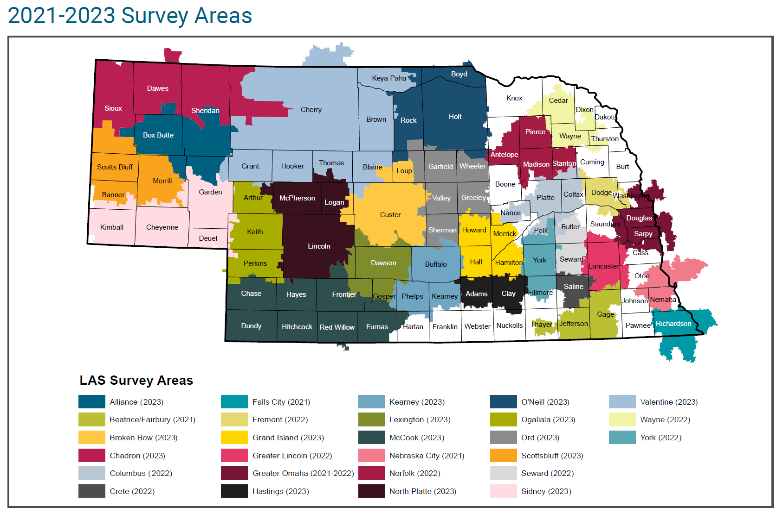Source: Nebraska Department of Labor, Labor Market Information, Labor Availability Study (LAS)

Table 30. Labor market availability survey areas and demographics
Survey area | Year of survey in field | Population age 18 and older | Estimated labor force # | Estimated potential job seeker # | Estimated potential job seeker %
Statewide | 2020 | 1,500,813 | 1,040,063 | 457,748 | 30.5
Alliance | 2023 | 8,360 | 5,674 | 2,022 | 24.2
Beatrice | 2021 | 24,301 | 16,548 | 7,339 | 30.2
Broken Bow | 2023 | 8,211 | 5,445 | 2,152 | 26.2
Central (Grand Island, Kearney, Hastings, Lexington) | 2019 | 167,782 | 116,608 | 59,395 | 35.4
Chadron | 2023 | 11,139 | 7,070 | 3,380 | 30.3
Columbus | 2022 | 41,637 | 29,584 | 16,173 | 38.8
Crete | 2022 | 11,482 | 7,855 | 3,071 | 26.7
Fairbury | 2021 | 17,515 | 11,634 | 5,325 | 30.4
Falls City | 2021 | 14,485 | 9,427 | 3,201 | 22.1
Fremont | 2022 | 31,688 | 21,793 | 10,330 | 32.6
Grand Island | 2023 | 60,878 | 43,497 | 23,536 | 38.7
Greater Lincoln | 2022 | 254,525 | 185,601 | 108,566 | 42.7
Greater Omaha | 2021 | 654,028 | 474,131 | 280,973 | 43.0
Hastings | 2023 | 28,067 | 19,202 | 9,163 | 32.6
Kearney | 2023 | 47,213 | 34,713 | 19,312 | 40.9
Lexington | 2023 | 19,131 | 13,752 | 6,910 | 36.1
McCook | 2023 | 20,637 | 13,304 | 6,408 | 31.1
Nebraska City | 2021 | 17,183 | 11,412 | 5,773 | 33.6
Norfolk | 2022 | 39,153 | 27,781 | 13,743 | 35.1
North Platte | 2023 | 27,376 | 18,076 | 8,500 | 31.0
Ogallala | 2023 | 8,845 | 5,719 | 2,223 | 25.1
O'Neill | 2018 | 37,809 | 26,277 | 11,154 | 29.5
O’Neill | 2023 | 10,253 | 6,995 | 2,329 | 22.7
Ord | 2023 | 9,401 | 5,991 | 2,535 | 27.0
Panhandle (Scottsbluff/Alliance/Chadron) | 2019 | 64,699 | 44,966 | 22,765 | 35.2
Scottsbluff | 2023 | 31,241 | 20,846 | 10,622 | 34.0
Seward | 2022 | 16,747 | 11,897 | 3,991 | 23.8
Sidney | 2023 | 13,211 | 8,169 | 3,671 | 27.8
Southwest (North Platte/McCook/Ogallala) | 2019 | 54,782 | 38,238 | 17,804 | 32.5
Valentine | 2018 | 18,956 | 13,174 | 6,328 | 33.4
Valentine | 2023 | 8,970 | 5,921 | 2,398 | 26.7
Wayne | 2022 | 14,870 | 10,972 | 4,922 | 33.1
York | 2022 | 16,739 | 11,128 | 6,687 | 39.9
Source: Nebraska Department of Labor, Labor Market Information, Labor Availability Study (LAS)

Difficulty in hiring
Surveyed businesses are asked to list the occupations they most frequently hire for or have attempted to hire for during the past two years. They are also asked if they have experienced difficulty hiring for those occupations and if so to indicate the reasons for difficulty. Tables 31a and 31b provide percentage rates relating to reasons for difficulty in hiring.

Table 31a. Reasons for difficulty in hiring (percentage rates)
Survey Area | Year of survey in field | Businesses indicating difficulty in hiring | Wage demands too high | Lack of occupation-specific skills | Lack of required licenses/ certificates | Lack of required education | Lack of work experience
Statewide | 2020 | 71.0 | 41.8 | 53.0 | 21.4 | 15.8 | 51.1
Alliance | 2023 | 84.2 | 46.5 | 49.1 | 25.8 | 19.1 | 57.2
Beatrice | 2021 | 81.4 | 50.1 | 60.0 | 23.3 | 19.5 | 65.1
Broken Bow | 2023 | 92.3 | 57.9 | 45.8 | 23.8 | 18.0 | 53.1
Central (Grand Island, Kearney, Hastings, Lexington) | 2019 | 73.3 | 58.4 | 47.7 | 26.4 | 16.1 | 57.8
Chadron | 2023 | 81.9 | 39.0 | 48.3 | 26.5 | 12.5 | 49.5
Columbus | 2022 | 86.9 | 49.1 | 49.3 | 17.8 | 16.1 | 56.6
Crete | 2022 | 94.1 | 63.4 | 51.4 | 20.9 | 21.1 | 41.4
Fairbury | 2021 | 92.5 | 39.7 | 47.4 | 17.0 | 7.8 | 43.6
Falls City | 2021 | 94.2 | 47.5 | 48.2 | 26.4 | 18.3 | 55.3
Fremont | 2022 | 87.1 | 57.7 | 52.0 | 21.6 | 16.6 | 52.4
Grand Island | 2023 | 89.9 | 59.5 | 47.6 | 24.5 | 16.7 | 60.5
Greater Lincoln | 2022 | 82.0 | 60.5 | 47.5 | 25.2 | 18.9 | 55.9
Greater Omaha | 2021 | 84.1 | 58.0 | 51.6 | 23.4 | 14.4 | 56.3
Hastings | 2023 | 86.6 | 57.5 | 49.0 | 24.1 | 17.7 | 54.1
Kearney | 2023 | 87.0 | 56.9 | 44.9 | 27.1 | 13.9 | 56.5
Lexington | 2023 | 91.2 | 60.0 | 53.6 | 33.5 | 18.2 | 58.6
McCook | 2023
Nebraska City | 2021 | 90.3 | 44.2 | 45.8 | 20.1 | 12.0 | 52.8
Norfolk | 2022 | 89.1 | 59.3 | 46.6 | 27.0 | 16.8 | 53.4
North Platte | 2023 | 87.3 | 57.6 | 42.3 | 22.0 | 14.3 | 58.1
Ogallala | 2023 | 78.8 | 47.7 | 33.0 | 16.7 | 18.1 | 43.5
O'Neill | 2018 | 90.0 | 41.6 | 57.1 | 21.1 | 17.7 | 57.1
O’Neill | 2023 | 75.2 | 57.8 | 44.2 | 25.9 | 16.8 | 57.4
Ord | 2023 | 86.8 | 39.9 | 43.3 | 26.6 | 19.7 | 44.2
Panhandle (Scottsbluff/Alliance/Chadron) | 2019 | 84.0 | 45.4 | 69.4 | 25.0 | 23.2 | 64.2
Scottsbluff | 2023 | 91.2 | 53.9 | 42.8 | 25.3 | 19.3 | 49.7
Seward | 2022 | 93.2 | 59.3 | 47.0 | 29.8 | 21.1 | 47.3
Sidney | 2023 | 89.3 | 51.4 | 55.4 | 31.4 | 26.3 | 55.8
Southwest (North Platte/McCook/Ogallala) | 2019 | 72.4 | 46.8 | 68.4 | 25.8 | 20.9 | 62.2
Valentine | 2018 | 83.8 | 37.1 | 59.8 | 19.4 | 17.6 | 56.6
Valentine | 2023 | 88.8 | 51.9 | 38.7 | 19.7 | 10.3 | 51.7
Wayne | 2022 | 85.4 | 56.1 | 54.5 | 21.0 | 16.6 | 49.2
York | 2022 | 90.3 | 54.6 | 48.4 | 23.7 | 18.0 | 56.0
Source: Nebraska Department of Labor, Labor Market Information, Labor Availability Study (LAS)

Table 31b. Reasons for difficulty in hiring (percentage rates)
Survey Area | Year of survey in field | Not enough applicants | Poor Work History | Unavailable for required shifts | Applicants lack childcare | Available housing in your area | Language barrier
Statewide | 2020 | 85.8 | 47.0 | 34.7 | * | * | *
Alliance | 2023 | 95.0 | 64.4 | 38.0 | 19.6 | 11.6 | 5.4
Beatrice | 2021 | 88.2 | 61.1 | 42.2 | * | 5.4 | 3.9
Broken Bow | 2023 | 86.1 | 65.6 | 41.6 | 47.9 | 54.8 | 13.6
Central (Grand Island, Kearney, Hastings, Lexington) | 2019 | 91.5 | 61.4 | 34.0 | * | 19.1 | 14.6
Chadron | 2023 | 86.5 | 49.5 | 28.5 | 18.7 | 32.9 | 6.9
Columbus | 2022 | 91.4 | 58.4 | 32.7 | * | 19.6 | 12.4
Crete | 2022 | 94.6 | 54.2 | 41.9 | 18.9 | 15.8 | 28.4
Fairbury | 2021 | 78.2 | 70.5 | 31.7 | * | 8.2 | 10.7
Falls City | 2021 | 87.5 | 60.1 | 45.5 | * | 19.1 | 0.0
Fremont | 2022 | 91.3 | 63.2 | 32.8 | * | 13.3 | 13.2
Grand Island | 2023 | 92.2 | 65.8 | 34.6 | 16.4 | 16.2 | 18.1
Greater Lincoln | 2022 | 89.5 | 54.6 | 34.8 | 10.9 | 2.7 | 7.9
Greater Omaha | 2021 | 82.5 | 56.1 | 36.4 | * | 3.7 | 16.2
Hastings | 2023 | 88.4 | 61.0 | 29.0 | 18.0 | 9.5 | 12.2
Kearney | 2023 | 92.4 | 55.2 | 32.1 | 14.6 | 21.2 | 9.4
Lexington | 2023 | 91.0 | 65.6 | 44.6 | 36.7 | 35.8 | 21.2
McCook | 2023 | 89.7 | 62.0 | 45.8 | 29.8 | 44.5 | 8.6
Nebraska City | 2021 | 88.9 | 52.2 | 44.8 | * | 8.8 | 12.6
Norfolk | 2022 | 92.0 | 61.6 | 38.8 | * | 8.2 | 10.1
North Platte | 2023 | 84.1 | 61.9 | 39.2 | 23.0 | 20.5 | 6.1
Ogallala | 2023 | 85.8 | 56.9 | 27.8 | 27.5 | 52.3 | 8.3
O'Neill | 2018 | 90.9 | 62.0 | 33.3 | * | * | 5.7
O’Neill | 2023 | 92.7 | 60.6 | 36.5 | 38.3 | 40.4 | 9.6
Ord | 2023 | 88.5 | 56.2 | 36.8 | 37.9 | 54.9 | 10.5
Panhandle (Scottsbluff/Alliance/Chadron) | 2019 | 84.1 | 71.2 | 32.9 | * | 7.2 | 6.5
Scottsbluff | 2023 | 84.1 | 55.6 | 30.1 | 15.8 | 9.8 | 4.0
Seward | 2022 | 92.5 | 58.7 | 36.2 | 14.2 | 16.0 | 5.2
Sidney | 2023 | 81.7 | 63.9 | 39.9 | 26.7 | 32.5 | 4.8
Southwest (North Platte/McCook/Ogallala) | 2019 | 82.1 | 73.6 | 38.7 | * | 16.4 | 7.2
Valentine | 2018 | 93.7 | 59.7 | 34.0 | * | * | 3.7
Valentine | 2023 | 92.0 | 47.7 | 26.3 | 43.4 | 58.7 | 6.9
Wayne | 2022 | 88.1 | 52.9 | 32.3 | * | 21.2 | 9.7
York | 2022 | 93.6 | 61.1 | 31.9 | 17.9 | 25.9 | 5.9
Source: Nebraska Department of Labor, Labor Market Information, Labor Availability Study (LAS)

Benefits offered to full-time employees
Businesses are asked whether they offer a list of benefits to all, some, or none of their full-time employees. Table 32 indicates the percentage of businesses that offer each benefit to all or some of their full-time employees.

Table 32. Benefits offered to all or some full-time employees (percentage rates)
Survey Area | Year of survey in field | Paid vacation leave | Paid sick leave | Paid family and/or medical leave | Childcare assistance | Retirement | Health Insurance
Statewide | 2020 | 88.1 | 64.5 | * | 4.3 | 64.5 | 71.6
Alliance | 2023 | 74.5 | 46.8 | 23.3 | 4.5 | 54.2 | 41.1
Beatrice | 2021 | 83.5 | 62.3 | 36.2 | 1.7 | 57.7 | 46.4
Broken Bow | 2023 | 83.4 | 68.8 | 49.7 | 26.8 | 50.4 | 60.8
Central (Grand Island, Kearney, Hastings, Lexington) | 2019 | 89.0 | 59.3 | * | * | 67.2 | 59.1
Chadron | 2023 | 81.6 | 66.1 | 50.3 | 20.2 | 56.0 | 54.5
Columbus | 2022 | 81.9 | 55.2 | 30.1 | 7.2 | 57.4 | 55.6
Crete | 2022 | 66.1 | 59.0 | 41.6 | 19.8 | 51.3 | 45.6
Fairbury | 2021 | 86.4 | 70.1 | 47.7 | 3.9 | 67.7 | 51.7
Falls City | 2021 | 79.3 | 67.3 | 34.1 | 4.9 | 43.3 | 50.9
Fremont | 2022 | 87.7 | 60.9 | 38.9 | 5.2 | 62.2 | 59.7
Grand Island | 2023 | 86.5 | 61.9 | 34.7 | 20.4 | 62.5 | 56.1
Greater Lincoln | 2022 | 89.2 | 65.8 | 44.0 | 20.3 | 67.6 | 62.8
Greater Omaha | 2021 | 90.3 | 67.9 | 42.9 | 8.7 | 68.4 | 71.9
Hastings | 2023 | 83.8 | 55.8 | 35.4 | 16.4 | 70.3 | 53.0
Kearney | 2023 | 87.7 | 62.5 | 42.1 | 15.9 | 65.9 | 54.4
Lexington | 2023 | 84.6 | 62.6 | 36.9 | 16.1 | 54.8 | 48.4
McCook | 2023 | 81.9 | 66.0 | 36.3 | 18.1 | 60.7 | 55.8
Nebraska City | 2021 | 86.7 | 61.8 | 31.1 | 2.6 | 61.5 | 43.4
Norfolk | 2022 | 87.6 | 65.1 | 36.8 | 5.6 | 62.0 | 51.9
North Platte | 2023 | 80.3 | 53.9 | 30.0 | 8.6 | 52.2 | 38.1
Ogallala | 2023 | 81.5 | 65.1 | 47.6 | 16.3 | 42.0 | 43.4
O'Neill | 2018 | 78.2 | 57.2 | * | * | 48.3 | 46.7
O’Neill | 2023 | 81.6 | 55.5 | 36.5 | 12.2 | 55.9 | 47.1
Ord | 2023 | 88.1 | 57.9 | 35.3 | 21.8 | 66.7 | 63.0
Panhandle (Scottsbluff/Alliance/Chadron) | 2019 | 86.2 | 62.0 | * | * | 62.7 | 55.5
Scottsbluff | 2023 | 88.2 | 69.8 | 32.3 | 14.3 | 61.4 | 53.6
Seward | 2022 | 81.9 | 56.2 | 31.8 | 10.6 | 58.4 | 48.1
Sidney | 2023 | 81.9 | 48.2 | 37.8 | 23.5 | 57.3 | 59.3
Southwest (North Platte/McCook/Ogallala) | 2019 | 81.3 | 59.1 | * | * | 54.1 | 55.6
Valentine | 2018 | 73.5 | 53.7 | * | * | 34.9 | 40.7
Valentine | 2023 | 81.3 | 60.8 | 42.4 | 11.7 | 44.6 | 47.6
Wayne | 2022 | 80.7 | 62.2 | 36.4 | 5.6 | 50.4 | 53.1
York | 2022 | 87.3 | 64.9 | 49.8 | 22.9 | 63.3 | 58.6
Source: Nebraska Department of Labor, Labor Market Information, Labor Availability Study (LAS)

Potential job seekers
A potential job seeker is an employed person who answered either ‘yes’ or ‘maybe’ to the question “Are you likely to change jobs in the next year if a suitable job is available?” or a non-employed person who answered ‘yes’ or ‘maybe’ to the question “Are you likely to reenter the workforce in the next year if a suitable job is available?” The potential job seekers group includes all individuals who indicated that they may accept a new job within the next year, given the right circumstances.

Important factors when considering job opportunities
Potential job seekers are asked to gauge the importance of a number of factors when considering new job opportunities. Tables 33, 34, and 35 show the percentage of respondents who indicated that a particular factor was an important or very important factor when considering a new job.

Table 33. Important factors for potential job seekers: General, skills, and education (percentage rates)
Survey area | Year of survey in field | Salary | Job security, stability | Opportunity for advancement | Opportunity to use existing skills | Opportunity to learn new skills | Opportunity to use education, training, degree
Statewide | 2020 | 89.8 | 87.1 | 77.2 | 79.7 | 74.8 | 55.2
Alliance | 2023 | 84.0 | 83.5 | 75.5 | 78.3 | 69.3 | 55.2
Beatrice | 2021 | 80.1 | 86.6 | 63.3 | 73.0 | 69.2 | 52.7
Broken Bow | 2023 | 94.6 | 90.6 | 72.2 | 76.2 | 69.3 | 55.1
Central (Grand Island, Kearney, Hastings, Lexington) | 2019 | 91.2 | 90.2 | 81.3 | 85.4 | 79.3 | 60.9
Chadron | 2023 | 91.7 | 86.9 | 70.4 | 72.8 | 67.3 | 54.7
Columbus | 2022 | 95.0 | 84.5 | 71.8 | 82.2 | 82.0 | 59.3
Crete | 2022 | 96.9 | 90.3 | 74.9 | 67.2 | 57.9 | 53.1
Fairbury | 2021 | 87.2 | 86.2 | 72.7 | 75.6 | 78.9 | 63.1
Falls City | 2021 | 87.2 | 87.3 | 65.5 | 78.0 | 67.5 | 49.0
Fremont | 2022 | 96.3 | 94.1 | 75.2 | 92.8 | 84.1 | 60.8
Grand Island | 2023 | 96.1 | 87.9 | 80.6 | 78.7 | 76.5 | 56.3
Greater Lincoln | 2022 | 89.8 | 87.1 | 74.6 | 77.7 | 73.7 | 59.8
Greater Omaha | 2021 | 89.6 | 88.1 | 73.7 | 86.9 | 78.8 | 63.7
Hastings | 2023 | 91.3 | 92.9 | 78.0 | 77.8 | 76.9 | 52.4
Kearney | 2023 | 87.3 | 88.1 | 67.6 | 76.7 | 69.3 | 56.0
Lexington | 2023 | 89.3 | 95.7 | 83.5 | 85.4 | 89.9 | 47.8
McCook | 2023 | 92.5 | 86.2 | 70.6 | 75.1 | 67.9 | 54.2
Nebraska City | 2021 | 81.4 | 76.5 | 53.7 | 84.0 | 65.4 | 55.4
Norfolk | 2022 | 91.0 | 87.3 | 72.6 | 77.7 | 69.7 | 48.7
North Platte | 2023 | 92.1 | 89.5 | 78.8 | 74.9 | 79.8 | 52.1
Ogallala | 2023 | 86.2 | 88.4 | 70.6 | 89.4 | 79.1 | 57.8
O'Neill | 2018 | 90.5 | * | 75.7 | 79.7 | 69.0 | 56.1
O’Neill | 2023 | 96.4 | 87.7 | 59.1 | 78.3 | 68.0 | 50.8
Ord | 2023 | 89.7 | 80.6 | 71.3 | 79.0 | 63.1 | 53.1
Panhandle (Scottsbluff, Alliance, Chadron) | 2019 | 89.0 | 87.8 | 76.6 | 78.4 | 71.2 | 53.4
Scottsbluff | 2023 | 85.4 | 84.6 | 75.1 | 83.1 | 76.8 | 62.9
Seward | 2022 | 92.9 | 86.1 | 75.9 | 69.5 | 69.6 | 50.9
Sidney | 2023 | 90.5 | 90.2 | 66.3 | 77.3 | 67.1 | 53.7
Southwest (North Platte, McCook, Ogallala) | 2019 | 87.4 | 89.0 | 73.9 | 83.2 | 76.3 | 55.4
Valentine | 2018 | 93.4 | * | 79.6 | 80.8 | 73.6 | 57.1
Valentine | 2023 | 84.4 | 81.4 | 68.2 | 74.5 | 68.3 | 54.0
Wayne | 2022 | 85.3 | 83.5 | 75.2 | 74.8 | 81.0 | 66.5
York | 2022 | 97.6 | 88.8 | 73.1 | 84.0 | 73.0 | 50.6
Source: Nebraska Department of Labor, Labor Market Information, Labor Availability Study (LAS)

Table 34. Important factors for potential job seekers: Benefits (percentage rates)
Survey area | Year of survey in field | Paid vacation | Paid sick leave | Health insurance | Retirement benefits | Paid family leave | Tuition reimbursement
Statewide | 2020 | 85.9 | 80.2 | 78.5 | 83.5 | * | 24.4
Alliance | 2023 | 79.7 | 79.6 | 73.2 | 76.4 | 73.4 | 29.6
Beatrice | 2021 | 76.1 | 69.7 | 75.4 | 81.5 | 57.9 | 14.6
Broken Bow | 2023 | 82.7 | 79.3 | 77.0 | 77.3 | 74.7 | 33.2
Central (Grand Island, Kearney, Hastings, Lexington) | 2019 | 82.1 | 75.8 | 80.4 | 80.8 | * | 25.5
Chadron | 2023 | 74.6 | 77.2 | 77.4 | 82.5 | 60.9 | 23.4
Columbus | 2022 | 87.6 | 85.1 | 84.1 | 85.4 | 70.5 | 28.8
Crete | 2022 | 84.2 | 75.8 | 82.8 | 87.5 | 60.4 | 22.8
Fairbury | 2021 | 71.4 | 63.9 | 76.1 | 85.9 | 60.2 | 18.3
Falls City | 2021 | 86.3 | 83.0 | 80.8 | 89.1 | 68.5 | 13.5
Fremont | 2022 | 84.4 | 84.1 | 82.3 | 82.2 | 71.1 | 34.1
Grand Island | 2023 | 95.9 | 93.9 | 86.6 | 90.2 | 78.3 | 32.4
Greater Lincoln | 2022 | 87.2 | 80.9 | 83.2 | 82.8 | 68.1 | 20.9
Greater Omaha | 2021 | 86.3 | 77.2 | 73.0 | 79.4 | 65.9 | 29.7
Hastings | 2023 | 89.1 | 82.8 | 82.6 | 87.2 | 79.3 | 18.8
Kearney | 2023 | 79.4 | 70.9 | 76.7 | 77.8 | 60.5 | 19.6
Lexington | 2023 | 83.2 | 84.6 | 91.3 | 94.4 | 73.4 | 48.9
McCook | 2023 | 84.2 | 78.6 | 82.7 | 86.2 | 73.3 | 33.4
Nebraska City | 2021 | 79.3 | 76.9 | 74.0 | 79.5 | 58.4 | 16.0
Norfolk | 2022 | 89.1 | 86.1 | 77.1 | 85.7 | 72.7 | 24.7
North Platte | 2023 | 86.5 | 82.3 | 75.9 | 83.6 | 69.9 | 37.2
Ogallala | 2023 | 81.4 | 81.0 | 69.9 | 80.3 | 60.9 | 21.8
O'Neill | 2018 | 73.9 | 76.1 | 76.3 | 79.7 | * | 24.5
O’Neill | 2023 | 81.2 | 85.4 | 83.2 | 76.4 | 66.2 | 27.7
Ord | 2023 | 79.1 | 77.1 | 74.1 | 81.4 | 63.6 | 23.1
Panhandle (Scottsbluff/Alliance/Chadron) | 2019 | 78.1 | 74.1 | 81.1 | 82.2 | * | 24.0
Scottsbluff | 2023 | 84.2 | 85.1 | 82.0 | 86.4 | 71.4 | 31.5
Seward | 2022 | 82.3 | 70.4 | 75.5 | 69.9 | 57.7 | 35.3
Sidney | 2023 | 92.3 | 82.1 | 77.5 | 80.5 | 66.2 | 19.3
Southwest (North Platte/McCook/Ogallala) | 2019 | 74.8 | 68.9 | 76.1 | 81.1 | * | 22.2
Valentine | 2018 | 78.2 | 77.0 | 80.6 | 80.3 | * | 23.8
Valetine | 2023 | 79.6 | 80.1 | 82.9 | 75.2 | 63.8 | 16.8
Wayne | 2022 | 84.0 | 76.2 | 76.7 | 84.2 | 72.6 | 38.4
York | 2022 | 87.9 | 83.2 | 72.4 | 85.3 | 78.4 | 16.6
Source: Nebraska Department of Labor, Labor Market Information, Labor Availability Study (LAS)

Table 35. Important factors for potential job seekers: Other (percentage rates)
Survey area | Year of survey in field | Accessible childcare | Telecommuting opportunities | Near public transportation | Available housing | Commute time | Flexible work schedule
Statewide | 2020 | 18.0 | 32.8 | 10.1 | 19.1 | 73.1 | *
Alliance | 2023 | 27.6 | 31.6 | 10.2 | 33.5 | 66.6 | 80.7
Beatrice | 2021 | 16.8 | 26.6 | 7.3 | 27.2 | 69.0 | 70.0
Broken Bow | 2023 | 35.4 | 32.2 | 10.3 | 59.6 | 74.2 | 72.6
Central (Grand Island, Kearney, Hastings, Lexington) | 2019 | 21.4 | 24.0 | 8.8 | 34.1 | 67.4 | *
Chadron | 2023 | 24.5 | 30.0 | 12.0 | 42.1 | 74.0 | 74.1
Columbus | 2022 | 33.0 | 30.1 | 11.6 | 36.5 | 73.6 | 77.0
Crete | 2022 | 26.5 | 29.6 | 22.4 | 12.3 | 86.8 | 73.7
Fairbury | 2021 | 18.7 | 31.5 | 6.2 | 24.0 | 80.2 | 76.0
Falls City | 2021 | 17.7 | 22.5 | 8.2 | 24.7 | 62.5 | 72.2
Fremont | 2022 | 23.4 | 32.5 | 4.3 | 37.0 | 69.8 | 81.6
Grand Island | 2023 | 32.2 | 29.8 | 3.9 | 38.0 | 54.6 | 67.3
Greater Lincoln | 2022 | 23.9 | 36.7 | 11.9 | 29.9 | 64.7 | 80.8
Greater Omaha | 2021 | 16.2 | 47.1 | 10.0 | 20.4 | 61.8 | 79.3
Hastings | 2023 | 28.5 | 15.7 | 4.1 | 30.5 | 75.8 | 74.2
Kearney | 2023 | 31.5 | 26.8 | 9.4 | 31.3 | 74.2 | 56.3
Lexington | 2023 | 47.8 | 16.5 | 10.3 | 30.0 | 55.2 | 68.8
McCook | 2023 | 28.2 | 31.5 | 6.0 | 39.1 | 65.6 | 80.6
Nebraska City | 2021 | 13.4 | 20.7 | 3.5 | 20.9 | 69.5 | 65.4
Norfolk | 2022 | 27.0 | 26.2 | 11.0 | 21.6 | 62.6 | 76.5
North Platte | 2023 | 27.6 | 24.6 | 6.7 | 40.1 | 70.0 | 72.1
Ogallala | 2023 | 16.2 | 26.2 | 19.2 | 40.1 | 80.0 | 67.2
O'Neill | 2018 | 24.7 | 30.2 | 6.9 | * | 74.2 | *
O’Neill | 2023 | 31.3 | 29.1 | 17.6 | 40.3 | 75.1 | 77.1
Ord | 2023 | 27.6 | 36.4 | 6.8 | 42.1 | 79.6 | 73.7
Panhandle (Scottsbluff/Alliance/ Chadron) | 2019 | 21.6 | 29.4 | 8.0 | 29.2 | 61.8 | *
Scottsbluff | 2023 | 18.3 | 26.9 | 15.3 | 37.9 | 59.9 | 73.3
Seward | 2022 | 18.2 | 26.9 | 2.2 | 32.4 | 66.6 | 72.7
Sidney | 2023 | 16.8 | 38.7 | 6.9 | 38.5 | 66.8 | 67.4
Southwest (North Platte, McCook, Ogallala) | 2019 | 21.2 | 29.1 | 6.5 | 38.8 | 58.6 | *
Valentine | 2018 | 24.9 | 21.9 | 9.7 | * | 65.3 | *
Valentine | 2023 | 26.7 | 25.1 | 4.6 | 41.0 | 63.5 | 77.3
Wayne | 2022 | 27.0 | 27.6 | 2.9 | 30.6 | 69.3 | 81.8
York | 2022 | 17.7 | 35.8 | 6.2 | 24.9 | 80.5 | 75.7
Source: Nebraska Department of Labor, Labor Market Information, Labor Availability Study (LAS)

Barriers to changing jobs or reentering the workforce
Tables 36, 37, and 38 show the percentage of potential job seekers who identified barriers that may prevent them from changing jobs or reentering the workforce within the next year.

Table 36. Barriers for potential job seekers by survey area: Pay, benefits, hours (percentage rates)
Survey area | Year of survey in field | Inadequate pay | Inadequate benefits | Lack of job opportunities | Inadequate hours | Work schedule flexibility
Statewide | 2020 | * | * | * | * | *
Alliance | 2023 | 70.3 | 67.8 | 75.7 | 53.6 | 64.2
Beatrice | 2021 | 43.4 | 44.6 | 53.8 | 43.4 | 49.4
Broken Bow | 2023 | 81.8 | 72.7 | 75.4 | 50.2 | 72.1
Central (Grand Island, Kearney, Hastings, Lexington) | 2019 | 65.6 | 57.3 | 68.5 | 50.9 | 51.0
Chadron | 2023 | 69.8 | 71.2 | 82.4 | 60.5 | 61.7
Columbus | 2022 | 63.2 | 54.5 | 51.3 | 42.2 | 52.4
Crete | 2022 | 82.6 | 77.3 | 72.8 | 57.0 | 65.5
Fairbury | 2021 | 57.4 | 46.4 | 67.9 | 46.2 | 49.8
Falls City | 2021 | 71.4 | 59.6 | 69.5 | 60.3 | 39.9
Fremont | 2022 | 72.9 | 65.1 | 59.7 | 59.5 | 65.8
Grand Island | 2023 | 77.4 | 75.4 | 66.3 | 65.3 | 62.3
Greater Lincoln | 2022 | 69.6 | 56.2 | 56.7 | 50.6 | 64.0
Greater Omaha | 2021 | 57.2 | 49.3 | 45.6 | 42.8 | 58.3
Hastings | 2023 | 65.9 | 60.9 | 67.6 | 48.7 | 50.6
Kearney | 2023 | 63.1 | 50.3 | 59.2 | 46.4 | 48.5
Lexington | 2023 | 69.3 | 60.0 | 84.5 | 54.3 | 64.2
McCook | 2023 | 79.2 | 73.2 | 80.7 | 61.7 | 72.0
Nebraska City | 2021 | 72.0 | 49.0 | 78.4 | 45.6 | 40.5
Norfolk | 2022 | 73.3 | 61.5 | 61.3 | 44.4 | 58.8
North Platte | 2023 | 77.1 | 70.9 | 74.0 | 48.5 | 61.0
Ogallala | 2023 | 67.6 | 64.7 | 77.0 | 46.1 | 59.1
O'Neill | 2018 | 76.1 | 65.9 | 78.3 | 48.9 | *
O’Neill | 2023 | 65.3 | 62.1 | 69.0 | 51.4 | 68.9
Ord | 2023 | 70.9 | 61.2 | 67.3 | 51.3 | 62.7
Panhandle (Scottsbluff/Alliance/ Chadron) | 2019 | 71.3 | 65.0 | 76.0 | 52.5 | 44.5
Scottsbluff | 2023 | 86.2 | 78.4 | 79.1 | 64.6 | 64.2
Seward | 2022 | 64.5 | 54.9 | 50.1 | 42.8 | 61.8
Sidney | 2023 | 80.3 | 76.2 | 78.0 | 59.5 | 58.1
Southwest (North Platte/McCook/Ogallala) | 2019 | 65.9 | 61.0 | 69.8 | 47.3 | 49.9
Valentine | 2018 | 68.9 | 63.4 | 73.6 | 48.0 | *
Valentine | 2023 | 75.0 | 66.3 | 73.5 | 52.4 | 52.1
Wayne | 2022 | 70.6 | 77.9 | 76.5 | 55.3 | 63.9
York | 2022 | 68.9 | 60.3 | 59.9 | 43.0 | 61.6
Source: Nebraska Department of Labor, Labor Market Information, Labor Availability Study (LAS)

Table 37. Barriers for potential job seekers by survey area: Family, housing, transportation (percentage rates)
Survey area | Year of survey in field | Lack of childcare | Transportation | Available housing | Language barriers | Family commitments
Statewide 2020 | 2020 | * | * | * | * | *
Alliance | 2023 | 14.9 | 15.4 | 22.2 | 16.7 | 48.3
Beatrice | 2021 | 15.3 | 17.1 | 9.6 | 15.2 | 36.4
Broken Bow | 2023 | 23.4 | 24.1 | 40.6 | 18.1 | 38.3
Central (Grand Island, Kearney, Hastings, Lexington) | 2019 | 14.0 | 18.9 | 15.2 | 16.2 | 32.1
Chadron | 2023 | 19.0 | 28.7 | 35.1 | 21.4 | 42.5
Columbus | 2022 | 12.7 | 15.4 | 18.7 | 16.0 | 35.6
Crete | 2022 | 17.6 | 35.2 | 15.9 | 20.9 | 37.9
Fairbury | 2021 | 11.2 | 25.7 | 9.0 | 7.2 | 30.3
Falls City | 2021 | 15.9 | 10.2 | 13.5 | 13.8 | 18.6
Fremont | 2022 | 9.9 | 16.3 | 20.8 | 18.1 | 39.5
Grand Island | 2023 | 19.1 | 9.7 | 27.0 | 12.1 | 27.3
Greater Lincoln | 2022 | 13.5 | 15.5 | 13.2 | 6.9 | 31.8
Greater Omaha | 2021 | 7.3 | 14.0 | 9.7 | 9.2 | 26.5
Hastings | 2023 | 20.3 | 16.6 | 17.9 | 20.0 | 41.5
Kearney | 2023 | 25.5 | 25.9 | 19.0 | 19.4 | 44.3
Lexington | 2023 | 17.1 | 8.6 | 27.0 | 39.0 | 40.6
McCook | 2023 | 17.4 | 21.0 | 32.9 | 21.6 | 50.7
Nebraska City | 2021 | 4.4 | 7.2 | 10.7 | 11.8 | 19.4
Norfolk | 2022 | 18.7 | 16.7 | 19.7 | 13.3 | 26.9
North Platte | 2023 | 19.4 | 18.7 | 27.8 | 14.2 | 40.7
Ogallala | 2023 | 10.8 | 30.4 | 23.6 | 16.2 | 38.4
O'Neill | 2018 | 14.5 | 26.2 | * | 21.1 | 36.5
O’Neill | 2023 | 15.6 | 30.4 | 39.3 | 23.8 | 43.6
Ord | 2023 | 18.5 | 23.2 | 28.4 | 19.3 | 44.7
Panhandle (Scottsbluff/Alliance/Chadron) | 2019 | 12.8 | 19.5 | 10.9 | 13.1 | 39.9
Scottsbluff | 2023 | 12.1 | 18.9 | 32.4 | 17.5 | 37.0
Seward | 2022 | 6.9 | 9.5 | 4.7 | 6.3 | 48.0
Sidney | 2023 | 12.4 | 27.1 | 20.0 | 23.3 | 27.8
Southwest (North Platte/McCook/Ogallala) | 2019 | 14.6 | 0.1 | 21.9 | 15.5 | 27.7
Valentine | 2018 | 15.0 | 20.0 | * | 12.2 | 31.6
Valentine | 2023 | 18.7 | 20.9 | 32.8 | 25.7 | 46.4
Wayne | 2022 | 15.2 | 24.7 | 30.5 | 20.1 | 51.9
York | 2022 | 13.7 | 22.2 | 23.4 | 16.0 | 39.8
Source: Nebraska Department of Labor, Labor Market Information, Labor Availability Study (LAS)

Table 38. Barriers for potential job seekers by survey area: Training, education, experience (percentage rates)
Survey area | Year of survey in field | Lack of training | Lack of education | Lack of job experience | Overqualified | Employment history
Statewide | 2020 | * | * | * | * | *
Alliance | 2023 | 35.7 | 25.6 | 18.4 | 19.9 | 7.1
Beatrice | 2021 | 21.8 | 19.4 | 9.0 | 17.1 | 11.3
Broken Bow | 2023 | 31.6 | 24.2 | 14.0 | 30.8 | 2.8
Central (Grand Island, Kearney, Hastings, Lexington) | 2019 | 32.3 | 29.3 | 12.6 | 23.7 | 9.3
Chadron | 2023 | 35.3 | 27.0 | 19.4 | 16.5 | 7.9
Columbus | 2022 | 24.5 | 16.1 | 13.6 | 22.0 | 3.9
Crete | 2022 | 23.5 | 19.1 | 23.8 | 30.0 | 6.1
Fairbury | 2021 | 18.1 | 12.5 | 8.2 | 16.2 | 8.9
Falls City | 2021 | 16.5 | 12.0 | 5.3 | 18.8 | 6.1
Fremont | 2022 | 28.2 | 15.4 | 15.4 | 33.1 | 2.3
Grand Island | 2023 | 33.6 | 23.1 | 15.8 | 31.8 | 5.0
Greater Lincoln | 2022 | 28.4 | 17.9 | 20.0 | 31.1 | 8.6
Greater Omaha | 2021 | 30.9 | 20.4 | 22.1 | 29.7 | 7.6
Hastings | 2023 | 32.6 | 23.0 | 16.4 | 27.4 | 13.0
Kearney | 2023 | 37.5 | 20.3 | 18.6 | 27.6 | 3.5
Lexington | 2023 | 44.8 | 32.5 | 29.5 | 8.2 | 2.7
McCook | 2023 | 39.8 | 30.3 | 27.7 | 26.4 | 4.7
Nebraska City | 2021 | 13.2 | 12.0 | 4.5 | 21.8 | 5.2
Norfolk | 2022 | 33.7 | 28.4 | 17.2 | 24.7 | 9.1
North Platte | 2023 | 38.4 | 30.3 | 24.5 | 19.0 | 6.3
Ogallala | 2023 | 39.1 | 24.0 | 18.4 | 26.7 | 8.4
O'Neill | 2018 | 31.9 | 29.1 | * | 19.9 | 4.4
O’Neill | 2023 | 36.8 | 28.8 | 18.5 | 25.9 | 6.1
Ord | 2023 | 31.2 | 22.7 | 11.9 | 24.7 | 2.8
Panhandle (Scottsbluff/Alliance/Chadron) | 2019 | 21.9 | 18.1 | * | 22.8 | 8.3
Scottsbluff | 2023 | 32.6 | 22.6 | 15.0 | 28.0 | 7.6
Seward | 2022 | 26.1 | 20.9 | 21.2 | 12.3 | 0.0
Sidney | 2023 | 22.9 | 14.1 | 15.3 | 32.5 | 5.6
Southwest (North Platte/McCook/Ogallala) | 2019 | 32.1 | 25.0 | 10.5 | 18.4 | 5.1
Valentine | 2018 | 25.8 | 23.1 | * | 20.1 | 5.2
Valetine | 2023 | 24.9 | 25.1 | 14.0 | 21.8 | 5.7
Wayne | 2022 | 27.7 | 21.3 | 20.1 | 27.6 | 8.0
York | 2022 | 30.5 | 27.7 | 13.8 | 27.1 | 1.5
Source: Nebraska Department of Labor, Labor Market Information, Labor Availability Study (LAS)

Veterans
According to 2023 American Community Survey 1-year Estimates, Veterans make up 6.6 percent of Nebraska’s overall estimated population. Table 39 shows notable differences between Nebraska’s overall population compared to Nebraska’s Veteran population in 2023, of which the following are worth noting.
- 89.7 percent of Veterans were male compared to 49.6 percent of the civilian population
- 10 percent of Veterans were age 18 to 34 compared to 29.6 percent of civilians
- 21.6 percent of Veterans were age 65 to 74 compared to 13.5 percent of civilians
- 28.7 percent of Veterans were age 75 and older compared to 9.3 percent of civilians
- 4.1 percent of Veterans were Hispanic or Latino compared to 9.8 percent of civilians
- Median income for Veterans was $51,887 compared to $41,446 for civilians ages 18 and over
- 6.7 percent of Veterans had income below poverty level compared to 10.5 percent of civilians
- 30.6 percent of Veterans were disabled compared to 14.6 of civilians

Table 39. Veterans in Nebraska, 2023
Data element | Total estimate # | Total estimate % | Veterans estimate # | Veteran estimate %
Civilian population 18 years and over | 1,494,050 | (X) | 98,571 | 6.6
PERIOD OF SERVICE | - | - | - | -
Gulf War (9/2001 or later) Veterans | (X) | (X) | 26,713 | 27.1
Gulf War (8/1990 through 8/2001) Veterans | (X) | (X) | 23,756 | 24.1
Vietnam era Veterans | (X) | (X) | 34,007 | 34.5
Korean War Veterans | (X) | (X) | 3,943 | 4.0
World War II Veterans | (X) | (X) | 296 | 0.3
SEX | - | - | - | -
Male | 741,231 | 49.6 | 88,429 | 89.7
Female | 752,819 | 50.4 | 10,142 | 10.3
AGE | - | - | - | -
18 to 34 years | 442,640 | 29.6 | 9,819 | 10
35 to 54 years | 480,952 | 32.2 | 21,379 | 21.7
55 to 64 years | 229,533 | 15.4 | 17,817 | 18.1
65 to 74 years | 201,646 | 13.5 | 21,308 | 21.6
75 years and over | 139,279 | 9.3 | 28,248 | 28.7
RACE AND HISPANIC OR LATINO ORIGIN | - | - | - | -
White alone | 1,201,538 | 80.4 | 84,630 | 85.9
Black or African American alone | 63,928 | 4.3 | 4,238 | 4.3
American Indian and Alaska Native alone | 14,736 | 1 | 582 | 0.6
Asian alone | 36,925 | 2.5 | 1,113 | 1.1
Native Hawaiian and Other Pacific Islander alone | N | N | N | N
Some other race alone | 67,019 | 4.5 | 2,379 | 2.4
Two or more races | 109,682 | 7.3 | 5,629 | 5.7
Hispanic or Latino (of any race) | 143,890 | 9.8 | 4,460 | 4.1
White alone, not Hispanic or Latino | 1,173,278 | 78.5 | 83,477 | 84.7
MEDIAN INCOME IN THE PAST 12 MONTHS (IN 2019 INFLATION-ADJUSTED DOLL.ARS) | - | - | - | -
Civilian population 18 years and over with income | $41,446 | (X) | $51,887 | (X)
Male | (X) | (X) | 52,933 | (X)
Female | (X) | (X) | 35,079 | (X)
EDUCATIONAL ATTAINMENT | - | - | - | -
Civilian population 25 years and over | 1,302,480 | (X) | 96,818 | (X)
Less than high school graduate | 93,025 | 7.1 | 3,045 | 3.1
High school graduate (includes equivalency) | 294,489 | 22.6 | 29,122 | 30.1
Some college or associate degree | 387,583 | 29.8 | 35,649 | 36.8
Bachelor's degree or higher | 430,565 | 33.1 | 29,002 | 30
EMPLOYMENT STATUS | - | - | - | -
Civilian population 18 to 64 years | 1,104,110 | (X) | 49,015 | (X)
Labor force participation rate | (X) | 84 | (X) | 82.3
Civilian labor force 18 to 64 years | 927,014 | (X) | 40,325 | (X)
Unemployment rate | (X) | 2.6 | (X) | 2.2
POVERTY STATUS IN THE PAST 12 MONTHS | - | - | - | -
Civilian population 18 years and over for whom poverty status is determined | 1,356,955 | (X) | 96,407 | (X)
Income in the past 12 months below poverty level | 142,979 | 10.5 | 6,471 | 6.7
Income in the past 12 months at or above poverty level | 1,213,976 | 89.5 | 89,936 | 93.3
DISABILITY STATUS
Civilian population 18 years and over for whom poverty status is determined | 1,356,955 | (X) | 96,407 | (X)
With any disability | 198,547 | 14.6 | 29,542 | 30.6
Without a disability | 1,158,408 | 85.4 | 66,865 | 69.4
Source: United States Census Bureau, American Community Survey, 2023 ACS 1-Year Estimates,” https://data.census.gov/table?q=nebraska+Veterans&t=Veterans&g=040XX00US31&tid=ACSST1Y2021.S2101&moe=false [accessed October 2025]
Footnote. In the table, (X) means not applicable, and N means data cannot be displayed because the number of sample cases is too small.

Underutilization
Table 40 provides data on labor utilization in the United States and Nebraska for 2023 and 2024. In 2023, the broadest measure of labor underutilization, designated U-6 (which includes the unemployed, workers employed part-time for economic reasons, and those marginally attached to the labor force), was 4.5 percent in Nebraska, significantly lower than the 6.9 percent rate for the nation. Two of the six alternative measures of labor underutilization in Nebraska were significantly different from the rates recorded a year ago, U-5 and U-6. Nationally, all six measures had significant declines over the year. The official concept of unemployment, U-3 in the U-1 to U-6 range of measures, includes all jobless persons who are available to take a job and have actively sought work in the past 4 weeks. In Nebraska, 2.8 percent of the labor force was unemployed, as measured by U-3 in 2024, lower than the national rate of 4.3 percent.
Table 41 provides data on selected categories of underutilized workers in Nebraska in 2024. Nebraska had 29,500 unemployed residents in 2024, according to the Current Population Survey. In addition, there were 24,200 workers who were employed part time for economic reasons (also known as involuntary part time). These individuals were working part time because of slack work or business conditions or because they were unable to find a full-time job. In 2024, the number of individuals considered to be marginally attached to the labor force in Nebraska was 7,900. People marginally attached to the labor force are not working, but indicate that they would like to work, are available to work, and have looked for work at some time during the past 12 months, even though they had not searched for work in the 4 weeks preceding the survey for reasons such as school attendance or family responsibilities. The U-4 measure (see Table 40), which adds discouraged workers to the number of the unemployed (expressed as a percentage of the labor force plus the number of discouraged workers) was 2.8 percent in Nebraska, significantly lower than the 4-percent rate for the nation.

Table 40. Over-the-year change and measure of statistical significance in alternative measures of labor underutilization for the United States and Nebraska, 2023 to 2024 annual averages (percentage rates)
Measure | United States, 2023 | United States, 2024 | Unites States, change 2023 to 2024 | Nebraska, 2023 | Nebraska, 2024 | Nebraska, change 2023 to 2024
U-1 Persons unemployed 15 weeks or longer, as a percent of the civilian labor force | 1.3 | 1.5 | 0.2* | 0.4 | 0.6 | 0.2
U-2 Job losers and persons who completed temporary jobs, as a percent of the civilian labor force | 1.7 | 1.9 | 0.2* | 1 | 1.4 | 0.4
U-3 Total unemployed, as a percent of the civilian labor force (official concept of unemployment) (1) | 3.6 | 4 | 0.4* | 2.2 | 2.8 | 0.6
U-4 Total unemployed plus discouraged workers, as a percent of the civilian labor force plus discouraged workers (2) | 3.9 | 4.3 | 0.4* | 2.3 | 2.8 | 0.5
U-5 Total unemployed, plus discouraged workers, plus all other persons marginally attached to the labor force, as a percent of the civilian labor force plus all persons marginally attached to the labor force (2) | 4.5 | 4.9 | 0.4* | 2.8 | 3.5 | 0.7*
U-6 Total unemployed, plus all persons marginally attached to the labor force, plus total employed part time for economic reasons, as a percent of the civilian labor force plus all persons marginally attached to the labor force (2) | 6.9 | 7.5 | 0.6* | 4.5 | 5.8 | 1.3*
Source: United States Department of Labor, Bureau of Labor Statistics, Alternative Measures of Labor Underutilization, Nebraska – 2024, https://www.bls.gov/regions/midwest/news-release/laborunderutilization_nebraska.htm [accessed October, 2025]
Footnotes.
(1) The U-3 rates presented are unofficial state estimates derived from the Current Population Survey (CPS). The official measure is a model-based estimate available through the Local Area Unemployment Statistics (LAUS) program at https://www.bls.gov/lau/data.htm.
(2) Persons marginally attached to the labor force are those who currently are neither working nor looking for work but indicate that they want and are available for a job and have looked for work sometime in the past 12 months. Discouraged workers, a subset of the marginally attached, have given a job-market related reason for not currently looking for work. Persons employed part time for economic reasons are those who want and are available for full-time work but have had to settle for a part-time schedule.
* indicates that the over-the-year change is statistically different at the 90-percent confidence level

Table 41. Underutilized workers in Nebraska, 2024 annual averages (in thousands)
Worker category | 2019 | 2020 | 2021 | 2022 | 2023 | 2024
Unemployed | 34.3 | 45.7 | 26.4 | 28.9 | 23.2 | 29.5
Employed part-time for economic reasons | 24.9 | 31.9 | 19.9 | 20.1 | 18.4 | 24.2
Marginally attached to the labor force | 6.1 | 8.9 | 5.1 | 4.5 | 6.4 | 7.9
Source: United States Department of Labor, Bureau of Labor Statistics, Alternative Measures of Labor Underutilization, Nebraska – 2024, https://www.bls.gov/regions/midwest/news-release/laborunderutilization_nebraska.htm [accessed October 2025]
Individuals with disabilities
Table 42 provides county-level statistics for Nebraska regarding employment of people with disabilities. The data is presented as the number of employed civilians with and without disabilities, ages 18 to 64 years living in the community in Nebraska and Nebraska counties during 2023.

Table 42. Employment of civilians with and without disabilities ages 18 to 64 years living in the community in Nebraska and Nebraska counties, 2023
County | Total disabled # | Total disabled employed # | Total disabled employed % | Total not disabled # | Total not disabled employed # | Total not disabled employed %
Nebraska | 117285 | 62099 | 52.9% | 1024598 | 865794 | 84.5%
Adams | 1991 | 1080 | 54.2% | 15766 | 13397 | 85.0%
Antelope | 287 | 165 | 57.5% | 2933 | 2584 | 88.1%
Arthur | 35 | 19 | 54.3% | 213 | 170 | 79.8%
Banner | 51 | 2 | 3.9% | 296 | 231 | 78.0%
Blaine | 19 | 15 | 78.9% | 160 | 135 | 84.4%
Boone | 258 | 129 | 50.0% | 2542 | 2178 | 85.7%
Box Butte | 667 | 409 | 61.3% | 5141 | 4366 | 84.9%
Boyd | 104 | 59 | 56.7% | 702 | 567 | 80.8%
Brown | 142 | 93 | 65.5% | 1277 | 1030 | 80.7%
Buffalo | 3399 | 2011 | 59.2% | 27005 | 23417 | 86.7%
Burt | 457 | 247 | 54.0% | 3063 | 2504 | 81.7%
Butler | 651 | 383 | 58.8% | 4019 | 3453 | 85.9%
Cass | 1912 | 1157 | 60.5% | 13576 | 11702 | 86.2%
Cedar | 374 | 249 | 66.6% | 3971 | 3571 | 89.9%
Chase | 100 | 32 | 32.0% | 1756 | 1522 | 86.7%
Cherry | 255 | 163 | 63.9% | 2684 | 2370 | 88.3%
Cheyenne | 681 | 309 | 45.4% | 4597 | 3855 | 83.9%
Clay | 384 | 240 | 62.5% | 2911 | 2541 | 87.3%
Colfax | 262 | 85 | 32.4% | 5620 | 4705 | 83.7%
Cuming | 323 | 193 | 59.8% | 4490 | 3923 | 87.4%
Custer | 629 | 329 | 52.3% | 4994 | 4226 | 84.6%
Dakota | 1503 | 868 | 57.8% | 10701 | 9034 | 84.4%
Dawes | 417 | 172 | 41.2% | 4700 | 3732 | 79.4%
Dawson | 1298 | 723 | 55.7% | 11994 | 10166 | 84.8%
Deuel | 144 | 67 | 46.5% | 862 | 667 | 77.4%
Dixon | 260 | 156 | 60.0% | 2681 | 2374 | 88.5%
Dodge | 2472 | 1327 | 53.7% | 18162 | 15213 | 83.8%
Douglas | 32711 | 16643 | 50.9% | 319150 | 266288 | 83.4%
Dundy | 101 | 58 | 57.4% | 883 | 775 | 87.8%
Fillmore | 348 | 188 | 54.0% | 2769 | 2519 | 91.0%
Franklin | 198 | 96 | 48.5% | 1272 | 1030 | 81.0%
Frontier | 212 | 121 | 57.1% | 1140 | 917 | 80.4%
Furnas | 357 | 129 | 36.1% | 2048 | 1699 | 83.0%
Gage | 1818 | 941 | 51.8% | 10100 | 8600 | 85.1%
Garden | 109 | 15 | 13.8% | 695 | 559 | 80.4%
Garfield | 73 | 38 | 52.1% | 836 | 762 | 91.1%
Gosper | 102 | 35 | 34.3% | 961 | 820 | 85.3%
Grant | 27 | 13 | 48.1% | 362 | 291 | 80.4%
Greeley | 140 | 59 | 42.1% | 978 | 780 | 79.8%
Hall | 4076 | 2115 | 51.9% | 31193 | 26613 | 85.3%
Hamilton | 376 | 171 | 45.5% | 4749 | 4012 | 84.5%
Harlan | 166 | 97 | 58.4% | 1323 | 1132 | 85.6%
Hayes | 44 | 17 | 38.6% | 401 | 328 | 81.8%
Hitchcock | 224 | 85 | 37.9% | 1069 | 882 | 82.5%
Holt | 708 | 343 | 48.4% | 4549 | 3918 | 86.1%
Hooker | 30 | 8 | 26.7% | 302 | 256 | 84.8%
Howard | 360 | 188 | 52.2% | 3040 | 2593 | 85.3%
Jefferson | 700 | 258 | 36.9% | 3033 | 2474 | 81.6%
Johnson | 324 | 89 | 27.5% | 2030 | 1719 | 84.7%
Kearney | 203 | 127 | 62.6% | 3438 | 3102 | 90.2%
Keith | 402 | 130 | 32.3% | 3824 | 3321 | 86.8%
Keya Paha | 20 | 14 | 70.0% | 451 | 341 | 75.6%
Kimball | 242 | 120 | 49.6% | 1526 | 1276 | 83.6%
Knox | 587 | 360 | 61.3% | 3610 | 3006 | 83.3%
Lancaster | 20451 | 11126 | 54.4% | 177892 | 150393 | 84.5%
Lincoln | 2755 | 1475 | 53.5% | 16314 | 13593 | 83.3%
Logan | 44 | 22 | 50.0% | 372 | 314 | 84.4%
Loup | 22 | 16 | 72.7% | 271 | 237 | 87.5%
Madison | 22 | 16 | 72.7% | 246 | 192 | 78.0%
McPherson | 2035 | 1103 | 54.2% | 18242 | 15515 | 85.1%
Merrick | 624 | 391 | 62.7% | 3641 | 3168 | 87.0%
Morrill | 298 | 99 | 33.2% | 2223 | 1856 | 83.5%
Nance | 242 | 66 | 27.3% | 1586 | 1378 | 86.9%
Nemaha | 747 | 399 | 53.4% | 3245 | 2445 | 75.3%
Nuckolls | 243 | 78 | 32.1% | 1904 | 1711 | 89.9%
Otoe | 1000 | 513 | 51.3% | 7857 | 6890 | 87.7%
Pawnee | 184 | 85 | 46.2% | 1005 | 848 | 84.4%
Perkins | 143 | 81 | 56.6% | 1323 | 1167 | 88.2%
Phelps | 447 | 193 | 43.2% | 4469 | 3817 | 85.4%
Pierce | 373 | 221 | 59.2% | 3606 | 3087 | 85.6%
Platte | 1997 | 999 | 50.0% | 16981 | 15016 | 88.4%
Polk | 219 | 113 | 51.6% | 2610 | 2336 | 89.5%
Red Willow | 855 | 477 | 55.8% | 5034 | 4331 | 86.0%
Richardson | 605 | 263 | 43.5% | 3574 | 2948 | 82.5%
Rock | 38 | 9 | 23.7% | 653 | 558 | 85.5%
Saline | 872 | 472 | 54.1% | 7589 | 6523 | 86.0%
Sarpy | 10199 | 5887 | 57.7% | 103546 | 88198 | 85.2%
Saunders | 1164 | 648 | 55.7% | 11573 | 10101 | 87.3%
Scotts Bluff | 2554 | 1259 | 49.3% | 17048 | 14075 | 82.6%
Seward | 859 | 526 | 61.2% | 9353 | 7884 | 84.3%
Sheridan | 325 | 173 | 53.2% | 2225 | 1857 | 83.5%
Sherman | 140 | 76 | 54.3% | 1363 | 1157 | 84.9%
Sioux | 39 | 10 | 25.6% | 606 | 513 | 84.7%
Stanton | 291 | 207 | 71.1% | 2949 | 2545 | 86.3%
Thayer | 258 | 140 | 54.3% | 2278 | 1952 | 85.7%
Thomas | 13 | 13 | 100.0% | 302 | 288 | 95.4%
Thurston | 363 | 140 | 38.6% | 3148 | 2263 | 71.9%
Valley | 336 | 174 | 51.8% | 1812 | 1589 | 87.7%
Washington | 1009 | 581 | 57.6% | 10868 | 9251 | 85.1%
Wayne | 726 | 312 | 43.0% | 5476 | 4561 | 83.3%
Webster | 161 | 74 | 46.0% | 1665 | 1475 | 88.6%
Wheeler | 5 | 5 | 100.0% | 397 | 335 | 84.4%
York | 894 | 517 | 57.8% | 6804 | 5781 | 85.0%
Source: United States Census Bureau, American Community Survey, 2023 ACS 5-Year Estimates,” https://data.census.gov/chart/ACSDT5Y2023.C18120?q=nebraska+disability&t=Employment&g=040XX00US31,31$0500000&y=2023 [accessed October 2025]

Labor market trends

Industry and occupational projections
The Nebraska Department of Labor calculates long term occupational projections by combining industry projections with staffing patterns from the Bureau of Labor Statistics Occupational Employment Statistics program. This combination reveals the occupational employment ratios within industries and forms the basis for long-term occupational projections.

Job growth by region
Table 43 shows projected employment growth by economic region from 2022 to 2032. The data also gives estimates of the number of job openings due to new job creation (jobs due to growth), and the number of job openings due to workers leaving their positions (jobs due to labor force exits and occupational transfers). The Omaha Consortium (Cass, Dodge, Sarpy, Saunders, and Washington Counties) and Lincoln metropolitan statistical area (MSA) are expected to grow at a faster rate than the state, as well as the other Nebraska economic regions. Job growth in the Omaha Consortium and Lincoln MSA are projected to increase by 7.1 and 6.2 percent, respectively, compared to the projected 5.6 percent growth rate for the state and 1.3 to 5.3 percent among all other economic regions. The Omaha Consortium has the highest projected job growth rate in the state at 7.1 percent, and the Panhandle economic region has the lowest at 1.3 percent.

Table 43. Long-term occupational projections for job growth by Nebraska region, 2022 to 2032
Region | Projected job growth % | Labor force exits | Occupational transfers | Growth openings
Statewide | 5.6% | 562,482 | 714,222 | 63,862
Omaha Consortium | 7.1% | 243,866 | 311,793 | 36,047
Lincoln MSA | 6.2% | 100,883 | 128,637 | 12,803
Grand Island MSA | 5.3% | 25,014 | 32,195 | 2,663
Central | 2.5% | 39,721 | 49,593 | 1,961
Mid Plains | 2.8% | 27,846 | 34,730 | 1,513
Northeast | 4.6% | 68,190 | 86,552 | 6,133
Panhandle | 1.3% | 21,461 | 26,545 | 561
Sandhills | 2.9% | 7,673 | 9,419 | 418
Southeast | 3.2% | 28,167 | 35,550 | 1,805
Source: Nebraska Department of Labor, “Long-term Occupational Projections: 2022-2032,” https://neworks.nebraska.gov/vosnet/gsipub/documentView.aspx?docid=440 [accessed October, 2025]

Education and skill levels of the workforce

Educational attainment
Table 44 provides information on 2023 educational attainment in Nebraska by age group, race/ethnic origin, and poverty rate for ages 25 years and older for whom poverty status is determined by educational attainment; and Table 45 compares Nebraska public school graduation rates by gender, race/ethnicity, and other groups.

Table 44. Estimated educational attainment in Nebraska, 2023
Data element | Total estimate # | Total estimate % | Male estimate # | Male estimate % | Female estimate # | Female estimate %
AGE BY EDUCATIONAL ATTAINMENT | - | - | - | - | - | -
Population 18 to 24 years | 192,539 | (X) | 99,002 | (X) | 93,537 | (X)
Less than high school graduate | 19,536 | 10.1 | 11,633 | 11.8 | 7,903 | 8.4
High school graduate (includes equivalency) | 64,891 | 33.7 | 34,884 | 35.2 | 30,007 | 32.1
Some college or Associate degree | 82,495 | 42.8 | 42,246 | 42.7 | 40,249 | 43
Bachelor's degree or higher | 25,617 | 13.3 | 10,239 | 10.3 | 15,378 | 16.4
Population 25 years and over | 1,307,246 | (X) | 647,082 | (X) | 660,164 | (X)
Less than 9th grade | 48,270 | 3.7 | 25,627 | 4 | 22,643 | 3.4
9th to 12th grade, no diploma | 47,800 | 3.7 | 26,741 | 4.1 | 21,059 | 3.2
High school graduate (includes equivalency) | 324,140 | 24.8 | 172,468 | 26.7 | 151,672 | 23
Some college, no degree | 276,934 | 21.2 | 136,076 | 21 | 140,858 | 21.3
Associate degree | 148,822 | 11.4 | 71,815 | 11.1 | 77,007 | 11.7
Bachelor's degree | 298,782 | 22.9 | 140,686 | 21.7 | 158,096 | 23.9
Graduate or professional degree | 162,498 | 12.4 | 73,669 | 11.4 | 88,829 | 13.5
High school graduate or higher | 1,211,176 | 92.7 | 594,714 | 91.9 | 616,462 | 93.4
Bachelor's degree or higher | 461,280 | 35.3 | 214,355 | 33.1 | 246,925 | 37.4
Population 25 to 34 years | 254,207 | (X) | 130,599 | (X) | 123,608 | (X)
High school graduate or higher | 239,244 | 94.1 | 123,038 | 94.2 | 116,206 | 94
Bachelor's degree or higher | 101,654 | 40 | 44,005 | 33.7 | 57,649 | 46.6
Population 35 to 44 years | 262,121 | (X) | 131,823 | (X) | 130,298 | (X)
High school graduate or higher | 240,956 | 91.9 | 119,283 | 90.5 | 121,673 | 93.4
Bachelor's degree or higher | 105,922 | 40.4 | 48,256 | 36.6 | 57,666 | 44.3
Population 45 to 64 years | 449,993 | (X) | 227,560 | (X) | 222,433 | (X)
High school graduate or higher | 413,728 | 91.9 | 206,825 | 90.9 | 206,903 | 93
Bachelor's degree or higher | 159,538 | 35.5 | 74,569 | 32.8 | 84,969 | 38.2
Population 65 years and over | 340,925 | (X) | 157,100 | (X) | 183,825 | (X)
High school graduate or higher | 317,248 | 93.1 | 145,568 | 92.7 | 171,680 | 93.4
Bachelor's degree or higher | 94,166 | 27.6 | 47,525 | 30.3 | 46,641 | 25.4
RACE AND HISPANIC OR LATINO ORIGIN BY EDUCATIONAL ATTAINMENT | - | - | - | - | - | -
White alone | 1,065,140 | (X) | 526,160 | (X) | 538,980 | (X)
High school graduate or higher | 1,023,220 | 96.1 | 502,895 | 95.6 | 520,325 | 96.5
Bachelor's degree or higher | 405,341 | 38.1 | 187,505 | 35.6 | 217,836 | 40.9
White alone, not Hispanic or Latino | 1,043,444 | (X) | 515,488 | (X) | 527,956 | (X)
High school graduate or higher | 1,005,987 | 96.4 | 495,002 | 96 | 510,985 | 96.8
Bachelor's degree or higher | 401,015 | 38.4 | 185,068 | 35.9 | 215,947 | 40.9
Black alone | 54,435 | (X) | 27,871 | (X) | 26,564 | (X)
High school graduate or higher | 45,966 | 84.4 | 24,611 | 88.3 | 21,355 | 80.4
Bachelor's degree or higher | 9,347 | 17.2 | 5,000 | 17.9 | 4,347 | 16.4
American Indian or Alaska Native alone | 12,082 | (X) | 5,036 | (X) | 7,046 | (X)
High school graduate or higher | 9,214 | 76.3 | 3,180 | 63.1 | 6,034 | 85.6
Bachelor's degree or higher | 1,803 | 14.9 | 390 | 7.7 | 1,413 | 20.1
Asian alone | 31,484 | (X) | 14,788 | (X) | 16,696 | (X)
High school graduate or higher | 25,000 | 79.4 | 11,857 | 80.2 | 13,143 | 78.7
Bachelor's degree or higher | 13,739 | 43.6 | 6,298 | 42.6 | 7,441 | 44.6
Native Hawaiian and Other Pacific Islander alone | N | (X) | N | (X) | N | (X)
High school graduate or higher | N | N | N | N | N | N
Bachelor's degree or higher | N | N | N | N | N | N
Some other race alone | 53,293 | (X) | 28,764 | (X) | 24,529 | (X)
High school graduate or higher | 34,992 | 65.7 | 18,539 | 64.5 | 16,453 | 67.1
Bachelor's degree or higher | 7,972 | 15 | 4,481 | 15.6 | 3,491 | 14.2
Two or more races | 90,611 | (X) | 44,306 | (X) | 46,305 | (X)
High school graduate or higher | 72,583 | 80.1 | 33,475 | 75.6 | 39,108 | 84.5
Bachelor's degree or higher | 22,991 | 25.4 | 10,618 | 24 | 12,373 | 26.7
Hispanic or Latino Origin | 127,631 | (X) | 64,974 | (X) | 62,657 | (X)
High school graduate or higher | 86,872 | 68.1 | 41,231 | 63.5 | 45,641 | 72.8
Bachelor's degree or higher | 21,651 | 17 | 11,329 | 17.4 | 10,322 | 16.5
POVERTY RATE FOR THE POPULATION 25 YEARS AND OVER FOR WHOM POVERTY STATUS IS DETERMINED BY EDUCATIONAL ATTAINMENT LEVEL | - | - | - | - | - | -
Less than high school graduate | (X) | 21.8 | (X) | 17 | (X) | 27.6
High school graduate (includes equivalency) | (X) | 12.9 | (X) | 11.1 | (X) | 14.9
Some college or Associate degree | (X) | 7.7 | (X) | 6.1 | (X) | 9.2
Bachelor's degree or higher | (X) | 4.3 | (X) | 4.5 | (X) | 4.1
Source: United States Census Bureau, “EDUCATIONAL ATTAINMENT 2023 American Community Survey 1-year Estimates,” https://data.census.gov/chart/ACSST1Y2023.S1501?q=educational+attainment&g=040XX00US31&y=2023 [accessed October 2025]
Note. In the table, (X) means not applicable, and N means data cannot be displayed because the number of sample cases is too small.

Table 45. Distribution of Nebraska public school graduates by gender, race/ethnicity, and other groups: 2020-2021, 2021-2022, 2022-2023, 2023-2024 school years
Student group | Graduates 2020-2021 # | 4-year graduation rate 2020-2021 % | Graduates 2021-2022 # | 4-year graduation rate 2021-2022 % | Graduates 2022-2023 | 4-year graduation rate 2022-2023 % | Graduates 2023-2024 | 4-year graduation rate 2023-2024 %
Total Cohort Graduates | 20,914 | 88 | 21,274 | 87 | 21,232 | 87 | 21,444 | 88
Male | 10,505 | 85 | 10,611 | 84 | 10,702 | 85 | 10,726 | 86
Female | 10,409 | 90 | 10,663 | 90 | 10,530 | 90 | 10,718 | 90
Race/ethnicity: White non-Hispanic | 14,613 | 92 | 14,771 | 92 | 14,486 | 92 | 14,281 | 93
Race/ethnicity: Asian | 569 | 89 | 604 | 90 | 623 | 88 | 619 | 90
Race/ethnicity: Native Hawaiian/Other Pac. Islander | 29 | 83 | 28 | 90 | 35 | 85 | 29 | 73
Race/ethnicity: Hispanic | 3,654 | 79 | 3,795 | 77 | 3,898 | 77 | 4,259 | 80
Race/ethnicity: Native American | 228 | 73 | 208 | 70 | 212 | 74 | 233 | 74
Race/ethnicity: Black non-Hispanic | 1,159 | 75 | 1,154 | 74 | 1,214 | 76 | 1,247 | 76
Race/ethnicity: Two or More Races | 662 | 81 | 714 | 82 | 764 | 81 | 776 | 84
Other groups: Eligible for Free or Reduced Lunch | 8,429 | 80 | 8,260 | 79 | 7,990 | 79 | 8,543 | 82
Other groups: Special Education Students | 1,931 | 65 | 1,978 | 66 | 2,019 | 67 | 2,108 | 69
Other groups: English Language Learners | 596 | 58 | 616 | 53 | 693 | 53 | 779 | 61
Source: Nebraska Coordinating Commission for Postsecondary Education, “2025 Nebraska Higher Education Progress Report,” Table A3.1, https://ccpe.nebraska.gov/sites/default/files/PR_2025.pdf [accessed November 2025]

Language
Table 46 provides information on languages spoken at home and ability to speak English by Nebraskans. Of the 1,857,880 Nebraskans ages five years and older, 1,626,489 (87.5 percent) speak English only at home. Among the 231,391 Nebraskans who speak a language other than English (12.5 percent), 157,012 speak Spanish and 66,332 of those “speak English less than very well.”

Table 46. Languages spoken at home and ability to speak English by Nebraskans, 2023
Language and population group | Nebraska total estimated # | Nebraska total estimated % | Nebraska estimated #: Speak English only or speak English "very well" | Nebraska estimated % Speak English only or speak English "very well" | Nebraska estimated #: Speak English less than "very well" | Nebraska estimated %: Speak English less than "very well"
Population ages 5 years and older | 1,857,880 | (X) | 1,763,771 | 94.9 | 94,109 | 5.1
Speak only English | 1,626,489 | 87.5 | (X) | (X) | (X) | (X)
Speak a language other than English | 231,391 | 12.5 | 137,282 | 59.3 | 94,109 | 40.7
SPEAK A LANGUAGE OTHER THAN ENGLISH | - | - | - | - | - | -
Spanish | 157,012 | 8.5 | 90,680 | 57.8 | 66,332 | 42.2
5 to 17 years old | 38,106 | 2.1 | 30,953 | 81.2 | 7,153 | 18.8
18 to 64 years old | 109,535 | 5.9 | 56,045 | 51.2 | 53,490 | 48.8
65 years old and over | 9,371 | 0.5 | 3,682 | 39.3 | 5,689 | 60.7
Other Indo-European languages | 28,130 | 1.5 | 20,255 | 72 | 7,875 | 28
5 to 17 years old | 4,435 | 0.2 | 3,222 | 72.6 | 1,213 | 27.4
18 to 64 years old | 19,301 | 1.0 | 13,939 | 72.2 | 5,362 | 27.8
65 years old and over | 4,394 | 0.2 | 3,094 | 70.4 | 1,300 | 29.6
Asian and Pacific Island languages | 31,260 | 1.7 | 17,653 | 56.5 | 13,607 | 43.5
5 to 17 years old | 4,934 | 0.3 | 3,887 | 78.8 | 1,047 | 21.2
18 to 64 years old | 23,308 | 1.3 | 12,318 | 52.8 | 10,990 | 47.2
65 years old and over | 3,018 | 0.2 | 1,448 | 48 | 1,570 | 52
Other languages | 14,989 | 0.8 | 8,694 | 58 | 6,295 | 42
5 to 17 years old | 2,617 | 0.1 | 1,649 | 63 | 968 | 37
18 to 64 years old | 11,184 | 0.6 | 6,465 | 57.8 | 4,719 | 42.2
65 years old and over | 1,188 | 0.0 | 580 | 48.8 | 608 | 51.2
CITIZENS 18 YEARS AND OVER | - | - | - | - | - | -
All citizens 18 years old and over | 1,420,996 | (X) | 1,388,113 | 97.7 | 32,883 | 2.3
Speak only English | 1,311,563 | 92.3 | (X) | (X) | (X) | (X)
Speak a language other than English | 109,433 | 7.7 | 76,550 | 70 | 32,883 | 30
Spanish | 70,084 | 4.9 | 49,591 | 70.8 | 20,493 | 29.2
Other languages | 39,349 | 2.8 | 26,959 | 68.5 | 12,390 | 31.5
Source: United States Census Bureau, “LANGUAGE SPOKEN AT HOME 2023 American Community Survey 1-year Estimates, Table S1601” https://data.census.gov/table?g=040XX00US31&tid=ACSST1Y2021.S1601&moe=false [accessed November 2025]
Note. In the table, (X) means not applicable, and N means data cannot be displayed because the number of sample cases is too small.

C. Comparison of economic and workforce analytical conclusion
Describe areas of opportunity for meeting hiring, education, and skills needs identified in the economy compared to the assets available in the labor force in the state.

Overview
The first subsection below provides data on employer difficulty in hiring and benefits offered to all or some full-time employers. The second subsection provides data on important factors job seekers consider when evaluating new job opportunities. The final subsection describe areas of opportunity for meeting hiring, education, and skills needs identified in the economy compared to the assets available for the labor force in the state.

Employer data
Tables 31a and 31b above in Section II.a.1.B. provide data on employer-reported reasons for difficulty in hiring. Table 47 below provides Statewide percentage averages of employer reasons for difficulty in hiring based on data provided in Tables 31a and 31b.

Table 47. Statewide percentage averages of employer reasons for difficulty in hiring, as listed in Tables 31a and 31b
Reasons for difficulty in hiring (refer also to Tables 31a and 31b) | Statewide average %
Employers experiencing difficulty in hiring | 71.0
Not enough applicants | 85.8
Poor work history | 47.0
Lack of work experience | 51.1
Lack of occupation-specific skills | 53.0
Wage demands too high | 41.8
Unavailable for required shifts | 34.7
Lack of required licenses and certificates | 21.4
Lack of childcare | 25.1
Lack of available housing in your area | 22.8
Lack of required education | 15.8
Language barrier | 9.7

Table 32 above in Section II.a.1.B. provides data on employer benefits offered to all or some full-time employees. Table 48 below provides statewide percentage averages of employer benefits offered to all or some full-time employees based on data provided in Table 32.

Table 48. Statewide percentage averages of employer benefits offered to all or some full-time employees, as listed in Table 32
Benefits offered to all or some full-time employees (refer also to Table 32) | Statewide average %
Paid vacation leave | 88.1
Paid sick leave | 64.5
Retirement benefits | 64.5
Health insurance | 71.6
Childcare assistance | 4.3

Job seeker data
Tables 33, 34, and 35 above in Section II.a.1.B. provide data on factors that are important to job seekers considering new jobs. Table 49 below provides statewide percentage averages for those factors.

Table 49. Statewide percentage averages of factors important to job seekers considering new jobs, as listed in Tables 33, 34, and 35
Important factors when considering a new job (refer also to Tables 33. 34. and 35) | Statewide average %
Salary | 89.9
Job security and stability | 87.1
Retirement benefits | 83.5
Paid vacation | 85.9
Opportunity to use existing skills | 79.7
Health insurance | 78.5
Paid sick leave | 80.2
Opportunity to learn new skills | 74.8
Opportunity for advancement | 77.2
Commute time | 73.1
Opportunity to use education, training, and degrees | 55.2
Telecommuting opportunities | 32.8
Available housing | 19.1
Tuition reimbursement | 24.4
Accessible childcare | 18.0
Near public transportation | 10.1

Tables 36, 37, and 38 above in Section II.a.1.B. provide data on barriers identified by job seekers that may prevent them from changing jobs or reentering the workforce within the next year. Table 50 below provides statewide percentage averages for those barriers.

Table 50. Statewide percentage averages of barriers identified by job seekers that may prevent them from changing jobs or reentering the workforce within the next year, as listed in tables 36, 37, and 38
Barriers that may prevent them from changing jobs or reentering the workforce within the next year (refer also to Tables 36, 37, and 38) | Statewide average %
Inadequate pay | 70.1
Lack of job opportunities | 69.1
Inadequate benefits | 63.0
Work schedule flexibility | 58.0
Inadequate hours | 51.4
Family commitments | 37.0
Lack of training | 29.8
Overqualified | 23.7
Lack of education | 22.5
Transportation issues | 19.2
Available housing | 21.7
Lack of job experience | 16.5
Language barriers | 17.0
Lack of childcare | 15.1
Employment history | 6.1

Summary
The statewide percentage average data in Tables 47 through 50 show areas of opportunity for meeting hiring, education, and skills needs, the majority of which are currently being addressed through use of assets available for the labor force in the state.

Labor force expansion
Concerning Nebraska employers and their difficulty in hiring, 71 percent of Nebraska employers experience difficulty in hiring (row 1, Table 47). Because of the design of the underlying surveys, the reasons for difficulty in hiring listed in the remainder of Table 47 focus narrowly on conditions external to employers. The State recognizes that future surveys could and should include questions relating to employer characteristics that contribute to difficulty in hiring.
It is important to note that Nebraska is geographically diverse. As mentioned in Section I.a.1.A, Nebraska covers 76,817.87 square miles, with a population density of 25.5 persons per square mile. Approximately 52 percent of the state’s population is concentrated in 4 of Nebraska’s 93 counties, Cass, Douglas, Lancaster, and Sarpy Counties. Nebraska is also economically diverse. In 2023, the largest industries by revenue in Nebraska were meat, beef, and poultry processing; corn, wheat, and soybean wholesaling; and natural gas distribution, which generated $26.4 billion, $21.9 billion, and $16.8 billion in state revenue, respectively.[1] When considering that the top three industries by revenue, two of the three operate and hire primarily in the rural parts of Nebraska (outside of the four most densely populated Nebraska counties). Based on that consideration, the statewide percentage averages concerning hiring difficulties listed in Table 47 are not surprising, especially in relation to the “not enough applicants” reason and the population density rate by county. While employers surveyed weren’t asked about employment of individuals with disabilities, there is certainly an untapped labor pool considering the total percentage of employed disabled individual is 52.9 percent (see Table 42 above in Section II.a.1.B.). Only 58 of Nebraska’s 93 counties have employment rates for individuals with disabilities that exceed 50 percent.
Nebraska’s Governor Jim Pillen proclaimed the month of October as Developmental Disabilities Employment Awareness Month and highlighted the contributions of capable and eager individuals who are ready to join the workforce and help the state’s economy grow. “Creating a welcoming and supportive workplace is not only beneficial for individuals with disabilities, it’s also a benefit to Nebraska businesses,” said Governor Pillen. “Although our state continues to have one of the lowest unemployment rates in the nation, individuals with disabilities are an underutilized resource who can help fill workplace gaps in our communities.” By hiring individuals with disabilities, a business can expand its talent pool and strengthen its workforce. According to a national survey by National Core Indicators, 54 precent of individuals with intellectual and developmental disabilities (IDD) in Nebraska do not have a community job but would like one. “All Nebraskans deserve to live, love, work, play, and pursue their life aspirations,” said Tony Green, Director of the Division of Developmental Disabilities at the Nebraska Department of Health and Human Services. “Many individuals with disabilities are willing, ready, and excited to work. Employment provides an opportunity for individuals with disabilities to be contributing members of their communities while helping businesses strengthen their workforce and increase their overall bottom line.”
One of the resources available for employers who are interested in hiring individuals with IDD is Nebraska VR. The organization works with businesses to find and retain talent, and also works with individuals to make sure their new at-work match is a positive one. That includes identifying on and off-site job supports and tools that can help make the worker more successful in their new role. “Nebraska VR is proud to be a part of this year’s Developmental Disability Employment Awareness Month,” said Nebraska VR Director Lindy Foley. “This year is the 50th anniversary of the Rehabilitation Act which underscores the importance of our work to advance access to build a workforce including the skills and talents of all individuals, including individuals with disabilities.” Hands of the Heartland is another community resource offering a variety of services to individuals with IDD. Employment services include working with individuals on job coaching, interview skills, and identifying specific employment opportunities that fit the person’s interests. One client, Desi, has been a standout employee at the Stewart Seed Lab at the University of Nebraska-Lincoln. “We at Hands of Heartland take great pride in helping individuals secure, succeed, and maintain wonderful working relationships with their employers,” said Erin Ruskamp, Employment Administrator, Hands of the Heartland. “The University of Nebraska has been nothing short of accommodating and wonderful to work with. We are proud to partner with Desi and the University to make all of her dreams come true.”

Labor force qualifications
Table 47 indicates that Nebraska employers cited poor work history, lack of work experience, occupation-specific skills, and required licenses and certificates as significant reasons for difficulty in hiring. Job seekers recognize the same issues as significant barriers that may prevent them from changing jobs or reentering the workforce, which is reflected in Table 50.
Plan partners and other one-stop partners provide employment and training services that address work history and experience deficiencies, and occupation-specific skills training, as indicated in Tables 51 and 52 below.
- Title I adult and dislocated worker programs provide transitional jobs services that offer opportunities for individuals to establish work history and experience.
- Title I adult, dislocated worker, and youth programs provide occupational skills training services that result in in attainment of occupational licenses and certificates.
- Titles I and IV (general) provide:
  - short-term pre-vocational services including development of learning skills, communication skills, interviewing skills, punctuality, personal maintenance skills, and professional conduct services to prepare individuals for unsubsidized employment or training;
  - internships and work experiences that are linked to careers; and
  - workforce preparation activities.
- Title II provides:
  - short-term pre-vocational services including development of learning skills, communication skills, interviewing skills, punctuality, personal maintenance skills, and professional conduct services to prepare individuals for unsubsidized employment or training;
  - workforce preparation activities; and
  - internships and work experience that are linked to careers through career pathways and Integrated Education and Training opportunities.
- TANF, SNAP, Trade, JVSG, and SCSEP provide access to short-term pre-vocational services including development of learning skills, communication skills, interviewing skills, punctuality, personal maintenance skills, and professional conduct services to prepare individuals for unsubsidized employment or training.
- SNAP and SCSEP provide access to internships and work experiences that are linked to careers.
- SNAP, Trade, JVSG, and SCSEP provide access to workforce preparation activities.
Plan partners and other one-stop partners also provide youth-specific employment and training services that address work history and experience deficiencies, and occupation-specific skills training, as indicated in Tables 53 and 54 below. Titles I and IV (general and blind) and TANF provide occupational skills training and education offered concurrently with workforce preparation and training for youth.
In addition to the legislatively authorized program services described above, the state board, state plan partners, local area partners, and others began work on a career pathways strategy under the 2020 state plan, continued work on the initiative under the 2022 state plan modification, and are continuing work on the strategy under this plan. Detailed information on that strategy appears in Section II.c.1., which includes four tasks for strategy implementation:
- selecting and prioritizing development of career pathways for three or more in-demand industry sectors;
- identifying three or more barriers to participation in career pathways among job seekers and workers, including unemployed workers, Veterans, and individuals with barriers to employment;
- identifying five or more critical barriers to participation in career pathways among employers and priority industry sectors; and
- determining methods for addressing the top five identified critical barriers to participation in career pathways experienced by job seekers and workers, including unemployed workers; Veterans; individuals with barriers to employment; and employers and priority industry sectors.
As mentioned in Section II.c.1., tasks 1 and 2 are complete but will be revisited during implementation of this state plan. Task 3 is in progress and task 4 will begin under this plan.

Labor force wages
Employers cited “wage demands as too high” as another reason contributing to significant difficulty in hiring (Table 47). Conversely, job seekers cited inadequate pay as a significant barrier to changing jobs or reentering the workforce within the next year (Table 50). Employer wage limitations and job seeker wage needs are not easily addressed within Nebraska’s workforce development system. While plan partners and other one-stop partners are not able to fully address wage-related needs of employers and job seekers, some but not all partners are able to mitigate those needs through program services that provide wage supports for employers or job seekers.

Labor force work availability
Table 47 data indicates that Nebraska employers cited “unavailable for required shifts” as a reason for difficulty in hiring. Tables 49 and 50 show that job seekers, when considering new jobs or experiencing barriers that may prevent them from changing jobs or reentering the workforce within the next year, consider job opportunities that offer flexible work schedules and telecommuting opportunities. This is an issue that plan partners and other one-stop partners are not able to address, as employer work schedules are unique to and dependent upon employer business needs and job seeker availability is unique to and dependent on job seeker life circumstances.

Labor force childcare needs
Tables 47 through 50 include data that shows that availability and accessibility of childcare impacts employers and job seekers.
- Table 47 shows that 25.1 percent of employers surveyed indicated that applicants lacking childcare creates difficulty in hiring.
- Table 48 data indicates that only 4.3 percent of surveyed employers offer childcare assistance to all or some full-time employees.
- Table 49 data shows that 18.0 of job seekers surveyed consider accessible childcare is an important factor when considering new jobs.
- Table 50 shows that 15.1 percent of job seekers experience lack of childcare as a barrier to changing jobs or reentering the workforce within the next year.
Availability and accessibility of childcare across Nebraska is an issue, exacerbated by the effect of the pandemic. The Nebraska Farm Bureau published an articles on February 20, 2023 titled “Access to Childcare a Growing Concern”, an issue that significantly impacts the agriculture industry sector, which contributes 48.3 billion dollars to Nebraska’s economy as mentioned above in the subsection above titled “Labor force expansion”.[2]
Access to and the affordability of childcare was a much-discussed topic during Nebraska Farm Bureau policy development meetings last fall. The discussions reflected growing concerns among working parents in rural areas over access to affordable childcare. But access to childcare is not just a Nebraska problem. U.S. Senator Amy Klobuchar of Minnesota, a member of the Senate Agricultural Committee, told Brownfield Ag News that she heard a lot about childcare during listening sessions across Minnesota. Moreover, American Farm Bureau has made support of increased access and incentives to provide adequate childcare a part of its 2023 Farm Bill priorities.
Rising childcare costs have factored into the growing concern. According to survey results from the UrbanSitter platform provided to Axios, increases in childcare costs have outpaced inflation over the past two years. Childcare rates nationally rose 9.7 percent in 2022 and 11 percent in 2021. A shortage of childcare workers and growing pay for workers who remain in the field are responsible for the higher costs. The shortage of workers is also restricting access to daycare. The Wall Street Journal reports there are presently 58,000 fewer daycare workers nationwide compared to pre-pandemic. Lack of access and higher costs have compelled some parents to stay home with children rather than work. Anecdotal reports suggest this is occurring in rural Nebraska. Reportedly a school district in rural Nebraska opted to provide childcare when faced with the possibility of a teacher resigning because she was unable to secure childcare.
Rising costs also means affordability of daycare has become problematic. A database developed by the Women’s Bureau of the U.S. Department of Labor (DOL) provides county-level data on the cost of childcare and can help shed light on affordability. The database categorizes the data according to the age of child—infant, toddler, pre-school, and school-aged—and includes cost information for both center and in-home care. For more information, go to https://www.dol.gov/agencies/wb/topics/childcare.
If rural communities hope to grow and attract young families, providing access to affordable childcare will be critical. Awareness of the issue is growing among federal and state officials. But the onus will be on local communities to develop solutions to fit their communities.
Childcare availability and accessibility again is an issue that plan partners and other one-stop partners are not able to address, other than through limited supportive services for childcare.

Labor force education
Table 47 shows that employer surveys cited lack of required education as a reason for difficulty in hiring. Similarly, Table 50 data shows that job seekers surveyed indicated that lack of education is a barrier that may prevent them from changing jobs or reentering the workforce. As mentioned above in subsection “Labor force qualifications”, plan partners and other one-stop partners provide employment and training services for that address work history and experience deficiencies, and occupation-specific skills training.

Labor force housing
Tables 47, 49, and 50 all include data relating to availability of housing:
- 22.8 percent of employers surveyed cited lacking housing as a reason for difficulty in hiring;
- 19.1 percent of job seekers surveyed indicated available housing an important factor when considering new jobs; and
- 21.7 percent of job seekers surveyed specified available housing as a barrier to changing jobs or reentering the workforce.
While plan partners and other one-stop partners are not able to directly address labor force housing issues, an October 12, 2023 article published by the Nebraska Examiner, titled “Survey: Housing surprises jobs as top reason Nebraskans move away”, states the Nebraska State Legislature is actively working on this issue. In a subsection of that article, Nebraska Examiner discusses housing availability as an economic growth hindrance.
Among other growth hindrances UNO researchers described in their report, which was prepared in large part with the legislative planning committee in mind:
- On average across the state, only 2% of housing units are for sale or rent, while the Nebraska Realtors Association defines 7% to 8% as a healthy rental vacancy rate. When it comes to for-sale homes, a healthy inventory is an amount typically sold over a six-month period, but August data showed a statewide supply of about one month. Nebraska was one of only four states with an inventory of less than two months.
- The share of relatively newer homes — those built since 2000 — is a fraction of all properties statewide, even in larger and growing counties. For example, in Douglas County, that relatively newer housing stock makes up 21.1% in Sarpy, 38.7% Lancaster 24%; Hall 14%.
“In summary, housing availability, particularly of quality homes, is highly restricted throughout Nebraska in both metropolitan and non-metropolitan counties,” said the UNO report [Housing Availability and Quality in Nebraska]. If not addressed, the researchers said, the state could expect ongoing problems with population attraction and retention. State Sen. Teresa Ibach, who lives in Sumner and co-sponsored Legislative Bill 249 on workforce housing last session, said she anticipates more attention next year on meeting the state’s housing demands. Ibach, who also is a member of the Legislature’s planning committee, said she anticipates a better reception next year from Gov. Jim Pillen on housing bills. The governor earlier this year line-item vetoed $40 million in housing funds. A key, Ibach said, is ensuring that communities are willing to invest and provide matching funds for housing projects. “That’s how we grow,” she said. “If communities have skin in the game, we’re willing to invest in them as well.” With the increase in remote work possibilities following the pandemic, Ibach said, rural communities have an opportunity to attract or retain more young professionals. She said that can’t happen without housing choices. Among barriers to adding housing is the shortage of construction crews, especially in smaller Nebraska towns, said Ibach and others. “Finding enough construction companies and service companies to do that work is a real frustration,” Ibach said. From a Chamber of Commerce point of view, workforce housing and affordable, quality childcare have become two top challenges to filling vacant jobs and spurring growth, said Jennifer Creager, senior vice president of public policy for the Greater Omaha Chamber. The need for more quality housing that began in western rural areas of the state has moved eastward to become a prominent statewide concern, she said. Business chambers are motivating employers to become more active in developing housing and childcare options, Creager said. “On a company or employer level you’re seeing a lot of people get more creative,” she [Ibach] said. “They see it as a talent recruitment (tool).”
By year’s end, the Legislature’s planning committee will inform lawmakers of its latest research and recommendations on tackling pressing issues such as workforce housing, said DeBoer. She anticipates legislation that could devote funding for housing development, but also envisions proposals to incentivize construction in other ways. Harner said she’s not seen a period in recent history where as much concerted effort was placed on housing. She expects the NIFA-led housing council, which includes state lawmakers and policymakers, to work with other players to turn around the housing availability outlook. “We are trying to get everyone rowing in the same direction,” Harner said, “so that we really make a difference.”

Labor force language barriers
Table 47 and 50 provide data showing that language barriers impact employers and job seekers, with 9.7 percent of employers and 17.0 percent of job seekers experiencing language barriers as reasons for difficulty in hiring and barriers to changing jobs or reentering the workforce, respectively. Nebraska’s Title II partner addresses this barrier through provision adult education services, as described in Sections II.a.2.C., II.c.1, and III.a.2.A., as well as Section VI, Program-specific requirements for Adult Education and Family Literacy Act Programs.

Labor force workplace benefits
Tables 48, 49, and 50 include data concerning workplace benefits. This is a summary of the data in those tables:
- employers surveyed:
  - 88.1 percent offer paid vacation leave;
  - 64.5 percent offer paid sick leave;
  - 64.5 percent offer retirement benefits; and
  - 71.6 percent offer health insurance.
- job seekers surveyed:
  - 83.5 percent indicated retirement benefits are an important factor when considering new jobs;
  - 85.9 percent indicated paid vacation is an important factor;
  - 78.5 percent indicated health insurance is an important factor;
  - 80.2 percent indicated paid sick leave is an important factor; and
  - 63.0 percent indicated inadequate benefits may prevent them from changing jobs or reentering the workforce within the next year.
These are issues that plan partners and other one-stop partners are not able to address, as employer ability to provide workplace benefits are unique to and dependent upon employer business needs, and job seeker workplace benefits needs are unique to and dependent on job seeker life circumstances.

Labor force: Other important factors and barriers
Tables 49 and 50 provide data on other important factors and barriers affecting job seeker employment:
- factors:
  - 87.1 percent indicated job security and stability are important factors when considering new jobs;
  - 79.7 percent indicated opportunities to use existing skills are an important factor;
  - 74.8 percent indicated opportunities to learn new skills are an important factor;
  - 77.2 percent indicated opportunities for advancement are an important factor;
  - 73.1 percent indicated commute time is an important factor;
  - 55.2 percent indicated opportunities to use education, training, and degrees are important factors;
  - 24.4 percent indicated tuition reimbursement is an important factor; and
  - 10.1 percent indicated that proximity to public transportation is an important factor;
- barriers:
  - 37 percent indicated family commitments are barriers that may prevent them from changing jobs or reentering the workforce within the next year;
  - 23.7 percent indicated that being overqualified is a barrier; and
  - 19.2 percent indicated transportation issues are barriers to employment.
These are issues that plan partners and other one-stop partners are not generally able to address, with the exception of opportunities to learn new skills as discussed above in subsections “Labor force qualifications” and “Labor force education”.
[1] IBIS World, “State Economic Profile,” https://www.ibisworld.com/united-states/economic-profiles/nebraska/ [accessed November 30, 2023]
[2] IBIS World, “State Economic Profile,” https://www.ibisworld.com/united-states/economic-profiles/nebraska/ [accessed November 30, 2023]

2. Workforce Development, Education and Training Activities Analysis
The Unified or Combined State Plan must include an analysis of the workforce development activities, including education and training in the State, to address the education and skill needs of the workforce, as identified in (a)(1)(B)(iii) above, and the employment needs of employers, as identified in (a)(1)(A)(iii) above. This must include an analysis of—
A. The State’s Workforce Development Activities
Provide an analysis of the State’s workforce development activities, including education and training activities of the core programs, Combined State Plan partner programs included in this plan, and required ³ and optional one-stop delivery system partners.⁴
[3] Required one-stop partners: In addition to the core programs, the following partner programs are required to provide access through the one-stops: Career and Technical Education (Perkins), Community Services Block Grant, Indian and Native American programs, HUD Employment and Training programs, Job Corps, Local Veterans' Employment Representatives and Disabled Veterans' Outreach Program, National Farmworker Jobs program, Senior Community Service Employment program, Temporary Assistance for Needy Families (TANF) (unless the Governor determines TANF will not be a required partner), Trade Adjustment Assistance programs, Unemployment Compensation programs, and YouthBuild.
[4] Workforce development activities may include a wide variety of programs and partners, including educational institutions, faith- and community-based organizations, and human services.
B. The Strengths and Weaknesses of Workforce Development Activities
Provide an analysis of the strengths and weaknesses of the workforce development activities identified in (A), directly above.
C. State Workforce Development Capacity
Provide an analysis of the capacity of State entities to provide the workforce development activities identified in (A), above.

State workforce development activities
The education and skills needs of the workforce and the employment needs of employers, as identified above, are addressed through delivery of basic and individualized career services by plan partner programs. Basic and individualized career services for adults and dislocated workers are provided in partnership with other required one-stop partners operating in Nebraska’s comprehensive American Job Centers and other one-stop centers. Tables 51 and 52 identify the plan partner programs that provide basic and individualized career services for adults and dislocated workers. Tables 53 and 54 identify plan partner programs that provide youth employment and training activities. Detailed descriptions of job seeker, worker, and employer services provided by each plan partner program are described in Sections VI and VII of this plan.
Career services for adults and dislocated workers and youth services are physically and programmatically accessible to individuals with disabilities, as well as employers. Plan partners and required and additional one-stop partners assist employers through the delivery of other business services as described below in the key strengths section.

Table 51. Basic and individualized career services for adults and dislocated workers provided by core partner programs
Basic and individualized career services | Title I Adult, Dislocated Worker | Title II Adult Education | Title III Wagner-Peyser | Title IV VR General | Title IV VR Blind
Eligibility determinations adult, dislocated worker, or youth programs | yes | – | – | yes | yes
Outreach, intake (including worker profiling), and orientation to information and other services available through the one-stop delivery system. For the TANF program, provide individuals with the opportunity to initiate an application for TANF assistance and non-assistance benefits and services. | yes | yes | yes | yes | yes
Initial assessment of skill levels including literacy, numeracy, and English language proficiency, as well as aptitudes, abilities (including skills gaps), and supportive services needs | yes | yes | – | yes | yes
Labor exchange services, including:  - job search and placement assistance, and career counseling  - recruitment and other business services on behalf of employers, including information and referrals to specialized business services other than those traditionally offered through the one-stop delivery system | yes | yes | yes | yes | yes
Provision of referrals to and coordination of activities with other programs and services, including programs and services within the one-stop delivery system and, when appropriate, other workforce development programs | yes | yes | yes | yes | yes
Provision of workforce and labor market employment statistics information, including the provision of accurate information relating to local, regional, and national labor market areas, including:  - job vacancy listings in labor market areas;  - information on job skills necessary to obtain the vacant jobs listed; and  - information relating to local occupations in demand and the earnings, skill requirements, and opportunities for advancement for those jobs | yes | yes | yes | yes | yes
Provision of performance information and program cost information on eligible providers of education, training, and workforce services by program and type of providers | yes | yes | yes | yes | –
Provision of information, in usable and understandable formats and languages, about how the local area is performing on local performance accountability measures, as well as any additional performance information relating to the area's one-stop delivery system | yes | yes | yes | yes | –
Provision of information, in usable and understandable formats and languages, relating to the availability of supportive services or assistance, and appropriate referrals to those services and assistance, including:  - childcare; child support; medical or child health assistance available through the State's Medicaid program and Children's Health Insurance Program; benefits under SNAP; assistance through the earned income tax credit; and  - assistance under a State program for TANF, and other supportive services and transportation provided through that program | yes | yes | – | yes | yes
Provision of information and meaningful assistance to individuals seeking assistance in filing a claim for unemployment compensation | yes | – | yes | – | yes
Assistance in establishing eligibility for programs of financial aid assistance for training and education programs not provided under WIOA | yes | yes | – | yes | yes
Development of an individual employment plan, to identify employment goals, appropriate achievement objectives, and appropriate combination of services for the participant to achieve employment goals, including the list of and information about eligible training providers | yes | yes | – | yes | yes
Group [career] counseling | yes | yes | yes | – | yes
Individual [career] counseling | yes | yes | yes | yes | yes
Career planning | yes | yes | yes | yes | –
Short-term pre-vocational services including development of learning skills, communication skills, interviewing skills, punctuality, personal maintenance skills, and professional conduct services to prepare individuals for unsubsidized employment or training | yes | yes | – | yes | –
Internships and work experiences that are linked to careers | yes | yes | – | yes | –
Workforce preparation activities | yes | yes | – | yes | –
Financial literacy services | yes | yes | – | – | yes
Out-of-area job search assistance and relocation assistance | yes | – | – | yes | yes
English language acquisition and integrated education and training programs | yes | yes | – | – | yes
Follow-up services, including counseling regarding the workplace, for participants in adult or dislocated worker workforce investment activities who are placed in unsubsidized employment, for a minimum of 12 months after the first day of employment | yes | yes | – | yes | –
Source: WIOA core partner programs, Titles I – IV

Table 52. Basic and individualized career services or adults and dislocated workers provided by other plan partner programs
Basic and individualized career services | TANF | SNAP | Trade | JVSG | UI | SCSEP
Eligibility determinations adult, dislocated worker, or youth programs | yes | – | – | – | – | –
Outreach, intake (including worker profiling), and orientation to information and other services available through the one-stop delivery system. For the TANF program, provide individuals with the opportunity to initiate an application for TANF assistance and non-assistance benefits and services. | yes | yes | – | yes | – | –
Initial assessment of skill levels including literacy, numeracy, and English language proficiency, as well as aptitudes, abilities (including skills gaps), and supportive services needs | yes | yes | yes | yes | – | yes
Labor exchange services, including:  - job search and placement assistance, and career counseling  - recruitment and other business services on behalf of employers, including information and referrals to specialized business services other than those traditionally offered through the one-stop delivery system | yes | yes | yes | yes | – | yes
Provision of referrals to and coordination of activities with other programs and services, including programs and services within the one-stop delivery system and, when appropriate, other workforce development programs | yes | yes | yes | yes | – | yes
Provision of workforce and labor market employment statistics information, including the provision of accurate information relating to local, regional, and national labor market areas, including:  - job vacancy listings in labor market areas;  - information on job skills necessary to obtain the vacant jobs listed; and  - information relating to local occupations in demand and the earnings, skill requirements, and opportunities for advancement for those jobs | yes | yes | yes | yes | – | yes
Provision of performance information and program cost information on eligible providers of education, training, and workforce services by program and type of providers | – | – | yes | yes | – | –
Provision of information, in usable and understandable formats and languages, about how the local area is performing on local performance accountability measures, as well as any additional performance information relating to the area's one-stop delivery system | – | yes | yes | yes | – | –
Provision of information, in usable and understandable formats and languages, relating to the availability of supportive services or assistance, and appropriate referrals to those services and assistance, including:  - childcare; child support; medical or child health assistance available through the State's Medicaid program and Children's Health Insurance Program; benefits under SNAP; assistance through the earned income tax credit; and  - assistance under a state program for TANF, and other supportive services and transportation provided through that program | yes | yes | yes | yes | – | yes
Provision of information and meaningful assistance to individuals seeking assistance in filing a claim for unemployment compensation | – | – | yes | – | – | –
Assistance in establishing eligibility for programs of financial aid assistance for training and education programs not provided under WIOA | yes | yes | yes | yes | – | yes
Development of an individual employment plan, to identify employment goals, appropriate achievement objectives, and appropriate combination of services for the participant to achieve employment goals, including the list of and information about eligible training providers | – | yes | yes | yes | – | yes
Group [career] counseling | yes | – | yes | yes | – | yes
Individual [career] counseling | yes | yes | yes | yes | – | yes
Career planning | yes | yes | yes | yes | – | yes
Short-term pre-vocational services including development of learning skills, communication skills, interviewing skills, punctuality, personal maintenance skills, and professional conduct services to prepare individuals for unsubsidized employment or training | yes | yes | yes | yes | – | yes
Internships and work experiences that are linked to careers | – | yes | – | – | – | yes
Workforce preparation activities | – | yes | yes | yes | – | yes
Financial literacy services | – | yes | – | yes | – | yes
Out-of-area job search assistance and relocation assistance | – | yes | yes | yes | – | –
English language acquisition and integrated education and training programs | – | yes | yes | – | – | –
Follow-up services, including counseling regarding the workplace, for participants in adult or dislocated worker workforce investment activities who are placed in unsubsidized employment, for a minimum of 12 months after the first day of employment | – | yes | – | – | – | yes
Source: Other state plan partner programs, TANF, SNAP, Trade, JVSG, UI, SCSEP
In addition to the services identified in Table 52, Nebraska’s Trade program also provides the following services, as authorized by legislation and the US Department of Labor:
- training and Trade Readjustment Allowances (TRA) to workers laid off prior to July 1, 2022;
- coenrollment and referral to partner programs;
- wage subsidy for reemployed older workers, only if the first payment was issued prior to July 1, 2022;
- job search allowances; and
- relocation allowances.
Further, detailed descriptions of program services and benefits for TANF and SNAP are provided in the respective program-specific sections of Section VII.

Table 53. Youth employment and training activities provided by core partner programs
Youth employment and training activities | Title I Youth | Title II Adult Education | Title III Wagner-Peyser | Title IV VR General | Title IV VR Blind
Tutoring, study skills training, instruction, and dropout prevention | Yes | Yes* | – | Yes | Yes
Alternative secondary school and dropout recovery | Yes | – | – | – | –
Paid and unpaid work experience | Yes | – | – | Yes | Yes
Occupational skills training | Yes | Yes | – | Yes | Yes
Education offered concurrently with workforce preparation and training | Yes | Yes | – | Yes | Yes
Leadership development opportunities | Yes | Yes | – | Yes | Yes
Supportive services | Yes | Yes | – | Yes | Yes
Comprehensive guidance and counseling (individualized counseling to participants that includes substance and alcohol abuse counseling, mental health counseling, and referral to qualified partner programs) | Yes | - | – | Yes | Yes
Financial literacy education | Yes | Yes | – | – | –
Entrepreneurial skills training | Yes | Yes | – | Yes | Yes
Labor market information services | Yes | Yes | – | Yes | Yes
Postsecondary preparation and transition activities | Yes | Yes | – | Yes | Yes
Follow-up services | Yes | – | – | Yes | Yes
* Title II provides tutoring, study skills training, and instruction but does not provide dropout prevention services due to Federal eligibility requirements.
Source: WIOA core partner programs, Titles I – IV

Table 54. Youth employment and training activities provided by other plan partner programs
Youth employment and training activities | TANF | SNAP E&T | Trade | JVSG | UI | SCSEP
Tutoring, study skills training, instruction, and dropout prevention | Yes | – | – | – | – | –
Alternative secondary school and dropout recovery | – | – | – | – | – | –
Paid and unpaid work experience | Yes | – | – | – | – | –
Occupational skills training | Yes | – | – | – | – | –
Education offered concurrently with workforce preparation and training | Yes | – | – | – | – | –
Leadership development opportunities | Yes | – | – | – | – | –
Supportive services | – | – | – | – | – | –
Adult mentoring | – | – | – | – | – | –
Comprehensive guidance and counseling (individualized counseling to participants that includes substance and alcohol abuse counseling, mental health counseling, and referral to qualified partner programs) | – | – | – | – | – | –
Financial literacy education | Yes | – | – | – | – | –
Entrepreneurial skills training | Yes | – | – | – | – | –
Labor market information services | – | – | – | – | – | –
Postsecondary preparation and transition activities | Yes | – | – | – | – | –
Follow-up services | – | – | – | – | – | –
Source: Other state plan partner programs, TANF, SNAP, Trade, JVSG, UI, SCSEP

Strengths, weaknesses, and challenges of workforce development activities
Below are analyses of the strengths and weaknesses of the workforce development activities described in the State Workforce Development Activities section.

Key strengths

Collaboration among workforce system partners
Through collaborative relationships, plan partners, other required and additional required one-stop partners, and other workforce system partners, high-quality career and business services are provided, addressing the needs of the job seekers, workers, and employers. Key collaborations among partners include:
- secondary and postsecondary institutions collaborative dual-credit secondary and postsecondary programs;
- earn-and-learn opportunities provided by community colleges, Registered Apprenticeship programs, and on-the-job training;
- incumbent worker training and customized training programs have been implemented in the Greater Lincoln Workforce Development area, focusing on enhancing occupational skills for current and potential workers and focusing on targeted sector strategies and career pathways, including training for entry-level positions in advanced manufacturing, pathways to entry-level jobs in healthcare and information technology, and early childcare development occupations, as well as integrated English language learning in the workplace;
- recently enhanced youth services for youth within the Greater Lincoln Workforce Development Area through collaboration with:
  - community-based-organization programs tailored to support young adults transitioning between high school and future opportunities through career exploration and work experiences; and
  - local youth programs offering summer work experiences, such as the Mayor’s Youth Employment Program [Mayor, City of Lincoln] and the Lancaster County Youth Program, both of which offer summer work experiences for youth; and
  - Lincoln Manufacturing Council, which facilitates valuable worker experience opportunities within the field of manufacturing;
- non-profit organizations that serve employers and specific job seeker and worker populations;
- workforce preparation academies, bring workforce development services to high school students, provide resume preparation assistance and mock interview services while the students learn about careers and services available to them;
- collaboration between Title I, Title II, community colleges, and employers providing integrated education and training programs;
- development of Community Impact Network with United Way, a task force that works to align resources, foster communication and cooperation, and bridge the gap between the multiple organizations that support children and families on the road to stability, with employment being a focus area;
- collaboration between local workforce development areas and Nebraska’s Homeless Continuums of Care to provide workforce development and homeless services;
- cross training with WIOA Title I and SNAP Next Step E&T staff on virtual service delivery, marketing and outreach, best practices, coenrollment and co-case management, braided funding, and aligned performance;
- Trade and WIOA Title I collaboration to develop a standard operating procedure and complete cross-training on coenrollment and co-case management;
- a healthcare sector partnership among major healthcare organizations in the Greater Omaha Workforce Development Area (Charles Drew, Children’s Hospital, Methodist Hospital, Nebraska Medicine, OneWorld, and QLI) focusing on making pathways to employment with local major healthcare employers more accessible through the Greater Omaha American Job Center;
- collaborative community-based strategies in the Greater Omaha Workforce Development area, such as the Omaha STEM Ecosystem, which focuses on promoting high paying career pathways across various industries through collaborations between, workforce, education, and local businesses;
- collaboration between Nebraska Department of Labor and Nebraska VR to develop career pathways and increase sustainable employment for job seekers; and
- collaboration between Nebraska Department of Labor and Nebraska Adult Education providers to provide orientation and increase participant awareness of partner program activities.
In addition to the collaborations listed above, there has been increased communication between workforce agencies and education insttituations through the P-20 Committee. This new Nebraska P-20 Working Group unites committeed leaders from early learning, elementary, secondary, and higher education, and continuing education with workforce development to ensure every learner has a clear, supported pathway through a range of education opportunities to well-paying employment in Nebraska and beyond.
Members are working together to identify ways to strengthen Nebraska’s educational systems and better connect them so every learner is prepared to succeed, including recogizning that less populated rural regions may require tailored strategies. This initiative is guided by core goals:
- Attainment: Achieve Nebraska’s 70% postsecondary credential goal by aligning supports from early childhood through adulthood and tracking progress through transparent metrics. This aligns with Pillar II Worker Mobility by providing tangible steps that lead to upward mobility and long-term economic independence for indivdiuals returning to the workforce or seeking better career opportunities.
- Workforce Readiness: Ensure all learners, regardless of background or geography, develop the employability and life skills required for workforce success.
- Efficiency and Accountability: Promote a system that is effective for learners and employers and efficient for taxpayers, built on shared data, coordinated services, and a focus on return on investment. This aligns closely with Pillar IV Accountability by ensuring taxpayer funded workforce development programs deliver measurable and transparent results for job seekers and employers.

The work conducted by the P-20 Committee aligns with Pillar III Integrated Systems by supporting a unified and navigable workforce system built around the needs of its users. The Commissioner of Labor and the Commissioner of Education have also increased communication to further these integration efforts. In addition, Career and Technical Education with the Nebraska Department of Education, Nebraska’s Perkins V eligible agency, participated in state planning efforts and participates on the Career Pathways workgroup established by the Workforce Development Board to carry out the Career Pathways strategies and goals included in this plan.

Nebraska Department of Labor is also collaborating with Nebraska Department of Health and Human Services on laying the foundation for building pathways between eligibility and workforce systems through the Aligned Customer-Centered Ecosystem of Services & Supports (ACCESS) Data & Impact State Action and Innovation Lab (Data SAIL) grant. Nebraksa will use the grant to lay the foundaion for building pathways between eligibility and workforce systems, specifically NFOCUS and NEworks. The work will focus on discovery and planning, including mapping workflows, defining data elements, and engaging staff and customers through focus groups and listening sessions. This deliberate approach will produce comprehensive, user-informed requirements that reflect real-world needs. By reducing duplicaton and strengthening program alignment, Nebraska will prepare for future integration, including the planned transiton of TANF Employment First into NEworks, and advance its mission of helping families achieve long-term self-sufficiency.

In addition to the collaborations listed above, collaborative relationships among plan partners, other required and additional required one-stop partners, and other workforce system partners, the following initiatives have resulted in the provision of high-quality career and business services are provided that addressing the needs of the job seekers, workers, and employers.
- JAG Nebraska (the Jobs for America’s Graduates program operating in Nebraska) is a state-based program currently operating in the Greater Nebraska and Omaha Workforce Development Areas with plans to expand statewide. JAG Nebraska is dedicated to preventing high-school dropout among young people who have significant barriers to graduation or employment. JAG Nebraska provides a variety of services and special projects and activities. Below are two examples.
  - Norfolk – Macy JAG project: Native American youth living on the Omaha Reservation participate in work experience opportunities, cultivating crops in gardens on donated land, setting prices and marketing food for sale, and making decisions on which harvested crops are to be donate to the Umoⁿhoⁿ Nation Public School in Macy, Nebraska; and
  - Omaha Public School System: JAG students are brought to the Omaha American Job Center for a day of workshops including work readiness, program presentations, and familiarization with the AJC to encourage them to come in for employment and training activities and services.
- SNAP Next Step E&T, an employment and training program provided through a partnership between the Nebraska Department of Health and Human Services and the Nebraska Department of Labor, places underemployed SNAP clients who are coenrolled in WIOA Title I programs in jobs that pay family-sustaining wages.
- The Greater Omaha Workforce Development Area has partnered with the Omaha Public Power District (OPPD) Legacy Program. The Legacy Program is offered to high school seniors and provides opportunities for students to learn about character development and jobs available within OPPD and how to land those jobs;
- The Greater Nebraska Workforce Development Areas has partnered with SCSEP and Nebraska’s library system to increase service delivery in rural areas by utilizing SCSEP participants as workforce navigators. Through this partnership, training is provided to library staff on workforce service offerings and how to be a good host agency; and SCSEP participants are trained on basic workforce service delivery and then assigned to a library to help job seekers access career center services in their community. Two sites have been selected to pilot this project in 2022.
- Greater Nebraska Title I and Title III staff have established a collaboration targeting youth participating in Job Corps programs to promote additional career and educational opportunities that will enhance and build upon Job Corps instruction and ensure seamless transition from training to careers with opportunities to advance within specific career fields. Through this collaboration, Title I and Title III staff present to upcoming Job Corps graduates on a rotatory basis so that each region has the opportunity to market employers in their local area in hopes of increasing youth talent to local employers.
- RISE, Nebraska’s Reentry Program, uses an inside/out model that bridges incarceration to the community and considers all the critical steps in that journey, preparing and training people for each phase through intensive character development, employment readiness, job creation through entrepreneurship and case management and transforming people in the community by building awareness and empathy that leads to support and opportunity and healing families, creating employment pathways, and lowering recidivism. RISE opened a new location in Lincoln during October 2023 to expand its reentry services in Nebraska.
- The Greater Lincoln Workforce Development Area maintains a close partnership with the Lincoln Chamber of Commerce, ensuring streamlined coordination of hiring events, training sessions in collaboration with Lincoln Manufacturing Council, and engaging worksite tours. Further, the Greater Lincoln American Job Center provides support for EmployLNK events.
- The City of Lincoln has integrated workforce activities from the Greater Lincoln American Job Center into its Lincoln Forward Initiative, emphasizing economic growth, alongside the One Lincoln Initiative which focuses on enhancing opportunities for all residents. Lancaster County also synchronizes activities, with current participation in the Career Success program sponsored by the National Association of Counties and involving the Greater Lincoln American Job Center and Southeast Community College.
- IGNITE Nebraska. Ignite Nebraska is a continuing workforce development model designed to spark meaningful career opportunities for individuals who are active in the workforce but underrepresented in higher-paying, high-impact industries In collaboration with Bellevue University and community partners, Blue Cross and Blue Shield of Nebraska (BCBSNE) is providing accelerated higher learning and paid, on-the-job training in the field of information technology (IT) to low-income individuals receiving public assistance at no cost. Upon program completion, participants will earn a full-time, rewarding job at BCBSNE or get help finding another local position to put their new skills to work. Ignite provides end-to-end support for individuals’ career development, including:
  - identifying individuals who fit the criteria, need the support and have the desire;
  - eliminating financial barriers to post-secondary education and providing accelerated, specialized, hands‑on, paid training that leads to a full-time position; and
  - ensuring access to necessary family and financial resources along the way.

Business-focused employer services
Plan partner programs and other required and additional one-stop partners, in partnership with local workforce development boards and other workforce system partners, provide business-focused services, including:
- job fairs, hiring events, and industry sector networks;
- Veteran-specific business services, including assistance with attracting, onboarding, and retention of Veterans and implementing Veteran-hiring initiatives;
- collaborative meetings among employers and workforce system partners and programs offering recruitment assistance and incentives;
- employer incentives, including tax incentives, grants from the Nebraska Department of Economic Development[1] and grants from Nebraska’s state-funded Worker Training Program;[2]
- incumbent worker and customized training services and referrals to specialized business services other than those typically offered through the one-stop delivery system;
- development of a labor market analysis tool to assist staff with the planning and implementation of career pathways in high demand fields with sustainable wages;
- assistance with development of Registered Apprenticeship programs, including youth Registered Apprenticeship programs;
- collaborative approach to Career Pathway development to increase recruiting and retention;
- business services for agricultural employers employing migrants and seasonal farmworkers;
- statewide and regional industry-specific labor market information, including information resulting from studies on labor availability, skills gaps, hiring and training needs;
- Rapid Response services for employers experiencing layoffs and business closures, including assistance for Trade-effected employers;
- assistance with compliance with the requirements of Section 3 of Americans with Disabilities Act, nondiscrimination and equal opportunity requirements of WIOA Sec. 188 and 29 CFR Part 38, and other workplace accessibility requirements; and
- worksite modifications to accommodate the needs of individuals with special workforce needs.
Table 55 provides data on the growth of Registered Apprenticeship programs and participating employers in Nebraska for Fiscal Years 2018 to 2024 (FY18 to FY24). NDOL has continued its efforts to facilitate development of Registered Apprenticeship in Nebraska, in partnership with US Department of Labor Nebraska Office of Apprenticeship; and employers continue to demonstrate willingness to work collaboratively with one-stop delivery system partner programs, especially in relation to work-based education and training programs. This is apparent considering the 240.71 percent growth in the total number of Nebraska employers actively sponsoring Registered Apprenticeship through group programs since FY18.

Table 55. Registered apprenticeship programs and participating employers in Nebraska, 2018 to 2024
FY | Total programs | Registered programs | Total active employers (working with group programs) | New participating employers | % growth of total active employers working with group programs since FY18
2018 | 63 | 10 | 140 | 0 | NA
2019 | 76 | 16 | 151 | 11 | 7.86
2020 | 86 | 10 | 156 | 5 | 11.43
2021 | 102 | 16 | 177 | 21 | 26.43
2022 | 109 | 10 | 230 | 53 | 64.29
2023 | 109 | 14 | 296 | 66 | 111.43
2024 | 117 | 16 | 477 | 156 | 240.71
Source: US Department of Labor Office of Apprenticeship, Omaha, Nebraska [accessed September 2025]
On October 14, 2025, Governor Jim Pillen signed Executive Order 25-15 to launch the Good Life, Great Career Initiative focused on developing a quality, skilled workforce in Nebraska. The initiative focuses on connecting Nebraskans to Nebraska careers. As part of the initiative, NDOL will create the Office of Registered Apprenticeship. The Office of Registered Apprenticeship will develop and expand registered apprenticeship programs to align with the State of Nebraska’s workforce needs, with a primary focus on manufacturing, healthcare, transportation, construction, the bioeconomy, and other high-demand industries. In addition, the Office of Registerd Apprenticeship will take steps to be recognized by USDOL as a State Apprenticeship Agency. The Office of Registered Apprenticeship will coordinate with existing workforce partners under WIOA to integrate apprenticeship programs as a core workforce development strategy.
The Good Life, Great Careers initiative aims to add 6,000 new registered active apprentices in Nebraska by December 31, 2030.
In addition to expanding Registered Apprenticeship in Nebraska, NDOL in partnership with the US Department of Labor State Nebraska Office of Apprenticeship has developed and continues to develop Registered Apprenticeship programs that serve youth ages 16 and older through collaboration with public and private high schools and employers in Nebraska, as certain Nebraska Registered Apprenticeship programs allow high school juniors and seniors ages 16 and older to simultaneously further their educational attainment while earning wages through participation in Registered Apprenticeship programs, subject to law labor requirements and limitations. This provides participating youth with significant advantages as they embark on their career pathways.
Registered Apprenticeships in Nebraska continue to expand as a key workforce strategy across industries such as healthcare, manufacturing, construction, IT, and advanced technology. Apprenticeships allow individuals to earn while they learn, combining paid on-the-job training with education that leads to an industry-recognized credential.
Statewide efforts are supported and strengthened by partners such as NeMAC (Nebraska Manufacturing Alliance & Consortium) and Aksarben Workforce Development, both of which play an important role in aligning education, industry, and workforce needs.
Nebraska’s focus includes:
- Expanding apprenticeships into non-traditional and high-demand fields
- Supporting youth apprenticeships for high school students
- Creating pathways for adult learners and career changers
- Strengthening collaboration between employers, colleges, high schools, NeMAC, and Aksarben
Cross-Training in Apprenticeship
Cross-training is becoming an increasingly important component of apprenticeship programs across Nebraska. Employers are looking for workers who can develop multiple, transferable skill sets, and organizations like NeMAC and Aksarben support these efforts by promoting flexible, industry-driven training models.
Cross-training may include:
- Exposure to multiple departments or job roles
- Building complementary skills (for example: manufacturing + maintenance fundamentals, CNA + advanced healthcare credentials)
- Developing soft skills such as communication, teamwork, and leadership
- Preparing apprentices for long-term growth and career advancement
- This approach strengthens retention, adaptability, and workforce sustainability.
What’s Going On Right Now
Across Nebraska:
- Employers are facing ongoing workforce shortages and are turning to apprenticeship as a solution
- Organizations like NeMAC and Aksarben are actively supporting employer engagement, innovation, and talent development
- Apprenticeship conversations are expanding beyond training to include community impact, retention, and career purpose
- Colleges and employers are working together to create programs that are more flexible, accessible, and aligned with industry needs
- Apprenticeship in Nebraska is no longer just about filling jobs—it’s about building long-term career pathways, strengthening communities, and supporting economic growth.

Leveraging of resources to serve job seekers, workers, and employers
Plan partner programs and other required and additional required one-stop partners continue to successfully coordinate program services and maximize the availability of services for job seekers, workers, and employers and eliminate duplication of services. Leveraging of resources is achieved through:
- coenrollment of individuals in partner programs;
- coordination of funding for program participants taking part in occupational skills training, including those participating in Registered Apprenticeship programs;
- coordination of funding for supportive services for program participants, including transportation services which is an essential supportive service in Nebraska, especially within the Greater Nebraska Workforce Development Area, which is predominately rural, covering 88 of Nebraska’s 93 counties;
- cross-training of partner program staff on program eligibility requirements and program services;
- connecting employers with work-based training resources available through the Nebraska Department of Education Continuing Education Program, Nebraska Department of Labor, and the US Department of Labor Office of Apprenticeship;
- coordination with resources offered by Nebraska’s community colleges and private postsecondary career schools, as described below in Section III.a.2.G.;
- coordination of Rapid Response services with plan partner programs, required and additional one-stop partner programs, community-based organizations, local workforce development boards and chief elected officials, economic development organizations, education institutions, FEMA, NEMA, and Trade Adjustment Assistance as described below in Sections VI.a.2.B. – D.;
- coordination with economic development entities that support development and implementation of industry sector partnerships, including the Nebraska Department of Economic Development, as described below in Section III.a.2.I.;
- a written agreement between the Nebraska VR Program and Nebraska Department of Health and Human Services Division of Behavioral Health regarding evidence-based supported employment services to individuals with behavioral health diagnoses, as described in subsection n.2.B. of the Vocational Rehabilitation – General program-specific section of this plan modification; and
- a written agreement between the Nebraska VR Program and Nebraska Department of Health and Human Services Division of Developmental Disabilities regarding services for youth and adults with disabilities.
These leveraging efforts are supported by the Nebraska Partner Council, a public sector partnership among plan partner programs, required and additional one-stop partner programs, and other workforce system partners. Refer to Section II.c.2. for additional information on the Council.

State funded or supported programs

Workforce Development Program Cash Fund
In accordance with Nebraska Rev. Stat. § 81-407, the Workforce Development Program Cash Fund is used to fund:
- workforce development grants;
- the costs of administering the workforce development grant program;
- the costs of establishing, assessing, collecting, and maintaining state unemployment insurance tax liability and payments;
- unemployment benefits if determined necessary by the Commissioner of Labor;
- labor availability, skills gap, and workforce development studies and reports by the Department of Labor; and
- the Manufacturing Modernization and Workforce Development Pilot Investment Act.

As part of the Workforce Development Grant Program, the Nebraska Workforce Development Board shall submit grant proposals to the Commissioner of Labor for the commissioner’s consideration. The board’s proposals shall be submitted by April 30th of each year and shall set forth strategies and initiatives designed to develop the workforce in the state.

Economic development programs
As stated in Section III.a.2.I, the Nebraska Department of Economic Development funds economic development programs that benefit Nebraska communities and employers, which are described in detail at https://opportunity.nebraska.gov/programs/.

Job seekers and workers
Important factors affecting the key strengths of plan partner programs, required and additional one-stop partner programs and the success of Nebraska’s employers are job seeker and worker strengths, including:
- willingness to learn and adapt to ever-changing labor market conditions and employer skills needs;
- resourcefulness;
- work ethic and motivation to succeed;
- diverse skills and backgrounds; and
- openness to and acceptance of change.

Key weaknesses, challenges, and opportunities

Geographic size of the state in contrast to population and geographic distribution of target populations
As mentioned in Section II.a.1, the Nebraska covers 76,817.87 square miles, with the State’s estimated population being 1,927,923 and approximately 52 percent of the population concentrated in four of the State’s 93 counties: Cass, Douglas, Lancaster, and Sarpy Counties. The concentration of the state’s population in four counties directly affects formula-funded core programs that serve the remaining 89 counties, especially the ability of those programs to effectively serve remote rural areas.
The geographic distribution of Nebraskans who face barriers to employment presents unique challenges regarding service delivery and coordination of services in areas where these populations reside. This includes remote rural areas, areas with capacity issues, and individuals affected by other factors that complicate service delivery, including basic skills deficiency, language barriers, and transportation.

Communication and common programmatic terminology among statewide one-stop delivery system partners

Employer engagement in the one-stop delivery system
Employer engagement with the one-stop delivery system continues to be a challenge for some plan partner programs and other required and additional one-stop partners. There is willingness among employers to work collaboratively with one-stop delivery system partner programs, especially in relation to work-based education and training programs and in consideration of increases in Registered Apprenticeship programs and employer participation from 2018 to 2023. (Refer to Table 55 above.) However, work remains to be done to increase employer engagement with other workforce development activities described in this section and the business services described in the key strengths section.
Progress toward improving employer engagement is underway through the efforts of the state board’s Career Pathways Workgroup. Refer to Section II.c.1. for additional information.

Job seekers and workers
In 2020, Nebraska’s workforce system partners, including plan partners, other required and additional one-stop partners, and Nebraska’s state board and local boards, identified challenges to meeting the workforce development needs of job seekers, workers, and employers. Those challenges are described in detail in Section II.c.1.
One obvious challenge experienced by some job seekers, workers, and employers involves language barriers and lacking education, as indicated in Tables 31a, 31b, and 38 in Section II(a)(1)(B). Title II serves a large population of non-native English speakers. To address this challenge, Title II provides adult education and literacy activities, supporting individuals who are basic skills deficient and ELLs, translating to opportunities for job seekers, workers, and employers. This includes workplace literacy classes held at employee work sites as well as offsite locations.

State workforce development capacity
Good jobs are the foundation of an equitable economy that supports workers and families and makes businesses more competitive globally. Workers know the value of a good job that provides stability and security for them and their families. Many companies recognize that providing good quality jobs creates clear competitive advantages when it comes to recruitment, retention, and execution of company mission. Plan partners understand that all workers should have equal opportunity. Workers should be respected, empowered, and treated fairly. Plan partners further understand all individuals from underserved communities should not face systemic barriers in the workplace.
Plan partners and other required and additional one-stop system partners seek to address the issues described above and have the capacity to deliver the workforce development activities described above in Section II.a.2. Services are delivered to job seekers, workers, and employers onsite at four comprehensive American Job Centers and seven additional one-stop centers. Services are also delivered electronically or virtually, as appropriate, through the partner technology infrastructures. Business services are also delivered in-person at employer locations, and job seeker and worker services are delivered in-person at alternative locations for incarcerated individuals and individuals residing in remote rural areas who are not able to travel to a one-stop center or receive services electronically or virtually. Further, the plan partners and other required and additional one-stop system partners provide regular professional development for staff and program service providers. Technical assistance is also provided across partner programs, as needed.
[1] Information on currently available grant opportunities through the Nebraska Department of Economic Development is accessible at https://opportunity.nebraska.gov/ded-resources/.
[2] Information on Nebraska’s Worker Training Program is accessible at https://dol.nebraska.gov/ReemploymentServices/Training/WorkerTrainingProgram.

b. State Strategic Vision and Goals
The Unified or Combined State Plan must include the State’s strategic vision and goals for developing its workforce and meeting employer needs in order to support economic growth and economic self-sufficiency. This must include—
1. Vision
Describe the State’s strategic vision for its workforce development system.
2. Goals
Describe the goals for achieving this vision based on the analysis in (a) above of the State’s economic conditions, workforce, and workforce development activities. This must include—
(A) Goals for preparing an educated and skilled workforce, including preparing youth and individuals with barriers to employment5 and other populations.6
(B) Goals for meeting the skilled workforce needs of employers.
[5] Individuals with barriers to employment include displaced homemakers; low-income individuals; Indians, Alaska Natives, and Native Hawaiians; individuals with disabilities, including youth who are individuals with disabilities; older individuals; ex-offenders; homeless individuals, or homeless children and youths; youth who are in or have aged out of the foster care system; individuals who are English language learners, individuals who have low levels of literacy, and individuals facing substantial cultural barriers; eligible migrant and seasonal farmworkers (as defined at section 167(i) of WIOA and Training and Employment Guidance Letter No. 35-14); individuals within 2 years of exhausting lifetime eligibility under the Temporary Assistance for Needy Families Program; single parents (including single pregnant women); and long-term unemployed individuals.
[6] Veterans, unemployed workers, and youth and any other populations identified by the State
3. Performance Goals
Using the tables provided within each Core Program section, include the State's expected levels of performance relating to the performance accountability measures based on primary indicators of performance described in section 116(b)(2)(A) of WIOA. (This Strategic Planning element only applies to core programs.)
4. Assessment
Describe how the State will assess the overall effectiveness of the workforce development system in the State in relation to the strategic vision and goals stated above in sections (b)(1), (2), and (3) and how it will use the results of this assessment, which may include evaluation findings, and other feedback to make continuous or quality improvements.

Vision
Nebraska’s vision is to provide the highest quality workforce development services through innovation and collaboration.

Goals
Nebraska’s two-part statewide goal for preparing an educated and skilled workforce that meets the needs of employers is:
- selection and prioritization of development of career pathways; and
- alignment of the state’s workforce development system.

2024 goals for selection and prioritization of development of career pathways
During implementation of the 2020-2023 state plan, the Policy and Oversight Subcommittee of the Nebraska Workforce Development Board (state board) established the Career Pathways Workgroup comprising state plan partners, required and additional one-stop partners, other workforce system partners, and local area representatives. During implementation of this plan, the Workgroup will continue work on the goals listed below:
- prioritizing development of career pathways for identified in-demand industry sectors;
- identifying barriers to participation in career pathways among job seekers and workers, including unemployed workers, Veterans, and individuals with barriers to employment, including:
  - displaced homemakers;
  - low-income individuals;
  - Indians, Alaska Natives, and Native Hawaiians;
  - individuals with disabilities, including youth who are individuals with disabilities;
  - older individuals;
  - ex-offenders;
  - homeless individuals or homeless children and youths;
  - youth who are in or have aged out of the foster care system;
  - individuals who are English language learners;
  - individuals who have low levels of literacy;
  - individuals facing substantial cultural barriers;
  - eligible migrant and seasonal;
  - individuals within two years of exhausting lifetime eligibility under the Temporary Assistance for Needy Families Program;
  - single parents (including single pregnant women); and
  - long-term unemployed individuals;
- identifying critical barriers to participation in career pathways among employers and priority industry sectors; and
- determining methods for addressing the top five identified critical barriers to participation in career pathways experienced by job seekers and workers, including unemployed workers; Veterans; individuals with barriers to employment; and employers and priority industry sectors.
Refer to Section II.c.1. for detailed information on strategies for achieving these goals.

2024 goals for alignment of the state’s workforce development system
During implementation of the 2020-2023 state plan, the Policy and Oversight Subcommittee of the Nebraska Workforce Development Board (state board) established the Alignment Workgroup comprising state plan partners, required and additional one-stop partners, other workforce system partners, and local area representatives. During implementation of this plan, the Workgroup will continue work on the goals listed below:
- development and implementation of cross-training and technical assistance resources;
- development and implementation of a common intake practices;
- programmatic coenrollment;
- continued coordination with Nebraska's public sector partnership (Nebraska Partner Council);
- coordination of workforce development activities;
- availability of online resources; and
- collaborative interagency policy development.
Refer to Section II.c.2. for detailed information on strategies for achieving these goals.

Performance goals
Performance goals are provided in the program-specific sections for the core programs.

Assessment
Assessment of the overall effectiveness of Nebraska’s workforce development system in relation to the state’s vision and goals will involve the collaborative efforts of plan partners. Data will be collected and analyzed by plan partners, including employment rates, median earnings, credential attainment rates, measurable skills gains, employer services, and other data. This data may be derived from plan partners’ respective management information systems, the Nebraska Statewide Longitudinal Data System (SLDS) described below in Section III.b.6.B, or other sources or initiatives described in Section III.b.4.C. Data analysis will allow plan partners to identify trends in workforce system performance and initiate necessary program refinements as part of a continuous improvement approach. (Refer also to Section III.b.4.A. for additional information on assessment.)

c. State Strategy
The Unified or Combined State Plan must include the State's strategies to achieve its strategic vision and goals. These strategies must take into account the State’s economic, workforce, and workforce development, education and training activities and analysis provided in Section (a) above. Include discussion of specific strategies to address the needs of populations provided in Section (a).
- Describe the strategies the state will implement, including industry or sector partnerships related to in-demand industry sectors and occupations and career pathways, as required by WIOA section 101(d)(3)(b), (d). “career pathway” is defined at WIOA section 3(7) and includes registered apprenticeship. “in-demand industry sector or occupation” is defined at WIOA section 3(23)
- Describe the strategies the State will use to align the core programs, any Combined State Plan partner programs included in this Plan, required and optional one-stop partner programs, and any other resources available to the State to achieve fully integrated customer services consistent with the strategic vision and goals described above. Also describe strategies to strengthen workforce development activities in regard to weaknesses identified in section II(a)(2)

Selecting and prioritizing development of career pathways
Work on this strategy began under the state’s 2020-2023 state plan, with the Policy and Oversight Subcommittee of the Nebraska Workforce Development Board (state board) establishing the Career Pathways Workgroup comprising state plan partners, required and additional one-stop partners, other workforce system partners, local area representatives, and the Nebraska Department of Labor Registered Apprenticeship Unit. During the 2020 state plan, the Workgroup identified four tasks for strategy implementation. (Refer to Section III.a.2.A. for information on additional career pathways activities conducted by Title II and Title IV.)
Task 1. Selecting and prioritizing development of career pathways for three or more in-demand industry sectors
Task 2. Identifying three or more barriers to participation in career pathways among job seekers and workers, including unemployed workers, Veterans, and individuals with barriers to employment
Task 3. Identifying five or more critical barriers to participation in career pathways among employers and priority industry sectors
Task 4. Identifying and determining methods for addressing the top five identified critical barriers to participation in career pathways experienced by job seekers and workers, including unemployed workers; Veterans; individuals with barriers to employment; and employers and priority industry sectors
The career pathways strategy in Nebraska aligns with Pillar 1 Industry-Driven Strategies. The Career Pathwys Workgroup includes Registered Apprenticeship partners, Career and Technical Education partners, and business partners to ensure Nebraska’s career pathway strategy targets investments towards employer-led upskilling initiatives designed to fill talent shortages in priority industries.

Task 1. Selecting and prioritizing development of career pathways for three or more in-demand industry sectors
During implementation of the 2020 plan, the Workgroup identified nine in-demand industry sectors in Nebraska, the top five of which the Workgroup focused its efforts for prioritized career pathway development, because those sectors were in-demand across all three of Nebraska local workforce development areas. Table 56 lists selected priority in-demand industry sectors, statewide by local area.

Table 56. Selected priority in-demand industry sectors, statewide by local area
Rank | Priority in-demand industry sectors | In demand – Greater Lincoln Workforce Development Area | In demand – Greater Nebraska Workforce Development Area | In demand – Greater Omaha Workforce Development Area
1 | Healthcare/medical | Yes | Yes | Yes
2 | Manufacturing | Yes | Yes | Yes
3 | Accommodation and food services | Yes | Yes | Yes
4 | Heavy and tractor-trailer and transportation/warehouse | Yes | Yes | Yes
5 | Construction | Yes | Yes | Yes
6 | Educational services, pre-K through K12 and early childhood providers | No | Yes | Yes
7 | Agribusiness/natural resources | Yes | Yes | No
8 | Technology | Yes | No | Yes
9 | Finance and insurance | No | Yes | Yes
Source: Nebraska Workforce Development Board, Career Pathways Workgroup
During PY24 and PY25 the group revisited Task 1 and acknowledged that it was completed earlier in the process, though significant time has passed since the original work. Members recalled that initial efforts included surveys sent to businesses across priority sectors to identify perceived workforce barriers. In some regions, this work was expanded to include convenings of employers and educators, particularly in manufacturing and healthcare, to map out career pathways. These efforts were disrupted by COVID according to the workgroup and did not fully continue.
The group discussed whether the originally identified top five sectors remain relevant statewide. Consensus from multiple members indicated that the sectors are still relevant, particularly in Greater Nebraska. While there was some discussion about whether certain sectors [food service] should remain a priority, the group agreed to move forward using the existing sector list. Examples of local career pathway work, including apprenticeship models and pathway videos developed in Greater Lincoln, were shared as best practices.

Task 2. Identifying three or more barriers to participation in career pathways among job seekers and workers, including unemployed workers, Veterans, and individuals with barriers to employment
In addition to identification of the top five priority in-demand industry sectors during implementation of the 2020 plan, the Workgroup identified seven critical barriers to participation in career pathway programs and systems among job seekers and workers, including unemployed workers, Veterans, and individuals with barriers to employment. Workgroup members determined that the list of barriers originally identified in the 2020 plan overlapped considerably. For that reason, the workgroup combined the barriers modified the barrier list, as indicated in the 2022 modification. Below is the Workgroup’s current list of critical barriers, with an operationalization statement for each.
- Childcare. The financial burden for maintaining adequate childcare impedes continuous employment and may also include an inability to find adequate childcare or disruptions in service that adversely impact single parents at a high rate.
- Criminal history. Exclusionary employment policies and practices create structural barriers for ex-offenders and prevent them from entering or reentering the workforce.
- Low income. Limited income precludes job seekers/workers from obtaining necessary occupational skills training and credentials and accessing transportation resources necessary for employment in in-demand industry sectors in local and regional labor markets.
- Disability/health. Unfavorable institutional barriers arise from misperceptions of increased business costs, lack of worker qualifications, or performance issues due to job seeker/worker disabilities or health issues.
- Cultural differences. Cultural differences compete with norms, values, and beliefs, which may extend to language barriers for individuals lacking English language proficiency.
- Literacy skills, basic credentials, occupational credentials. Barriers are created when individuals lack adequate literacy skills, basic credentials (GED or high school diploma), and occupational credentials required to perform minimum job requirements or essential employment functions.
- Aging-out of foster care. Youth who have aged-out of foster care and lack adequate housing, transportation, education, or training necessary to enter the workforce experience significant barriers.
During PY24 and PY25 the group reviewed Task 2 and agreed that the barriers identified previously largely remain the same today.
While the severity and prioritization of barriers vary by local area, members agreed this variability does not invalidate the statewide list. Discussion highlighted that barriers impact different populations differently, particularly adults seeking mid-career transitions versus youth focused initiatives. There was also recognition that an overemphasis on youth pathways can unintentionally overlook the financial realities of adult learners. Additionally, gaps were identified including the need for stronger connections to Adult Education, Reentry Services, and employer perspectives related to application barriers and language access.
As the Workgroup continues its work under this plan, business and industry representatives of the top five priority in-demand industry sectors, including sponsors of Registered Apprenticeship programs, will continue to be engaged to gain feedback on the barriers described above in order to identify the top four barriers for each of the five priority in-demand industry sectors among job seekers and workers, including unemployed workers, Veterans, and individuals with barriers to employment. Business and industry representatives also will be asked to provide feedback on the barriers identified in Tables 36, 37, and 38 and how they may relate to their respective businesses and industry sectors.
The Workgroup will continue to work with the business and industry representatives to identify methods for addressing the top four barriers to participation in career pathways among job seekers and workers (including unemployed workers), Veterans, individuals with barriers to employment, as well as employers and regional and local industry sector partnerships, by priority in-demand industry sector. (Task 3 provides additional information relating to identification of barriers to career pathways participation among employers and in-demand industry sectors.) In addition, the Workgroup will continue collaborate with the following entities to ensure a thorough evaluation of potential methods for addressing identified barriers:
- local boards and local area administrative entities;
- required and additional one-stop partners;
- employers and regional and local industry sector partnerships; and
- training providers across the state.
(For additional information on Registered Apprenticeship activities in Nebraska, please refer to Sections II.c., III.a.2.A., III.a.2.B., III.a.2.F., III.a.2.G., III.a.2.H., VI.a.2.A., VI.b.1., VI.b.2., VI.b.3., and VI.c.3.)

Task 3. Identifying five or more critical barriers to participation in career pathways among employers and priority industry sectors
During implementation of the 2020 plan, the Workgroup developed a plan for engaging business and industry representatives from the priority industry sectors identified under Task 1 in order to identify at least five critical barriers to participation in career pathways among employers and priority industry sectors. The engagement plan includes three phases, with an operationalization statement for each. The engagement plan has been refined and is provided below.

- Outreach and recruitment of business and industry sector representatives. The Career Pathways Workgroup, in collaboration with the state board’s Strategy and Innovation Subcommittee and local area representatives, will conduct outreach to and recruit business and industry representatives from the priority industry sectors identified under Task 1, including sponsors of Registered Apprenticeship programs and regional and local industry sector partnerships to obtain feedback, as described below in item 2.
- Engagement and collaboration with business and industry sector representatives of the five identified priority industry sectors. The Workgroup will convene the recruited representatives to identify:
- the top five critical barriers for each of the five priority in-demand industry sectors identified under Task 1 regarding participation in career pathways among employers and priority industry sectors; and
- needs for addressing the identified top five critical barriers regarding participation in career pathways among employers and priority industry sectors.
- Engagement and collaboration with workforce system partners, programs, and initiatives. The Workgroup will engage and collaborate with the following entities to ensure a thorough evaluation of methods for addressing the top five critical barriers for each of the five priority in-demand industry sectors to participation in career pathways among employers and priority industry sectors:
- state plan partners;
- state board Strategy and Innovation Subcommittee;
- local boards and local area administrative entities;
- required and additional one-stop partners;
- training providers; and
- initiatives and partnerships described below.
During PY24 and PY25 the group determined that Task 3 is where additional work is needed. Members did not recall a coordinated statewide effort to systematically gather feedback from job seekers, employers, and local workforce areas. Several opportunities were identified, including:
• Leveraging existing surveys and feedback collected by local boards
• Engaging Business Services Representatives [BSRs]
• Collecting direct feedback from job seekers, especially those with significant barriers
• Involving Adult Education partners to address digital literacy and basic skills gaps
• Including reentry and corrections representation
Discussion emphasized the importance of hearing directly from job seekers about their experiences navigating career pathways and support services. Examples were shared with the group where skipping foundational assessments [language skills, digital literacy, background issues] led to unsuccessful outcomes. The group wants to develop a strategy to collect feedback in coordination with local and statewide partners.

Initiatives and partnerships

Economic Mobility Task Force
The Nebraska Economic Mobility Task Force comprises Nebraska Departments of Labor and Health and Human Services and other State agencies and community-based organizations having similar goals aimed at reducing unemployment, underemployment, and poverty in Nebraska. The Economic Mobility Task Force established three separate subcommittees focusing on the benefits cliff, industry sector initiatives, and policies and procedures.
- The benefits cliff subcommittee met with the Atlanta Federal Reserve, which agreed to provide tools, including a benefit cliff calculator, and a career-ladder identifier financial forecaster that will be leveraged to train field staff and program participants. The Nebraska Department of Health and Human Services is piloting the benefits cliff tool with the SNAP Next Step E&T program.
- The industry sector initiative subcommittee began development of business focus groups to gain a deeper understanding of the interrelationships between Nebraska business competitiveness and workforce needs. This subcommittee will be working with Nebraska Department of Labor business services representatives to identify regional and local industry sector needs and develop strategies to assist in their recruitment and placement efforts. These efforts tie in with career pathways initiatives currently underway.
- The policy and procedures subcommittee began work on identification of opportunities to coordinate service delivery strategies across program partners. The subcommittee began and continues review of program policies, searching for opportunities to improve policies and procedures to remove coenrollment barriers and increase quality referrals. This subcommittee will communicate all identified program-imposed barriers and suggestions for resolution to the Alignment Workgroup established by the Nebraska Workforce Development Board Policy and Oversight Subcommittee. In addition, this subcommittee is working on developing a common intake process.

American Public Human Services Association partnership
The Nebraska Departments of Labor and of Health and Human Services have partnered to participate in a technical assistance grant through American Public Human Services Association (APHSA). This grant focuses on enhancing and refining the career pathways model for the State and involves Blue Cross Blue Shield, SNAP Next Step SNAP Next Step E&T program, and Equus Workforce Solutions (TANF subrecipient service provider), as well as leadership from the Nebraska Departments of Labor and Health and Human Services. The group is currently working to better understand how job seekers, workers, and employers experience the workforce system and identify ways to streamline that experience by focusing on alignment of resources along career pathways for in-demand industry sectors and developing a model that works across partner programs. Current partnership action items include:
- reviewing labor market information to assist in the selection and prioritization of industry sectors;
- gathering baseline data on customer and employer experiences through surveys developed across programs and comparing captured data;
- hosting focus groups with job seekers, workers, and employers to develop a deeper understanding of data gathered through surveys and discuss topical information not easily gathered through surveys;
- collaboration with the Nebraska Vocational Rehabilitation Program to identify best practices arising through its current Career Pathways Advancement Project (CPAP) 2.0 and how services provided through other agencies can contribute to CPAP 2.0; and
- development of an ecosystem map that lists services offered and sequencing of events for leveraging workforce activities to remove participation barriers and easing access to career pathway development with identified supportive services and available training programs.

Task 4. Determining methods for addressing the top five identified critical barriers to participation in career pathways experienced by job seekers and workers, including unemployed workers; Veterans; individuals with barriers to employment; and employers and priority industry sectors
Through collaboration with state and local boards, regional and local employers, industry sector partnerships, and other workforce system stakeholders, the Workgroup will determine methods during for addressing the top five identified critical barriers to participation in career pathways experienced by job seekers and workers, including unemployed workers, Veterans, and individuals with barriers to employment, as well as employers and priority in-demand industry sectors, including:
- career services, youth program services, and supportive services that resolve the identified critical barriers experienced by job seekers and workers, including unemployed workers, Veterans, and individuals with barriers to employment;
- work-based training opportunities that resolve the identified critical barriers experienced by employers and priority in-demand industry sectors, such as Registered Apprenticeship programs, pre-apprenticeship programs, on-the-job training, internships, customized training, and incumbent worker training; and
- coordination of services by and among the entities identified in Task 3 to minimize the effects of the top five identified critical barriers to participation in career pathways experienced by job seekers and workers, including unemployed workers, Veterans, and individuals with barriers to employment, as well as employers and priority in-demand industry sectors.

Career pathways development tool
During implementation of the 2020 state plan, the Greater Nebraska Workforce Development Area One-stop Operator designed a Career Pathways Development Tool. Because of the significance of the tool to the purposes of the Career Pathways Workgroup, the One-stop Operator began participation in the Workgroup to facilitate engagement of business and industry representatives and enhance the Workgroup’s efforts:
- presenting to the Nebraska Workforce Development Board (state board) on the scope of and methodology behind the tool;
- providing training to all Nebraska Department of Labor business services representatives and most job seeker staff regarding use and implementation of the tool;
- working with Nebraska VR (Title IV core partner), providing training to Nebraska VR staff on use of the Tool; and
- convening Greater Nebraska one-stop partners to discuss career pathways and help bring together current efforts as a whole.
During PY24 and PY25 it was decided task 4 will focus on developing and implementing solutions to address the barriers identified in Tasks 1-3. The group agreed it would be premature to move into solution development without first strengthening the feedback and data collected in Task 3.

Talent Marketplace
Nebraska is prioritizing the development of a talent marketplace. This will include a credential registry and resume feature to better connect employers to skilled talent. This will also enable more effective student employment opportunity and worker mobility – mapping skills to occupational and employer needs in real time. This will allow individuals to own and make portable their skills and learning assertions and control where and when the skills and credentials are shared.
Nebraska’s workforce and education partners agree the state requires a unified, transparent, and standards-based approach to describing and connecting credentials, competencies, programs, and jobs. The credential registry will be built using Credential Transparency Description Language (CTDL) and integrated with Learning and Employment Records (LERs) and will allow Nebraska to describe every credential in a consistent, machine-readable format, reveal competencies taught by programs and the skills that employers demand, make clear how programs stack and lead to employment, connect short-term programs with career pathways and registered apprenticeship options, support employers in identifying qualified candidates based on verified skills, and provide learners with transparent and comparable information about pathway options.
When combined with a Talent Marketplace (creates verified learner profiles and uses skills-based job matching) Nebraska will have a useful public platform and expanded capacity to support learners across the state. This will support learners, including learners in rural regions, with clear, navigable pathways from education to employment, using Artificial Intelligence tools, with a focus on high-quality short-term programs.
This project aligns with the Administration’s Executive Order “Preparing Americans for High-Paying Skilled Trade Jobs of the Future” by advancing Nebraska’s statewide workforce strategies. This is being driven in Nebraska by Governor Pillen’s Good Life, Great Careers initiative and related Executive Order which recognizes that Registered Apprenticeship Programs (RAPs) contribute significantly to workforce development by supporting future economic growth and ensuring Nebraskans have access to training and great careers. The Governor supports the expansion of RAPs in Nebraska as one of many necessary steps to strengthen the state’s workforce system. The Governor has called for the creation of 6,000 new apprentices by the end of 2030 and emphasizes the need for a unified system to connect learners to apprenticeship sponsors and employers.
In furtherance of Good Life, Great Careers, NDOL is finalizing a new workforce development grant with the Nebraska State Chamber Foundation, a nonprofit entity committed to strengthening Nebraska’s economic vitality. The Foundation, in coordination with the Nebraska Manufacturing Advisory Council (NeMAC) and Nebraska’s six community colleges, is launching the Level 1 Manufacturing Certification Credential and Apprenticeship initiative to address Nebraska’s urgent workforce needs. Funded by the workforce development grant approved by NDOL Commissioner Katie Thurber, the certification initiative establishes a statewide, stackable entry-level credential that verifies core manufacturing competencies and creates a consistent, industry-recognized credential across Nebraska. The goals of the certification initiative are to deliver modular, employer-validated training that supports immediate entry for individuals into critical manufacturing roles. The credentials earned by individuals completing the high-value, short-term curriculum will be recognized by the 41 manufacturing employers that comprise NeMAC, and these individuals will be afforded a hiring preference. The certification initiative aims to position Nebraska’s community colleges as apprenticeship hubs, making registered apprenticeships the default pathway for credential completers. Additionally, this certification initiative includes the creation of further curriculum and corresponding certifications which potentially could be supported by sustainable funding sources such as Workforce Pell grants.
The expected impact of the new certification initiative will be immediate as it strengthens Nebraska’s talent pipeline by aligning training with employer demand, embedding pre-apprenticeship and apprenticeship pathways into statewide systems, and ensuring rapid and measurable outcomes such as credential attainment, employment, and wage growth. By integrating an industry-driven curriculum, uniform data tracking, and funding strategies, the certification initiative offers a credentialing certification system for individuals that enhances worker mobility and provides skillsets needed to pursue new and expanded career opportunities through apprenticeship programs.
Directly aligned to the Governor’s Good Life, Good Careers initiative, the Nebraska Department of Education’s (NDE) Pathway2Careers (P2C) Labor Market Navigator gives schools and colleges access to realistic regional labor-market data, high-value career opportunities, and industry trends. Using data from multiple data sources, P2C aims to provide an accurate picture of the local and regional job markets. Along with providing job trends, high-value career opportunities are also identified, thus allowing decision-makers to align or adjust their programs to meet these needs.
Despite this significant work and progress, better information is needed by Nebraska’s students, employers, and decisionmakers to support the development of new high-quality, short-term programs. Apprenticeship-related credentials, competencies, and employer requirements are not described in a transparent or consistent format. By integrating apprenticeship pathways and other vital information into the Credential Registry and connecting them to the Talent Marketplace, Nebraska will equip employers, learners, and training providers with a modern, data-driven approach to expanding work-based learning opportunities.
As part of the Good Life, Great Careers initiative, the Nebraska Department of Labor conducted a comprehensive inventory and assessment of workforce development programs administered by the State of Nebraska. This effort included collecting information from all state agencies under the Governor, community colleges, the state college system, the university system, tribal colleges, the Nebraska Department of Education, and the Coordinating Commission for Postsecondary Education. Requested information included program names, legal citations, program goals, performance metrics, reporting requirements, administrative costs, annual funding amounts, funding sources, and populations served. Each workforce program was then mapped to its respective agency or educational institution.
As part of this assessment, Nebraska will create a comprehensive, strategic workforce development plan that addresses critical workforce needs and supports future economic growth for the state. A key component of that strategic plan will include the integration of the new Workforce Pell grants to help students complete short-term credential programs. This plan aligns with Pillar III to replace fragmented and duplicative programs with a streamlined, coordinated system that delivers unified workforce services.
In addition, a survey was distributed to 34,692 businesses registered in Nebraska, representing 621,621 covered employees in the first quarter of 2025, approximately 61.8% of the state’s covered workforce during that period. A total of 4,001 responses were received during the two-week survey window. Survey topics included registered apprenticeships, employer partnerships with educational institutions, and the use of artificial intelligence (AI). Only 8.5% of respondents reported currently using or having used registered apprenticeships, while 46.5% indicated they have not used apprenticeships and 45% reported they are not familiar with registered apprenticeships.
Employers were also asked about collaboration with educational institutions to meet hiring needs. Most respondents (70%) reported that they do not collaborate with educational institutions for this purpose. Overall, most employers reported limited current use of AI and do not anticipate significant workforce disruption in the near term. Instead, employers expressed interest in guidance, training, and support to help workers and managers effectively adopt and use new AI tools.
NDOL will continue efforts in this area aligned with President Trump’s Executive Order, “Ensuring A National Policy Framework for Artificial Intelligence.”

Workforce Pell
The Commissioner of Labor is working with the Governor to establish a plan for implementation. To date Nebraska has established a working group to begin creating structure for Workforce Pell. The group includes representatives from NDOL, NDE, the post-secondary commission, the university system, the state college system, the community college system, and the tribal college system. NDOL presented to the State Workforce Development Board in preparation of their involvement with Workforce Pell in the future. The community colleges have reviewed existing programs that they believe meet statutory eligibility requirements. NDOL Labor Market Information team is reviewing proposed definitions for high-skill high-wage or in demand sector and meet hiring requirements of employers in alignment with the negotiated rules.

Strategies for alignment
Work on alignment strategies began under the state’s 2020-2023 state plan, with the Policy and Oversight Subcommittee of the Nebraska Workforce Development Board (state board) establishing the Alignment Workgroup comprising state plan partners, required and additional one-stop partners, other workforce system partners, and local area representatives. Under this plan, the Workgroup will align these efforts with America’s Talent Strategy, which calls for a shift from fragmentation to alignment, where federal, state, and local actors work together to deliver a streamlined experience for America’s workers and employers.

Development and implementation of cross-training and technical assistance resources
The Alignment Workgroup has developed and implemented state-level cross training and technical assistance resources for state, regional, and local area administrative staff and required and additional one-stop partner programs through virtual cross-training sessions held to provide information about services available through core programs, related eligibility requirements, and how to apply for services. Cross-training sessions have been posted on the Nebraska Department of Labor Youtube channel for future staff training purposes, as well as informational purposes for individuals seeking services. Moving forward, the workgroup will assess the need for udpates to cross-training videos and similar tools that can be used to keep partners informed of each other’s services.

Development and implementation of a common intake practices
The development of common intake practices is an important aspect of integrated systems and aligns with Pillar III. For this pillar, States are encouraged to build unified online portals and create locations where people can access multiple services in one place. To achieve this goal, the workgroup will focus on integrating data between partner programs and partner management information systems. In addition, the workgroup will focus on warm hand-offs and efficient referrals between partners, to ensure customers experience a ‘no wrong door’ approach.
The workgroup is exploring a secure ShareFile system as a starting point, with an intent to build from there. ShareFile provides a secure resource that partner programs can utilize at a low price. A ShareFile common intake form will be developed and will include collection of basic intake information from potential participants, as well as a release of information function or form for the agency with which potential program participant information will be shared. Within the ShareFile system, documentation can be uploaded to a secure password-protected folder from which authorized agency representatives may retrieve intake information.
In addition to the ShareFile system, the Nebraska Department of Labor MIS (NEworks) includes an Eligibility Explorer function, which allows potential program participants to indicate interest in multiple programs as part of their initial application process within NEworks. Programs that have access to data collected in NEworks through the Eligibility Explorer are:

- Title I adult, dislocated worker, and youth programs;
- Title III Wagner-Peyser Employment Service;
- employment services for Migrant and Seasonal Farmworkers;
- Jobs for Veterans State Grant program;
- SNAP Employment and Training; and
- Trade Adjustment Assistance program.
In addition, NEworks allows for creating, sending, and tracking referrals to partners from and between any of the programs listed above.
Lincoln AJC and Omaha AJC use similar Program Matchers to connect job seekers to MOU AJC partners. This tool is incorporated into AJC orientations where results are viewed in detail with the job seeker.

Programmatic coenrollment
As described in Section III.b.2., policies supporting the state’s implementation of its strategies include a performance accountability policy that defines mandatory coenrollment requirements for the following programs whenever eligibility permits:
- Title I youth, adult, and dislocated worker programs;
- Title ID Dislocated Worker Grant programs (DWG), whether administered at state or local levels;
- Title III Wagner-Peyser Employment Service;
- Jobs for Veterans State Grant program; and
- Trade Adjustment Assistance program (TAA).
Further, state policy requires that all TAA and DWG participants must be, at a minimum, coenrolled in local dislocated worker programs. In addition to the coenrollment requirements established under state policy, there are Federal coenrollment requirements.
- Local youth programs must coenroll any in-school youth (ISY) in an adult or dislocated worker program in order for the ISY to use an Individual Training Account (ITA) for occupational skills training provided by an Eligible Training Provider, unless the state has an active waiver of this requirement that permits use of ITAs for ISY.
- Individuals participating in Nebraska’s RESEA program (NEres) must be coenrolled in Wagner-Peyser.
- Homeless Veterans Reintegration Programs (HVRP) must coenroll all HVRP participants in Wagner-Peyser, JVSG, or a local adult, dislocated worker, or youth program.
For the programs listed above, programs in which participants may be coenrolled include:
- Title I youth, adult, and dislocated worker programs;
- Title IC Job Corps;
- Title ID Dislocated Worker Grant programs (DWG), whether administered at state or local levels;
- Title ID Indian and Native American (INA) employment and training programs;
- Title ID National Farmworker Jobs Program;
- Title ID YouthBuild;
- Title II Adult Education and Family Literacy Act programs;
- Title III Wagner-Peyser Employment Service;
- Title IV vocational rehabilitation programs provided by the:
  - Nebraska Commission for the Blind and Visually Impaired; and
  - Nebraska Vocational Rehabilitation Program;
- Jobs for Veterans State Grant program;
- Senior Community Service Employment Program;
- Trade Adjustment Assistance program;
- Unemployment Insurance, including NEres (Nebraska’s RESEA program); and
- employment and training programs provided by:
  - Supplemental Nutrition Assistance Program (SNAP); and
  - Temporary Assistance for Needy Families program (TANF).

Continued coordination with Nebraska’s public sector partnership (Nebraska Partner Council)
State plan partners, including core partners, other required and additional one-stop partners, and other workforce system partners actively participate in the Nebraska Partner Council. The council was established in 2013 by state-level partners and programs, including core partners, other required and additional one-stop partners, and other workforce development system partners to strengthen state-level partnerships that focus on:
- increasing access to and opportunities for the individuals served by Nebraska’s one-stop delivery system regarding employment, education, training, and supportive services;
- improving the workforce system through:
  - coordination of funding streams;
  - targeted distribution of available funding streams;
  - coordination with planning regions and local workforce development areas to strengthen workforce system alignment;
  - targeted outreach to disadvantaged populations; and
  - continuous improvement;
- supporting the alignment of the workforce, education, training, and economic development systems at state, regional, and local levels; and
- improving the quality and labor-market relevance of workforce investment, education, and economic development efforts through promotion of industry sector partnerships, career pathways, and regional service delivery strategies that provide:
  - job seekers and workers with occupational skills training and recognized postsecondary credentials that enable them to secure and advance in employment with family-sustaining wages; and
  - employers with the skilled workers they need to succeed in a global economy.
Participation in the Nebraska Partner Council will continue during implementation of this plan to ensure continued collaboration among Nebraska’s state-level workforce development system partners.

Coordination of workforce development activities
The Alignment Workgroup continues to work to ensure best practices in referrals between partner programs. In addition, the workgroup is looking into hosting an in-person state workforce conference to bring all the partners together to discuss better alignment and coordination of programs.
To ensure alignment of education with workforce needs, as discussed in Pillar 1 Industry-Driven Strategies, representation from Nebraska’s Career and Technical Education team participated in state plan modification workgroups and are included in the Career Pathways workgroup and the Nebraska Partner Council discussed above.
Nebraska Department of Economic Development, Nebraska Department of Education, and Nebraska Department of Labor are partnering with the Nebraska Manufacturing Advisory Council to bring awareness and increase registered apprenticeships in the manufacturing industries. See the Career Pathways section and Strengths section for more information on Registered Apprenticeship activities in Nebraska.

Availability of online resources
The Alignment Workgroup will continue work on this strategy component by focusing future Workgroup meeting agenda items related to online resources and customer service. The Workgroup is considering approaches to making existing online resources more readily available to plan partner programs and other required and additional one-stop partner programs to support fully integrated customer service. Examples of online resources include 211.org, Tranform NE, mylnk, and FindHelp.org.

Collaborative inter-agency policy development
The Alignment Workgroup will continue to explore opportunities for inter-agency collaboration on policy development. This will include sharing policy changes to collect feedback and input from partners, ensure partners are aware of policy changes that may impact them and their customers, and align state strategies through policy priorities. To support alignment and collaboration at the state, regional, and local levels, policy priorities to explore include common intake practices, coenrollment, timeliness of services, referral practices, and coordination of funding across programs.

III. Operational Planning Elements
The Unified or Combined State Plan must include an Operational Planning Elements section that supports the State’s strategy and the system-wide vision described in Section II(c) above. Unless otherwise noted, all Operational Planning Elements apply to Combined State Plan partner programs included in the plan as well as to core programs. This section must include—

a. State Strategy Implementation
The Unified or Combined State Plan must include–

1. State Board Functions
Describe how the State board will implement its functions under section 101(d) of WIOA (i.e., provide a description of Board operational structures and decision-making processes to ensure such functions are carried out).

Board functions
The specific functions performed by the Nebraska Workforce Development Board pursuant to WIOA Sec. 101(d) include:
- developing and implementing the state plan;
- providing recommendations to help align the workforce system in the state;
- increasing activity in developing career pathways;
- unifying workforce investment activities with education and supportive services in the development of career pathways;
- improving outreach and access to programs;
- developing strategies for meeting the needs of employers and job seekers through sector partnerships (with an emphasis on in-demand industry sectors and occupations);
- developing and implementing the one-stop delivery system, including continuous improvement of the system;
- providing assistance to local boards, one-stop operators, and their partners;
- assisting with planning, including training and supportive services to workers, job seekers, and employers;
- identifying planning regions in consultation with local boards and CEOs;
- providing consultation to the Governor on the designation of local areas;
- assisting the Governor in the development and updating of comprehensive state performance accountability measures, including state-adjusted levels of performance, to assess the effectiveness of the core programs;
- developing policies to coordinate services;
- developing criteria and procedures for local board to use in assessing core programs;
- developing guidance for local boards on infrastructure costs and defining what required and additional one-stop partners must do to contribute to the services delivered through the one-stop delivery system
- defining the role and contributions of required one-stop partners, including methods for equitable and efficient cost allocation;
- developing strategies to improve technology for digital literacy and accelerating learning, accessibility, and professional development;
- reviewing the state plan at the end of the first two-year period of each four-year plan to submit modifications relating to labor market information, economic conditions, or other factors affecting the plan; and
- helping in designing evaluations of state programs.
Implementation of the Nebraska Workforce Development Board’s functions is achieved through quarterly Board Meetings and oversight by the Executive Committee. Decisions of the Board are made according to the requirements and procedures established in the Board’s current bylaws.
The full Board provides oversight regarding the workforce development and one-stop delivery system, including development of Nebraska’s WIOA state plan, review of the WIOA annual performance report narrative, and WIOA Title I funding allocation formulas.

Executive Committee
The Executive Committee has the authority to act on behalf of the Nebraska Workforce Development Board on issues that require action between scheduled Board meetings. As permitted under the bylaws of the Board, the Governor designates the members of the Executive Committee of the Board. Section 6.1 of the bylaws requires that the membership of the Executive Committee include:
- the Chair;
- the Vice Chair;
- two representatives from the business category;
- one representative of a labor organization from the workforce category;
- one representative of an organization serving youth from the workforce category; and
- the Commissioner of the Nebraska Department of Labor.

2. Implementation of State Strategy
Describe how the lead State agency with responsibility for the administration of each core program or a Combined Plan partner program included in this plan will implement the State’s Strategies identified in Section II(c). above. This must include a description of—

A. Core program activities to implement the state’s strategy
Describe the activities the entities carrying out the respective core programs will fund to implement the State’s strategies. Also, describe how such activities will be aligned across the core programs and Combined State Plan partner programs included in this plan and among the entities administering the programs, including using co-enrollment and other strategies, as appropriate.

Overview
Core programs will fund the activities and services described below to implement the State’s strategies and create alignment across plan partner programs through the implementation of the strategies described above in Section II.c.

Title I adult, dislocated worker, and youth programs

Title I adult and dislocated worker programs
Title I adult and dislocated worker programs provide the basic and individualized career services described in Table 51 of Section II.a.2.C. of this plan. In addition, the programs provide the following training services for program participants and employers:
- occupational skills training, including training for nontraditional employment and enrollment of participants in Registered Apprenticeship programs;
- on-the-job training;
- incumbent worker training;
- programs that combine workplace training with related instruction, which may include cooperative education programs, including Registered Apprenticeship programs;
- training programs operated by the private sector;
- skills upgrading and retraining;
- entrepreneurial training;
- transitional jobs;
- job readiness training provided in combination with one or more of the training services listed in items 1 through 8 in Table 51;
- adult education and literacy activities, including English language acquisition and integrated education and training programs provided concurrently or in combination with 1 or more of the training services listed in items 1 through 8 in Table 51; and
- customized training conducted with a commitment by an employer or group of employers to employ an individual upon successful completion of the training.

Title I youth program elements
Title I youth programs provide the following 14 youth program elements (services):
- tutoring, study skills training, instruction, and dropout prevention activities that lead to completion of a high school diploma or recognized equivalent;
- alternative secondary school and dropout recovery services that assist youth who have struggled in traditional secondary education or who have dropped out of school;
- paid and unpaid work experience, which are structured learning experiences in a workplace and provides opportunities for career exploration and skill development;
- occupational skills training provided through an organized program of study that provides specific skills and leads to proficiency in an occupational field, including Registered Apprenticeship programs and on-the-job-training;
- education offered concurrently with workforce preparation, an integrated education and training model combining workforce preparation, basic academic skills, and occupational skills;
- leadership development opportunities that encourage responsibility, confidence, employability, self-determination, and other positive social behaviors;
- supportive services that enable an individual to participate in youth program activities, including Registered Apprenticeship programs and on-the-job-training;
- adult mentoring, a formal relationship between a youth and an adult mentor with structured activities where the mentor offers guidance, support, and encouragement;
- follow-up services provided following program exit to help ensure youth succeed in employment or education;
- comprehensive guidance and counseling, which provides individualized counseling to participants, including drug/alcohol and mental health counseling;
- financial literacy education that provides youth with the knowledge and skills they need to achieve long-term financial stability;
- entrepreneurial skills training that provides the basics of starting and operating a small business and develops entrepreneurial skills;
- services that provide labor market information and offer employment and labor market information about in-demand industry sectors or occupations; and
- postsecondary preparation and transition activities that help youth prepare for and transition to postsecondary education and training.

Business services
Through the American Job Centers and other one-stop centers, Title I programs and other one-stop center partners deliver business services that assist employers with their business needs, including the provision of labor exchange services and labor marker information. In addition, business services provided to employers, employer associations, and other such organizations may include those described in 20 CFR § 678.435(b). Further, business services consultants promote the benefits of becoming sponsors of Registered Apprenticeship programs and participating in Nebraska’s Eligible Training Provider List as a solution to employer staffing needs.

Title II Adult Education and Family Literacy Act
Nebraska’s Title II program provides the career services described in Table 51 of Section II.a.2.A of this plan, in addition to the following services:
- adult education and literacy activities;
- English as a second language activities;
- workplace adult education and literacy activities;
- family literacy activities;
- integrated English literacy and civics education;
- integrated education and training;
- distance education;
- remote learning and assessment;
- utilizing resources
- using information;
- working with others;
- understanding systems;
- transitional skills;
- civics education;
- rights and responsibilities of citizenship and civic participation;
- career interest assessment;
- employability skills improvement;
- transition planning and preparation activities; and
- career pathways.
These activities are aligned across the core and state plan partners based on the needs of the individuals served and eligibility for respective partner services. Eligible adult learners identified in WIOA Section 203(4) and those who are eligible for federal public benefits are served under Nebraska Title II, recognizing the individual’s educational functioning level, need for high school equivalency credentialing and the language learning needs of non-native English speakers. Title II serves individuals who are currently not ready for the workforce due to educational credential requirements often requested by employers by prioritizing high school equivalency credentialing through GED testing, in combination with workforce preparation activities and integrated education and training opportunities.

Title III Wagner-Peyser Act Employment Service
Nebraska’s Wagner-Peyser Employment Service provides the career services described in Table 51 of Section II.a.2.A, as well as the services described in Wagner-Peyser program-specific Section VI. Through the American Job Centers and other one-stop centers, Wagner-Peyser and other one-stop center partners deliver business services that assist employers with their business needs, including the provision of labor exchange services and labor marker information. In addition, business services provided to employers, employer associations, and other such organizations may include those described in 20 CFR § 678.435(b). Also, as mentioned above in the Title I subsection, business services consultants promote the benefits of becoming sponsors of Registered Apprenticeship programs and participating in Nebraska’s Eligible Training Provider List as a solution to employer staffing needs.

Title IV Vocational Rehabilitation Programs
Nebraska’s Title IV vocational rehabilitation programs collectively provide the career services described in Table 51 of Section II.a.2.A of this plan, in addition to the following services:
- career interest assessment;
- community- and job-based evaluations;
- functional skills assessment;
- disability skills training;
- customized job training;
- academic/foundation skills education;
- computer literacy education;
- postsecondary credentialing;
- networking/peer counseling (job clubs) services;
- self-employment services;
- employer incentives; and
- worksite modification.

Career pathways

Title II
Due to the unique nature of serving eligible individuals for Title II services in Nebraska, WIOA Title II conducts required and targeted career pathways activities for adult learners entering Title II programs across the State. All providers conduct an interactive career pathways interview and intake designed to engage the adult learner and discover education and career goals, both short-term and long-term, with the overall goal of improving exit-based performance at second and fourth quarter after exit. Information received during the career pathways intake process allows for a more accurate assessment of potential WIOA partner services that may be of benefit to the adult learner. This process is proven to improve transitional outcomes resulting in improved post-exit performance for the primary indicators of performance.

Title IV
The Nebraska VR Program (VR general) was awarded a Career Pathway Advancement Project (CPAP) 2.0 grant through the Rehabilitation Service Administration (RSA). The grant began October 2021 and will continue through June 2026. CPAP 2.0 represents the next evolution of Vocational Rehabilitation by proactively improving the likelihood of economic self-sufficiency for individuals with disabilities through an aggressive campaign of outreach, recruitment, and services to support advancement in the high demand jobs/career pathways of:
- administrative support;
- construction;
- healthcare;
- lodging;
- manufacturing;
- professional sales;
- restaurant and food/beverage service; and
- transportation, distribution and logistics (TDL).
The project builds on Nebraska VR’s previous Nebraska Career Pathway Advancement Project grant which promoted upskilling/backfilling and advancing incumbent workers with disabilities, which ended June 2021. A proven Upskill/Backfill business model will be used to create opportunities for former VR eligible individuals to advance in their careers and provide new opportunities for other VR eligible individuals to backfill the vacant positions. Allowing new VR eligible individuals to enter a career pathway of their interest with opportunities for advancement.

Alignment across the core programs and other state-plan partner programs
The activities described above will be aligned across all state plan partners programs to support implementation of the strategies described in Section II.c. through:
- collaboration and coordination among the plan partners and other workforce system partners;
- business-focused employer services; and
- leveraging of resources to service job seekers, workers, and employers.

Collaboration and coordination among workforce system partners
As described in detail in Section II.a.2.C. (key strengths subsection), plan partners, other required and additional required one-stop partners, and other workforce system partners, deliver high-quality career and business services, through strong collaborative relationships that address the needs of the job seekers, workers, and employers. Collaboration and coordination among plan partners, other required and additional required one-stop partners, and other workforce system partners also occurs through the Nebraska Partner Council, a public sector partnership that includes all plan partners, other required and additional one-stop partners, and other workforce system partners. The Council meets regularly and Council members serve on the subcommittees of the Nebraska Workforce Development Board and provide guidance and feedback to the Board regarding one-stop and workforce delivery system activities, including career pathway programs and initiatives. Plan partners, in collaboration with the Board, the Council, local workforce development boards, other required and additional required one-stop partners, and other workforce system partners will continue work on implementation of the strategies described in Section II.c.
Because programs and services provided among partner programs vary based on the focus of those programs and the requirements of their authorizing legislation, collaboration and coordination services at the service-delivery level is crucial to the implementation of the state’s strategies. Service delivery staff will continue collaborate and coordinate services within and outside of the one-stop delivery system to ensure the availability of the full array of services within the State’s workforce development system. This collaboration and coordination of services occurs through regular and ad hoc partner meetings, case management activities (including co-case management), coenrollment, as well as participation in regional and local workforce system initiatives.

Business-focused approach to employer services
High quality business-focused employer services will continue to be provided by plan partners, other required and additional one-stop partners, and other workforce system partners as described in Section II.a.2.C. (key strengths subsection).

Leveraging of resources to serve job seekers, workers, and employers
As described in Section II.a.2.C. (key strengths section), plan partners, other required and additional one-stop partners, and other workforce system partners will continue to leverage resources as described in Section II.a.2.C. (key strengths subsection), including coordination and alignment with Registered Apprenticeship activities described in Secs. II.a.1.B., III.a.2.A., III.a.2.B., III.a.2.F., III.a.2.G., III.a.2.H., VI.a.2.A., VI.b.1., VI.b.2., VI.b.3., and VI.c.3.

B. Alignment with Activities Outside the Plan
Describe how the activities identified in (A) will be aligned with programs and activities provided by required one-stop partners and other optional one-stop partners and activities provided under employment, training (including Registered Apprenticeships), education (including career and technical education), human services and other programs not covered by the plan, as appropriate, assuring coordination of, and avoiding duplication among these activities.
Alignment with activities outside of the plan is described in Secs. II.a.1.B., II.c., III.a.2.A., III.a.2.B., III.a.2.F., III.a.2.G., III.a.2.H., VI.a.2.A., VI.b.1., VI.b.2., VI.b.3., and VI.c.3N.

C. Coordination, Alignment and Provision of Services to Individuals
Describe how the entities carrying out the respective core programs, Combined State Plan partner programs included in this plan, and required and optional one-stop partner programs will coordinate activities and resources to provide comprehensive, high-quality, customer-centered services, including supportive services (e.g., transportation), to individuals, including those populations identified in section II(a)(1)(B), and individuals in remote areas. The activities described shall conform to the statutory requirements of each program.
Alignment and coordination of services among plan partners, other required and additional required one-stop partners, and other workforce system partners, as described in Section III.a.2.A. and Section II.a.2.C. (key strengths subsection). The plan partner programs and required and additional one-stop partner programs will continue to coordinate activities to provide comprehensive, high-quality, customer-centered services, including supportive services to individuals, including individuals with barriers to employment, populations identified in Section II.a.1.B., and individuals in remote areas. Further, alignment and coordination of services among plan partners, other required and additional required one-stop partners, and other workforce system partners, as described in Section III.a.2.A. and Section II.a.2.C. (key strengths subsection).

D. Coordination, Alignment and Provision of Services to Employers
Describe how the entities carrying out the respective core programs, any Combined State Plan partner program included in this plan, required and optional one-stop partner programs will coordinate activities and resources to provide comprehensive, high-quality services to employers to meet their current and projected workforce needs and to achieve the goals of industry or sector partners in the state. The activities described shall conform to the statutory requirements of each program.
Plan partner programs and required and additional one-stop partner programs have developed a statewide network of Business Services Consultants that focuses on connecting employers to highly qualified and skilled job seekers. This network developed one unified document of available business services and implemented multi-partner business services committees throughout the state. In addition, the network will continue to:
- conduct collaborative meetings with employers and various agencies offering recruitment assistance and incentives;
- assist with development and implementation of industry sector partner strategies; and
- host multi-partner job fairs, including job fairs for target populations, such as individuals with disabilities, Veterans, and ex-offenders.
In addition, plan partners and other required and additional one-stop partners, in partnership with local workforce development boards and other workforce system partners, will continue to provide business-focused business services as described in Section II.a.2.C. (key strengths subsection).
Layoff aversion services will continue to be provided to reduce the number of layoffs and closures, through the coordinated efforts of state agencies such as the Nebraska Department of Labor and the Nebraska Department of Economic Development, local chambers of commerce, and local Business Services Representatives.

E. Partner Engagement with Educational Institutions and other Education and Training Providers.
Describe how the State’s Strategies will engage the State’s community colleges, adult education providers, area career and technical education schools, providers on the State’s eligible training provider list, and other education and training providers, as partners in the workforce development system to create a job-driven education and training system. WIOA section 102(b)(2)(B)(iv). Include how the State’s strategies will enable the State to leverage other Federal, State, and local investments to enhance access to workforce development programs at these institutions.

Engagement with education institutions
The strategies described in Section II.c. regarding development of career pathways and initiatives will continue to rely heavily on engagement with the Nebraska State College System and the State’s four-year postsecondary schools, community colleges, and area career and technical education schools. These institutions coordinate with employers to ensure programs align with and support Nebraska’s in-demand industry sectors and occupations. Six community colleges serve the central, mid-plains, northeast, southeast, western, and metropolitan regions of the state. These institutions are tremendous partners in the workforce development efforts occurring within their respective regions:
- providing high-quality and affordable education and training programs along career pathways;
- coordinating programming with four-year institutions;
- developing and maintaining relationships with regional and local employers to align curriculum with industry and occupational needs;
- coordinating bridge and other programs to increase access; and
- supporting placement of students in employment that provides family-sustaining wages.

Partner with other education and training providers
Under this plan, ongoing implementation of the strategies described in Section II.c. regarding development of career pathways will continue to rely heavily on engagement with the State’s education and training providers, including secondary schools, four-year institutions, private postsecondary career schools, and Registered Apprenticeship programs. Like Nebraska’s community colleges, these institutions and Registered Apprenticeship programs coordinate with Nebraska’s employers to ensure education and training programs align with and support Nebraska’s in-demand industry sectors and occupations. Collectively, four-year postsecondary institutions, community colleges, private postsecondary career schools, and Registered Apprenticeship programs offer more than 700 programs on Nebraska’s Eligible Training Provider List that provide occupational skills training for in-demand occupations in Nebraska.
Implementation of the strategies. will also rely heavily on engagement with the state’s public schools through the Nebraska Department of Education reVISION program, which provides Nebraska public schools with the opportunity to analyze and transform their current career education systems in order to improve their ability to educate a qualified workforce that meets industry needs within an ever-changing economy. Working in collaboration with postsecondary education and regional workforce and economic development leaders, reVISION connects career educators, school administrators, school counselors, and industry professionals. Under the leadership of the Nebraska Department of Education and in partnership with the Nebraska Departments of Economic Development and Labor, the reVISION program is a strategic approach for schools to analyze their current career education system and make plans, as needed, for adjustments.

Leveraging resources to increase education access
The strategies described in Section II.c. regarding development of career pathways and initiatives will enable the state to leverage other Federal, state, and local investments.
- Registered Apprenticeship services provided by the Nebraska Department of Labor (NDOL) enhance access to workforce development programs provided by secondary schools, community colleges, private postsecondary career schools, four-year institutions. NDOL assists Nebraska’s US Department of Labor Office of Apprenticeship with development of Registered Apprenticeship programs, including youth Registered Apprenticeship programs provided in partnership with public schools that provide the related instruction.
- Nebraska’s Community College Gap Assistance Program offers financial aid to community college students taking non-credit courses that could lead to jobs in in-demand occupations. State-level financial aid is provided for low-income students who are not eligible for Federal financial aid, because they are not enrolled in for-credit courses that lead to a degree. Gap Program funds are distributed to the State’s six community colleges. The community colleges recruit and select eligible low-income students participating in eligible programs to receive state-funded grants. Eligible students must have a family income at or below 250 percent of Federal poverty guidelines. Student grants can be used for tuition, direct training costs, required books and equipment, and fees, including those for industry testing services and background check services.
- EducationQuest has college planning offices in Kearney, Lincoln, Omaha, and Scottsbluff where they provide resources that help students and parents research colleges, explore career options, search for scholarships, complete and file the FAFSA, and learn about student loans. All services are free and most are provided by appointment to provide families with one-on-one assistance. Students and parents also learn about college planning and financial aid through EducationQuest’s statewide college fairs, educational planning programs, and financial aid programs. EducationQuest also creates college planning handbooks, newsletters, and brochures and distributes them to students and parents across the state.
- EducationQuest College Access Grants provide funding for Nebraska high schools that seek to develop or enhance college access activities within their school. The program’s goal is to increase the number of Nebraska students going to college. Every two years, EducationQuest provides grants to approximately 15 high schools and commits funding to each school for four years. Funding amounts depend on the school’s enrollment.
- Students who face significant obstacles to higher education are the target of the Reaching Your Potential Scholarship Program, a need-based renewable scholarship program that provides approximately $100,000 in scholarships each year. Applicants are referred to the program by community agencies and colleges.
- The Susan Thompson Buffett Foundation offers scholarships to college students in Nebraska. Scholarships are awarded on a competitive basis to first-time entering freshmen who reside in Nebraska and graduates of a Nebraska high schools with plans to attend a public institution in Nebraska and have demonstrated financial need.
- The Nebraska Opportunity Grant (NOG) program provides financial aid to students who are Nebraska residents; have not earned a bachelor’s, graduate; or professional degree; have high financial need; and who are attending eligible postsecondary schools in Nebraska to earn a degree or credential. Scholarships are given based on financial need and can be renewed as long as academic and financial need requirements are met.
- The Nebraska Rural Schools Community Schools Association (NRCSA) Scholarships Program NRCSA honors excellence in its member schools annually through a scholarship program designed to help deserving students attend college and pursue careers in public education. There are two different awards given, the NRCSA Scholarships and the Gary Fisher Fine Arts Scholarship. The NRCSA scholarships are endowed through the Lincoln Community Foundation through a gift made by the family of Sheila Dickenson Dinsmore Graf. The Gary Fisher Fine Arts Scholarship is funded through donations from NRCSA members, business affiliates, and a portion of the proceeds from the annual NRCSA golf tournament. Currently, NRCSA gives $44,000 dollars in scholarships to students from its member schools, and through the generosity of the Graf family, this number will increase in the coming years. NRCSA is also hopeful that the Gary Fisher Fine Arts Scholarship will grow as well.
- The Federal Supplemental Educational Opportunity Grant (FSEOG) is a grant that is awarded to an undergraduate student who demonstrates exceptional financial need to help pay for their education. Awards can range from $100–$4,000 and do not need to be repaid.

F. Improving Access to Postsecondary Credentials
Describe how the State’s strategies will improve access to activities leading to recognized postsecondary credentials, including Registered Apprenticeship certificates. This includes credentials that are industry-recognized certificates, licenses or certifications, and that are portable and stackable.
Implementation of the career pathways strategies described in Section II.c. will improve access to activities leading to recognized postsecondary credentials, including Registered Apprenticeship certificates of completion and industry-recognized certificates, licenses, certifications, and credentials that are portable and stackable through:
- coordination with entities implementing industry sector strategies focusing on in-demand jobs essential to the economic vitality of the Nebraska’s communities and regions;
- scaling industry sector, public sector, and private partnerships that create customized workforce solutions and work-based training opportunities, including Registered Apprenticeship programs and pre-apprenticeship programs;
- identification of barriers to participation in career pathway programs and systems by job seekers, workers, employers, including industry sector partnerships;
- inventory and coordination of services statewide to maximize service delivery for job seekers, workers, and employers;
- identification of technological resources that support participation in career pathway programs and systems by job seekers, workers, and employers;
- promotion of career pathway programs and systems, including career readiness services;
- collaboration with workforce system partners that support career pathway programs and systems as described in Section III.a.2.G.;
- integrated education and training activities that provide adult education and literacy activities concurrently and contextually with workforce preparation activities and workforce training for a specific occupation or occupational cluster; and
- integrated English literacy and civics education activities that provide education services to English language learners, including professionals with degrees and credentials in their native countries, delivered in combination with integrated education and training.

G. Coordinating with Economic Development Strategies
Describe how the activities identified in (A) will be coordinated with economic development entities, strategies, and activities in the State.
Core partners will continue to coordinate activities identified in Section III.a.2.A. with economic development entities, strategies, and activities in the state through engagement and collaboration with:
- Blueprint Nebraska, an economic strategic plan for making Nebraska a leader among its peers by 2030 through an alliance among the Platte Institute, Nebraska Chamber of Commerce and Industry, and Aksarben Foundation, which is currently proposing 15 initiatives to achieve the goals of the strategic plan (https://platteinstitute.org/blueprint-nebraska/); and
- programs provided by the Nebraska Department of Economic Development, such as those described in Section II.a.2.C. (key strengths subsection).

b. State Operating Systems and Policies
The Unified or Combined State Plan must include a description of the State operating systems and policies that will support the implementation of the State strategy described in section II Strategic Elements. This includes—

1. The State operating systems that support coordinated implementation of State strategies (for example labor market information systems, data systems, communication systems, case management systems, job banks, etc.).
The operating systems that support implementation of the strategies described in Section II.c. include systems for case management, content/document management, labor market information, labor exchange, and performance accountability systems. Collectively, these systems provide information necessary to make data-driven decisions and track and monitor program activities. The data collected and maintained in the systems will continue to be essential to implementation of the strategies as plan partners work together to make data-driven decisions in collaboration with the Nebraska Workforce Development Board, the Nebraska Partner Council, local boards, local area administrative entities, required and additional one-stop partners, other workforce system partners, and training providers. The systems supporting implementation of the state’s strategies are described separately in the following sections.

NEworks
NEworks is a comprehensive web-based management information system used by Title I programs, Title III Wagner-Peyser Employment Service, Trade Assistance Act, Jobs for Veterans State Grant program, and SNAP Next Step E&T program for service delivery, case management, document management, and performance reporting. The management of multiple programs within a single system allows for integrated service delivery and performance reporting. NEworks also functions as Nebraska’s self-service labor exchange for job seekers, workers, and employers; the operating system for the Nebraska Department of Labor Unemployment Insurance Benefits and Tax; and labor market information platform. NEworks also provides additional resources, including the Eligibility Explorer described in Section II.c. in addition to a resume builder, assessment and communication tools, online learning, and Nebraska’s Eligible Training Provider List.

NEworks Document Manager
NEworks Document Manager (NDM) is a content management system within NEworks where supporting eligibility documentation and case-management documentation is stored. The electronic format leads to increased efficiency with data storage, retrieval, document sharing across programs, and off-site monitoring. In addition, NDM provides for secure segregation of disability-related documentation.

QE2
QE2 is a web-based case management and fiscal reporting system used by the Nebraska VR Program. The application was written in Ruby on Rails, an open-source object-oriented web framework, with a MySQL backend. End-user authentication utilizes the Nebraska Directory Services (NDS) framework. Development, hosting, and support are provided by Nebraska VR Program application developers and network administrators. QE2 contains many validation checks within the codebase to check for validity and accuracy of data entry. Processes are in place to exchange data with the Department of Labor for wage information for reporting purposes. Nebraska VR also develops and maintains the Employer Database application. This application contains information on employers across the state that provide different kinds of work-based opportunities (such as OJT’s etc.) to our clients.

AWARE
The Nebraska Commission for the Blind and Visually Impaired (NCBVI) uses AWARE, hosted by Alliance Enterprises. The case management system is used by multiple vocational rehabilitation agencies and allows NCBVI to:
- manage cases through the vocational rehabilitation timeline from application to closure;
- provide reminders to staff to ensure timely review of cases through annual reviews, plan amendments, and planned service changes;
- Federal reporting capabilities and mechanisms for administrators to confirm internal controls through reports, security profiles and system parameters;
- authorize consumer purchases and document service delivery provided by NCBVI staff; and
- complete payments through an interface from the State Accounting system to AWARE.
NCBVI also will be implementing a hosted web-based application, AWARE Business Enterprise Program (BEP) for its Nebraska Business Enterprise (NBE) program in conjunction with AWARE. The NBE program is governed by the Randolph Sheppard Act. This tool will provide an electronic method to further track our program and has Federal reporting abilities.

National Reporting System
The National Reporting System for Adult Education (NRS) is the accountability system for the Federally funded adult education program, authorized by Section 212 of the Workforce Innovation and Opportunity Act (WIOA). The NRS includes the WIOA primary indicators of performance, measures that describe adult education students and their program participation, methodologies for collecting performance data, and program reporting procedures. NRS is an outcome-based reporting system for the state-administered, Federally funded adult education program. Developed by the US Department of Education's Division of Adult Education and Literacy (DAEL), NRS continues a cooperative process through which state adult education directors and DAEL manage a reporting system that demonstrates learner outcomes for adult education. The Nebraska Department of Education, as the State Eligible Agency (SEA) for WIOA Title II funding, utilizes LACES-LiteracyPro Systems, Inc. (LACES) to meet the NRS reporting requirement for Nebraska’s Adult Education program.

Online student portal
Nebraska Adult Education (Title II) has a direct online student portal allowing any interested adult learner direct access to all Title II providers across the State, which negates the need to address possible non-eligibility by other plan partner programs and avoids having other workforce system partners incorrectly identify a person as ineligible for services when they might be eligible for Title II. This online student portal negates the need for Title II to participate in a common intake process, allowing all plan partners the ability to efficiently and effectively refer adult learners.

ACCESSNebraska
ACCESSNebraska is a web-based system used by programs administered or implemented by the Nebraska Department of Health and Human Services (economic assistance such as TANF and SNAP, Medicaid, Federal Insurance Affordability Programs, Qualified Healthcare plans, Developmental Disabilities Services, etc.). Through ACCESSNebraska, individuals are able to access information on available assistance, apply for benefits, upload documentation relating to current benefits, and report changes to household circumstances. ACCESSNebraska also allows individuals to manage their benefits and explore other benefits available.

Statewide Longitudinal Data System
In 2015, Nebraska was awarded its second Workforce Data Quality Initiative Grant through the US Department of Labor. The grant funded the establishment of a workforce data warehouse, Nebraska Statewide Longitudinal Data System (SLDS). In addition to the fiscal and management information systems described above, the core partners also participate in SLDS, along with:
- NDOL UI Benefits and Tax;
- Nebraska Department of Motor Vehicles; and
- all community and state colleges, the state’s university system, and Carl Perkins.
NDOL has extended data sharing agreements to include records of the following workforce system partners and programs:
- INA programs;
- Nebraska Department of Corrections.
- Nebraska Department of Education;
- Nebraska Veterans Affairs;
- Temporary Assistance to Needy Families (TANF); and
- US Department of Labor State Office of Apprenticeship (RAPIDS).
The data housed in SLDS is robust. Customized reports can be developed based on the needs of organizations participating in SLDS.

2. The State policies that will support the implementation of the State’s strategies (for example, co-enrollment policies and universal intake processes where appropriate). In addition, provide the State’s guidelines for State-administered one-stop partner programs’ contributions to a one-stop delivery system and any additional guidance for one-stop partner contributions.
Policies supporting the implementation of the state’s strategies include provisions regarding coenrollment and guidelines for contributions by state-administered one-stop partner programs to the one-stop delivery system.

NDOL Coenrollment
Co-enrolling participants in partner programs maximizes use of program funding, as well as the number of individuals served by Nebraska’s one-stop delivery system. Co-enrolling participants also ensures participants have access to and receive the full spectrum of services available through the one-stop delivery system, including follow-up services. The subsections below outline state and Federal level coenrollment requirements.

State-level coenrollment requirements
NDOL requires that coenrollment of participants occur whenever eligibility permits. This coenrollment requirement applies to:
- local adult, dislocated worker, and youth programs;
- Wagner-Peyser;
- JVSG;
- TAA; and
- DWG, whether administered at state or local levels.
All DWG and TAA participants must be, at a minimum, coenrolled in a local dislocated worker program.

Federal level coenrollment requirements
In addition to NDOL’s coenrollment requirements, there are Federal coenrollment requirements.
- Local youth programs must coenroll any in-school youth (ISY) in an adult or dislocated worker program in order for the ISY to use an Individual Training Account for occupational skills training provided by an Eligible Training Provider.[1]
- Individuals participating in Nebraska’s RESEA program (e.g., NEres) must be coenrolled in Wagner-Peyser.[2]
- Homeless Veterans Reintegration Programs (HVRP) must coenroll all HVRP participants in Wagner-Peyser, JVSG, or a local adult, dislocated worker, or youth program.[3]
It should be noted that the Monitor Advocate System does not have a coenrollment requirement, because the Monitor Advocate System is a system that uses performance data within Wagner-Peyser and does not operate as a separate program.[4]

Partner program coenrollment options
For the programs listed above, partner programs in which participants may be coenrolled include, but are not limited to:
- local adult, dislocated worker, and youth programs;
- Adult Education and Family Literacy Act program;
- Wagner-Peyser;
- vocational rehabilitation programs provided by the:
  - Nebraska Commission for the Blind and Visually Impaired; and
  - Nebraska Vocational Rehabilitation Program;
- DWG;
- Indian and Native American (INA) employment and training programs;
- Job Corps;
- JVSG;
- National Farmworker Jobs Program provided by Proteus;
- Senior Community Service Employment Program;
- TAA;
- Unemployment Insurance; and
- employment and training programs provided by:
  - Supplemental Nutrition Assistance Program (SNAP); and
  - Temporary Assistance for Needy Families program (TANF);
- YouthBuild.

MOUs and infrastructure funding contributions by state-administered one-stop partner programs
The State provides policy guidance regarding:
- timelines for developing, negotiating, and entering into MOUs and funding agreements and reporting outcomes of MOU and funding agreement negotiations;
- funding of infrastructure and additional costs of one-stop center operations using a local funding mechanism or the state funding mechanism; and
- establishes the process by which one-stop partners may appeal decisions regarding partners’ required contributions under the state funding mechanism.

MOUs
MOUs are products of local discussions and negotiations and are developed and executed between local boards and one-stop partners, with the agreement of local CEOs, relating to the operation of local one-stop delivery systems and one-stop centers. MOUs must include the elements described in 20 CFR § 678.500(b)-(e), which includes funding agreements, and must be negotiated in accordance with 20 CFR § 678.510. Required elements of MOUs are described under 29 USC § 3151(c) and 20 CFR § 678.500. Funding agreements

Local funding mechanisms
Local funding mechanisms for infrastructure and additional costs must comply with and are subject to the requirements of 29 USC §§ 3151(b)-(e), (h)(1), and (i); 2 CFR Part 200; 20 CFR Part 678 Subpart C; 20 CFR §§ 678.715, 678.720, 678.755, and 678.760; and TEGLs 16-16, 16-16 Change 1, and 17-16. Local board and CEO responsibilities relating to local funding mechanisms are described in 20 CFR § 678.715. Required elements of funding agreements are describe under 20 CFR § 678.755 and TEGLs 16-16 and 17-16.

State funding mechanism
Pursuant to 20 CRF §§ 678.725, 678.730, and 678.736 and TEGL 17-16, the process for determining required one-stop partner contributions under the state funding mechanism consists of five steps.
      - Notice of failure to reach consensus. If a local board, CEO, and one or more required one-stop partners fail to reach consensus on methods of sufficiently funding a one-stop center's infrastructure costs and amounts to be contributed by each partner program, the local board is required to notify NDOL. Notification must be given as described in Section II(a).
      - Provision of local negotiation materials. To assist with state-funding mechanism calculations and determinations, the local board and CEO must provide the following materials and documents used during funding agreement negotiations:
        - local plan;
        - cost allocation methodology or methodologies proposed by the partners to be used in determining the proportionate share;
        - proposed amounts or budget to fund infrastructure costs and the amount of partner funds included;
        - types of funds available (cash, non-cash, and third-party in-kind contributions);
        - any proposed or agreed upon one-stop center or system budget;
        - any partially agreed upon, proposed, or draft funding agreements; and
        - materials the local board and CEO feel are relevant.
      - Determining the budget for infrastructure costs. If the local board provides an agreed-upon budget for infrastructure costs with its notification and only the individual programmatic contributions to funding of infrastructure costs funding are at issue, that budget may be used to calculate each required one-stop partner's contribution consistent with the cost allocation methodologies contained in the Uniform Guidance. If an agreed-upon budget is not submitted or the agreed-upon budget does not adequately meet the needs of the local area, the formula established by the state board is used to determine the budget. To determine a budget using the state board formula, the one-stop center budget for the local area from the previous program year is adjusted by subtracting all:
        - additional costs (i.e., non-infrastructure costs);
        - costs charged to non-required one-stop partners and INA programs; and
        - alternative funding that defrays infrastructure costs.
The resulting amount would be the local area budget for infrastructure costs under the state funding mechanism. The budget may be increased by up to three percent, if warranted, based on materials provided with the local board’s notification, subject to the approval of NDOL.
      - Establishing the cost allocation methodology. Once the budget is determined for a local area in step 3, the Commissioner of Labor in consultation with Commissioner Education, must determine the appropriate cost allocation methodology to be applied to required one-stop partner programs in the local area, which must be consistent with the Federal cost principles permitted under 2 CFR Part 200 to fund the infrastructure costs budget. When determining each required one-stop partner’s proportionate share of infrastructure costs, consideration must be given to the costs of administration of the one-stop delivery system for purposes not related to one-stop centers, such as:
        - costs associated with maintaining the local board or information technology systems;
        - statutory requirements for each partner program;
        - required one-stop partners’ ability to fulfill such requirements; and
        - all other applicable legal requirements.
Consideration may also be given to the extent to which the required one-stop partners in the local area have agreed in determining partners’ proportionate share, including any agreements reached at the local level by one or more partners, as well as any other materials or documents of the negotiating process provided by the local board.
      - Determining partner shares. Each required one-stop partner’s proportionate share of the infrastructure costs budget is determined, subject to the requirements and limitations established under 20 CFR § 678.738 and TEGL 17-16, using the four-step methodology described below. Required one-stop partners are then notified of their determined costs in writing according to timelines established in Table 2 in Section II(a)(2).
        - Determining maximum statewide contributions. Formula for calculations: ma = sc x ff where ma = maximum statewide contributions in dollars, sc = statewide cap percentage, and ff = federal funds.
        - Determining maximum local contributions. Formula: lc = ma x u where ic = maximum local area contribution in dollars, ma = maximum statewide contribution in dollars, u = use of local area and u = p1/p2 where p1 = local area population and p2 = state population.
        - Determining proportionate share. Formula = n1/n2 = s where n1 = number of local area participants served by the required one-stop partner program at the one-stop center, as reported by the partner, during the previous program year. N2 = number of locatl area participants served by all required one-stop programs at the one-stop cetner (sum n1 for all partners) during the previous program year. S = proportionate share.
        - Determining contribution amount. Note. Required one-stop partner contributions amounts under the state funding mechanism must not exceed the local area percentage cap for the partner program. Percentage caps on required one-stop partner contributions under the state funding mechanism are described under 20 CFR § 678.738(c).
Pursuant to 20 CFR § 678.750, required one-stop partners may appeal determinations of their required contributions to funding of infrastructure costs under the state funding mechanism. To appeal determinations of required contributions to funding of infrastructure costs, required one-stop partners must: submit appeals and supporting documentation within 15 days of NDOL’s notification to the partners regarding their required contributions simultaneously to: Commissioner of Labor, Nebraska Department of Labor, PO Box 94600, Lincoln, NE 68509-4600, chair of the applicable local board and applicable CEO; all other required one-stop partners operating in the applicable local area; Erick Carrillo, Director, Reemployment Services, erick.carrillo@nebraska.gov; and policy mailbox at ndol.wioa_policy@nebraska.gov. Provide the following information with written appeals: descriptions of the bases for appeal; and rationale for reversing the determination or establishing a compromise.
Absent extenuating circumstances, the Commissioner of Labor will assign a hearing officer and a hearing will take place and a determination made within 30 days of receipt of the written appeal and supporting documentation. The hearing will include: statement of the reasons for the determination of the required one-stop partner’s required contribution; statement by the partner, describing why the decision should be reversed or a compromise established; and final judgment that will include an explanation of the reasons for retention or reversal of the determination or establishment of a compromise, if reasonably possible during the hearing.

Local boards and CEOs must promptly notify NDOL by email once they’ve failed to reach consensus during negotiation of MOUs and local funding mechanisms. Pursuant to 20 CFR § 678.510(c), if local boards fail to reach consensus during MOU negotiations with one or more required one-stop partners, email notifications must be sent as described above, according to the timelines described below in Table 1. Email notifications must include, as attachments, the materials described above in Section I(c)(1) under item 2 (Provision of local negotiation materials). NDOL will provide technical assistance to local boards as described in Table 1. Pursuant to 20 CFR § 678.510 and TEGL 17-16, of a local board fails to reach consensus during local funding mechanism negotiations with one or more required one-stop partners, email notification must be made as described in Table 2. Email notifications must include, as attachments, the materials described above in Section I(c)(1) under item 2 (Provision of local negotiation materials). NDOL will provide technical assistance to local boards as described in Table 2.
Table 1.
Responsible party – event | Deadline
Local board – notifies NDOL that it has failed to reach consensus with 1 or more required one-stop partners during MOU negotiation | No later than April 1 of the applicable calendar year
NDOL – provides initial technical assistance to the local board and requires the local board to resume negotiations for up to 30 days | No longer than 30 days starting on April 1 of the applicable calendar year
Local board – notifies NDOL of the outcome of the first round of resumed negotiations | No later than May 1 of the applicable calendar year
NDOL – if the local board fails to reach consensus with 1 or more required one-stop partners during first-round negotiations, NDOL provides follow-up technical assistance and requires the local board to resume negotiations for up to 15 calendar days | No longer than 15 days starting on May 1 of the applicable calendar year
Local board – notifies NDOL of the outcome of second-round negotiations and, if the impasse is not resolved or consensus is not reached, the local board must notify the state board and state-level entity(ies) responsible for administering the impacted applicable partner program(s) | No later than May 16 of the applicable calendar year
NDOL – if the local board fails to reach consensus with 1 or more required one-stop partners following second-round negotiations, NDOL provides additional technical assistance to the local board and requires the local board to resume negotiations for the third and final round of resumed negotiations, for up to 15 additional days | No longer than 15 days starting on May 16 of the applicable calendar year
Local board – notifies NDOL of the outcome of the third and final round of resumed negotiations | No later than June 1 of the applicable calendar year
NDOL – if the local board fails to reach consensus with 1 or more required one-stop partners following the third and final round of resumed negotiations,  NDOL reports the failure to the state board and the Federal entity(ies) responsible for administering the impacted required one-stop partner programs | Within 15 days of receipt of notification of failure to execute MOUs by June 16 of the applicable calendar year
Table 2.
Responsible party – event | Deadline
Local board – notifies NDOL that it has failed to reach consensus with 1 or more required one-stop partners during local funding mechanism negotiations | No later than April 1 of the applicable calendar year
NDOL – provides initial technical assistance to the local board and requires the local board to resume negotiations for up to 30 days | No longer than 30 days starting on April 1 of the applicable calendar year
Local board – notifies NDOL of the outcome of the first round of resumed negotiations | No later than May 1 of the applicable calendar year
NDOL – if the local board fails to reach consensus with 1 or more required one-stop partners during first-round negotiations, NDOL provides follow-up technical assistance and requires the local board to resume negotiations for up to 15 calendar days | No longer than 15 days starting on May 1 of the applicable calendar year
Local board – notifies NDOL of the outcome of second-round negotiations and, if the impasse is not resolved or consensus is not reached, the local board must notify the state board and state-level entity(ies) responsible for administering the impacted applicable partner program(s) | No later than May 16 of the applicable calendar year
NDOL – if the local board fails to reach consensus with 1 or more required one-stop partners following second-round negotiations, NDOL provides additional technical assistance to the local board and requires the local board to resume negotiations for the third and final round of resumed negotiations, for up to 15 additional days | No longer than 15 days starting on May 16 of the applicable calendar year
Local board – notifies NDOL of the outcome of the third and final round of resumed negotiations | No later than June 1 of the applicable calendar year
NDOL – if the local board fails to reach consensus with 1 or more required one-stop partners following the third and final round of resumed negotiations, NDOL reports the failure to the state board and the Federal entity(ies) responsible for administering the impacted required one-stop partner programs | Within 15 days of receipt of notification of failure to execute local funding mechanism under MOUs by June 16 of the applicable calendar year

Career pathways
Title II has established policies for adult education providers to follow in order to align with the implementation of the state’s strategies regarding the seven critical barriers to participation in career pathways programs identified under Task 2 in Section II.c.1. Nebraska Adult Education focuses specifically on serving adult learners experiencing cultural differences including those lacking English language proficiency, as well as those experiencing low levels of literacy and lacking educational credentials necessary to be successful in the workforce. Providers work to establish processes to continuously expand and improve the delivery of career pathways activities to adult learners to maximize learning and student success. Programmatic requirements to support future job seekers include:
- a career pathways interview including goal setting and a transitional plan;
- ONET based career interest inventories for career exploration;
- learning styles inventories or checklists to better understand the learning needs of students; and
- CASAS assessments and progress measurements.

3. State Program and State Board Overview

A. State Agency Organization
Describe the organization and delivery systems at the State and local levels for the programs covered in the plan, including the organizational structure. Include an organizational chart.
The organization and delivery systems at the state and local levels for plan partner programs fall under three leadership structures, as follows.
- The Governor provides leadership for and oversight of the Nebraska Departments of Labor and Health and Human Services.
- The Board of Commissioners provides leadership for and oversight of the Nebraska Commission for the Blind and Visually Impaired.
- The State Board of Education provides leadership for and oversight of the Nebraska Department of Education.
Under the Nebraska Department of Labor are:
- Title I adult, dislocated worker, youth programs, are administered at the state level and implemented at the local level by subrecipients.
  - Local implementation of Title I adult, dislocated worker, and youth programs services occurs within Nebraska’s three local workforce development areas, with leadership and oversight provided by Chief Elected Officials and Chairs of local workforce development boards:
    - Greater Lincoln Workforce Development Area:
      - Chief Elected Official: Mayor Leirion Gaylor Baird; and
      - Chair, Greater Lincoln Workforce Development Board, Sherla Post;
    - Greater Nebraska Workforce Development Area:
      - Chief Elected Officials Board: Chair Joe Hewgley; and
      - Chair, Greater Nebraska Workforce Development Board, Lisa Wilson;
    - Greater Omaha Workforce Development Area:
      - Chief Elected Official: Mayor John Ewing Jr.; and
      - Chair, Greater Omaha Workforce Development Board, Keisha Thomas.
- Title III Wagner-Peyser Employment Service is administered and implemented at the state level.
- Jobs for Veterans State Grant program is administered and implemented at the state level.
- Senior Community Services Employment Program is administered at the state level and implemented at the local level by a subrecipient.
  - Local implementation of SCSEP is the responsibility of subrecipient National Able.
- Trade Adjustment Assistance program is administered and implemented at the state level.
- Unemployment Insurance is administered and implemented at the state level.
Under the Nebraska Department of Health and Human Services are:
- Supplemental Nutrition Assistance Program is administered and implemented at the state level; and
- Temporary Assistance for Needy Families program is administered at the state level and implemented at the local level by a subrecipient.
Under the Nebraska Department of Education:
- The Title II Adult Education program is administered at the state level and implemented at the local level by subrecipients are:
  - Central Community College Adult Education program;
  - Crete Public Schools Adult Education program;
  - Metropolitan Community College Adult Education program;
  - Mid-Plains Community College Adult Education program;
  - Nebraska Department of Correctional Services Adult Education program;
  - Northeast Community College Adult Education program;
  - Southeast Community College Adult Education program; and
  - Western Nebraska Community College Adult Education program.
- The Title IV Vocational Rehabilitation (general) program is administered and implemented at the state level by the Nebraska VR Program, as illustrated in Diagram 3.
Under the Nebraska Commission for the Blind and Visually Impaired, the Title IV Vocational Rehabilitation (blind) program is administered and implemented at the state level by the Commission.

B. State Board
Provide a description of the State Board activities that will assist State Board members and staff in carrying out State Board functions effectively. Also, provide a membership roster for the State Board consistent with 20 CFR 679.110-120, including members’ organizational affiliations and position titles.

Structure
The membership of the Nebraska Workforce Development Board (NWDB) currently comprises the Governor, one legislative representative, and 19 other members representing business, labor, workforce, education, and government:
- 9 business representatives (with 6 current vacancies);
- 5 workforce representatives (with 1 current vacancies);
- 3 individuals representing Titles I, II, III, and IV;
- 1 individual representing 2 required one-stop partners (TANF and SNAP);
- 1 local governance representative (with 1 current vacancy); and
- 1 vacancy for the individual representing state-level economic development.

Membership
The current membership roster for the NWDB, pursuant to WIOA Sec. 101(b) and the Board’s bylaws, is provided in Table 57.

Table 57. Nebraska workforce development board membership roster
Last | First | Representation category | Title | Organization
Pillen | Jim | Governor | Governor | State of Nebraska
Kauth | Kathleen | Legislative | Senator | Nebraska State Legislature
Schroeder | Bradley | Business  (Acting Chair/Vice Chair of the Board) | Chief Executive Officer | Trivium Life Services
Bulkley | Jim | Local Chief Elected Official | Mayor | City of Columbus
Corsi | Steve | Government (DHHS) | Chief Executive Officer | Nebraska Department of Health and Human Services
Dixon, Jr | Gary D. | Workforce, apprenticeship | Financial/Secretary-Treasurer | Steamfitters and Plumbers Local 464
Estrada | Joanna | Business | Talent Acquisition Manager | Valmont Industries
Foley | Lindy | Government (WIOA Title IV) | Director | Nebraska Vocational Rehabilitation Program
Geary | Michael | Business | Owner | CMG Holdings
Hansen | James | Business | Outreach Coordinator | Sandhills Global
Lauer | Tate | Government (Education, WIOA Title II) | State Director of Adult Education | Nebraska Department of Education
Nordell | Don | Business | Director | Black Hills Energy
Riffel | Sara | Workforce, youth | Senior Vice President | Nebraska Children and Families Foundation
Sedlacek | Jennifer | Business | General Director Operating Systems | Union Pacific Railroad
Thomas | Keisha | Business | Vice President, Human Resources | North End Teleservices
Thurber | Katie | Government (Labor, WIOA Titles I and III) | Interim Commissioner | Nebraska Department of Labor
Turman | Paul | Workforce, youth | Chancellor | Nebraska State College System
Wetuski | Kevin | Workforce, labor organization | Training Director | Omaha Joint Electrical Apprenticeship & Training Committee
Wilson | Lisa | Business | Human Resource Manager | Case New Holland Industrial (CNHI)
Wittstruck | Courtney | Workforce, youth | Executive Director | Nebraska Community College Association
Wright | Mark | Business | Assistant Manager/Animal Welfare | Parks Company

* Nebraska’s state legislature is a unicameral having only one chamber. For that reason, the Nebraska Workforce Development Board includes only one legislative representative in its membership.
** Vacancy is due to resignation.
The State, in collaboration with the NWDB, is working with agency leadership and the Governor’s office to fill current vacancies.

Board functions
Newly appointed members of the Nebraska Workforce Development Board (NWDB) are provided with information regarding:
- purposes and requirements of the Workforce Innovation and Opportunity Act, including the required functions of state workforce development boards;
- responsibilities of NWDB members, including the assigned duties and responsibilities of NWDB subcommittees; and
- the Board’s bylaws.
Additionally, all NWDB members have access to Nebraska Department of Labor websites, which include:
- WIOA policies;
- employment statistics;
- labor market information publications;
- statutes and regulations; and
- other workforce- and labor-related information.
Administrative support and guidance is provided to the NWDB by the Nebraska Department of Labor regarding planning, coordination, and development of:
- state plans and modifications;
- policies; and
- annual WIOA reports.
NDOL subject matter experts and advisors support the NWDB and the Executive Committee.

4. Assessment and Evaluation of Programs and One-Stop Program Partners

A. Assessment of Core and One-Stop Program Partner Programs.
Describe how the core programs will be assessed each year based on State performance accountability measures described in section 116(b) of WIOA. Describe how other one-stop delivery system partner program services and Combined State Plan partner programs included in the plan will be assessed each year. This State assessment must include the quality, effectiveness, and improvement of programs broken down by local area or provider. Such state assessments should take into account local and regional planning goals.
Each state plan partner is required by its respective federal agency to provide performance data. Annually, performance assessments of the performance accountability measures described in section 116(b) of WIOA are prepared by federal partners and provided to the State. The State reviews the performance assessments for successes or failures, technical assistance needs, and continuous improvement goals. In addition, each core program has its own monitoring processes and corrective action processes for addressing deficiencies in performance.
For Title I and Title III, NDOL creates a local area assessment of the performance accountability measures described in WIOA section 116(b) following the same format as is used by USDOL. The local area performance assessment is based on negotiated targets, actual performance results, and a statistical adjustment model as required under WIOA Section 116(c)(3). Technical assistance is provided anytime a local area fails an adjusted performance goal.
All WIOA Title II providers are assessed consistently throughout each program year through a complex system of monitoring and technical assistance to ensure quality, effectiveness and continuous improvement of programs and successful year-end performance outcomes. Providers of WIOA Title II cover all 93 counties of Nebraska, ensuring access to programs and services. This system of program delivery requires continuous monitoring and technical assistance to ensure compliant and positive outcomes.
The State Office of WIOA Title II utilizes a complex system of monitoring, including full-program, virtual, targeted and desktop monitoring of local providers. Consistent communication with providers helps ensure overall compliance and positive performance accountability. An elaborate structure for local provider self-monitoring creates a beneficial system that enables local providers to identify, analyze and correct data issues, thereby maximizing compliance and improving performance. Local provider performance improvement and monitoring plans help facilitate the structure for continuous improvement and a consistent and uniform approach to State Office technical assistance.
Technical assistance to providers is identified through a variety of communications, including quarterly reports, self-assessments, data quality checklists, data analysis, direct communication and observations noted through desktop and on-site monitoring. Technical assistance is based on identified needs using the best available research and is continuously evaluated and updated.
For Title IV, Nebraska VR has created a section of the agency data dashboard to display performance accountability measures. Data are displayed by state performance and also disaggregated by local VR office. Performance trends are presented twice a year by VR administration and office leaders are accountable for tracking progress against negotiated targets. Program/policy staff work with VR field offices to identify best practices for areas exceeding targets and to provide support to those needing improvement.
For Title IV, the Nebraska Commission for the Blind and Visually Impaired (NCBVI) uses a structured, data-driven approach to monitor and improve vocational rehabilitation (VR) performance. Each quarter, NCBVI receives a performance dashboard from the Rehabilitation Services Administration (RSA). This dashboard is used to track progress toward the negotiated performance measures jointly established by VR and RSA.
Quarterly dashboard results are shared with the Commission Board and agency staff to promote transparency and provide ongoing updates on performance outcomes. Key measures, including job placements, are reviewed and discussed at monthly supervisors’ meetings, with a more comprehensive review of quarterly performance data occurring during these same meetings. These discussions support informed decision-making and allow leadership to identify trends, successes, and areas needing improvement.
NCBVI also leverages data at multiple levels to ensure data quality and accuracy, strengthening overall performance reporting. This continuous review process helps ensure that all components of VR service delivery are aligned and effectively contributing to improved performance outcomes.
Annually, RSA provides national VR performance totals across all states. NCBVI uses these national benchmarks to assess its performance relative to VR programs nationwide. These comparisons inform agency-wide discussions and guide strategies to improve outcomes through targeted trainings, enhanced data analysis, and ongoing refinement of processes.
In addition, as part of the one-stop center certification and continuous improvement process outlined in WIOA section 121(g), each local board must assess the effectiveness, physical and programmatic accessibility, and continuous improvement of its local one-stop delivery system at least once every three years. In addition, each local board must annually assess the physical and programmatic accessibility of all one-stop centers in the local area based on the requirements outlined in NDOL’s One-Stop Delivery System Assessment and One-Stop Center Certification, Change 4 policy.
The local board’s assessment of the effectiveness of the local one-stop delivery system and local one-stop centers includes how well the system operates in a cost-efficient manner, integrates available services for jobseekers, workers, and employers, meets the workforce development needs of jobseekers, workers, and employment needs of local employers, coordinates services among the one-stop partner programs, and provides access to one-stop partner program services to the maximum extent practicable, including providing services outside of the regular business hours where there is a workforce need identified by the local board.
The local board’s assessment of the physical and programmatic accessibility of its local one-stop delivery system includes how well the system provides reasonable accommodations for individuals with disabilities; make reasonable modifications to policies, practices, and procedures where necessary to avoid discrimination against individuals with disabilities, administer programs in the most appropriate integrated setting, communicate with individuals with disabilities as effectively as with other individuals, provide appropriate auxiliary aids and services, including assistive technology devices and services when necessary, to provide individuals with disabilities an equal opportunity to participate in and enjoy the benefits of the program or activity, provide physical accessibility for individuals with disabilities, provide meaningful access for individuals who are limited English proficient (LEP) and ensure LEP individuals are effectively informed about program services and able to participate in those services, use common identifier (American Job Center or a proud partner of the American Job Center network) on all signage, and ensure the physical security of system facilities and property. All one-stop centers, including affiliate sites and specialized centers must comply with physical and programmatic accessibility requirements.
The local board’s assessment of continuous improvement of the local one-stop delivery system includes how well the system and centers support the achievement of negotiated local levels of performance for the performance indicators described in WIOA Section 116(b) and may include other continuous improvement factors such as regular processes for identifying and responding to technical assistance needs of the system and centers, regular systems of continuing professional staff development, and systems for capturing and responding to specific customer feedback.

B. Previous Assessment Results
For each four-year state plan and state plan modification, provide the results of assessments of the effectiveness of the core programs and other one-stop partner programs and Combined State Plan partner programs included in the Unified or Combined State plan during the preceding 2-year period (i.e., the 2-year period of the plan modification cycle), in accordance with methods described in 4(A). Describe how the State is adapting its strategies based on these assessments.
State Performance Assessment
Nebraska Performance Results for PY 2023
The table below shows the individual indicator scores for each program. The scores are calculated by dividing the actual level of performance by the adjusted level of performance. A failure occurs if an individual indicator score is below 50%. Nebraska passed all individual indicator scores and overall program scores that were assessed for PY23. As stated in TEN 04-24, The U.S. Departments of Labor and Education used their transition authority pursuant to section 503(a) of WIOA to delay assessment of Measurable Skill Gains Rate for WIOA titles I and IV core programs, all performance indicators for the WIOA title II core program, the Overall State Indicator Scores for all core programs, and the Overall State Program Scores for the WIOA titles I, II, and IV programs.
 | Adult | Dislocated Worker | Youth | Wagner-Peyser | Vocational Rehabilitation
ERQ2 | 100.2% | 118.3% | 106.1% | 94.5% | 99.6%
MEQ2 | 122% | 105.1% | 118.4% | 108.1% | 87.4%
ERQ4 | 96.9% | 105.8% | 108.3% | 91.6% | 101%
CRED | 118.6% | 97.9% | 111.2% |  | 152.5%
Overall Program |  |  |  | 98%
Source: State Performance Assessment, U.S. Department of Labor, Employment and Training Administration (ETA), U.S. Department of Education, Office of Career, Technical, and Adult Education (OCTAE), U.S. Department of Education, Rehabilitation Services Administration (RSA), February, 26, 2025 (https://www.dol.gov/sites/dolgov/files/ETA/opder/DoP/WIOA_Annual_Reports/2023/NE_PY_2023_WIOA_Performance_Assessment.html)

WIOA Title IB Local Area Performance Assessment
Local Area Performance Results for PY 2023
The table below shows the individual indicator scores for each program within each local area. The scores are calculated by dividing the actual level of performance by the adjusted level of performance. A failure occurs if an individual indicator score is below 50%. The local areas passed all individual indicator scores that were assessed for PY 2023. Nebraska aligned with TEN 04-24 and only assessed individual indicator scores for employment rate 2nd quarter after exit, median earnings 2nd quarter after exit, employment rate 4th quarter after exit, and credential attainment for PY 2023.
 | Adult |  |  | Dislocated Worker |  |  | Youth
 | GL | GO | GN | GL | GO | GN | GL | GO | GN
ERQ2 | 112.27% | 103.86% | 106.42% | 114.39% | 99.16% | 108.07% | 101.96% | 99.90% | 94.38%
MEQ2 | 126.81% | 142.98% | 137.11% | 106.60% | 117.48% | 113.49% | 112.07% | 120.28% | 132.86%
ERQ4 | 94.83% | 101.57% | 101.07% | 82.90% | 114.72% | 102.19% | 112.36% | 101.08% | 112.77%
CRED | 113.62% | 123.24% | 112.73% | 97.65% | 74.03% | 114.73% | 129.49% | 90.57% | 108.68%
Source: PY23_GL_GN_GO_ADJUSTED_PERFORMANCE_LEVELS_F01_05MARCH2025, Nebraska Department of Labor, March 5, 2025.
Nebraska is currently passing all performance accountability measures described in section 116(b) of WIOA and has consistently passed all performance accountability measures since the state assessments have been provided. The State is committed to continuous improvement on these measures, as is discussed during bi-annual performance target negotiations with federal partners. In addition, Nebraska is focused on continuing to ensure accurate reporting and on training staff to properly report performance data to ensure the State is well positioned as federal partners assess additional measures and overall scores.
All three local areas completed their assessment and certification of one-stop centers in 2023. Greater Lincoln Workforce Development Board’s certification team met on February 24, 2023 and certified the Lincoln American Job Center as defined in NDOL’s policy on One-Stop Delivery System Assessment and Certification. The team reviewed effectiveness criteria, physical accessibility criteria, programmatic accessibility criteria, and continuous improvement criteria, as described in 4(A) above and determined the Lincoln AJC and all partners located at the AJC passed on all criteria. They will complete the process again in February of 2026.
Greater Omaha completed the triennial certification process and certified that as of June 22, 2023 the Greater Omaha American job Center successfully met the requirements outlined in the One-Stop Delivery System Assessment and One-Stop Certification policy. Greater Omaha validated the center demonstrated its commitment to providing efficient and effective services to job seekers and employers in the Omaha area. The certification applies to Program Years 2023 through 2025.
The Greater Nebraska Workforce Development Area certified two comprehensive one-stop American Job Centers in Grand Island and Beatrice in March of 2023. Greater Nebraska identified an area for improvement to ensure the local board annually assesses the physical and programmatic accessibility of all one-stop centers in the local area as required under NDOL’s One-Stop Delivery Assessment and One-stop Center Certification policy. Partners co-located or with direct linkage to the one-stop center of an affiliate site were assessed as part of the certification process including Title IB programs, Title III, TAA, JVSG, Title II, Career and Technical Education at a Postsecondary Level, Community Services Block Grant programs, HUD programs, Job Corps, MSFW, NFJP, Native American Programs, SCSEP, TANF, SNAP, UI, and Title IV.
Based on the results of these assessments, NDOL will provide reminders and technical assistance to ensure the local boards are conducting annual physical and programmatic accessibility assessments along with the full assessments required for triennial certification of the one-stop delivery center(s). While the annual assessment results are not required to be shared with the State, it is important to communicate with the local areas the importance of conducting the annual assessment to ensure the American Job Centers in Nebraska continue to be fully accessible.

C. Evaluation
Describe how the State will conduct evaluations and research projects of activities carried out in the State under WIOA core programs; how such projects will be coordinated with, and designed in conjunction with, State and local boards and with State agencies responsible for the administration of all respective core programs; and, further, how the projects will be coordinated with the evaluations provided for by the Secretary of Labor and the Secretary of Education under WIOA (WIOA Section 116(e )).
During technical assistance provided to the State by USDOL Region 5 during Program Year 2023, the Region 5 USDOL Management and Program Analyst indicated that the State should simplify its research and evaluation project described in the State’s Combined State Plan for Program Years 2024 – 2027. The example that was provided and encouraged by the Analyst was that the state refocus its evaluation efforts to answer this question: Do follow-up services improve outcomes for WIOA participants?” Based on the Analyst’s recommendation, the State began planning an evaluation and research project that focuses on core program participant outcomes factored by receipt and non-receipt of follow-up services.
However, due to limited data, the State decided to focus on supportive service instead of follow-up services. During PY24, the State coordinated with the state board, local boards, and state agencies responsible for administration of core partner programs to establish the evaluation timeline and goals. The State utilized PIRL data and survey responses from previous program participants to study outcomes factored by receipt and non-receipt of supportive services. The primary objectives of the project were to assess the effect of supportive services on participant outcomes, with a focus on Federal performance indicators, examine the influence of policy and guidance on the delivery of supportive services, compare local-level barriers and successes in implementing supportive services, and deliver actionable insights aimed at improving service delivery and participant outcomes across the state. The State will also consider how this planned project will be coordinated with evaluations provided for by the Secretaries of Labor and Education under WIOA.
The State will begin collaborating with the state and local boards to begin planning the next annual research and evaluation project during a state board meeting in 2026. All state agencies responsible for administration of all respective core programs as well as all three local boards have representation on the Nebraska Workforce Development Board.

5. Distribution of Funds for Core Programs
Describe the methods and factors the State will use in distributing funds under the core programs in accordance with the provisions authorizing such distributions.

A. For Title I Programs
Provide a description of the written policies that establish the State's methods and factors used to distribute funds to local areas for—

i. Youth Activities in Accordance with WIOA Section 128(b)(2) or (b)(3)
Allocation of youth funds to local areas is based on the state’s allotment of funds pursuant to WIOA Sec. 128(b)(2) and the state’s determination of local area allocation rates based on local area characteristics determined by data provided by the Nebraska Department of Labor Division of Labor Market Information and defined in the state’s program funding policy. The availability of youth funds for disbursement to local areas are described below and are established by the US Department of Labor. Youth funds are typically available for disbursement to local areas on July 1, subject to the latter of the following requirements:
- 30 days after the funds are made available to NDOL; or
- 7 days after the date of approval of a local plan or local plan modification, as applicable.

ii. Adult and Training Activities in Accordance with WIOA Section 133(b)(2) or (b)(3)
The state’s determination of local area allocation rates based on local area characteristics determined by data provided by the Nebraska Department of Labor Division of Labor Market Information and defined in the state’s program funding policy. The availability of adult funds for disbursement to local areas are described below, including conditions established by the US Department of Labor. Adult funds are typically available for disbursement to local areas on July 1, subject to the latter of the following requirements:
- 30 days after the funds are made available to NDOL; or
- 7 days after the date of approval of a local plan or local plan modification, as applicable.

iii. Dislocated Worker Employment and Training Activities in Accordance with WIOA Section 133(b)(2) and Based on Data and Weights Assigned
Allocation of dislocated worker funds to local areas is based on the state’s allotment of funds pursuant to WIOA Sec. 133(b)(2) and the state’s determination of local area allocation rates based on the factors and weights described in Table 54 and local area characteristics determined by data provided by the Nebraska Department of Labor Division of Labor Market Information. The factors and weights in Table 58 are prescribed by the Governor as required under WIOA Sec. 133(b)(2)(B)(i) and defined in the state’s program funding policy.

Table 58. Dislocated worker allocation factors
Allocation Factor | Weight %
Ensured unemployment data | 15
Unemployment concentrations | 15
Plant closings and mass layoff data | 20
Declining industries data | 5
Farmer-rancher economic hardship data | 5
Long-term unemployment data | 20
Dislocated worker program enrollment data | 20
Total | 100

Calculation of dislocated worker allocations of funds is made in two steps.
- The state determines the portion of the state’s allotment of dislocated worker funds to be assigned to each allocation factor described in Table 58.
- The state determines the percentage amount of the assigned portion to be applied to each local area for each allocation factor.
Dislocated worker funds are typically available for disbursement to local areas on July 1, subject to the latter of the following requirements:
- 30 days after the funds are made available to NDOL; or
- 7 days after the date of approval of a local plan or local plan modification, as applicable.

B. For Title II

i. Describe the methods and factors the eligible agency will use to distribute title II funds.
From grant funds made available under section 222(a)(1) of the Act, the Nebraska Adult Education at the Nebraska Department of Education, as the State Eligible Agency (SEA), will award competitive multiyear grants or contracts to eligible providers within the State to enable the eligible providers to develop, implement, and improve adult education and literacy activities within the State.
Nebraska Adult Education will require that each eligible provider receiving a grant use the funding to establish or operate programs that provide adult education and literacy activities, including programs that provide such activities concurrently.
Nebraska Adult Education will host a statewide request for applications for WIOA Title II funding for Sections 231, 225 and 243. Eligible providers will identify the funding sources for which they are applying.
Eligible providers for Title II, as defined in Section 203(5), means an organization that has demonstrated effectiveness in providing adult education and literacy activities that may include -
- a local educational agency;
- a community-based organization or faith-based organization;
- a volunteer literacy organization;
- an institution of higher education;
- a public or private nonprofit agency;
- a library;
- a public housing authority;
- a nonprofit institution that is not described in any of subparagraphs (A) through (G) and has the ability to provide adult education and literacy activities to eligible individuals;
- a consortium or coalition of the agencies, organizations, institutions, libraries, or authorities described in any of subparagraphs (1) through (8); and
- a partnership between an employer and an entity described in any of subparagraphs (A) through (I).
An eligible provider must demonstrate past effectiveness by providing performance data on its record of improving the skills of eligible individuals, particularly eligible individuals who have low levels of literacy, in the content domains of reading, writing, mathematics, English language acquisition, and other subject areas relevant to the services contained in the State's application for funds.
An eligible provider must also provide information regarding its outcomes for participants related to employment, attainment of secondary school diploma or its recognized equivalent, and transition to postsecondary education and training.
Eligible providers may meet the requirements of demonstrated effectiveness in two ways:
- An eligible provider that has been funded under title II of the Act must provide performance data required under section 116 to demonstrate past effectiveness.
- An eligible provider that has not been previously funded under title II of the Act must provide performance data to demonstrate its past effectiveness in serving basic skills deficient eligible individuals, including evidence of its success in achieving outcomes listed above.
Eligible providers will submit an application to Nebraska Department of Education including information required by Nebraska Adult Education as well as items in Section 232 of WIOA, including:
- a description of how funds awarded under this title will be spent consistent with the requirements of this title;
- a description of any cooperative arrangements the eligible provider has with other agencies, institutions, or organizations for the delivery of adult education and literacy activities;
- a description of how the eligible provider will provide services in alignment with the local plan under section 108, including how such provider will promote concurrent enrollment in programs and activities under Title I, as appropriate;
- a description of how the eligible provider will meet the State adjusted levels of performance described in section 116(b)(3), including how such provider will collect data to report on such performance indicators;
- a description of how the eligible provider will fulfill one-stop partner responsibilities as described in section 121(b)(1)(A), as appropriate;
- a description of how the eligible provider will provide services in a manner that meets the needs of eligible individuals; and
- information that addresses the considerations described under section 231(e), as applicable.
All grant applications received by the published deadline will be read and scored by a compliance review team using a published point-systems rubric. Total points awarded to each applicant will determine the amount of funding for each application, up to the amount requested by the applicant, but subject to the amount of and availability of federal funding, with final grant awards being approved by the Nebraska State Board of Education. Upon approval by the State Board of Education, Grant Award Notices (GANS) are distributed to the subrecipient providers.

ii. Describe how the eligible agency will ensure direct and equitable access to all eligible providers to apply and compete for funds and how the eligible agency will ensure that it is using the same grant or contract announcement and application procedure for all eligible providers.
Nebraska Adult Education will ensure that all eligible providers have direct and equitable access to apply and compete for grants by issuing a request for proposals announcement through various media sources that are accessible by all applicants, to include newspapers, State-sponsored social media and the Nebraska Department of Education website. Announcement of funding opportunity will not be sent to single sources or through other means during the competitive process. Requests for additional information or requests for grant applications will be directed to only those announcements to maintain direct and equitable access and to ensure fairness in the application process. All Nebraska Adult Education staff will be given specific instructions to follow during the competitive process.
During the competitive process, interested eligible providers will have the opportunity to submit an intent to apply notice via email to the Nebraska Department of Education. The intent to apply period is open for a period of weeks with official start and end dates published in the formal announcement, allowing for ample time for interested applicants to request an application for consideration of funding. Upon receipt of the intent to apply email at the agency, Nebraska Adult Education will send the full grant application package via email, which includes the application, information document and the Excel budget workbook to the applicant. The same grant application package is emailed to each applicant directly to ensure that only the same, unaltered application document is used by all applicants and that receipt can be tracked by the state agency. Once the intent to apply period closes, applications will no longer be available from the state agency and interested parties will not be considered for funding. Eligible applicants will submit the appropriate application for each funding source for which they are applying.

C. Vocational Rehabilitation Program
In the case of a State that, under section 101(a)(2)(A)(i) of the Rehabilitation Act designates a State agency to administer the part of the Vocational Rehabilitation (VR) services portion of the Unified or Combined State Plan under which VR services are provided for individuals who are blind, describe the process and the factors used by the State to determine the distribution of funds among the two VR agencies in the State.
Pursuant to a longstanding agreement between Nebraska’s Title IV programs (general and blind), the Federal allotment of total dollars to Nebraska is divided as follows: 84.5 percent to the Nebraska VR Program (VR general) and 15.5 percent to the Nebraska Commission for the Blind and Visually Impaired (VR blind).

6. Program Data

A. Data Alignment and Integration
Describe the plans of the lead State agencies with responsibility for the administration of the core programs, along with the State Board, to align and integrate available workforce and education data systems for the core programs, unemployment insurance programs, and education through postsecondary education, and to the extent possible, the Combined State Plan partner programs included in this plan. The description of the State’s plan for integrating data systems should include the State’s goals for achieving integration and any progress to date.
Describe data-collection and reporting processes used for all programs and activities, including the State’s process to collect and report data on co-enrollment, and for those present in the one-stop centers.

i. Describe the State’s plans to make the management information systems for the core programs interoperable to maximize the efficient exchange of common data elements to support assessment and evaluation
The Nebraska Department of Labor (NDOL) and the Nebraska Department of Education’s Nebraska VR Program (Nebraska VR) has an interface to exchange participant enrollment data between their respective systems to report coenrollment information between local Title I programs, Title III Wagner-Peyser Employment Service, Job for Veterans State Grant program, Trade Adjustment Assistance program, and Dislocated Worker Grant programs administered at state and local levels. The interface runs quarterly.
The Nebraska Department of Labor and Nebraska VR have a data sharing agreement in place to share coenrollment and effectiveness in serving employers data.
NDOL and the Nebraska Department of Education will continue to work together to share data from their respective management information systems in order to exchange common data elements in support of assessment and evaluation of core programs Title II and Title IV programs.
Due to the project office, classroom locations and service delivery of Title II adult education programs across the state, and the reliance on distance education and remote learning to best serve students across a mostly rural state, management information systems are not interoperable. Current practices ensure continued, equitable access to adult learner populations eligible under WIOA Title II. The sharing of co-enrollment information is conducted on a case-by-case basis at the local programmatic level, through communication and partnership with the workforce system partners.
The Nebraska Department of Labor and Department of Education have a data sharing agreement in place to share post-exit employment data for federal reporting purposes to report on post-exit performance measures including effectiveness in seving employers.

ii. Describe the State’s plans to integrate data systems to facilitate streamlined intake and service delivery to track participation across all programs included in this plan
Refer to Section II.c. for additional information on Nebraska’s current common-intake practices.
In addition to the State’s common intake practices, the Nebraska Department of Labor (NDOL) MIS (NEworks) now includes an “Eligibility Explorer” function. Eligibility Explorer allows potential program participants to indicate interest in multiple one-stop partner programs as part of an initial application for program services. As described in greater detail in Section III.b.6.A.iii., access to the NEworks Eligibility Explorer is available to all potential program participants. Partner access to Eligibility Explorer is currently limited to Title I, Title III, MSFW, JVSG, and TAA. (Title II and Title IV do not utilize NEworks, and the same is true of other plan partner programs and required and additional one-stop partner programs. (Refer to Section III.b.6.A.iii. for additional information .)) Pre-intake information collected through Eligibility Explorer is used to determine appropriate referrals for potential program participants to one-stop partner programs. Following referral, program-specific participant information required by one-stop partner programs is collected by the respective programs. For example, if a potential program participant indicates interest in Title II adult education or English language services, the individual is referred to the local Title II program or provided the link to the Title II online student application portal, after which the program collects program-specific information. It should be noted that while Title II does not have access to NEworks or Eligibility Explorer, Title II does provide direct access to an online student portal for purposes of direct referrals by program partners and direct access by adult learners, as mentioned in Section III.b.1.
In addition to the State’s current common intake system and the Eligibility Explorer, NEworks provides a “Virtual One Stop Greeter” system (VOS Greeter). One-stop center customers use VOS Greeter to check in when visiting a one-stop center, using a tablet or computer to identify which partner they are there to meet or would like to meet with. Following check in, VOS Greeter sends an email alert to appropriate staff members in one-stop centers, notifying them that they have a customer waiting. To support one-stop center and partner program effectiveness and data-based decision making, reports may be run using VOS Greeter data to identify one-stop center visits by customer type, date and time of visits, reasons for visits, and staff members assisting customers.

iii. Explain how the State board will assist the governor in aligning technology and data systems across required one-stop partner programs (including design and implementation of common intake, data collection, etc.) and how such alignment will improve service delivery to individuals, including unemployed individuals
The Nebraska Workforce Development Board (NWDB) continues to assist the Governor, in collaboration with the Nebraska Department of Labor (NDOL), with alignment of technology and data systems across required one-stop partner programs. NWDB has assisted and continues to assist the Governor with aligning technology and data systems, in collaboration with NDOL, examples of which include:
- establishment of the Eligibility Explorer function in NDOL’s management information system (described in Sections II.c. and III.b.1.), which is a program-interest tool available to potential program participants:
  - Eligibility Explorer is available to potential program participants (job seekers and workers) who access NEworks. Using Eligibility Explorer, individuals can indicate interest in multiple one-stop partner programs.
  - Access to NEworks Eligibility Explorer by one-stop system partners is currently limited to Titles I and III, MSFW, JVSG, TAA).
    - Numerous one-stop delivery system partners are not able to enter into required data-sharing agreements for NEworks access due to fiscal or programmatic constraints.
      - Title II and Title IV partner programs utilize program/agency specific MIS and, therefore, are not currently in a position to establish data-sharing agreements with NDOL to gain NEworks access because of costs associated with transitioning to NEworks from their established MISs.
      - The same is true of other plan partner programs and required and additional one-stop partner programs.
    - When potential program participants indicate interest in services provided by one-stop partner programs that do not have access to NEworks, referrals to those partners are generated through Eligibility Explorer.
- establishment of the VOS Greeter, a statewide one-stop center check-in system that allows potential one-stop system customers (including employers) to identify which partner program(s) customers are seeking services from (refer to Section III.b.1. for additional information on VOS Greeter); and
- integration of NDOL’s Unemployment Insurance (UI) program into NEworks which resulted in:
  - creation of a streamlined experience for UI claimants and employers;
  - provision of efficient exchange of UI payment data and other elements required for accurate reporting;
  - supporting goals of NEres, Nebraska’s RESEA program;
  - information sharing and customer tracking capabilities between UI and NEres; and
  - enhanced meaningful assistance with UI claims throughout Nebraska’s one-stop delivery system.
- integration of DHHS’s SNAP Employment and Trianing program into NEworks which allows for easier co-enrollment and greater collaboration between Title I Adult, Dislocated Worker, and Youth programs with SNAP E&T.

iv. Describe the State’s data systems and procedures to produce the reports required under section 116, performance accountability system. (WIOA section 116(d)(2)).
As required under WIOA Section 116(i)(1), core partners have established and operate their respective fiscal and management information systems to meet the reporting requirements outlined in WIOA Section 116(d)(2).
- The Nebraska Department of Labor (NDOL) uses NEworks, NDOL’s management information system of record, to track and report reportable data elements for the Title I adult, dislocated workers, and youth programs and Title III Wagner-Peyer Employment Service, as well as eligible providers of training services. In addition, NDOL uses its agency-wide fiscal system for fiscal management and reporting for Title I and Title III programs.
  - Local boards and CEOs use their respective fiscal systems for fiscal management and reporting, as required under WIOA Sec. 116(i)(1) and use NEworks to support NDOL’s Title I performance-reporting activities.
- The Nebraska Department of Education, as the State Eligible Agency (SEA) for WIOA Title II funding, utilizes LACES-LiteracyPro Systems, Inc. to track and report reportable data elements and meet the NRS (National Reporting System) reporting requirements for Nebraska’s Title II Adult Education program (refer also to Section III.b.1.A).
- The Nebraska VR Program (Title IV) utilizes QE2, a web-based case management and fiscal reporting system, to operate its fiscal and accountability data in order to record, track, and report required data elements.
- The Nebraska Commission for the Blind and Visually Impaired (Title IV) uses AWARE, a client database management system to track and report reportable data elements (refer also to Section III.b.1.A).

B. Assessment of Participants’ Post-program Success
Describe how lead State agencies will use the workforce development system to assess the progress of participants who are exiting from core programs in entering, persisting in, and completing postsecondary education, or entering or remaining in employment. States may choose to set additional indicators of performance.
Refer to section Section III.b.4.B. for the State’s assessment tools and methodologies.

C. Use of Unemployment Insurance (UI) Wage Record Data
Explain how the State will meet the requirements to utilize quarterly UI wage records for performance accountability, evaluations, and as a source for workforce and labor market information, consistent with Federal and State law. (This Operational Planning element applies to core programs.)
Through data sharing agreements with the Nebraska Department of Labor, core partner programs use UI wage records to assess workforce performance, as part of an overall strategy for performance accountability, evaluations, and as a source for workforce and labor market information. Nebraska signed the agreement to participant in the new State Wage Interchange System (SWIS) effective January 1, 2020. SWIS is the mechanism through which Nebraska can exchange wage data on an interstate basis with other states needing the wage data for WIOA performance reporting and is specifically designed to help facilitate the generation of aggregate statistical reports and subsequent analysis in satisfaction of Federal and state performance. While Title II uses UI and SWIS wage records, GED Testing Service for high school equivalency credentials, and National Student Clearinghouse for post-secondary records, Title II supplements UI and SWIS wage records for the large population of adult learners who do not present SSNs during enrollment by utilizing a system of conducting quarterly follow-up surveys with exited Title II participants to collect post-exit performance data.

D. Privacy Safeguards
Describe the privacy safeguards incorporated in the State’s workforce development system, including safeguards required by section 444 of the General Education Provisions Act (20 U.S.C. 1232g) and other applicable Federal laws.
Data shared between the parties is subject Section 444 of the General Education Provisions Act (20 USC 1232g) and other applicable Federal privacy laws. Plan partners work with their respective legal counsels to review all interagency agreements involving data sharing and ensure the inclusion of provisions regarding:
- privacy safeguards;
- use of available data security protocols; and
- assurances to protect the privacy of data shared, manipulated, and extracted.
Plan partner staff accessing and utilizing protected data are subject to the privacy provisions of interagency agreements, as well as the data usage policies of their respective agencies, all of which define the purposes and proper use of protected data.
WIOA authorizes the collection of eligibility, enrollment, and participant data. Only the minimum number of data elements are maintained and shared between plan partners to meet WIOA performance reporting requirements. Any data released or shared between or among plan partners is in aggregate form and does not reveal personally identifiable information. Shared wage and education data will be used solely for:
- program administration;
- Federal and state reporting; and
- statistical research.
All necessary steps are taken to protect shared data from unauthorized disclosure and personally identifiable information will be destroyed when no longer needed for the purposes of performance reporting.

7. Priority of Service for Veterans.
A. Describe how the State will implement the priority of service provisions for covered persons in accordance with the requirements of the Jobs for Veterans Act, codified at section 4215 of 38 U.S.C., which applies to all employment and training programs funded in whole or in part by the Department of Labor.
B. Describe how the State will monitor priority of service provisions for veterans.
C. Describe the triage and referral process for eligible veterans and other populations determined eligible to receive services from the Jobs for Veterans State Grants (JVSG) program’s Disabled Veterans’ Outreach Program (DVOP) specialist/Consolidated Position.
Priority of service requirements are established in the state’s policy on priority of service, including directives regarding local area policies and procedures on implementation of priority of service and monitoring of priority of service implementation. Under the state’s policy, Title I, Title III Wagner-Peyser Employment Service, JVSG, National Dislocated Worker Grant, Senior Community Service, and Trade Adjustment Assistance programs must ensure priority service for Veterans.
(a) Priority of service mandate
Priority of service requirements for covered persons are mandated under 38 USC § 4215. Priority of service requirements apply to qualified job training programs funded in whole or in part by Federal funds and includes any program or service defined under 38 USC § 4215(a)(2). In accordance with 38 USC § 4215(a)(3), priority of service means covered persons must be given priority over non-covered persons concerning receipt of employment, training, and placement services.
(b) Priority of service implementation
20 CFR Part 1010 describes requirements for implementation of priority of service by recipients and subrecipients of Federal funds for job training programs for covered persons. An agreement to implement priority of service is a condition for receipt of all Federally funded job training program funds, as described under 20 CFR § 1010.220, applicable USDOL guidance, and this policy. Priority of service requirements cannot be waived.
(c) Priority of service data collection and maintainenance
20 CFR § 1010.330 defines requirements for collection and maintenance of data on covered persons and non-covered persons.
Title I Adult
(1) Implementation requirements
In addition to priority of service requirements described in Section I, local boards must ensure that at least 75 percent of adult participants receiving individualized career and training services through Title I adult programs are from at least one of the three adult priority groups: (1) recipients of public assistance; (2) low-income individuals; or (3) individuals who are basic skills deficient, including English language learners. Priority of service for individualized career services and training services under Title I adult programs must be implemented in the following order:
- Veterans and eligible spouses who are:
  - recipients of public assistance;
  - low-income individuals; or
  - basic skills deficient;
- non-covered persons who are:
- recipients of public assistance;
- low-income individuals; or
- basic skills deficient;
- Veterans and eligible spouses who are not:
- recipients of public assistance;
- low-income individuals; or
- basic skills deficient;
- priority populations established by the local board, consistent with subsection (3) below;
- non-covered persons who are not:
- recipients of public assistance;
- low-income individuals; or
- basic skills deficient.
(2) Income exclusion for veterans and eligible spouses
Under 38 USC § 4213, when past income is an eligibility determinant for qualified job training programs, any amounts received as military pay or allowances by any person who served on active duty and certain other specified benefits must be disregarded for veterans and eligible spouses for whom those amounts would normally be applied when making eligibility determinations. Regardless of this exclusion, veterans and eligible spouses must still meet program eligibility criteria to receive priority services under Title I adult programs.
(3) Local priority populations
Local boards may establish policies and processes that give priority to other individuals eligible to receive Title I individualized career services and training services, provided that the policies and processes are consistent with priority of service requirements for veterans and eligible spouses under 29 USC § 3174(c)(3)(E); 20 CFR §§ 680.600(c), 680.650, and 683.230; and TEGLs 19-16, and 07-20.
Title I dislocated worker
(1) Implementation requirements
In addition to priority of service requirements described in Section I, individuals who meet dislocated worker program eligibility criteria defined in NDOL’s program eligibility policy and are veterans or military spouses must be given priority over dislocated workers who are not veterans or military spouses.
(2) Policy clarification on separating military service members
A basic requirement to qualify as a Title I dislocated worker is that a worker be terminated or laid off. It is USDOL policy that being discharged under honorable conditions, either voluntarily or involuntarily, terminates an employment relationship between the military service member and the military and, therefore, meets the termination criterion for the dislocated worker program. Separating military service members must also satisfy other criteria for dislocated worker program eligibility, including the unlikely to return to a previous industry or occupation criterion. Additionally, under the priority of service provisions of the Jobs for Veterans Act, separating military service members who upon discharge meet eligibility criteria for dislocated worker programs are afforded priority over individuals who are not veterans.
(3) Policy clarifications on military spouses
(i) Cessation of employment
TEGLs 22-04 and 22-04 Change 1 provide policy clarifications concerning military spouses, cessation of employment, and Title I dislocated worker program eligibility.
(ii) Displaced homemakers
TEGL 22-04 provides clarification on military spouses and Title I dislocated worker program eligibility as displaced homemakers.
Title I youth
In addition to the priority of service requirements described in Section I, there are additional priority of service requirements that apply to Title I youth programs. As stated under 29 USC § 3164(a)(1), potential youth program participants must be low-income individuals. However, exceptions to this rule are described under 20 CFR §§ 681.250(c) and 681.310(b), TEGL 21-16, and NDOL’s program eligibility policy.
Title III Wagner-Peyser
In addition to the priority of service requirements described in Section I, Wagner-Peyser must prioritize delivery of career services for veterans and eligible spouses over non-covered persons.
JVSG
TEGL 03-24 and VPL 05-24 clarify statutory duties of JVSG staff, including priority of service and implementation requirements. Refer to NDOL’s policy titled Jobs for Veterans State Grant Program for additional information.
NDWG
NDWG programs are qualified job training programs. Therefore, priority of service must be implemented under NDWG programs for covered persons who meet eligibility requirements described in and conditions of NDWG grant awards, in accordance with 38 USC § 4215.
SCSEP
In addition to the priority of service requirements described in Section I, SCSEP staff must give priority to individuals with one or more of the following characteristics:
- are 65 years of age or older;
- have a disability;
- have limited English proficiency;
- have low literacy skills;
- reside in a rural area;
- are veterans or eligible spouses, in accordance with 38 USC § 4215(a);
- have low employment prospects;
- have failed to find employment after using services provided under WIOA;
- are homeless or at risk for homelessness; or
- are formerly incarcerated or on supervision from release from prison or jail within five years of the date of initial eligibility determination.
For priority groups listed above, SCSEP staff must apply priority of service in the following order:
- persons who qualify as veterans or eligible spouses and who meet at least one of the other priority characteristics listed above; then
- persons who qualify as a veteran or eligible spouse who do not meet any of the other priority characteristics listed above; then
- persons who do not qualify as a veteran or eligible spouse but who meet at least one of the other priority characteristics listed above.
TAA
TAA must give priority for approval and funding of TAA Program benefits to trade-affected workers meeting the definition of veteran or eligible spouse, including training benefits when approval of training criteria are met.
State monitoring of priority of service provisions for Veterans
State-level oversight and monitoring of priority of service is conducted by NDOL’s Reemployment Services Division State Monitoring Unit, in accordance with the state’s policy on monitoring.
Adult and dislocated worker programs
Oversight
Each local board must:
- ensure its adult and dislocated worker programs and local area administrative entity staff comply with the requirements of this section, as well as Section I and Section II;
- ensure its local plan addresses the requirements of this policy, including the requirements of Section II(b)(2);
- ensure appropriate implementation of local priority-of-service policies and procedures at all one-stop centers in its respective local area;
- make all local area priority-of-service policies and procedures readily available to and easily accessible by the general public and adult and dislocated worker program participants, including those who are covered entrants, Veterans, and eligible spouses, by:
  - publishing them on local area websites in machine-readable format; and
  - making printed versions available at all one-stop centers in its respective local area;
- ensure that signage is prominently displayed in each one-stop center announcing the availability of priority of service for covered persons (Veterans and eligible spouses) through its adult and dislocated worker programs.
Monitoring
Each local board must establish policies and procedures that address oversight and monitoring of priority of service for covered entrants and covered persons receiving services through its adult and dislocated worker programs. The local board’s policies and procedures must, at a minimum, comply with the requirements of this policy and clearly define actions that must be taken by local area administrative entity staff when:
- performing quarterly monitoring of implementation of the requirements of this policy and the local board’s priority-of-service policies and procedures by local area adult and dislocated worker program staff, in accordance with Federal laws and regulations and State policies, which must include review of randomly sampled participant records in NEworks and source documentation in NEworks or ECM, as applicable;
- submitting accurate quarterly priority-of-service monitoring reports to the local board, subject to limitations necessary to protect PII; and
- developing and implementing corrective action as required to ensure priority of service for covered entrants and covered persons (Veterans and eligible spouses) under adult and dislocated worker programs.
NDOL-administered programs
Oversight
NDOL Administrators must:
- ensure its adult and dislocated worker programs and local area administrative entity staff comply with the requirements of this section, as well as Section I and the program-specific section applicable to their respective programs;
- ensure the implementation of priority-of-service procedures at all one-stop centers in the local areas in which their respective programs operate;
- make all procedures readily available to and easily accessible by the general public and program participants, including those who are Veterans and eligible spouses, by:
  - publishing them on local area websites in machine-readable format; and
  - making printed versions available at all one-stop centers in its respective local area;
- ensure that signage is prominently displayed in each one-stop center announcing the availability of priority of service for covered persons (Veterans and eligible spouses) under their respective programs.
Monitoring
NDOL Administrators must establish procedures that address oversight monitoring of priority of service for their respective programs. The procedures must, at a minimum, comply with the requirements of this policy and clearly define actions that must be taken by administrative staff when:
- performing quarterly monitoring and oversight of the implementation of the procedures by program staff in accordance with Federal laws and regulations and State policies, which must include review of randomly sampled participant records in NEworks and source documentation in NEworks or ECM, as applicable;
- submitting accurate quarterly priority-of-service monitoring reports to the Reemployment Services Director, subject to limitations necessary to protect PII; and
- developing and implementing corrective action as required to ensure priority of service for covered entrants and covered persons (Veterans and eligible spouses) under respective programs.
Triage and referral process for eligible Veterans and eligible other populations
All one-stop centers have integrated the Jobs for Veterans State Grant program into their one-stop delivery system. Each one-stop center has signage that promotes priority of service for Veterans. Staff greet all individuals that come into the center and ask each individual if they have ever served in the military or are a military spouse. If the individual answers yes, then greeter staff advise individuals that they may qualify for Veterans’ priority of service. Greeter staff also ask individuals if they are interested in Veteran services. If yes, greeter staff ask individuals to complete the Veteran Eligibility Triage Form. When Veterans or eligible persons are determined to have significant barriers to employment (SBEs), they are referred Disabled Veterans Outreach Program Specialists (DVOPs) for individualized career services. DVOPs serve as case managers for Veterans having SBEs. Each region of the state has at least one DVOP consolidated position, and/or LVER staff members, along with at least one Title III staff member trained and certified in Veterans programs by the National Veterans Training Institute.
All one-stop centers utilize the VOS (Virtual One Stop) Greeter. The VOS Greeter provides a digital checklist that is completed by staff or one-stop customers and identifies SBE’s. (As described in Sections III.b.1 and III.b.6.A.ii, the VOS Greeter provides one-stop partners with enhanced capabilities to conduct real-time common intake and use common intake data to make effective data-driven decisions.)
If Veterans or eligible persons do not have SBEs, they still receive priority of service in programs funded in whole or in part by USDOL. If Veterans or eligible persons are referred to partners administering a USDOL-funded program, status as a Veteran or eligible person is communicated to the partner to ensure priority of service.

8. Addressing the Accessibility of the One-Stop Delivery System for Individuals with Disabilities
Describe how the one-stop delivery system (including one-stop center operators and the one-stop delivery system partners), will comply with section 188 of WIOA (if applicable) and applicable provisions of the Americans with Disabilities Act of 1990 (42 U.S.C. 12101 et seq.) regarding the physical and programmatic accessibility of facilities, programs, services, technology, and materials for individuals with disabilities. This also must include a description of compliance through providing staff training and support for addressing the needs of individuals with disabilities. Describe the State’s one-stop center certification policy, particularly the accessibility criteria.
EO reviews
The state’s compliance with the requirements of WIOA Sec. 188 and the American with Disabilities Act regarding physical and programmatic accessibility is addressed under Nebraska’s Nondiscrimination Plan, which includes provisions for Equal Opportunity (EO) reviews of the one-stop delivery system. The Nebraska Department of Labor State Monitoring Unit performs the EO reviews.
Assistive technology
Since 1989, the Assistive Technology Partnership (ATP) has assisted Nebraskans with disabilities, their families, educators, service coordinators, employers and a host of agencies to learn about and use assistive technology. ATP is a state agency in the Department of Education. Nebraska VR applied for a startup grant and ATP was funded by the Technology-Related Assistance Act of 1988. The original name of the program was the Assistive Technology Project. The name was changed in 1998. The new name is symbolic of the tremendous changes that occurred in Nebraska’s technology delivery system during ATP’s early years. Creating a partnership with Nebraska Health and Human Services and Nebraska VR (Title IV general) was just the beginning of a unique collaboration. Initially called Solutions on Site, Technology Specialists conducted on-site assessments at homes and worksites for their new partners, which resulted in consumer success using appropriate and cost-effective solutions. Creating a partnership with agencies resulted in a unique collaboration. The seamless service across program lines resulted in less duplication and made it possible for individuals of all ages and disabilities to access success through a single point of entry. ATP provides services to explore potential funding sources, try equipment before buying, and have an assessment/consultation done by a qualified technology specialist at home, school, and work.
Project SEARCH partners with ATP, as well as Nebraska VR and business, area school systems, the commission for the blind and visually impaired, and the Nebraska Department Of Health and Human Services Division of Developmental Disabilities. Project SEARCH is a one-year school-to-work program that is business led and takes place entirely in the workplace. the experience includes a combination of classroom instruction, job exploration, and hands-on training through worksite rotations.
Nondiscrimination and Equal Opportunity policy
The state’s non-discrimination and equal opportunity policy requires that each local board ensure its one-stop centers provide equal access to programs and services.
Physical accessibility requirements
Recipients[1] must ensure that no qualified individual with a disability is excluded from participation in, or be denied the benefits of a recipient's service, program, or activity or be subjected to discrimination by any recipient because a recipient's facilities are inaccessible or unusable by individuals with disabilities.
Programmatic accessibility
Each recipient must ensure that all WIOA Title I financially assisted programs and activities are programmatically accessible, which includes:
- providing reasonable accommodations for individuals with disabilities;
- making reasonable modifications to policies, practices, and procedures;
- administering programs in the most integrated setting appropriate;
- communicating with persons with disabilities as effectively as with others; and
- providing appropriate auxiliary aids or services, including assistive technology devices and services, where necessary to afford individuals with disabilities an equal opportunity to participate in, and enjoy the benefits of, the program or activity.
Reasonable accommodations and modifications
With regard to employment and aid, benefits, service, and training, each recipient must:
- provide reasonable accommodation to qualified individuals with disabilities who are applicants, registrants, eligible applicants/registrants, participants, employees, or applicants for employment, unless providing the accommodation would cause undue hardship; and
- make reasonable modifications in policies, practices, or procedures when the modifications are necessary to avoid discrimination on the basis of disability, unless making the modifications would fundamentally alter the nature of the service, program, or activity.
Communications
Each recipient must take appropriate steps to ensure that communications with individuals with disabilities are as effective as communications with others, including communications with program applicants and participants, applicants for employment and employees, members of the public, and their companions.
Assurances
Each recipient of WIOA Title I financial assistance must provide written assurances that it will adhere to and comply with the requirements of WIOA Sec. 188 and 29 CFR Part 38.
- In the case of a local board, the assurances are included in the local board’s WIOA Title I grant agreement with NDOL.
- For all other recipients of WIOA Title I financial assistance provided through the local board, the assurances must be provided in writing as part of an appropriate written agreement between the recipient and the local board or its authorized designee.
Equal Opportunity Notice
Each recipient of WIOA Title I financial assistance must provide initial and continuing notice that it does not discriminate on any prohibited basis. The notice must be provided to:
- registrants;
- applicants;
- participants;
- applicants for employment and employees;
- unions or professional organizations that hold collective bargaining or professional agreements with the recipient;
- subrecipients that receive WIOA Title I financial assistance from the recipient; and
- members of the public, including those with impaired vision or hearing and those with limited English proficiency.
The notice must contain the specific wording identified in 29 CFR § 38.35.
Publications, broadcasts, and other communications
Publication of the Equal Opportunity Notice
At a minimum, the Equal Opportunity Notice must be:
- posted prominently, in reasonable numbers and places, in available and conspicuous physical locations and on the recipient's web site pages;
- disseminated in internal memoranda and other written or electronic communications with staff;
- included in employee and participant handbooks or manuals regardless of form, including electronic and paper form if both are available;
- provided to each participant and employee; and
- made part of each participant’s and employee's file and be a part of both paper and electronic files, if both are maintained.
In addition, the Equal Opportunity Notice must be:
- provided in appropriate formats to registrants, applicants, eligible applicants/registrants, applicants for employment and employees and participants with visual impairments;
- provided to participants in appropriate languages other than English; and
- initially published and provided within 90 calendar days of the latter of January 3, 2017 or the first date the requirements of WIOA Sec. 188 and 29 CFR Part 38 apply to the recipient (i.e., within 90 days of first becoming a recipient).
Where the Equal Opportunity Notice has been given in an alternate format to registrants, applicants, eligible applicants/registrants, participants, applicants for employment and employees with a visual impairment, a record that the alternate-format notice has been given must be made a part of the employee's or participant's file.
Printed and electronic materials and verbally provided information
Recipients must indicate:
- the WIOA Title I financially assisted program or activity in question is an equal opportunity employer/program; and
- auxiliary aids and services are available upon request to individuals with disabilities.
This requirement applies to recruitment brochures and other materials that are ordinarily distributed or communicated in written and/or oral form, electronically and/or on paper, to staff, clients, or the public at large, to describe WIOA Title I financially assisted program or activities or the requirements for participation by recipients and participants. When these materials indicate that the recipient may be reached by voice telephone, the materials must also prominently provide the telephone number of the text telephone (TTY) or other equally effective telecommunications system, such as a relay service, videophone, or captioned telephone used by the recipient.
Information provided through news media
Recipients that publish or broadcast program information in the news media must ensure that the publications and broadcasts state that:
- the WIOA Title I financially assisted program or activity in question is an equal opportunity employer/program (or otherwise indicate that discrimination in the WIOA Title I financially assisted program or activity is prohibited by Federal law); and
- auxiliary aids and services are available upon request to individuals with disabilities.
Orientations
During each presentation to orient new participants, new employees, and/or the general public to its WIOA Title I financially assisted program or activity, a recipient must include a discussion of rights under the nondiscrimination and equal opportunity provisions of WIOA, including the right to file a complaint of discrimination with the recipient or CRC Director. This information must be communicated in appropriate languages and in formats accessible for individuals with disabilities. When possible, the Equal Opportunity Notice should be provided in print and signed by WIOA Title I program participants and employees of the recipient and retained on file.
Affirmative outreach
Recipients must take appropriate steps to ensure that they are providing equal access to their WIOA Title I financially assisted programs and activities. These steps should involve reasonable efforts to include members of the various groups protected under 29 CFR Part 38, including but not limited to:
- individuals with limited English proficiency;
- individuals with disabilities;
- persons of different sexes and age groups; and
- persons of various racial and ethnic/national origin groups and religions.
Collection and maintenance of EO data
Each recipient must collect data and maintain records the CRC Director finds necessary to determine whether the recipient has complied or is complying with the nondiscrimination and equal opportunity provisions of WIOA Sec. 188 and 29 CFR Part 38. The system and format in which the records and data are kept must be designed to allow the Governor and CRC to conduct statistical or other quantifiable data analyses to verify the recipient's compliance with WIOA Sec. 188 and 29 CFR Part 38.
Records must be collected and maintained on:
- program applicants;
- registrants;
- eligible applicants/registrants;
- participants;
- terminees;
- employees; and
- applicants for employment.
Each recipient must record the race/ethnicity, sex, age, and where known, disability status of the groups specified above. Beginning on January 3, 2019, each recipient must also record the limited English proficiency and preferred language of each applicant, registrant, participant, and terminee. This collected information must be stored in a manner that ensures confidentiality, and must be used only for the purposes of:
- recordkeeping and reporting;
- determining eligibility, where appropriate, for WIOA Title I financially assisted programs or activities;
- determining the extent to which the recipient is operating its WIOA Title I financially assisted program or activity in a nondiscriminatory manner; and
- other uses authorized by law.
Medical and disability-related information
Any medical or disability-related information obtained about a particular individual, including information that could lead to the disclosure of a disability, must be collected on separate forms. All such information, whether in hard copy, electronic, or both, must be maintained in one or more separate files, apart from any other information about the individual, and treated as confidential. Whether these files are electronic or hard copy, they must be locked or otherwise secured (for example, through password protection).
Complaints
Each recipient must maintain, and submit to CRC upon request, a log of complaints filed with the recipient that allege discrimination on the basis of:
- race;
- color;
- religion;
- sex (including pregnancy, childbirth, and related medical conditions);
- national origin;
- age;
- disability;
- political affiliation or belief;
- citizenship; or
- participation in a WIOA Title I financially assisted program or activity.
The log must include:
- the name and address of the complainant;
- the basis of the complaint;
- a description of the complaint;
- the date the complaint was filed;
- the disposition and date of disposition of the complaint; and
- other pertinent information.
Information that could lead to identification of a particular individual as having filed a complaint must be kept confidential.
Where designation of individuals by race or ethnicity is required, the guidelines of the Office of Management and Budget must be used.
A service provider's responsibility for collecting and maintaining the information required under this section may be assumed by the Governor or local area grant recipient, as provided in the state's nondiscrimination plan.
Information to be provided to CRC
Notification of administrative enforcement actions or lawsuits. Each recipient must promptly notify the CRC Director when any administrative enforcement actions or lawsuits are filed against it alleging discrimination on the basis of:
- race;
- color;
- religion;
- sex (including pregnancy, childbirth, and related medical conditions);
- national origin (including limited English proficiency);
- age;
- disability;
- political affiliation or belief; or
- for beneficiaries, applicants, and participants only, on the basis of citizenship or participation in a WIOA Title I financially assisted program or activity.
This notification must include the:
- names of the parties to the action or lawsuit;
- forum in which each case was filed; and
- relevant case numbers.
Compliance reviews and complaint investigations. Each recipient, as part of a compliance review or monitoring activity conducted or carried out by the CRC Director, must provide the following information:
- the name of any other Federal agency that conducted a civil rights compliance review or complaint investigation, and that found the grant applicant or recipient to be in noncompliance, during the two years before the grant application was filed or CRC began its examination; and
- information about any administrative enforcement actions or lawsuits that alleged discrimination on any protected basis, and that were filed against the grant applicant or recipient during the two years before the application or renewal application, compliance review, or monitoring activity.
This information must include the:
- names of the parties;
- forum in which each case was filed; and
- relevant case numbers.
At the discretion of the CRC Director, recipients may be required to provide, in a timely manner:
- any information and data that the Director considers necessary to investigate complaints and conduct compliance reviews on bases prohibited under the nondiscrimination and equal opportunity provisions of WIOA and 29 CFR Part 38; and
- the particularized information and/or to submit the periodic reports that the CRC Director considers necessary to determine compliance with the nondiscrimination and equal opportunity provisions of WIOA or 29 CFR Part 38.
Where designation of individuals by race or ethnicity is required, the guidelines of the Office of Management and Budget must be used.
Records retention
Each recipient must maintain the following records, whether they exist in electronic form (including email) or hard copy, for a period of not less than three years from the close of the applicable program year:
- records of applicants, registrants, eligible applicants/registrants, participants, terminees, employees, and applicants for employment; and
- other records as are required under 29 CFR Part 38 or by the CRC Director.
Where a discrimination complaint has been filed or compliance review initiated, every recipient that possesses or maintains any type of hard-copy or electronic record related to the complaint (including records that have any relevance to the underlying allegations in the complaint, as well as records regarding actions taken on the complaint) or to the subject of the compliance review must preserve all records, regardless whether hard-copy or electronic, that may be relevant to a complaint investigation or compliance review, and maintain those records for a period of not less than three years from the date of final action related to resolution of the complaint or compliance review.
Records access
Each recipient must permit access by the CRC Director or the Director's designee during its hours of operation to its premises and to its employees and participants, to the extent that such individuals are on the premises during the course of the investigation, for the purpose of conducting complaint investigations, compliance reviews, or monitoring activities associated with a state's development and implementation of a nondiscrimination plan, and for inspecting and copying such books, records, accounts and other materials as may be pertinent to ascertain compliance with and ensure enforcement of the nondiscrimination and equal opportunity provisions of WIOA or 29 CFR Part 38.
Asserted considerations of privacy or confidentiality are not a basis for withholding information from CRC and will not bar CRC from evaluating or seeking to enforce compliance with the nondiscrimination and equal opportunity provisions of WIOA Sec. 188 and 29 CFR Part 38.
Whenever any information that the Director asks a recipient to provide is in the exclusive possession of another agency, institution, or person, and that agency, institution, or person fails or refuses to furnish the information upon request, the recipient must certify to CRC that it has made efforts to obtain the information and that the agency, institution, or person has failed or refused to provide it. This certification must list the name and address of the agency, institution, or person that has possession of the information and the specific efforts the recipient made to obtain it.
Procedures
Complaint filing
Any individual, or individual’s representative, who believes that the individual or any specific class of individuals, has been or is being subjected to discrimination, harassment, or retaliation prohibited under WIOA Sec. 188 or 29 CFR Part 38 may file a written complaint. The complaint may be filed with the recipient’s EO Officer or the Director, Civil Rights Center, U.S. Department of Labor, Room N4123, 200 Constitution Avenue, NW, Washington, DC 20210.
Generally, a complaint must be filed within 180 days of the alleged discrimination, harassment, or retaliation. However, for good cause shown, the CRC Director may extend the filing time. The time period for filing is for the administrative convenience of CRC and does not create a defense for the respondent.
Each complaint must be filed in writing, either electronically or in hard copy, and must contain the following information:
- the complainant's name, mailing address, and, if available, email address (or another means of contacting the complainant);
- the identity of the respondent (the individual or entity that the complainant alleges is responsible for the discrimination);
- a description of the complainant's allegations, which must include enough detail to allow the CRC Director or the recipient, as applicable, to decide whether CRC or the recipient, as applicable, has jurisdiction over the complaint; the complaint was filed in time; and the complaint has apparent merit, in other words, whether the complainant's allegations, if true, would indicate noncompliance with any of the nondiscrimination and equal opportunity provisions of WIOA Sec. 188 or 29 CFR Part 38; and
- the written or electronic signature of the complainant or the written or electronic signature of the complainant's representative.
A complaint may be filed by completing and submitting CRC's Complaint Information Form and Privacy Act Consent, which may be obtained either from the recipient's EO Officer or from CRC. The forms are available electronically on CRC's website and in hard copy via postal mail upon written request to Director, Civil Rights Center, U.S. Department of Labor, Room N4123, 200 Constitution Avenue, NW, Washington, DC 20210.
Right to representation
Both the complainant and the respondent have the right to be represented by an attorney or other individual of their choice.
Complaint processing procedures for recipients
The procedures that a recipient adopts and publishes for processing complaints permitted under WIOA Sec. 188 and 29 CFR Part 38 must state that the recipient will issue a written notice of final action on complaints within 90 calendar days of the date on which the complaint is filed. At a minimum, the procedures must include the following elements:
- initial, written notice to the complainant that contains the following information:
  - an acknowledgment that the recipient has received the complaint;
  - notice that the complainant has the right to be represented in the complaint process;
  - notice of rights contained in 29 CFR § 38.35; and
  - notice that the complainant has the right to request and receive, at no cost, auxiliary aids and services, language assistance services, and that this notice will be translated into the non-English languages as required in 29 CFR §§ 38.4(h) – (i), 38.34, and 38.36.
- a written statement of the issue(s), provided to the complainant, which includes the following information:
  - a list of the issues raised in the complaint; and
  - For each such issue, a statement whether the recipient will accept the issue for investigation or reject the issue, and the reasons for each rejection;
- a period for fact-finding or investigation of the circumstances underlying the complaint;
- a period during which the recipient attempts to resolve the complaint which must include alternative dispute resolution (ADR), as described in 29 CFR § 38.72(c);
- a written notice of final action, provided to the complainant within 90 calendar days of the date on which the complaint was filed, that contains the following information:
  - for each issue raised in the complaint, a statement of either:
    - the recipient's decision on the issue and an explanation of the reasons underlying the decision; or
    - a description of the way the parties resolved the issue; and
  - notice that the complainant has a right to file a complaint with CRC within 30 days of the date on which the notice of final action is received if the complainant is dissatisfied with the recipient's final action on the complaint.
Alternative dispute resolution (ADR)
The recipient's ADR procedures must provide for the following.
- The complainant may attempt ADR at any time after the complainant has filed a written complaint with the recipient, but before a Notice of Final Action has been issued.
- The choice whether to use ADR or the customary process rests with the complainant.
- A party to any agreement reached under ADR may notify the CRC Director in the event the agreement is breached. In such circumstances, the following rules will apply.
  - The non-breaching party may notify with the CRC Director within 30 days of the date on which the non-breaching party learns of the alleged breach; and
  - The CRC Director must evaluate the circumstances to determine whether the agreement has been breached. If the Director determines that the agreement has been breached, the complaint will be reinstated and processed in accordance with the recipient's procedures.
If the parties do not reach an agreement under ADR, the complainant may file a complaint with the CRC Director as described in 29 CFR §§ 38.69 – 38.71.
Complaint processing procedures for service providers
The Governor or the local area grant recipient (i.e., Chief Elected Official), as provided in the state's nondiscrimination plan, must develop and publish, on behalf of its service providers, the complaint processing procedures required in 29 CFR § 38.72. The service providers must then follow those procedures.
Notice of recipient’s lack of jurisdiction
If a recipient determines that it does not have jurisdiction over a complaint, it must notify the complainant, in writing within five business days of making such determination. This notice of lack of jurisdiction must include:
- a statement of the reasons for that determination; and
- notice that the complainant has a right to file a complaint with CRC within 30 days of the date on which the complainant receives the notice.
Notice of final action
If the recipient issues a notice of final action before the 90-calendar day period ends, but the complainant is dissatisfied with the recipient's decision on the complaint, the complainant or the complainant's representative may file a complaint with the CRC Director within 30 days after the date on which the complainant receives the notice. If, by the end of 90 calendar days from the date on which the complainant filed the complaint, the recipient has failed to issue a notice of final action, the complainant or the complainant's representative may file a complaint with the CRC Director within 30 calendar days of the expiration of the 90-calendar day period. In other words, the complaint must be filed with the CRC Director within 120-calendar days of the date on which the complaint was filed with the recipient.
One-stop delivery system assessment and one-stop center certification policy
The state’s policy on one-stop delivery system assessment and one-stop center certification establishes criteria and procedures for assessment of local one-stop delivery systems and one-stop centers and certification of one-stop centers.
Effectiveness
The local board’s assessment of the effectiveness of the local one-stop delivery system and one-stop centers must include how well the system and centers:
- integrate available services for job seekers and employers;
- meet the workforce development needs of job seekers and employment needs of local employers;
- operate in a cost-efficient manner;
- coordinate services among the one-stop partner programs; and
- provide access to one-stop partner program services to the maximum extent practicable, including providing services outside of regular business hours where there is a workforce need as identified by the local board.
In addition, the local board’s assessment of the effectiveness of the local one-stop delivery system and one-stop centers must take into account feedback from one-stop customers.
Physical and programmatic accessibility
The local board’s assessment of the physical and programmatic accessibility of the local one-stop delivery system and one-stop centers must include how well the system and centers take actions to comply with the requirements established in WIOA Sec. 188 and its implementing rule, 29 CFR Part 38, regarding equal opportunity and non-discrimination. The actions must include:
- providing reasonable accommodations for persons with disabilities;
- making reasonable modifications to policies, practices, and procedures where necessary to avoid discrimination against persons with disabilities;
- administering programs in the most appropriate integrated setting;
- communicating with persons with disabilities as effectively as with others;
- providing appropriate auxiliary aids and services, including assistive technology devices and services when necessary, to afford persons with disabilities an equal opportunity to participate in and enjoy the benefits of the program or activity;
- providing physical accessibility for persons with disabilities; and
- utilizing the common identifier (American Job Center or a proud partner of the American Job Center network) on all:
  - products, programs, activities, services, electronic resources, facilities, and related property and new materials used in the one-stop delivery system; and
  - exterior branding, including signage.
All one-stop centers, including affiliate sites and specialized centers, must comply with the physical and programmatic accessibility requirements described WIOA Sec. 188 and 29 CFR Part 38.
Continuous improvement
The local board’s assessment of the continuous improvement of the local one-stop delivery system and one-stop centers:
- must include how well the system and centers support the achievement of the negotiated local levels of performance for the indicators described in WIOA Sec. 116(b)(2) and 20 CFR § 677.205; and
- may include other continuous improvement factors such as having:
  - a regular process for identifying and responding to technical assistance needs of the system and centers;
  - a regular system of continuing professional staff development; and
  - systems in place to capture and respond to specific customer feedback.
Local criteria
A local board may establish additional assessment criteria or set higher standards for service coordination than those established in this policy. If additional criteria are established, the local board must review and update the criteria every two years as part of its regional and local plan development process.
Procedures
Methods for (a) assessment of the local one-stop delivery system and one-stop centers and (b) certification of one-stop centers must be established in writing by the local board prior to commencement of the assessment and certification process. In addition, the methods must be based on the criteria described above.
Each local board must notify the Nebraska Department of Labor (NDOL) of the outcomes of the assessments of the system and centers and certification of centers. The notification must be made by email submitted to ndol.wioa_policy@nebraska.gov and must:
- include a clear and descriptive written analysis of compliance of the systems and centers with the criteria established above; and
- identify all certified one-stop centers in the local area, including affiliate sites, and provide, for each center, the physical address, phone number, website address, and contact information for the one-stop operator.
Timelines
As of July 1, 2017, each local board must:
- assess its local one-stop delivery system and one-stop centers at least once every three years using the criteria and procedures described in above; and
- certify at least one comprehensive one-stop center at least once every three years using the criteria, procedures, and methods described in above.
The notification described above must be submitted to NDOL no later than June 1 of the applicable year.
[1] For purposes of the policy, the term recipient means any entity that receives WIOA Title I funds either directly from the US Department of Labor or through the Governor or another recipient, including, but not limited to, local workforce development boards; one-stop operators; one-stop delivery system partners; Job Corps contractors and center operators, excluding the operators of Federally-operated Job Corps centers; Job Corps national training contractors; outreach and admissions agencies, including Job Corps contractors that perform these functions; placement agencies, including Job Corps contractors that perform these functions; and other national program recipients, including Native American program recipients; Migrant and Seasonal Farmworker Program recipients; and YouthBuild recipients; and other subrecipients, except for service providers. Individuals participating in WIOA Title I programs are not recipients

9. Addressing the Accessibility of the One-Stop Delivery System for Individuals who are English Language Learners
Describe how the one-stop delivery system (including one-stop center operators and the one-stop delivery system partners) will ensure that each one-stop center is able to meet the needs of English language learners, such as through established procedures, staff training, resources, and other materials. Describe how English language learners will be made aware of the opportunity to enroll and/or co-enroll in all the core programs for which they are eligible.
LEP plan
In addition to the state’s Nondiscrimination Plan and policy on nondiscrimination and equal opportunity Nebraska has established a Limited English Proficiency (LEP) Plan. The LEP Plan ensures that individuals with limited English proficiency are able to access programs and services provided through the one-stop delivery system on an equitable basis. Key features of the LEP Plan include:
- establishment of the Limited English Proficiency Planning Committee (LEPPC) to provide guidance and leadership around the equitable provision of services to individuals with limited English proficiency;
- thorough assessment of the language needs of the populations served by attempting to identify LEP individuals;
- availability of specific resources at one-stop centers, include bilingual staff, LanguageLine or International Communications translation services, referral to ESL resources and the availability of materials in Spanish; and
- training staff on serving individuals with LEP needs.
The current LEP plan is accessible on the Nebraska Department of Labor Manuals, Plans, and Reports webpage (https://dol.nebraska.gov/ReemploymentServices/WIOA/WIOAPartners/Plans).
The LEPPC established five objectives for serving LEP individuals across Nebraska’s one-stop delivery system.
- Increased outreach to limited English proficiency populations
To increase outreach strategies to LEP job seekers. The LEPPC will work on increasing collaborative partnership engagements with WIOA core partner programs, one-stop partners, and community organizations that routinely serve this distinct population. Specifically organizing partner engagement summits for all organizations serving LEP individuals to identify the barriers and service gaps that have hindered employment and training program participation to:
- leverage existing Migrant Seasonal Farmworker (MSFW) outreach staff to identify LEP individuals that may be geographically isolated from local American Job Centers and other one-stop center locations;
- expand community partner presence on the monthly MSFW partner meetings to connect with additional resources serving LEP populations; and
- connect with regional libraries with a high concentration of LEP individuals to market the availability of interpretation and translation services for workforce and education participation within local American Job Centers and other one-stop centers.
- Program content translation needs
The LEPPC sent a list of enrollment and marketing documents for a variety of programs to the state for translation into Spanish. They are still waiting on the documents and will continue to identify and prioritize other material and languages as needs arise. Additional steps under this objective consist of:
- verifying that local American Job Centers and other one-stop centers are strategically placing information on the availability of translation services throughout center resource rooms and distribution of marketing material throughout the regional areas of operation;
- verifying that current assistive technology used at the local American Job Centers and other one-stop centers are set-up to interpret the preferred language of the job seekers; and
- ensuring that local American Job Centers and other one-stop centers can identify the full spectrum of the current assistive technology for LEP individuals through collaboration with the Assistive Technology Partnership, identifying translation and interpretation capabilities of the current assistive technology for LEP individuals with disabilities that limit their ability to access other forms of language assistance.
- Additional avenues to track most frequently encountered languages
The LEPPC is considering avenues for tracking the most frequently encountered languages across local American Job Centers and other one-stop centers. The LEPPC will be looking into gathering data from contracted interpretation services in an attempt to track the mostly commonly used languages while working with LEP job seekers utilizing interpretation services. The committee is also looking into leveraging the NEworks Virtual One-stop Greeter[1] to capture information concerning preferred languages of one-stop center customers at check-in. The LEPPC will also use other data areas in NEworks to identify individuals that have indicated they are LEP and capture the number of newly registered LEP job seekers and those that have participated in WIOA core partner programs or one-stop partner programs.
- New hire on-boarding and training and annual training on serving LEP job seekers
The LEPPC has implemented training that is provided by the contracted interpretation services in each local workforce development area. The current training focuses on the proper steps to take in connecting a LEP job seeker to an interpreter when providing career and training services. The LEPPC is currently working on expanding this annual training to cover additional topics such as:
- engaging with community-based organizations serving LEP populations;
- legal background and framework;
- accurate workforce registration completion to capture sought after data of the labor users;
- providing meaningful access for LEP individuals:
  - recognizing LEP barriers;
  - language access and coordination;
  - document translation; and
  - protecting personally identifiable information.
- Shared reporting and monitoring measures across all three workforce development areas.
To increase accurate reporting and universal monitoring within the implementation of improved service delivery to LEP individuals, the LEPPC is currently working on developing a standardized reporting and monitoring measure across the Greater Lincoln, Omaha, and Nebraska Workforce Development Areas. This includes developing measures that will allow the state to quantify the progression of LEP individuals through one-stop partner program participation, including:
- review of current reports available to track individuals with language barriers in NEworks as they enroll into programs, receive services, and enter employment.
- development of a tracking model that can identify program progression, unique barriers faced, and gaps in service alignment; and
- identification of opportunities to connect with program completers to pinpoint successes, as well as those that did not complete based on recognized service improvements.
State level ELL support
The Nebraska Department of Labor (NDOL) public website (dol.nebraska.gov) provides information for job seekers, workers, and employers, including information about employment and reemployment services, unemployment insurance benefits, labor law, as well as information for businesses, labor market information, publications and legal guidance, access to agency news and NEworks. NDOL’s public website includes an option for translation of the site via Google Language Tools. The translation through Google utilizes an automated translation process that provides an approximation of the site’s original content. The website provides a Translation Disclaimer Statement on the website, indicating the possibility of potential issues with the automated translation process. Languages available through the automated translation process include Spanish, Chinese, French, German, Italian, Korean, Russian, Polish, Arabic, Portuguese, Japanese, and Norwegian. The website also provides information on how to contact local field staff for additional assistance. In addition, NEworks, which includes the state’s labor-exchange system, is available in Spanish.
English-as-a-second Language (ESL) instruction is available throughout the state to provide populations with low levels of English literacy with the instruction they need to improve fluency. Referral to providers of ESL education and the provision of transportation and other forms of assistance necessary to access these courses will continue to occur through one-stop centers. Refer to Sections II.a.2.C., II.c.1, and III.a.2.A., as well as Section VI, Program-specific requirements for Adult Education and Family Literacy Act Programs for information on ESL services.
Local level ELL support
Greater Lincoln Workforce Development Area
The Greater Lincoln American Job Center uses qualified interpreters from Language Linc. Customers can self-identify their language using the Translation Tool posted at the front desk. There is cubical reserved for language translation in the resource room which includes two sets of headphones for the customer and case manager. In-person translations are also available, if requested in advance. Additionally, most of Greater Lincoln’s Title 1B outreach content has been translated into Arabic, Kurdish, Spanish, Ukrainian, and Vietnamese. These languages were selected based on request for translation services from Language Linc and customers served primarily from Lincoln Literacy (a non-Title II provider) and ECHO Collective. Lastly, the AJC website can easily be translated into the following languages to ensure access: Chinese, French, Kurdish, Burmese, Russian, Spanish, and Ukrainian.
Greater Nebraska Workforce Development Area
In addition to participation in the LEPPC, Greater Nebraska has implemented several strategies to ensure English language learners (ELL) are aware of opportunities to enroll and co-enroll in WIOA core programs. Targeted outreach is made to individuals who have registered in NEworks and indicated they speak a primary language other than English. Greater Nebraska also focuses heavily on outreach strategies and partnerships with other agencies to connect with ELL. Local area teams collaborate with cultural organizations, community-based organizations, and local area partners throughout Nebraska to increase participation and services to minorities. Outreach is made to various community-based organizations that provide services to minorities for training, translation assistance, referrals, and additional resources. Cultural organizations identified within Nebraska that serve targeted populations include, but are not limited to:
- Guadalupe Center (Scottsbluff);
- Centro Hispano (Columbus);
- Hope-Esperanza (North Platte);
- Las Mananitas Community Advocates (North Platte);
- United by Culture Media (Lexington);
- Islamic Center of Lexington (Lexington);
- Multicultural Coalition of Grand Island (Grand Island);
- El Centro Hispano (Grand Island); and
- Immigrant Legal Center + Refugee Empowerment Center (Nebraska City)
Outreach strategies include the utilization of multilingual digital outreach tools, including social media and the Nebraska Department of Labor website. Staff are trained on resources available to assist in service provision to all individuals, including use of Language Line and adaptive equipment in the American Job Centers and affiliate sites.
Greater Nebraska is committed not just to meeting the requirements of providing services to, but to ensuring the services provided to all populations are designed to best meet their individual needs. Through Greater Nebraska’s one-stop operator, Greater Nebraska partners work as part of an integrated and coordinated team within the American Job Centers and affiliate sites to improve performance and outcomes across all populations. Efforts include co-enrollment with partner programs such as Proteus (NFJP service provider in Nebraska), Nebraska VR, TANF, and SNAP Next Step Employment & Training. In addition, Greater Nebraska has established a universal local area process for educating and promoting services to ELL.
- For individuals that are registered in NEworks, staff can run individual service reports that identify primary languages other than English that individuals have indicated during their NEworks registration process. The reports provide information on individuals within local service delivery areas who speak languages other than English. The reports also provide staff with the ability to map primary-language trends to better prepare for an increase in services required by LEP participants.
- To identify LEP individuals’ primary languages, NDOL staff use one or more of the following criteria:
  - self-identification by the LEP individual or their companion;
  - language identification guides that are posted in intake areas and resource rooms; or
  - if available, verification by a bilingual staff member.
- Greater Nebraska staff, at the point of first contact with LEP individuals, make initial assessments of language assistance needs and immediately connect them with interpretation services provided by LanguageLine Solutions via phone or video conferencing. One-stop centers that have bilingual staff onsite attempt to connect LEP individuals with those staff members at the time of service, when possible. However, LanguageLine is the primary accommodation due to its timeliness and effectiveness in rendering applicable services immediately. As additional language assistance service needs are identified, staff adapt service delivery as needed to ensure the participation of LEP individuals in programs is successful, through education about referrals to additional required and additional one-stop partner programs operating in the local one-stop delivery system.
- Greater Nebraska staff take reasonable steps to respond in a timely and effective manner to LEP individuals who need assistance or information. LEP individuals are advised that they may choose to either use the services of an interpreter provided by LanguageLine at no cost to them, through other translation services, or the assistance of an interpreter of their own choosing. To ensure that language assistance services are accurate, meaningful, and effective, staff will, on a case-by-case basis, determine which mix of services (interpretation or translation) should be provided.
- Greater Nebraska staff make every effort to identify potential LEP individuals with whom they may come in contact prior to their initial visit and prepare accordingly. This includes verifying that communication systems used for interpretation services are available and functional and ensuring that language ID cards, posters, and instructions are visible and accessible in intake areas and resource rooms. Space is provided to coordinate services in a way that protects personally identifiable information when working with an interpreter. If Greater Nebraska staff encounter LEP individuals who require interpretation services but were not identified prior to an on-site visit, staff will ask LEP individuals to identify their language preference using the language identification guide created by LanguageLine and arrange for interpretation services while on site.
Greater Omaha Workforce Development Area
Greater Omaha prioritizes seamless support for ELL, which includes:
- prompt and assisted greetings, with a multilanguage poster accessible to self-identify language spoken and Language Line services;
- collaborative ecosystem with multilingual staff within the American Job Center, offering interpreter services;
- English/Spanish marketing materials and postings across various media platforms;
- Greater Omaha’s website translated in the top 25 languages in the Omaha metro area;
- launching of an affiliate site in South Omaha, an area known for its diverse languages, with Spanish being the most prevalent after English and Metropolitan Community College (MCC) plans to conduct ELL classes there nightly;
- partnering with Omaha Housing Authority (OHA) and MCC for tailored support and referrals and:
  - OHA funds two liaison positions within Greater Omaha, ensuring services effectively reach ELL individuals within the OHA housing system; and
  - MCC facilitates referrals between the American Job Center and its ELL program;
- collaborating with organizations for refugee support and program referrals and services, such as Lutheran Family Services, Immigrant Legal Center, and Refugee Empowerment Center;
active involvement in refugee-focused committees for effective program communication to ELL, including the Omaha Refugee Taskforce and Refugee Workforce Committee.

IV. Coordination with State Plan Programs
Describe the methods used for joint planning and coordination among the core programs, and with the required one-stop partner programs and other programs and activities included in the Unified or Combined State Plan.
Joint planning and coordination for development of this plan was facilitated by the Nebraska Workforce Development Board (the Board) during Program Year 2023, through its Policy and Oversight Subcommittee. The Subcommittee hosted a series of planning and development meetings on behalf of the Governor, the Board, plan partners, local areas, and required one-stop partners. The purpose of the meetings was to obtain input from state plan shareholders, which was used by the during development of this plan. Following approval of this plan, the Subcommittee and state plan partners will work with the Nebraska Partner Council (the State’s public sector partnership; see Sections II.c.2.4. and III.a.2.A. for Council information) to establish ongoing quarterly meetings that provide a platform for communication and collaboration among state plan partners, local workforce development areas, and required one-stop partner programs pertaining to progress on plan implementation. Further, an annual meeting will also be held one year after plan approval to evaluate progress on plan implementation and kick off development of the 2026 state plan modification.

V. Common Assurances (For All Core Programs)
The Unified or Combined State Plan must include assurances that:
The State Plan must include | Include
1. The State has established a policy identifying circumstances that may present a conflict of interest for a State Board or local board member, or the entity or class of officials that the member represents, and procedures to resolve such conflicts; | Yes
2. The State has established a policy to provide to the public (including individuals with disabilities) access to meetings of State Boards and local boards, and information regarding activities of State Boards and local boards, such as data on board membership and minutes; | Yes
3. The lead State agencies with optimal policy-making authority and responsibility for the administration of core programs reviewed and commented on the appropriate operational planning elements of the Unified or Combined State Plan, and approved the elements as serving the needs of the populations served by such programs; | Yes
4. (a) The State obtained input into the development of the Unified or Combined State Plan and provided an opportunity for comment on the plan by representatives of local boards and chief elected officials, businesses, labor organizations, institutions of higher education, the entities responsible for planning or administrating the core programs, required one-stop partners and the other Combined Plan programs (if included in the State Plan), other primary stakeholders, including other organizations that provide services to individuals with barriers to employment, and the general public, and that the Unified or Combined State Plan is available and accessible to the general public;  (b) The State provided an opportunity for review and comment on the plan by the State Board, including State agency official(s) for the Unemployment Insurance Agency if such official(s) is a member of the State Board; | Yes
5. The State has established, in accordance with WIOA section 116(i), fiscal control and fund accounting procedures that may be necessary to ensure the proper disbursement of, and accounting for, funds paid to the State through allotments made for the core programs to carry out workforce development activities; | Yes
6. The State has taken appropriate action to secure compliance with uniform administrative requirements in this Act, including that the State will annually monitor local areas to ensure compliance and otherwise take appropriate action to secure compliance with the uniform administrative requirements under WIOA section 184(a)(3); | Yes
7. The State has taken the appropriate action to be in compliance with WIOA section 188, Nondiscrimination, as applicable; | Yes
8. The Federal funds received to carry out a core program will not be expended for any purpose other than for activities authorized with respect to such funds under that core program; | Yes
9. The State will pay an appropriate share (as defined by the State board) of the costs of carrying out section 116, from funds made available through each of the core programs; | Yes
10. The State has a one-stop certification policy that ensures the physical and programmatic accessibility of all one-stop centers with the Americans with Disabilities Act of 1990 (ADA); | Yes
11. Service providers have a referral process in place for directing Veterans with Significant Barriers to Employment (SBE) to DVOP services, when appropriate; and | Yes
12. Priority of service for veterans and eligible spouses is provided in accordance with 38 USC 4215 in all workforce preparation, development or delivery of programs or services funded directly, in whole or in part, by the Department of Labor. | Yes

VI. Program-Specific Requirements for Core Programs
The State must address all program-specific requirements in this section for the WIOA core programs regardless of whether the State submits either a Unified or Combined State Plan.

Program-Specific Requirements For Adult, Dislocated Worker, And Youth Activities Under Title I-B

a. General requirements

1. Regions and Local Workforce Development Areas

A. Identify the regions and the local workforce development areas designated in the State

Planning region
In lieu of Nebraska’s three previously designated planning regions, the Governor designated a single statewide planning region during Program Year 2020. All Nebraska local areas have been assigned to the statewide planning region.

Local workforce development areas
Boundaries for Nebraska’s three local workforce development areas remain unchanged:
- Greater Lincoln Local Workforce Development Area, serving Lancaster and Saunders Counties;
- Greater Omaha Local Workforce Development Area, serving Douglas, Sarpy, and Washington Counties; and
- Greater Nebraska Local Workforce Development Area, serving the remaining 88 Nebraska Counties.

B. Describe the process and policy used for designating local areas, including procedures for determining whether the local area met the criteria for “performed successfully” and “sustained fiscal integrity” in accordance with 106(b)(2) and (3) of WIOA. Describe the process used for identifying regions and planning regions under section 106(a) of WIOA. This must include a description of how the State consulted with the local boards and chief elected officials in identifying the regions
The State’s policy on local workforce development areas and the statewide planning region describes requirements and processes for identifying and designating the statewide planning region and local areas, in accordance with WIOA Secs. 106(a) and (b)(2)-(3), respectively. In addition, the State’s policy on performance accountability defines the standards for performed successfully and sustained fiscal integrity. The remainder of this section includes content from the policies.

Planning region identification and designation
In 2016, the Governor designated three planning regions and assigned Nebraska’s three local workforce development areas to the planning regions:
- Greater Lincoln Workforce Development Area was assigned to the Southeast Region (covering Fillmore, Gage, Jefferson, Johnson, Lancaster, Nemaha, Otoe, Pawnee, Richardson, Saline, Seward, Thayer, and York Counties).
- Greater Omaha Workforce Development Area was assigned to the Metro Region (covering Dodge, Douglas, Cass, Sarpy, Saunders, and Washington Counties).
- Greater Nebraska Workforce Development Area was assigned to the Greater Nebraska Region (covering the remaining 74 counties in Nebraska).
Because the boundaries of each planning region included counties from multiple local areas, it was necessary for the State to obtain a waiver to retain the designated planning regions and assignments of the local areas to those planning regions. The State’s waiver expired on June 30, 2020. Submission of a new waiver request to retain the State’s existing three planning regions and local area assignments was considered. Four factors were evaluated:
- Burden placed on local areas regarding regional planning and development of regional plans. WIOA requires that local areas assigned to a planning region participate in regional planning activities and development of a regional plan. Under the waiver, the Greater Lincoln and Greater Omaha Workforce Development Areas were required to participate in regional planning activities and development of two regional plans due to the overlapping planning region and local area boundaries; and the Greater Nebraska Workforce Development Area was required to participate in planning activities for development of three regional plans. Involvement in the development of multiple regional plans proved to place excessive burden on each local area and ineffective regarding efficient use of local area resources.
- Commuting patterns of Nebraska’s workers. Statewide commuting patterns of Nebraska workers were key factors in identifying the State’s original planning regions in 2016. Commuting patterns of Nebraska’s workers were reevaluated based on 2020 data, which revealed that commuting patterns had shifted substantively since 2016.
- Mobility of individuals participating in WIOA Title IB adult, dislocated worker, and youth programs. An evaluation of the in-state mobility of individuals participating in Title IB programs showed that a significant number of job seekers and workers were relocating within the State and seeking Title IB employment and training services in two or more local areas. This indicates that a statewide, planned, and coordinated approach to delivery of Title IB program services across all local areas under the framework of a single statewide regional plan would benefit job seekers and workers, as well as employers.
Following the data evaluation process, NDOL consulted with representatives of CEOs and local workforce development boards in October 2020, on behalf of the Governor. The evaluated data was provided for review and discussion during the consultation. The local areas agreed with the establishment of a single statewide planning region. For these reasons, the Governor established a single statewide planning region in December 2020 and assigned Nebraska’s three local areas to the statewide planning region at that time.

Local area designation

Initial designation
The State’s local areas received initial designation prior to the effective date of this policy in accordance with 29 USC § 3121(b) and 20 CFR §§ 679.230, 679.250(a)-(b), and 679.260.
New local area designation
The Governor may designate new local areas, meaning those that were not designated as local area under the Workforce Investment Act of 1998 (WIA), in accordance with the requirements of 29 USC § 3121(b)(1)(B) and 20 CFR § 679.240(a)-(b).

Redesignation
The Governor may redesignate two or more local areas in a planning region as a single local area if the redesignation has been requested jointly by applicable chief elected officials (CEOs) and local boards, provided the Governor approves the request.

Subsequent designation
After initial designation of local areas, the Governor must approve requests for subsequent designation from such local areas, in accordance with 29 USC § 3121(b)(3), if they have: performed successfully, sustained fiscal integrity, and met all requirements described under 29 USC § 3121(c)(1).

Performed successfully and sustained fiscal integrity
Under the state’s current performance accountability policy, procedures for determining whether a local area met criteria for performed successfully and sustained fiscal integrity are consistent with WIOA Sec. 106(b)(2) and (3), 20 CFR § 679.260(a) and (b), and TEGL 11-19.

Performed successfully
For Program Year 2022 and forward, the standard of performed successfully is measured based on for the following Title I performance indicators:
- employment rate second quarter after program exit;
- employment rate fourth quarter after program exit;
- median earnings second quarter after program exit;
- credential attainment; and
- measurable skills gains.
The Nebraska Department of Labor has established the following thresholds for determining a local area’s failure to meet adjusted levels of performance for Title I programs.
- Individual local-area single indicator score. For any single adult, dislocated worker, or youth program, failure to meet an adjusted level of performance occurs when any local-area single individual indicator score falls below 50 percent of the local area adjusted level of performance for that single indicator during the previous two consecutive program years.
- Overall local-area single program score. For any single adult, dislocated worker, or youth program, failure to meet overall adjusted levels of performance for the program occurs when the overall local-area single program score falls below 90 percent of the overall adjusted levels of performance for that single program during the previous two consecutive program years.
- Overall local-area single indicator score. For any single performance indicator across all local area adult, dislocated worker, and youth programs, failure to meet adjusted levels of performance for the indicator occurs when the overall local-area single indicator score falls below 90 percent of the adjusted levels of performance for that indicator during the previous two consecutive program years.

Sustained fiscal integrity
The standard of sustained fiscal integrity means the Secretary of the US Department of Labor has not made a formal determination that either the grant recipient or administrative entity for the local area, for the two-year period preceding the date of a request for designation as a local area, misexpended funds due to willful disregard of the requirements of applicable regulations; gross negligence; or failure to comply with accepted standards of administration.

General procedural requirements
The State adheres to the general procedural requirements for designation of local areas defined under 29 USC § 3121(b)(1) and 20 CFR § 679.230.

New local area procedural requirements
The Governor may approve requests for designation as new local workforce development areas not designated as local areas under WIA, in accordance with 29 USC § 3121(b)(1)(B) and 20 CFR § 679.240(a)-(b), from any unit of general local government including a combination of such units, if the Nebraska Workforce Development Board determines that the area meets the requirements of 20 CFR § 679.240(a) and recommends designation of the area to the Governor. NDOL has established the following procedures for new local area designation.
Units of general local government, or combinations of such units, seeking designation as new local areas must submit written requests and documentation to ndol.wioa_policy@nebraska.gov demonstrating they meet the requirements of 29 USC § 3121(b)(1)(B) and 20 CFR §§ 679.230 and 679.240(a).
Following receipt of requests and documentation, NDOL will review the requests and required documentation; and prepare a written recommendation for consideration by the Nebraska Workforce Development Board.
Following the Nebraska Workforce Development Board’s review and consideration of the submitted requests and documentation, NDOL will forward to the Governor the submitted requests and required documentation; the Nebraska Workforce Development Board’s recommendation; and NDOL’s recommendation.
The Governor will review the materials and will make a determination within 120 calendar days, absent extenuating circumstances.
NDOL will notify the Nebraska Workforce Development Board and requesting units of general local government, as well as current CEOs and local boards, of the outcome of the Governor’s determinations.

Redesignation procedural requirements
NDOL has established the following procedures for redesignation of two or more local areas as a single local area, in accordance with 20 CFR § 679.230.
- Local boards and chief elected officials seeking redesignation as a single local area must:
  - prepare a joint written request and documentation:
    - demonstrating general procedural requirements have been met;
    - describing reasonable and verifiable projected costs for redesignation activities; and
    - submit a request and supporting documentation by email to the policy mailbox at ndol.wioa_policy@nebraska.gov.
- Following receipt of the request and documentation, NDOL will:
  - review the request and supporting documentation to ensure the request meets the requirements of 20 CFR § 679.280 and general procedural requirements described above;
  - verify the availability of Title I statewide funds for the current program year; and
  - prepare a written recommendation for consideration by the state board.
- NDOL will provide the following materials to the state board for review and consideration during the board’s next regularly scheduled meeting:
  - the submitted request and supporting documentation;
  - assessment of the availability of Title I statewide funds; and
  - NDOL recommendation on the request.
- Following the state board’s review and consideration of the submitted request and documentation, NDOL will forward to the Governor:
  - submitted request and documentation;
  - state board recommendation;
  - assessment of the availability of Title I statewide funds; and
  - NDOL recommendation on the request.
- The Governor will review the materials and will make a determination within 120 calendar days, absent extenuating circumstances.
- NDOL will notify the state board, local boards, and chief elected officials of the Governor’s determination.
- If the Governor approves the request, the state board must authorize use of Title I statewide funds during its next regularly scheduled meeting, provided Title I statewide funds are available for the current program year. If statewide funds are not available during the program year when the request is approved, funds from the next program year may be provided.

Subsequent designation procedural requirements
The Governor must approve a request from a local board and chief elected official for subsequent designation if requirements for subsequent designation have been met, which are describe above.
- The local board and chief elected official seeking subsequent designation must submit a written request and documentation demonstrating the requirements of 20 CFR § 679.250(b) and requirements for subsequent designation described above have been met.
- The request and documentation must be submitted by email to the policy mailbox at ndol.wioa_policy@nebraska.gov.
- Following receipt of the request and documentation, NDOL will:
  - review the request and supporting documentation to ensure the request and documentation meet the requirements of 20 CFR § 679.250 and requirements for subsequent designation described above; and
  - prepare a written recommendation for consideration by the Governor.
- NDOL will provide to the Governor for review and consideration:
  - submitted request and documentation; and
  - NDOL recommendation.
- The Governor will review the materials and will make a determination within 120 calendar days, absent extenuating circumstances.
- NDOL will notify the local board and chief elected official of the Governor’s determination.

Continued subsequent designation
For local areas that have received subsequent designation, the local board and chief elected official are considered to have requested continued subsequent designation unless the local board and chief elected official notify the Governor in writing that they no longer seek continued subsequent designation. The notification must be made in writing by email to the policy mailbox at ndol.wioa_policy@nebraska.gov. The notification will be transmitted to the Governor by NDOL.

Review following subsequent designation
The Governor must review a local area that has received subsequent designation during each four-year state-plan planning cycle to evaluate whether the local area continues to meet requirements for subsequent designation as described in Section I(d). In addition, the Governor may review a local area at any time to evaluate whether it continues to meet requirements for subsequent designation.

C. Provide the appeals process and policy referred to in section 106(b)(5) of WIOA relating to designation of local areas
The Nebraska Department of Labor policy on local workforce development areas and the statewide planning region describes appeal requirements and processes concerning local area designation. The remainder of this section includes content from the policy.

Appeal processes
A local board and chief elected official or unit of general local government or combination of such units may appeal a denied request for designation, redesignation, or subsequent designation to the Nebraska Workforce Development Board and US Secretary of Labor (Secretary), according to the procedures described below

Appeal to the Nebraska Workforce Development Board
CEOs and local boards or units of general local government or combination of such units must submit a written request for a hearing to the Chair of the Nebraska Workforce Development Board within 15 calendar days of the date of notification of denial of designation, redesignation, of subsequent designation. Written requests must include descriptions of the bases for the appeal and be submitted by certified mail, return receipt requested to Chair, Nebraska Workforce Development Board, Attention: Director, Reemployment Services Division, Nebraska Department of Labor, 550 South 16th Street, Lincoln, NE 68508. In addition, a copy of the request must be sent by email to ndol.wioa_policy@nebraska.gov. Absent extenuating circumstances, the Chair will assign a hearing officer and a hearing will take place within 15 calendar days of the Chair’s receipt of the request. The hearing will include a statement of the reason(s) for denial of the request; and an appeal by the local board and chief elected official or unit of general local government or combination of such units describing why the decision should be reversed or a compromise established. The Chair will render a decision within 15 calendar days of the date of the hearing.

Appeal to the Secretary of Labor
In accordance with 20 CFR §§ 683.630(a) and 683.640, if the appeal to the Nebraska Workforce Development Board does not result in designation, CEOs and local boards or units of general local government or combination of such units may request a review by the Secretary. When appealing to the Secretary, appellants must file the appeal no later than 30 calendar days after receipt of written notification from the Chair of the Nebraska Workforce Development Board of denying designation. In the appeal, appellants must establish that: procedural rights under the appeal process set forth in the state plan were not afforded regarding designation, redesignation, or subsequent designation; or they meet the requirements for designation, redesignation, or subsequent designation under 29 USC § 3121(b) and 20 CFR § 679.250, as applicable. The appeal to the Secretary must be submitted by certified mail, return receipt requested, to:
Secretary
United States Department of Labor
200 Constitution Avenue NW
Washington, DC 20210
Attention: ASET
In addition, a copy of the appeal to the Secretary must be submitted simultaneously by certified mail, return receipt requested, to:
Chair, Nebraska Workforce Development Board
Attention: State WIOA Team,
Division of Reemployment Services
Nebraska Department of Labor
550 South 16th Street
Lincoln, NE 68508
In addition, a copy of the appeal to the Secretary must also be submitted simultaneously by email to the policy mailbox at ndol.wioa_policy@nebraska.gov.

D. Provide the appeals process and policy referred to in section 121(h)(2)(E) of WIOA relating to determinations for infrastructure funding
The Nebraska Department of Labor policy on memorandums of understanding and funding agreements describes requirements and processes concerning infrastructure funding determinations. The remainder of this section includes content from the policy.

Appeal process
Pursuant to 20 CFR § 678.750, required one-stop partners may appeal determinations of their required contributions to funding of infrastructure costs under the state funding mechanism. To appeal determinations of required contributions to funding of infrastructure costs, required one-stop partners must: submit appeals and supporting documentation within 15 days of NDOL’s notification to the partners regarding their required contributions simultaneously to: Commissioner of Labor, Nebraska Department of Labor, PO Box 94600, Lincoln, NE 68509-4600 chair of the applicable local board and applicable CEO; all other required one-stop partners operating in the applicable local area; the Director of Reemployment Services, and policy mailbox at ndol.wioa_policy@nebraska.gov. Provide the following information with written appeals: descriptions of the bases for appeal; and rationale for reversing the determination or establishing a compromise.
Absent extenuating circumstances, the Commissioner of Labor will assign a hearing officer and a hearing will take place and a determination made within 30 days of receipt of the written appeal and supporting documentation. The hearing will include: statement of the reasons for the determination of the required one-stop partner’s required contribution; statement by the partner, describing why the decision should be reversed or a compromise established; and final judgment that will include an explanation of the reasons for retention or reversal of the determination or establishment of a compromise, if reasonably possible during the hearing.

2. Statewide Activities

A. Provide State policies or guidance for the statewide workforce development system and for use of State funds for workforce investment activities
The state’s current policies are listed in Table 1, with descriptions of primary topics covered in the policies, which are accessible in the State policy manual at https://dol.nebraska.gov/ReemploymentServices/WIOA/WIOAPartners/Policies.

Table 1. State level policies relating to WIOA and TAA
Policy title | Policy category
Memorandums of Understanding and Local Funding Mechanisms | Governance
Local Chief Elected Officials, Fiscal Agents, and Workforce Development Boards | Governance
Local Workforce Development Areas and Statewide Planning Region | Governance
Statewide Region Plans and Local Plans | Governance
Local One-stop Delivery Systems and One-stop Centers | One-stop Delivery System
One-stop Delivery System Assessment and One-stop Center Certification | One-stop Delivery System
One-stop Operator Competitive Selection | One-stop Delivery System
Priority of Service | One-stop Delivery System
Security and the One-stop Delivery System | One-stop Delivery System
Performance Accountability | Performance Accountability
WIOA Title IB Program Funding | Administrative Requirements
Procurement | Administrative Requirements
Records Management | Administrative Requirements
Internal Controls and Conflicts of Interest | Administrative Requirements
State Monitoring Program | Administrative Requirements
Audit and Audit Resolution | Administrative Requirements
Grant Closeout | Administrative Requirements
Nondiscrimination and Equal Opportunity | Administrative Requirements
Non-criminal Grievances and Complaints and Criminal Complaints | Administrative Requirements
Program Eligibility for Adults, Dislocated Workers, and Youth | Adult, Dislocated Worker, and Youth
WIOA Title IB Adult and Dislocated Worker Programs | Adult, Dislocated Worker, and Youth
Youth Program | Adult, Dislocated Worker, and Youth
Eligible Training Provider List | Adult, Dislocated Worker, and Youth
On-the-Job Training (OJT) | Adult, Dislocated Worker, and Youth
Work-based Training | Adult, Dislocated Worker, and Youth
Jobs for Veterans State Grants Program (JVSG) and Roles and Responsibilities of American Job Center (AJC) Staff Serving Veterans | Jobs for Veterans State Grant Program
Rapid Response Services | Rapid Response
Trade Adjustment Assistance Program | Trade Adjustment Assistance
The State’s policies are based on the state’s reading of the applicable statutes, regulations, rules, and guidance released by the US Government and the State of Nebraska and are subject to change as revised or additional statutes, regulations, rules and guidance are issued.

B. Describe how the State intends to use Governor’s set aside funding for mandatory and discretionary activities, including how the State will conduct evaluations of Title I Adult, Dislocated Worker, and Youth activities.
In accordance with 20 CFR § 682.200, the State will use set aside funding for the following mandatory activities:
- required Rapid Response activities;
- disseminating the following resources and information:
  - Nebraska’s Eligible Training Provider List through NEworks, the State’s management information system of record;
  - information identifying eligible providers of on-the-job training (OJT), customized training, incumbent worker training, internships, paid or unpaid work experience opportunities, and transitional jobs through NEworks;
  - information on effective outreach and partnerships with business through written communications and technical assistance;
  - information on effective service delivery strategies and promising practices to serve workers and job seekers through written communications and technical assistance;
  - performance information and information on the cost of attendance, including tuition and fees, through NEworks, as well as written communications;
  - a list of eligible providers of youth activities; and
  - information on physical and programmatic accessibility for individuals with disabilities;
- conducting evaluations, a description of which is provided in Section III.b.4.C. above;
- providing technical assistance to state entities and agencies, local areas, and one-stop partners in carrying out activities described in the state plan, including coordination and alignment of data systems used to carry out the requirements of WIOA; and
- assisting local areas, one-stop operators, one-stop partners, and eligible providers, including development of staff, staff training on provision of opportunities for individuals with barriers to employment to enter in-demand industry sectors or occupations and non-traditional occupations, and the development of exemplary program activities;
- assisting local areas concerning carrying out the regional planning and service delivery efforts;
- assisting local areas by providing information on and support for the effective development, convening, and implementation of industry and sector partnerships;
- providing technical assistance to local areas that fail to meet the adjusted levels of performance;
- carrying out monitoring and oversight of activities for services to Title I adults, dislocated workers, and youth;
- comparing the services provided to male and female youth through use of EEO data derived from NEworks;
- providing additional assistance to local areas that have a high concentration of eligible youth; and
- operating a fiscal and management accountability information system, based on guidelines established by the Secretary of Labor.
In accordance with 20 CFR § 682.210, the State intends to use set-aside funding for the following allowable activities:
- state administration of the adult, dislocated worker and youth workforce investment activities, consistent with the five percent administrative cost limitation at WIOA Sec. 134(a)(3)(B) and 20 CFR § 683.205(a)(1); and
- providing technical assistance to local areas that are implementing WIOA pay-for-performance contract strategies and conducting evaluations of such strategies, which may include technical assistance relating to data collections, meeting data entry requirements, and identifying level of performance.

C. Describe how the State will utilize Rapid Response funds to respond to layoffs and plant closings and coordinate services to quickly aid companies and their affected workers. States also should describe any layoff aversion strategies they have implemented to address at risk companies and workers.
Nebraska will utilize Governor’s set-aside funding for delivering Rapid Response services to businesses and employees experiencing a dislocation event to maximize quickly public and private resources and to minimize the disruptions on companies, affected workers, and communities. Rapid Response activities are overseen by the Nebraska Department of Labor and are delivered at the local-area level by workforce and community partners. The Rapid Response team of workforce professionals includes:
- Unemployment Insurance representatives;
- Trade Adjustment Assistance representatives;
- Wagner-Peyser Employment Service representatives;
- WIOA Title I programs representatives; and
- other community partners including healthcare, financial planning, and community assistance.
Other partners that NDOL collaborates with include:
- local boards and chief elected officials;
- economic development organizations;
- educational institutions; and
- local community organizations.
Local Rapid Response team members typically provide customized activities onsite at an affected company or alternate location, to assist companies and workers through the transitions associated with job loss.
Rapid Response activities are provided for any dislocation, regardless of company size and number laid off. An onsite or virtual response will be offered to all companies facing a downsizing or closing and all services will be tailored to the needs and schedules of the affected employees.
The topics presented at Rapid Response events regularly include:
- American Job Center resources;
- Title I adult and dislocated worker program services;
- Unemployment Insurance benefits;
- Trade Adjustment Assistance (if Trade certified);
- employment services;
- labor market information;
- financial counseling programs;
- resume and interview guidance;
- Veterans program assistance;
- local health and human services programs; and
- health insurance options.
Rapid Response events are used to connect directly with affected workers to introduce them to the workforce system. Follow-up outreach is conducted for additional partner program service referrals. A questionnaire is distributed at each event and used to identify dislocated workers’ needs and interests for future workforce services. This questionnaire is offered on paper during in-person events and via a SurveyMonkey link for events offered remotely. Rapid Response survey data will also be used with the submission of a Dislocated Worker Grant in situations that warrant additional funding to address increased need for employment and training services.
In addition to assisting employers who are in the final stages of closing or laying off individuals, Nebraska also provides layoff aversion services to assist employers who are in the early stages of laying off or closing. Identification of these situations comes from partnerships with economic development, chambers of commerce, industry associations, and local area business service representatives of the core partner programs. During initial consultations with employers, business services representatives (BSRs) provide information to employers to increase employer awareness and outreach to BSRs when they are considering decisions that may impact their current workers. The information provided includes information relating to opportunities to receive assistance with skills upgrade and incumbent worker training, customized training, English-as-a-Second Language (ESL) classes, and basic skills training.
The Rapid Response team will closely collaborate with and leverage existing relationships between employers and business service representatives to identify opportunities for layoff aversion assistance. A successful layoff-aversion strategy will incorporate the utilization of funds from multiple sources including grants from Nebraska’s Worker Training Program, WIOA Title I programs, Dislocated Worker Grants, and core partner programs.

D. Describe the State policies and procedures to provide Rapid Responses in cases of natural disasters including coordination with FEMA and other entities.
In response to a layoff or closure as the result of a natural disaster, the Rapid Response team will quickly organize an event in coordination with FEMA and NEMA representatives:
- FEMA: Region VII contact is 816-283-7061 or FEMARegion7info@fema.dhs.gov
- NEMA: Emergency Management Program Specialist at 402-471-7426
Essential planning topics will address:
- whether an individual assistance declaration has been requested/approved;
- whether a Disaster Recovery Center (DRC) is available in the area;
- what services will be available to workers through FEMA; and
- logistics of internet availability, space, capacity limitations, and related issues.
The Rapid Response team will also closely coordinate with Unemployment Insurance, especially in the event of a Presidential declaration for Disaster Unemployment Assistance (DUA).
Options for meeting places across the state will depend on the type and severity of the natural disaster along with the location of the affected workers. If the President issues an Individual Assistance (IA) declaration, FEMA will open Disaster Recovery Centers (DRCs), which may be used for Rapid Response events and used as Red Cross Stations and community centers.
A Rapid Response event for a natural disaster will include more than the traditional mandated partners in order to coordinate and inform local and national disaster relief efforts. Information will be exchanged with agencies and contacts that can meet the needs of the impacted individuals, based on the type and severity of the natural disaster, including emergency housing and clothing and nutritional needs. The list of invited additional partners may include, but would not be limited to:
- Federal Emergency Management Agency (FEMA);
- Nebraska Emergency Management Agency (NEMA);
- Red Cross;
- faith-based organizations; and
- community-based organizations.
The Rapid Response team will play a key role in recommending the request for disaster Dislocated Worker Grant funding if it is determined that there is an opportunity to support clean-up and recovery efforts in the impacted area.

E. Describe how the State provides early intervention (e.g., Rapid Response) and ensures the provision of appropriate career services to worker groups on whose behalf a Trade Adjustment Assistance (TAA) petition has been filed. (Section 134(a)(2)(A) and TAA Section 221(a)(2)(A) .) This description must include how the State disseminates benefit information to provide workers in the groups identified in the TAA petitions with an accurate understanding of the provision of TAA benefits and services in such a way that they are transparent to the dislocated worker applying for them (Trade Act Sec. 221(a)(2)(A) and Sec. 225; Governor-Secretary Agreement). Describe how the State will use funds that have been reserved for Rapid Response to provide services for every worker group that files a TAA petition and how the state will ensure the provision of appropriate career service to workers in the groups identified in the petition (TAA Sec. 221(a)(2)(A)).NOTE. until the TAA PROGRAM is reauthorized, the requirements to provide rapid response and appropriate career services to worker groups on whose behalf a petition has been filed is not applicable.
Nebraska provides early intervention services, such as Rapid Response services, to all worker groups, including workers identified in a TAA petition filing, when notified of a possible layoff or closure. All layoffs and closures identified by the Rapid Response team are investigated by the state TAA Program Coordinator to determine if conditions indicate that a TAA petition should be filed on behalf of the workers. A Trade petition is filed if research demonstrates that foreign trade may have contributed to the downsizing or closure. Once a petition is certified, a worker list is obtained from the company and a Rapid Response event is hosted with content specific to the identified Trade-affected workers, including information relating to TAA and TRA benefits. Additional agenda topics include an orientation to Nebraska’s one-stop delivery system and services available from partner programs including WIOA Title I dislocated worker programs and the Wagner-Peyser Employment Service.
Rapid Response activities related to the TAA program must include:
- provision of information and access to unemployment compensation benefits and programs, such as short-term compensation, comprehensive one-stop system services, and employment and training activities, and information on the TAA program; and
- delivery of services to worker groups for which a TAA petition has been filed.
Upon receipt of a certified TAA petition, a notice will be sent from the state TAA Program Coordinator to all eligible workers to notify them of their TAA eligibility. Workers are then contacted by phone and email to ensure they received the notice. A public notice is also published in the local-area newspaper, and social media is utilized to increase visibility of the notice. The mailed notifications contain information on TAA program benefits along with details of the related Rapid Response event; including location, date, time, and contact information for the local TAA program representative. Follow-up outreach is conducted to members of the eligible worker group who do not attend the Rapid Response event, offering an individualized orientation of TAA benefits.

b. Adult and Dislocated Workers Program Requirements

1. Work-Based Training Models
If the State is utilizing work-based training models (e.g., on-the-job training, incumbent worker training, transitional jobs, and customized training) as part of its training strategy and these strategies are not already discussed in other sections of the plan, describe the State’s strategies for how these models ensure high quality training for both the participant and the employer.
Work-based training in Nebraska’s one-stop delivery system is driven locally and at the State level with education as a supporting component. Work-based training activities provide access to training services that align with in-demand industry sectors and occupations, including on-the-job training, work experiences, and internships; Registered Apprenticeship programs; and customized training and incumbent worker training programs that ensure quality work-based training activities for employers and participants. (Work-based training models are also discussed in Sections II.a.2.C. and III.2.H.)
Work-based training activities and opportunities are developed as described below.
- Local Title I program staff coordinate with business services consultants and employers to develop on-the-job training, internship, and work experience opportunities for Title I participants based on established individual employment plans for adults and dislocated workers and individual service strategies for youth.
  - Examples of successful work-based training models include SCSEP’s partnership with Nebraska’s statewide library system, Job Corps, RISE (Nebraska’s Reentry Program), and IGNITE Nebraska (see Section II.a.2.C., key strengths subsection).
- Registered Apprenticeship programs are established by Nebraska’s US Department of Labor Office of Apprenticeship, facilitated by the Nebraska Department of Labor (NDOL) Registered Apprenticeship Unit, as described in Secs. II.a.2.C. (key strengths subsection).
- Customized training and incumbent training programs are developed, approved, and implemented by local workforce development boards in partnership with employers, local Title I programs, and other workforce system partners.
Regarding the development of Registered Apprenticeship programs mention in item 2 above, NDOL’s Registered Apprenticeship Unit Program Coordinator and NDOL’s State Policy Unit Program Coordinator, who manages the State’s Eligible Training Provider List (ETPL), work closely to maximize the number of Registered Apprenticeship programs on the ETPL. As mentioned in Sec. II.c., Nebraska’s ETPL includes 57 Registered Apprenticeship programs, representing more than 50 percent of Nebraska’s active Registered Apprenticeship programs. Also mentioned in Sec. II.c., both program coordinators are active members of the State Board’s Career Pathways workgroup. (Refer to Sec. II.c. for detailed information on the efforts and progress of the Career Pathways workgroup.)
Decisions made by local boards and Title I programs relating to work-based training opportunities in Nebraska’s in-demand industry sectors are data driven. In April 2016, the Nebraska State Legislature passed the Sector Partnership Program Act (Neb. Rev. Stat. §§ 48-3401 - 48-3407). The purpose of the Act is to support local sector partnerships that will close skill gaps in high-demand sectors of business and industry. By conducting labor availability and skills gap studies, the Sector Partnership Program identifies work-based training opportunities to ensure that the state’s workforce and economic development activities, including those of local boards and Title I programs, align with the needs of employers in the state’s key industries. (Refer to Section II.a.1.B. for information on Nebraska’s labor availability and skills gaps.)

2. Registered Apprenticeship
Describe how the State will incorporate Registered Apprenticeship into its strategy for service design and delivery (e.g., outreach to sponsors and prospective sponsors, identifying potential participants and connecting them to apprenticeship opportunities).

Service design to support employers and registered apprenticeship sponsors
The Nebraska Department of Labor (NDOL) has adopted a coordinated approach to service design and delivery for employers in order to identify the most practical workforce solutions for employers through Registered Apprenticeship. Under NDOL’s 2016 ApprenticeshipUSA Accelerator grant, NDOL’s Registered Apprenticeship Unit launched its close working relationship with the Director of the Omaha USDOL Office of Apprenticeship to accelerate growth of Registered Apprenticeship in Nebraska. That relationship continued under NDOL’s 2019 Apprenticeship State Expansion grant. Under both grants, NDOL’s Registered Apprenticeship Unit successfully worked and continues to work with Nebraska employers interested in establishing Registered Apprenticeship programs, which is apparent when considering the data in Table 55 in Section II.a.1. showing 240.71 percent growth in the total number of Nebraska employers actively sponsoring Registered Apprenticeship. In addition to providing assistance directly to employers, NDOL’s Registered Apprenticeship Unit works with NDOL’s business services representatives (BSRs) and representatives from the Nebraska Department of Economic Development (NDED). All BSRs are trained to discuss Registered Apprenticeship with employers during employer outreach to identify those who are interested in and suited for implementing a Registered Apprenticeship program. NDED representatives have been trained equally. When BSRs and NDED representatives identify businesses requesting assistance with Registered Apprenticeship program development, as well as sponsors of Registered Apprenticeship programs requiring technical assistance relating to their approved programs, businesses are referred to the Registered Apprenticeship Program Coordinator for assistance.
Once an employer decides to build a Registered Apprenticeship program, a one-on-one consultation is scheduled to discuss program objectives. The Registered Apprenticeship Program Coordinator acts as a facilitator between local educational institutions, sponsoring employers, and the Omaha US Department of Labor Office of Apprenticeship, bringing appropriate parties together to enhance program development. During facilitation, the Program Coordinator assists with building new programs, revision of established programs, and program submission to the Omaha Office of Apprenticeship for review and approval. Once a program is approved, the Program Coordinator and BSRs provide sponsoring employers with technical assistance, as applicable to their roles:
- delivering guidance concerning best practices for Registered Apprenticeship program implementation;
- organizing signing ceremonies for new program promotion, apprentice recruitment, and signing of new apprentices into established programs;
- providing guidance on Registered Apprenticeship regulations;
- serving as a liaison or first point of contact between employers and the Omaha US Department of Labor Office of Apprenticeship;
- providing promotional material regarding automatic inclusion of Nebraska Registered Apprenticeship sponsors on Nebraska’s Eligible Training Provider List and instructions on how to request inclusion on the list;
- coordinating and facilitating apprentice-recruiting events at American Job Centers and other one-stop centers for participating employers; and
- connecting sponsors with one-stop delivery system program services to encourage recruitment of underserved populations; adults, dislocated workers, and youth; and Veterans and other individuals with barriers to employment.
In addition, NDOL’s Registered Apprenticeship Unit, in partnership with the Omaha US Department of Labor Office of Apprenticeship, has and will continue to implement strategies for Registered Apprenticeship mentor support and training during implementation of Registered Apprenticeship programs. Well-developed mentoring programs that are employer driven strengthen the success of Registered Apprenticeship programs. The Registered Apprenticeship Unit has two primary approaches for providing assistance to mentors.
- The first approach is delivery of consultation services. This is standard practice when programs are in development and includes connecting employers and their mentors to established programs that are willing to serve as peer-to-peer mentors in similar industries. This peer-to-peer exchange enables businesses to gain best-practice knowledge from others. The Registered Apprenticeship Unit also encourages this peer-to-peer approach for high schools participating in youth Registered Apprenticeship programs. Peer-to-peer engagement enables high schools to align established career and technical education practices with the Registered Apprenticeship system. The Unit also supports employers by offering guidance for best practices and creating strong mentorship programs. Also, the Unit works closely with the Omaha US Department of Labor Office of Apprenticeship to ensure that employers are compliant with regulations relating to mentorship.
- The second approach is engagement of local community colleges and industry associations to provide resources and education for program mentors. The Unit continues to build relationships with the local educational system in order to provide customized training for mentors, which may include project management and leadership education.

Service design to support recruitment of apprentices
In order to support recruitment of apprentices, including individuals from underrepresented populations, NDOL’s Registered Apprenticeship Unit utilizes three strategies.
- First, the Unit promotes Registered Apprenticeship with community organizations and workforce partners. NDOL partner organizations are encouraged to refer job seekers to BSRs for assistance. BSRs coordinate their Registered Apprenticeship responsibilities with their responsibilities to implement other reemployment programs, which results in integration of Registered Apprenticeship with the State’s other reemployment programs.
- Second, Registered Apprenticeship program sponsors are invited to job fairs at local American Job Centers and other one-stop centers to promote Registered Apprenticeship and recruit apprentices.
- Third, the Registered Apprenticeship Program Coordinator is a member of the state board’s career pathways workgroup, which focuses of development and implementation of career pathways programs and systems in Nebraska, including Registered Apprenticeship programs. (Refer to Section II.c.1. for additional information on the career pathways workgroup.)
NDOL applied for and received the State Apprenticeship Expansion Formula, Round 3 grant in 2025 and continues to expand Registered Apprenticeship across the State.
As described in Section II.a.1 above, the Governor launched the Good Life, Great Career initiative with a goal of adding 6,000 new apprentices in Nebraska. In addition, the Governor established the Office of Registered Apprenticeship within NDOL and directed the Office to take the necessary steps to because a State Apprenticeship Agency.

3. Training Provider Eligibility Procedure
Provide the procedure, eligibility criteria, and information requirements for determining training provider initial and continued eligibility, including Registered Apprenticeship programs (WIOA Section 122).
Eligibility is based on the characteristics of training providers and the training provider programs

Provider and program eligibility requirements
Eligibility criteria
Training provider and training program eligibility for ETPL inclusion is determined based on characteristics of the providers and programs, as described below in subsections (1) and (2).
Training providers: Pursuant to 29 USC § 3152(a)-(b), 20 CFR Part 680 Subpart D, TEGL 8-19, and other applicable Federal and State laws, rules, regulations, guidance, and policies cited below, training providers must meet the following eligibility criteria to be considered for ETPL inclusion.
- Training providers must provide information about their organizations and primary representatives.
- Training providers must be accredited, licensed, or authorized by applicable governing authorities to provide training services to Nebraska residents. For example:
  - Governing authorities for four-year universities and colleges and community colleges are their respective accrediting higher education authorities.
  - Governing authorities for private postsecondary career schools may include but not be limited to:
    - Nebraska Department of Education in relation to private postsecondary career schools:
      - operating in Nebraska; or
      - operating outside of Nebraska but providing training services to Nebraska residents;
    - Nebraska Department of Motor Vehicles and Federal Motor Carrier Safety Administration (FMCSA) in relation to FMCSA Entry Level Driver Training (ELDT).
  - If training providers contract with third parties to provide training services for a training program and those third parties are the entities that award the resulting credentials, the third parties must be accredited, licensed, or authorized by applicable governing authorities to provide training services to Nebraska residents.
- Training providers that operate as private postsecondary career schools must have been in operation for at least 12 months, at the time of application, as accredited, licensed, or authorized providers of training services to Nebraska residents.
  - Supporting documentation is required.
- Training providers must provide information about their participation or non-participation in the Federal Pell Grant Program.
- Training providers must not be debarred, suspended, or otherwise excluded from or ineligible for participation in Federal programs or activities pursuant to 2 CFR Part 180.
- Training providers must:
- comply with the requirements of 29 USC § 3248, 29 CFR Part 38, and the Americans with Disabilities Act, as amended;
- provide physical and programmatic accessibility to their training programs for:
- individuals who are employed; and
- individuals with barriers to employment, including individuals with disabilities;
- submit program performance data:
- initially to NDOL as described in Section I(b)(1); and
- annually to NDOL as described in Section I(b)(2).
- Training providers must provide all additional information and documentation requested by NDOL pertaining to training provider and training program eligibility.
- In addition to eligibility requirements described above, NDOL may consider other factors described in 29 USC § 3152(b) and 20 CFR § 680.460(f) when determining training provider eligibility.
Training Programs: In accordance with 29 USC § 3152, 20 CFR § 680.450(e), and TEGL 8-19, training programs must meet one or more of the following eligibility criteria described below to be considered for ETPL inclusion.

- Training programs must provide courses or classes that lead to one or more of the following outcomes:
  - industry recognized certificates or certifications;
  - licenses recognized by the Federal government, the State, or other states;
  - associate or baccalaureate degrees;
  - postsecondary certificates or diplomas;
  - high school diplomas or GEDs earned in conjunction with occupational skills training; or
  - employment.
- Training providers must submit complete ETPL program applications in NEworks that include:
  - thorough program descriptions;
  - information about business partnerships pertaining to training programs;
  - current cost information for training programs;
  - identification of all locations where training programs are offered;
  - information concerning alignment of training programs with in-demand occupations in Nebraska; and
  - other information required in the NEworks ETPL program application.
- Training program applications will not be considered if they result in multiple outcomes (certificates of completion, diplomas, associate degrees, etc.).
  - Separate program applications must be submitted for each potential outcome, in accordance with TEGL 3-18.
- Training providers must provide training program performance information as described in Section I(c) of this policy.
- Training providers must provide all additional information and documentation requested by NDOL pertaining to training program eligibility.
- In addition to eligibility requirements described above, NDOL may consider other factors described in 29 USC § 3152(b) when determining training program eligibility.
Initial eligibility may be granted for up to one year, in accordance with 29 USC § 3152(b)(4)(B), 20 CFR § 680.450(g), and TEGL 8-19. Continued eligibility may be granted for up to two years, in accordance with 20 CFR 680.460 and TEGL 8-19.
Ineligible training programs: Work-based training services described under 20 CFR § 680.530(a) are not included in the ETPL. Further, training programs associated solely with occupations resulting in commission-only earnings are not eligible for inclusion in the ETPL. This is a requirement established by NDOL, as permitted under 29 USC § 3152(b)(1)(J).

Eligibility performance reporting requirements: Training providers applying for initial eligibility for new training programs must submit initial training program performance data for their programs to the ETPL mailbox (ndol.etpl@nebraska.gov), in accordance with Section I(b)(1) of this policy. Types of acceptable performance data for training program initial eligibility purposes may include, but are not limited to: academic research suggesting the selected training strategy for the programs is effective in relation to the minimum performance standards described in Section I(c)(2)(A) of this policy; or other data relating to employment, earnings, or credential attainment among students in the applicable program.
Failure to submit required initial training program performance data will result in delayed or denied initial eligibility.

Performance reporting continued eligibility: To obtain or maintain continued eligibility for ETPL inclusion, in accordance with 20 CFR § 680.460 and Section I(b)(2) of this policy, training providers must submit training program performance data to NDOL for each reporting period no later than August 31 of each calendar year using the training program performance reporting tool provided by NDOL through NEworks. (“Reporting period” means the 12-month period beginning on July 1 of a calendar year and ending on June 30 of the following calendar year.)

Registered Apprenticeship Programs (RAPs)

RAPs are structured training models that combine on-the-job learning (i.e., on-the-job training) with related technical instruction (i.e., occupational skills training) to develop skilled workers. RAPs always offer career pathways in in-demand occupations that allow individuals to gain practical experience, receive mentorship, and earn nationally recognized credentials, all while being paid.

RAPs registered by the USDOL Office of Apprenticeship in Omaha are automatically eligible for placement on the ETPL. The ETPL Unit conducts outreach to RAPs registered by the Omaha Office in real time, rather than conducting semi-annual outreach as described in TEGLs 13-16 Change 1 and 08-19 Change 1, through coordination with the State Director of the Omaha Office, Specifically, the State Director includes the ETPL Unit on emails when issuing new or revised RAP standards to sponsors. Following receipt of standards, the ETPL Unit conducts outreach by email to each RAP sponsor and provides technical assistance to the sponsor by promoting and providing information on the benefits of ETPL placement.

A RAP registered by the National USDOL Office of Apprenticeship is automatically eligible for placement on the ETPL, provided the National RAP: has an operational presence in Nebraska; or provides on-line instruction that is available to Nebraska residents.

Unlike the process for in-state RAPs described in subsection (a) above, a representative from a National RAP or a representative from the USDOL Office of Apprenticeship may initiate contact with the ETPL Unit concerning placement of the National RAP on the ETPL. If a National RAP contacts the ETPL Unit directly about placement on the ETPL, the ETPL Unit contacts the State Director of the Omaha Office and requests confirmation of registration. If the State Director is unable to confirm registration, the ETPL Unit contacts the USDOL Office of Apprenticeship Multi-State Navigator and requests confirmation.

Once registration status is confirmed and the ETPL Unit receives confirmation that the National RAP has an operational presence in Nebraska or provides on-line instruction that is available to Nebraska residents, the ETPL Unit provides an information sheet to the sponsor for completion. The information sheet asks for the following information necessary to add the National RAP to the ETPL: RAP ZA number, name of RAP sponsor and sponsor contact information, physical address, and FEIN, occupations included in the RAP, RAPIDS and ONET-SOC codes for RAP occupation(s), number of active apprentices, description of methods and lengths of instruction for each of the included occupations: method refers to whether the program is time-based, competency-based or hybrid, and whether the program is in-person, virtual, or uses blended methods (i.e., combination of in-person and virtual), length of instruction refers to the number of hours required to complete the RAP, which may be expressed as a range, name, contact information, and physical address of related technical instruction provider(s) if different from the program sponsor.
The ETPL Unit is solely responsible for the addition and maintenance of all RAPs on the ETPL. RAPs remain on the ETPL: as long as they remain registered with the USDOL Office of Apprenticeship and confirm at least biennially by email that they want their RAPs to remain on the ETPL (ETPL Unit initiates the confirmation process); until RAP sponsors contact the ETPL Unit by email at ndol.etpl@nebraska.gov and request removal of their RAPs from the ETPL; or until RAPs are deregistered or they’ve been removed in accordance with subsection (2) below.
Reasons for removal
Placement of RAPs on the ETPL must be denied or terminated under certain conditions, pursuant to 29 USC § 3152(f) and 20 CFR § 680.470. NDOL must deny or terminate ETPL placement of RAPs on the ETPL if they have been deregistered by the USDOL Office of Apprenticeship. NDOL must remove RAPs from the ETPL for a period of not less than two years and require repayment of WIOA Title IB funds they received during any period of noncompliance based on the following substantial violations: intentionally supplying inaccurate information or individuals providing information on behalf of RAP sponsors intentionally supplying inaccurate information; substantially violating any applicable provision of 29 USC Chapter 32 Subchapter 1, including 29 USC § 3248; 29 CFR Part 38, and the Americans with Disabilities Act, as amended; or NDOL must remove RAPs from the ETPL for other substantial violations relating to: applicable provisions of 29 USC Chapter 32 and its implementing rules, regulations, and guidance; other applicable Federal and State laws, regulations, rules, guidance, and policies; and this policy.
Remedies and penalties prescribed under applicable provisions of 29 USC Chapter 32 and its implementing rules, regulations, and guidance; other applicable Federal and State laws, rules, regulations, guidance, and policies; and this policy supplement but do not supplant other civil and criminal remedies and penalties available under other provisions of law, pursuant to 29 USC § 3152(f)(2).

Processes

Initial eligibility application process

New training providers and new programs
New training providers applying for new training provider eligibility and eligibility for new programs must, in the following order:
- register for new provider accounts by accessing the NEworks sign-in page (https://neworks.nebraska.gov/vosnet/loginintro.aspx?plang=E), selecting Option 3 on that page, and completing the account registration process (takes approximately 10 minutes);
- following approval of provider accounts, sign into their respective provider accounts from the NEworks sign-in page using Option 1 on the sign-in page; then
- complete and submit one or more new program applications for eligibility determination and provide program performance information for each program as described below.

Current training providers and new programs
Approved training providers applying for eligibility for new programs must, in the following order:
- sign into their existing provider accounts from the NEworks sign-in page using Option 1 on the sign-in page; then
- complete and submit one or more new program applications for eligibility determination and provide program performance information for each new program as described below.

Continued eligibility application process
During the 30-day period preceding expiration of eligibility of new programs, approved training providers applying for continued eligibility for the program must:
- sign into their existing provider accounts from the NEworks sign-in page using Option 1 on the sign-in page; then
- review and update the applicable program applications resubmit the applications for continued eligibility determination; and
- provide program performance information for each program as described below.

Eligibility determinations

Training providers

New training providers
During review of NEworks new provider account applications, NDOL verifies new training providers meet eligibility requirements described above. Absent extenuating circumstances, NDOL issues eligibility determinations by email within 15 calendar days of commencement of the review process.

Approved training providers
NDOL biennially reviews approved training provider accounts to ensure training providers continue to meet eligibility requirements described above. If NDOL determines training providers no longer meet eligibility requirements, NDOL notifies training providers by email within 15 calendar days of commencement of the review process, absent extenuating circumstances.

Programs

Initial eligibility
Applications for initial eligibility for new programs are reviewed by NDOL based on the applicable requirements defined above. Initial program eligibility determinations will not be completed until:
- provider eligibility has been verified or reverified;
- each submitted program application is complete; and
- program performance data has been submitted as described below.
Absent extenuating circumstances, NDOL issues program determinations for initial eligibility to training providers by email within 30 calendar days of NDOL’s receipt of complete applications and required program performance data. Failure to submit required program performance data will result in denial of eligibility as described below.

Continued eligibility
Program applications for continued eligibility are reviewed by NDOL based on the requirements defined above. Program eligibility determinations will not be completed until:
- provider eligibility has been verified;
- each submitted program reapplication is complete;
- program performance data has been submitted as described below; and
- evaluation of calculated program performance has been completed based on the minimum program performance standards described below.
Absent extenuating circumstances, NDOL issues program determinations for continued eligibility to training providers by email within 30 calendar days of NDOL’s receipt of complete reapplications and required program performance data. Failure to submit required program performance data will result in denial of eligibility as described below.

Program performance reporting

Requirements for initial-eligibility performance reporting for new programs
A training provider applying for initial eligibility for a new program must submit performance data for the new program. Types of acceptable performance data for initial eligibility purposes include:
- academic research suggesting the selected training strategy for the program is effective in relation to employment, earnings, and credential attainment; or
- other data relating to employment, earnings, or credential attainment for participants with the program or provider.
When applying for initial eligibility, the training provider must submit the performance data by email to the policy mailbox at ndol.wioa_policy@nebraska.gov.

Requirements for annual program performance reporting for approved programs
To establish continued eligibility for approved programs on the ETPL, training providers must submit annual program performance data for all students enrolled in or exiting from the programs during 12-month period beginning July 1 of the previous calendar year. This 12-month period is the “reporting period” for continued eligibility purposes. The program performance data must be submitted no later than August 31 of each calendar year using the performance reporting tool provided by NDOL, which is described below.

Performance reporting tool for annual program performance reporting purposes
NDOL provides a reporting tool through NEworks for purposes of annual program performance reporting purposes. The tool is an .xlsx file that can be downloaded by the training provider, populated with the required program performance data, and then uploaded to NEworks. Within the tool, the following data elements are collected for all students participating the training provider’s ETPL-approved programs.
- Social Security Numbers (SSNs). Training providers enter nine-digit SSNs for all students who enrolled or exited the program during the reporting period. Missing SSNs will result in an error messages and upload failures. If SSNs are not available, training providers should enter unique nine-digit all-numeric student identifiers. Note that invalid SSNs (i.e., student identifiers) will affect training provider employment and median wage performance outcomes.
- Start date. Training providers enter start dates for all students who were enrolled or exited during the reporting period. The start dates must be in MM/DD/YYYY format and cannot be future dates. Missing or invalid start dates will result in error messages and upload failures.
- Status. Training providers select statuses from the drop-down list for all students who enrolled or exited during the reporting period (selection options: completed, withdrew, transferred). If no statuses are selected, the system will default to a status of enrolled.
- Exit date. Exit dates are required for all students who enrolled and exited during the reporting period (selection options: completed, withdrew, transferred). Exit dates must be in MM/DD/YYYY format and cannot be future dates or earlier than start dates. Missing or invalid exit dates will result in an error message and upload failure.
- Credential. Training providers select credential statuses from the drop-down list (selection options: yes, no, unknown) for the program displayed at the top of the respective worksheet. Credential statuses are required for all students who exited during the reporting period.

Program performance calculations
Program performance outcomes are calculated annually for each reporting period using uploaded training provider performance data and wage matching data for all students for the following performance indicators:
- total number of students enrolled;
- total number of students exited;
- total number of program completers;
- credential rate;
- employment rate 6 months after program exit;
- employment rate 12 months after program exit; and
- median earnings 6 months after program exit.
Outcomes for indicators 1 through 4 are based on data reported by the training provider; and outcomes for indicators 5, 6, and 7 are calculated through NDOL’s wage matching systems. Program performance outcomes are reported to the US Department of Labor in aggregate. No student-level data appears in NDOL’s annual program performance reports to the US Department of Labor in compliance with requirements established under the Family Educational Rights and Privacy Act (FERPA) regarding privacy of student education records, as well as other applicable Federal laws, regulations, and rules concerning protection of personally identifiable information. Aggregate program performance outcomes appear within each program application following annual system-automated processing.

Minimum performance standards for continued eligibility
To establish continued eligibility for inclusion on Nebraska’s ETPL, programs must meet the following minimum performance standards for all students for each reporting period:
- 50 percent or more of all students who enrolled in and exited the program attained a credential;
- 50 percent or more of all students who enrolled in the program are employed 6 months after program exit;
- 50 percent or more of all students who enrolled in the program are employed 12 months after program exit; and
- median earnings 6 months after program exit for all students who enrolled in and exited programs are at least $6,240.

Training programs that fail to meet minimum performance standards for three consecutive reporting periods will be denied continued elibility. However, prior to denying continued eligibility, the ETPL Unit will provide technical assistance to training providers to ensure training programs are not removed from the ETPL erroneously due to performance reporting errors, effects of small cohort sizes, and other extenuating circumstances.

Denial or termination by NDOL
NDOL is solely responsible for making determinations on the denial or termination of eligibility for inclusion on the ETPL and will do so based on:
- the provisions of WIOA, its implementing rules and regulations, and other applicable laws, rules, and regulations;
- eligibility documentation that substantiates the determination; and
- if applicable, any supplemental criteria and information and performance requirements established by a local board under local policy.
In the case of termination of eligibility, NDOL will notify the training provider, sponsor of a Registered Apprenticeship program, or sponsor of a National Registered Apprenticeship program in writing of termination of eligibility and provide the reason(s) for termination.

Reasons for denial or termination
- NDOL must deny or terminate ETPL inclusion of any training provider or program that fails to meet eligibility requirements defined above, including failure to submit timely, accurate, and verifiable program-specific performance data as defined above.
- NDOL must deny or terminate ETPL inclusion of sponsors of Nebraska Registered Apprenticeships and National Registered Apprenticeships and their respective programs and when it is determined that the programs are no longer registered with the US Department of Labor Nebraska Office of Apprenticeship or the US Department of Labor National Office of Apprenticeship, as applicable, based on confirmation by the applicable registering authority. In the event that sponsors have more than one program, the sponsor will remain on the ETPL along with any programs that are still registered with the applicable registering authority.
- NDOL must terminate the eligibility of a training provider, sponsor of a Nebraska Registered Apprenticeship program, or sponsor of a National Registered Apprenticeship program for a period of not less than two years and require repayment of Title I funds received by the provider or sponsor during the period of noncompliance, when it is determined through investigation by the Commissioner of Labor, Reemployment Services Division Director, and the NDOL Office of the General Counsel that the training provider or sponsor:
  - intentionally supplied inaccurate information, or an individual supplying information on behalf of the training provider or sponsor intentionally supplied inaccurate information;
  - substantially violated any provision of WIOA Title I:[5]
    - including the requirement to adhere to the nondiscrimination requirements of WIOA Sec. 188 and 29 CFR Part 38;
    - including the requirement to adhere to the requirements of the Americans with Disabilities Act, as amended; or
    - by refusing to submit timely, accurate, and verifiable program-specific performance data as defined above (does not apply to sponsors of Nebraska Registered Apprenticeship or National Registered Apprenticeship programs);
  - intentionally failed to retain or provide access to program-specific documentation, as required below.
- NDOL must terminate the eligibility of a training provider or program for other substantial violations relating to the provisions of WIOA, its implementing rules and regulations, and other applicable laws, rules, and regulations, including requirements established by a local board under local policy.
- For Registered Apprenticeship and National Registered Apprenticeship programs on the ETPL, NDOL verifies the program’s registration status once every two years with Nebraska’s US Department of Labor State Office of Apprenticeship. Programs that are no longer registered will be removed from the ETPL and notified in writing of the reason for removal.
The remedies and penalties prescribed under WIOA, and in this policy, supplement but do not supplant other civil and criminal remedies and penalties in other provisions of law.

Removal process based on conditions of ineligibility
In the event that NDOL determines that a training provider, sponsor of a Nebraska Registered Apprenticeship program, or sponsor National Registered Apprenticeship program is not or is no longer eligible for ETPL inclusion based on the conditions described below, paragraphs 1 and 2, NDOL will notify the training provider or sponsor by email that eligibility has been denied or terminated and provide:
- reason(s) for denial or termination based on applicable provisions of this policy;
- a copy of this policy; and
- supporting documentation provided to NDOL by the US Department of Labor Nebraska Office of Apprenticeship or the US Department of Labor National Office of Apprenticeship, as applicable.
The training provider or sponsor may appeal the decision to deny or terminate ETPL inclusion as required above.

Removal process based on substantial violations
As mentioned above, the Commissioner of Labor, Reemployment Services Division Director, and the NDOL Office of the General Counsel (collectively, the Review Panel) investigates allegations of substantial violations, based on conditions described above, by:
- reviewing all available documentation allegedly supporting allegations of substantial violations, including applicable Federal statutes, rules, and regulations and the provisions this policy, along with the submitted complaint and its supporting documentation, as available; and
- interviewing involved program staff and complainants, when possible.
Once the Review Panel reasonably determines the allegations of substantial violations are valid, NDOL issues written notice to the applicable training provider, Nebraska Registered Apprenticeship program sponsor, or National Registered Apprenticeship program sponsor of NDOL’s intent to remove the effected provider and/or program from ETPL inclusion and impose time-based and financial sanctions described above. In its written notice, NDOL advises the provider or sponsor of its right to appeal.

Appeal process
Training providers and sponsors of Nebraska Registered Apprenticeship and National Registered Apprenticeship programs may appeal denials or terminations of eligibility, including denial or termination of local eligibility by a local board. To appeal, the training provider or sponsor must submit a written request for a hearing to the Commissioner of Labor at the address provided below within 30 calendar days of notification of denial or termination.
Commissioner of Labor
Nebraska Department of Labor
PO Box 94600
Lincoln, NE 68509-4600
Absent extenuating circumstances, the Commissioner will assign a hearing officer and a hearing will take place within 30 calendar days of the Commissioner’s receipt of the written request for a hearing. The hearing will include:
- a statement of the reasons why training provider or sponsor eligibility was denied or terminated; and
- an appeal by the training provider or sponsor describing why the decision should be reversed or a compromise established.
The Commissioner will render a final judgment that will include the length of time the training provider or sponsor remains ineligible, financial sanctions to be imposed, and conditions under which reinstatement of training provider or sponsor eligibility are justified.
A decision issued under this appeal process may not be appealed to the Secretary of Labor.

Denial or termination by local boards
If a local board requires supplemental criteria and information from local training providers or has established levels of performance higher than those required by NDOL according to local policy, as permitted below, the local board may deny or terminate a program’s local eligibility for failure to meet those supplemental requirements or standards. Training providers may appeal a local board’s denial or termination of local eligibility, according to the procedures described above.

4. Describe how the State will implement and monitor for the Adult Priority of Service requirement in WIOA section 134 (c)(3)(E) that requires American Job Center staff, when using WIOA Adult program funds to provide individualized career services and training services, to give priority of service to recipients of public assistance, low-income individuals, and individuals who are basic skills deficient (including English language learners).

Implementation of adult program priority of service
Adult Priority of Service requirements are included in the State’s Priority of Service, Change 4 policy, portions of which are provided below.

In addition to priority of service requirements described in Section I, local boards must ensure that at least 75 percent of adult participants receiving individualized career and training services through Title I adult programs are from at least one of the three adult priority groups: (1) recipients of public assistance; (2) low-income individuals; or (3) individuals who are basic skills deficient, including English language learners.3 Priority of service for individualized career services and training services under Title I adult programs must be implemented in the following order:

1. Veterans and eligible spouses who are:
a. recipients of public assistance;
b. low-income individuals; or
c. basic skills deficient;
2. non-covered persons who are:
a. recipients of public assistance;
b. low-income individuals; or
c. basic skills deficient;
3. Veterans and eligible spouses who are not:
a. recipients of public assistance;
b. low-income individuals; or
c. basic skills deficient;
4. priority populations established by the local board, consistent with subsection (3) below;
5. non-covered persons who are not:
a. recipients of public assistance;
b. low-income individuals; or
c. basic skills deficient.

Income exclusion for veterans and eligible spouses: Under 38 USC § 4213, when past income is an eligibility determinant for qualified job training programs, any amounts received as military pay or allowances by any person who served on active duty and certain other specified benefits must be disregarded for veterans and eligible spouses for whom those amounts would normally be applied when making eligibility determinations. Regardless of this exclusion, veterans and eligible spouses must still meet program eligibility criteria to receive priority services under Title I adult programs.

Local priority populations: Local boards may establish policies and processes that give priority to other individuals eligible to receive Title I individualized career services and training services, provided that the policies and processes are consistent with priority of service requirements for veterans and eligible spouses under 29 USC § 3174(c)(3)(E); 20 CFR §§ 680.600(c), 680.650, and 683.230; and TEGLs 19-16, and 07-20.

Oversight
Under the State’s policy on priority of service policy, each local board must:
- ensure its adult, dislocated worker, and youth program staff and local area administrative entity staff comply with the requirements of this section and the State’s policy on priority of service policy;
- ensure its local plan addresses the requirements of this policy, including the requirements established in the State’s policy on priority of service policy;
- ensure appropriate implementation of local priority-of-service policies and procedures at all one-stop centers in its respective local area;
- make all local area priority-of-service policies and procedures readily available to and easily accessible by the general public and adult, dislocated worker, and youth program participants, including those who are covered entrants, Veterans, and eligible spouses, by:
  - publishing them on local area websites in machine-readable format; and
  - making printed versions available at all one-stop centers in its respective local area;
- ensure that signage is prominently displayed in each one-stop center announcing the availability of priority of service for covered persons (Veterans and eligible spouses) through its adult, dislocated worker, and youth programs.
Monitoring
Under the State’s priority of service policy, each local board must establish policies and procedures that address oversight and monitoring of priority of service for covered entrants and covered persons receiving services through its adult, dislocated worker, and youth programs. The local board’s policies and procedures must, at a minimum, comply with the requirements of the State’s policy on priority of service policy and clearly define actions that must be taken by local area administrative entity staff when:
- performing quarterly monitoring of implementation of the requirements of this policy and the local board’s priority-of-service policies and procedures by local area adult, dislocated worker, and youth program staff, in accordance with Federal laws and regulations and State policies, which must include review of randomly sampled participant records in NEworks and source documentation in NEworks or ECM, as applicable;
- submitting accurate quarterly priority-of-service monitoring reports to the local board, subject to limitations necessary to protect PII as defined in Section I(a)(8); and
- developing and implementing corrective action as required to ensure priority of service for:
  - youth who are low-income individuals through its youth program; and
  - covered entrants and covered persons receiving services through its adult, dislocated worker, and youth programs.
As stated in the State’s state monitoring program policy, NDOL’s State Monitor is responsible for oversight and monitoring of Nebraska’s Title I subrecipients. Oversight is performed in many ways, through evaluation of local area Title I record correction requests; scheduled annual monitoring, including risk assessments, and desktop reviews; and analysis of local area Title I program implementation of priority of service, performance, and financial reports. The State Monitor may also evaluate other materials, data, and conditions relevant to local area operations.
Under the State Monitoring Program policy, the following activities and actions must occur.
- The State Monitor must conduct an annual on-site monitoring review of subrecipient compliance with 2 CFR Part 200, as required under WIOA Sec. 184(a)(3), WIOA and its implementing rules, regulations, and guidance, as well as requirements established under the State’s policies.
- NDOL must require its subrecipients to take prompt corrective action be taken if any substantial violation of 2 CFR Part 200 are found.
- The Governor must impose sanctions pursuant to WIOA Sec. 184(b)-(c) in the event of a subrecipient's failure to take corrective actions required under paragraph 2.
The State Monitor uses USDOL’s Core Monitoring Guide as a tool when performing on-site and virtual reviews of the core activities of the State’s Title I subrecipients to evaluate:
- subrecipient management and administration of Title I grants;
- quality of subrecipient Title I programs and services; and
- performance of subrecipient grants to determine if subrecipient programs are operating in compliance with their respective grant agreements with NDOL; Federal and State laws, regulations, rules, guidance, and policies; and 2 CFR Part 200, in a manner that ensures achievement of Title I subrecipient goals and outcomes.
The State Monitor issues its planned monitoring schedules on an annual basis. In addition, the State Monitor may schedule ad hoc monitoring events and single audits, as circumstances require. In both cases, established schedules may be adjusted to accommodate the business purposes of NDOL.
Sanctions
If NDOL identifies any substantial violation of the 2 CFR Part 200 regarding use of Title I funds by a subrecipient through compliance monitoring or financial audits, or other means such as single audits, and a local board fails to take corrective actions as required by NDOL, including its State Monitor, the Governor must:
- issue a notice of intent to revoke approval of all or part of the local board’s local plan; or
- impose a reorganization plan, which may include:
  - decertifying the local board;
  - prohibiting the use of Eligible Training Providers by the local area;
  - selecting an alternative entity to administer the local board’s affected Title I program;
  - merging the local area into one or more other local areas; or
  - making other changes as the Secretary of the US Department of Labor (Secretary) or the Governor determine necessary to secure compliance.
Repayment of misexpended funds
If the Secretary requires that the State repay funds to the US Department of Labor as a result of a determination that a subrecipient expended funds in a manner contrary to the requirements of WIOA Title I, NDOL will deduct an amount equal to the misexpenditure from subsequent Program Year allocations to the affected local area from funds reserved for administrative costs of the local Title I program involved.
Appeals and administrative adjudication
A subrecipient found in substantial violation of 2 CFR Part 200 regarding use of Title I funds through financial or compliance monitoring or audits or other means and has received notice from the Governor that either all or part of its local area plan will be revoked or that a reorganization will occur may appeal the sanction imposed by the Governor to the Secretary. The Governor’s sanction will not become effective until the time for appeal has expired or the Secretary has issued a decision.
The subrecipient’s appeal must be filed no later than 30 calendar days after receipt of written notification of local plan revocation or imposed reorganization. The appeal must be submitted by certified mail, return receipt requested, to: Secretary, US Department of Labor, 200 Constitution Avenue NW, Washington, DC 20210, Attention: ASET; and Office of the Governor, PO Box 94848, Lincoln, NE 68509-4848.
Further, NDOL requires that a copy of the appeal be provided simultaneously by certified mail, return receipt requested, to: Commissioner of Labor, Nebraska Department of Labor, PO Box 94600, Lincoln, NE 68509-4600; and Director, Reemployment Services Division, Nebraska Department of Labor, PO Box 94600, Lincoln, NE 68509-4600.
The Secretary will notify the subrecipient and the Governor in writing of the Secretary's decision within 45 calendar days after receipt of the appeal. In making this decision, the Secretary may consider any comments submitted by the Governor in response to the appeal.
If the subrecipient is dissatisfied with the Secretary’s final decision, the local area may appeal to the US Department of Labor Office of Administrative Law Judges by requesting a hearing. The request for a hearing must: specifically identify the issues or findings in the Secretary’s final decision upon which review is requested; be transmitted by certified mail, return receipt requested, to Chief Administrative Law Judge, US Department of Labor, Suite 400, 800 K Street NW, Washington, DC 20001; and be provided simultaneously to Secretary, US Department of Labor, 200 Constitution Avenue NW, Washington, DC 20210, Attention: ASET.
Further, NDOL requires that a copy of the secondary appeal be provided simultaneously by certified mail, return receipt requested, to: Commissioner of Labor, Nebraska Department of Labor, PO Box 94600, Lincoln, NE 68509-4600; and Director, Reemployment Services Division, Nebraska Department of Labor, PO Box 94600, Lincoln, NE 68509-4600.
Note that a subrecipient’s failure to request a hearing within 21 calendar days of receipt of the Secretary’s final decision constitutes the subrecipient’s waiver of its right to administrative adjudication.
Further, note that issues or findings identified in the Secretary’s final decision that are not specified in the subrecipient’s request for review, or the Secretary’s entire final decision when no hearing has been requested within the 21-day period, are considered resolved and not subject to further review. Only alleged violations of WIOA, its implementing regulations, the applicable grant or other agreement under WIOA raised in the Secretary’s final decision and the subrecipient’s request for hearing are subject to review.

5. Describe the State’s criteria regarding local area transfer of funds between the adult and dislocated worker programs
Criteria regarding local area transfer of funds between adult and dislocated workers is covered in the State’s WIOA Title IB Program Funding, Change 6 policy, portions of which are below.
Local boards may transfer up to 100 percent of program year allocations between adult and dislocated worker programs, in accordance with Federal and State laws, rules, regulations, guidance, and this policy. Local boards must obtain written approval from NDOL before any transfer will be made. NDOL’s written approval will be based on requirements and factors described below in subsections (a) and (b).
Submission requirements: Transfer request forms (NDOL provides the current transfer request form to local boards and administrative entities by email) must be signed digitally and submitted by email by chairs of local boards according to the instructions in the form and must be accompanied by all required supporting documentation described in the form.
Transfer request determinations: In addition to submitted transfer request forms and supporting documentation, NDOL may take into account any other factors it deems relevant to transfer requests, including monitoring reports issued by the NDOL State Monitoring Unit.
Absent extenuating circumstances, determinations on transfer requests will be issued in writing to local board chairs by an NDOL Reemployment Services Division representative within 30 calendar days of NDOL’s receipt of complete, compliant, and signed transfer request forms.
Submitted transfer requests that are incomplete or conflict with Federal, State, or local laws, rules, regulations, guidance, or this policy will not be approved; in which case, an NDOL Reemployment Services Division representative will advise the applicable local board chairs accordingly.
If outdated or modified versions of the current transfer request form are submitted, resubmission will be required using NDOL’s current form.
Transfer Request Form content: Local boards may request transfer of up to 100 percent of WIOA Title IB funding allocations between adult and dislocated worker programs, in accordance with Federal and State laws, rules, regulations, guidance, and NDOL’s current program funding policy. Determinations on transfer requests will be issued in writing to local board chairs by an NDOL Reemployment Services Division representative within 30 calendar days of NDOL’s receipt of signed transfer request forms and required supporting documentation. Submitted transfer requests that are incomplete or conflict with Federal, State, or local laws, rules, regulations, guidance, or NDOL’s current program funding policy will not be approved; in which case, an NDOL Reemployment Services Division representative will advise chairs of the local boards accordingly.
Instructions: This transfer request form must be signed digitally and submitted by the chair of the local board to: NDOL Reemployment Services Division Director, NDOL Reemployment Services Division Quality Control Unit Administrator, NDOL policy mailbox.
The following documentation must be submitted with the signed form: minutes from local board public meetings during which proposed transfer requests were approved, which must demonstrate that documentation required below was provided to the local board, fiscal report that details current local area funding available for adult and dislocated worker programs, as of the date of the request, description of the programs to and from which funds may be transferred and total amount of funds requested for transfer, description of the program year or fiscal year from which from funds may be transferred and in what amounts (example: $20,000 from PY23 and $50,000 from FY24), NEworks reports detailing the following characteristics of current adult and dislocated worker program participants:age; sex; race/ethnicity; low-income status; and Veteran and non-Veteran status, NEworks reports that list the number of enrollments in adult and dislocated worker programs for the 8 most recently completed program performance quarters preceding the date of the request, detailed description of how this transfer will meet employment and training needs of current and future participants in the program to which funds may be transferred, detailed description of how the local board will continue to meet employment and training needs of current and future participants in the program from which funds may be transferred, detailed description of how the local board will ensure priority of service is and will continue to be implemented within adult and dislocated worker programs in accordance with Federal and State laws, rules, regulations, guidance, and NDOL’s current policy on priority of service, current labor market information reports available through NEworks concerning employment and training needs of employers providing employment opportunities in in-demand occupations in the local area, detailed description of how this this transfer will support employment and training needs of employers providing employment opportunities in in-demand occupations in the local area, detailed response to the following questions: Will funds that may be approved for transfer under this request be used to directly or indirectly fund incumbent worker training or customized training services provided to employers? If the answer to the previous question is yes: What is the specific amount of the transferred funds that will be used to directly fund incumbent worker training or customized training services provided to employers? How will indirect support of incumbent worker training or customized training services based on transfer of funds effect the employment and training needs of current and future participants in programs to and from which funds may be transferred? detailed description of how the transfer is consistent with the goals and strategies described in the current state plan annual adjusted levels of performance reports issued by NDOL for the previous two completed program years preceding the date of this request, when applicable, detailed explanation of reasons for local area failure meet adjusted levels of performance for adult and dislocated worker programs
Additional factors: NDOL may take into account any other factors it deems relevant to this transfer request, including monitoring reports issued by the NDOL State Monitor.

6. Describe the State’s policy on WIOA and TAA co-enrollment and whether and how often this policy is disseminated to the local workforce development boards and required one-stop partners. Trade Act Sec. 239(f), Sec. 235, 20 CFR 618.325, 20 CFR 618.824(a)(3)(i).
The Nebraska Department of Labor (NDOL) performance accountability policy addresses coenrollment requirements.
Coenrollment requirements established by USDOL are described in TEGLs 10-16 Change 3, 14-18, and 21-16, as well as UIPLs 8-18 and 7-19. In addition, NDOL requires that participants in the programs listed above in subsection (b) (local Title IB adult, dislocated worker, and youth programs; Title III Wagner-Peyser Employment Service; Title ID national dislocated worker grants; Jobs for Veterans State Grant program; and Trade Adjustment Assistance program) must be coenrolled whenever eligibility permits to ensure maximization of funding, service delivery, and coordination of services. Participants may be coenrolled in a variety of one-stop delivery system partner programs, including: local Title IB adult, dislocated worker, and youth programs (Title IB); Title IC Job Corps; Title ID national dislocated worker grants (DWG); Title ID National Farmworker Jobs Program provided by Proteus; Title ID Native American employment and training programs; Title ID YouthBuild; Title II Adult Education and Family Literacy Act programs; Title III Wagner-Peyser Employment Service (Title III); Title IV vocational rehabilitation programs provided by: Nebraska Commission for the Blind and Visually Impaired; and Nebraska Vocational Rehabilitation Program; Jobs for Veterans State Grant program (JVSG); Senior Community Service Employment Program; Supplemental Nutrition Assistance Program employment and training program (SNAP E&T); Trade Adjustment Assistance program (TAA); Temporary Assistance for Needy Families (TANF) employment and training program (Employment First); and Unemployment Insurance.

7. Describe the State’s formal strategy to ensure that WIOA and TAA co-enrolled participants receive necessary funded benefits and services. Trade Act Sec. 239(f), Sec. 235, 20 CFR 618.816(c)
As stated above in Section VI.b.6., the Nebraska Department of Labor (NDOL) requires that coenrollment of participants occur whenever eligibility permits. This coenrollment requirement applies to:
- local adult, dislocated worker, and youth programs;
- Wagner-Peyser;
- JVSG;
- TAA; and
- DWG, whether administered at state or local levels.

Coenrollment and coordination of services
Under NDOL’s Trade Adjustment Assistance (TAA) program policy, participants enrolled in TAA must be coenrolled, if eligible, in the applicable local Title I dislocated worker program. Further, TAA staff and local Title I dislocated worker program staff must coordinate service delivery and use of funding. NDOL’s adult and dislocated workers program policy includes comparable requirements. Adults and dislocated workers must be coenrolled in partner programs, including TAA, whenever eligibility permits. Local boards must ensure that local adult and dislocated worker programs:
- coordinate the provision of services, including career, training, and supportive services, with one-stop partners and other entities;
- identify and track funding streams that pay the costs of services provided to coenrolled participants; and
- ensure no duplication of services across programs.
Likewise, NDOL’s youth program policy includes similar requirements. Youth participants must be coenrolled in partner programs whenever eligibility permits. Local boards must ensure that the local youth program identifies and tracks funding streams that pay the costs of services provided to coenrolled youth participants to ensure no duplication of services across programs and youth service providers, including supportive services and training services.

8. Describe the State’s process for familiarizing one-stop staff with the TAA program. 20 CFR 618.804(j), 20 CFR 618.305
NDOL’s TAA Program Coordinator holds technical assistance calls with one-stop staff concerning the TAA program, discussing revised and current TAA program requirements and modifications and addressing TAA program questions from staff. In addition, the state board’s alignment workgroup implemented state-level cross training and technical assistance resources for state, regional, and local area administrative staff and required and additional one-stop partner programs, as described in Section II.c.2.1. of this plan. Monthly virtual cross training sessions were held to provide information about services available through one-stop partner programs, including TAA, related eligibility requirements, and how to apply for services. Cross- training sessions have been posted on the Nebraska Department of Labor YouTube channel for future staff training purposes, as well as informational purposes for individuals seeking services.

c. Youth Program Requirements.
With respect to youth workforce investment activities authorized in section 129 of WIOA, States should describe their strategies that will support the implementation of youth activities under WIOA. State’s must-

1. Identify the State-developed criteria to be used by local boards in awarding grants or contracts for youth workforce investment activities and describe how the local boards will take into consideration the ability of the providers to meet performance accountability measures based on primary indicators of performance for the youth program as described in section 116(b)(2)(A)(ii) of WIOA.7 Further, include a description of how the State assists local areas in determining whether to contract for services or to provide some or all of the program elements directly.

Youth service provider selection and procurement
The Nebraska Department of Labor (NDOL) has not developed state-level criteria to be used by local boards in awarding grants or contacts for youth workforce investment activities. However, NDOL has defined criteria for selection and procurement of youth service providers under two policies, based on Federal regulation, rules, and guidance.

Youth policy: Service provider selection and procurement
Local boards (or their fiscal agents) have the option of directly providing some or all of the required youth employment and training activities, rather than entering into a grant or contract to provide the activities. If a local board chooses to award grants or contracts to youth service providers to carry out some or all of the youth employment and training activities, the following requirements apply.
- The local board must ensure that grants and contracts are awarded on a competitive basis and must procure youth service providers in accordance with:
  - Federal principles of competitive procurement defined in 2 CFR Parts 200 and 2 CFR Part 180; and
  - state and local procurement policies and procedures and applicable state, and local procurement laws
- If the local board determines there are an insufficient number of youth service providers in the local area, such as a rural area, the local board may award grants or contracts on a non-competitive basis. Non-competitive procurement must be conducted in accordance with:
  - local procurement policies and procedures and applicable state and local procurement laws; and
  - principles of non-competitive procurement in 2 CFR Parts 200 and 2900, including 2 CFR Part 180.
- The local board may implement a pay-for-performance contract strategy for one or more of the required 14 program elements and may reserve and use not more than 10 percent of total youth program funds allocated annually to the local area for pay-for-performance contract strategies.
- When selecting youth service providers, the local board must take into consideration the ability of youth service providers to meet performance accountability measures based on the primary indicators of performance for youth programs, which are described in detail in the State’s performance accountability policy.
- If the local board has a standing youth committee, the local board may assign the function of selecting and recommending youth service providers to the committee.
- Contracts for training services may be used instead of ITAs only when the local board has fulfilled the applicable consumer choice requirements described in Section I(a) and at least one of the following conditions exist.
  - The training services are on-the-job-training (OJT), customized training, incumbent worker training, or transitional jobs.
  - The local board determines there are an insufficient number of Eligible Training Providers (ETPs) in the local area to accomplish the purpose of a system of ITAs. The local board’s determination process must be described in its local plan. If the local board elects to contract with training providers for occupational skills training, the local board must ensure the providers are authorized or licensed to provide training services in Nebraska or to Nebraska residents by applicable accrediting or governing authorities, which may include the Nebraska Department of Education pursuant to the requirements of the Nebraska Private Postsecondary Career School Act.
  - The local board determines there is a program of training services offered in the local area by a community-based organization (or other private organization) that has demonstrated effectiveness in serving individuals with barriers to employment, subject to the following requirements.
    - The local board must develop criteria to be used in determining demonstrated effectiveness, particularly as it applies to the individuals with barriers to employment to be served. The criteria may include:
      - financial stability;
      - demonstrated performance in the delivery of services to individuals with barriers to employment based on measures such as program completion rate; attainment of the skills, certificates, or degrees the program is designed to provide; placement after training in unsubsidized employment; and retention in employment; and
      - how the specific program relates to the workforce investment needs identified in the board’s local plan.
  - The local board determines that it would be most appropriate to contract with an institution of higher education (or other accredited, authorized, or licensed provider of training services) in order to facilitate the training of multiple individuals in in-demand industry sectors or occupations, as long as the contract does not limit consumer choice. If the selected provider of training services is not an institution of higher education, the provider must be authorized or licensed to provide training services in Nebraska or to Nebraska residents by applicable accrediting or governing authorities, which may include the Nebraska Department of Education according to the requirements of the Nebraska Private Postsecondary Career School Act.
  - The local board is considering entering into a pay-for-performance contract and ensures that the contract is consistent with the requirements of and the Uniform Guidance.

Procurement policy: Administrative requirements and procurement requirements and methods

Administrative requirements
The provisions of the policy apply to administrative entities in their role as pass-through entities that award:
- subawards to subrecipients to carry out part of the local WIOA Title I program; and
- contracts to contractors for purchasing property or other services needed to carry out WIOA Title I programs.

Procurement requirements
Administrative entities must follow the procurement standards established in the Uniform Guidance, key provisions of which are summarized below to stress their importance.
Each administrative entity must:
- use its own documented procurement policies and procedures, provided they conform to the standards identified in the Uniform Guidance;
- maintain written standards of conduct covering conflicts of interest and governing the actions of its employees engaged in the selection, award, and administration of subawards and contracts;
- maintain written standards of conduct covering organizational conflicts of interest if the administrative entity has a parent, affiliate, or subsidiary organization that is not a state or local government;
- maintain, retain, and provide access records detailing the history of procurement;
- make case-by-case determinations on:
  - whether the third party qualifies as a subrecipient or a contractor based on the substance of the administrative entity’s relationship with that party; and
  - the appropriate legal instrument for procurement (grant agreement, pay-for-performance contract, cooperative agreement, contract) and ensure that the provisions required under the Uniform Guidance are included;
- conduct all procurement transactions in a manner providing full and open competition;
- take all necessary affirmative steps to assure that minority businesses, women's business enterprises, and firms in labor surplus areas are used when possible;
- ensure that subawards and contracts are not awarded to third parties that are debarred, suspended, or excluded from or ineligible for participation in Federal programs;
- award subawards and contracts only to third parties capable of successful performance under the provisions of their respective agreement or contract;
- maintain oversight to ensure that subrecipients perform according to the provisions of their respective grant agreement, pay-for-performance contract, or cooperative agreement; and
- be responsible for the settlement of all contractual and administrative issues arising out of agreements and contracts.

Procurement methods
Table 3 provides an overview of permitted procurement methods, which are described in detail in 2 CFR § 200.320. Local boards must use one of these methods or the leveraged resource method described below Table 3.

Table 3. Methods of procurement
Method | Description
Micro-purchase | Procurement by micro-purchase is the acquisition of supplies or services, the aggregate dollar amount of which does not exceed the micro-purchase threshold. To the extent possible, local boards must distribute micro-purchases equitably among qualified third parties. Micro-purchases may be awarded without soliciting competitive quotations if the local board considers the price to be reasonable.
Small purchase procedure | The small purchase procedure is the relatively simple and informal procurement method for securing services that do not cost more than the Simplified Acquisition Threshold. If small purchase procedure is used, price or rate quotations must be obtained from an adequate number of qualified third parties.
Sealed bid (formal advertising) | Under the sealed bid procedure, bids are publicly solicited and a firm fixed price contract (lump sum or unit price) is awarded to the third party whose bid, conforming to all the material terms and conditions of the invitation for bids, is the lowest in price.
Competitive proposal | The technique of the competitive proposal is normally conducted with more than one provider submitting an offer, and either a fixed price or cost-reimbursement type contract is awarded. It is generally used when conditions are not appropriate for the use of sealed bids.
Noncompetitive (sole source) proposal | The noncompetitive (sole source) proposal method is procurement through solicitation of a proposal from only one third party. Noncompetitive procurement may be used only when:  - the item is available only from a single source;  - public exigency or emergency will not permit a delay resulting from competitive solicitation;  - the US Department of Labor Employment and Training Administration or NDOL expressly authorizes noncompetitive proposals in response to a written request from the administrative entity;  - after solicitation of a number of sources, competition is determined inadequate; or  - there are an insufficient number of eligible youth providers or Eligible Training Providers in the local area, which is determined according to local procurement policies and procedures.
Local WIOA Title I programs are not required to use program funds for procurement of program services and may leverage partner resources to provide some or all services. If a program service is not funded with program funds, the local board or applicable Title I program provider must:
- have a written agreement with the partner to ensure that the service will be offered; and
- ensure that the service is closely connected to and coordinated with the program.

Technical assistance
NDOL provides technical assistance to local areas, upon request, with determining whether to contract for services or to provide some or all of the program elements directly.

2. Explain how the State assists local workforce boards in achieving equitable results for out-of-school and in-school youth. Describe promising practices or partnership models that local areas are implementing and the state’s role in supporting and scaling those models within the state for both in-school and out-of-school youth.
The Nebraska Department of Labor (NDOL) assists local workforce boards in achieving equitable results for in-school and out-of-school through coenrollment requirements and coordination and collaboration with workforce system programs:
- coenrollment requirements for youth eligible for partner program coenrollment; and
- coordination and collaboration with:
  - Title II Adult Education;
  - Title III Wagner-Peyser Employment Service;
  - Title IV programs:
    - Nebraska VR Program; and
    - Nebraska Commission for the Blind and Visually Impaired;
  - Connected Youth Initiative;
  - Nebraska Continuums of Care;
  - Project Everlast;
  - Fostering Achievement Network;
  - Bring Up Nebraska;
  - SNAP Next Step E&T;
  - TANF; and
  - United Way Opportunity Youth Initiative.

Coenrollment requirement
As mentioned above, Title I youth programs are required under NDOL’s performance accountability policy and youth program policy to coenroll youth program participants when eligibility permits. Partner programs in which youth participants may be coenrolled include:
- local adult and dislocated worker programs;
- Title II Adult Education and Family Literacy Act program;
- Title III Wagner-Peyser Employment Service program;
- Title IV Vocational Rehabilitation programs provided by the:
  - Nebraska Commission for the Blind and Visually Impaired; and
  - Nebraska Vocational Rehabilitation Program;
- DWG programs, when available;
- Indian and Native American (INA) employment and training programs, as applicable;
- Job Corps;
- JVSG;
- National Farmworker Jobs Program;
- TAA;
- employment and training programs provided by:
  - Supplemental Nutrition Assistance Program (SNAP); and
  - Temporary Assistance for Needy Families program (TANF);
- YouthBuild.

Collaboration and coordination of services
Local Title I youth programs collaborate and coordinate services with the partners programs listed below and refer youth participants to the programs, as appropriate:
- Title II Adult Education and Family Literacy Act program providers;
- Title III Wagner-Peyser Employment Service;
- Title IV Vocational Rehabilitation programs provided by the:
  - Nebraska Commission for the Blind and Visually Impaired; and
  - Nebraska Vocational Rehabilitation Program;
- TANF;
- SNAP employment and training programs;
- TAA;
- JVSG; and
- other workforce system partner programs (see applicable subsections below for information on the programs):
  - Bring Up Nebraska;
  - Connected Youth Initiative;
  - Fostering Achievement in Nebraska;
  - Nebraska Continuums of Care;
  - Project Everlast;
  - SNAP Next Step E&T;
  - TRANSFORM Nebraska; and
  - United Way Opportunity Youth Initiative.
Collaboration and coordination of services by Title I youth programs with core partner programs, other state plan partner programs, and other workforce system partners eliminates duplication of services and maximizes use of Title I program and partner resources in order to provide ISY and OSY with access to the full array of workforce investment activities available through the State’s one-stop delivery system and improve outcomes for ISY and OSY.

Bring Up Nebraska
Bring Up Nebraska believes LOCAL communities are best situated and most motivated to understand their own needs and strengths as they relate to:
- reducing entry into the child welfare system and other higher end systems of care (behavioral health, juvenile justice, etc.); and
- increasing informal and formal community supports for children and families.
Bring Up Nebraska knows preventing crises requires long-term plans that will:
- identify and support solutions to remove barriers in community-based prevention efforts;
- raise awareness of what is working and what is needed to promote a community-based model around prevention;
- bring local, state, and national partners together to develop new strategies around prevention for Nebraska—including setting priority policies and practices; and
- make sure that all communities in Nebraska have more support and opportunities for community-based prevention.
Bring Up Nebraska goals:
- work to keep children safe, support strong parents, and help families address challenges before they become a crisis;
- bring new and flexible funding to the community collaboratives and overall prevention work;
- remove the policy and funding barriers to prevention work;
- inspire new partners to get involved in the community collaboratives;
- educate communities about their child well-being data and evidence-based prevention strategies; and
- educate Nebraskans about why moving solutions "upstream" is the right thing to do.
Bring Up Nebraska coordinates existing resources within a community, enabling young adults and families to determine their own paths toward well-being goals, and lifts up their lived experiences to shape the well-being system. Longer term solutions are designed to increase family and community protective factors, strengthen parent and child resiliency, increase self-sufficiency, and realize positive life outcomes. Bring Up Nebraska has 22 local community collaboratives across the state that support Bring Up Nebraska goals. Information on each community collaborative is accessible at https://bringupnebraska.org/who-we-are/collaboratives/. In addition to local community collaboratives, Bring Up Nebraska has nine collaborative partners:
- Administrative Office of Courts and Probation;
- Annie E. Casey Foundation;
- Casey Family Programs;
- Center for the Study of Social Policy;
- Children and Family Coalition of Nebraska;
- Nebraska Child Abuse Prevention Fund Board;
- Nebraska Children and Families Foundation;
- Nebraska Department of Education; and
- Nebraska Department of Health and Human Services.

Connected Youth Initiative
The Connected Youth Initiative (CYI) exists to support transition-aged youth and young adults, ages 14 to 26, in Nebraska, who are living without the support of family and have life experiences that can make transitioning to adulthood feel overwhelming. CYI provides assistance with:
- living arrangements;
- employment and finances;
- relationships;
- mental and physical health; and
- community participation.
CYI serves young people, ages 14 through 24, who are or have been in the Nebraska foster care system, have had contact with child protective services and/or with the juvenile justice system (but are not on probation), or are homeless or near homeless. CYI uses a collective impact approach to create systems change in rural Nebraska communities by serving young people through the following essential elements: Youth Leadership, Opportunity Passport™ Program, support service funding, voluntary case management (coaching), and system support. Ultimately, the objective of CYI is to realize positive outcomes for participating young people in domains of education, employment, permanence, housing, health, transportation, and economic stability.

Fostering Achievement in Nebraska
Fostering Achievement in Nebraska (FAN) network convenes statewide stakeholders and leaders to share best practices and accelerate the discussion on the intersection of unconnected and opportunity students and postsecondary policy and practice in Nebraska. Data, best practices, and student voices are utilized to improve equitable outcomes in postsecondary education attainment for students who are unconnected and/or considered opportunity students in Nebraska:
- educational attainment: the completion of credentials beyond high school diploma or GED such as certificate, associate degree, bachelor’s degree, and professional degree;
- unconnected youth: young people aged 14 to 26 that have experience in public systems such as foster care, juvenile justice, probation, homeless, and/or are at-risk of homelessness and/or experienced or at-risk of human trafficking; and
- opportunity students: population of postsecondary students that include those that are pregnant/parenting, first-generation, indigenous, immigrant, and/or refugee.
FAN is a cross-sector stakeholder network that aims to (1) increase the number of unconnected and opportunity students who enter into, persist in, and graduate from postsecondary education or training and (2) build and strengthen the education-to-career pipeline for Nebraska’s unconnected and opportunity students by 2025. This is achieved through identified goals, strategies, and strategic partnerships in the following areas:
- identification and creation of resources needed to succeed in postsecondary pathways; including financing education and training, access to wraparounds support, and leveraging resources from multiple partners;
- creating and coordinating multiple entry points to postsecondary education; including identifying young people, aligning multiple systems, strengthening accessible pathways into education and training programs, informing students and prospective students of options and strengthening advisement;
- preparing students to succeed academically, including higher education developmental course reform, pathways to college at the secondary level, and academic services; and
- creating and strengthening connections to career and employment; including creating and strengthening apprenticeship opportunities, partnering with workforce boards and employers, establishing connections to quality jobs, and strengthening 2- and 4-year and graduate education pathways and stackable credentialing programs.
FAN is also focused on two systems-level strands, critical to each goal and strategy listed above:
- building whole family supports using a 2Gen focus; and
- understanding opportunities and successes through success indicators, data, tracking and monitoring.

Nebraska Continuums of Care
The Nebraska Continuums of Care system is a community and regionally based process that provides a comprehensive and coordinated housing and service delivery system. The US Department of Housing and Urban Development initiated the Continuum of Care process in 1994. The process promotes a coordinated and strategic planning approach for programs that assist families and individuals who are homeless or at risk of homelessness. The Continuum of Care System has the goal of stably housing all persons who are homeless or at risk of homelessness. This means identifying all homeless and at-risk-of-homelessness populations in communities, including youth, understanding their needs, and building a comprehensive and responsive system. The Continuum of Care System helps communities and regions strategically plan for and provide a balance of emergency, transitional, and permanent housing and services to address the needs of individuals who are homeless or at risk of homelessness, so they are able to make the critical transition to jobs, independent living, and permanent housing. It is widely recognized that homelessness is not due to just a lack of shelter. Homelessness encompasses a wide range of conditions and involves a variety of unmet needs as well as underlying economic, physical, and social challenges. Nebraska’s Continuum of Care System operates statewide through the:
- Lincoln Continuum of Care;
- Metro Area Continuum of Care for the Homeless; and
- Nebraska Balance of State Continuum of Care.

Project Everlast
In 2007, the Nebraska Children and Families Foundation led an intensive youth-driven planning process involving more than 40 public and private partners to create the Omaha Independent Living Plan. A steering committee of Omaha youth, and representatives from the Nebraska Department of Health and Human Services, the Sherwood Foundation, the William and Ruth Scott Family Foundation, and Nebraska Children and Families Foundation, developed this dynamic, innovative plan that when launched became Project Everlast. Project Everlast is a statewide, youth-led initiative committed to providing resources, connections and support to young adults without family support. Project Everlast is a grassroots effort that promotes using community resources to improve a youth’s opportunities and networks for housing, transportation, health care. Project Everlast’s young adult services help ensure a smooth transition to adulthood. Our goal is to empower them to build successful lives as independent adults.
Project Everlast works to help foster youth establish lifelong connections. These youth deserve the advice, support, and community built for typical teens. Project Everlast promotes use of community resources to improve youth opportunities and networks for:
- housing;
- transportation;
- health care;
- education;
- employment;
- daily living; and
- personal and community engagement.

SNAP Next Step E&T
As described in Sections II(a)(2)(C), II(c), VII (TANF), and VII (SNAP), SNAP Next Step E&T is an employment and training program provided by the Nebraska Department of Health and Human Services in collaboration with Nebraska Department of Labor (NDOL). SNAP Next Step E&T places underemployed and unemployed clients of the Supplement Nutrition Assistance Program, including youth, in jobs that pay livable wages (described further in Section II(a)(2)(C)).
SNAP Next Step Employment & Training (E&T) includes a partnership with NDOL and coenrollment of participants in WIOA Title IB programs, which provides the participant additional support and services. SNAP Next Step E&T services provided through SNAP and WIOA title I programs include:
- job search;
- preparing for an interview;
- updating a resume;
- occupational skills training;
- work experience or on-the-job training;
- tuition assistance for short-term programs; and
- supportive services (based on eligibility and need):
  - assistance with transportation;
  - clothing for an interview; and
  - education materials.
SNAP Next Step E&T is currently available in 28 of Nebraska’s 93 counties. Expansion of SNAP Next Step E&T is ongoing. Also, Senator Pete Ricketts (former Nebraska Governor) introduced the SNAP Next Step Act bill on July 18, 2023, which is modeled after Nebraska’s SNAP Next Step E&T program initiated by the Senator during his gubernatorial tenure.

TRANSFORM Nebraska
Nebraska became the fourth state to join the national Reentry 2030 initiative in February 2024, reinforcing its commitment to improving reentry outcomes for individuals leaving prison or supervision. This effort is driven by TRANSFORM Nebraska, a comprehensive framework that integrates rehabilitative services, programs, and initiatives into a unified approach.
At its foundation, TRANSFORM Nebraska emphasizes holistic rehabilitation, focusing on personal development, behavior change, and long-term well-being. By addressing multiple aspects of rehabilitation, the initiative supports successful reintegration and helps reduce recidivism.

United Way of the Midlands: Opportunity Youth Alliance
The Opportunity Youth Alliance (OYA) is a collective impact group that works to connect youth between the ages of 16 and 24 with basic-needs services, educational opportunities, and employment prospects. Created with help from the national Forum for Youth Investment, guidance from the Aspen Institute, and research from the US Department of Education, OYA formalized community efforts to serve opportunity youth. OYA consists of more than 40 agency partners with participation from government, non-profit and for-profit employers from across the Omaha-Council Bluffs metro area.
One Alliance member organization Nebraska Children and Families Foundation (NCFF) operates Project Everlast (see related section above), which provides navigation services which are available only to young adults with foster care experience. With support and leadership from OYA, United Way of the Midlands and NCFF collaborated to leverage the collective resources and expertise to create a pilot program, the Opportunity Youth Hub, with the primary purpose of offering navigation services for all OY. The Opportunity Youth Hub began serving clients on June 1, 2017 with the goal of serving 100 OY in a year. At the end of the pilot year, the Opportunity Youth Hub served 200 OY in the Omaha-Council Bluffs metro area. The Opportunity Youth Hub continues and works directly with OYA members to provide direct navigation services to OY, as well as indirect support by sharing local resource information with human service professionals working with OY. Once a client has secured basic supports and stability, the Hub works to help connect them back to education, training, and/or employment. The hope is that the young adult will continue their path toward prosperity, but the reality is that they will face continued barriers as they develop the skills and knowledge to maintain stability. Therefore, the Opportunity Youth Hub’s services are not just for reengagement activities. They also act as a safety net for young adults who are on the path to stability. Many times, a young adult’s progress can be impeded by simply not knowing there is a needed resource available to them. The Opportunity Youth Hub works to ensure that a “slip” does not turn into a “slide” in terms of an OY’s progress.

3. Describe how the State assists local workforce boards in implementing innovative models for delivering youth workforce investment activities, including effective ways local workforce boards can make available the 14 program elements described in WIOA section 129(c)(2); and explain how local areas can ensure work experience, including quality pre-apprenticeship and registered apprenticeship, is prioritized as a key element within a broader career pathways strategy.
The State assists local workforce development board with implementing innovative models for delivering youth workforce investment activities through technical assistance, including how local areas can ensure work experience, including quality pre-apprenticeship and registered apprenticeship, is prioritized as a key element within a broader career pathways strategy. (Refer to Section II.c. for information on the State’s career pathways efforts.)

4. Provide the language contained in the State policy for “requiring additional assistance to enter or complete an educational program, or to secure and hold employment” criterion for out-of-school youth specified in WIOA section 129(a)(1)(B)(iii)(VIII) and for “requiring additional assistance to complete an education program, or to secure and hold employment” criterion for in-school youth specified in WIOA section 129(a)(1)(C)(iv)(VII). If the state does not have a policy, describe how the state will ensure that local areas will have a policy for these criteria.
The Nebraska Department of Labor (NDOL) program eligibility policy requires local boards and administrative entities establish policies and procedures pertaining to Title I youth program eligibility that include definitions for the:
- requires additional assistance to complete an education program or to secure or hold employment criterion pertaining to ISY eligibility based on the need for the additional assistance; and
- requires additional assistance to enter or complete an education program or to secure or hold employment criterion used to determine eligibility as an OSY based on the need for the additional assistance.
In both cases, the policies and procedures, including definitions of the criteria, must:
- be reasonable, quantifiable, and based on objective evidence that the individual requires the additional assistance;
- describe methods that must be used to determine eligibility based on the criteria; and
- describe acceptable source documentation required to demonstrate eligibility determinations based on the criteria, in accordance with TEGL 23-19 Change 2 Attachment II.
NDOL will ensure that local areas have established policies and procedures regarding these criteria through the State’s monitoring processes.

d. Single-area State Requirements
In States where there is only one local workforce investment area, the governor serves as both the State and local chief elected official. In such cases, the State must submit any information required in the local plan (WIOA section 106(d)(2)). States with a single workforce area must include—

1. Any comments from the public comment period that represent disagreement with the Plan. (WIOA section 108(d)(3).)

2. The entity responsible for the disbursal of grant funds, as determined by the governor, if different from that for the State. (WIOA section 108(b)(15).)

3. A description of the type and availability of WIOA title I Youth activities and successful models, including for youth with disabilities. (WIOA section 108(b)(9).)
Nebraska is not a single-area state.

4. A description of the roles and resource contributions of the one-stop partners.
Nebraska is not a single-area state.

5. The competitive process used to award the subgrants and contracts for title I activities.
Nebraska is not a single-area state.

6. How training services outlined in section 134 will be provided through individual training accounts and/or through contracts, and how such training approaches will be coordinated. Describe how the State will meet informed customer choice requirements regardless of training approach.
Nebraska is not a single-area state.

7. How the State Board, in fulfilling Local Board functions, will coordinate title I activities with those activities under title II. Describe how the State Board will carry out the review of local applications submitted under title II consistent with WIOA secs. 107(d)(11)(A) and (B)(i) and WIOA sec. 232.
Nebraska is not a single-area state.

8. Copies of executed cooperative agreements which define how all local service providers will carry out the requirements for integration of and access to the entire set of services available in the one-stop delivery system, including cooperative agreements with entities administering Rehabilitation Act programs and services.
Nebraska is not a single-area state.

e. Waiver Requests (optional)
States wanting to request waivers as part of their title I-B Operational Plan must include a waiver plan that includes the following information for each waiver requested:

1. Identifies the statutory or regulatory requirements for which a waiver is requested and the goals that the State or local area, as appropriate, intends to achieve as a result of the waiver and how those goals relate to the Unified or Combined State Plan;

2. Describes the actions that the State or local area, as appropriate, has undertaken to remove State or local statutory or regulatory barriers;

3. Describes the goals of the waiver and the expected programmatic outcomes if the request is granted;

4. Describes how the waiver will align with the Department’s policy priorities, such as:
A. Supporting employer engagement;
B. Connecting education and training strategies;
C. Supporting work-based learning;
D. Improving job and career results, and
E. Other guidance issued by the department.

5. Describes the individuals affected by the waiver, including how the waiver will impact services for disadvantaged populations or individuals with multiple barriers to employment; and

6. Describes the processes used to:
A. Monitor the progress in implementing the waiver;
B. Provide notice to any local board affected by the waiver;
C. Provide any local board affected by the waiver an opportunity to comment on the request;
D. Ensure meaningful public comment, including comment by business and organized labor, on the waiver.
E. Collect and report information about waiver outcomes in the State’s WIOA Annual Report.

7. The most recent data available regarding the results and outcomes observed through implementation of the existing waiver, in cases where the State seeks renewal of a previously approved waiver.

Waiver of 75 percent out-of-school youth expenditure requirements

Statutory and/or regulatory requirements to be waived
NDOL requests continuation of the waiver of requirements established under WIOA Sec. 129(a)(4)(A) and 20 CFR § 681.410, which mandate that at least 75 percent of funds allotted to states under WIOA Sec. 127(b)(1)(C), reserved under WIOA Sec. 128(a), and available for statewide activities under WIOA Sec. 129(b), and not less than 75 percent of funds available to local areas under WIOA Sec. 129(c) must be used to provide youth workforce investment activities for OSY.
- NDOL requests continuing waiver of the requirement to expend at least 75 percent of youth formula funds on OSY and requests that the required OSY expenditure rate be reduced to 50 percent.
- NDOL requests continuing waiver of the requirement that local area OSY spending meet the 75 percent minimum expenditure rate and requests that the 50 percent OSY expenditure rate be calculated at the state-level rather than by each local area’s rate of expenditure.
- NDOL requests continuing waiver of the limitation that no more than 25 percent of local area youth formula funds be expended on ISY workforce investment activities and requests that the 50 percent ISY expenditure rate be calculated at the state-level rather than by each local area’s rate of expenditure.
- NDOL requests continuing waiver of the requirement to expend 75 percent of the Governor’s reserve of youth formula funds on OSY statewide workforce investment activities and requests this percentage-expenditure requirement be eliminated to allow flexibility of funding for special projects that meet the vision and goals of Nebraska.

Waiver goal
Nebraska understands the importance of serving OSY but has also determined that engaging ISY earlier may help yield better results in Nebraska’s overall workforce strategies. Limiting use of WIOA Title IB youth funds to serving mostly OSY impedes Nebraska’s ability to effectively support Governor Pillen’s focus on Nebraska’s youth. Nebraska is committed to building and keeping talent here at home. Engaging with more youth prior to exiting school, helps youth to identify employment, education, and training objectives leading to their ideal future careers, setting them up for success and keeping them in Nebraska.

State strategic goal
Nebraska’s continuing strategic goal under this waiver is to increase the number of youth participating in evidence-based programs that result in positive outcomes for ISY, as well as OSY, including high school graduation, participation in postsecondary education, career development, and employment. This goal aligns with one of Nebraska’s two-part statewide goal for preparing an educated and skilled workforce that meets the needs of employers: selection and prioritization of development of career pathways (see Section II.b.2.).

Actions undertaken to remove state or local statutory or regulatory barriers
Currently, there are no state or local statutory or regulatory barriers to implementing the requested waiver. Applicable State law, regulations, and policy statements are in compliance with current Federal law.

Projected programmatic outcomes resulting from waiver implementation
The projected programmatic outcomes during performance of this continued waiver are:
- 10 percent overall increase of Title I youth program enrollment by the end of PY 27.
- Coenrollment of ten JAG Nebraska students in Title I youth program during each of PY26 and PY27.
- Enrollment of five Title I youth participants in Registered Apprenticeship or Pre-Apprenticeship programs by the end of PY27.

Alignment with Department policy priorities
WIOA places an emphasis on preemployment education and development as well as access to work-based learning opportunities. As stated in TEN 31-16, Registered Apprenticeship is a (a) valuable work-based training opportunity that can provide youth with academic and workplace skills and (b) proven model of job preparation that combines paid on-the-job training and related instruction to progressively increase worker skill levels and wages. Approval of this waiver will align with the Department’s policy priorities for Title I youth programs through increased services for ISY leading to greater numbers of skilled youth available to enter the workforce. This waiver provides greater opportunities for states and local areas to coordinate ISY services with Perkins V funded CTE programs and is aligned with the Administration’s industry-driven strategies Pillar by prioritizing Registered Apprenticeships and Quality Pre-Apprenticeship pathways for Youth.

Individuals, groups, or populations benefitting from the waiver
Approval of this waiver will enhance Nebraska’s ability to serve ISY, including those with basic skills deficiency and those who are English language learners, offenders, youth who are in or have aged out of foster care, pregnant or parenting youth, youth with disabilities, or youth that require additional assistance to complete education or secure employment. Approval of this waiver will also enhance capabilities of Nebraska’s Title I youth programs to enhance services for ISY, while continuing to serve OSY.

Monitoring of waiver implementation and outcome
NDOL will monitor progress on this waiver and ensure accountability for use of Federal funds in connection with this waiver by collecting and reviewing expenditure and performance data. In addition, NDOL will utilize NEworks (NDOL’s management information system of record) to develop relevant performance data reports to assist Title I service providers with effective monitoring of the agreed-upon projected programmatic outcomes defined in this waiver. NDOL will utilize NEworks to generate related reports, which will be provided to local Title I youth programs.
Notice to Local Boards and Public Comment
On January 30, NDOL published this waiver request on its public website, as part of the publication of the Nebraska’s 2026 modification of the 2024-2027 Combined State Plan. NDOL published a “Notice of Public Comment” in major newspapers statewide regarding this waiver request. The mandatory 30-day public comment period was provided, commencing on January 30 and concluding on March 2. Public comments on this waiver were not submitted to NDOL.
Most recent data available regarding results and outcomes observed through implementation of the existing waiver
Table 1. Nebraska WIOA Title IB youth participants served, PY21-PY24
 | PY21 | PY22 | PY23 | PY24
Total Participants Served | 294 | 390 | 463 | 409
While enrollment dipped for PY24, the previous two program years saw 33 percent and 19 percent increases. For PY25 Quarter 1, Nebraska has already served 233 participants, on pace to increase enrollment by 10 percent over the previous program year.
Table 2. Nebraska WIOA Title IB youth participants enrolled in Registered Apprenticeships
 | PY21 | PY22 | PY23 | PY24
Total Enrolled in RA | 0 | 0 | 0 | 0
Although Nebraska has not recently had a WIOA youth participant enrolled in a Registered Apprenticeship program, the table below shows the number of youth participants who engaged in Work Experience during each Program Year. Youth are interested in beginning their career path while still in school, a clear opportunity for Registered Apprenticeship. Nebraska has a renewed focus on Registered Apprenticeship under the Good Life, Great Careers initiative established by Governor Pillen in Executive Order 25-15 signed October 14, 2025. This waiver aligns with the Governor’s initiative by focusing on establishing career pathways for youth in Nebraska via Registered Apprenticeship.
Table 3. Nebraska WIOA Title IB youth participants enrolled in Work Experience, PY21 - PY24
 | PY21 | PY22 | PY23 | PY24
Total Enrolled in WEX | 118 | 110 | 123 | 100

Table 4. Nebraska WIOA Title IB youth performance results PY21 – PY23
 | PY21 | PY22 | PY23
ERQ2 | 100.4% | 96.5% | 106.1%
MEQ2 | 96.7% | 101.4% | 118.4%
ERQ4 | Not Assessed | 97.8% | 108.3%
CRED | Not Assessed | 157.7% | 111.2%
Nebraska has consistently passed all performance metrics for the WIOA Title IB youth program.

Title I-B Assurances
The State Plan must include assurances that:
The State Plan must include | Include
1. The State has implemented a policy to ensure Adult program funds provide a priority in the delivery of training services and individualized career services to individuals who are low income, public assistance recipients and basic skills deficient; | Yes
2. The State has implemented a policy to ensure local areas have a process in place for referring veterans with significant barriers to employment to career services provided by the JVSG program’s Disabled Veterans’ Outreach Program (DVOP) specialist; | Yes
3. The State established a written policy and procedure that set forth criteria to be used by chief elected officials for the appointment of local workforce investment board members; | Yes
4. The State established written policy and procedures to ensure local workforce investment boards are certified by the governor every two years in accordance with WIOA section 107(c)(2); | Yes
5. Where an alternative entity takes the place of a State Board, the State has written policy and procedures to ensure the alternative entity meets the definition under WIOA section 101(e) and the legal requirements for membership; | Yes
6. The State established a written policy and procedure for how the individuals and entities represented on the State Workforce Development Board help to determine the methods and factors of distribution, and how the State consults with chief elected officials in local areas throughout the State in determining the distributions; | Yes
7. The State will not use funds received under WIOA Title I to assist, promote, or deter union organizing in accordance with WIOA section 181(b)(7); | Yes
8. The State distributes adult and youth funds received under WIOA equitably throughout the State, and no local area suffers significant shifts in funding from year-to-year during the period covered by this plan; | Yes
9. If a State Workforce Development Board, department, or agency administers State laws for vocational rehabilitation of persons with disabilities, that board, department, or agency cooperates with the agency that administers Wagner-Peyser services, Adult and Dislocated Worker programs and Youth Programs under Title I; | Yes
10. The State agrees to report on the impact and outcomes of its approved waivers in its WIOA Annual Report. | Yes
11. The State has taken appropriate action to secure compliance with the Uniform Guidance at 2 CFR 200 and 2 CFR 2900, including that the State will annually monitor local areas to ensure compliance and otherwise take appropriate action to secure compliance with the Uniform Guidance under section WIOA 184(a)(3); | Yes

Performance Goals for Adult, Dislocated Worker, and Youth Programs
Each state submitting a Unified or Combined State Plan is required to identify expected levels of performance for each of the primary indicators of performance for the first two years covered by the plan. The state is required to reach agreement with the Secretary of Labor, in conjunction with the Secretary of Education, on state-negotiated levels of performance for the indicators for each of the first two years of the plan.

Adult Program Performance Indicators
Performance Indicators | PY 2026 Expected Level | PY 2026 Negotiated Level | PY 2027 Expected Level | PY 2027 Negotiated Level
Employment (Second Quarter After Exit) | 78.5% | TBD | 78.5% | TBD
Employment (Fourth Quarter After Exit) | 77.5% | TBD | 77.5% | TBD
Median Earnings (Second Quarter After Exit) | $8,500.00 | TBD | $8,500.00 | TBD
Credential Attainment Rate | 69.5% | TBD | 69.5% | TBD
Measurable Skill Gains | 69.5% | TBD | 69.5% | TBD

Dislocated Program Performance Indicators
Performance Indicators | PY 2026 Expected Level | PY 2026 Negotiated Level | PY 2027 Expected Level | PY 2027 Negotiated Level
Employment (Second Quarter After Exit) | 80% | TBD | 80% | TBD
Employment (Fourth Quarter After Exit) | 83% | TBD | 83% | TBD
Median Earnings (Second Quarter After Exit) | $9,500.00 | TBD | $9,500.00 | TBD
Credential Attainment Rate | 65% | TBD | 65% | TBD
Measurable Skill Gains | 70% | TBD | 70% | TBD

Youth Program Performance Indicators
Performance Indicators | PY 2026 Expected Level | PY 2026 Negotiated Level | PY 2027 Expected Level | PY 2027 Negotiated Level
Employment (Second Quarter After Exit) | 75% | TBD | 75% | TBD
Employment (Fourth Quarter After Exit) | 72% | TBD | 72% | TBD
Median Earnings (Second Quarter After Exit) | $4,500.00 | TBD | $4,500.00 | TBD
Credential Attainment Rate | 50% | TBD | 50% | TBD
Measurable Skill Gains | 56% | TBD | 56% | TBD

Program-Specific Requirements for Wagner-Peyser Program (Employment Services)
All Program-Specific Requirements provided for the WIOA core programs in this section must be addressed for either a Unified or Combined State Plan.

a. Employment Service Staff

1. Describe how the State will staff the provision of labor exchange services under the Wagner-Peyser Act, such as through State employees, including but not limited to state merit staff employees, staff of a subrecipient, or some combination thereof.
Nebraska plans to continue providing labor exchange services using state merit-staff employees exclusively.

2. Describe how the State will utilize professional development activities for Employment Service staff to ensure staff is able to provide high quality services to both jobseekers and employers
Professional development opportunities will be made available to Wagner-Peyser Employment Service (ES) staff through a variety of methods, including:
- ES in-service trainings provided by program administration, focused on specific topics and agenda items that will provide insight and guidance to assist job in performing ES duties, such as:
  - serving individuals with disabilities, veterans, MSFWs, Re-entry, and unemployment insurance claimants;
  - using labor market information in career planning and reemployment;
  - resume writing and interviewing best practices;
  - presentation skills;
  - motivational interviewing skills; and
  - active listening skills;
- the State of Nebraska Workday-HR, Recruiting, Learning, and Talent, which provides training opportunities in-person and through technology (webinars, recorded trainings, live streaming, etc.) on a variety of topics ranging from technical skills to customer service for government employees; and
- one-stop delivery system and community-partner trainings and conference opportunities.
Staff development will focus on assessing and reinforcing the core responsibilities and functions of ES, while also addressing new opportunities for ES to expand its role with special projects or initiatives. ES staff and managers will be given the opportunity to identify their training needs through yearly surveys.
The Wagner Peyser Program has two Program Coordinators, Wagner Peyser Job Seeker Program Coordinator and Wagner Peyser Business Services Program Coordinator. The Wagner Peyser Job Seeker Program Coordinator provides administrative support to ES Job Seekers focused staff as well as enhances training, onboarding, and resources. The Wagner Peyser Business Services Program Coordinator aligns with the Wagner Peyser Job Seeker Program Coordinator and the Jobs For Veterans State Grant Program Coordinator to create an all-encompassing administrative support team to the Wagner Peyser staff. .
Additional guidance, training, job aids, and resources have been created and provided to staff who provide labor exchange services. All trainings are archived and loaded on the staff NDOL intranet site as well as the NDOL L:Drive server, for new and existing staff.

3. Describe strategies developed to support training and awareness across core programs and the Unemployment Insurance (UI) program and the training provided for Employment Services and WIOA staff on identification of UI eligibility issues and referral to UI staff for adjudication
- employer confirmed attachment;
- enrolled in approved training program;
- a union member with a hiring hall;
- part of the short-time compensation program;
- not eligible for RESEA (see notes below for details);
- gained new employment without employer-confirmation;
- returned to work without employer-confirmation;
- claimant location outside of Nebraska;
- not able to work;
- not available for employment;
- active resume not on file;
- quit their job;
- refusal to return to work;
- refusal to interview for job opportunities; and
- discrepancies found (i.e., expired ID, missing ID, incorrect SSN, other).
UI staff communicates the referral process for information to ES and WIOA Title I staff and other one-stop partners and provides staff training to all interested parties.
UI is integrated into and highly involved in the mandatory annual training conducted for ES staff; and partner programs are invited to attend the trainings to gain a better understanding of the UI system and procedures. Partner trainings are conducted virtually to maximize the reach and availability to all ES staff WIOA Title I staff and One Stop Partners. Since 2022, there have been multiple UI Claim Specialist Staff in several offices across the state. UI also provides legislative and programmatic updates to ES and WIOA Title I staff, as they occur, to inform staff of potential impacts to the shared customer base.
Since the pandemic, we have made strides in support and training for ES and WIOA staff to serve UI claimants more effectively. Since October of 2021, Unemployment Insurance and ES management have refined the Unemployment Insurance ‘Meaningful Assistance’ training curriculum. The training is regularly provided to ES and WIOA Title I managers and staff with an overview of the following:
- Unemployment Insurance program design and eligibility requirements;
- claimant rights and responsibilities;
- initial claim filing assistance;
- weekly certifications assistance;
- work search activity logs;
- document uploads; and
- interpretation and resolution of commonly identified issues.
Along with the training, ES staff received:
- navigational overview of UI related screens in NEworks;
- increased access to UI related pages in NEworks;
- UI training guides, job aids, and step by step guides;
- access to the recording which was loaded in the learning management system (Employee Development Center) for new and existing staff to view; and
- a document outlining specific key UI contacts for ES staff to be able to utilize for direct contact for specific claim issues in order to make communication more efficient and effective in resolving issues.
The aforementioned ‘Meaningful Assistance’ service delivery model and training resources have been formally documented and are utilized for both initial staff onboarding trainings and annual refresher training for incumbent staff. New staff members must complete ‘Meaningful Assistance’ training within 30 calendar days of hire. We have continued to meet this goal every year.

b. Explain how the State will provide information and meaningful assistance to individuals requesting assistance in filing a claim for unemployment compensation through one-stop centers, as required by WIOA as a career service
Nebraska’s ‘Meaningful Assistance’ service delivery model utilizing ES and WIOA Title I staff has greatly improved the quality of services provided to individuals filing a UC claim through the one-stop centers. Not only has the service delivery model improved customer service, but it has also created a time-savings for UI staff, who are able to spend more time performing claim adjudication and improving adjudication timeliness.
In addition to ES ‘Meaningful Assistance’, several regions across the state are now assigned 1.0 FTE UI Claims Specialist to provide additional direct services to individuals beyond the scope of meaningful assistance. This additional resource also functions as a force-multiplier by continually improving the knowledge base of ES and WIOA Title I staff performing similar functions.
UI provides dedicated phone lines in the one-stop centers across the state. The phones are labeled with a sign designating them as a resource for individuals seeking assistance with filing an UI claim. In addition to the dedicated phones, there are also dedicated computers for use of filing an UI claim. ES staff is trained on the process for UI claim filing by customers and provide direct assistance with customer questions about the general UI process. In addition to dedicated phones, there is also dedicated UI benefits staff in the Omaha AJC, North Platte Career Center, and Scottsbluff Career Center that provide direct assistance to customers while navigating the initial UI claim and the weekly claims process. When UI staff are not present in a one-stop center, high levels of customer service can still be achieved as UI staff have the ability to remote in, on select computers in the one-stop centers to provide real-time technical assistance to customers filing for UI benefits. While ES staff are not equipped to provide direct information on UI customer benefits, one-stop center staff focuses on quality customer service and a streamlined customer experience.
One-stop centers are provided with UI information and materials that can be disseminated to customers with questions on filing UI claims. The information is reviewed with the customers to clarify language and provide guidance on the steps a customer must follow to file an UI claim, weekly certification, and job searches in NEworks. The use of NEworks, the integrated single sign-on system claimants use to register for work and file a UI claim, streamlines the process for claimants by allowing one-stop centers to provide information and assistance. One-stop center staff is trained on use of NEworks as a tool to provide employment and UI benefits navigational services. Staff’s strong knowledge and constant use of the system allows them to provide meaningful assistance to UI claimants as they use the system to file UI claims, register for work, and meet work search requirements.
With these modernizations and improvements in mind, in late 2020 the Nebraska Department of Labor formally re-branded its Office of Employment and Training to the Office of Reemployment Services, highlighting its expanded interoperability with the Office of Unemployment Insurance.

c. Describe the State’s strategy for providing reemployment assistance to UI claimants and other unemployed individuals
Nebraska is committed to strengthening reemployment services by integrating individualized support, enforcing meaningful work search requirements, and offering layoff aversion tools such as Short-Term Compensation (STC). These strategies work together to promote reemployment and support claimants in returning to the workforce as quickly and effectively as possible.
As of July 1, 2024, Nebraska’s Reemployment Services and Eligibility Assessment (RESEA) program was formally moved under the UI division, allowing for closer alignment with benefit operations and enhanced program oversight. Dedicated, full-time staff now manage the RESEA program, ensuring consistent service delivery. Nebraska is currently engaged in a RESEA process improvement project, focused on identifying operational efficiens, increasing participation, and improving overall program outcomes.
Nebraska maintains robust and enforceable work search requirements, which have been expanded to better align with reemployment outcomes and current labor market demands. These policies are designed to ensure that claimants are actively and consistently engaged in meaningful work search activities. In addition, Nebraska promotes the use of STC program as a proactive layoff aversion strategy. NDOL actively communicates with employers on the benefits of STC and has seen an increase in participation.
Other strategies include job fairs, job search workshops, in-person employment services, and virtual services for those who live in rural locations or have transportation issues. In addition, employment services staff often travel to local libraries and other locations to offer reemployment services in areas lacking a one-stop center.

d. Describe how the State will use W-P funds to support UI claimants, and the communication between W-P and UI, as appropriate including the following:

1. Coordination of and provision of labor exchange services for UI claimants as required by the Wagner-Peyser Act;
Wagner-Peyser funds are used to support UI claimants through regular and ongoing provision of labor-exchange services. NDOL uses NEworks as its labor exchange platform. NEworks offers customers a powerful and robust system for job searches. From quick job searches to advanced searches, NEworks features a host of options to view and apply for job openings across the state. NEworks provides job search and employment assistance opportunities that can be self-assisted or staff assisted. As a web-based system, NEworks provides claimants with 24/7 access to look for employment opportunities that meet their needs at their convenience. NEworks also allows staff and employers to view job seeker resumes, work history, and create job referrals based on the claimants’ interests, skills, and abilities. The Virtual Recruiter provided in NEworks is another job-matching tool that provides claimants with direct information about employment opportunities that match their interests, skills, and abilities. Further, ES supports UI claimants through job search and placement assistance by providing staff-assisted services based on the needs of each claimant and their employment goals and work experience, including:
- Evaluation of claimant abilities, job search approaches, and advice on alternative job search techniques.
- Labor market information, including assistance with occupation and industry research.
- Setting up a virtual recruiter for a specific occupation and/or industry.
- One-on-one resume development in individual and group workshop settings.
- Development of cover letters and other employment-related correspondence.
- Referrals for education and training resources and programs.
- Referrals for supportive services.
- Interviewing assistance.
- Connecting job seekers to employers.
- Administering the work test for the state unemployment compensation system.

ES also utilizes additional technology platforms to disseminate information to and communicate with UI claimants. Social media, virtual services, and user-friendly mobile applications provide 24/7 access to services and communication tools intended to support employment opportunities. The same tools allow program staff to follow-up, maintain contact with claimants, and ensure ES and reemployment services for UI claimants are being utilized in an effective manner to promote and encourage reemployment and career opportunities that match job seekers’ KSAs.
In addition to the services and assistance for claimants provided through NEworks and other platforms, ES coordinates with UI on a regular basis to discuss the provision and recording of reemployment services for UI claimants and assess current practices for opportunities for improvement. UI supervisors and staff are included in ES training, as participants and trainers, in order to communicate necessary and relevant strategies for provision of reemployment services to shared customers.

2. Registration of UI claimants with the State’s employment service if required by State law;
UI claimants are required by Nebraska state statute to register with the state’s labor exchange system, NEworks. NEworks is the single sign-on system for ES customers and UI claimants. ES staff works directly with UI claimants in one-stop centers or by phone to provide registration assistance on the NEworks system. Computers available in the resource rooms at one-stop centers provide direct customer access to NEworks and staff assistance is available, when necessary. ES staff recognizes that some customers lack computer literacy skills. To assist customers in overcoming this barrier, ES coordinates with local literacy groups, education institutions, and community-based organizations to provide computer literacy services, either in the one-stop centers or at other locations in the community. ES also conducts NEworks workshops to assist claimants in registering for work and navigating the labor exchange system. ES workshops include NEworks registration, resumes workshops, and job search workshops.

3. Administration of the work test for the State unemployment compensation system, including making eligibility assessments (for referral to UI adjudication, if needed), and providing job finding and placement services for UI claimants; and
ES staff are trained by NDOL’s Office of Unemployment Insurance (UI) regarding eligibility issues and how to communicate those issues to UI. This training is also a component of ES ‘Meaningful Assistance’ curriculum that is utilized for all new hires and as an annual refresher for incumbent staff. Identified eligibility issues are documented and communicated to UI the same day the issues are identified to allow UI to follow up accordingly utilizing standardized communication. Eligibility reviews are conducted the day UI claimants engage with staff physically or virtually to access services. In addition, specific UI trained staff are located in each region to provide direct UI adjudication and eligibility support. UI Staff are also trained in referring claimants in need of job search assistance to ES staff.

4. Provision of referrals to and application assistance for training and education programs and resources.
ES staff assesses claimants to determine their KSAs. Assessments include an initial assessment, either a formal or informal needs assessment based on first direct contact with claimants to determine their needs and appropriate services. Assessments may also include an interest/aptitude and skills assessment, which involves the administration of a formal assessment measuring the possession of interest in, or ability to acquire job skills or knowledge. Examples of interest/aptitude and skills assessments include Nebraska Career Connections, NEworks Skills Analyzer, O*NET Online, My Next Move, Career One Stop, My Skills My Future, and CASAS.
Based on claimant conversations, interviews, and assessments, ES staff makes appropriate referrals to employment, training, and education programs that can assist claimants with acquiring necessary upskilling required to be competitive in their reemployment efforts. Referrals to employment, training, and education programs are based on claimant needs and circumstances. Referrals are documented in NEworks to track progress of partnership development and use of community resources. ES staff also provide additional assistance if required by claimants regarding completion of application or job-reference materials. This additional assistance is provided on a case-by-case basis based on the needs of claimants.
Sharing of information on training and education programs and materials is a key strategy to support ES staff in their abilities to make appropriate referrals for claimants. ES staff communicates with training and education partners to determine current training and education opportunities and minimum requirements for claimants to participate in those opportunities.

e. Agricultural Outreach Plan (AOP). Each State agency must develop an AOP every four years as part of the Unified or Combined State Plan required under sections 102 or 103 of WIOA. The AOP must include:

1. Assessment of Need. Provide an assessment of the unique needs of farmworkers in the area based on past and projected agricultural and farmworker activity in the State. Such needs may include but are not limited to: employment, training, and housing.
Agriculture data from prior and current program years continue to be the foundation of this program plan to provide Wagner-Peyser funded services and activities to the agricultural community under the one-stop delivery system. Proteus, Nebraska’s National Farmworker Jobs Program grantee, reports that the main needs of MSFWs are housing and food. Housing is a challenge in rural areas of Nebraska, particularly for farmworkers with limited income who require affordable housing. In addition to those basic needs, Nebraska Department of Labor has identified that Nebraska MSFWs also require language acquisition and occupational skills training. Both needs significantly affect the end goal of job placement for the MSFW population. In addition to language acquisition, the needs of Nebraska’s MSFWs center on skills attainment, which can be addressed with training assistance and permanent employment opportunities that match the available skills sets of the MSFWs. A cultural connection and sense of belonging is a common need for MSFWs. The limited presence of individuals with similar cultural backgrounds that settle in Nebraska communities where MSFWs settle can be offset through community engagement and educational opportunities. Education beyond occupational skills training is also a need. Basic literacy training is a common need among MSFWs, many of whom have limited reading and writing ability in their native languages as well as English.

2. Provide an assessment of the agricultural activity in the State: 1) identify the top five labor-intensive crops, the months of heavy activity, and the geographic area of prime activity; 2) Summarize the agricultural employers’ needs in the State (i.e. are they predominantly hiring local or foreign workers, are they expressing that there is a scarcity in the agricultural workforce); and 3) Identify any economic, natural, or other factors that are affecting agriculture in the State or any projected factors that will affect agriculture in the State.
Identifying the top five labor-intensive crops, the months of heavy activity, and the geographic area of prime activity
Table 1. Top five labor-intensive crops; months of heavy activity; geographic area of prime activity
Crops | Months of activity | Geographic area
Corn | April – October | Statewide
Soybeans and soybean products | April – October | Eastern, Southern, and Central Nebraska
Winter Wheat | September—August | Panhandle of Nebraska and southwestern Nebraska
Hay and Alfalfa | May – October | Statewide
Dry beans | May – October | Western Nebraska
Sugar beets | April – October | Panhandle of Nebraska

Summarize the agricultural employers’ needs in the state (i.e., are they predominantly hiring local or foreign workers, are they expressing that there is a scarcity in the agricultural workforce)
Nebraska’s unemployment rate has been one of the lowest in the country and Nebraska’s agricultural employers are seeing a decline in agricultural workers but have also seen a lack of workers in truck drivers and port workers to move the products. Advancements in equipment and technology have aided in employers continuing high production levels however, there is still a need for workers to operate equipment and move goods. Each year the number of employers requesting H-2A workers has increased significantly. In FY16, Nebraska processed 92 certified H-2A petitions, FY20 processed 221 certified H-2A petitions, and in FY22, 195 H-2A petitions were certified. When examining the use of seasonal agricultural labor through the H-2A program, Nebraska trends consistently with national growth. A 2021 study conducted by the United States Department of Agriculture, Economic Research Service, found that certified H-2A positions increased by more than 200% from 2010 to 2019 and have continuously increased.
Identifying any economic, natural, or other factors that are affecting agriculture in the State or any projected factors that will affect agriculture in the State
Nebraska Farm Bureau stated that input prices, supply chain disruptions, and crop and livestock prices are the biggest concerns for agricultural employers in Nebraska. Hail has been a major weather-related issue in Nebraska that affects the production and harvesting of crops, in additional to thunderstorms, tornados, and drought. University of Nebraska (Lincoln) Institute of Agriculture and Natural Resources - Cropwatch is a valuable resource for farmers to prepare for weather-related challenges and other information if affected by weather-related events.
Nebraska's agriculture economy is also affected by mechanization, herbicide-resistant weeds, and increases in fruit and vegetable production. Automation and changes in planting techniques and weed control have drastically reduced the need for MFSWs in some areas of the state for crops like sugar beets and potatoes, which have traditionally required handwork. Row planting for some crops has been replaced by the drill-method of planting, which provides closer spacing of the plans and makes the application of chemicals to control weeds more effective; thereby reducing the need for hand-weeding and hoeing efforts. However, Proteus and Nebraska Extension Educators have indicated that some weeds are now proving resistant to herbicides, which has increased the need for hand-hoeing of weeds in some parts of the state.

3. Provide an assessment of the unique needs of farmworkers by summarizing Migrant and Seasonal Farm Worker (MSFW) characteristics (including if they are predominantly from certain countries, what language(s) they speak, the approximate number of MSFWs in the State during peak season and during low season, and whether they tend to be migrant, seasonal, or year-round farm workers). This information must take into account data supplied by WIOA Section 167 National Farmworker Jobs Program (NFJP) grantees, other MSFW organizations, employer organizations, and State and/or Federal agency data sources such as the U.S. Department of Agriculture and the U.S. Department of Labor Employment and Training Administration.
The primary language spoken by migrant farmworkers is Spanish. Most migrant farmworkers in Nebraska are from Texas, Florida, Colorado, California, Georgia, Missouri, and Kansas. Estimating the number of seasonal farmworkers proves far more difficult in a state where agricultural employment still accounts for twenty-five percent of employment opportunities. According to the 2022 Agricultural Census, Nebraska had 44,479 farms, a 4% decrease from 2017, with farms getting larger (avg. 989 acres). Most farms (81%) remained family-owned. Agricultural employers reported employing 24,522 workers for less than 150 days. Total hired farm workers in Nebraska: 43,740 workesr were reported across the state. This means that around 56% of the hired farm labor in Nebraska in 2022 was employed on a short-term or seasonal basis. With a high probability of significant duplication in this count; it is almost guaranteed that both migrant and seasonal farmworkers were employed by more than one agricultural employer. Furthermore, the use of NEworks is traditionally limited for this population given their limited time in the area and access to technology. The common populations for MSFWs are seasonal and year-round farmworkers, with migrant workers making up a smaller portion of MSFWs in the state. The peak season for MSFWs in the state is April through October annually, with low seasons occurring in the late fall through early spring (November – March).
In PY24 we are continuing to see a decline in MSFWs registering in NEworks as that number was a total of 44. In PY22 there were only 56 seasonal farmworkers and 24 migrant farmworkers registered in NEworks.
Nebraska is seeing the same trend as the rest of the nation in that H-2A workers are growing in numbers in filling seasonal agriculture jobs. The Nebraska Department of Labor has identified that the largest places of origin for H-2A workers is South Africa, and they are more fluent as English language speakers with Afrikaans being their native language. Other countries that make up the smaller percentage of H-2As are from Mexico, Guatemala, and Venezuela with Spanish being their main spoken language with some English. Australians with English as their primary language also constitute a small percentage of the H-2As. The Nebraska Department of Labor will continue to work with WIOA Section 167 required National Farmworker Jobs Program (NFJP) grantees, other MSFW organizations and employer organizations to better collaborate shared data through the renewal of MOUs in 2025.

4. Outreach Activities
The local offices outreach activities must be designed to meet the needs of MSFWs in the State and to locate and contact MSFWs who are not being reached through normal intake activities. Describe the State agency's proposed strategies for:
Nebraska's outreach activities are described below in subsections 4.A. through 4.E.

A. Contacting farmworkers who are not being reached by the normal intake activities conducted by the employment service offices on an ongoing basis. The plan must identify the number of full-time and part-time outreach staff positions in the State and must demonstrate that there are sufficient outreach staff to conduct MSFW outreach in each service area of the State and to contact a majority of MSFWs in the State annually. The plan must explain the materials, tools, and resources the SWA will use for outreach.
NDOL employs 1 FTE and 6 part-time Outreach Workers that provide services and information through multiple avenues outside of normal intake activities. Outreach Workers provide services and information through multiple avenues outside of normal intake activities. Outreach Workers will meet with MSFWs in gathering areas, work sites, partner agency locations, etc. to ensure MSFWs receive services on a basis which is qualitatively equivalent and quantitatively proportionate to services provided to non-MSFWs. Employment Services staff data mines information in NEworks to identify MSFWs and proactively conducts outreach to offer and promote permanent employment opportunities. Outreach Workers and ES staff utilize a database from Identification & Recruitment Consortium (IDRC) to identify locations for MSFWs along with NDOL administrative staff gathers information through the USDOL FLAG system as many MSFWs are employed for the same agricultural employer as H-2A workers. ES staff strategically partner with external agencies such as Proteus to provide information and conduct workshops for their MSFW customers. Other outreach efforts include:
- identification of community organizations that may come into contact with MSFWs:
  - churches with Spanish mass;
  - migrant Head Start programs;
  - libraries;
  - community-based organizations;
  - service agencies;
  - University of Nebraska Medical Centers;
  - Proteus; and
  - Legal Aid;
- identification of businesses that may have contact with MSFWs, such as ethnic markets, laundromats, restaurants, motels, and salons.
Available resources for the MSFW outreach include an MSFW brochure, Agricultural Worker’s Rights flyers, Heat illness prevention, Agricultural Recruitment System/Career One Stop flyer, and MSFW information bulletin. In addition to these state-developed materials, AJCs, other one-stop centers, and outreach staff provide information on local resources designed for the MSFW population. Outreach workers encourage MSFWs to go to the nearest AJC or other one-stop center for services. If the MSFW cannot or do not wish to access services at AJCs or other one-stop centers, outreach workers provide onsite assistance with:
- preparation of applications;
- resume development;
- assistance in obtaining referrals to specific employment opportunities;
- NEworks registration assistance;
- computer assistance;
- training opportunities;
- assistance in the preparation of either ES or employment-related law complaints;
- referral of complaints to the ES office Complaint System Representative or ES Office Manager;
- Agricultural Recruitment System assistance;
- referral to supportive services; and
- help in making appointments and arranging transportation.
In all cases, when appropriate, bilingual staff are available to conduct outreach activities.

B. Providing technical assistance to outreach staff.
Technical assistance (TA) is provided to outreach workers through virtual trainings through regularly scheduled technical conference calls and video conferences with local outreach staff throughout the year with additional trainings included during the peak MSFW season and as needed. MSFW partners are invited to virtual conference calls. Included in these meetings are Proteus, the Nebraska Department of Education Migrant Education Program, University of Nebraska Medical Center, Legal Aid, and other partner agencies. Group discussions include available services to MSFWs, the Complaint System, farmworker rights, best practices for outreach, and the Agricultural Recruitment System. TA calls throughout the year help to refresh the outreach workers of important knowledge about the complaint system, supportive services, and partner programs and serve as an opportunity for outreach workers to ask questions and share best practices. Technical Assistance calls also include partners and outreach workers sharing success stories, preparation and planning of upcoming events, and opportunities identified for the following year. Resources are provided to outreach workers for their incorporation into their MSFW outreach practices.

C. Increasing outreach worker training and awareness across core programs including the Unemployment Insurance (UI) program and the training on identification of UI eligibility issues
ES staff partner on a regular basis with the UI program in order to serve customers in an informative manner about the availability of services and eligibility issues. This same knowledge is leveraged by staff when outreaching to and serving MSFWs. UI assistance to MSFWs has improved through the development and implementation of ES meaningful assistance service delivery model and training for all staff positions. The UI program is integrated into mandatory annual training for ES staff. UI supervisors prepare and conduct training to educate ES staff on how to identify and report potential UI eligibility issues. Referrals regarding potential issues are provided to UI staff for adjudication through standardized communications described earlier.
Technical assistance (TA) is provided to outreach workers via virtual trainings, ongoing technical conference calls, and video conferences with local outreach staff throughout the year, with supplemental trainings offered during the peak MSFW season and as needed. WP Program coordinator met with each office to prepare a local plan and provide individual guidance, with the manager and outreach staff, that was implemented in 2025 and will continue into the years following.
ES staff collaborates or has a working partnership with the NFJP grantee, Proteus, and the Nebraska Department of Education Migrant Education Program to find and reach MSFW populations in order to directly share information about ES, including the ES complaint system. ES staff partner with local and regional advocacy groups, such as the Nebraska Appleseed Center for Law in the Public Interest and Legal Aid of Nebraska, to share and disseminate information to farmworkers about their rights. In addition, MSFW outreach staff seeks out advocacy groups and partners when promoting ES services for MSFW populations. During partnership development, outreach staff will request printed and electronic materials to share with other partners and promote to MSFWs directly, in order to inform them of services and agencies intended to serve and assist MSFWs.

D. Providing outreach staff professional development activities to ensure they are able to provide high quality services to both jobseekers and employers
ES conducts ongoing monthly TA video conferences with ES staff to provide tools and resources to equip staff with determining and meeting the needs of job seekers and employers. Topics include changes in state or federal regulation, updated features and training within NEworks, implementation of quality assurance requirements. Outreach staff must be trained in one-stop center procedures and in the services, benefits, and protections afforded MSFWs by the ES. In addition to TA video conferences, there are training opportunities offered throughout the year to share new or updated information and best practices – i.e. outreach staff receive targeted training on identifying, documenting, and referring issues related to sexual harassment, sexual coercion, sexual assault, and human trafficking, and on the ES Complaint System procedures. Examples of in-service training include attending relevant state and federal roundtables or conferences, enrollment in State of Nebraska professional development courses and leadership programs, and other emerging professional development opportunities. ES is constantly looking for innovative ways to train staff and provide them with new resources.

E. Coordinating outreach efforts with NFJP grantees as well as with public and private community service agencies and MSFW groups
ES partners across the state with Proteus, Nebraska’s NFJP grantee. After completion of competitive bidding processes, Proteus and the Nebraska Department of Labor signed an MOU in 2025 which outlines the partnership. The MOU ensures collaborative outreach to migrant and seasonal farmworkers (MSFWs) is successful in addressing barriers to employment and the provision of supportive services. The agreement expresses the joint willingness to work cooperatively and expeditiously to assure maximum services and outreach to MSFWs, combine resources and knowledge for more efficient service delivery and outreach, coordinate and exchange information to meet the unique needs of MSFWs, and the ongoing process for the SMA to receive input on improving communication with the American Job Centers (AJCs), One-Stop Centers, and all other workforce partners to provide more effective coordination of services to MSFWs in such areas as outreach, referrals, complaints, access to career pathways, job training, outreach worker contacts, job referrals, and other supportive services.
Proteus is no longer collocated in some AJCs and other one-stop centers but has access to services available across the state, even though they do not have a physical presence in AJCs or other one-stop centers. ES and Proteus staff partner at administrative, management, and staff levels, designing partnership opportunities that are appropriate for each community or region based on the needs of the current MSFW population.
Concentrated outreach is undertaken during the peak periods of MSFW activity, typically April through October. Outreach workers, in coordination with Proteus, maintain a record of outreach activities that includes the names of MSFWs. These records are especially utilized when an application is taken, employment services are offered, referral to a job is made, or a complaint is documented. This data is retained and preserved through outreach logs and NEworks, Nebraska’s management information system. NEworks allows the Nebraska Department of Labor (NDOL) to track the number of MSFWs contacted, any follow-up contacts that are made, and the types of services provided. This information is provided to the US Department of Labor Employment and Training Administration in the quarterly "Services to Migrant and Seasonal Farmworker Reports" (ETA Form 5148, LEARS Reporting System).
To assist with outreach, NDOL has developed a brochure detailing available services needed by MSFWs. The brochure is available in Spanish and English. The brochure is an important resource for direct outreach and connecting with programs serving the MSFWs that are collocated at AJCs and other one-stop centers, as well as other programs and agencies serving MSFWs. Nebraska’s core resource partners for MSFWs are Nebraska’s NFJP [Proteus], the Nebraska Title I-C Migrant Education Program, the University of Nebraska Medical Center, and Legal Aid of Nebraska. Coordination among these partners will continue to be of special importance to Nebraska’s Wagner-Peyser Employment Service.

5. Services provided to farmworkers and agricultural employers through the one-stop delivery system
Describe the State agency's proposed strategies for:

A. Providing the full range of employment and training services to the agricultural community, both farmworkers and agricultural employers, through the one-stop delivery system. This includes:
i. How career and training services required under WIOA Title I will be provided to MSFWs through the one-stop centers
ii. How the State serves agricultural employers and how it intends to improve such services
Career and training services
MSFW outreach activities are coordinated primarily through Nebraska’s one-stop delivery system. Dedicated state merit staff who meet the requirements set forth in 20 CFR § 653.107 provide services throughout the state and are responsible for conducting outreach to employers and MSFWs in their surrounding areas of service. Utilization of a common case management system and Title I adult program case managers is a key strategy in providing MSFW populations with WIOA Title I employment and training services. Utilizing the same state merit staff to conduct MSFW outreach and Title I adult program case management will allow staff to build relationships, identify needs and barriers, and provide continuous and comprehensive services through the Title I adult program. In local areas where WIOA Title I program services are contracted, MSFW outreach workers will maintain relationships with MSFWs and the contracted Title I case managers to increase the likelihood of MSFW program participation and success.
These services will be available to all job seekers in an equitable and nondiscriminatory fashion. Nebraska will ensure MSFWs have access to these services in a way that meets their unique needs. MSFWs must receive services on a basis which is qualitatively equivalent and quantitatively proportionate to services provided to non-MSFWs. Nebraska one-stop centers offer MSFWs the full range of career and supportive services, benefits and protections, and job and training referral services as are provided to non-MSFWs. ES staff at the one-stop centers tailor such ES services in a way that accounts for individual MSFW preferences, needs, skills, and the availability of job and training opportunities, so that MSFWs are reasonably able to participate in the ES.
Serving agricultural employers
Agricultural employers receive services from ES staff. ES services include posting of open positions in NEworks, recruitment of job seekers, hosting of job fairs, sharing open positions with partner organizations. Nebraska’s outreach workers have continuously worked to strengthen their rapport with agricultural employers throughout the state as this will be beneficial for both the employers and MSFWs to learn more about employment services available to them. However, NDOL will need to continue to leverage its existing partnerships with Proteus, the Nebraska Department of Education Migrant Education Program, and Legal Aid of Nebraska to identify agricultural employers and their needs as they relate to employment and training. By leveraging existing partnerships with organizations that agricultural employers trust, NDOL anticipates an increase in the usage rate of employer services and additional WIOA Title I services in ways that benefit both the employer and MSFWs.

B. Marketing the complaint system to farmworkers and stakeholders
MSFW outreach activities involve the provision of information about the ES Complaint System and a summary of farmworker rights with respect to employment. The ES Complaint System is also shared on the Nebraska Department of Labor’s Labor Standards web page and with MSFW partners, AJCs, other one-stop centers, and farmworker advocacy groups, including Legal Aid of Nebraska and Nebraska Appleseed. ES outreach staff and partners receive biannual training regarding the ES Complaint System. The SWA will ensure compliance with TEN 8-23 prior to April 1, 2024 with the marketing requirements of appropriate notices and posters are provided to one-stop centers, ES office managers, and interested stakeholders as well as a publication of the posters on the State’s Employment Services website.

C. Marketing the Agricultural Recruitment System for U.S. Workers (ARS) to agricultural employers and how it intends to improve such publicity.
MSFW outreach workers and business services representatives will market the Agricultural Recruitment System (ARS) to agricultural employers, including Farm Labor Contractors. Nebraska’s MSFW outreach workers and business service representatives are trained on how the Agricultural Recruitment System functions, allowing them to explain the benefits of advertising job openings in Nebraska’s agricultural worker supply states. In addition, staff will be provided with marketing resources advertising ARS. As part of monthly technical assistance calls and partner conference calls, MSFW outreach staff will discuss best practices for reaching agricultural employers to share with business service representatives throughout the state during their monthly TA calls. Subsequent training will be ongoing and additional resources provided as necessary and as requested.

6. Other Requirements

A. Significant MSFW One-Stop Center Staffing. If the SWA has significant MSFW one-stop centers, describe how the SWA intends to provide ES staff in the significant MSFW one-stop centers in accordance with 20 CFR 653.111.

Nebraska does not have significant MSFW one-stop centers.

B. Collaboration
Describe any collaborative agreements the state workforce agency (SWA) has with other MSFW service providers including NFJP grantees and other service providers. Describe how the SWA intends to build upon/increase collaboration with existing partners and in establishing new partners over the next four years (including any approximate timelines for establishing agreements or building upon existing agreements).
Proteus and NDOL entered into a collaborative agreement, which includes information about reporting apparent violations, and development of partnership and training opportunities across agencies, as well as signatures of both Proteus and Nebraska’s State Monitor Advocate (SMA). The agreement was finalized and signed by all parties in May 2025.
At the local level, ES staff meets with partner agencies at least quarterly. The local partner meetings include representatives from Proteus, other local one-stop center partners, and other local service providers, which may include the Nebraska Department of Education Migrant Education Program. As collaborative agreements are established statewide, local partnership meetings will be encouraged and strengthened.
NDOL attends state-level monthly meetings with Legal Aid of Nebraska, Proteus, and Nebraska Department of Education Migrant Education Program to coordinate services for Nebraska’s MSFWs. Subsequent meetings included Nebraska’s Wage and Hour Division, the SNAP Outreach program. Further, MSFW partners are eager to provide occupational safety training programs to MSFWs and employers, cross training for outreach staff from all programs throughout the state, and the development of a MSFW needs assessment. Additional collaborative projects and agreements will be developed as needs arise.
Nebraska Department of Labor established an MOU in August 2022 with the US Department of Labor Wage and Hour Division (DOL/WHD). Through the established understanding, NDOL and DOL/WHD will have a collaborative relationship to promote compliance with laws to include the Migrant and Seasonal Agricultural Worker Protection Act. This partnership will cultivate more effective and efficient communication and cooperation on areas of common interest, including sharing training materials, conducting joint investigations, sharing information as appropriate, and coordinating and conducting outreach presentations and activities.

B. Review and Public Comment
In developing the AOP, the SWA must solicit information and suggestions from NFJP grantees, other appropriate MSFW groups, public agencies, agricultural employer organizations, and other interested organizations. In addition, at least 45 calendar days before submitting its final AOP, the SWA must provide a proposed plan to NFJP grantees, public agencies, agricultural employer organizations, and other organizations expressing an interest and allow at least 30 days for review and comment. The SWA must: 1) Consider any comments received in formulating its final proposed AOP; 2) Inform all commenting parties in writing whether their comments have been incorporated and, if not, the reasons therefore; and 3) Transmit the comments and recommendations received and its responses with the submission of the AOP.
The AOP must include a statement confirming NFJP grantees, other appropriate MSFW groups, public agencies, agricultural employer organizations and other interested employer organizations have been given an opportunity to comment on the AOP. Include the list of organizations from which information and suggestions were solicited, any comments received, and responses to those comments.
On January 30, 2026, NDOL published this AOP for public comment on its public website, as part of the publication of Nebraska’s proposed 2024-2027 Combined State Plan Modification. In addition, NDOL published a “Notice of Public Comment” in major newspapers statewide regarding the availability of the draft state plan for public comment. The state plan draft was also provided to the following informed parties on that date, including representatives of all American Job Centers and affiliate one-stop centers; Legal Aid of Nebraska; Nebraska Department of Education (including Migrant Education Program); and Proteus, Inc. (NFJP Grantee). The mandatory 30-day public comment period commenced on January 30, 2026 and concluded on March 2, 2026. Public comments on the AOP were not submitted to NDOL.
Proteus and NDOL entered into a collaborative agreement, which includes information about reporting complaints and apparent violations, and development of partnership and training opportunities across agencies, as well as signatures of both Proteus and Nebraska’s SMA. The agreement was finalized and signed by all parties in May 2025 and remains in effect until June 30, 2026, with current discussions to update the collaborative agreement.
At the local level, ES staff meets with partner agencies at least quarterly. The local partner meetings include representatives from Proteus, other local one-stop center partners, and other local service providers, which may include the Nebraska Department of Education Migrant Education Program. As collaborative agreements are established statewide, local partnership meetings will be encouraged and strengthened.
NDOL has continued state-level monthly meetings with Legal Aid of Nebraska, Proteus, and Nebraska Department of Education Migrant Education Program to coordinate services for Nebraska’s MSFWs. Subsequent meetings included the SNAP Outreach program. Further, MSFW partners are eager to provide occupational safety training programs to MSFWs and employers, cross training for outreach staff from all programs throughout the state, and the development of a MSFW needs assessment. Additional collaborative projects and agreements will be developed as needs arise.

C. Data Assessment
Review the previous four years Wagner-Peyser data reports on performance. Note whether the State has been meeting its goals to provide MSFWs quantitatively proportionate services as compared to non-MSFWs. If it has not met these goals, explain why the State believes such goals were not met and how the State intends to improve its provision of services in order to meet such goals.
Equity Ratio Indicator Category | PY 2021 Equity Yes / No | PY 2022 Equity Yes / No | PY 2023 Equity Yes / No | PY 2024 Equity Yes / No
Received Basic Career Services (Staff-Assisted) | Yes | Yes | Yes | Yes
Received Staff-Assisted Career Guidance Services | No | Yes | Yes | No
Received Staff-Assisted Job Search Activities | Yes | Yes | Yes | No
Referred to Employment | Yes | Yes | Yes | No
Received Unemployment Insurance (UI) Claim Assistance | Yes | No | Yes | Yes
Referred to Federal Training | No | No | Yes | Yes
Referred to Other Federal /State Assistance | Yes | Yes | Yes | Yes
Received Individualized Career Service | No | No | No | Yes
Total Indicators Achieved | 5 of 8 | 5 of 8 | 7 of 8 | 5 of 8

Migrant Seasonal Farm Workers services were not managed by NDOL’s Reemployment Services Division until mid-year of PY18 but were rather managed by the Departments’ Legal Division. Since NDOL’s Reemployment Services Division has taken over the outreach and service implementation to MSFWs and agricultural employers there has been improvement with coordination with farmworker advocacy groups, WIOA Title I staff, MSFW outreach staff, and the one-stop delivery system at one-stop centers. Nebraska Department of Labor’s Reemployment Services Division have analyzed the programs processes and procedures and have continued to develop new efficient and effective protocols, procedures, and partnerships. Programmatic and structural improvements were developed with the collaboration and input from farmworker advocacy organizations to ensure the MSFW population is served equitably when compared to the general ES participant population. A State Monitor Advocate has been appointed from within the Office of Reemployment Services to ensure compliance and performance goals are achieved in relation to the MSFW population. Migrant Seasonal Farm Workers outreach staff have been identified and provided training, along with their managers, regarding new outreach requirements, documents, strategies, and goals. The State will continue to improve training and service delivery to facilitate continuous improvement.

D. Assessment of Progress
The plan must include an explanation of what was achieved based on the previous AOP, what was not achieved and an explanation as to why the State believes the goals were not achieved, and how the State intends to remedy the gaps of achievement in the coming year.
Since the previous AOP was written, many achievements have been made in relation to MSFW outreach collaborations and partnerships. MSFW outreach achievements have also been made in relation to expanded TA, including TA provided to NDOL leadership, the SMA, and MSFW outreach staff, as well as farmworker advocacy organizations throughout the state.
To demonstrate progress, a federal review conducted by the US Department of Labor in August 2024 identified several gaps. Those gaps included a lack of state merit staff who met the requirements of 20 § CFR 653.107 completing MSFW outreach and a failure to monitor MSFW services according to regulation. By October 2024, NDOL identified and trained MSFW outreach workers who do meet regulatory requirements.
The State Workforce Agency and the NDOL Reemployment Services Division State Monitoring Unit strategically work together through ongoing monitoring events to identify areas for improvement and compliance issues. The monitoring events give the SMA and Monitoring Unit the opportunity to find best practices and identify issues for the SWA to change and implement to provide improved services while ensuring compliance is met. Upon completion of the monitoring events, the SMA and Monitoring Unit provide technical assistance for ongoing support.

E. State Monitor Advocate
The plan must contain a statement confirming the State Monitor Advocate has reviewed and approved the AOP.
The State Monitor Advocate has reviewed and approved this AOP.

Wagner-Peyser Assurances
The State Plan must include | Include
1. The State will provide labor exchange services under the Wagner-Peyser Act using State merit staff. | Yes
2. The Wagner-Peyser Act Employment Service is co-located with one-stop centers or a plan and timeline has been developed to comply with this requirement within a reasonable amount of time (sec 121(e)(3)); | Yes
3. If a State Workforce Development Board, department, or agency administers State laws for vocational rehabilitation of persons with disabilities, that board, department, or agency cooperates with the agency that administers Wagner-Peyser Act services, Adult and Dislocated Worker programs and Youth Programs under Title I; and | Yes
4. SWA officials:  1) Initiate the discontinuation of services;  2) Make the determination that services need to be discontinued;  3) Make the determination to reinstate services after the services have been discontinued;  4) Approve corrective action plans;  5) Approve the removal of an employer’s clearance orders from interstate or intrastate clearance if the employer was granted conditional access to ARS and did not come into compliance within 5 calendar days; | Yes
5. The SWA has established and maintains a self-appraisal system for ES operations to determine success in reaching goals and to correct deficiencies in performance (20 CFR 658.601). | Yes

Performance Goals for Wagner-Peyser Program
Each state submitting a Unified or Combined State Plan is required to identify expected levels of performance for each of the primary indicators of performance for the first two years covered by the plan. The state is required to reach agreement with the Secretary of Labor, in conjunction with the Secretary of Education, on state-negotiated levels of performance for the indicators for each of the first two years of the plan.

Wagner Peyser Program Performance Indicators
Performance Indicators | PY 2026 Expected Level | PY 2026 Negotiated Level | PY 2027 Expected Level | PY 2027 Negotiated Level
Employment (Second Quarter After Exit) | 70% | TBD | 70% | TBD
Employment (Fourth Quarter After Exit) | 70% | TBD | 70% | TBD
Median Earnings (Second Quarter After Exit) | $7,800.00 | TBD | $7,800.00 | TBD

Program-specific Requirements for Adult Education and Family Literacy Act Programs
The Unified or Combined State Plan must include a description of the following as it pertains to adult education and literacy programs and activities under title II of WIOA, the Adult Education and Family Literacy Act (AEFLA).

a. Aligning of Content Standards
Describe how the eligible agency has aligned its content standards for adult education with State-adopted challenging academic content standards, as adopted under section 1111(b)(1) of the Elementary and Secondary Education Act of 1965, as amended (20 U.S.C. 6311(b)(1)).
WIOA Title II, Nebraska Adult Education aligns with the College and Career Readiness Standards for Adult Education https://lincs.ed.gov/publications/pdf/CCRStandardsAdultEd.pdf; as well as the English Language Proficiency Standards for Adult Education https://lincs.ed.gov/publications/pdf/elp-standards-adult-ed.pdf. At a minimum, providers must align with these standards. Additionally, Nebraska Revised Statute 79-760.01 requires the Nebraska State Board of Education to “adopt measurable academic content standards for at least the grade levels required for statewide assessment.” Those standards shall cover the subject areas of reading, writing, mathematics, science, and social studies, and the State Board of Education shall develop a plan to review and update standards for those subject areas every seven years.
With the adoption of the national standards for Adult Education, the Nebraska Department of Education, as the State Eligible Agency for federal funding under the Adult Education and Family Literacy Act (WIOA Title II), has aligned Adult Education standards with those for at least the grade levels required for statewide assessment. The standards contained in the College and Career Readiness Standards for Adult Education and English Language Proficiency Standards for Adult Education meet or exceed those adopted by the State. Providers receiving Title II funding are required to utilize curriculum that align with the standards, thus ensuring that students gain the knowledge identified in the standards. Each provider, upon receipt of funding, is required to submit a curriculum alignment certification to the State Office. Local providers work closely with curriculum vendors to ensure compliance. Additionally, providers collaborate with the State Office as well as each of their peers to discuss, evaluate and continuously improve the delivery of education activities through the use of content standards-based curricula.

b. Local Activities
Describe how the eligible agency will, using the considerations specified in section 231(e) of WIOA and in accordance with 34 CFR 463 subpart C, fund each eligible provider to establish or operate programs that provide any of the following adult education and literacy activities identified in section 203 of WIOA, including programs that provide such activities concurrently. The Unified or Combined State Plan must include at a minimum the scope, content, and organization of these local activities.

Adult Education and Literacy Activities (Section 203 of WIOA)
- Adult education;
- Literacy;
- Workplace adult education and literacy activities;
- Family literacy activities;
- English language acquisition activities;
- Integrated English literacy and civics education;
- Workforce preparation activities; or
- Integrated education and training that—
- Provides adult education and literacy activities, concurrently and contextually with both, workforce preparation activities, and workforce training for a specific occupation or occupational cluster, and
- Is for the purpose of educational and career advancement.
Special Rule. Each eligible agency awarding a grant or contract under this section shall not use any funds made available under this title for adult education and literacy activities for the purpose of supporting or providing programs, services, or activities for individuals who are under the age of 16 and are enrolled or required to be enrolled in secondary school under State law, except that such agency may use such funds for such purpose if such programs, services, or activities are related to family literacy activities. In providing family literacy activities under this title, an eligible provider shall attempt to coordinate with programs and services that are not assisted under this title prior to using funds for adult education and literacy activities under this title for activities other than activities for eligible individuals.
WIOA Title II, Nebraska Adult Education awards multiyear grants, on a competitive basis, to eligible providers to develop, implement and improve adult education and literacy activities within the State. An eligible provider must be an organization that has demonstrated effectiveness in providing adult education and literacy activities. These organizations may include:
- a local education agency;
- a community-based organization or faith-based organization;
- a volunteer literacy organization;
- an institution of higher education;
- a public or private nonprofit agency;
- a library;
- a public housing authority;
- a non-profit institution that is not described and has the ability to provide adult education and literacy activities to eligible individuals;
- a consortium or coalition of the agencies, organizations, institutions, libraries or authorities described; and
- a partnership between an employer and an entity described above.
Once the request for applications is announced and during the competitive process, the State Office assures direct and equitable access to the application with public notice being made across the State. Nebraska Adult Education provides access to the same application for all applicants which are submitted to the State Office by the posted deadline. In order to determine demonstrated effectiveness of all applicants, specific data for adult education related activities is requested in the application. Through the review of data, determination is made on whether the applicant is in fact, an organization of demonstrated effectiveness. Performance benchmarks are included in the application to ensure fairness and equity when making this determination. Direct and equitable access to apply and compete for grants is made for both applicants that were previously funded and also for those applicants that were not previously funded under AEFLA. An eligible provider that has been funded under title II of the Act must provide performance data required under section 116 to demonstrate past effectiveness. An eligible provider that has not been previously funded under title II of the Act must provide performance data to demonstrate its past effectiveness in serving basic skills deficient eligible individuals, including evidence of its success in achieving outcomes. Once applicants are determined to be organizations of demonstrated effectiveness, applications are reviewed and scored with additional reviews taking place by the local board in order to ensure alignment with local workforce plans. This process is further described below.
Nebraska Adult Education requires that each eligible provider receiving a grant use the grant funding to establish and operate programs that provide adult education and literacy activities, including programs that provide such activities concurrently.
All applicants for federal funding under WIOA Title II are required to submit a grant application that includes a written narrative on how the applicant meets the considerations identified in WIOA Section 231(e). Responses provided in the application are reviewed and scored by an established review committee, using a published rubric. Grant applications are also submitted to each local workforce board for a review of consistency with the local plan and to provide the workforce board an opportunity to make recommendations to Nebraska Adult Education to promote alignment with the local plan. Recommendations made by the local board will be considered by Nebraska Adult Education in determining the extent to which the application addresses the required considerations in Section 231(e) of WIOA.
In submitting grants for funding all applicants for WIOA Title II funding are required to submit a budget request of not less than 95% in instruction activities, with the remaining amount of the budget not to exceed 5%. This 5% can be used for planning, administration and professional development. In cases where the cost limits are too restrictive, the eligible provider shall negotiate with the state agency in order to determine an adequate level of funds to be used for non-instructional purposes. A request to negotiate local administrative costs waiver is included in the grant application.
Nebraska Adult Education provides a wide variety of activities to meet the needs of adult learners. All activities provide a foundation of English language acquisition for non-native English speakers, basic skills improvement and adult secondary education for adult learners who do not have a secondary school diploma or recognized equivalent. Instruction may include the following:
- Math;
- Reading;
- Writing;
- Science;
- Social Studies;
- Language Arts;
- Civics Education;
- Use of Technology.
All adult learners enrolled in Nebraska Adult Education receive a career pathways intake, which includes an interview to help instructors identify the mid- and long-term goals of the student. Transition plans focus on postsecondary education, training programs and employment opportunities. Both career pathways goals and transition plans are subject to improvement and modification throughout the learning process. Students’ individualized learning plans are tools used to help students stay on track with learning and transition goals.
Nebraska Adult Education also supports family literacy activities that are of sufficient intensity and quality, to make sustainable improvements in the economic prospects for a family and that better enable parents or family members to support their children’s learning needs, and that integrate all of the following:
- Parent or family adult education and literacy activities that lead to readiness for postsecondary education or training, career advancement and economic self-sufficiency.
- Interactive literacy activities between parents or family members and their children.
- Training for parents or family members regarding how to be the primary teacher for their children and full partners in the education of their children.
- Age-appropriate education to prepare children for success in school and life experiences.
Nebraska’s Integrated English Literacy and Civics Education activities provide services for English language learners who are adults, including professionals with degrees and credentials in their native countries. Such services are delivered in combination with integrated education and training, which focus on a service approach that provides adult education and literacy activities concurrently and contextually with workforce preparation activities and workforce training for a specific occupation or occupational cluster for the purpose of education and career advancement.
Workforce preparation activities are designed to help an individual acquire a combination of basic academic skills, critical thinking skills, digital literacy skills and self-management skills. Providers focus on improving an adult learner’s competency in utilizing resources and information for educational and career advancement, learning to work effectively with others and skills that are focused on increasing an individual’s ability to successfully enter the workforce and maintain consistent employment. With a focus on career pathways at intake, adult learners prepare for successful transition to postsecondary education and training opportunities and employment.
Per WIOA Section 203(4) and the Federal Register, Nebraska Adult Education serves only eligible individuals:
- who have attained 16 years of age;
- who are not enrolled or required to be enrolled in secondary school under State law; and
- who-
  - are basic skills deficient;
  - do not have a secondary school diploma or its recognized equivalent, and have not achieved an equivalent level of education; or
  - are English language learners.

c. Corrections Education and other Education of Institutionalized Individuals
Describe how the eligible agency will, using the considerations specified in section 231(e) of WIOA and in accordance with 34 CFR 463 subpart C, fund eligible providers to establish or operate programs that provide any of the following correctional educational programs identified in section 225 of WIOA:
- Adult education and literacy activities;
- Special education, as determined by the eligible agency;
- Secondary school credit;
- Integrated education and training;
- Career pathways;
- Concurrent enrollment;
- Peer tutoring; and
- Transition to re-entry initiatives and other post release services with the goal of reducing recidivism.

Each eligible agency using funds provided under Programs for Corrections Education and Other Institutionalized Individuals to carry out a program for criminal offenders within a correctional institution must give priority to serving individuals who are likely to leave the correctional institution within 5 years of participation in the program.
Nebraska Title II providers that serve or plan to serve adult learners in a correctional setting will identify this funding section in the combined Section 231/225 application during the open competitive process. Programs receiving Section 225 funding to serve adult learners in the State’s correctional institutions must establish programs identified in the regulations and provide:
- Adult education and literacy activities based on the adult learners educational functioning level determined through assessment;
- English language acquisition activities for adult learners who are non-native English speakers;
- A career pathways intake and interview to determine the mid- and long-term goals of adult learners, including transition to postsecondary education, job training and employment upon release;
- Concurrent enrollment while incarcerated;
- Transition to re-entry initiatives and other post release services in cooperation with State partners.
Nebraska Adult Education shall use not less than 82.5 percent of the grant funds to award grants under Section 231 and to carry out Section 225, of which not more than 20 percent of such amount shall be available to carry out Section 225.
Nebraska Adult Education providers receiving Section 225 funding are required at the time of application, to identify how the provider will prioritize service to individuals who are likely to leave the correctional institution within 5 years of participation in the program.
Nebraska’s correctional education providers mainly consist of state-level corrections through the Nebraska Department of Correctional Services and through select local county-level correctional institutions. There is a strong focus on providing quality and efficient adult education and literacy activities that help inmates achieve their learning goals. These goals most often are focused on achieving a high school equivalency credential prior to release. All adult learners in Nebraska, including inmates in corrections education, spend time working on a career pathways plan that identifies various goals for each adult learner. Additionally, the use of individualized learning plans help instructional staff identify the needs of the student, inform on instructional materials and curricula and allow for improvement and modification to student goals.

d. Integrated English Literacy and Civics Education Program
Describe how the eligible agency will, using the considerations specified in section 231(e) of WIOA and in accordance with 34 CFR 463 subpart C, fund eligible providers to establish or operate Integrated English Literacy and Civics Education (IELCE) programs under section 243 of WIOA. Describe how adult English language learners, including professionals with degrees and credentials in their native countries, are served in IELCE programs.
Describe how the Integrated English Literacy and Civics Education program under section 243(a) of WIOA will be offered in combination with integrated education and training activities found in 34 CFR section 463.36.
Describe how the Integrated English Literacy and Civics Education program under section 243(a) of WIOA will include instruction in literacy and English language acquisition and instruction on the rights and responsibilities of citizenship and civic participation.
Describe how the Integrated English Literacy and Civics Education program under section 243(a) of WIOA will be designed to prepare adults who are English language learners for, and place such adults in, unsubsidized employment in in-demand industries and occupations that lead to economic self-sufficiency.
Describe how the Integrated English Literacy and Civics Education program under section 243(a) of WIOA will be designed to integrate with the local workforce development system and its functions to carry out the activities of the program.
As described in section b, all applicants of Section 243 funding are provided direct and equitable access to the same application for funding which are submitted to the State Office by the posted deadline. Section 243 is a separate application and an optional funding source made available to applicants.
In order to determine demonstrated effectiveness of all applicants, specific data for adult education related activities is requested in the application. Through the review of data, determination is made on whether the applicant is in fact, an organization of demonstrated effectiveness. Benchmarks were designated in the application to ensure fairness and equity when making this determination. Direct and equitable access to apply and compete for grants is made for both applicants that were previously funded and also for those applicants that were not previously funded under AEFLA. An eligible provider that has been funded under title II of the Act must provide performance data required under section 116 to demonstrate past effectiveness. An eligible provider that has not been previously funded under title II of the Act must provide performance data to demonstrate its past effectiveness in serving basic skills deficient eligible individuals, including evidence of its success in achieving outcomes. Once applicants are determined to be organizations of demonstrated effectiveness, applications are reviewed and scored with additional reviews taking place by the local board in order to ensure alignment with local workforce plans.
Providers receiving Section 243 funding will establish and operate programs and activities that serve English language learners who are adults, including professionals with degrees and credentials in their native countries. Activities will include adult education and literacy services and will be delivered in combination with integrated education and training activities. Nebraska Adult Education does often serve adult learners under Section 243 who are already job attached when they enroll in adult education, however recent trends have brought students who are not familiar with the English language and require a more basic approach to language learning. A main focus of serving this population is to help them learn letter recognition of the English alphabet, basic pronunciation and sentence structure before moving to more advanced language skills and educational credentials that will allow them to focus on higher paying employment and/or enroll in postsecondary education to further advance their education.
All English language learners served under Section 243 will receive instruction in English language acquisition focusing on English oral communication improvement, as well as reading, writing and comprehension skills in English and mathematics. English language learners arrive in the State from numerous countries; therefore, Nebraska Adult Education implements various curricula aligned to the adopted content standards and that are robust and intuitive for speakers of languages other than English. Teaching approaches are culturally sensitive and focus on building a community of learners yet remains focused on each individual’s learning goals and needs. Adult learners under this section will also receive instruction on the rights and responsibilities of citizenship and civic participation and may include workforce training. This approach helps ensure that displaced persons and refugee populations who arrive in our programs have a sense of belonging and better understand their long-term citizen options. Students will eventually gain the ability to navigate community resources to support civic integration.
Nebraska Adult Education will continue to ensure that Integrated English Literacy and Civics Education program activities are integrated with the local workforce development system and its functions whenever possible. Local program providers are encouraged to work with their local workforce development board to assist in identifying and aligning educational and career services to meet the needs of their local and regional area. Partnering with WIOA programs focused on job training and workforce preparation can be beneficial for participants.
In the development of their Integrated Education and Training (IET) program, local program providers are required to, with the support of their local training and/or workforce partners, identify IETs for in-demand, H3 fields such as medical, construction, manufacturing, transportation, finance and technology. With this strategy, the goal is to provide students with opportunities to earn long-term, sustainable, unsubsidized employment. Collaborating with workforce partners in the design of the curriculum ensures students are equipped with the occupational knowledge and skills that are essential to employment opportunities currently available throughout the State.

e. State Leadership

1. Describe how the State will use the funds to carry out the required State Leadership activities under section 223 of WIOA
Funds set aside for Nebraska State Leadership activities are used to ensure compliance and performance. Nebraska Adult Education aligns activities with other core partners and one-stop partners whenever possible. Nebraska Adult Education’s online student portal enhances referrals by creating easy access for adult learners to apply for enrollment to adult education services statewide. Collaboration on cross training, career pathways and integrated education and training opportunities provides the wrap-around services necessary for adult learners to achieve their academic and career goals.
Title II representation on the State Workforce Development Board as well as each of the three local workforce development boards has facilitated collaboration and enhanced the partners’ understanding and delivery of adult education in the workforce system.
With the introduction of Nebraska Adult Education career pathways requirements in 2016, adult learners have benefited from a transition focused adult education experience that includes access to adult education activities, employment and training services all focused on goal setting and modification through the use of individualized training plans. Career pathways are supported with referrals to partners both concurrently and as the student transitions. Consistent and accurate assessments within adult education allows for a streamlined approach to serving students.
Nebraska Adult Education relies on multiple methods to deliver high-quality professional development activities across the State. These methods will continue and include utilization of a small cohort model with a train-the-trainer approach, online training programs, face-to-face trainings, web-based meetings and conference calls and attending both State and National conferences. Nebraska Adult Education will continue to partner with content experts to deliver training opportunities to eligible providers that focus on best practices using the most rigorous research available in reading, writing, speaking, mathematics, English language acquisition, digital literacy and distance education.
The establishment of Nebraska Adult Education’s technical assistance program and activities to eligible providers are subject to annual review and improvement, based on identified administrative and instructional needs and trends and to provide the foundation for consistent and reliable performance outcomes that are directly beneficial to students.
Nebraska Adult Education’s robust monitoring plan continuously evolves to ensure successful performance monitoring of all eligible providers across the State, but more importantly to ensure full compliance with the provisions of the Act. The State monitoring plan consists of on-site, targeted and desktop monitoring of providers. Consistent communication with directors and program staff helps ensure understanding and compliance under Title II and drives the streamlined focus of positive performance outcomes.
Nebraska Adult Education will continue to evaluate, modify and improve technical assistance to meet the needs of students and providers. Desktop monitoring of student outcomes and data provides the State with the ongoing opportunity to identify areas of improvement, thus ensuring compliance. This process has allowed providers to conduct their own technical assistance and professional development activities with local instructors and staff.
State leadership funds are used in the development of quality professional development and technical assistance activities at the State Office level. Through well-defined and targeted professional development and technical assistance activities, the State Office can effectively determine performance improvement needs of each local provider.
Each year, the State Office reevaluates the performance outcomes of the State and the training needs of both administrative staff and instructional staff at the local level. Once determinations are made, an updated annual training plan is created. This process ensures that as the needs of adult learners change and the support and training needs of the instructors are identified, the State Office can provide relevant and accurate professional development activities and ongoing technical assistance on a monthly and sometimes weekly basis.
Nebraska Adult Education has a continuously improving audit and evaluation process in place to best determine monitoring protocols and needs. Through consistent and supportive technical assistance, positive performance efforts are maximized and student success improves.
Through State Leadership, a training website ensures ongoing access to past trainings is made available to all local staff and instructors. State staff also provide targeted technical assistance for program improvement through various means of communication. Monthly scheduled calls, virtual meetings and one-on-one calls are all imperative in ensuring positive progress, communication and performance outcomes. Targeted meetings focus on NRS performance through data mining and evaluation training as well as local monitoring training to help providers discover issues within the data at the local level. State Leadership funds are also used to support local program staff attending the myriad of professional development opportunities and technical assistance trainings.

2. Describe how the State will use the funds to carry out permissible State Leadership Activities under section 223 of WIOA, if applicable
Nebraska Adult Education is committed to providing resources, training and assistance to ensure adult learners across the State have access to quality instruction, to improve English language acquisition, basic skills and preparedness for high school equivalency examinations.
Distance Education continues to be an integral part of Nebraska Adult Education. With the large rural areas, this form of learning provides access to a wider population of adult learners, especially those who are unable to travel regularly to a class site. Remote learning via online, virtual applications have also proven invaluable to reaching a larger number of adult learners across the State, especially when travel is impossible or impractical.
The State Office utilizes a proactive approach to continuously improve outcomes for the primary indictors of performance described in Section 116. Policies and procedures to improve exit-based outcomes are disseminated to eligible providers. Training is conducted across all programs with the expectation that eligible providers will take an active role in improving performance outcomes. Data match and quarterly surveys are used to continuously document, evaluate and improve exit-based performance.
With established employer-partner models, Nebraska Adult Education will support efforts at the local level to promote and establish new partnerships that integrate adult education and literacy activities, as well as English language instruction with occupational skill training at employer sites.

f. Assessing Quality
Describe how the eligible agency will assess the quality of providers of adult education and literacy activities under title II. Describe how the eligible agency will take actions to improve such quality, including providing the activities described in section 223(a)(1)(B) of WIOA. Describe how the eligible agency will use evaluations, data analysis, program monitoring, or other methods to improve the quality of adult education activities in the State.
Nebraska Adult Education has an established process to assess and evaluate providers of adult education across the State that can be easily modified as conditions or requirements change. Nebraska Adult Education will also continue to provide ongoing technical assistance and professional development necessary to ensure improvement and compliance.
Professional development is created based on the evaluation of local programs both annually and during routine monitoring throughout the program year.
Prior to awarding grants, the state office conducts an annual risk assessment of local providers. The results of this risk assessment allow the state office to focus technical assistance and professional development on the program that poses the highest risk to performance. The program with the highest risk is chosen for an annual full monitor by the state office to ensure full compliance under the Act.
Additional training and professional development activities are identified and offered to providers through ongoing evaluations of local programs throughout the program year.
Evaluation and Monitoring Processes:
- Risk Assessment- A detailed annual risk assessment is conducted on each eligible provider to identify needs for monitoring, technical assistance and professional development.
- Self-Assessment- Each provider conducts a self-assessment to identify strengths as well as needs for technical assistance and professional development.
- Quarterly Reports- Each provider will submit reports quarterly to monitor progress towards attainment of performance targets, analyze data regarding the previous quarter, as well as identify barriers and training needs.
- Monthly and Quarterly Desktop Monitoring Tool- Local program monitoring, data analysis, evaluation, error identification and resolution process ensures accurate and timely data entry and continuous measurable skills gain and post-exit performance improvement.
- Data Quality Checklist- A checklist designed to monitor data and ensure the accuracy of the information entered in the National Reporting System management information system will be conducted annually for each provider.
- Desktop Monitoring- Continual monitoring of reports in LACES will allow the State Office to track performance as well as the accuracy of data.
- On Site Monitoring- Monitoring protocol allows the State to review programmatic information through interview, reviewing materials, as well as direct observation.
- Program Improvement and Monitoring Plan- As issues are identified, providers are required to submit program improvement and monitoring plans to address issues and identify strategies for improvement.
- Corrective Action Plan- Findings that are identified through monitoring will be addressed by requiring the program to submit a corrective action plan that identifies the finding and the plan for resolution including the timeline.
- Technical Assistance- Technical assistance will be provided to address any needs identified through these evaluative processes.
- Professional Development- Targeted professional development on best practices to ensure quality will be provided on an ongoing basis. The selection and evaluation of trainings will be focused on the end user: the improvement of services provided for and by the instructor and the impact on the student’s performance.
Through these evaluative and monitoring processes and the identification of compliance issues, training needs are continuously adapted. Both synchronous and asynchronous targeted trainings are offered throughout the program year. Evaluation surveys, feedback solicited both informally and formally, as well as targeted evaluation of training results through data analysis are all used to assess the quality of the training and compliance needs of the local providers. Further monitoring is provided to ensure consistent compliance.

Adult Education and Family Literacy Act Program Certifications
The State Plan must include | Include
1. The plan is submitted by the State agency that is eligible to submit the plan; | Yes
2. The State agency has authority under State law to perform the functions of the State under the program; | Yes
3. The State legally may carry out each provision of the plan; | Yes
4. All provisions of the plan are consistent with State law; | Yes
5. A State officer, specified by title in the certification, has authority under State law to receive, hold, and disburse Federal funds made available under the plan; | Yes
6. The State officer who is submitting the plan, specified by the title in the certification, has authority to submit the plan; | Yes
7. The agency that is submitting the plan has adopted or otherwise formally approved the plan; and | Yes
8. The plan is the basis for State operation and administration of the program; | Yes

Adult Education and Family Literacy Act Program Assurances
The State Plan must include | Include
1. The eligible agency will expend funds appropriated to carry out title II of the Workforce Innovation and Opportunity Act (WIOA) only in a manner consistent with fiscal requirements under section 241(a) of WIOA (regarding the supplement-not-supplant requirement); | Yes
2. The eligible agency will ensure that there is at least one eligible provider serving each local area, as defined in section 3(32) of WIOA; | Yes
3. The eligible agency will not use any funds made available under title II of WIOA for the purpose of supporting or providing programs, services, or activities for individuals who are not “eligible individuals” within the meaning of section 203(4) of WIOA, unless it is providing programs, services or activities related to family literacy activities, as defined in section 203(9) of WIOA; | Yes
4. Using funds made available under title II of WIOA to carry out a program for criminal offenders within a correctional institution, the eligible agency will give priority to serving individuals who are likely to leave the correctional institution within five years of participation in the program. | Yes
5. The eligible agency agrees that in expending funds made available under Title II of WIOA, the eligible agency will comply with sections 8301 through 8303 of the Buy American Act (41 U.S.C. 8301-8303). | Yes

Authorizing or Certifying Representative
Certification regarding lobbying
Certification for Contracts, Grants, Loans, and Cooperative Agreements
The undersigned certifies, to the best of his or her knowledge and belief, that:
(1) No Federal appropriated funds have been paid or will be paid, by or on behalf of the undersigned, to any person for influencing or attempting to influence an officer or employee of an agency, a Member of Congress, an officer or employee of Congress, or an employee of a Member of Congress in connection with the awarding of any Federal contract, the making of any Federal grant, the making of any Federal loan, the entering into of any cooperative agreement, and the extension, continuation, renewal, amendment, or modification of any Federal contract, grant, loan, or cooperative agreement.
(2) If any funds other than Federal appropriated funds have been paid or will be paid to any person for influencing or attempting to influence an officer or employee of any agency, a Member of Congress, an officer or employee of Congress, or an employee of a Member of Congress in connection with this Federal contract, grant, loan, or cooperative agreement, the undersigned shall complete and submit Standard Form-LLL, ''Disclosure of Lobbying Activities,'' in accordance with its instructions.
(3) The undersigned shall require that the language of this certification be included in the award documents for all subawards at all tiers (including subcontracts, subgrants, and contracts under grants, loans, and cooperative agreements) and that all subrecipients shall certify and disclose accordingly. This certification is a material representation of fact upon which reliance was placed when this transaction was made or entered into. Submission of this certification is a prerequisite for making or entering into this transaction imposed by section 1352, title 31, U.S. Code. Any person who fails to file the required certification shall be subject to a civil penalty of not less than $10,000 and not more than $100,000 for each such failure.
Statement for Loan Guarantees and Loan Insurance
The undersigned states, to the best of his or her knowledge and belief, that:
If any funds have been paid or will be paid to any person for influencing or attempting to influence an officer or employee of any agency, a Member of Congress, an officer or employee of Congress, or an employee of a Member of Congress in connection with this commitment providing for the United States to insure or guarantee a loan, the undersigned shall complete and submit Standard Form-LLL, ''Disclosure of Lobbying Activities,'' in accordance with its instructions. Submission of this statement is a prerequisite for making or entering into this transaction imposed by section 1352, title 31, U.S. Code. Any person who fails to file the required statement shall be subject to a civil penalty of not less than $10,000 and not more than $100,000 for each such failure.
Please download and sign the forms below. Please scan and return the forms to wioa@ed.gov at the same time you submit your State Plan via the portal.
- SF424B - Assurances – Non-Construction Programs (http://www2.ed.gov/fund/grant/apply/appforms/appforms.html)
- Grants.gov - Certification Regarding Lobbying (http://www2.ed.gov/fund/grant/apply/appforms/appforms.html)
- SF LLL Form – Disclosure of Lobbying Activities (required, only if applicable) (http://www2.ed.gov/fund/grant/apply/appforms/appforms.html)

APPLICANT’S ORGANIZATION | Enter information in this column
Applicant’s Organization | Nebraska Department of Education
PRINTED NAME AND TITLE OF AUTHORIZED REPRESENTATIVE | Enter information in this column
First Name | Brian
Last Name | Maher, Ed.D.
Title | Commissioner of Education
Email | brian.maher@nebraska.gov

Section 427 of the General Education Provisions Act (GEPA)
Section 427 of the General Education Provisions Act (GEPA) (20 U.S.C. 1228a) applies to a State applicant submitting a state plan for a formula grant from the US Department of Education. The State applicant is responsible for completing the GEPA Section 427 form that provides a description of the steps the State proposes to take to ensure all program beneficiaries have equitable access to, and participation in, its Federally funded, State-level project or activity. The State applicant is also responsible for ensuring that its subrecipient applicants complete the GEPA Section 427 form or a State developed form that sufficiently meets the GEPA Section 427 requirement for any local-level-project and activity and maintains the subrecipients’ responses in the State office.
State applicants must respond to the following four questions:

1. Describe how your entity’s existing mission, policies, or commitments ensure equitable access to, and equitable participation in, the proposed project or activity.
Nebraska Adult Education at the Nebraska Department of Education, serving as the State Eligible Agency (SEA) for WIOA Title II funding, Adult Education and Family Literacy Act, recognizes the importance of equitable access to our State’s federally funded adult education program for students, educators and other beneficiaries with special needs and/or barriers to ensure they all have equitable access to successfully enroll in program services, apply for funding, carry out the duties of instructional positions and administer program services and activities, for adult education across Nebraska.
Individuals who possess special needs or barriers to participation, including federally protected categories such as gender, race, national origin, color, disability or age will be provided with equal access to employment, enrollment and placement in the appropriate educational programs available to those who are not members of special populations to the extent practicable and shall not be discriminated against on the basis of their status as members of special populations.
Nebraska Adult Education ensures equitable access is provided to all students, educators and other beneficiaries through monitoring and close collaboration with subrecipient providers acting as first points of contact with individuals who may be members of special populations.
Nebraska Adult Education is committed to an ongoing review and compliance process by the State Office throughout each program year and during monitoring activities. All eligible providers receiving funds under the Act are required to submit a General Education Provisions Act (GEPA) Attestation form on an annual basis to Nebraska Department of Education.

2. Based on your proposed project or activity, what barriers may impede equitable access and participation of students, educators, or other beneficiaries?
Barriers such as low literacy and functioning levels of English language learners in their own native languages, reaching students in extremely rural areas of the state and ongoing transportation issues in select communities may affect equitable access to programs and services. Although these potential barriers may affect equitable access for and successful participation by students, it is also important to identify any potential barriers that may exist for educators and other beneficiaries as well, which may include transportation distance and travel timelines to rural areas of the State.

3. Based on the barriers identified, what steps will you take to address such barriers to equitable access and participation in the proposed project or activity?
Steps Nebraska Adult Education State Office will take to ensure equitable access are:
- Ensure accessibility to facilities and programs for all students, educators and other beneficiaries.
- Provide access to all relevant academic adjustments, modifications and accommodations in curricula and instruction.
- Ensure instructors and instructional materials are relevant to the educational functioning level of the students.
- Access to relevant equipment or aids along with instruction in the proper use of said equipment or aids.
- Providing access to services and supports to enhance participation in instruction and learning.
- Ensuring the availability of in-person, remote learning and distance education curriculum allowing for students in rural areas or those facing transportation barriers the equitable opportunities to enroll in and benefit from adult education programs and services.
- Utilizing additional staff and resources as necessary to ensure positive participation by all parties.
- Working directly with subrecipient providers to ensure educators and other beneficiaries have equitable access through hiring and training practices.
- Evaluation of State Leadership activities to ensure full equitable access to training and professional development in a variety of platforms, delivery formats and follow-up access.
- Ensure that all administrative staff are given equitable access through a partnership with subrecipient providers.
- Commitment to ongoing review and compliance by the State Office with ensuring equitable access.

4. What is your timeline, including targeted milestones, for addressing these identified barriers?
Nebraska Adult Education is committed to an ongoing review and compliance process by the State Office throughout each program year, including but not limited to during funding competitions and prior to making awards, prior to making continuation of service awards on an annual basis, during monitoring activities, including during full onsite, targeted, random and during site visits by State Office staff. All eligible providers receiving funds under the Act are required to submit a General Education Provisions Act (GEPA) Attestation form on an annual basis to Nebraska Department of Education and provide ongoing updates as needs and barriers arise.

Adult Education and Literacy Program Performance Indicators
Performance Indicators | PY 2026 Expected Level | PY 2026 Negotiated Level | PY 2027 Expected Level | PY 2027 Negotiated Level
Employment (Second Quarter After Exit) | 52.8% | TBD | 53% | TBD
Employment (Fourth Quarter After Exit) | 54.7% | TBD | 54.8% | TBD
Median Earnings (Second Quarter After Exit) | $7,950.00 | TBD | $8,000.00 | TBD
Credential Attainment Rate | 55.8% | TBD | 55.9% | TBD
Measurable Skill Gains | 46.9% | TBD | 47.2% | TBD
Effectiveness in Serving Employers | Not Applicable 1 | Not Applicable 1 | Not Applicable 1 | Not Applicable 1
¹ The Departments have not established negotiated levels of performance for Effectiveness in Serving Employers for PY25.

Program-Specific Requirements for State Vocational Rehabilitation (Combined or General)
The Vocational Rehabilitation (VR) Services Portion of the Unified or Combined State Plan must include the following descriptions and estimates, as required by sections 101(a) and 606 of the Rehabilitation Act of 1973, as amended by title IV of WIOA.

a. State Rehabilitation Council.

1. All VR agencies, except for those that have an independent consumer-controlled commission, must have a State Rehabilitation Council (Council or SRC) that meets the criteria in Section 105 of the Rehabilitation Act. The designated State agency or designated State unit, as applicable, has:
Select A or B:
(A) is an independent State commission
(B) has established a State Rehabilitation Council
(B) has established a State Rehabilitation Council

2. In accordance with Assurance (a)(1)(B), if selected, please provide information on the current composition of the Council by representative type, including the term number of the representative, as applicable, and any vacancies, as well as the beginning dates of each representative’s term.
Council Representative | Current Term Number/Vacant | Beginning Date of Term Mo./Yr.
Statewide Independent Living Council (SILC) | 1 | 5/2024
Parent Training and Information Center | vacant | n/a
Client Assistance Program | on-going | n/a
Qualified Vocational Rehabilitation (VR) Counselor (Ex Officio if Employed by the VR Agency) | 1 | 2/2024
Community Rehabilitation Program Service Provider | on-going | n/a
Business, Industry, and Labor | 1 | 8/2024
Business, Industry, and Labor | 1 | 8/2024
Business, Industry, and Labor | 1 | 8/2023
Business, Industry, and Labor | 1 | 2/2025
Disability Advocacy Groups | 2  1 | 5/2021  8/2024
Current or Former Applicants for, or Recipients of, VR services | 1  2  2 | 2/2024  5/2022  5/2022
Section 121 Project Directors in the State (as applicable) | on-going | n/a
State Educational Agency Responsible for Students with Disabilities Eligible to Receive Services under Part B of the Individuals with Disabilities Education Act (IDEA) | vacant | n/a
State Workforce Development Board | vacant | n/a
VR Agency Director (Ex Officio) | on-going | n/a

3. If the SRC is not meeting the composition requirements in Section 105(b) of the Rehabilitation Act and/or is not meeting quarterly as required in Section 105(f) of the Rehabilitation Act, provide the steps that the VR agency is taking to ensure it meets those requirements.
The State Rehabilitation Council (SRC) meets quarterly in August, October, February and May.
The SRC currently has three vacancies: the State Workforce Board position, the State Educational Agency representative responsible for students with disabilities eligible to receive services under Part B of the Individuals with Disabilities Education Act (IDEA), and the Parent Training and Information Center representative. Contact has been made with each respective program to identify replacement members. These vacancies occurred during winter 2025 and are the result of recent retirements and staffing changes.

4. In accordance with the requirements in Section 101(a)(21)(A)(ii)(III) of the Rehabilitation Act, include a summary of the Council’s input (including how it was obtained) into the State Plan and any State Plan revisions, including recommendations from the Council's annual reports, the review and analysis of consumer satisfaction and other Council reports.
During all SRC meetings, the VR Director provides an update on new policies and procedures, staffing capacities, reallotment process, the Order of Selection and the implementation of the WIOA State Plan (progress against targets and success/barriers implementing strategies).
During the October 2023 meeting, VR Director provided an overview of the required components of the new WIOA State Plan. The process for evaluating data available from stakeholder input, recommendations offered by the SRC and the Client Assistance Program, and innovative practices researched by the Nebraska VR program team set the stage for developing new State Plan goals, priorities and strategies.
In November 2023, the Executive Committee convened to review drafted portions of the State Plan. The VR Director gave updates on each section and requested input in all areas. Following are the sections Nebraska VR received questions/feedback/recommendations:
Description (a) State Rehabilitation Council Membership
Question: Is there need to seek out additional parent representatives?
Description (c) Goals, Priorities, and Strategies
GOAL #1
Priority 1: Does Nebraska VR have access to attrition data from other states/agencies? How can Nebraska learn from other states who have better attrition rates?
Priority 2: No comments
Priority 3: Recommendation: Research modules currently available including resources from the ADA Centers.
Priority 4: Recommendation: Consider peer mentor groups across Nebraska VR. Offer monthly “Ask the Expert” learning opportunities for staff. A climate survey has been developed and can be used to gather additional information from staff.
GOAL #2
Priority1: Can Nebraska VR survey Special Education teachers to better understand why more students are not being referred? Since the implementation of this WIOA State Plan,VR Program staff are completing case reviews to identify trends.
Priority 2: No comments
Priority 3: There might be ways the SRC Client Satisfaction Committee can look at this priority as well.

GOAL #3
Priority 1: No comments
Priority 2: No comments
Priority 3: Consider church congregations which may help Nebraska VR locate clients. Possible resources might include: Guide Star (national listing of non-profits), 411 to specifically locate and target organizations that are focused on ethnicity and diversity. Better Business Bureau for minority owned businesses. May allow you to do placements in Hispanic owned businesses. Instructors: Are we reaching out to WIN Ahead to create a pipeline for recruiting Nebraska VR staff?
GOAL #4
Priority 1: No comments
Priority 2: : How does Nebraska VR’s data for people receiving supported employment compare to Employment Network (EN) data?
Priority 3: No comments
Description (g) Order of Selection
Since the implementation of this WIOA state plan, Nebraska VR no longer is in Order of Selection and does not have a waiting list.
Beginning in 2025, the SRC is utilizing its workgroups to review State Plan goals to ensure ongoing opportunity for input and clarification. These workgroups continue to review and analyze the client satisfaction survey results and other Council reports.
Description (i) Comprehensive System of Personnel Development
No comments
Descriptions j, k. l Cooperation, Collaboration, and Coordination
Recommendations: Work with Better Business Bureau Torch Award winners to build more connections with minority owned entrepreneurs. Increase participation with community-based organizations such as Chambers of Commerce and behavioral health councils. Provide more training to social workers and counselors to increase referrals.
In 2024, Nebraska VR conducted a climate survey and received 112 responses out of approximately 190 staff. The results of the survey were summarized and shared with the SRC. This survey is conducted every 3 years. One of the strategies Nebraska VR implemented in response to the survey findings, was all Office Directors and Program Team staff completed Reflective Supervision Training. Information about Reflective Supervision and its alignment with the agency mission and values were reviewed with the SRC.
Additionally, the SRC has been updated since the implementation of the State Plan on Nebraska VR’s involvement with Nebraska’s Olmstead Plan. Nebraska VR and Assistive Technology Partnership (ATP) are activiely engaged in implementing components of the Olmstead Plan. The Nebraska VR Director leads the Olmstead Employment Workgroup and the ATP Director leads the Housing Workgroup. Updates on collaboration and coordination as a result of Nebraska’s Olmstead Plan are shared with the SRC.

5. Provide the VR agency’s response to the Council’s input and recommendations, including an explanation for the rejection of any input and recommendations.
List each recommendation/input followed by the VR agency response
The SRC is made up of individuals from across the state that have an interest in working with Nebraska VR to ensure the needs of Nebraskans who experience a disability are being met in the most effective and efficient manner possible. Council members review, analyze, and advise Nebraska VR regarding the agency’s performance. The SRC also helps develop, agree to, and review the agency’s goals and priorities. The Council meets quarterly and is composed of 3 subcommittees: Client Services, Employer, and Transition. Each SRC member participates in a subcommittee based on their interests and background. These committees provide the Council members the opportunity to provide feedback on topics relevant to their individual group.

Pledge of Allegiance:
During the October 2024 meeting, a member proposed reciting the Pledge of Allegiance at the beginning of the SRC Meetings. This was voted on by secret ballot and approved with a vote of 8 for, and 4 against.

SRC annual events:
(1) Entrepreneur of Distinction Awards: The SRC selected and recognized Nebraska VR clients who were successful in their self-employment ventures and employers in 3 categories (New Business Partnership, Small Business, and Large Business).
(2) Annual outreach to the State Senators to provide information about Nebraska VR.

Client Services Committee reviewed and analyzed the Client Satisfaction Survey results. The committee monitored the number of surveys completed, percentage of clients still employed, reasons why clients are no longer employed, does the job meet their needs, what service did Nebraska VR provide that was most helpful, and are clients likely to recommend Nebraska VR to others. Some recommendations suggested for the survey that were adopted include:
(1) Added additional choices to why the job ended to reduce the number of “other” responses.
(2) Added the question if the job does not meet your current needs, what needs are not being met? The individual then needs to specifically identify the reason (no benefits, not enough pay, not a good fit, work schedule, not enough hours, and other). If other is chosen, the individual is asked to identify what need was not met. This question helps Nebraska VR identify the specific reasons the job is not meeting the individual’s needs.
(3) Added the question to specify the reason no longer working (no benefits, better job, daycare, disability issues, hospitalization or illness, housing, not enough pay, not a good fit, returning to college, transportation, work schedule, COVID and other (please specify).
(4) Added a question to ask if the individual would be interested in serving on the SRC as a recruitment tool. The committee evaluated the quarterly and year end survey reports to identify any possible trends. It was recommended Nebraska VR consider (1) broadening the survey respondents to include contacting individuals whose case was closed not working, and (2) include a question to address Nebraska VR customer service and awareness of their rights and the Client Assistance Program.
(5) Each VR office now has at least one designated team member responsible for completing the surveys.
(6) The committee would like to continue to explore options to survey more clients and how other states are doing this.

Employer Services Committee —
(1) Selected the Entrepreneur of Distinction Annual Award winners,
(2) Provided feedback on Nebraska VR job search services, Job Seeking Skills Training, Certificate Programs, and Project SEARCH,
(3) Adopted the recommendation of meeting on a more regular basis,
(4) Provided feedback on the webinar “Opportunities to Find, Develop, and Retain Employees in a Challenging Labor Market” and recruitment and retention of Nebraska VR staff, and
(5) Proposed expanding the client self-employment category to include expanding business or support of an existing business and this was approved.

Transition Services Committee —
(1) With the help of Nebraska VR, team members from the Project SEARCH site at the Lincoln Cornhusker Marriott Hotel and Catholic Health Initiatives (CHI) Good Samaritan were able to attend the National Project SEARCH Conference in Milwaukee, WI,
(2) The Nebraska VR Satisfaction Survey of School Personnel revealed 90% were satisfied with the experience in working with Nebraska VR Pre-Employment Transition Services Coordinators and 72.3% of the respondents were satisfied with the communication received from the coordinators,
(3) The Nebraska Youth Leadership Council (NYLC) had regular meetings via Zoom and in-person regional meetings to discuss presentation opportunities, to share, and to learn leadership skills. NYLC spoke at the SRC meeting to provide an overview of the NYLC and spoke at or attended events for youth with disabilities,
(4) Nebraska VR supported 10 Summer Transition Programs across Nebraska,
(5) 5 Job Expos across the state.
(6) Discussed State Plan Goal #2 to increase youth with disabilities awareness of Nebraska VR services to find a way to contact high school graduates 6-9 months after graduation to remind them Nebraska VR employment services are available to them if they wish to apply.
(7) Recommended adding a teacher award to the current employment award ceremony in October. This was discussed during the May 2025 meeting and agreed not to change the focus of the employment awards by adding a teacher category.

A summary of the SRC’s input on the WIOA State Plan was summarized in the introductory portion of this section. All SRC questions were provided a response and Nebraska VR agreed with all recommendations. The agency will take or has taken necessary action to implement these recommendations. Nebraska VR did not reject any of the SRC’s input or recommendations.

b. Comprehensive Statewide Needs Assessment (CSNA).
Section 101(a)(15), (17), and (23) of the Rehabilitation Act require VR agencies to provide an assessment of:

1. The VR services needs of individuals with disabilities residing within the State, including:

A. Individuals with the most significant disabilities and their need for Supported Employment;
Comprehensive Statewide Needs Assessment-
Consistent with federal requirements, Nebraska VR will complete its next CSNA during fall/winter of 2026.

Summary of Client Survey

During the winter of 2023, current and former clients who were receiving Nebraska VR services were surveyed regarding their experience receiving services. Advocates or guardians were also invited to respond. 63 respondents provided complete survey data including demographics. The individuals were an average age of 41 years. 84% were Caucasian, and respondents reported a variety of primary disabilities:

- 43% were reported as Autism, Learning Disability, or Intellectual Disability.
- 21% were reported as Hard of Hearing.
- 11% were reported as Physical Disability.

60% achieving an employment outcome credited Nebraska VR for assistance and 79% of clients were satisfied with the services they received.

Clients reported being employed full or part-time at the rate of 57%. Of the respondents currently employed:

- Nearly half of the respondents reported having access to medical insurance and dental insurance.
- When asked if there was an opportunity to get a promotion or advance in their current job, 32% reported they did.

When asked what were the most important services received to help prepare for or obtain a job, respondents shared the following:

- Having someone with connections to point me in the right direction for what the job was.
- Support, ongoing contact, helping stay on track.
- Job coaching.
- Hearing aids assistance.
- Financial assistance for training, education, work clothes.
- Opportunities to meet employers.

Respondents were asked to identify barriers and how it made it difficult to find or keep a job. Survey results identified the following as the top barriers largely affecting employment:

- Not having skills due to your disability.
- Lack of job experience or having gaps in your resumé.
- Lack of transportation to and from a job site.
- Lack of skills or abilities to perform job duties.
- Lack of jobs with adequate pay.
- Lack of knowledge about how to find a job.
- Potential loss of disability benefits if you work.
- Employer reluctance to provide needed accommodations.

When asked what recommendations respondents have for improving Nebraska VR, survey response themes identified the need for the following:
- Greater understanding of the process from referral and application through eligibility, planning, service delivery, and employment.
- Stronger communication about the expected timeline for the individualized process.
- Work to remove transportation barriers to appointments, work experiences, and employment.

B. Individuals with disabilities who are minorities and individuals with disabilities who have been unserved or underserved by the VR program;
Survey respondents identified the need for the following:
- Greater understanding of the process from referral and application through eligibility, planning, service delivery, and employment.
- Stronger communication about the expected timeline for the individualized process.
- Work to remove transportation barriers to appointments, work-experiences, and employment.

C. Individuals with disabilities served through other components of the workforce development system; and
Survey respondents identified the need for the following:
- Improved pay for employment opportunities.
- Access to more variety in work opportunities and career pathways.
- Greater understanding of additional resources in the community.
- Development of self-advocacy and day-to-day living skills.

D. Youth with disabilities, including students with disabilities and their need for pre-employment transition services. Include an assessment of the needs of individuals with disabilities for transition career services and pre-employment transition services, and the extent to which such services are coordinated with transition services provided under IDEA.
Comprehensive Statewide Needs Assessment
Summary of Pre-Employment Transition Services Survey

Parents and guardians were surveyed on behalf of their transition-age youth. Complete survey responses were gathered for 147 youth who were an average of 18 years of age. Responses were gathered for youth with a variety of disabilities of which 85% were Caucasian and 59% were on behalf of males. 74% of the primary disabilities were reported as Autism, Learning Disability, or Intellectual Disability and 54% of the youth were currently receiving services. When asked about satisfaction with Pre-Employment Transition Services, 65% responded they were satisfied.

When parents and guardians were asked what services were provided to their youth, the majority (69%) chose “helped your child explore career options, including identifying job strengths, weaknesses, and interests”. When asked to identify the top two or three supports provided, respondents identified:

- Workplace readiness training
- Instruction in self-advocacy
- Work-based learning
When asked how Nebraska VR can improve services, respondents identified the need for the following:
- Improved communication with parents regarding the scope and expectations of Pre-Employment Transition Services.
- Introduction to Pre-Employment Transition Services provided early in the school year to parents and students.
- Awareness of the benefits of applying for adult services from Pre-Employment Transition Services and the general criteria and timing for application.

Parents and guardians were asked, right now, what job or career seems most interesting to your child. They responded with:

- Plumbing, Welding, Robotics, Information Technology, Graphic Design
- Food Service, Retail, Customer Service
- Daycare, CNA, Animal Care/Vet Tech
- Photography, Sonography, Creative Arts
- Teaching, Psychology, Broadcasting

2. Identify the need to establish, develop, or improve community rehabilitation programs within the State.
Comprehensive Needs Assessment Survey
Summary of Stakeholder Survey

Workforce partners, service providers, partnering agencies, parents, teachers, and advocates were also surveyed. Responses were collected from 88 key stakeholders regarding meeting the employment needs for individuals with disabilities.

When these stakeholders were asked what are the needs for individuals with disabilities, respondents identified the need for the following:

- Timely access to needed supports.
- Support to get and keep a job that fits their needs. Rapid access to individual specific benefits information before creating a plan for employment.
- Support of the employer, the service provider, the job coach and support financially to cover costs for these services as well as assistive technology to help increase independence.
- More options for job coaching, more providers, especially in rural areas.
- Lack of job opportunity. Education with business owners.
- They may have more support needs than others with disabilities and it can be hard to find providers who can provide the support that is needed.
- Initial and ongoing support.
- Building awareness around career options that meet their individual needs and interest.
- Timely access to job search.
- Ongoing support for advancement.
- Person-centered planning. Access to services.
- Rapid access to services.
- Education, training and funding.
- To have equal access to employment and education.
- Timely access to Supported Employment services.
- Education on supports available, employment supports.

Stakeholders were asked, “What are the major barriers to employment for these individuals?” They commented:

- Transportation to and from work sites, having the proper documents in place before applying for a job (State ID, Social Security Number, etc.) and having enough job coaches available to support the individual at the work site.
- The lengthy process for new applicants to receive the services they desire.
- Employers may not be willing to work with individuals with disabilities. Job coaches are needed to help individuals learn the job.
- Not enough support for them; parents not understanding the benefits of employment; transportation.
- Accommodations, knowing how to apply/interview.
- Being afraid of losing insurance or other benefits. Great benefits planning through Easter Seals will assist with this fear.
- Not having the basic necessities, no access to needed therapy or medications to keep mental health stable.

Stakeholders were asked to identify specific needs for individuals with the the most significantly disabilities. Common themes emerged in the responses:
- Access to assistive technology, workplace accommodations, supported employment.
- More supports in exploring, training, learning, and keeping a job.
- Stronger communication about work experience expectations.
- Education for employers regarding job training and customized employment.

When asked what Nebraska VR could improve to help clients meet their needs, common themes emerged in the responses similar to those identified in the client survey:
- Greater understanding of the process from referral and application through eligibility, planning, service delivery, and employment.
- Stronger communication about the expected timeline for the individualized process.
- Work to remove transportation barriers to appointments, work experiences, and employment.

Stakeholders were next asked to consider the entire workforce system beyond VR as to what the needs are. Survey respondents identified the need for the following:
- Improved pay for employment opportunities.
- Access to more variety in work opportunities and career pathways.
- Greater understanding of additional resources in the community.
- Development of self-advocacy and daily living skills.

c. Goals, Priorities, and Strategies
Section 101(a)(15) and (23) of the Rehabilitation Act require VR agencies to describe the goals and priorities of the State in carrying out the VR and Supported Employment programs. The goals and priorities are based on (1) the most recent CSNA, including any updates; (2) the State’s performance under the performance accountability measures of Section 116 of WIOA; and (3) other available information on the operation and effectiveness of the VR program, including any reports received from the SRC and findings and recommendations from monitoring activities conducted under Section 107 of the Rehabilitation Act. VR agencies must—

1. Describe how the SRC and the VR agency jointly developed and agreed to the goals and priorities and any revisions; and
During all SRC meetings, the VR Director provides an update on new policies and procedures, staffing capacities, the Order of Selection and the implementation of the WIOA State Plan (progress against targets and success/barriers implementing strategies). During the October 2023 meeting, the VR Director provided an overview of the required components of the new WIOA State Plan. The process for evaluating data available from stakeholder input, recommendations offered by the SRC and the Client Assistance Program, and innovative practices researched by the Nebraska VR program team set the stage for developing new State Plan goals, priorities and strategies. In November 2023, the SRC Executive Committee convened to review drafted portions of the State Plan. The VR Director gave updates on each section and requested input in all areas. The SRC and Nebraska VR agreed to the goals and priorities. Nebraska VR addressed the SRC questions and accepted all recommendations and revisions.

2. Identify measurable goals and priorities in carrying out the VR and Supported Employment programs and the basis for selecting the goals and priorities (e.g., CSNA, performance accountability measures, SRC recommendations, monitoring, other information). As required in Section 101(a)(15)(D), (18), and (23), describe under each goal or priority, the strategies or methods used to achieve the goal or priority, including as applicable, description of strategies or methods that—

A. Support innovation and expansion activities;

B. Overcome barriers to accessing VR and supported employment services;

C. Improve and expand VR services for students with disabilities, including the coordination of services designed to facilitate the transition of such students from school to postsecondary life (including the receipt of VR services, post-secondary education, employment, and pre-employment transition services); and

D. Improve the performance of the VR and Supported Employment programs in assisting individuals with disabilities to achieve quality employment outcomes.
List and number each goal/priority, noting the basis, and under each goal/priority, list and number the strategies to achieve the goal/priority
Program Goal and Priorities

GOAL #1: Increase effective communication and engagement with clients, businesses, SRC, and staff members

Priority 1: Improve processes for communicating and engaging with clients —
Baseline PY 2023: Average days to eligibility = 24; average days to IPE = 40
Target PY 2024: 10% decrease in average days to eligibility 21.6 and IPE= 36 days
Target PY 2025: 10% decrease in average days to eligibility and IPE
Target PY 2026: 10% decrease in average days to eligibility and IPE
Target PY 2027: 10% decrease in average days to eligibility and IPE

Actual PY 2024: Average days to eligibility= 27 days; average days to IPE= 51 days

Baseline PY 2023: Attrition rate = 29.19%
Target PY 2024: 4% reduction in attrition rate (1.17% reduction) Target- 28.03%
Target PY 2025: 6% reduction in attrition rate
Target PY 2026: 8% reduction in attrition rate
Target PY 2027: 10% reduction in attrition rate

Actual PY 2024: Attrition rate= 33.11%

Strategies (in-progress):
- Add preferred contact method on Referral and Application form.
- A workgroup has been established to review agency forms to ensure preferred contact information is included and that all forms meet accessibility standards.
- Expand data fields in Nebraska VR’s case management system, QE2, to collect specific reason for exit to address attrition rates.
  - A workgroup has been formed to review exit reasons for attrition cases, with the goal of further refining and breaking down categories to provide more meaningful and actionable information.
- Continue to implement the Progressive Employment model in an effort to engage individuals early and often in the Nebraska VR process. Develop a measure for determining if there is a correlation between successful outcomes and the provision of Progressive Employment activities.
  - Reviewed the Working in Nebraska (WIN) referral tool to introduce job seekers and students to progressive employment (PE) activities; developed a WIN/PE activity dashboard to capture data elements and analyze correlations across services; and continued collaboration with ICI to provide monthly PE Community of Practice meetings for all staff, with the final session held in September 2025.
- Develop a process for tracking referrals to improve timelines for determining eligibility and improve timeliness of services.
- Identify a group of staff to get a referral list that is meaningful. Need to define exactly what the referral date is.
- Leverage strategies being developed and implemented at a systems level to address transportation barriers (e.g., Nebraska Olmstead Plan Goal 5: Nebraskans with disabilities have access to affordable and accessible transportation statewide.).
- Olmstead Transportation workgroup is focused currently on the following: (1) improve physical accessibility at public facilities; (2) advance digital accessibility of Neb Dept of Transportation (NDOT) web content; and (3) improve access to NDOT's public engagement processes to support participation of individuals with disabilities in transportation planning and decision-making.
Strategies Not Currently Started:
- Research innovative communication/technology tools which can be used to engage clients throughout the Nebraska VR process.
- Revise policies to reflect expectations for client contact.
- Increase collaboration with Assistive Technology Partnership (ATP) to improve response to client needs related to resolving transportation issues, gaining equal access to the school, campus or work environment, and increasing education and career opportunities.

Summary
Since implementation of the State Plan, Nebraska VR has made progress toward improving client communication and engagement. Meetings were held to review and update the VR Referral, Application, and PreETS consent processes, with initial focus on PreETS consent and continued work planned for the full application. Nebraska VR expanded data collection efforts related to attrition by obtaining and reviewing attrition case lists, completing case reviews, and scheduling follow-up discussions to refine and improve exit reason tracking.
Progressive Employment (PE) implementation continued to expand, including exploration of integrating PE activities into the WIN referral tool and development of a WIN/PE Activity Dashboard to better capture service data and analyze correlations with outcomes. Monthly PE Communities of Practice were provided in collaboration with ICI, concluding in September 2025.
Nebraska VR also advanced efforts related to transportation barriers through increased collaboration with the Assistive Technology Partnership and participation in Olmstead Transportation Workgroup activities focused on accessibility and engagement.
Priority 2: Improve processes for communicating and engaging with businesses to emphasize Nebraska VR’s dual-customer approach —
Baseline: Establish baseline in PY24 for business satisfaction with Nebraska VR services
Target PY 2025: 5% increase in business satisfaction with Nebraska VR services and/or trainings offered
Target PY 2026: 7% increase in business satisfaction with Nebraska VR services and/or trainings offered
Target PY 2027: 10% increase in business satisfaction with Nebraska VR services and/or trainings offered

Strategies (in-progress):
- Add data elements to the Nebraska VR dashboard to track business contacts and levels of engagement.
  - Creation of WIN/PE activity & Business Relations Dashboard to capture business contacts and levels of engagement.
- Continue to offer trainings to businesses including but not limited to Windmills, ADA, disability etiquette, customized employment, and other disability inclusion practices.
  - Creation of Business Relations Dashboard to capture data elements of trainings offered.
Within dashboard we can now record trainings on the employer database/ categories that track business trainings in a centralized location for this information versus just on a spreadsheet where trainings were previously tracked. BAMs continue to offer trainings to business partners and offered a total of 40 in PY 2024.
- Re-introduce Nebraska VR services to businesses which have not worked with the agency in the recent past.
  - Goal for each of our Business Account Mangers (BAMs) to connect with 50 businesses within their service area to re-engage with businesses that are not active with Nebraksa VR, information is tracked in the employer database/dashboard.

Strategies Not Currently Started:
- Develop procedures for collecting business satisfaction with Nebraska VR services.
- Develop procedures for measuring effectiveness of trainings offered to businesses.
- Coordinate data analysis and improvement activities with other workforce business service teams to address effectiveness in serving employers.
- Increase collaboration with Assistive Technology Partnership (ATP) to improve response to employer needs related to: finding appropriate and cost effective equipment; accessing loan equipment to help employees return to work after an injury or illness; and accessing job sites and making recommendations on equipment and adaptations that will meet the staff needs.

Summary
Since implementation of the State Plan, Nebraska VR has taken foundational steps to strengthen engagement with businesses and establish measurable outcomes. Business engagement data elements were added to dashboards, including the development of a Business Relations Dashboard that centralizes tracking of employer contacts, trainings, and engagement activities. This has replaced reliance on spreadsheets and improved consistency in data collection.
Trainings for businesses (e.g., ADA, disability etiquette, customized employment) are now tracked in the employer database. Business Account Managers (BAMs) have established goals for re-engaging past employers, with progress through the employer dashboard.
Priority 3: Improve processes for communicating and engaging with the State Rehabilitation Council (SRC) —
Baseline PY 2023: SRC member attendance
Target PY 2024: Increased attendance from previous PY by SRC members at meetings and events-
Target PY 2025: Increased attendance from previous PY by SRC members at meetings and events
Target PY 2026: Increased attendance from previous PY by SRC members at meetings and events
Target PY 2027: Increased attendance from previous PY by SRC members at meetings and events

For PY2024, member attendance at SRC meetings did not appear to increase but stayed consistent with attendance from PY 2023. A process has been established to follow up with members who miss meetings to review attendance expectations, allowing them to make informed decisions about their membership commitment. If members continue to miss meetings despite these discussions, they will be removed from the SRC.

Strategies (completed):
- Revisit orientation procedures for new SRC members.
  - Developed onboarding process of attending first meeting as a guest and receive orientation after the meeting prior to committing to becoming a SRC member.
Strategies (in-progress):
- Create opportunities for SRC members to share and network with other State Rehabilitation Council members at a national level.
  - Developed a process to invite a member of the Executive Committee to attend the National CSAVR conferences biannually, addressing current barriers such as travel costs.
Summary
Since implementation of the State Plan, significant progress has been made to strengthen SRC engagement and participation. Nebraska VR developed and implemented a process to support SRC member attendance at national conferences through offering to have one member of the executive committee attend and working on a process to address barriers to current attendance, mainly related to upfront costs. Attendance tracking has improved, and inactive membership is now actively addressed through agenda discussions and informed choice opportunities.
An onboarding process was implemented that allows prospective SRC members to attend meetings as guests before committing, followed by orientation after their first meeting. These efforts have improved clarity of expectations and strengthened SRC engagement.
Priority 4: Improve processes for communicating and engaging with Nebraska VR staff —
Baseline PY 2021: Nebraska VR Climate Survey Data
Target PY 2024: Increase in staff ratings related to positive experiences while working at Nebraska VR
Target PY 2027: Increase in staff ratings related to positive experiences while working at Nebraska VR

Strategies (completed):
- Increase the number of opportunities for staff to engage in statewide trainings.
- The Training and Development Coordinator supports continuous learning opportunities for staff. As part of this strategy, external VR-related trainings are shared with all staff at least weekly. Additional opportunities, including continued education, internal trainings, and in 2025 a required 1.5 day State Staff Conference for all staff.

Strategies (in progress):
- Continue to conduct stay interviews with 20% of randomly selected Nebraska VR staff. Stay interviews are with the Nebraska VR Director and Assistant Directors. Results from the stay interviews are shared with the Leadership Council in order to identify trends and best practices for retaining staff.
  - Stay interviews completed annually with at least 20% randomly selected staff.
An overall summary of findings from January 2023 to December 2024 was presented to the Leadership Council in the February 2025 meeting for review and discussion.
- Improve the results on the climate survey distributed to Nebraska VR staff.
  - 2024 Survey data was analyzed and reviewed with: Internal Committees, SRC committee, VR teams (during Team Tours) and VR Leadership Council.
- Establish the expectations for internal customer service and develop a process for measuring effectiveness.
  - Reflective Supervision training (pilot) in 2024 and all DIG training on March 5, 2025. Outcome focused competencies addressed: critical thinking, skill and confidence building, resilience and burnout prevention, and accountability.

Strategies Not Currently Started:
- Explore emerging leader training and peer mentoring models to create supports and a pathway for staff interested in advancing in the agency.
- Evaluate the on-boarding experience for new staff.

Summary
Since implementation of the State Plan, Nebraska VR has advanced multiple strategies to improve internal communication, engagement, and retention. Stay interviews were conducted with at least 20% of randomly selected staff, and a summary of findings from January 2023 through December 2024 was presented to the Leadership Council in February 2025.
Climate survey data from 2024 was analyzed and shared with internal committees, SRC representatives, VR teams during Team Tours, and the Leadership Council. Additionally, a pilot Reflective Supervision training was implemented in 2024, followed by agency-wide training for supervisors in March 2025, focusing on critical thinking, resilience, burnout prevention, accountability, and skill development.
GOAL #2: Increase youth with disabilities’ awareness of Nebraska VR services
Priority 1: Increase the number of youth applying for Nebraska VR services and the number of Individualized Plans for Employment (IPE) developed —
Baseline PY2022: 7.3% of students that received at least 1 Pre-Employment Transition Service and applied for Nebraska VR services. N=275/3751 students
PY 2023 Target: 8% of students that received at least 1 Pre-Employment Transition Service and applied for Nebraska VR services
PY 2024 Target: 10% of students that received at least 1 Pre-Employment Transition Service and applied for Nebraska VR services
PY 2025 Target: 12% of students that received at least 1 Pre-Employment Transition Service and applied for Nebraska VR services
PY 2026 Target: 14% of students that received at least 1 Pre-Employment Transition Service and applied for Nebraska VR services
Actual PY 2023: 6.8% of student that received at least 1 Pre-Employment Transition Service and applied for Nebraska VR.
Actual PY 2024: 7.8% of student that received at least 1 Pre-Employment Transition Service and applied for Nebraska VR
Strategies (in-progress) :
- Develop and implement a consistent process for transferring cases from Pre-Employment Transition Services staff to Nebraska VR specialists. This process will address specific steps for engaging with the student’s team, e.g., service coordination, foster care, probation, and additional strategies for keeping the student engaged.
  - We are holding internal discussions with teams to better understand their processes for transitioning cases from Pre-Employment Transition Services to VR services.
- Increase awareness of the benefits of applying for adult services from Pre-Employment Transition Services and the general criteria and timing for application.
  - In October 2025, the Pre-Employment Transition Services – Required Support Services policy was revised to ensure students receive comprehensive information on student work incentives, the age 18 SSI redetermination, and requirements for reporting earnings from Work-Based Learning Experiences (WBLE). The revised policy also clarifies how earnings are reported and counted as a training allowance under WIOA, ensuring they do not negatively impact EA or Medicaid benefits. These updates support students in understanding that they can work while maintaining necessary benefits and in preparing for a gradual transition off SSA benefits. The policy also highlights additional benefits planning services available once students apply for VR services, reinforcing the value of applying for employment services.
  - Transcend is providing training to families to increase awareness of employment opportunities and the benefits of work.
- Develop procedures for providing outreach to former students who participated in Pre-Employment Transition Services in high school but did not apply for VR services.
  - Schedule a meeting.Possibly have dashboard will help identify with the individuals.

Strategies Not Currently Started:
- Provide “Become An Adult Ally, Empowering Youth in Vocational Rehabilitation” training to all Nebraska VR staff.
- Add data elements in the Nebraska VR electronic case management system, QE2, to track how information was shared with the student and/or authorized representative.
- Expand Work in Nebraska (WIN) meeting agendas to include dedicated time to address student transfers from Pre-Employment Transition Services to Nebraska VR services.
- Provide opportunities during Nebraska VR internal committee meetings to spotlight student transition successes and celebrations.
- Develop a process for tracking the number of students from special populations including Youth Rehabilitation and Treatment Centers (YRTC), Division of Developmental Disabilities, Project SEARCH, and foster care youth that apply for Nebraska VR services to determine if there are unserved/underserved populations and/or barriers for accessing Nebraska VR services.
- Utilize partnership planning meetings to discuss with educators the importance of introducing Pre-Employment Transition Services earlier in the school year.

Summary
Since implementation of the State Plan, Nebraska VR has demonstrated progress toward increasing youth engagement following Pre-Employment Transition Services participation. The percentage of students receiving at least one Pre-Employment Transition Services service who applied for VR services increased from 6.8% in PY 2023 to 7.8% in PY 2024.
To further support these efforts and continue moving toward projected targets, Nebraska VR has implemented several internal strategies, including:
- Targeted sessions at State Staff Training focused on teamwork in the continuum of services and supporting youth engagement.
- Leadership discussions during the Team Tour in each office to review State Plan goals and performance targets.
- Ongoing internal committee discussions to examine current processes and identify opportunities for improving transitions from Pre-Employment Transition Services to VR services.
- Updates to the Pre-Employment Transition Services dashboard to improve tracking of student participation and progress, making data more accessible and actionable for staff.
Policy updates were implemented in October 2025 to strengthen Pre-Employment Transition Services Required Support Services, ensuring students receive accurate benefits counseling and understand the relationship between work, SSI, and Medicaid. Nebraska VR continues to explore ways to standardize case transfer processes, with guidance planned to be shared at Program Team and DIG meetings. Additionally, Transcend has provided training to families to increase awareness of employment opportunities and VR services.
Priority 2: Increase the number of Pre-Employment Transition Services cases that apply for Nebraska VR.
Strategies (in progress):
- Complete review of 20% of cases eligible for services but did not have an IPE written (attrition rate) to identify common themes and opportunities for process improvement.
  - Reviews completed in 12/2025 and group met to discuss initial findings in 01/2026.

Strategies Not Currently Started:
- Complete review of 20% of cases no longer eligible for Pre-Employment Transition Services and exiting without an application for Nebraska VR services to identify common themes and opportunities for process improvement.
- Complete review of 20% of cases with an IPE that exited before successful outcome to identify common themes and opportunities for process improvement.
- At the end of each school year, a targeted case review of task notes for a sampling of graduates will be conducted to determine if informed choice conversations occurred about Nebraska VR employment services. Results from the case reviews will be disseminated to Office Directors and the Transition Committee.
Summary
Since implementation of the State Plan, Nebraska VR initiated targeted case review activities to better understand attrition and barriers to application. Reviews of 20% of Pre-Employment Transition Services cases exiting without application and cases without IPEs were completed by December 2025, with meetings scheduled in January 2026 to analyze findings and identify improvement opportunities. These efforts represent a structured approach to reducing missed transitions from Pre-Employment Transition Services to VR services.
Priority 3: Increase the number of successful outcomes on cases with at least one Pre-Employment Transition Service.
In PY22, 5% of individuals receiving at least 1 Pre-Employment Transition Service reached a successful employment outcome.

Strategies Not Currently Started:
- Review 20% of successful outcome cases with at least 1 Pre-Employment Transition Service provided to determine potential indicators (e.g., paid work-based learning experience, post-secondary service, Progressive Employment, Career and Technical Education Concentrators, etc.) for employment success.
GOAL #3: Improve processes to ensure unserved and underserved populations have access to Nebraska VR services.
Baseline PY 2023: Number of applications for PY2023 for office identified unserved and underserved populations
Target PY 2024: 5% Increase in number of applications for unserved and underserved populations
Target PY 2025: 7% Increase in number of applications for unserved and underserved populations
Target PY 2026: 10% Increase in number of applications for unserved and underserved populations
Target PY 2027: 12% Increase in number of applications for unserved and underserved populations

Actual PY 2024- 12% increase in number of applications for unserved and underserved populations

Using PY 2023 as the baseline year, Nebraska VR set incremental annual targets for increasing applications from identified unserved and underserved populations. In PY 2024, Nebraska VR exceeded the established target by achieving a 12% increase in applications from these populations compared to the PY 2023 baseline. This growth surpasses the PY 2024 target and reflects the effectiveness of ongoing outreach, data-informed planning, and local office efforts to improve access to services. Nebraska VR will continue to build on this progress to support sustained increases of participation in future program years.

Priority 1: Expand the communication tools available to the agency for reaching diverse populations —

Strategies (in progress):
- Create program policy to emphasize importance, relevance, and applicability of current Nebraska VR initiatives, e.g., Bridges Out of Poverty, Motivational Interviewing, Progressive Employment, and Informed Choice.
  - Foundational Concepts Chapter in which training has been completed and chapter is live.

Strategies Not Currently Started:
- Review Nebraska VR forms, discuss the purpose and how information will be used, and communicate in a language understandable to the individual including the coordination of any necessary translation or interpreting services.
- Develop and deploy training specific to using tools and services such as Translator App, scheduling interpreters/translators.
- Identify tools which can be used on state-issued devices to assist with translation.

Summary
Since implementation of the State Plan, Nebraska VR completed training on Foundational Concepts, which is now live, emphasizing informed choice, motivational interviewing, Progressive Employment, and equity-focused practices. The agency also advanced efforts to improve communication accessibility by emphasizing use of interpreters, translators, and plain language in client-facing materials.

Priority 2: Each Nebraska VR Office will implement outreach strategies to identified unserved/underserved populations in order to increase the number of individuals served in these subgroups.

Strategies (in progress):
- Each office will continue to analyze demographics and disability populations present in the catchment area.
- Offices informed on Team Tour to revisit their demographic information and update their outreach plans as needed.

Strategies Not Currently Started
- Update Nebraska VR applications to include a question regarding the primary language spoken by a client. This information will be entered into Nebraska VR’s case management data system, QE2.
Summary
Since the implementation of the State Plan, Nebraska VR has emphasized equitable service delivery by requiring each office to analyze the demographics and disability populations within its catchment area to inform outreach efforts. During the statewide Team Tour, leadership reinforced expectations for data-informed outreach planning and directed Office Directors to review and update outreach plans with their teams as needed.

GOAL #4: Improve quality outcomes for clients receiving supported employment (SE) or customized employment (CE) .

Priority 1: Increase the percentage of individuals who exit Nebraska VR supported employment or customized employment with competitive integrated employment —

Baseline PY 2023: 53% of clients who received Nebraska VR supported employment (SE) or customized employment (CE) exited with competitive integrated employment.
PY 2024 Target: 54% of clients who receive Nebraska VR SE or CE will exit with competitive integrated employment.
PY 2025 Target: 55% of clients who receive Nebraska VR SE or CE will exit with competitive integrated employment.
PY 2026 Target: 56% of clients who receive Nebraska VR SE or CE will exit with competitive integrated employment.
PY 2027 Target: 57% of clients who receive Nebraska VR SE or CE will exit with competitive integrated employment.

Actual PY 2024: 36% of clients who receive Nebraska VR SE or CE will exit with competitive integrated employment.

Strategies (completed) :
- Develop and provide training for Nebraska VR staff on defining an SE case.
  - Updated the SE program manual to clearly define what constitutes an SE case and included a decision guide for SE and CE. VR staff have also received ongoing training and guidance to support appropriate consideration and use of SE services.
- Develop and provide training to service providers on SE and CE policies, processes, and best practices.
  - Completed SE training in partnership with VRTAC-QE and Virginia Commonwealth University for both staff and providers, with staff training completed on March 19 and provider training completed on July 1.

Summary
Since implementation of the State Plan, Nebraska VR strengthened staff and provider understanding of SE and CE through updated program manuals, decision guides, and targeted training. These trainings were provided as part of technical assistance through VRTAC-QE and Virginia Commonwealth University (VCU). VCU staff delivered the training to both Nebraska VR staff and providers. Staff training was completed in March, and provider training completed in July, reinforcing consistent application of SE and CE practices statewide.

Priority 2: Increase the average number of hours worked by successfully closed clients who received supported or customized employment —

Baseline FFY 2023: average # of client hours worked = 16.5
FFY 2024 Target: Average # of client hours worked = 17
FFY 2025 Target: Average # of client hours worked = 18
FFY 2026 Target: Average # of client hours worked = 19
FFY 2027 Target: Average # of client hours worked = 20

Actual FFY 2024: Average # of client hours worked- 18.26 hours

Strategies (in progress):
- Evaluate the implementation of a payment structure that incentivizes increases in client hours worked and job coach fading to determine the impact on achieving quality outcomes.
  - Information shared on Fall 2025 Team Tour with team specific SE and CE data.

Strategies Not Currently Started:
- Review 20% of SE or CE cases exceeding the targeted number of hours worked to identify best practices that result in a successful outcome with more hours.
- Review 20% of SE or CE cases not meeting the targeted number of hours worked to identify areas of improvement.

Summary
Since implementation of the State Plan, Nebraska VR exceeded its FFY 2024 target for average hours worked, achieving an average of 18.26 hours compared to the target of 17 hours. Data related to payment structures and outcomes was shared statewide during the Fall 2025 Team Tour, and office-level data was provided to Office Directors to support continuous improvement.

Priority 3: Increase the average earnings of successfully closed clients receiving supported employment or customized employment.

Baseline FFY 2023: average earnings of SE clients = $12.30
FFY 2024 Target: Average earnings of SE clients = $13.00
FFY 2025 Target: Average earnings of SE clients = $13.50
FFY 2026 Target: Average earnings of SE clients = $15.00
FFY 2027 Target: Average earnings of SE clients = $15.50

Actual FFY 2024: Average earnings of SE clients= $14.09

Strategies Not Currently Started:
- Review 20% of SE cases exceeding the average earnings to identify best practices that result in a successful outcome with more hours.
- Review 20% of SE cases not exceeding the average earnings to identify areas of improvement.

Summary
Since implementation of the State Plan, Nebraska VR surpassed its FFY 2024 earnings target for SE clients, achieving an average wage of $14.09 compared to the $13.00 target. Planned case reviews will further identify best practices and areas for improvement to sustain wage growth.

2. Performance on the performance accountability indicators under Section 116 of WIOA for the most recently completed program year, reflecting actual and negotiated levels of performance. Explain any discrepancies in the actual and negotiated levels; and
Table 2: Performance Accountability Indicators
Performance Accountability Measures | Negotiated Target | Actual NE(G) | Actual Statewide
Performance Accountability Measures | Negotiated Target | Actual NE(G) | Actual Statewide
Employment Rate – Quarter 2 | 62.5% | 64.6% | 63.6%
Employment Rate- Quarter 4 | 61.6% | 60.6% | 59.5%
Median Earnings | $5,058 | $3,555 | $3,748
Credential Attainment | 43.7% | 37.6% | 39.7%

For PY2024, Nebraska VR continued to monitor and evaluate performance on the WIOA Section 116 performance accountability indicators, comparing actual outcomes to negotiated levels of performance. As reflected in Table 4, Nebraska VR exceeded the negotiated target for Employment Rate – Quarter 2 and performed near negotiated levels for Employment Rate – Quarter 4. However, performance for Median Earnings, Credential Attainment (CA), and Measurable Skills Gains (MSG) fell below negotiated targets at both the general (NE(G)) and statewide levels.
Median Earnings.
Median earnings for PY 2024 remained below the negotiated target. Median earnings data are lagged, as they reflect wages in the second quarter after exit. In addition, analysis of occupational outcomes indicates that many individuals served by Nebraska VR continue to obtain employment in entry-level or lower-wage positions. While this employment is meaningful and appropriate for many individuals, it contributes to lower overall median earnings.
To better address this discrepancy, Nebraska VR has implemented several targeted strategies. A Quality Assurance (QA) position was established on March 10, 2025, with a specific focus on improving data accuracy, consistency, and outcome tracking. The QA staff will be conducting targeted reviews of wages reported at exit, ensuring earnings data are accurate and properly documented. As part of this effort, enhancements were made to the Nebraska VR QE2 dashboard, which now provides detailed information on successful and unsuccessful outcomes, including SOC codes and earnings. This dashboard has been completed and shared with all teams, allowing counselors and supervisors to analyze trends and make data-informed decisions.
Preliminary trends show improvement in median earnings over time, increasing from $3,748 in PY 2024 to approximately $4,858 in PY 2025 partial-year data, with the highest wages still averaging approximately $1,500 above prior performance.
Occupational Trends (SOC Categories).
An analysis of the top occupational categories for PY 2024 reflects a broader range of employment sectors compared to earlier years. The top ten SOC categories for PY 2024 include:
- Food Preparation and Serving Related
- Transportation and Material Moving
- Sales and Related
- Office and Administrative Support
- Building and Grounds Cleaning and Maintenance
- Production
- Healthcare Support
- Education, Training, and Library
- Personal Care and Service
- Installation, Maintenance, and Repair
While some of these occupations remain entry-level, the diversification of SOC categories indicates progress toward broader employment options and increased alignment with local labor market needs.
Credential Attainment (CA) and Measurable Skills Gains (MSG).
Credential Attainment and Measurable Skills Gains performance in PY 2024 fell below negotiated targets. In June 2025, QA reviews identified documentation and enrollment issues impacting MSG and CA calculations. Specifically, some individuals were enrolled in education or training programs that should not have been included in MSG calculations, and staff did not consistently disenroll participants when appropriate. These issues resulted in a lower reported performance.
As a corrective action, the QA position now conducts routine monitoring of MSG and CA documentation to ensure accurate enrollment, proper disenrollment, and timely documentation. Additional guidance and technical assistance have been provided to staff to reinforce consistent application of MSG and CA definitions and requirements. These actions are expected to result in more accurate reporting and improved performance in future program years.
Career Pathways Advancement Project (CPAP).
Nebraska VR continues to build on the long-term impact of the Career Pathways Advancement Project (CPAP) 2.0, which was included in the prior plan. CPAP promotes upskilling, backfilling, and advancement of incumbent workers through a proven business-driven model. This approach creates advancement opportunities for individuals with disabilities while opening entry points for new Nebraska VR participants to backfill vacated positions. CPAP 2.0 supports Nebraska VR’s strategic focus on high-demand, high-quality careers and is expected to contribute to sustained improvements in median earnings, credential attainment, and long-term employment outcomes.
Summary.
Overall, PY 2024 performance reflects continued strengths in achieving employment outcomes, alongside identified challenges in earnings, credential attainment, and measurable skills gains. Nebraska VR has taken deliberate steps to address these discrepancies through the addition of a QA position, enhanced data tools, targeted reviews, and continued implementation of career pathway strategies such as CPAP 2.0. These efforts position the agency to improve both performance outcomes and data quality in future program years.

3. The use of funds reserved for innovation and expansion activities (Sections 101(a)(18) and 101(a)(23) of the Rehabilitation Act) (e.g., SRC, SILC).
Innovation and expansion funds are used for the State Rehabilitation Council. These funds are expended to provide travel and transportation costs for SRC members to participate in quarterly meetings. Funds are also expended to ensure interpreters are available for the deaf and hard of hearing or those whose native language is not English. Nebraska VR has previously contracted for assistance in the coordination and scheduling of SRC meetings and activities. For the FFY25 110 grant, Nebraska VR expended $3,240.94.

e. Supported Employment Services, Distribution of Title VI Funds, and Arrangements and Cooperative Agreements for the Provision of Supported Employment Services.

1. Acceptance of title VI funds:
(A) VR agency requests to receive title VI funds.

2. If the VR agency has elected to receive title VI funds, Section 606(b)(3) of the Rehabilitation Act requires VR agencies to include specific goals and priorities with respect to the distribution of Title VI funds received under Section 603 of the Rehabilitation Act for the provision of supported employment services. Describe the use of Title VI funds and how they will be used in meeting the goals and priorities of the Supported Employment program.
Nebraska VR has allocated the funds received under section 603 to providing supported employment (SE) services to persons with the most significant disabilities. The program’s expenditures for SE services are supplemented by section 110 funds. With the funds under 603(d) to be expended on youth with the most significant disabilities, additional 110 funds will be used to provide extended services, if needed. Currently, Nebraska VR does not have any formal Cooperative Agreements that utilize state and local dollars for matching federal funds.
Nebraska VR uses $15,000 of general funds allocated from the Nebraska legislature to match the SE grants received from RSA. Including this match, in FFY24, Nebraska VR expended $285,000 in SE grant funds after placement. These funds were paid to agency and private providers to provide SE services to persons with the most significant disabilities.
In an effort to align state plan initiatives, the following goals and priorities are also outlined in Nebraska’s draft Olmstead Plan. The goals and priorities, specific to SE, for PY 2019-2023 are:

Increase the number of individuals who exit VR supported employment with competitive integrated employment.

Table 3: Increase the number of individuals who exit VR SE with competitive integrated employment
 | PY 2019 | PY 2020 | PY2021 | PY2022 | PY2023
Target or Baseline | Baseline Year | 47% | 49% | 51% | 53%
Performance | 45.6% | 48% | 53% | 26% | 51%
Met/Not Met | N/A | MET | MET | NOT MET | NOT MET

2020 – 377 total, 181 successful = 48.01%
2021 – 596 total, 316 successful = 53.02%
2022 – 362 total, 94 successful = 25.96%
2023- 659 total, 334 successful = 50.68%
Several cases were not successfully closed in PY 2022 due to changes in the SE payment structure and were therefore reflected in PY 2023 performance data.
Effective July 1, 2023, and following the completion of a cost rate study, Nebraska VR implemented a revised SE service delivery and payment structure. The updated model emphasizes increased client hours worked and the systematic fading of job coaching supports. Following implementation of the revised SE payment structure, cases are remaining open for longer periods. This is primarily due to structural changes in the model, including the use of benchmark-based job stability, increased emphasis on hours worked and fading of supports, and the requirement that cases remain open for 90 days following the conclusion of the last authorized service. While these changes extend overall case timelines, they are intended to support more stable and sustainable employment outcomes rather than expedite case closure. As a result, performance against time-based targets may appear reduced, even as individuals achieve stronger employment outcomes.
SE providers have reported ongoing staffing challenges that have impacted the timeliness of service initiation and delivery. In some instances, delays have negatively affected client engagement and motivation toward employment. Nebraska VR has also identified situations in which providers overcommitted service capacity without having sufficient organizational infrastructure in place to support sustainable service delivery.
In response, Nebraska VR has taken multiple steps to strengthen provider capacity and promote alignment with SE best practices. These efforts include formal technical assistance through an agreement with VRTAC-QE and the implementation of a standardized training series that providers must complete prior to initial approval or service agreement renewal. Nebraska VR has also developed a comprehensive provider handbook outlining service expectations, documentation standards, and reporting requirements. Additionally, a Community of Practice has been established to support collaboration, information sharing, and continuous improvement among SE providers and agency partners.
Ongoing technical assistance is provided to support compliance and effective service delivery. Nebraska VR conducts annual case reviews to evaluate provider performance, adherence to best practices, and compliance with agency requirements. Findings from these reviews are used to provide corrective feedback, and the agency is currently exploring additional mechanisms to further strengthen provider accountability.
Nebraska VR continues to analyze case closure data, including reasons for exit prior to achieving successful outcomes, to identify trends and inform corrective strategies aimed at improving rehabilitation and attrition rates. Additional data collection efforts are underway to examine service timeliness and its relationship to successful employment outcomes. Nebraska VR will continue to monitor both SE provider performance and VR Specialist practices to ensure services support sustained client engagement and successful employment outcomes.
Due to our ongoing commitment to continuous improvement of the SE program, Nebraska VR has retained SE as an agency goal in this State Plan to ensure continued tracking, monitoring, and program enhancement.

3. Supported employment services may be provided with Title 1 or Title VI funds following placement of individuals with the most significant disabilities in employment. In accordance with Section 101(a)(22) and Section 606(b)(3) of the Rehabilitation Act, describe the quality, scope, and extent of supported employment services to be provided to individuals with the most significant disabilities, including youth with the most significant disabilities; and the timing of transition to extended services.
Quality of SE Services
SE services will be provided by qualified professionals who meet the training requirements and competency standards assigned by Nebraska VR. Fidelity reviews will be completed on a semi-annual basis until fidelity is achieved and annually thereafter.

Scope of SE Services
The services made available by Nebraska VR using Title VI funds are limited to those initial services resulting in stable job performance in an integrated competitive work setting. These may include as appropriate to individual needs:

- Intensive on-site job coaching and/or off-site job support, based on individual need, is provided by skilled coaches, supervisors, co-workers, and other qualified persons based on an individualized analysis of the job duties and employer’s performance standards. Individualized methods of instruction and positive behavioral support are provided with the intention of reducing the level of these interventions over time, thus enhancing worksite independence and stable job performance.
- Follow-up services including regular contact with the employer, the individual with a most significant disability, the individual’s parents, guardian or other representative, in order to reinforce and stabilize the job placement.
- On-going monitoring services from the time of job placement until the transition to extended services. These services include, at a minimum, the assessment of employment stability and, based on that assessment, the coordination or provision of specific services needed to maintain employment stability.
- Other vocational rehabilitation services needed to achieve and maintain job stability are provided by 110 funds and include, but are not limited to —
a. Interpreter services for individuals with hearing impairments to permit communication between the individual and the skilled job trainer.
b. Occupational licenses and permits required by federal, state, and local laws to perform an occupation.
c. Occupational tools and equipment required by the employer but not routinely provided to new employees.
d. Rehabilitation technology services including adaptations and modifications of the workplace.
e. Work clothing and uniforms required by the employer but not routinely provided to new employees, safety shoes, and other articles of clothing necessary to permit safe performance on the job.
f. Transportation from place of residence to the worksite and return until the person can pay for the cost from earnings and/or work incentives.
g. Benefits planning to ensure an understanding of work incentives and earnings reporting requirements.
h. CE services to enhance the likelihood of competitive, integrated employment for individuals with significant disabilities.

Extent of SE Services
1. Intensive on-the-job and other training services are provided to the person to the extent necessary to achieve stable job performance or to determine on the basis of clear and convincing evidence this cannot be achieved. SE services are provided for a maximum of 24 cumulative months, with up to an additional 48 months of extended services provided to a youth with a disability (ages 16-24) utilizing Title VI or 110 funds unless a longer period is identified in the IPE of the person.
2. Other services are made available to the extent necessary to support the individual achieving a successful competitive integrated outcome.
3. Follow-up services are provided to the individual to the extent necessary to assure job stability has occurred, or to determine on the basis of clear and convincing evidence job stability cannot be achieved.
4. Services are provided, at a minimum, twice monthly at or away from the worksite for the purposes of achieving and maintaining job stability. Employer contact must occur at least once a month, as permitted by the individual. Providers are required to complete monthly reporting of the number of individual hours worked, on- and off-site contacts, types of services delivered, ratings of job performance, and individual feedback on job satisfaction.

The Timing of the Transition to Extended Services
Nebraska VR transitions the person to extended services provided by other public agencies, nonprofit agencies or organizations, employers, natural supports, or other entities no later than 24 cumulative months after placement in SE (unless a longer period is established in the IPE), provided that —
- the person has made substantial progress toward their hours per week goal in the IPE,
- the individual is stabilized on the job,
- the team agrees with the decision, and
- extended services are available to youth with the most significant disabilities up to for a period of time not to exceed 4 years or until such time the youth reaches the age of 25 and no longer meets the definition of a youth with a disability, whichever occurs first.

4. Sections 101(a)(22) and 606(b)(4) of the Rehabilitation Act require the VR agency to describe efforts to identify and arrange, including entering into cooperative agreements, with other State agencies and other appropriate entities in order to provide supported employment services. The description must include extended services, as applicable, to individuals with the most significant disabilities, including the provision of extended services to youth with the most significant disabilities in accordance with 34 C.F.R. § 363.4(a) and 34 C.F.R. § 361.5(c)(19)(v).
Nebraska VR has a written agreement with the Nebraska Health and Human Services Division of Behavioral Health that promotes evidence-based SE services to individuals with behavioral health diagnoses. The Division agrees to fund extended services to youth and adults qualifying for behavioral health services after transition from Nebraska VR SE service funding.

Nebraska VR also has a written agreement with the Nebraska Health and Human Services Division of Developmental Disabilities. The Division agrees to fund extended services to youth and adults qualifying for developmental disabilities services after transition from Nebraska VR SE service funding.

f. Annual Estimates
Sections 101(a)(15) and 101(a)(23) of the Rehabilitation Act require all VR agencies to annually conduct a full assessment of their resources and ability to serve all eligible individuals before the start of the Federal fiscal year. In accordance with 34 C.F.R. § 361.29(b), annual estimates must include the following projections:

1. Estimates for next Federal fiscal year—

A. VR Program; and

Table 4: VR Program Estimates for next federal fiscal year
Priority Category (if applicable) | No. of Individuals Eligible for Services | No. of Eligible Individuals Expected to Receive Services under VR Program | Costs of Services using Title I Funds | No. of Eligible Individuals Not Receiving Services (if applicable)
 | 3576 | 3576 | $5,527,008

B. Supported Employment Program.

Table 5: Supported Employment Program Estimates for next federal fiscal year
Priority Category (if applicable) | No. of Individuals Eligible for Services | No. of Eligible Individuals Expected to Receive Services under Supported Employment Program | Costs of Services using Title I and Title VI Funds | No. of Eligible Individuals Not Receiving Services (if applicable)
Priority 1 | 1308* | 1308 | $2,093,501 | 0

*Individuals not identified as supported employment until Plan

g. Order of Selection

1. Pursuant to Section 101(a)(5) of the Rehabilitation Act, this description must be amended when the VR agency determines, based on the annual estimates described in description (f), that VR services cannot be provided to all eligible individuals with disabilities in the State who apply for and are determined eligible for services.
* VR agencies may maintain an order of selection policy and priority of eligible individuals without implementing or continuing to implement an order of selection.
The VR agency is not implementing an order of selection and all eligible individuals will be served.

2. For VR agencies that have defined priority categories describe—

A. The justification for the order
No Order of Selection is being implemented at this time.

B. The order (priority categories) to be followed in selecting eligible individuals to be provided VR services ensuring that individuals with the most significant disabilities are selected for services before all other individuals with disabilities; and
Nebraska VR maintains its processes for assigning a priority category for all eligible individuals; however, no Order of Selection is being implemented at this time.

C. The VR agency’s goals for serving individuals in each priority category, including how the agency will assist eligible individuals assigned to closed priority categories with information and referral, the method in which the VR agency will manage waiting lists, and the projected timelines for opening priority categories. NOTE. Priority categories are considered open when all individuals in the priority category may be served.
No Order of Selection is being implemented at this time.

3. Has the VR agency elected to serve eligible individuals outside of the order of selection who require specific services or equipment to maintain employment?
No

h. Waiver of Statewideness.
The State plan shall be in effect in all political subdivisions of the State; however, the Commissioner of the Rehabilitation Services Administration (Commissioner) may waive compliance with this requirement in accordance with Section 101(a)(4) of the Rehabilitation Act and the implementing regulations in 34 C.F.R. § 361.26. If the VR agency is requesting a waiver of statewideness or has a previously approved waiver of statewideness, describe the types of services and the local entities providing such services under the waiver of statewideness and how the agency has complied with the requirements in 34 C.F.R. § 361.26. If the VR agency is not requesting or does not have an approved waiver of statewideness, please indicate “not applicable.”
not applicable

i. Comprehensive System of Personnel Development.
In accordance with the requirements in Section 101(a)(7) of the Rehabilitation Act, the VR agency must develop and maintain annually a description (consistent with the purposes of the Rehabilitation Act) of the VR agency’s comprehensive system of personnel development, which shall include a description of the procedures and activities the State VR agency will undertake to ensure it has an adequate supply of qualified State rehabilitation professionals and paraprofessionals that provides the following:

1. Analysis of current personnel and projected personnel needs including—

A. The number of personnel currently needed by the VR agency to provide VR services, broken down by personnel category; and

B. The number and type of personnel that are employed by the VR agency in the provision of vocational rehabilitation services, including ratios of qualified vocational rehabilitation counselors to clients;

C. Projections of the number of personnel, broken down by personnel category, who will be needed by the VR agency to provide VR services in 5 years based on projections of the number of individuals to be served, including individuals with significant disabilities, the number of personnel expected to retire or leave the field, and other relevant factors.
Table 6: Current Personnel and Projected Personnel Needs
Personnel Category | No. of Personnel Employed | No. of Personnel Currently Needed | Projected No. of Personnel Needed in 5 Years
Rehabilitation Specialists | 71 | 71 | 79
Service Specialists | 49 | 52 | 58
Field Office Associates | 31 | 33 | 35
Senior Administrator | 1 | 1 | 1
Administrators | 2 | 2 | 2
Program Directors and Office Directors | 20 | 21 | 21
Information and Technology | 6 | 6 | 6
Program Specialists, Administrative Specialists,  Administrative Associate, Office Associate, Executive Associate | 13 | 14 | 14

D. Ratio of qualified VR counselors to clients:
1:94

E. Projected number of individuals to be served in 5 years:
9,316 eligible clients will be served in 5 years

2. Data and information on personnel preparation and development, recruitment and retention, and staff development, including the following:

A. A list of the institutions of higher education in the State that are preparing VR professionals, by type of program; the number of students enrolled at each of those institutions, broken down by type of program; and the number of students who graduated during the prior year from each of those institutions with certification or licensure, or with the credentials for certification or licensure, broken down by the personnel category for which they have received, or have the credentials to receive, certification or licensure.
Table 7: Institutions of Higher Education
Institute of Higher Education | Type of Program | No. of Students Enrolled | No. of Prior Year Graduates
There are no institutions of higher education in Nebraska receiving funds from WIOA to prepare vocational rehabilitation professionals.

B. The VR agency’s plan for recruitment, preparation and retention of qualified personnel, which addresses the current and projected needs for qualified personnel; and the coordination and facilitation of efforts between the VR agency and institutions of higher education and professional associations to recruit, prepare, and retain personnel who are qualified, including personnel from minority backgrounds and personnel who are individuals with disabilities.
There is a projected need to replace an average of 8-12 service delivery staff annually due to resignations and retirements over the next 5 years. The dual customer focus of serving both individuals with a disability and employers along with a heightened emphasis on providing Pre-Employment Transition Services to students with a disability and serving youth with a disability may have an impact on how staff are recruited. Nebraska VR has identified recruitment, preparation and retention of personnel from minority backgrounds and personnel who are individuals with disabilities as a priority. Strategies and agency measures are highlighted in Goal 3, Priority 3.

Recruitment
The ability of Nebraska VR to recruit qualified specialists continues to be impaired by the absence of:
(1) a federal traineeship support for a long-term rehabilitation training program in Nebraska,
(2) the inadequate regional supply of qualified applicants with an obligation to the public vocational rehabilitation program, and
(3) recruiting personnel having a 21st century understanding of the evolving labor force and needs of individuals with disabilities.

As previously stated, there are no institutions of higher education in Nebraska receiving funds to prepare vocational rehabilitation professionals. However, Nebraska VR has had staff enrolled in programs located in other states.
Nebraska Department of Education and Nebraska VR policy supports continuing education for employees in 2 primary ways: (1) allowing employees to take post-secondary coursework during work time or (2) reimbursement for job-related post-secondary coursework taken by the employee on non-work time.

A review of job classifications along with a market salary was completed by NDE. This resulted in the consolidation of classifications and allowed for increased wages for all union covered employees.

Qualified Rehabilitation and Service Specialists are actively recruited from the Nebraska higher education institutions as well as rehabilitation education programs located primarily in the Midwest. The agency supplements the distribution of Rehabilitation and Service Specialists’ vacancy postings by posting jobs on the following schools’ career center webpages through Handshake:
University of Nebraska Lincoln
University Nebraska Omaha
University Nebraska Kearney
Midland University
Creighton University
Bellevue University
Chadron State College
Doane College
Wayne State College

The following are rehabilitation education programs in adjacent and other Midwest states the agency posts on Handshake as well:
Northern Colorado
Drake University
Emporia State University
South Dakota State University
St. Cloud State University
The University of Iowa
University of Wisconsin-Stout

There is active recruitment of qualified personnel with disabilities and those from racial and ethnic minorities. Our vacancy title, apply link, location, and closing date are sent to the Statewide Independent Living Council and the closest Independent Living Centers to the position:
Gothenburg (North Platte, Kearney, Hastings, and Grand Island VR offices)
Lincoln (Lincoln VR office)
Omaha (Omaha VR office)
Norfolk (Columbus and Fremont VR offices)
NDE also requests a posting with Urban League of Nebraska with basic information and the link where candidates can apply.

Retention
The VR Director offers an opportunity for all staff to provide personal feedback on specific policies, procedures or any concern a staff member has by anonymously posting questions to “Ask the Director” on an internal website.
Nebraska VR offers staff work schedule options which include, but are not limited to a 4-day workweek (four-10 hour workdays) and compressed workweek (four-9 hour workdays and one-4 hour workday). This option provides a measure of autonomy to staff in balancing work and family. A hybrid schedule may also be offered to staff.
On-line exit interviews are offered to staff exiting the agency. The goal of the interview is to assess why people leave, look for trends, and to learn if there was anything the agency could have done to retain them.
Administrators complete stay interviews with 20% of staff annually. Meetings with new staff members are completed twice within the first 5-7 months of working with the agency.

C. Description of staff development policies, procedures, and activities that ensure all personnel employed by the VR agency receive appropriate and adequate training and continuing education for professionals and paraprofessionals:

i. Particularly with respect to assessment, vocational counseling, job placement, and rehabilitation technology, including training implemented in coordination with entities carrying out state programs under section 4 of the assistive technology act of 1998; and

ii. Procedures for the acquisition and dissemination of significant knowledge from research and other sources to VR agency professionals and paraprofessionals and for providing training regarding the amendments to the Rehabilitation Act made by the Workforce Innovation and Opportunity Act.
For staff development purposes, the organizational knowledge and skill base is made up of the 3 major domains: Disabilities, Service Delivery Processes, and Team Services. These domains are critical knowledge and skills shared by all team members.
Nebraska VR provides and supports on-going, professional career development training which may be provided either internally or externally to the agency.
Assistive Technology Partnership (ATP) is a partner and resource to all Nebraska VR staff. ATP and Nebraska VR staff are co-located which offers frequent informal opportunities to share resources and consult. An example of a formal approach to ensuring Nebraska VR staff have adequate training and continuing education related to assistive technology is the Assistive Technology Industry Association (ATIA) training the ATP education team offers to staff across the state. ATP, in partnership with the Nebraska Department of Education – Office of Special Education, offers a free membership to the ATIA Learning Center. This is available to all Nebraskans including educators and Nebraska VR staff. The Learning Center has over 210 high-quality professional development webinars and courses focusing on assistive technology. ATP has worked with Nebraska VR to put together bundles of classes that pertain specifically to Certified Rehabilitation Counselors (CRC) where Nebraska VR staff can earn CRC Continuing Education Credits (CEU).
Internal
• New Staff Training: Nebraska VR Rehabilitation Specialists, VR Service Specialists, VR Associates, and VR Directors must be provided with intensive initial post-hire training to assure they possess critical performance-related vocational rehabilitation knowledge and skills. This includes training of different partner programs, agency program areas, policy and procedures. The agency continues to explore different ways of utilizing videoconferencing, blended courses, asynchronous modules, video streaming, and live and virtual methods as a way to deliver timely training to new staff.
• QE2 Case Management System (case review discussion)
• Motivational Interviewing: Staff receive 2 phases of Motivational Interviewing training to contextualize the use of Motivational Interviewing in practice. Training is provided to all new staff as well as experienced staff with supervisor recommendation.
• Bridges Out of Poverty: All new staff receive Bridges Out of Poverty training to better understand the perspectives of the diverse communities being served and the intersection of poverty and other identity-related factors which may cause barriers to employment and basic human needs.
• Benefits Specialist Training: Select staff who plan to provide general Benefits Planning Services are trained to identify and share general Social Security benefits information with clients who are SSI/SSDI beneficiaries.
• Windmills Training: Select staff volunteer or are chosen to be trained in Windmills for the purpose of educating businesses on changing the perception of disability to integrate more inclusive recruitment and retention practices for individuals with disabilities.
• Assistive Technology Training: Nebraska VR, Assistive Technology Partnership, and the Assistive Technology Industry Association have partnered to offer AT-related courses specifically for working with Education and Higher Education, Physical Access and Participation, Augmentative and Alternative Communication, and Workplace Accessibility. All courses are free and most offer CEUs.
• Policy/Procedures: Program Directors provide specialized training by virtual platforms to update all staff on any policy/procedure/chapter changes.
• Committees: There are internal committees for each direct service. These committees provide opportunities for staff to discuss new policy and process barriers in service delivery and innovative practices.
• Each Office Director assesses the current knowledge, skill, and ability of the team and its members, and identifies the personnel development activities necessary to enable the team and its members to achieve their strategic and performance goals and identifies how the personnel development activities will be arranged.
External
• Staff have the opportunity to participate in webinars, workshops, seminars and concentrated training activities to improve their skills. The staff identify training activities in collaboration with the supervisor.
• One required goal of the annual performance review of all staff relates to training needs identified by the staff member.

ii. Procedures for the acquisition and dissemination of significant knowledge from research and other sources to VR agency professionals and paraprofessionals and for providing training regarding the amendments to the Rehabilitation Act made by the Workforce Innovation and Opportunity Act.
It is essential for all of Nebraska VR’s administrative staff to stay current on research trends and methodologies. The vocational rehabilitation program is ever changing because the world of work is constantly changing and finding/creating opportunities for individuals with disabilities to find employment must never end. Staying current on research allows Nebraska VR to continually build knowledge and facilitate learning.
It is specifically the responsibility of the Program Directors with Nebraska VR to provide extensive direction and professional-level technical program support in the areas of compliance, regulations, rules, policies, procedures and standards; to develop and maintain technical programs and services; apply current/new management practices, techniques, and methodologies. The Program Directors have the responsibility to stay current with any research trends and, if appropriate, review/change policies, procedures, and training.
When possible, staff will participate in national conferences. Administrative staff will attend the spring and fall CSAVR Conferences where practices and research-based ideas are shared. Nebraska also participates in regional meetings with Kansas, Missouri, and Iowa where there is an opportunity for training and sharing of practices.
The Rehabilitation Services Administration (RSA) created Training and Technical Assistance Centers (TAC) and demonstration projects to assist state vocational rehabilitation agencies and partners in providing services to individuals with disabilities. Each TAC focuses its efforts on a specific set of topics designed to provide universal, targeted, and intensive technical assistance (TA) for the purpose of improving services to individuals with disabilities to maximize their employment, independence, and integration into the community and the competitive labor market.
When Nebraska VR becomes aware of new initiatives, this information is brought to administrative staff, discussed in any of the standing direct services committees and determine if any policies, procedures, or training should be changed as a result.

3. Description of VR agency policies and procedures for the establishment and maintenance of personnel standards consistent with section 101(a)(7)(B) to ensure that VR agency professional and paraprofessional personnel are adequately trained and prepared, including—

A. Standards that are consistent with any national or State-approved or -recognized certification, licensing, registration, or other comparable requirements that apply to the profession or discipline in which such personnel are providing VR services; and

Nebraska VR employs staff in 12 self-directed teams and 1 administrative team throughout the state to provide services and supports.

VR Program Associate
VR Program Associates provide direct support to teams serving persons with disabilities seeking employment, provide follow-up monitoring with clients, request/collect necessary medical, demographic, financial, and employment information, maintain confidential staff files, make copies, route information, process mail, maintain mailing lists, perform receptionist duties, validate and process bills for payment, prepare authorizations, procure agreed-upon goods and services, verify their receipt, and work with providers regarding payments.

Associate academic degree standards
High school diploma or equivalent and 2 years of experience related to the essential functions of the position. Any equivalent education and/or work experience may be substituted in order to meet the minimum qualifications of the position.

VR Service Specialist
VR Service Specialists provide direct support to persons with disabilities seeking employment. Their responsibilities include conducting orientation to Social Security benefits and benefits analysis, client orientation, respond to basic questions about vocational rehabilitation, assist clients in developing resumes and completing job applications, arrange job shadowing experiences and information interviews, record basis for extension of time to determine eligibility, basis for termination of VR services for reasons other than ineligibility, and trial work experience periodic assessment plan, analyze and synthesize client medical, demographic, and employment information, analyze client strengths and barriers, assess independent living skills, conduct job site analysis, make appropriate referrals to community resources, provide individualized planning and Individualized Plan for Employment (IPE) development.
VR Service Specialist academic degree standards
Bachelor’s degree in a related field and at least 1 year of work experience related to the essential functions of the position.

VR Rehabilitation Specialist
VR Rehabilitation Specialists make determinations and provide specialized direct services to persons with disabilities pursuing employment goals. Their responsibilities include facilitating and supporting clients in overcoming barriers to employment, interacting with clients with disabilities and responding to their individual needs which may include approving employment outcomes, finalizing and approving IPEs and amendments to IPEs, approving IPE annual reviews, determining eligibility, priority group, and recording basis for eligibility, priority group, IPE, and employment outcome determinations and approvals.

VR Rehabilitation Specialist academic degree standards
Master’s degree with emphasis in 1 of the following areas: Vocational Rehabilitation Counseling, Counseling and Guidance, or another field that reasonably provides competence in the employment sector, in a disability field or both.

B. The establishment and maintenance of education and experience requirements, in accordance with section 101(a)(7)(B)(ii) of the Rehabilitation Act, to ensure that the personnel have a 21st century understanding of the evolving labor force and the needs of individuals with disabilities.
Nebraska VR has worked diligently the past few years to ensure we continue to evolve and meet the needs of individuals with disabilities and an ever-changing labor force. Nebraska VR has created the Business Account Manager (BAM) role. This position is designed specifically to build relationships with Nebraska businesses, learn about their evolving needs, and track labor market developments. BAMs perform these functions by going out into the community and meeting with business owners/managers and working with them to help meet their needs for hiring, training or consultation. The BAMs regularly attend trainings and other educational opportunities to keep up-to-date on national business practices as well as local trends.

The BAMs share this information with Nebraska VR staff through Work in Nebraska (WIN) meetings, team meetings, and through email communications. In addition, Nebraska VR maintains an employer database which is accessible to every Nebraska VR staff member and contains all the information regarding each of the business partnerships Nebraska VR has developed within the state. It not only contains information about the business itself, but what kind of outreach has been conducted with that business and what types of engagements the business will consider. BAMs have also worked with WIOA partners and other community agencies to establish Employ groups throughout the state that track and report local business needs and practices, perform outreach in their community, conduct tours of businesses, and report out on the latest labor market trends.

In addition to the BAM role and the Employ meetings, Nebraska VR regularly engages businesses with Nebraska VR clients in different worksite experiences that provide 3 different benefits:
• allow the person with a disability to gain experience in the field and assessment of their abilities in a job;
• provide Nebraska VR with a pulse on current business practices and engagements, and
• give businesses exposure to having a person with a disability in their workplace and what benefits the person with a disability can bring to the worksite.

These opportunities can include Work-Based Learning Experiences, On-the-Job Evaluations, On-the-Job Training, job shadowing, employer tours, and informal or mock interviews. It is through these experiences Nebraska VR keeps up-to-date on the labor force as well as maintaining strong business relations in communities.

Nebraska VR must provide staff with timely training on Nebraska labor market information and trends, career pathways, the world of work and career connections in order to equip Nebraska VR staff with the knowledge to counsel individuals with disabilities in their pursuit of work and career and provide effective employment services.

In August of 2020, Nebraska VR added a new position, VR Training and Development Specialist. This staff creates, organizes, and implements training and development opportunities in areas such as new staff training, annual staff training, and other professional development opportunities to improve Nebraska VR’s delivery of services.

In March 2025, Nebraska VR added a Quality Assurance position to further strengthen staff capacity by supporting consistent practice, data quality, and continuous improvement aligned with current workforce demands and service delivery expectations.

4. Method(s) the VR agency uses to ensure that personnel are able to communicate in appropriate modes of communication with or in the native language of applicants or eligible individuals who have limited ENGLISH-SPEAKING ability.
Nebraska VR, to the maximum extent possible, recruits and hires qualified personnel who can communicate in the native languages of applicants and recipients with limited English-speaking ability. An increased salary differential is offered to individuals who are bilingual or fluent in American Sign Language (ASL) if they are expected to interpret/translate foreign languages as a primary job function listed on their job description upon hire. Interpreter services for persons with limited English-speaking ability are also obtained from agencies, vendors, ethnic organizations, and advocacy groups, if/when available. Nebraska VR has staff with sign language skills and staff fluent in a foreign language.
Deaf Services Unlimited and Linguabee are contracted with to provide Video Remote Interpreting (VRI) and Communication Access Realtime Translation (CART) services. Exclusive Reporting Inc DBA Inclusive Communication Access Nebraska is contracted with to provide CART services. These remote services are provided when in-person interpreting services are not available. The State of Nebraska has passed legislation requiring the use of only licensed sign language interpreters and licensed VRI businesses in Nebraska.

Rapport International, Inc. is contracted to provide scheduled and immediate (on-demand) foreign language interpreting (not ASL) when local, independent providers and bilingual Nebraska VR staff members are not available. Each field office or team has their own access code to use when contacting Rapport including a set of directions to help arrange a scheduled meeting or an on-demand service for unscheduled meetings such as walk-ins. This service is available to Nebraska VR applicants, clients, and accompanying authorized representatives, but is unavailable to students only participating in the Pre-Employment Transition Services program. Additionally, each office has been provided a handout from Rapport which includes a greeting in various languages for an individual to select from to help identify the language they are speaking.

5. As appropriate, describe the procedures and activities to coordinate the designated State unit's comprehensive system of personnel development with personnel development under the Individuals with Disabilities Education Act.
Nebraska VR coordinates with the Comprehensive System of Personnel Development under the Individuals with Disabilities Education Act (IDEA) by: (1) exchanging needs assessment/survey findings in areas or topics of mutual concern, (2) exchanging schedules of training and personnel development activities, and (3) joint development of training programs of mutual concern and priority, and joint funding of trainer costs for conducting joint training, when appropriate.
At least quarterly, Nebraska Department of Education Offices of Special Education, Career and Technical Education and Nebraska VR meet to discuss training needs and opportunities for collaboration. Agenda topics for these meetings include: partnership planning meetings between schools and Nebraska VR staff to coordinate the timing of services to students with disabilities, national webinars or trainings the staff can participate in together (e.g., NTACT: C and ADVANCE CTE Perkins webinars and Capacity Building Institute) and developing and implementing strategies identified during the state’s Pushing the Limits: Nebraska work.

j. Coordination with Education Officials.
In accordance with the requirements in Section 101(a)(11)(D) of the Rehabilitation Act—

1. Describe plans, policies, and procedures for coordination between the designated State agency and education officials responsible for the public education of students with disabilities, that are designed to facilitate the transition of the students with disabilities from the receipt of educational services in school to the receipt of vocational rehabilitation services, including pre-employment transition services.
The Office of Special Education in the Nebraska Department of Education is responsible for ensuring of the provision of a free and appropriate public education for students with disabilities. Nebraska VR is the adult services agency responsible for providing vocational rehabilitation services. There is a current Inter-Departmental Agreement to facilitate the transition of students receiving special education services.
Nebraska has over 250 local school districts offering secondary education. Nebraska has VR Specialists assigned to each of the Nebraska high schools partnering and collaborating with school staff in providing transition services including Pre-Employment Transition Services.
Nebraska VR and the Nebraska Commission for the Blind and Visually Impaired (NCBVI) have jointly agreed on the minimum age of 14 for students with disabilities to begin the provision of Pre-Employment Transition Services per the NCBVI and Nebraska VR Interagency Agreement.

Nebraska VR must ensure that students and their authorized representatives, as appropriate, are provided with the necessary information and assistance to exercise informed choice in relation to decisions about the services offered by the agency. A decision to apply for the Nebraska VR employment program should not be denied.

Staff may use a projected post-school employment outcome to develop the Individualized Plan for Employment (IPE) with students eligible for Pre-Employment Transition Services after eligibility for Nebraska VR services is established. The IPE should be developed and approved within 90 days of determining eligibility for Nebraska VR employment services. The IPE with projected post-school employment outcome should:
- Outline the services and activities that will guide the student’s exploration
- Include the Pre-Employment Transition Services necessary for the student to explore career options
- Align with the Individualized Education Program (IEP) or 504 services, as applicable
- Facilitate the student’s exploration and identification of an employment goal based upon informed choice
- Utilize a broad SOC category

An IPE with a projected post-school employment outcome with a student and youth with a disability should be amended when:
- a change in the projected post-school employment outcome (exploring another broad SOC category)
- a specific employment goal is developed
- the student with a disability is no longer eligible to receive Pre-Employment Transition Services
- the youth with a disability prior to the youth’s 25th birthday

Nebraska VR Pre-Employment Transition Services Coordinators work in collaboration with school and Educational Service Unit (ESU) representatives to complete and implement activities outlined in the Transition Partnership Planning Agreement. The Transition Partnership Planning Agreement helps to identify the nature and scope of services provided by each entity so students with disabilities receive the services to which they are entitled. Nebraska VR’s role is primarily one of exploring appropriate post-school goals and needed supports that lead to employment. Services supplement those provided by the schools and ESUs and do not supplant those services. Although only one Nebraska VR staff member may be working directly with the student, other team members may be involved—providing input, as needed, at key decision points. This might occur where more specialized knowledge of a rehabilitation service such as assistive technology is needed or more information is needed in the case of a specific disability.

2. Describe the current status and scope of the formal interagency agreement between the VR agency and the State educational agency. Consistent with the requirements of the formal interagency agreement pursuant to 34 C.F.R. § 361.22(b), provide, at a minimum, the following information about the agreement:

A. Consultation and technical assistance, which may be provided using alternative means for meeting participation (such as video conferences and conference calls), to assist educational agencies in planning for the transition of students with disabilities from school to post-school activities, including pre-employment transition services and other vocational rehabilitation services;
The Inter-Departmental Agreement with the Nebraska Department of Education outlines the consultation and technical assistance needed to assist local educational agencies and Educational Service Units (ESUs) in planning for Pre-Employment Transition Services and the transition of students with disabilities from school to post-school activities including employment, post-secondary education, vocational rehabilitation services or services from an appropriate adult service agency.

The current Inter-Departmental Agreement to facilitate the transition of students receiving Special Education services was signed by the Director of Nebraska VR, Director of Special Education, and the Commissioner of Education, effective 1/1/25-12/31/26.

Nebraska VR will provide consultation and technical assistance to Local Education Agencies (LEAs) regarding services to potentially eligible and eligible students with disabilities. These services are intended to benefit students with disabilities as they transition from school to post-secondary life related to an employment outcome.

Consultation and technical assistance will encompass sharing specialized knowledge of disabilities and the implications for employment, labor market information and information about in-demand industry sectors, career pathways, rehabilitative services such as assistive technology, types of educational and occupational training needed to succeed in the workplace, post-secondary opportunities, understanding employer expectations, youth leadership opportunities, and linkages to other service agencies. Such consultation will be shared individually with LEAs as needed and requested by Nebraska VR Pre-Employment Transition Coordinators and as members of state and regional advisory and capacity building teams. A Transition Services Planner booklet serves as a guide to educators in arranging Pre-Employment Transition Services and Nebraska VR services for students with disabilities. The Transition Partnership Planning Agreement is completed on an annual basis with every high school in the state to define roles and responsibilities as well as guide the coordination of effective transition services delivery. Consultation and technical assistance are provided in-person or through alternative means such as video conferences or conference calls. Nebraska VR may utilize a variety of virtual platforms to best meet the needs of students, families, and schools.

The Program Director for Transition participates as a member of the Nebraska Special Education Advisory Council (SEAC), the Transition Advisory Team, and other statewide bodies related to transition services planning and delivery.

B. Transition planning by personnel of the designated State agency and educational agency personnel for students with disabilities that facilitates the development and implementation of their individualized education programs (IEPs) under section 614(d) of the Individuals with Disabilities Education Act;
Transition partnership planning occurs with schools, ESUs, and Nebraska VR at the local level. This planning meeting promotes a coordinated effort between the local school, ESU, and the local Nebraska VR Office. The planning process identifies the nature and scope of services the local Nebraska VR Office will provide in coordination with the efforts of the school and/or ESU. The process addresses the schedule of events and activities, expected outcomes, and a process to evaluate the effectiveness of the partnership. Nebraska VR develops Partnership Planning Agreements with school districts and ESUs to address the coordination of the provision of Pre-Employment Transition Services to students with disabilities and the joint responsibilities of each agency in providing and paying for Pre-Employment Transition Services and transition services. Yearly surveys are completed with schools and ESU personnel to support continuous improvement.

C. The roles and responsibilities, including financial responsibilities, of each agency, including provisions for determining State lead agencies and qualified personnel responsible for transition services and pre-employment transition services;
The Inter-Departmental Agreement between Nebraska VR and the Nebraska Department of Education/Office of Special Education specifies roles and responsibilities, including financial obligations for both Nebraska VR and the Nebraska Department of Education/Office of Special Education in the provision of transition services including Pre-Employment Transition Services. Nebraska VR continues to work closely with the Office of Special Education to provide cross-training to schools, ESUs, and Nebraska VR staff about the provisions of WIOA pertinent to transition services, and jointly developed a Transition Planning Guide for use by school staff, agency staff, parents, and students to help guide the transition process.

The roles, responsibilities and financial responsibilities for Nebraska VR specified in the Inter-Departmental Agreement include:
- Provide Pre-Employment Transition Services in collaboration and coordination with the LEA ensuring that services, including individuals served under an IPE, are not duplicative nor do they supplant existing LEA services
- Provide consultation and technical assistance to educators
- Participate in the development of the employment related components of the IEP based on individual need
- Develop an IPE for students within 90 days of eligibility unless an extension is approved
- Ensure the IEP goals are consistent with the IPE employment goals
- Provide or arrange for services required by the IPE goal
- Provide assistance in the purchase of tools, supplies or other job-related expenses for eligible students as it relates to the IPE goal
- Arrange and pay for job development needed to serve students with the most complex support needs who require SE services and assist in the coordination of long-term supports
- Assure the completion of certain service-related activities and that these activities are documented before a 14 (c) may begin compensating a youth with a disability at sub-minimum wage
- Use information provided by education to provide appropriate Pre-Employment Transition Services and to determine eligibility for Nebraska VR services, securing additional information only when necessary and assuming the financial cost of obtaining additional information

NDE Office of Special Education will ensure LEAs understand their responsibilities to:

- Provide all existing educational assessment and performance information relevant to the determination of Nebraska VR eligibility and to assist in the delivery of Pre-Employment Transition Services
- Consult with Nebraska VR for identification of students’ vocational needs and services
- Develop and complete the transition component of the IEP based on individual need
- Ensure IEP transition/employment goals are consistent with IPE goals, where appropriate
- Work with Nebraska VR staff to identify appropriate referrals and supports needed to complete a Nebraska VR application where appropriate
- Pay for all services listed on the IEP unless another agency or entity agrees to provide such services
- Provide and/or pay for job coaching when needed as part of the instructional component of the IEP
- Provide and/or pay for extended school year supports as needed
- Request consultation and technical assistance from Nebraska VR for planning and implementation of transition services

At a state level, Nebraska VR and NDE meet regularly to discuss the delivery of Pre-Employment Transition Services. Nebraska VR takes the lead in ensuring the delivery of Pre-Employment Transition Services and partners with NDE on specific measures to support such delivery including joint guidance documents for school districts, summer transition program funding, and transition services monitoring efforts.
On the annual Transition Partnership Planning Agreement that is completed with every school district, the question of who will provide each of the 5 Pre-Employment Transition Services is addressed as well as how Nebraska VR, the school, and the ESU will collaborate around the delivery of Pre-Employment Transition and Transition Services. Nebraska VR Pre-Employment Transition Coordinators provide direct services to students and are trained in the delivery of Pre-Employment Transition and Transition Services and provide resources through the Nebraska VR Job Planning Resource Guide. Pre-Employment Transition Coordinators work collaboratively with schools and ESU staff to identify the services required by students and to plan the most effective service delivery method including which agency will take the lead on such delivery. In Nebraska’s Multi-Tiered System of Support (NeMTSS), Nebraska VR’s involvement is directly related to the level of support needed by the student and the point at which Nebraska VR involvement is required.

The Inter-Departmental Agreement between Nebraska VR and NDE contains a clause to accommodate amendments at any time based on mutual consent of the parties and requiring the amendment to be written, signed, and dated. At this time, no changes are anticipated in the Agreement prior to its end date of 12/31/2026.

D. Procedures for outreach to and identification of students with disabilities who need transition services and pre-employment transition services. Outreach to these students should occur as early as possible during the transition planning process and must include, at a minimum, a description of the purpose of the vocational rehabilitation program, eligibility requirements, application procedures, and scope of services that may be provided to eligible individuals;
Outreach and identification efforts are directed to Special Education staff, school administration, career technical education, school counseling, school nursing, and school personnel having knowledge of students with disabilities including those not receiving special education services. In addition, outreach efforts are made to students with disabilities and their parents.

Following are examples of transition services outreach and collaboration:

- Nebraska VR serves on the Nebraska Department of Education’s Special Education Advisory Council. This committee meets throughout the year to share information, identify issues, and coordinate secondary education and transition services for students with disabilities.
- Nebraska VR and the Nebraska Department of Education/Office of Special Education co-fund a Youth Leadership Facilitator and a Nebraska Youth Leadership Council.
- Serving on the statewide Nebraska Youth Leadership Council provides an opportunity for youth with disabilities to develop leadership skills and promote self-advocacy. The Council works with youth and organizations across the state to promote the Council’s goals and activities. Council members reach out to students and youth with disabilities as well as to community members to highlight and promote awareness of disability rights issues. There are 4 regional councils across the state that meet, as needed, for speaking engagements or special projects throughout the year. All regional councils meet virtually twice per month to learn about upcoming opportunities, to share experiences, and to learn about self-advocacy and organizations that support individuals with disabilities. All members come together for a statewide leadership conference in the summer that focuses on building leadership and self-advocacy skills.
- Nebraska VR provides financial support and consultation for job exploration conferences for students aged 14-21. The conferences focus on employment, post-secondary educational opportunities, self-advocacy, utilizing community support, and assistive technology. The students are exposed to a variety of interactive and informative discussions and activities to prepare for learning, working, and navigating as a young adult in the real world.
- In an interagency collaborative effort, Nebraska VR partnered with the Nebraska Department of Education/Office of Special Education, ESUs, Disability Service Offices at Institutes for Higher Education, and PTI Nebraska to participate in a Capacity Building Institute hosted by the National Secondary Transition Technical Assistance Center. Work continues at a local level to develop resources which will help professionals, parents, and students answer critical questions about the coordination of services and access to resources surrounding the 5 required Pre-Employment Transition Services activities.
- The Nebraska Assistive Technology Partnership (ATP), a section of Nebraska VR and the Nebraska Department of Education (NDE), receives a grant from NDE/Office of Special Education to provide services to professionals, e.g., Individualized Education Program (IEP)/Individualized Family Service Plan (IFSP) team, working with children, ages birth to 21, with disabilities. These services include technical assistance and training on assistive technology (AT). Examples of technical assistance and trainings provided are how to consider AT in the IEP/IFSP, how to conduct an AT assessment, how to acquire and provide AT tools/systems, implementing AT effectively, and evaluating the effectiveness of the AT for the student/child. ATP also promotes the use of AT through various awareness activities and maintains a statewide AT loan pool that professionals can access in order to fill a temporary need for a student/child or assist in the AT decision-making process. The vision of the ATP/Education program is to ensure that individual children/students can be successful by creating systemic capacity that results in quality AT services for every child/student who needs AT.
- Nebraska VR supports 11 Project SEARCH sites across the state. Consistent with the national model, Project SEARCH is a partnership between Nebraska VR, a business, area school systems, the Nebraska Commission for the Blind and Visually Impaired, ATP, and Division of Developmental Disabilities. The 1-year school-to-work program is business-led and takes place entirely in the workplace. The experience includes a combination of classroom instruction, career exploration, and hands-on training through worksite rotations. While completing the rotations, the students can gain transferable skills, practice self-advocacy, and demonstrate work readiness. Nebraska’s Project SEARCH programs are hosted in a variety of businesses including hotels, hospitals, and distribution.
- Nebraska VR funds Family Employment Awareness Training (FEAT). The goals of FEAT are to increase expectations for competitive, integrated employment for students with disabilities and to increase knowledge of state and federal resources to support the employment of young people with disabilities.
- Nebraska VR has supported summer transition programs through partnerships with agencies, businesses, schools and ESUs. The summer transition programs are provided pursuant to a yearly formal Request for Proposal process.

Referral Process

Who should be referred? Students verified for Special Education, students under a 504 Accommodation Plan, students with a disability for the purposes of section 504 (even if they do not have a 504 Accommodation Plan in place).

When should a referral be made? Students may be referred at age 14 to begin the process of engaging in Pre-Employment Transition Services.

What is the referral process? Any referral source may complete a Nebraska VR Referral Form and submit to the Nebraska VR Pre-Employment Transition Services Coordinator. The Nebraska VR Pre-Employment Transition Services Coordinator will contact the student and parent or authorized representative within 10 days of the referral. An appointment will be scheduled at the earliest possible time to provide Pre-Employment Transition Services Orientation and to complete a Pre-Employment Transition Services Consent and Information Release form or an application for Nebraska VR services. A parent or authorized representative’s consent is required for students under the age of 19 and all students with an IEP.

A Pre-Employment Transition Services Coordinator is assigned to every high school in Nebraska, and a Transition Partnership Planning Agreement is signed with every school district every year, outlining the process for Nebraska VR referral, and discussing the options for obtaining parent/authorized representative signatures. In some cases, where practical, an educator may obtain parental/authorized representative signature on the Pre-Employment Transition Services Consent & Information Release form.

A parent or authorized representative signature on the Pre-Employment Transition Consent and Information Release form is sufficient to verify the student’s disability for the purposes of Pre-Employment Transition Services. Further information can be gathered to assist with planning including the Multidisciplinary Team Report, IEP, medical information, etc.

Nebraska VR determines the number of potentially eligible students with disabilities in the state through:

- partnership planning meetings and agreements,
- accessing data from the Nebraska Department of Education,
- meeting annually with schools (to complete the Transition Partnership Planning Agreement) and this is an opportunity to identify students on IEPs, 504 plans and those who might be potentially eligible for services,
- exchanging information from Division of Developmental Disability regarding potentially eligible students.

E. Coordination necessary to satisfy documentation requirements set forth in 34 CFR part 397 regarding students and youth with disabilities who are seeking subminimum wage employment; and
The local education agency (LEA) will refer any student with a disability known to be seeking subminimum wage to Nebraska VR. Nebraska VR in collaboration with the LEA involved will provide or arrange for the provision of Pre-Employment Transition Services for all students with disabilities and provide documentation about the provisions of Pre-Employment Transition Services.

F. Assurance that, in accordance with 34 CFR 397.31, neither the SEA nor the local educational agency will enter into a contract or other arrangement with an entity, as defined in 34 CFR 397.5(d), for the purpose of operating a program under which youth with a disability is engaged in work compensated at a subminimum wage.
Nebraska VR will advise SEA and LEA to not enter into an agreement with an entity holding a special wage certificate under 14 (c) of the Fair Labor Standards Act for the purpose of operating a program where the student with a disability is engaged in work compensated at a subminimum wage.

The current Inter-Departmental Agreement between Nebraska VR and the NDE Office of Special Education documents assurance that neither the SEA/Office of Special Education nor an LEA in Nebraska will enter into an arrangement with an entity holding a special wage certificate for the purpose of operating a program under which a youth with a disability is engaged in work at a subminimum wage.

k. Coordination with Employers
Nebraska VR Services
In Nebraska, coordination with employers is essential to creating competitive integrated employment and exploration opportunities. In an effort to increase the partnerships Nebraska VR has with employers, the following activities have been implemented:
Nebraska VR’s Dual-Customer Approach
Nebraska VR has engaged in a dual-customer approach to the provision of employment-related services for many years as embodied in its mission statement, “We help people with disabilities prepare for, obtain, and maintain employment while helping businesses recruit, train, and retain employees with disabilities.” This has led to a job-driven approach in Nebraska VR’s development of customized training programs such as Project SEARCH, Work-Based Learning Experiences (WBLE), and On the Job Evaluation (OJE) and training sites. Nebraska VR extended the job-driven emphasis with the implementation of a Progressive Employment Model which focuses on engaging individuals in an element of work as quickly as possible. These opportunities provide positive and constructive exposure to both Nebraska VR clients and our business partners. Nebraska VR staff are actively involved in the recruitment and support of businesses to partner with Nebraska VR.
Business Account Managers and Placement Specialists
Nebraska VR has created 5 positions designated as Business Account Managers (BAMs) whose role is fostering relationships with current and prospective business partners. As the BAMs meet with employers, the focus is not only on current hiring needs and exploration of opportunities that may eventually lead a client to employment, but also on providing education and resources to businesses regarding accommodations, creating an inclusive workplace, disability etiquette, and other related topics. The coordinated exploration opportunities include but are not limited to OJE, WBLE, mock interviews, and company tours. The second piece of this partnership includes training, outreach, and resource sharing. Several Nebraska VR staff have undergone Windmills Training, a highly interactive disability inclusion training that empowers and equips employment professionals to understand the business community and help businesses to become more inclusive of individuals. These staff are able to provide Windmills Training to businesses, community agencies, and partners.
Nebraska VR Placement Specialists are available across the state to assist individuals with disabilities find and keep jobs. The Placement Specialists work with clients and businesses to ensure appropriate supports are available for job seeking and job retention.
Placement Specialists and BAMs enter business information into an electronic Employer Database application. This application is accessible to all Nebraska VR staff. It not only provides the agency with “business memory,” it also allows Nebraska VR to track employer contacts and the variety of career exploration activities each business is willing to complete. The Employer Database has been updated so Nebraska VR can now track the number and types of employer outreaches being conducted for Nebraska VR’s purposes as well as federal 911 reporting.
Nebraska VR’s Talent Bank is another resource available to staff. The Talent Bank can graphically display aggregate information from Nebraska VR’s case management system, QE2, by client job goal. This allows teams to strategically target employers by sectors in response to the number of job goals presented.
As the BAMs and Placement Specialists are meeting with employers, anecdotal labor market information is gathered. Employers are sharing current hiring needs with Nebraska VR staff. The use of anecdotal and real time labor market information is an important component of Nebraska VR’s work to support businesses. Nebraska VR staff provide information gathered from businesses during Work in Nebraska (WIN) meetings.
BAMs have also developed a Business Newsletter which is sent out monthly to share information with businesses and help keep the businesses engaged with Nebraska VR.

Nebraska VR staff have also presented at ADA conferences and hosted National Disability Employment Awareness Month forums.

Career Pathways Advancement Project 2.0
Nebraska VR applied for and received a second Disability Innovation Fund-Career Advancement Initiative Model Grant. This is a 5-year grant that began October 1, 2021. The project builds off a previous Nebraska Career Pathways Advancement Project Grant which promoted upskilling/backfilling. CPAP 2.0 staff provide outreach to over 400 businesses who provide employment opportunities in the career pathways of Architecture/Construction, Healthcare, Manufacturing and Transportation, and Distribution and Logistics. CPAP 2.0 will assist in addressing the business workforce needs and providing for a well-trained staff. Businesses can refer their incumbent workers with a disability to assist the employee in upskilling through advancement opportunities. After the employee is trained and advances with the company, CPAP 2.0 staff assist the business to backfill the position vacated due to the advancement. This allows for additional individuals with a disability to be hired, trained, and reduces on-boarding and training costs for the business.
NET and TAP
Nebraska’s Program Director for Business Services is the Regional National Employment Team (NET) contact. Nebraska’s NET contact receives timely information about national job openings and partnerships and participates in conference call business meetings. This relationship has opened the doors to multiple partnerships with businesses whom Nebraska VR has struggled to connect with at the local level. The Regional NET contact also holds meetings with business services staff in Region VII to share best practices, business engagements, and other relevant information. Nebraska VR staff receive information/training specific to the Talent Acquisition Portal (TAP) and its benefits are shared with businesses.
Transition services including Pre-Employment Transition Services for students and youth with disabilities
Nebraska VR and Nebraska Commission for the Blind and Visually Impaired (NCBVI) work with students with disabilities to begin the provision of Pre-Employment Transition Services per the NCBVI and Nebraska VR Interagency Agreement.
Work-Based Learning Experiences
The BAMs are working with employers and opportunities for students and youth are also explored. These work-based learning opportunities may include informational interviews, paid or unpaid WBLEs, job shadows, and company tours.
Project SEARCH and Business Advisory Councils (BAC)
There are currently 11 Project SEARCH sites in Nebraska. Consistent with the national model, Project SEARCH is a partnership between Nebraska VR, a business, area school systems, NCBVI, Assistive Technology Partnership, and Division of Developmental Disabilities. The 1-year school-to-work program is business-led and takes place entirely in the workplace. The experience includes a combination of classroom instruction, career exploration, and hands-on training through worksite rotations. While completing the rotations, the students have the opportunity to gain transferable skills, practice self-advocacy, and demonstrate work readiness. Nebraska’s Project SEARCH programs are hosted in a variety of businesses including hotels, hospitals, and colleges.
There are currently 4 Project SEARCH BACs in Nebraska with the potential expansion of 3 more. The goal of the BAC is to broaden the program across a variety of industries, provide individuals with disabilities access to the resources needed to be successfully employed in a wide-range of fields and serve as a platform to further educate business professionals about the benefits of employing individuals with disabilities. Among the 4 Nebraska BACs, there are more than 42 businesses involved. Nebraska VR will consider the expansion of BACs.

l. Interagency Cooperation with Other Agencies
In accordance with the requirements in Section 101(a)(11)(C) and (K), describe interagency cooperation with and utilization of the services and facilities of agencies and programs that are not carrying out activities through the statewide workforce development system to develop opportunities for community-based employment in integrated settings, to the greatest extent practicable for the following:

1. State programs (designate lead agency(ies) and implementing entity(ies)) carried out under Section 4 of the Assistive Technology Act of 1998;
The Assistive Technology Partnership (ATP) provides assessments for individuals in need of assistive devices, adaptations for vehicle, home or worksite modifications due to their disability.

The Nebraska Assistive Technology Partnership (ATP), a section in Nebraska VR and the Nebraska Department of Education (NDE) receives a grant from NDE/Office of Special Education to provide services to professionals, e.g., Individualized Education Program (IEP)/Individualized Family Service Plan (IFSP) teams, working with children, ages birth to 21, with disabilities. These services include technical assistance and training on assistive technology (AT). Examples of technical assistance and trainings provided are how to consider AT in the IEP/IFSP, how to conduct an AT assessment, how to acquire and provide AT tools/systems, implementing AT effectively, and evaluating the effectiveness of the AT for the student/child. ATP also promotes the use of AT through various awareness activities and maintains a statewide AT loan pool that professionals can access in order to fill a temporary need for a student/child or assist in the AT decision-making process. The vision of the ATP/Education program is to ensure that individual children/students can be successful by creating systemic capacity that results in quality AT services for every child/student who needs AT.

Nebraska VR has a Memorandum of Understanding for Intradepartment Funding Activities with ATP to provide rehabilitation engineering and AT services to agency clients at all stages of the rehabilitation process. Clients are referred to ATP by Nebraska VR staff for all AT assessments, funding coordination, and AT solutions. ATP offices are located throughout the state and in some cities are co-located with the Nebraska VR office. Nebraska VR will continue to participate in the Nebraska VR/ATP monthly meetings and serve as a member of the ATP Advisory Council.

2. Programs carried out by the Under Secretary for Rural Development of the Department of Agriculture;
Nebraska VR works cooperatively with and utilizes Rural Economic Area Partnerships and other programs carried out by the Under Secretary for Rural Development of the United States Department of Agriculture (USDA), when these programs and resources are available to local communities for economic development, and to the extent such cooperation and utilization is permissible under the Rehabilitation Act, as amended.

Nebraska VR works with AgrAblity which is a National AgrAbility Project (NAP) and a State/Regional AgrAbility Project (SRAP). All AgrAbility Projects report to the USDA Cooperative State Research, Education, and Extension Service in Washington, DC. The NAP and its state programs are supported by the USDA through a competitive grant process. Nebraska AgrAbility is a joint effort of the University of Nebraska Extension and Easterseals Nebraska.

Since 1995 Nebraska AgrAbility has helped individuals with disabilities overcome barriers to continue in their chosen agricultural profession. The vision of AgrAbility is to enhance quality of life for farmers, ranchers, and other agricultural workers with disabilities, so that they, their families, and their communities continue to succeed in rural America.

Nebraska VR and AgrAbility staff work collaboratively in serving farmers/ranchers with a disability. Recently Nebraska VR made it a requirement to involve ATP in all AgrAbility cases to further enhance communication and collaboration. Cases are now jointly staffed with ATP, AgrAbility, Nebraska VR Office Director and Counselor, and the Nebraska VR State Office Self-Employment Team prior to sharing the recommendations with the client to ensure all parties involved are in agreement with the recommendations and answer questions on next steps. Nebraska VR services are available to clients working with the AgrAbility project that are necessary to prepare for, secure, retain, advance or regain an employment outcome, e.g., assessment to determine vocational rehabilitation needs, counseling and guidance, information and referral, physical and mental restoration services, vocational training, maintenance, transportation, occupational licenses, tools, equipment, initial stocks and supplies, rehabilitation technology and technical assistance.

Most AgrAbility clients are expressing a need for rehabilitation technology to maintain their current employment. Nebraska VR determines the employment status (self-employed, partner, contract worker or labor-employee) and the specific vocational needs of the individual to determine next steps. For self-employed, partners, and contract workers, Nebraska VR determines ownership and financial viability of the business prior to investing state and federal funds. If the business is viable, AgrAbility conducts an assessment of the work environment to provide recommendations for accommodations to Nebraska VR and the client. If a business is determined not to be viable, all Nebraska VR services are available to assist the client in finding alternative employment or referral to other resources for assistance. An individual who is an employee of an agricultural business is subject to employment laws surrounding reasonable accommodations by the employer in the workplace. Nebraska VR does not conduct a financial viability study of the business in these cases, but includes the employer/owner of the business in the AgrAbility assessment and plans to accommodate the client. The Nebraska VR Program Director of Counseling and AgrAbility staff meet regularly to discuss service expectations to ensure consistency across the state.

3. Non-educational agencies serving out-of-school youth;
Nebraska VR works closely with local Workforce Boards in coordinating services and supports for out-of-school youth. An agreement providing data exchange and sharing of information has been established between Nebraska VR and the local Workforce Boards. Nebraska VR staff also participate in the Fostering Connections-Education Initiative, a committee that works on issues related to systems involved with youth and statewide facility-based youth.

4. State use contracting programs;
The State of Nebraska does not have a state use contracting program.

5. State agency responsible for administering the State Medicaid plan under title XIX of the Social Security Act (42 U.S.C. 1396 et seq.);
Nebraska VR and the Division of Developmental Disabilities (DDD) of the Nebraska Department of Health and Human Services (DHHS) which administers Medicaid state waivers for people with intellectual and developmental disabilities collaborate in the following ways according to a Memorandum of Understanding:

Reciprocal Referrals Between Agencies
DDD refers to Nebraska VR eligible persons of any age who desire to seek competitive, integrated employment. DDD provides a copy of the individual’s current Individual Support Plan (ISP) for use in developing and complementing the Nebraska VR Individualized Plans for Employment (IPE). DDD service coordinators are invited to meetings in which IPEs are developed.

Nebraska VR counselors are trained to identify and support people to apply for developmental disabilities services so that extended services can be accessed under Nebraska’s waivers.

An administrative process completed by the 2 agencies support the identification of students graduating from Nebraska’s schools so that efforts can be made to identify potential extended services funding after Nebraska VR services are complete.

Liaison staff
Liaison staff from Nebraska VR and DDD meet regularly to address concerns, develop and improve joint processes, identify training needs of staff in both agencies, and conduct such training.

Directors and program administrative staff from both agencies meet regularly to assess processes and resolve issues that arise.

Confidentiality of Information
The Memorandum of Understanding between DDD and Nebraska VR outlines agreements to ensure records are maintained in a confidential manner and communication between agencies is completed via encrypted email.

6. State agency responsible for providing services for individuals with developmental disabilities;
Nebraska VR and DDD share information on funding levels, persons served, and related data to monitor and evaluate the implementation of supported employment (SE) programs for this population. Nebraska VR accepts referrals of people with developmental disabilities who have a desire to seek competitive, integrated employment and coordination of services with DDD to support employment goals. Nebraska VR works with DDD-contracted providers, developing Service Agreements for the provision of SE services. Nebraska VR pays for SE services and DDD pays for extended supports after stabilization.
Under Nebraska VR’s written agreement, Nebraska VR and DDD share information on the status of referrals and applications for both agencies and eligibility status or students exiting education programs. Communication occurs regarding SE provider implementation of sub-minimum wage requirements consistent with and in compliance with the Workforce Innovation and Opportunity Act. In addition, Nebraska VR provides written documentation about individuals’ inability to benefit from Nebraska VR services or about specific long-term support needs so that individuals can be appropriately and effectively served.
Nebraska VR has a representative on the Nebraska Council of Developmental Disabilities and a liaison with DDD. Periodically, training is provided to staff of both agencies by the liaisons.

7. State agency responsible for providing mental health services; and
Nebraska VR and Nebraska Health and Human Services, Division of Behavioral Health (DBH) share information on funding levels, persons served, and related data to monitor and evaluate the implementation of SE programs for this population. Nebraska VR has Service Agreements with SE providers that contract with 6 Behavioral Health Regions funded by DBH. Nebraska VR pays for SE services and DBH pays for extended supports after stabilization.
Regular communication is key to ensuring on-going success of this model. DBH and Nebraska VR staff at the administrative level meet regularly to discuss and problem-solve issues that arise. All local Nebraska VR teams have at least 1 designated liaison who meets regularly with each area SE provider. In addition, the Nebraska VR Program Director and/or Nebraska VR Office Directors meet quarterly with SE providers to discuss data reports identifying progress to consider what is working and process improvements to achieve greater success of the SE program.

8. Other Federal, State, and local agencies and programs outside the workforce development system.
Nebraska VR seeks to work cooperatively with numerous other state and local agencies and programs. Collaborative efforts are manifested through coordinated committees throughout the state with Nebraska VR State Office and local field staff actively participating in:
Perkins Advisory Consortium, Coordinated Transit Committee (CTC), Native American Education Committee, Metro Regional Transition Team, Mental Health/Joint Advisory Committee, Alternative, Financing Loan Review Committee, Supported Employment Advisory Committees, Buffalo County Community Partners, Nebraska Economic Mobility Task Force, Dismas Charities Board Meetings, Community Connections, New Americans Welcome Committee for Lexington, Employ Meetings, Chamber of Commerce Business and Youth Leadership Committee, Local Chambers of Commerce, TACQE Business Relations Blueprint Learning Community, ICI Business Relations Affinity Group, WIOA Partner Meetings, Planning Council on Developmental Disabilities, Nebraska Special Education Advisory Council, Omaha Public School Superintendent Special Education Advisory Committee, Transition Practitioners Committee & Advisory Committee, Nebraska Brain Injury Advisory Council, Assistive Technology Partnership (ATP) Advisory Council, Autism Standing Committee, Autism State Collaborative, Training Coordinators CoP, Statewide Independent Living Council (SILC), National Employment Team (NET), Project SEARCH Business Advisory Councils, Transition Advisory Committee, and Deaf and Hard of Hearing Stakeholders Committee
Nebraska VR maintains interagency agreements with Nebraska Health and Human Services/Divisions of Developmental Disabilities and Behavioral Health, Nebraska Commission for the Blind and Visually Impaired, and Nebraska Department of Education/Special Education for purposes of providing an understood and coordinated effort to achieve employment goals for persons with disabilities.
Nebraska VR maintains written agreements throughout the state to coordinate efforts and services to persons with disabilities experiencing severe and persistent mental illness, developmental disability, brain injury, autism spectrum disorders, and those experiencing multiple disabilities.
Written agreements are also maintained to outline roles and responsibilities for Project SEARCH. Project SEARCH partners in Nebraska include:
Businesses: Marcus Lincoln Hotel, LLC DBA The Lincoln Marriott Cornhusker Hotel, Madonna Rehabilitation Hospital, Embassy Suites LaVista, JDHQ Hotels LLC, DBA Embassy Suites by Hilton Lincoln, St. Francis CHI Health, Heritage at Sterling Ridge, Mary Lanning Health Care, Children’s Nebraska, CHI Health Good Samaritan Medical Center.
Schools: Crete Public Schools, Elkhorn Public Schools, Grand Island Public Schools, Hastings Public Schools, Kearney Public Schools, Lincoln Public Schools, Millard Public Schools, Norris Public Schools, Papillion LaVista School District, Waverly Public Schools, Westside Community Schools, and Educational Service Units 6 and 9.
To maximize limited resources and assist individuals to access other programs which can provide needed services essential to individuals achieving employment, Nebraska VR works cooperatively with and utilizes numerous services and facilities within the state. These services and facilities include Centers for Independent Living, the Parent Training and Information Center, apprenticeship programs, schools, Educational Service Units and businesses.

9. Other private nonprofit organizations.
Nebraska VR has written procedures for establishing written agreements with 413 service providers including private nonprofit vocational rehabilitation service providers, e.g. Goodwill, NorthStar Services. These procedures emphasize the role of local Nebraska VR offices in identifying needs for specific vocational rehabilitation services responsive to the needs of persons with significant disabilities in their areas. The procedures also emphasize the role of local Nebraska VR and community rehabilitation staff in monitoring the agreements including usage and effectiveness of services.

Program-Specific Requirements for State Vocational Rehabilitation (Blind)
The Vocational Rehabilitation (VR) Services Portion of the Unified or Combined State Plan must include the following descriptions and estimates, as required by sections 101(a) and 606 of the Rehabilitation Act of 1973, as amended by title IV of WIOA.

a. State Rehabilitation Council.

1. All VR agencies, except for those that have an independent consumer-controlled commission, must have a State Rehabilitation Council (Council or SRC) that meets the criteria in Section 105 of the Rehabilitation Act. The designated State agency or designated State unit, as applicable, has:
Select A or B:
(A) is an independent State commission
(B) has established a State Rehabilitation Council
(A) is an independent State commission

2. In accordance with Assurance (a)(1)(B), if selected, please provide information on the current composition of the Council by representative type, including the term number of the representative, as applicable, and any vacancies, as well as the beginning dates of each representative’s term.
Council Representative | Current Term Number/Vacant | Beginning Date of Term Mo./Yr.
Statewide Independent Living Council (SILC) | NA | NA
Parent Training and Information Center | NA | NA
Client Assistance Program | NA | NA
Qualified Vocational Rehabilitation (VR) Counselor (Ex Officio if Employed by the VR Agency) | NA | NA
Community Rehabilitation Program Service Provider | NA | NA
Business, Industry, and Labor | NA | NA
Business, Industry, and Labor | NA | NA
Business, Industry, and Labor | NA | NA
Business, Industry, and Labor | NA | NA
Disability Advocacy Groups | NA | NA
Current or Former Applicants for, or Recipients of, VR services | NA | NA
Section 121 Project Directors in the State (as applicable) | NA | NA
State Educational Agency Responsible for Students with Disabilities Eligible to Receive Services under Part B of the Individuals with Disabilities Education Act (IDEA) | NA | NA
State Workforce Development Board | NA | NA
VR Agency Director (Ex Officio) | NA | NA

3. If the SRC is not meeting the composition requirements in Section 105(b) of the Rehabilitation Act and/or is not meeting quarterly as required in Section 105(f) of the Rehabilitation Act, provide the steps that the VR agency is taking to ensure it meets those requirements.
NA

4. In accordance with the requirements in Section 101(a)(21)(A)(ii)(III) of the Rehabilitation Act, include a summary of the Council’s input (including how it was obtained) into the State Plan and any State Plan revisions, including recommendations from the Council's annual reports, the review and analysis of consumer satisfaction and other Council reports.
NA

5. Provide the VR agency’s response to the Council’s input and recommendations, including an explanation for the rejection of any input and recommendations.
List each recommendation/input followed by the VR agency response
NA

b. Comprehensive Statewide Needs Assessment (CSNA).
Section 101(a)(15), (17), and (23) of the Rehabilitation Act require VR agencies to provide an assessment of:

1. The VR services needs of individuals with disabilities residing within the State, including:

A. Individuals with the most significant disabilities and their need for Supported Employment;
During PY 2021, the Nebraska Commission for the Blind and Visually Impaired (NCBVI) established a contract with the Gemini Research and Training, LLC, (GRT) to conduct the Comprehensive Statewide Needs Assessment (CSNA) on behalf of the NCBVI for PY 2018-PY 2021. GRT developed, collected data, analyzed, and developed a report based on five separate surveys on consumers. These surveys included: (a) Survey of NCBVI consumers; (b) Survey of the needs of transition-age youth and their need for pre-employment transition services; (c) Survey of current NCBVI staff; (d) Survey of employers who NCBVI has worked with; and (e) Survey of other Key informants. GRT also assisted NCBVI in developing their analysis and interpretation of the CSNA findings. GRT used existing data from various sources, such as the RSA–911 data for NCBVI, American Community Survey data, and Bureau of Labor Statistics labor and economic forecasts. Data gathering began in January 2022 and continued through December 2022. The full report was provided to NCBVI in January 2023. The next Statewide Assessment will cover the period of PY 2022 through PY 2024 and be completed by December 31, 2025. NCBVI received the results of the PY 2022-2024 CSNA from GRT. Initial review and determining next steps for implementation of changes are currently in process.
Regarding the provision of services to individuals with the most significant disabilities, NCBVI is tasked with the mission to serve individuals with legal blindness and significant visual impairment, which meets the definition of the Rehabilitation Services Administration's definition of "most significantly disabled." To that end, the data show that most consumers served by NCBVI (54%) have a primary disability of legal blindness, with the remainder being visually impaired. Regarding the satisfaction with the services that were provided, 80% of consumers surveyed stated being satisfied or very satisfied with the services being provided. According to the chart of services that were provided to consumers, it appears that most of the indicated services were used by all consumers. Of the consumers surveyed, 58% were employed full or part time or were self-employed, 47% had access to medical and dental insurance, and 52% had access to retirement. Of those who were employed, 79% said they were satisfied or very satisfied with their job, and these individuals reported an average monthly salary over $2,000. Of those who were unemployed, lack of transportation was cited as the single biggest factor in their inability to find or keep work.
In the specific area of supported employment, no consumers reported this as an area of need or had advice for the Commission in this area. Staff cited supported employment as an area that needed additional focus and improvement on par with many other services, but not better or worse than many other services offered. Key informants did cite supported employment as an area that was very important and needed improvement.
NCBVI has added our Supported Employment and Customized Employment policies to its Goal and Priorities to ensure we are providing sound services to Blind Nebraskans who need further supports to achieve successful employment.

B. Individuals with disabilities who are minorities and individuals with disabilities who have been unserved or underserved by the VR program;
Across the RSA data reports, consumer, staff, Pre-ETS and employer surveys, the ethnic diversity of the consumers served is on par with the demographics for the state of Nebraska. The survey conducted for this survey showed that when considering the ethnicity of these individuals, 33 individuals were white or Caucasian (63.33%), five were African American (9.62%), three were Hispanic or Latino (5.7%), one Native American (1.85%) and eight who preferred not to answer (15.38%). Regarding visual acuity, nine individuals, or 18% of the sample reported being totally blind, with considerable range reported by the others.
When staff were asked about their effectiveness in working with underserved populations, many felt that the needs of this group are the same as the needs for all other consumers; however, they felt that the Native American population, recent African immigrants, non-English speaking persons and the older blind were particularly vulnerable and needed additional support. When staff were asked what the Commission could do better to meet this need, the largest consensus revolved around the need for additional staff training on serving these populations.
NCBVI currently has six Spanish speaking staff, one Asian-Pacific, seven minorities, and 12 Blind staff employed at the agency. Our hope is to leverage this strength to promote and find options for our current consumers as well as to find ways to have minorities and other unserved and underserved people apply for services at our agency. Previously, we have included VR consumers who are over 55 in our Older Blind seminars, including our Silver Summit training for Older Blind Nebraskans and offer access to our blindness rehabilitation center, Nebraska Center for the Blind, which provides structured and intensive training in Blindness skills for independence, education and employment goals. Statistically Nebraska is a majority white/Caucasian populated state but we will continue to look at the opportunities to serve and find training opportunities for these populations.
NCBVI has two physical offices and staff on other four rural areas throughout the State of Nebraska, to reach blind consumers in their home communities. Vocational Rehabilitation staff travel around their areas to meet with referrals and consumers, to educate the public and employers, and to reach out to individuals who may need our services. NCBVI counselors and technology specialists attend IEP meetings at the school. Our districts have also started to provide workshops for Pre-Employment Transition students to attend and learn skills in a fun and educational environment with their fellow peers.
NCBVI Staff attends several monthly meetings with organizations that serve minorities. We attend Partner Forum meetings which are organized by the American Job Center. NCBVI staff also attend meetings to collaborate on employment opportunities (presenting to employers, hosting hiring events, etc.). We provide training about the services that NCBVI can offer.
Additional strategies used are mailings with brochures and contact information on an annual basis to eye doctors, senior centers, and area agencies on aging, and many other agencies and organizations who work underserved and minority populations.

C. Individuals with disabilities served through other components of the workforce development system; and
When key informants were asked what the Commission could do more of to increase their presence or use of other statewide Workforce components, they stated wanted to find more, meaningful opportunities for individuals of all ability levels, more time with our students, more training for trade jobs, acceptance of blindness, and opportunities to do internships job shadowing.
Partnering with other organizations throughout Nebraska and the nation is crucial to assuring equitable access to and participation of individuals who are blind in the State VR and SE services programs. Resources external to NCBVI can help to address areas and issues of potential barriers. Partnering with other agencies, components of the statewide workforce system, consumer organizations and experts expands the capacities of NCBVI and of those other entities. Particularly in rural areas, collaboration improves outreach and services to those living in less–populated communities.
NCBVI is a part of the American Job Centers and also has completed MOUs with Nebraska DHHS, the Nebraska Center for the Education of Children who are Blind and Visually Impaired (NCECBVI), the Department of Education, The Enrichment Foundation, The Greater Nebraska Workforce Development Board, Nebraska VR and the Nebraska Educational Service Units for Project Search. These MOUs will continue to foster the work we have accomplished as a part of WIOA. We engage with the Local Workforce Boards in all parts of the State. This helps to assure that we do have knowledge of and interaction with other components of the workforce system statewide. When staff members learn of new entities, or ones that have not worked with NCBVI in the past, the information is shared with other staff and consumers who need it.
Our field supervisors have developed partnerships with their local businesses and local governments to educate them about our agency and the capability of the blind in the workforce. NCBVI has also developed workshops for consumers that give a jump–start toward competitive employment. They also serve to educate businesspeople about the positive enrichment involved with hiring blind job candidates, the capabilities of blind individuals, and technology related to blind persons in the workplace.
As a part of the Goal and Priorities for this State Plan (Goal 4), NCBVI has included being more innovative in our funding for Pre-ETS and fiscal forecasting around this population. NCBVI is looking to increase conversations around trade school, and more opportunities for Work Based Learning Experiences and On the Job Trainings. Our hope is this will also increase acceptance of blindness and job shadowing opportunities. Another avenue is also public presence in the community through outreach and Public Service Announcements.

D. Youth with disabilities, including students with disabilities and their need for pre-employment transition services. Include an assessment of the needs of individuals with disabilities for transition career services and pre-employment transition services, and the extent to which such services are coordinated with transition services provided under IDEA.
The Commission maintains an active database of all consumers being served, including those of Pre-Employment Transition Service (Pre-ETS) age. In this study the sample consisted of 19 youth who reported an average age of 18.05 years (SD=3.26), ranging from 15 to 26 years. These youth were 13 females (65.00%) and seven males (35.00%), who were 16 white or Caucasian (80.00%), two Asian American, Asian (10.00%) and two Hispanic, Latino (including Puerto Rican) (10.00%). This group mostly had visual acuity of legal blindness or less, as follows 20/200 or better (n=10, 62.50%); 20/200-20/400 (n=2, 12.50%), 20/400-20/800 (n=11, 6.25%), 20/800 or worse, but could count fingers (n=2, 12.50%), totally blind (n=1, 6.25%). All youth reported having no additional disabilities
The Key Informants survey consisted entirely of parents, teachers or special educators for youth. Some of the informants mentioned finding out about NCBVI later in high school. A law was put in place in Nebraska, with implementation on August 27, 2021, that lowered the age at which high school students with developmental disabilities begin planning for their transition to adulthood to 14. Previously, Nebraska was not required to begin the transition planning process until age 16. NCBVI anticipates schools in Nebraska referring their students to our agency sooner because of this new law. As a goal and priority for the next four years (Goal 4), NCBVI anticipates further funds spent on this population as well as internal NCBVI programs continuing to be offered.

2. Identify the need to establish, develop, or improve community rehabilitation programs within the State.
NCBVI collaborates with a wide range of community partners statewide, working together to develop and improve services, including supported employment. NCBVI provides services and training on all areas regarding blindness. We work mainly with CRPs that provide services and training for the most significantly disabled. Agency staff members also work with CRPs and independent living centers to assure that services are coordinated and meeting the needs of Nebraskans with disabilities, especially those who are blind and with multiple disabilities. In addition to services specific to individuals, collaboration on other projects occurs as the need and opportunity arises. The activities enable NCBVI to inform many persons about the services available to individuals who are blind, thus expanding opportunities to those who are, or who may become, eligible for services of the Vocational Rehabilitation or the Supported Employment program. The agency collaborates with the Nebraska Department of Health and Human Services–Division of Developmental Disabilities services (NDHHS–DDD) to identify potential clients, coordinate service plans and share funding for those individuals in the System who are described as blind and visually impaired. Efforts have been initiated to establish a similar relationship with the Department of Health and Human Services–Division of Behavioral Health (NDHHS–DBH) on behalf of blind clients with behavioral health issues. For the most part, job coaching to SE clients is provided through contracts with community rehabilitation programs. DDD provides ongoing funding for the job supports. Contracts with CRPs and coordination for services all serve to expand, develop and improve such programs across the State of Nebraska.

c. Goals, Priorities, and Strategies
Section 101(a)(15) and (23) of the Rehabilitation Act require VR agencies to describe the goals and priorities of the State in carrying out the VR and Supported Employment programs. The goals and priorities are based on (1) the most recent CSNA, including any updates; (2) the State’s performance under the performance accountability measures of Section 116 of WIOA; and (3) other available information on the operation and effectiveness of the VR program, including any reports received from the SRC and findings and recommendations from monitoring activities conducted under Section 107 of the Rehabilitation Act. VR agencies must—

1. Describe how the SRC and the VR agency jointly developed and agreed to the goals and priorities and any revisions; and
NCBVI does not have an SRC as it is governed by a consumer-controlled commission board. The commission board meets at least quarterly. During the meetings, the commissioners are apprised of the agency’s status via reports from NCBVI Leadership, Administrative Staff and field supervisors. Commissioners have the opportunity to provide their input and/or guidance. In addition, during the quarterly meetings, the commission board has time for public comments, where the public also has a chance to provide input about the report or any of NCBVI services. Finally, NCBVI leadership and supervisors attend the state consumer conventions where there is a time for the consumers to provide input, questions, concerns, and/or recommendations.

2. Identify measurable goals and priorities in carrying out the VR and Supported Employment programs and the basis for selecting the goals and priorities (e.g., CSNA, performance accountability measures, SRC recommendations, monitoring, other information). As required in Section 101(a)(15)(D), (18), and (23), describe under each goal or priority, the strategies or methods used to achieve the goal or priority, including as applicable, description of strategies or methods that—

A. Support innovation and expansion activities;

B. Overcome barriers to accessing VR and supported employment services;

C. Improve and expand VR services for students with disabilities, including the coordination of services designed to facilitate the transition of such students from school to postsecondary life (including the receipt of VR services, post-secondary education, employment, and pre-employment transition services); and

D. Improve the performance of the VR and Supported Employment programs in assisting individuals with disabilities to achieve quality employment outcomes.
List and number each goal/priority, noting the basis, and under each goal/priority, list and number the strategies to achieve the goal/priority
- Establish partnerships with community organizations, ensuring the NCBVI’s VR program reaches diverse audiences, ultimately bridging the gap for unserved and underserved populations.
NCBVI has continuously worked to identify and serve blind individuals who are of minority backgrounds, have the most significant disabilities, and those who have been unserved or underserved. Contact is made with organizations and populations in each area of the state to inform others about the availability of services. However, our agency knows more work can be done in this area. NCBVI has worked on Public Service Announcements (PSAs) in our bigger cities. Our goal is to broadcast these to a broader audience and further promote the translation of our PSAs to Spanish. Even though NCBVI is currently attending job fairs, speaking to schools in the area and involved with workforce development system opportunities, our goal is to seek additional opportunities to grow and find methods to improve our impact in Nebraska. Per our latest CSNA results, more emphasis needs to be on trade jobs and non-traditional work environments. NCBVI will work on promoting these avenues when building Individualized Plans for Employment (IPEs) with consumers and discussing their goals for employment. Working with the community to find more on-the-job training and Work Based Learning Experiences will also increase this option for our consumers. NCBVI will continue to take full advantage of opportunities for our consumers by referring them to other supportive service offerings, such as TANF, SNAP, Housing Authority, and DHHS. NCBVI appreciates the stability these agencies provide for our consumers to reduce barriers as they look for career opportunities.
NCBVI will develop a resource document outlining potential transportation networks across Nebraska to be utilized for employment-related transportation needs (such as churches, community centers, service clubs, etc.). NCBVI anticipates providing cultural competency trainings agency-wide staff meetings, including but not limited to language services, and will ensure that existing district resource guides include outreach strategies.
Measurables for completion: Trainings at agency wide State Staff meetings are completed, and networking guides are disseminated amongst staff.
Update at midpoint: Trainings will continue at bi-annual all staff meetings that include both field and administrative staff. Blindness Experience Training has been provided by Mississippi State University and completed virtually. Additional training is scheduled for 2026 by Sky’s the Limit Communications.
- Enhance the compatibility of NCBVI’s supported employment milestones with federal regulations by restructuring them within the existing policy and fostering a framework that adheres to established guidelines.
During our FFY 2020 RSA monitoring, it was noted there could be some further work to reinforce our Supported Employment milestones and complete the workflow of employment for this population. NCBVI will strategize with leadership and supervisors to ensure our current policy adheres to federal regulations as well as providing competitive options for service providers to work with our consumers. Once this is finalized, training will be provided statewide to affirm compliance.
Measurables for completion: Milestones (fee-for-service) schedule is finalized, reviewed by RSA, existing policy is revised and reviewed by VRTAC-QM, and training is completed.
Update at midpoint: Milestone process has been finalized, and training has been completed for field staff as a pilot to ensure the policy is feasible. NCBVI will reach out to VRTAC for review.
- Revise and implement NCBVI's customized employment policy, ensuring alignment with the federal regulations set forth by RSA for a comprehensive and compliant framework.
Another policy mentioned in our FFY 2020 monitoring was our Customized Employment policy. As new deputy director leadership has been added to our agency, NCBVI wants to ensure this as an influential option for our consumers. NCBVI will work with the Vocational Rehabilitation Technical Assistance Center and Quality Management (VRTAC-QM) to further develop our existing policy. Once the policy is finalized, NCBVI will ensure proper training to our staff and utilize with our consumers to expand our current work with job exploration and working with employers for placements.
Measurables for completion: Technical Assistance is completed by VRTAC-QM, policy is revised by NCBVI, reviewed by VRTAC-QM, and training is provided to NCBVI staff.
Update at midpoint: NCBVI ensured the Supported Employment policy (Goal 2) was piloted by staff as a steppingstone before finalizing the Customized Employment policy. NCBVI has reached out to VRTAC to receive technical assistance.
- Optimize fiscal forecasting by revising policies, streamlining communication between field services and the financial department to improve service delivery, and incorporating advanced data analytics to make informed financial decisions for long-term stability.
With emphasis by RSA and other stakeholders on financial investments to further spend federal dollars on serving vocational rehabilitation consumers and their career pathway through the WIOA framework, NCBVI will have open discussions within our staff, both at the leadership and counselor levels to maximize funds spent. By strategizing on innovative ways to spend dollars on our consumers, with an emphasis on youth, NCBVI has the opportunity to drive change within the Blind population in Nebraska. However, NCBVI recognizes the complexities of balancing service provision with sound financial decision making. We will use our internal data metrics with our case management system; outside data analysis through the Department of Labor, Labor Market Information, and other avenues to ensure we are considering where the current needs are for our consumers. As a separate agency for the Blind in Nebraska, we put considerable emphasis on open dialogue with our State VR agency partner, Nebraska General VR, in regard to tracking our federal grant awards, Maintenance of Effort (MOE) and Pre-Employment Transition Services funds spent towards the reserve. As a part of our continual analysis on our fiscal footprint, NCBVI leadership promotes open communication with our VR partner. NCBVI will maintain emphasis on the importance of areas of financial training, including but not limited to fiscal forecasting, internal controls, federal reporting, performance measures and period of performance.
Measurables for completion - Meeting with Nebraska General VR has been established semi-annually to discuss fiscal forecasting to ensure we are meeting reserve. NCBVI and Nebraska General VR will also include discussions about Negotiated Levels of Performance to ensure negotiation with RSA are met. Fiscal training has been completed at annual all-agency State Staff meeting and business practices cheat sheet is disseminated to all staff. For further follow up, supervisors have been provided with an annual snapshot of spending by district and have discussions amongst staff to ensure informed choice, service delivery and fiscal responsibility.
Update at midpoint: Training by the NCBVI Business Office has been disseminated at NCBVI staff meetings as well as monthly supervisor meetings. Next steps are to reach out to Nebraska General VR to set up a bi-annual meeting.

d. Evaluation and Reports of Progress: VR and Supported Employment Goals
For the most recently completed program year, provide an evaluation and report of progress for the goals or priorities, including progress on the strategies under each goal or priority, applicable to that program year. Sections 101(a)(15) and 101(a)(23) of the Rehabilitation Act require VR agencies to describe—

1. Progress in achieving the goals and priorities identified for the VR and Supported Employment Programs;
List the goals/priorities and discuss the progress or completion of each goal/priority and related strategies
Goal 1 - Establish partnerships with community organizations, ensuring the NCBVI’s VR program reaches diverse audiences, ultimately bridging the gap for unserved and underserved populations.
Midpoint completion: NCBVI has worked with numerous members of the state of Nebraska community as well as national vendors to enhance the lives of Blind Nebraskans as well as provide training to our staff to promote working with these populations. NCBVI has contracted with Sky’s the Limit Communications for training in 2026 with the goal of strengthening vocational rehabilitation (VR) knowledge, skills, and practices. Services will focus on equipping VR counselors with strategies to improve consumer outcomes, increase engagement with businesses, and address the diverse needs of individuals with visual impairments seeking employment.
As a part of our effort to continue reaching diverse audiences, NCBVI has partnered with museums in Nebraska to provide accessible exhibits for blind consumers to enjoy including Joslyn, Durham, and the Great Plains Museums. Also, NCBVI was a part of the 3D tactile art of the Pershing mural project. NCBVI completed its work on the PSA about our Nebraska Center for the Blind. This PSA included staff interviews, consumers who graduated, and are currently at the Center about their experience and what makes our Center for the Blind unique.
At a WIOA level, our Deputy Director of Services is a part of a Nebraska Workforce Alignment Group, and we have representation of a new group called the Nebraska Community of Practice on Transition. This group is a collaborative network dedicated to supporting high-quality transition planning and services for students across our state. The group will strive to ensure that students have purposeful and inclusive opportunities to build awareness, understanding, and exploration of post-secondary pathways in employment, education, independent living, and community involvement. Through this work, they aim to prepare young people to confidently pursue learning, earning, and living by advocating, contributing, and engaging in their communities.
The State of Nebraska enacted Legislative Bill 1098, which establishes the State Rail Plan Act. Nebraska Legislative Bill 1098, and the associated ProRail Nebraska initiative, support expanded access to transportation infrastructure that is critical for individuals who are blind or visually impaired. The agency’s participation, including engagement by the Executive Director at ProRail Nebraska meetings, helps ensure that the transportation needs of blind individuals are considered in statewide planning efforts. Improved transportation access supports increased independence, access to employment in underserved and rural communities, and participation in vocational rehabilitation services.
Goal 2 - Enhance the compatibility of NCBVI’s supported employment milestones with federal regulations by restructuring them within the existing policy and fostering a framework that adheres to established guidelines.
Midpoint completion: NCBVI has restructured the Supported Employment milestone process and completed a Guide to Supported Employment document to aid staff with the new process. Training was completed to field staff about the new policy. This new milestone workflow compliments Nebraska General VR’s milestones process and encompasses the goals of placement into high quality employment.
As a part of succession planning, NCBVI has acquired a new position at our agency, VR Specialist. Part of this new role is to manage the milestone workflow and initiate regular meetings with service providers. By utilizing the streamlined milestones and increased oversight process, new service provider contracts have increased.
Goal 3 - Revise and implement NCBVI's customized employment policy, ensuring alignment with the federal regulations set forth by RSA for a comprehensive and compliant framework.
Midpoint completion: NCBVI has initiated discussions about this policy and will work with VRTAC to outline a policy that adheres to federal guidelines.
Goal 4 - Optimize fiscal forecasting by revising policies, streamlining communication between field services and the financial department to improve service delivery, and incorporating advanced data analytics to make informed financial decisions for long-term stability.
Midpoint completion: NCBVI’s Deputy Director of Finance has instituted a fiscal literacy program to strengthen understanding of fiscal responsibility, key financial terminology, and internal controls. Monthly sessions held during supervisor and leadership team meetings address core financial concepts, including agency financial fundamentals, internal budget structure, allocation of funds across programs and grants (e.g., Older Individuals who are Blind, Independent Living, Supported Employment, non-match funds, and other federal grants), distinctions among operational, staffing, and consumer service expenditures, and federal financial reporting requirements. Key information is shared with district-level staff through standing agenda items at monthly meetings. In addition, the agency employs a color-coded fiscal monitoring framework to guide grant expenditures, supporting appropriate spending while identifying areas requiring increased fiscal restraint.
To further support data-driven decision-making, the agency is exploring the use of artificial intelligence and advanced analytics tools, including Tableau Creator Plus analytics through Salesforce and Gemini accounts for staff. These tools are being implemented on an exploratory basis, with a deliberate focus on evaluating effectiveness, usability, and outcomes prior to determining any long-term application across the agency.

2. Performance on the performance accountability indicators under Section 116 of WIOA for the most recently completed program year, reflecting actual and negotiated levels of performance. Explain any discrepancies in the actual and negotiated levels; and
NCBVI worked with RSA and Nebraska General to produce actual and negotiated levels for the five performance measures. As a part of the continued monitoring of these areas, the Administrative Programs Officer II at NCBVI verifies all grades received meet the standards to be used for Measurable Skill Gains as well as Credentials achieved. During the FFY 2020 Monitoring, the NCBVI policies surrounding performance measures and supporting documentation was verified with our RSA regional team. Training was provided in this area to internal NCBVI staff, recorded and placed on the internal shared drive.
NCBVI continues to monitor performance measures via the RSA Dashboard provided each quarter to ensure stable and accurate numbers in the five areas. In PY 2022, the Administrative Programs Officer II presented on Performance Measures as the focus topic at the quarterly Board meeting with all commissioners present along with some internal NCBVI staff and public present. This was an opportunity to provide the Commissioners more background on the measures, the reports given internally to NCBVI staff stakeholders, and how NCBVI is tracking these for success. As a request from the Board, the Administrative Programs Officers II created a streamlined dashboard that provides key elements in text format. This has been implemented and sent quarterly as a part of the Board report submitted prior to the Commission Board Meeting.
PY 2022 Nebraska Combined Expected Levels, Negotiated Levels and Final Numbers
Performance Indicators | PY 2022 Expected Level | PY 2022 Negotiated Level | PY 2022 Final Level
Employment (Second Quarter After Exit) | 45.0% | 60.5% | 62.2%
Employment (Fourth Quarter After Exit) | 40.0% | 60.0% | 61.5%
Median Earnings (Second Quarter After Exit) | $5,000.00 | $5,058.00 | $3,542.00
Credential Attainment Rate | 25.0% | 31.8% | 43.6%
Measurable Skill Gains | 43.0% | 61.5% | 40.3%
NCBVI as an individual agency met the negotiated levels in MSG Rate, Credential Attainment Rate, and Median Earnings. Combined with Nebraska General, we met the Employment Rate – 2nd Quarter and 4th Quarter after Exit negotiated levels. As an individual agency, we saw a decrease in Median Earnings. NCBVI ensures the consumer is stable in their employment and provides all opportunities for education and training towards a consumer’s employment goal. We promote consumers to attain goals that are to their strengths and their overall career path. NCBVI continues to work with consumers on obtaining jobs above minimum wage. As we continue to promote education past secondary school, spend federal dollars on transition aged youth and seek out WIOA workforce opportunities, we hope to see increase in our median earnings.
As a part of our completion of Goal 4 of our NCBVI Goals and Priorities, we will be meeting semi-annually with Nebraska General VR to discuss our numbers and what we can do to help each other meet negotiated levels.

3. The use of funds reserved for innovation and expansion activities (Sections 101(a)(18) and 101(a)(23) of the Rehabilitation Act) (e.g., SRC, SILC).
In PY 2022, NCBVI completed its customization project with Alliance Enterprises to create an interface between AWARE, our case management system, and the state of Nebraska accounting system, Enterprise One (E1). Payments made in the state accounting system are gathered on a nightly feedback file from E1 and used to pay and close authorizations in AWARE. This has cut down on the amount of time needed to pay authorizations manually by front office staff. The payments are quality checked for accuracy by internal NCBVI Business Office staff and the AWARE system administrator. As a part of the interface customization, the consumer’s accounting system number, called the Address Book Number, is viewable on the top of each module in AWARE. Further expansion of searching by the Address Book number is forthcoming and should be implemented by the end of PY 2023. This will help alleviate extra time for the internal NCBVI Business Office staff searching for consumers.
NCBVI also implemented a customization to documenting service provision by NCBVI staff in AWARE. Counselors can enter multiple services provided by agency staff in one record. This saves the counselor’s time and ensures all services are captured by staff for the RSA 911 report. The documentation requires a service date, services provided, the staff who provided the service, the time spent providing each service and the note of what was provided to the consumer.
Upcoming projects for AWARE customization include enhancements to authorizations to multiple consumers and implementation of the Business Enterprise Program (BEP) software to enhance our data collection of the Randolph Sheppard program in Nebraska, known as Nebraska Business Enterprise (NBE). The changes to authorizations to groups will save time for entry of complex authorizations. The additional BEP software will add quality assurance to our RSA 15 federal reporting and allow our NBE program data to be housed in one location and accessed efficiently.
Midpoint review: The AWARE BEP software has been implemented and is currently being used by our Nebraska Business Enterprise NCBVI staff. In addition, the authorizations to groups customizations have been completed and staff will be trained on how to incorporate the changes into their workflow.

e. Supported Employment Services, Distribution of Title VI Funds, and Arrangements and Cooperative Agreements for the Provision of Supported Employment Services.

1. Acceptance of title VI funds:
(A) VR agency requests to receive title VI funds.

2. If the VR agency has elected to receive title VI funds, Section 606(b)(3) of the Rehabilitation Act requires VR agencies to include specific goals and priorities with respect to the distribution of Title VI funds received under Section 603 of the Rehabilitation Act for the provision of supported employment services. Describe the use of Title VI funds and how they will be used in meeting the goals and priorities of the Supported Employment program.
NCBVI will service and assist individuals with the most significant disabilities, who need intensive services and ongoing support to achieve competitive integrated employment, through its Supported Employment Services program. Supported Employment is for individuals for whom:
- Competitive employment has not historically occurred; and
- Competitive integrated employment has been interrupted or intermittent because of a significant disability; and
- Because of the nature and severity of their significant disability, require intensive supported employment services to perform this work, as well as extended services after time-limited services from NCBVI has completed.
Since the total VR grant award is split between NCBVI and Nebraska General VR, our agencies have collaborated to ensure the total amount awarded is spent annually on Supported Employment clients. NCBVI and VR will continue to work together on an annual basis.
The goal for NCBVI regarding the Supported Employment (SE) program is to develop appropriate individualized SE placements for blind and visually impaired persons with developmental disabilities including but not limited to brain injury, mental illness, hearing impairment, or other multiple disabilities. The priorities to accomplish these placements are identifying clients who are eligible for receiving SE services, increase training opportunities that NCBVI can offer to consumers in the SE program, work with area employers to increase opportunities and continue to learn about post-employment services.
Further training and education also should be done after the consumers have reached the age of 21, as that is typically when this population transitions from secondary school to the next steps in their progression as notated on their IPE. Guidance, not only on educational training for NCBVI staff but also for the consumers, is critical to their success. Emphasis is also placed on NCBVI developing employment opportunities for consumers.
NCBVI utilizes a milestone service and payment structure for service providers that assist our consumers through the supported employment process. Basic Support VR funds must be used through job placement services. SE or VR Basic Support funds may be used for ongoing support services after job placement.

3. Supported employment services may be provided with Title 1 or Title VI funds following placement of individuals with the most significant disabilities in employment. In accordance with Section 101(a)(22) and Section 606(b)(3) of the Rehabilitation Act, describe the quality, scope, and extent of supported employment services to be provided to individuals with the most significant disabilities, including youth with the most significant disabilities; and the timing of transition to extended services.
NCBVI typically does not expend funds on extended services. Generally, if the individual has a secondary disability other than a significant behavioral health condition, there may not be a source of ongoing financial support for these services extending beyond the time allowed for NCBVI support. In such cases, the Deputy Director of Services and the immediate supervisor of field services work with the NCBVI Counselor involved to identify possible resources for the ongoing support, such as developing a PASS (Plan to Achieve Self Sufficiency) or personal resources. With any extended services funded by NCBVI for a youth, they will be utilized only up to 48 months or until the youth with a disability turns 25.
On-going Support Services are those services that are needed to support and maintain an individual with a most significant disability, including a youth with a most significant disability in SE; based upon:
- The rehabilitation needs of the individual identified in the Individualized Plan for Employment (IPE); from the time of job placement until transition to extended services provided throughout the individual’s term of employment in a particular job placement;
- Include an assessment of employment stability and provisions of specific services or the coordination of services at or away from the worksite that are needed to maintain stability based on:
  - At a minimum, twice-monthly monitoring at the worksite of each consumer in SE; or
  - If under specific circumstances, especially at the request of the consumer, the IPE provides for off-site monitoring twice monthly meetings with the individual.
Prior to job placement in SE, individuals with the most significant disabilities receive VR services identified in the IPE, and which the VR Counselor and the individual have determined will lead to achievement of the SE outcome. SE services identified on the IPE, begin at the time of the individual’s job placement.
On-going SE Services consist of:
- Any particularized assessment supplementary to the comprehensive assessment of rehabilitation needs;
- The provision of skilled job trainers who accompany the consumer for intensive job skill training at the work site (Job Coaching);
- Job development and training;
- Social Skills training;
- Regular observation or supervision of the consumer;
- Follow-up services including regular contact with the employers, the consumer; the parents, family members, guardians, advocates or authorized representatives of the consumer, and other suitable professional and informed advisors, in order to reinforce and stabilize the job placement;
- Facilitation of natural supports at the worksite;
- Any other service identified in the scope of VR services for individuals; or
- Any service similar to the foregoing services.
Extended Services means on-going support services and other appropriate services, for youth with a most significant disability that are:
- Needed to support and maintain a consumer with a most significant disability, including a youth with a most significant disability, in SE;
- Organized or made available, singly or in combination, in such a way as to assist and eligible individual in maintaining SE;
- Based on the needs of an eligible individual, as specified in an IPE;
- Provided by a State agency, a private nonprofit organization, employer, or any other appropriate resource, after an individual has made the transition from support from the state agency; and
- Provided to a youth with a most significant disability by the designated State unit in accordance with SE and VR requirements for a period not to exceed four years, or at such time that a youth reaches age 25 and no longer meets the definition of a youth with a disability, whichever occurs first.
Extended services, which may only be provided to youth for four years or until they are 25 years old, must:
- Be coordinated and provided by an entity other than NCBVI (typically the service provider accessing the use of natural supports) when the time-limited services would expire, which is when the youth turns 25 years of age or four years, whichever comes first.
- May be provided from more than one source and can be natural supports such as employers, co-workers, family or friends.
The intent of SE services is for a consumer with the most significant disability to work toward CIE. Therefore, beginning at Job Placement through High Quality Employment and then the transition to Extended Services, the consumer must be working to their maximum potential and earning at least minimum wage. NCBVI will not fund Extended On-going Support Services except in the instance of a youth with a most significant disability. In such instances, NCBVI will provide extended services for a period of not more than 48 months or when the youth with most significant disabilities turns 25 years of age. For consumers who are adults (25 and older) NCBVI may only support up to 24 months and under certain circumstances longer if documented. If a comparable benefit is available to provide extended services to youth, NCBVI will not fund extended services. However, if NCBVI is funding extended services for youth, the IPE will cover one year only and should be continued every year until the services are no longer needed, another funding source is identified, services have been provided for 48 months, or the youth reaches their 25th birthday.
The NCBVI case may not be closed successfully, even if the employment has stabilized, until the extended supports have transitioned to the Medicaid Waiver or other public/private funding for 90 days after NCBVI has stopped funding. A plan of natural supports should be implemented simultaneously with the extended services.

4. Sections 101(a)(22) and 606(b)(4) of the Rehabilitation Act require the VR agency to describe efforts to identify and arrange, including entering into cooperative agreements, with other State agencies and other appropriate entities in order to provide supported employment services. The description must include extended services, as applicable, to individuals with the most significant disabilities, including the provision of extended services to youth with the most significant disabilities in accordance with 34 C.F.R. § 363.4(a) and 34 C.F.R. § 361.5(c)(19)(v).
NCBVI enters into cooperative agreements with other state agencies and providers of supported employment when specific clients are identified as candidates for those services. The agreements are based on a model utilized for the purpose of providing supported employment, including the assurance of long-term services. NCBVI’s Deputy Director of Services has lead responsibility for Supported Employment. They are the point of contact for the Nebraska Department of Health and Human Services-Division of Developmental Disabilities (NDHHS–DDD). NCBVI Field Supervisors and Vocational Rehabilitation Counselors typically identify providers of supported employment services and make the necessary contractual arrangements. Each consumer with a developmental disability has a case service coordinator employed by the NDHHS–DDD. The case service coordinator is responsible for leading a multi–disciplinary team in the development of an Individualized Service Plan (ISP) for mutual clients served by NCBVI and NDHHS–DDD. When supported employment services are involved, NCBVI provides incentive payments at specific intervals (start of job search, start of employment, stabilization, maintenance, and start of long-term support.). Supported employment services begin after job placement and are to maintain and support an individual with the most significant disabilities in employment. Job placement services are VR services (34 C.F.R. 361.48(b)). NCBVI will be working collaboratively with VRTAC-QM and our RSA regional team to change its Supported Employment Milestones (fee-for-service) structure as a part of our goal and priorities (Goal 2) for PY 2024-2027.
NCBVI has an MOU with the NDHHS-DDD to share information and to serve clients mutually. NCBVI is currently contracting for supported employment services with independent contractors across Nebraska. NCBVI collaborated with the Department of Education, Special Education and Vocational Rehabilitation (Nebraska VR Services) in the development of policies and procedures more clearly delineating the responsibilities of the different agencies and institutions involved and the scope and nature of services available to younger persons with disabilities in transition from school. The Collaborative Agreement between NCBVI, Department of Education – Office of Special Education, and the Nebraska Center for the Education of Children who are Blind or Visually Impaired, applies to persons who are likely to require supported employment or extended services in the future, as well as those students without this need. NCBVI has MOUs with Nebraska VR, Assistive Technology Partnership, several public schools and employers to serve students under Project Search. These MOUs are renewed annually.

f. Annual Estimates
Sections 101(a)(15) and 101(a)(23) of the Rehabilitation Act require all VR agencies to annually conduct a full assessment of their resources and ability to serve all eligible individuals before the start of the Federal fiscal year. In accordance with 34 C.F.R. § 361.29(b), annual estimates must include the following projections:

1. Estimates for next Federal fiscal year—

A. VR Program; and
Priority Category (if applicable) | No. of Individuals Eligible for Services | No. of Eligible Individuals Expected to Receive Services under VR Program | Costs of Services using Title I Funds | No. of Eligible Individuals Not Receiving Services (if applicable)
NA | 500 | 500 | $3,882,635 | NA

B. Supported Employment Program.
Priority Category (if applicable) | No. of Individuals Eligible for Services | No. of Eligible Individuals Expected to Receive Services under Supported Employment Program | Costs of Services using Title I and Title VI Funds | No. of Eligible Individuals Not Receiving Services (if applicable)
NA | 95 | 95 | $623,835 | NA

g. Order of Selection

1. Pursuant to Section 101(a)(5) of the Rehabilitation Act, this description must be amended when the VR agency determines, based on the annual estimates described in description (f), that VR services cannot be provided to all eligible individuals with disabilities in the State who apply for and are determined eligible for services.
* VR agencies may maintain an order of selection policy and priority of eligible individuals without implementing or continuing to implement an order of selection.
The VR agency is not implementing an order of selection and all eligible individuals will be served.

2. For VR agencies that have defined priority categories describe—

A. The justification for the order
NCBVI is not in an order of selection.

B. The order (priority categories) to be followed in selecting eligible individuals to be provided VR services ensuring that individuals with the most significant disabilities are selected for services before all other individuals with disabilities; and
NCBVI is not in an order of selection. Policy and procedures are in place to implement Order of Selection should it ever be imminent again. It is not expected that an Order of Selection will be required during PY 2024-27.

C. The VR agency’s goals for serving individuals in each priority category, including how the agency will assist eligible individuals assigned to closed priority categories with information and referral, the method in which the VR agency will manage waiting lists, and the projected timelines for opening priority categories. NOTE. Priority categories are considered open when all individuals in the priority category may be served.
NCBVI is not in an order of selection.

3. Has the VR agency elected to serve eligible individuals outside of the order of selection who require specific services or equipment to maintain employment?
No

h. Waiver of Statewideness.
The State plan shall be in effect in all political subdivisions of the State; however, the Commissioner of the Rehabilitation Services Administration (Commissioner) may waive compliance with this requirement in accordance with Section 101(a)(4) of the Rehabilitation Act and the implementing regulations in 34 C.F.R. § 361.26. If the VR agency is requesting a waiver of statewideness or has a previously approved waiver of statewideness, describe the types of services and the local entities providing such services under the waiver of statewideness and how the agency has complied with the requirements in 34 C.F.R. § 361.26. If the VR agency is not requesting or does not have an approved waiver of statewideness, please indicate “not applicable.”
Not Applicable

i. Comprehensive System of Personnel Development.
In accordance with the requirements in Section 101(a)(7) of the Rehabilitation Act, the VR agency must develop and maintain annually a description (consistent with the purposes of the Rehabilitation Act) of the VR agency’s comprehensive system of personnel development, which shall include a description of the procedures and activities the State VR agency will undertake to ensure it has an adequate supply of qualified State rehabilitation professionals and paraprofessionals that provides the following:

1. Analysis of current personnel and projected personnel needs including—

A. The number of personnel currently needed by the VR agency to provide VR services, broken down by personnel category; and

B. The number and type of personnel that are employed by the VR agency in the provision of vocational rehabilitation services, including ratios of qualified vocational rehabilitation counselors to clients;

C. Projections of the number of personnel, broken down by personnel category, who will be needed by the VR agency to provide VR services in 5 years based on projections of the number of individuals to be served, including individuals with significant disabilities, the number of personnel expected to retire or leave the field, and other relevant factors.
Personnel Category | No. of Personnel Employed | No. of Personnel Currently Needed | Projected No. of Personnel Needed in 5 Years
Vocational Rehabilitation Counselors | 11 | 11 | 11
Orientation Counselors (Rehab Teachers) | 14 | 15 | 15
Nebraska Business Enterprise (Randolph-Sheppard) | 3 | 3 | 3
Vocational Rehabilitation Supervisors | 4 | 4 | 4
Deputy Directors | 2 | 2 | 2
Business, Personnel, Other | 10 | 10 | 10
Executive Director | 1 | 1 | 1

D. Ratio of qualified VR counselors to clients:
At end of PY 2024, 494 consumers received vocational rehabilitation services (completed an IPE). NCBVI projects the total number of people to be 500 in PY 2025 and 525 in PY 2026. The ratio of active individuals served to Vocational Rehabilitation Counselors will be 45 to 1 in PY 2025 and 48 to 1 in PY 2026. The current staffing level enables NCBVI to provide core services to consumers. In some areas our Orientation Counselors provide skills training in the field to assist Vocational Rehabilitation Counselors. Generally, the number of individuals served each year stays steady.

E. Projected number of individuals to be served in 5 years:
When numbers of referrals increase, we work to find ways to effectively streamline our processes to enable us to continue meeting consumer needs. NCBVI is constantly monitoring services to assure that all core services are provided, and active Individualized Plans for Employment are carried out in full. During the next five years, we project the number of individuals served, including those with significant disabilities, will either increase nor decrease significantly from the current level. As such, we anticipate serving 500 VR consumers in 5 years.
The plan is to consider the needs of the agency as people retire/leave the agency. When any vacancy occurs, we assess consumer needs statewide, to determine whether to change the staffing patterns. We may decide whether to move any vacant position to a different location in the State or to put the resources toward a different position. Vacancies projected during the next five years include due to retirement include: one (1) Vocational Rehabilitation counselor, two (2) Orientation Counselors, and three (3) Business Personnel/Other.
NCBVI is currently working with an Independent Contractor to provide Succession Planning. NCBVI composed a team of staff members from all types of positions and locations from across the state: Administrative, VR Counselors, Orientation Counselors (both from the field and our Training Center), Nebraska Business Enterprise, and a Deputy Director. The contractor has completed their initial report and provided the results to NCBVI. Once the results are finalized, NCBVI leadership will determine feasibility and the positions that match the appropriate state of Nebraska payroll classifications. After classifications are determined, NCBVI will work with state of Nebraska Shared Services to post any positions needed and hire accordingly. PY 2025 update: NCBVI completed the review of the final report from our contractor that completed the succession planning process. NCBVI Leadership collaborated to complete position description questionnaires (PDQ) and then worked with Nebraska Shared Services and the Nebraska Personnel Division to hire a VR Program Specialist and Human Resource Specialist/Generalist.

2. Data and information on personnel preparation and development, recruitment and retention, and staff development, including the following:

A. A list of the institutions of higher education in the State that are preparing VR professionals, by type of program; the number of students enrolled at each of those institutions, broken down by type of program; and the number of students who graduated during the prior year from each of those institutions with certification or licensure, or with the credentials for certification or licensure, broken down by the personnel category for which they have received, or have the credentials to receive, certification or licensure.
Institute of Higher Education | Type of Program | No. of Students Enrolled | No. of Prior Year Graduates
NA | NA | NA | NA

B. The VR agency’s plan for recruitment, preparation and retention of qualified personnel, which addresses the current and projected needs for qualified personnel; and the coordination and facilitation of efforts between the VR agency and institutions of higher education and professional associations to recruit, prepare, and retain personnel who are qualified, including personnel from minority backgrounds and personnel who are individuals with disabilities.
Currently, there is one (1) vacancy for an Orientation Counselor (technology specialty) and it is currently posted. When vacancies occur, NCBVI recruits through local and statewide newspapers, State of Nebraska Personnel services, consumer organizations of blind persons, University graduate programs beyond our immediate geographic area, and related list-serves. As a result, about 30% of NCBVI’s staff are blind. There are no institutions of higher education in Nebraska receiving funds under Title III of the Rehabilitation Act, to prepare vocational rehabilitation professionals in the disciplines designated in the Act [29 USC 771(b)(1)(B)]. Nor are there any colleges or universities offering academic programs in vocational rehabilitation at the Baccalaureate or Graduate degree levels. Therefore, there is no coordination or facilitation of recruitment, preparation or retention efforts between the Commission and colleges or universities within Nebraska. There are, however, some such graduate programs in the Midwest. NCBVI has contacted the university placement offices of nine institutions. All have indicated that they will post any job openings that we transmit to them. During 2014, we began to do this on a routine basis. The goal is to recruit recent graduates to apply for open positions with NCBVI in the future.
Non–Discriminatory Plan: NCBVI always strives to be non–discriminatory in hiring, retention, and promotion of staff from minority backgrounds and with disabilities. To recruit qualified personnel, including those from minority backgrounds and those with disabilities, NCBVI follows federal Affirmative Action guidelines. We recruit via national consumer groups of blind individuals. To prepare and retain all personnel, including those from minority backgrounds and those with disabilities, the initial preparation and the ongoing training plan are individualized according to each person’s specific education needs and encompasses training issues that will maximize the agency’s effectiveness and efficiency.

C. Description of staff development policies, procedures, and activities that ensure all personnel employed by the VR agency receive appropriate and adequate training and continuing education for professionals and paraprofessionals:

i. Particularly with respect to assessment, vocational counseling, job placement, and rehabilitation technology, including training implemented in coordination with entities carrying out State programs under section 4 of the Assistive Technology Act of 1998; and

ii. Procedures for the acquisition and dissemination of significant knowledge from research and other sources to VR agency professionals and paraprofessionals and for providing training regarding the amendments to the Rehabilitation Act made by the Workforce Innovation and Opportunity Act.
NCBVI recently closed its Corrective Action Plan with RSA at the end of 2022. As a part of that work with our RSA liaison team, we collaborated along with a contracted policy writer to strengthen our policies around Personnel, and agency administration. These included Personal Activity Records (PAR) and timekeeping, Cost Allocation, and a Case Review instrument for supervisors/field counselors. Staff were trained on these policies, and they were placed on our internal shared drive. New staff are encouraged to reach out to staff who have been at the agency longer to foster inclusiveness and bounce ideas back and forth about blindness alternatives, job opportunities, training possibilities, etc. Sometimes the knowledge our staff have is not something you can find outside of the agency, only after time spent working in the field.
Nebraska statute requires a State Certification for Vocational Rehabilitation Counselors for the Blind. This law is the highest standard in Nebraska for the discipline of rehabilitation counseling for the blind. All NCBVI Vocational Rehabilitation Counselors meet the state standard by having achieved the status of Certified Vocational Rehabilitation Counselor for the Blind. Eleven staff members also hold degrees of a master’s or higher. Certified Vocational Rehabilitation Counselor for the Blind (CVRCB) is defined as a person who is certified to practice vocational rehabilitation counseling for blind persons and holds a certificate issued by NCBVI. Vocational rehabilitation counseling for the blind is defined as the process implemented by a person who operates a comprehensive and coordinated program designed to assist blind persons to gain or maintain remunerative employment, to enlarge economic opportunities for blind persons, to increase the available occupational range and diversity for blind persons, and to stimulate other efforts that aid blind persons in becoming self-supporting.
NCBVI encourages staff to pursue additional academic work. NCBVI has a tuition reimbursement policy in place for those staff who want to continue their education in a school setting. Another area we strongly believe in is promoting opportunities for our staff to learn about areas of blindness and other disabilities. Due to the nature of small number of staff our agency employs, it is important for our staff to seek training but also for NCBVI Leadership to approve time to attend training and seminars. All staff meet twice a year at an annual in-person staff meeting. NCBVI uses this as a chance to provide pertinent training to all staff, complete team building exercises to reinforce the cohesiveness of our group as well as the philosophy of our agency and blindness in general. Recent training has included assistive technology, disability advocacy, specific areas of blindness not well known to the public, Social Security benefits, fiscal responsibilities, case management, team communication, life coaching, diversity awareness and identity/societal systems. Our Orientation Counselors in the Nebraska Center for the Blind have completed training at other similar Blindness Training Centers to ensure sound training on blindness skills as well as keep apprised of new teaching methodologies. On a broader scale staff are encouraged to attend consumer groups both at the state and national level. These are great prospects for our staff to learn about cutting-edge technology, gain better access to our consumers and seek out vendors and training for consumers.
Since the beginning of PY 2024, staff were provided training on building team morale, mandatory reporting, personality assessments, work life balance, reinvention and the speed of change, and suicide awareness training. The Technology Program Manager has incorporated bi-monthly technology open hours for internal staff to discuss new technology or questions that may arise. NCBVI is also incorporating artificial intelligence products to continue learning and the ability to incorporate with service provision to consumers. Additionally, NCBVI contracted with the National Research and Training Center on Blindness and Low Vision at Mississippi State University to provide blindness experience training. This training included topics about vision loss, assessments, referrals, vocational outcomes, psychosocial impacts and the adjustment process, case studies and resources.
The Deputy Director of Services redesigned the annual case review process to be more meaningful for staff. This new tool will be used for upcoming quarterly targeted reviews with counselors. NCBVI also purchased career pathway curricula and training materials for Pre-ETS kits through Education Associates for staff to use with consumers.
NCBVI staff are encouraged to spend time providing staffing for our internal programs, such as Winnerfest, WAGES and Project Independence. Not only are counselors able to participate but administrative staff have also taken an afternoon to assist with the programs. Our hope is that this provides non-public-facing staff understanding of the services we offer, the complexities of the consumers we serve and how our services can change lives.
From a VR agency standpoint, staff have attended CSAVR and NCSAB conferences previously if the agenda is pertinent to their work. NCBVI will continue to promote staff attendance depending on the items covered. Recently, our supervisory staff have attended CSAVR regional meetings. This is a great opportunity for staff to meet their peers at other state agencies and open lines of communication to ask what other states are doing in Vocational Rehabilitation. These ideas are brought to the attention of NCBVI Leadership during monthly meetings.
For numerous years, NCBVI has selected staff to attend the National Rehabilitation Leadership Institute (NRLI) and receive certification. NCBVI staff are also on Workforce Boards to ensure continuing communication among the core partners of WIOA. NCBVI will continue to provide these options for our staff to receive appropriate and adequate training to complete their work with Blind Nebraskans.
NCBVI follows section 4 of the Assistive Technology Act of 1998 in many facets. NCBVI has the following staff certifications: Freedom Scientific JAWS Certification: two (2) staff; NVDA certification: one (1) staff. Also, we have four (4) technology specialists statewide to assist consumers obtaining and being trained in technology and assistive tech devices/software/apps. The technology staff have previously been sent to the California State University Northridge (CSUN) Assistive Technology Conference. In the future, these training courses will be available to staff who are interested, if funding is available. NCBVI also coordinates with employers to ensure accessibility for employees as well as participate in the National Assistive Technology Device Loan Program.

3. Description of VR agency policies and procedures for the establishment and maintenance of personnel standards consistent with section 101(a)(7)(B) to ensure that VR agency professional and paraprofessional personnel are adequately trained and prepared, including—

A. Standards that are consistent with any national or State-approved or -recognized certification, licensing, registration, or other comparable requirements that apply to the profession or discipline in which such personnel are providing VR services; and

B. The establishment and maintenance of education and experience requirements, in accordance with section 101(a)(7)(B)(ii) of the Rehabilitation Act, to ensure that the personnel have a 21st century understanding of the evolving labor force and the needs of individuals with disabilities.
As mentioned above, the CVRCB Certification is requirement for all new Vocational Rehabilitation Counselors. The qualifications to be a certified vocational rehabilitation counselor for the blind in Nebraska are: (a) to have a bachelor’s degree from an appropriate educational program approved by the NCBVI Executive Director; (b) to have completed six hundred (600) hours of immersion training under sleep shades (for persons with any functional vision) at the Nebraska Center for the Blind (operated by NCBVI); and (c) to have completed appropriate continued education training credits as approved by the NCBVI Executive Director. The plan for training newly hired personnel who do not meet the established standards is as follows: New hires for VR Counselor positions must have a bachelor’s degree (a) before being hired. Training in the immersion setting (b), begins on the first day of the second week of employment. It continues for 600 hours of employment, which is roughly four (4) months of work time. The period allowed is sometimes extended if there are interruptions to the training, such as leave needed for illness, vacation, or sometimes meetings that must be attended, etc. The continuing education credits (c) are accrued over time and are reviewed every three years to qualify for certification renewal.
Intensive systematic immersion training of six hundred (600) hours is provided by NCBVI Nebraska Training Center for all newly hired counselors, followed by three months of training in the field specific to the individual’s new position. This training provides an orientation to the agency understanding of all aspects of blindness and the strategy of service delivery that grows out of that knowledge. The training includes reading and discussion of many articles and documents in the blindness field, and skills training in non–visual techniques and technologies through hands–on experiences. To a lesser degree, paraprofessional or support personnel also receive intensive pre–service training in the office where they will be working at the start of their employment. In addition, we have one (1) staff member with a National Orientation and Mobility Certification on Orientation and Mobility (NOMC), as well as one (1) staff enrolled in the NOMC Master’s Degree program. Three (3) staff members have a National Certification in Rehabilitation Teaching for the Blind (NCRTB), and seven (7) staff have National Certification in Unified English Braille (NCUEB). Currently we also have one (1) staff member licensed in occupational therapy, one (1) certified occupational therapist assistant (COTA), one (1) staff member enrolled in the Business Enterprise Program Licensee Training (BEPLT), and one (1) staff member enrolled in a master’s degree program for Rehabilitation Counseling.
Following Center Training, newly hired rehabilitation personnel continue with two to three months of on–the–job training activities for specific job duties including agency policies and procedures, accessing local resources, sensitivity training, social security, vocational counseling techniques, consumer group information, etc. The topics covered include a wide range of policies and procedures, counseling techniques, teaching modalities, etc. Each Certified Vocational Rehabilitation Counselor for the Blind shall, in the period since his or her certificate was issued or last renewed, complete continuing competency requirements as set forth by NCBVI under the Executive Director’s approval. Annually, each employee and supervisor review performance and plan for individualized training. The goals include activities to enhance abilities in blindness skills, to refresh and deepen understanding of philosophical concepts, to expand professional knowledge within the field of rehabilitation counseling for the blind, and opportunities for training specific to rehabilitation counseling for specific positions. Discussions of appropriate training and services are held in local offices and by the Administrative Team in Central office. Employees are also encouraged to spend time with other staff to learn new practices and to stimulate ongoing improvement.

4. Method(s) the VR agency uses to ensure that personnel are able to communicate in appropriate modes of communication with or in the native language of applicants or eligible individuals who have limited ENGLISH-SPEAKING ability.
NCBVI has several employees across the State of Nebraska with bilingual skills in English and Spanish and one staff member with bilingual skills in English, Urdu, and Pashto. Independent contracts are established as needed to obtain services from individuals who can communicate in the native language of applicants or consumers who have limited English speaking ability or in appropriate modes of communication. Contracts have included, but are not limited to American Sign Language, including Tactile Signing for Deaf–Blind individuals, Spanish, French, Turkish, Arabic, Vietnamese, Burmese, Kareni, Swahili and others according to the needs of applicants and eligible individuals.

5. As appropriate, describe the procedures and activities to coordinate the designated State unit's comprehensive system of personnel development with personnel development under the Individuals with Disabilities Education Act.
NCBVI coordinates with the Comprehensive System of Personnel Development under the Individuals with Disabilities Education Act (IDEA) in several ways. NCBVI and a team of educators and other stakeholders established a Protocol for educators and NCBVI counselors, for providing high quality services to blind and visually impaired children and youth in Nebraska. The handbook is titled Opening Doors: A Transition Guide. This tool serves as a vehicle for educating parents and families, service providers, educators, and others about the best way for children from birth through transition age, to obtain the education and rehabilitation services that will move them into adulthood successfully. NCBVI provides information to educators and to VR personnel about training opportunities relevant to personnel development in the fields of both education and vocational rehabilitation. NCBVI counselors, especially those who work with transition age clients, meet on ongoing basis with vision teachers in their statewide conferences and attend regular meetings with NCECBVI. Additional joint personnel development efforts will be held when specific issues of mutual concern are identified. For example, teachers of blind children from the public school system provide presentations to NCBVI at Staff Meetings. NCBVI staff members provide presentations at training sessions of the school system, university and college classes, and other opportunities which arise. We will continue to explore ways to assure success in education and quality employment. One avenue will be collaborating with the WinAHEAD organization (Western Iowa and Nebraska Association on Higher Education and Disabilities). On an ongoing basis, the primary emphasis will be individual communication between NCBVI counselors and parents, teachers and others in the education system.
Currently, through our attendance at consumer group organizations, National Federation of the Blind (NFB) and the American Council of the Blind (ACB), at both the national and state level, our staff are gaining knowledge about the Pre-ETS population and best practices to ensure we are remaining abreast of the issues facing our consumers.
For further development in this area, NCBVI is currently in the process of creating a proposal for creating/updating outreach materials including our previous transition guide mentioned above, Opening Doors Transition Guide, as well as highlighting other transition services to promote the innovative practices NCBVI is providing. There will also be outreach materials targeting the Pre-ETS population.

j. Coordination with Education Officials.
In accordance with the requirements in Section 101(a)(11)(D) of the Rehabilitation Act—

1. Describe plans, policies, and procedures for coordination between the designated State agency and education officials responsible for the public education of students with disabilities, that are designed to facilitate the transition of the students with disabilities from the receipt of educational services in school to the receipt of vocational rehabilitation services, including pre-employment transition services.
Consistent with requirements of the Workforce Investment and Opportunities Act, NCBVI coordinates with entities within the WIOA system, including teachers of the visually impaired, the Nebraska Center for the Education of Children who are Blind or Visually Impaired (NCECBVI), and education officials, to facilitate the transition of students with disabilities from school to the vocational rehabilitation service system. We have developed a number of strategies to address the seamless transition from school to work for blind students. The most formal is a Cooperative Agreement, signed and updated periodically. The Nebraska Department of Education administers NCECBVI, therefore, our agreement is included within the Nebraska Department of Education-Office of Special Education Memorandum of Understanding (MOU) executed on August 25, 2021. The Agreement states that a person is eligible for Nebraska VR services if they have a disability that impacts their ability to prepare for, find, or keep a job. A person must also require and be able to benefit from VR services. Students aged 14-21, who are involved in Special Education, or are served under a 504 Plan, may receive Pre-Employment Transition Services (Pre-ETS). Nebraska law has expanded transition services to start at 14 years of age.
Both agencies may include students with a disability typically served by the other agency when providing group pre-employment transition services.
NCBVI has created a Pre-ETS Memorandum of Understanding (MOU) that outlines the procedures for providing Pre-Employment Transition Services (Pre-ETS) to students. NCBVI and the local educational agencies (LEAs), must work together to provide or arrange for the provision of Pre-ETS for all eligible and potentially eligible blind and visually impaired students. Pre-ETS are a defined set of five required and nine authorized services, which also includes allowable transition coordination efforts. Pre-ETS may be provided to all blind and visually impaired students regardless of whether an application has been completed, eligibility has been determined, or an IPE developed. NCBVI may take applications on all those potentially eligible students who may be eligible for VR services. The five required Pre-ETS may occur in group or individualized settings. As NCBVI staff build rapport with a student, Pre-ETS will become more individualized for each consumer. Because all of the required Pre-ETS are incorporated in statewide programming and at district level group and individual activities, NCBVI staff must document service delivery in these areas when they occur. NCBVI ensures that no individual with a disability is excluded from participation in or be denied the benefits of services, programs, or activities. Therefore, if a student with a disability requires an auxiliary aid or service to access or participate in any of the required Pre-ETS services we must pay for such costs.
Pre-ETS are tracked in our case management system, AWARE, through the use of adding all applicable services to an IPE when the client reaches the minimum age, the education of the client is kept up-to-date by staff and used when determining if the consumer meets the requirements of a Student with a Disability and thus Pre-ETS can be provided, and monthly reports are generated to staff listing current clients who meet the age requirements to ensure all applicable clients are receiving Pre-ETS. For students eligible for VR services, an IPE will be developed and Pre-ETS will be explained in detail to students and parents/guardians. NCBVI staff will document services provided to eligible students by recording Case Documentation in AWARE and authorizations may be completed for eligible students for the 5 required Pre-ETS. NCBVI follows the same timeline for Pre-ETS clients as non-Pre-ETS clients for VR services (60 days to determine eligibility, 90 days to initiate an IPE).

2. Describe the current status and scope of the formal interagency agreement between the VR agency and the State educational agency. Consistent with the requirements of the formal interagency agreement pursuant to 34 C.F.R. § 361.22(b), provide, at a minimum, the following information about the agreement:

A. Consultation and technical assistance, which may be provided using alternative means for meeting participation (such as video conferences and conference calls), to assist educational agencies in planning for the transition of students with disabilities from school to post-school activities, including pre-employment transition services and other vocational rehabilitation services;

B. Transition planning by personnel of the designated State agency and educational agency personnel for students with disabilities that facilitates the development and implementation of their individualized education programs (IEPs) under Section 614(d) of the Individuals with Disabilities Education Act;

C. The roles and responsibilities, including financial responsibilities, of each agency, including provisions for determining State lead agencies and qualified personnel responsible for transition services and pre-employment transition services;

D. Procedures for outreach to and identification of students with disabilities who need transition services and pre-employment transition services. Outreach to these students should occur as early as possible during the transition planning process and must include, at a minimum, a description of the purpose of the vocational rehabilitation program, eligibility requirements, application procedures, and scope of services that may be provided to eligible individuals;

E. Coordination necessary to satisfy documentation requirements set forth in 34 C.F.R. part 397 regarding students and youth with disabilities who are seeking subminimum wage employment; and

F. Assurance that, in accordance with 34 C.F.R. § 397.31, neither the SEA nor the local educational agency will enter into a contract or other arrangement with an entity, as defined in 34 C.F.R. § 397.5(d), for the purpose of operating a program under which youth with a disability is engaged in work compensated at a subminimum wage.
On August 25, 2021, NCBVI signed a memorandum of understanding (MOU)with the Nebraska Department of Education-Office of Special Education (NDE-SPED) outlining mutual collaboration to serve students who are blind. The purpose is to coordinate and promote the cooperation of programs and services available to students who are blind (including additional disabilities, deaf-blind and visually impaired during the transition process. The agreement includes consultation and technical assistance to assist educational agencies in planning for the transition of students with disabilities from school to post-school activities, including VR services. It also includes provisions, coordinating the Individualized Education Plan (IEP) and Individualized Plan for Employment (IPE) for roles and responsibilities amongst key individuals, financial responsibilities and procedures for outreach.
The MOU provides assurance that, in accordance with 34 C.F.R. § 397.31, the DOE will advise that the LEA will not enter into an agreement with an entity holding a special wage certificate under section 14( c) of the Fair Labor Standards Act for the purpose of operating program under which a youth with a disability is engaged in work at a sub-minimum wage. The LEA will refer any student with a visual impairment related disability known to be seeking sub-minimum wage employment to NCBVI and provide documentation regarding the provision of Pre-ETS for those seeking sub-minimum wage employment.
Potentially eligible students with disabilities in Nebraska would fall between the age range of 14 up through the end of their 21 year, which aligns with the transition services age range in Nebraska under Rule 51 and IDEA. Nebraska VR General and NCBVI have signed an agreement stating that Pre-ETS services will be for students ages 14-21. These students can either be eligible for or receiving special education services or considered disabled under a 504 plan.
The NDE-SPED and NCBVI will work together to implement services at the local level through communication and collaboration with the Local Educational Agencies (LEAs) across the state of Nebraska. This relationship will include collaborating with other departments, divisions, and agencies as needed to ensure the needs of students with disabilities are met and to remove barriers that may interfere with their success in education and eventual independent living.
NCBVI staff will provide consultation and technical assistance to LEAs and students with disabilities. These services are intended to benefit students with disabilities as they transition from secondary school to post-secondary life related to an employment outcome. These services are to assist school personnel in developing a seamless system of transition for all students. LEAs have been apprised that our agency provides Pre-ETS starting at the age of 14. When the youth is ready for employment, counselors will also work with the student to place them in employment settings consistent with their strengths, preferences, resources, priorities, concerns, abilities, capabilities, interest, and informed choice. NCBVI provides consultation and technical assistance at no cost on:
- Pre-employment transition services (Pre-ETS) to students who are between the ages of 14-21. Services may include, but are not limited to, tours of universities and vocational training programs, employer or business site visits to learn about career opportunities, career fairs coordinated with Workforce Development partners and employers to facilitate mock interviews, resume writing, job exploration counseling, work place readiness, work-based learning, counseling on opportunities at post-secondary institutions, self-advocacy and other general services applicable to students with disabilities. These services may be provided in groups when applicable but are most often provided on an individual basis. Pre-employment transition services (Pre-ETS) are considered an early start on career exploration for students with disabilities and are provided to students who are eligible for NCBVI services or have signed up as a potentially eligible client to NCBVI.
- Assistive technology that may be of benefit to the student. NCBVI has a team of rehabilitation technology specialists who are highly trained in the area of assistive technology as it relates to vision loss and blindness.
- Vision teachers and parents regarding vocational rehabilitation services, including transition and Pre-ETS. NCBVI counselors, when given adequate notice, will prioritize attending IEP meetings for students who are receiving NCBVI services.
- NCBVI also has a representative who will attend NDE transition practitioners/advisory council meetings to discuss the services the agency provides, including transition and Pre-ETS.
- Instruction in the areas of orientation and mobility, braille, Industrial arts, home management, etc. in accordance with the IEP.
- Coordination necessary to satisfy documentation requirements set forth in 34 C.F.R. part 397 regarding students and youth with disabilities who are seeking subminimum wage employment; and Transition services to students who plan to enter into subminimum wage employment at a 14(c) entity and ensure that proper documentation is completing before the youth enters sub-minimum wage employment.
NCBVI may provide services to students of all ages, and while most of these students will be receiving special education services under an IEP or 504 plan, it is not a requirement to be eligible for NCBVI services.
Potentially eligible students with disabilities in Nebraska would fall between the age range of 14 up through the end of their 21 year, which aligns with the transition services age range in Nebraska under Rule 51 and IDEA. Nebraska VR General and NCBVI have signed an agreement stating that Pre-ETS services will be for students ages 14-21.These students can either be eligible for or receiving special education services or considered disabled under a 504 plan.
LEAs and NCBVI will maintain communication regarding services that are being provided to minimize duplication of services. Coordination of these services should lead to maximizing the services that each agency can provide. Discussions will occur to identify and address gaps in services. NCBVI offers services statewide; counselors are available to every school in the state. Counselors will:
- Maintain cooperative working relationship with LEAs.
- Develop and implement additional training programs and employment initiatives when needs are identified and agreed upon.
- Inform LEAs when clients are receiving NCBVI services who are also enrolled in their school district.
- Compliment instruction in the areas of orientation and mobility, braille, etc. in accordance with the IEP. If additional services are being provided to the student that may impact their schooling and are not listed in the IEP, it will be communicated to the designated school contact.
NCBVI and LEAs are both responsible for the development and completion of the transition component of a student's IEP in conjunction with the student, the parents, and the IEP team. NCBVI and LEAs should ensure IEP employment goals are consistent with the goal on the IPE, where appropriate. IEP teams and NCBVI counselors will consider four factors to determine when employment preparation should start and the intensity of the services that should be provided:
- Student knowledge and skills;
- Student learning characteristics, including student response to ease of accessibility and accommodations;
- Complexity of support needs, and;
- Number of environments effected.
The more intense the need for services, the earlier preparation should start and the more people who have specialized knowledge (e.g., work experience counselors, NCBVI counselors) should be involved. In some instances, it may be in the student's best interest to start preparing for the student's transition to independence prior to the age of 14, such as in the instances of teaching the student to use assistive technology to independently complete tasks rather than only accommodating with a reader and scribe for tasks.
The LEA and NCBVI must collaborate to ensure the provision of the following pre-employment transition services to students:
- Job exploration counseling;
- Work-based learning experiences;
- Counseling on opportunities for enrollment in comprehensive transition or post­ secondary educational programs at institutions of higher education;
- Workplace readiness training to develop social and independent living skills; and,
- Instruction in self-advocacy, which may include peer mentoring.
The LEA will facilitate referrals to parents/guardians of potential students of the services that NCBVI can offer and assist with referrals as requested. The LEA will ensure informed written consent for release of information is obtained prior to sharing information with NCBVI. Guardians of students who are receiving services from a Teacher of the Visually Impaired, Orientation and Mobility Specialist, or Certified Braille Instructor will receive information about the services NCBVI can provide and will facilitate referrals as appropriate. The LEA will:
- Invite the NCBVI counselor to IEP meetings for all students with visual impairments including blindness and deaf blindness, after parental consent is obtained by the LEA specific to outside agencies. Educators will request consultation and technical assistance services from NCBVI when needed in order to plan for individual transition needs.
- Arrange for the provision of services in orientation and mobility and braille by certified providers as identified by the IEP. Educators will share results of the assessments and training plans with the family and NCBVI counselor upon obtainment of release of information.
- Identify locations in the school buildings for the NCBVI counselor to meet with students (and staff, as appropriate) during scheduled visits.
- Pay for all services listed on the IEP unless another agency or entity agrees to provide such services. Note. Assistive Technology needs are determined by the IEP team, and provided by the LEA. In some instances, NCBVI may use funding available to provide assistive technology if the client would benefit having the item in situations that are limited by the school or to keep it post-secondary.
A part of the executed MOU with the NDE-SPED includes an agreement with NCECBVI. This agreement seeks to establish a framework of consistent outreach on both sides to assist one another and ultimately blind and visually impaired students and their families who have access to NCBVI and NCECBVI services and seeks to strengthen the collaborative efforts between our two organizations to move toward a more seamless exchange of information to the potentially eligible students we both serve.
NCECBVI is the entity under the Nebraska Department of Education that provides consultation and technical assistance to the LEAs on the area of education for blind and visually impaired children. The MOU, among working in partnership, also mentions NCBVI’s provision of consultation and technical assistance to NCECBVI regarding vocational rehabilitation services, including transition and Pre-ETS services. In this Agreement the following is outlined:
- NCBVI is the Vocational Rehabilitation agency for blind, visually impaired, and deaf-blind persons in Nebraska. NCBVI provides a broad range of rehabilitation and education skills and techniques to persons who are blind, visually impaired, and deaf-blind, including those with all other disabilities who are also blind or visually impaired, supporting them to be full participants in adult life both for employment and independent living.
- NCBVI may be involved with students of any age. Involvement with younger students will generally be for the provision of independent living skills training or parent training, whereas services for students aged 14-21 may also include vocational and other post-school goals. An NCBVI staff member may participate in the IEP/IFSP process when invited by the student, parent, or school and when adequate notification of the meeting is given.
- NCBVI provides the following consultation to NCECBVI and the LEAs: offering education and training of parents and students, serving as a technology resource, providing specific skill training, offering connection to role models, mentors and peers, offering access to transition programs, and, providing opportunities to interface with consumer groups for mentoring and advocacy skills.
The NCBVI Executive Director also comes to the annual meeting of the NCECBVI stakeholders, where administrators of special education/vision teachers, transition statewide director, parents of blind children, and more come to talk and advise NCECBVI. As a stakeholder, NCBVI explains to the rest of the vision teacher professionals the VR process and Pre-ETS services, eligibility and how we can collaborate to serve youth with blindness. Our Lincoln District staff and Center also meets with NCECBVI on quarterly basis. In addition, the Executive Director is on the State Education Advisory Council (SEAC).
Consultation services provided by NCBVI include:
- Advice on Vocational Evaluations,
- Instruction or training for the individual to minimize the limitations of the visual disability, which may include cane travel, Braille, disability information, non-visual techniques, and advice on assistive technology.
NDE-SPED is responsible for assuring that a free, appropriate public education, in accordance with federal and state laws, rules and regulations, to children with disabilities from date of diagnosis to age 21 or graduation. Local school districts and Educational Service Units operate under the structure of NDE and are responsible to fund the education of children with disabilities who are in that particular district. This may include direct provision of educational services in the district itself or at NCECBVI. Ongoing communication amongst NCBVI, educators, parents, and students, are an important strength to the overall transition efforts in Nebraska. NCBVI counselors and administrators will continue a process of informing educators and service providers about the services NCBVI has available to children who are blind. Students of NCECBVI and those attending school in their local school districts also have the opportunity to participate in specialized NCBVI programs for children and youth.
We invite educators to also attend and observe our programs for students. NCBVI youth programs are offered each year. In all NCBVI Transition Programs our participants are exposed to successful adult blind role models. The impact of the events is clear in terms of self–confidence, blindness skills, and elevated expectations. We can see qualitatively that many if not most adults who have attended such programs in previous years, are active, competent members of the workforce and their communities.
Project Independence (PI) is a five-day summer program for transition clients seven-twelve years old. PI provides counseling on attitudes about blindness, self–esteem building, recreational and social experiences. It enables students to develop and to utilize relevant skills in conjunction with the discussions and activities. The opportunity to be with other blind and visually impaired children is a vital factor to the success of the program participants. Pre-ETS and other transition aged students from across the state participate in the opportunity for work-based learning, advocacy skills, and fellowship with blind and visually impaired peers and adult role models. The curriculum focuses on the five Pre-ETS required areas mandated by WIOA and personal achievement. Through workshops, videos, role-play activities and group discussion, young people explore a variety of topics relative to their everyday lives and to their career aspirations. Participants have the opportunity to learn from and with each other about how to be competent and successful in all aspects of their lives. WAGES (Work and Gain Experience in the Summer) is a summer employment program for students sixteen up to they approach high school graduation. WAGES provides students with an average of 30 hours per week work experience, social skills, advocacy skills, peer interaction, and the opportunity to enhance pre–employment and independent living skills. Participants are trained in job–readiness skills, perform actual jobs with businesses in the community, and practice the behaviors needed to maintain employment. WAGES also enhances entities within the workforce system, particularly those participating employers who learn the value of employees who are blind or visually impaired. Fifteen percent (15%) of VR funds are committed to the provision of pre–employment transition services to blind and visually impaired students in transition between 14 and up to, but not including 22 years of age. NCBVI District Supervisors and NCBVI staff work to strengthen the partnership with educational institutions statewide with the objective of making a smooth transition from school to adult life and the world of work possible for blind and visually impaired students and youth. NCBVI staff members work with local Workforce Investment Boards and Youth Councils to inform them of the program and to develop the job opportunities for the young blind participants.
NCBVI uses a Fiscal Forecast to produce the cost of providing the five required Pre-ETS to potentially eligible students. Towards the end of the calendar, NCBVI Leadership and District Supervisors meet to discuss:
- The internal NCBVI programs being offered for the next year and the dates of the programs. The cost of the programs in the prior year are used to produce an estimate, including a margin for cost increases.
- Cost of providing Work Based Learning Experiences throughout the previous year.
- Number of students eligible for Pre-ETS from the previous fiscal year and the funds spent outside of programs and WBLEs.
- Staff salaries spent on service provision.
Once that amount is finalized, the Deputy Director of Finance will work with Nebraska General VR to determine if the 15% reserve is met and if NCBVI can expend funds for authorized activities and coordination services under Pre-ETS. NCBVI Leadership will review all the budget information to make a final determination on the NCBVI spending allocation for Pre-ETS.

k. Coordination with Employers
In accordance with the requirements in Section 101(a)(11)(E) of the Rehabilitation Act, describe how the VR agency will work with employers to identify competitive integrated employment and career exploration opportunities in order to facilitate the provision of VR services; and transition services for youth and students with disabilities, including pre-employment transition services for students with disabilities.
The business community is a key customer for vocational rehabilitation. NCBVI professionals across the State have active approaches to reaching out to employers in their areas of coverage. NCBVI counselors and supervisors are engaged with the American Job Centers (AJC) and the WIOA state and local boards. In addition, VR counselors and supervisors are members of employer groups, or business networking organizations, as available in each area. These include local Chambers of Commerce, leadership organizations on several cities, and other entities established for businesses to connect in a meaningful way.
Employers and Human Resource personnel of companies are invited to tour the Nebraska Center for the Blind. This gives them a chance to learn about the potential capability of blind persons as potential employees and to dispel misconceptions held by many people about blindness, and thus be open to give blind people internships or OJTs opportunities. Furthermore, VR professionals, including counselors and technology specialists in particular are available to spend time at companies to assess the positions or openings, to identify if any accommodations may be needed and to provide information about the various technologies and adaptations that can facilitate employing blind and visually impaired persons in most every occupation. Our field staff also bring our consumers to employment conferences and job fairs. Information is also provided about the resources available – some directly from NCBVI, such as paying for technology, or from external sources, such as tax supports or benefits to the employer as a result of hiring a person with a disability.
NCBVI has developed partnerships with a number of employers where our clients get career exploration and/or on the Job Training Opportunities (OJT). NCBVI liability insurance covers the client so the employers do not have to be concerned about it when providing career exploration or OJT opportunities.
Transition services, including Pre-Employment Transition services (Pre-ETS) for students and youth with disabilities are key to life-long successful employment of persons with disabilities. NCBVI has a strong emphasis on building the skills and abilities of blind and visually impaired youth and blind students, so that they will be successful. The Work And Gain Experience in the Summer (WAGES) program is an example already in place. WAGES first focuses on identifying employers who will hire young clients for a nearly full–time job during the summer. Employers involved are encouraged to consider the youth as any employee, with high expectations for performance. This and other such programs are effective in the career success of the young clients; they are also instrumental in enabling employers to have direct experience with the benefits of hiring people who are blind. This promotes more opportunities for VR clients of all ages to achieve full–time integrated employment. We have also partnered with NCECBVI and ATP to provide equipment and training to Vision Teachers and blind students on science, technology, engineering, and math (STEM) so blind students can be better prepared for a career in the future. NCECBVI also has an annual summer camp that NCBVI will send students to, as applicable, depending on age range. Blind Savvy USA is a vendor that NCBVI has worked with the past and will continue collaboration. They provide multiple trainings and workshops. During Blind Savvy high school and college students and adults with disabilities or who are blind collaborate with their peers as they prepare for success in school and future work life. During these interactive, online or in person experiences, participants receive coaching and mentoring by successful blind professionals and motivational coaches. Blind and low-vision students will grow confidence and independence as they explore the power of pre-employment transition skills and blindness nuances such as business dining etiquette. The participants begin with the basics such as the many benefits of work. Participants will also practice harnessing the power of first impressions through practicing effective body language, connecting through conversation and projecting a polished image. NCBVI has previously completed a College Workshop series with both a student and parent track to aid in the transition from secondary to post-secondary life. The Workshop provided an opportunity for students to learn about scholarships, internships and interview techniques and network with other peers from the state. Parents were offered workshops about financial planning, advocacy, IDEA, IEPs, and accessible tools available. Blind Savvy USA also has other opportunities through Low Vision Logic, Sky’s the Limit, etc. NCBVI will be further researching the feasibility and benefit of these programs to our Blind consumers.

l. Interagency Cooperation with Other Agencies
In accordance with the requirements in Section 101(a)(11)(C) and (K), describe interagency cooperation with and utilization of the services and facilities of agencies and programs that are not carrying out activities through the statewide workforce development system to develop opportunities for community-based employment in integrated settings, to the greatest extent practicable for the following:

1. State programs (designate lead agency(ies) and implementing entity(ies)) carried out under Section 4 of the Assistive Technology Act of 1998;
NCBVI provides assistive technology services throughout the state of Nebraska to blind and visually impaired consumers. The Commission’s technology specialists provide assessment, consultative support, and training on mainstream and access technology products. The specialists participate in trainings and research to discover technology solutions and provide consumers and businesses the ability to weigh the pros and cons of specific technologies to support their informed choice.
In accordance with Section 4 of the Assistive Technology Act of 1998, NCBVI collaborates with Assistive Technology Partnership throughout the state in field offices and is active on the ATP Advisory Council. NCBVI utilizes Nebraska Talking Book and Braille Service Library for the eReader program and are a part of the National Assistive Technology Device Loan Program. We partner with LEAs to coordinate and provide technology devices and services for our Pre-ETS consumers. We collaborate with NCECBVI for equipment to be available to students in schools throughout the state of Nebraska.

2. Programs carried out by the Under Secretary for Rural Development of the Department of Agriculture;
The United States Rural Development Agency (RDA) administers programs related to self-employment, business opportunities, housing, and other community economic development activities. NCBVI collaborates by providing information to counseling staff about the RDA programs that might benefit their clients. NCBVI VR Counselors also provide information to RDA representatives about efforts to assist blind and visually impaired Nebraskans to access funds available for developing self-employment and business opportunities.

3. Non-educational agencies serving out-of-school youth;
NCBVI programs partner with non-educational agencies serving out-of-school youth. Some of those partners are: Mexican American Commission, Latino American Commission, Nebraska Ombudsman Office, Developmental Services of Nebraska, Latino Center of the Midlands, United Way, and Nebraska Foundation for Visually Impaired, among others. If they are out of school, NCBVI provides training opportunities in-house by NCBVI staff (i.e., Nebraska Center for the Blind, employment workshops, etc.).

4. State use contracting programs;
NCBVI does not have any state use contracts.

5. State agency responsible for administering the State Medicaid plan under title XIX of the Social Security Act (42 U.S.C. 1396 et seq.);
NCBVI has an Interagency Agreement with the Nebraska Department of Health and Human Services, Division of Developmental Disabilities in which cooperation and collaboration regarding the State Medicaid plan under title XIX of the Social Security Act is addressed.
The purpose of the Agreement is to establish the terms and conditions of the relationship between the parties regarding the exchange of information related to DHHS Medicaid beneficiaries referred to or currently receiving services from NCBVI. According to this interagency agreement:
DHHS Developmental Disabilities (DD) shall:
1. Refer to NCBVI eligible Medicaid beneficiaries who have a visual impairment along with other disabilities and who desire to seek competitive integrated employment, including those beneficiaries receiving Supplemental Security Income (SSI) and Social Security Disability Insurance (SSDI). Such referral shall include any case information related to the current Individual Support Plan (ISP) needed to determine eligibility under this agreement; and,
2. Provide information on the status of applications for developmental disabilities services and eligibility of students exiting education programs so that DHHS/DD and NCBVI can coordinate efforts to provide uninterrupted services to such students.
NCBVI shall:
- Communicate with DHHS/DD on matters related to Supported Employment Provider implementation of sub minimum wage requirements consistent with and in compliance with the Workforce Innovation and Opportunity Act,
- Work with DHHS/DD to determine the status of referrals and applications for VR clients and students receiving Pre-Employment Transition Services,
- Provide written documentation when an individual is determined unable to benefit from VR services in terms of an employment outcome because of the severity of their disability,
- Provide to DHHS/DD the names of beneficiaries as they are removed from the VR wait list,
- Provide detailed, written documentation of VR clients' specific long-term support needs when closure occurs and milestones ends,
- Provide periodic reports of services authorized, based on mutually agreed upon content; and
- Comply with the HIPAA Business Associate Agreement.
DHHS/DD and NCBVI shall:
Share information and data as mutually agreed upon in order to most effectively and efficiently serve those clients to whom each agency provides services.

6. State agency responsible for providing services for individuals with developmental disabilities;
NCBVI collaborates with the Nebraska Department of Health and Human Services–Division of Developmental Disabilities services (NDHHS–DDD) to identify potential clients, coordinate service plans and share funding for those individuals in the System who are described as blind and visually impaired.

7. State agency responsible for providing mental health services; and
Representatives of NCBVI and the Department of Health and Human Services-Division of Behavioral Health (NDHHS-DBH) are in contact to discuss how our two agencies can work together to provide VR services and to promote competitive integrated employment opportunities on behalf of blind and visually impaired people with behavioral health conditions. Services include A method for providing supported employment utilizing the milestone approach. Other mental health services are provided statewide by various entities. NCBVI personnel in each area cooperate with those providers to ensure that mutual clients, or persons who may need both VR and mental health services, will be adequately and appropriately served.

8. Other Federal, State, and local agencies and programs outside the workforce development system.
NCBVI works across the state of Nebraska to establish interagency cooperation with, and utilization of the services of all relevant entities, including those which are not within the Workforce Development System. NCBVI administrative personnel communicate and cooperate with representatives of the statewide or corporate level of such entities. Counseling and other staff of our District and area rehabilitation offices do so in their areas.
In each area where we had employees, NCBVI staff identify and network with a wide range of professionals in both the public and the private sectors. Doing so serves multiple purposes. NCBVI’s VR professionals become well versed in the resources and opportunities available to blind consumers across Nebraska. They are able to make NCBVI services known to those same entities, to educate them about the resource available to them from blind and visually impaired individuals in their community. In some cases, NCBVI Counselors participate with local Chambers of Commerce, Lions Clubs, Rotary Clubs, Commissions or Area Agencies on Aging, Community Networking Councils, Project Search, and related organizations.
NCBVI staff are located in six locations (in four locations staff telecommute from home); NCBVI staff work in all communities across the State of Nebraska. Agency staff members go to where the referrals and clients live, to provide the rehabilitation services specific to each individual. In each area and statewide, they work with local, state, and regional resources available. These include, but are not limited to, small business, women’s and minority business initiatives, community commercial, recreational and educational programs, religious entities (churches, synagogues, mosques), and private or public organizations are available and relevant to helping blind Nebraskans achieve their employment goals.

9. Other private nonprofit organizations.
Most private non–profit vocational rehabilitation service providers in Nebraska do not specifically serve persons who are blind or visually impaired; however, NCBVI works cooperatively with community rehabilitation programs when the needs and interests of mutual clients dictate. These non–profit organizations are Region V, Region 1 Office of Human Development – Scottsbluff, Outlook Nebraska, Developmental Services of Nebraska – Kearney, Goodwill Industries, South Central Behavioral Services – Cozad, Project Search, Mid-Nebraska Individual Services, Children’s Hospital and Medical Center-Westside Community Schools, Columbus Community Hospital, and Madonna Rehab Hospital. NCBVI also partners with the Nebraska Foundation for Visually Impaired Children in the provision of assistive technology for blind and visually impaired children under 14 years of age on an ongoing basis.

Assurances
The designated State agency or designated State unit, as appropriate and identified in the State certifications included with this VR services portion of the Unified or Combined State Plan and its supplement, through signature of the authorized individual, assures the Commissioner, that it will comply with all of the requirements of the VR services portion of the Unified or Combined State Plan and its supplement, as set forth in sections 101(a) and 606 of the Rehabilitation Act. The individual authorized to submit the VR services portion of the Unified or Combined State Plan and its supplement makes the following assurances:
The State Plan must include
1. Public Comment on Policies and Procedures: The designated State agency assures it will comply with all statutory and regulatory requirements for public participation in the VR Services Portion of the Unified or Combined State Plan, as required by section 101(a)(16)(A) of the Rehabilitation Act.
2. Submission of the VR services portion of the Unified or Combined State Plan and Its Supplement: The designated State unit assures it will comply with all requirements pertaining to the submission and revisions of the VR services portion of the Unified or Combined State Plan and its supplement for the State Supported Employment Services program, as required by sections 101(a)(1), (22), (23), and 606(a) of the Rehabilitation Act; section 102 of WIOA in the case of the submission of a Unified State plan; section 103 of WIOA in the case of a submission of a Combined State Plan; 34 CFR 76.140.
3. Administration of the VR services portion of the Unified or Combined State Plan: The designated State agency or designated State unit, as appropriate, assures it will comply with the requirements related to:
3.a. the establishment of the designated State agency and designated State unit, as required by section 101(a)(2) of the Rehabilitation Act.
3.b. either a State independent commission or State Rehabilitation Council, as required by section 101(a)(21) of the Rehabilitation Act.
3.c. consultations regarding the administration of the VR services portion of the Unified or Combined State Plan, in accordance with section 101(a)(16)(B) of the Rehabilitation Act.
3.d. the financial participation by the State, or if the State so elects, by the State and local agencies, to provide the amount of the non-Federal share of the cost of carrying out the VR program in accordance with section 101(a)(3).
3.e. as applicable, the local administration of the VR services portion of the Unified or Combined State Plan, in accordance with section 101(a)(2)(A) of the Rehabilitation Act.
3.f. as applicable, the shared funding and administration of joint programs, in accordance with section 101(a)(2)(A)(ii) of the Rehabilitation Act.
3.g. statewideness and waivers of statewideness requirements, as set forth in section 101(a)(4) of the Rehabilitation Act.
3.h. the requirements for cooperation, collaboration, and coordination, as required by sections 101(a)(11) and (24)(B); and 606(b) of the Rehabilitation Act.
3.i. all required methods of administration, as required by section 101(a)(6) of the Rehabilitation Act.
3.j. the requirements for the comprehensive system of personnel development, as set forth in section 101(a)(7) of the Rehabilitation Act.
3.k. the compilation and submission to the Commissioner of statewide assessments, estimates, State goals and priorities, strategies, and progress reports, as appropriate, and as required by sections 101(a)(15), 105(c)(2), and 606(b)(8) of the Rehabilitation Act.
3.l. the reservation and use of a portion of the funds allotted to the State under section 110 of the Rehabilitation Act for the development and implementation of innovative approaches to expand and improve the provision of VR services to individuals with disabilities, particularly individuals with the most significant disabilities as set forth in section 101(a)(18)(A).
3.m. the submission of reports as required by section 101(a)(10) of the Rehabilitation Act.
4. Administration of the Provision of VR Services: The designated State agency, or designated State unit, as appropriate, assures that it will:
4.a. comply with all requirements regarding information and referral services in accordance with sections 101(a)(5)(E) and (20) of the Rehabilitation Act.
4.b. impose no duration of residence requirement as part of determining an individual's eligibility for VR services or that excludes from services under the plan any individual who is present in the State in accordance with section 101(a)(12) of the Rehabilitation Act.
4.c. provide the full range of services listed in section 103(a) of the Rehabilitation Act as appropriate to all eligible individuals with disabilities in the State who apply for services or, if implementing an order of selection, in accordance with criteria established by the State for the order of selection as set out in section 101(a)(5) of the Rehabilitation Act.
4.d. determine whether comparable services and benefits are available to the individual in accordance with section 101(a)(8) of the Rehabilitation Act.
4.e. comply with the requirements for the development of an individualized plan for employment in accordance with section 102(b) of the Rehabilitation Act.
4.f. comply with requirements regarding the provisions of informed choice for all applicants and eligible individuals in accordance with section 102(d) of the Rehabilitation Act.
4.g. provide vocational rehabilitation services to American Indians who are individuals with disabilities residing in the State, in accordance with section 101(a)(13) of the Rehabilitation Act.
4.h. comply with the requirements for the conduct of semiannual or annual reviews, as appropriate, for individuals employed either in an extended employment setting in a community rehabilitation program or any other employment under section 14(c) of the Fair Labor Standards Act of 1938, as required by sections 101(a)(14) and 511 of the Rehabilitation Act.
4.i. meet the requirements in sections 101(a)(17) and 103(b)(2) of the Rehabilitation Act if the State elects to construct, under special circumstances, facilities for community rehabilitation programs.
4.j. with respect to students with disabilities, the State:
4.j.i. has developed and will implement,
4.j.i.A. strategies to address the needs identified in the assessments; and
4.j.i.B. strategies to achieve the goals and priorities identified by the State, to improve and expand vocational rehabilitation services for students with disabilities on a statewide basis; and
4.j.ii. has developed and will implement strategies to provide pre-employment transition services (sections 101(a)(15), 101(a)(25) and 113).
4.j.iii. shall reserve not less than 15 percent of the allocated funds for the provision of pre-employment transition services; such funds shall not be used to pay for the administrative costs of providing pre-employment transition services.
5. Program Administration for the Supported Employment Title VI Supplement to the State plan:
5.a. The designated State unit assures that it will include in the VR services portion of the Unified or Combined State Plan all information required by section 606 of the Rehabilitation Act.
5.b. The designated State agency assures that it will submit reports in such form and in accordance with such procedures as the Commissioner may require and collects the information required by section 101(a)(10) of the Rehabilitation Act separately for individuals receiving supported employment services under title I and individuals receiving supported employment services under title VI of the Rehabilitation Act.
6. Financial Administration of the Supported Employment Program (Title VI):
6.a. The designated State agency assures that it will expend no more than 2.5 percent of the State's allotment under title VI for administrative costs of carrying out this program; and, the designated State agency or agencies will provide, directly or indirectly through public or private entities, non-Federal contributions in an amount that is not less than 10 percent of the costs of carrying out supported employment services provided to youth with the most significant disabilities with the funds reserved for such purpose under section 603(d) of the Rehabilitation Act, in accordance with section 606(b)(7)(H) and (I) of the Rehabilitation Act.
6.b. The designated State agency assures that it will use funds made available under title VI of the Rehabilitation Act only to provide supported employment services to individuals with the most significant disabilities, including extended services to youth with the most significant disabilities, who are eligible to receive such services; and, that such funds are used only to supplement and not supplant the funds provided under Title I of the Rehabilitation Act, when providing supported employment services specified in the individualized plan for employment, in accordance with section 606(b)(7)(A) and (D), of the Rehabilitation Act.
7. Provision of Supported Employment Services:
7.a. The designated State agency assures that it will provide supported employment services as defined in section 7(39) of the Rehabilitation Act.
7.b. The designated State agency assures that the comprehensive assessment of individuals with significant disabilities conducted under section 102(b)(1) of the Rehabilitation Act and funded under title I of the Rehabilitation Act includes consideration of supported employment as an appropriate employment outcome, in accordance with the requirements of section 606(b)(7)(B) of the Rehabilitation Act an individualized plan for employment that meets the requirements of section 102(b) of the Rehabilitation Act, which is developed and updated with title I funds, in accordance with sections 102(b)(3)(F) and 606(b)(7)(C) and (E) of the Rehabilitation Act.

Do you attest that these assurances will be met?
Yes

Vocational Rehabilitation (Blind) Certifications
States must provide written and signed certifications that:

1. The (enter the name of designated State agency or designated State unit, as appropriate,) is authorized to submit the VR services portion of the Unified or Combined State Plan under title I of the Rehabilitation Act of 1973 (Rehabilitation Act), as amended by title IV of WIOA[1], and its State Plan supplement under title VI of the Rehabilitation Act. ^{[1]} Public Law 113-128.
Nebraska Commission for the Blind and Visually Impaired (NCBVI)

2. In the event the designated State agency is not primarily concerned with vocational and other rehabilitation of individuals with disabilities, the designated State agency must include a designated State unit for the VR program (Section 101(a)(2)(B)(ii) of the Rehabilitation Act). As a condition for the receipt of Federal funds under title I of the Rehabilitation Act for the provision of VR services, the (designated State agency or the designated State unit when the designated State agency has a designated State unit)[2]agrees to operate and is responsible for the administration of the State VR Services Program in accordance with the VR services portion of the Unified or Combined State Plan[3], the Rehabilitation Act, 34 CFR 361.13(b) and (c), and all applicable regulations[4], policies, and procedures established by the Secretary of Education. Funds made available to States under section 111(a) of the Rehabilitation Act are used solely for the provision of VR services and the administration of the VR services portion of the Unified or Combined State Plan;
Nebraska Commission for the Blind and Visually Impaired (NCBVI)

3. As a condition for the receipt of Federal funds under title VI of the Rehabilitation Act for supported employment services, the designated State agency, or the designated State unit when the designated State agency has a designated State unit, agrees to operate and is responsible for the administration of the State Supported Employment Services Program in accordance with the supplement to the VR services portion of the Unified or Combined State Plan[5], the Rehabilitation Act, and all applicable regulations[6], policies, and procedures established by the Secretary of Education. Funds made available under title VI are used solely for the provision of supported employment services and the administration of the supplement to the VR services portion of the Unified or Combined State Plan;

4. The designated State unit or, if not applicable, the designated State agency has the authority under State law to perform the functions of the State regarding the VR services portion of the Unified or Combined State Plan and its supplement and is responsible for the administration of the VR program in accordance with 34 CFR 361.13(b) and (c);

5. The State legally may carry out each provision of the VR services portion of the Unified or Combined State Plan and its supplement.

6. All provisions of the VR services portion of the Unified or Combined State Plan and its supplement are consistent with State law.

7. The (enter the name of authorized representative below) has the authority under State law to receive, hold, and disburse Federal funds made available under the VR services portion of the Unified or Combined State Plan and its supplement;
Carlos Servan

8. The (enter the title of authorized representative below) has the authority to submit the VR services portion of the Unified or Combined State Plan and the supplement for Supported Employment services;
Executive Director

9. The agency that submits the VR services portion of the Unified or Combined State Plan and its supplement has adopted or otherwise formally approved the plan and its supplement. [1] Public Law 113-128. [2] All references in this plan to "designated State agency" or to "the State agency" relate to the agency identified in this paragraph. [3] No funds under title I of the Rehabilitation Act may be awarded without an approved VR services portion of the Unified or Combined State Plan in accordance with section 101(a) of the Rehabilitation Act. [4] Applicable regulations, in part, include the Education Department General Administrative Regulations (EDGAR) in 34 CFR parts 76, 77, 79, 81, and 82; 2 CFR part 200 as adopted by 2 CFR part 3474; and the State VR Services program regulations at 34 C.F.R. part 361. [5] No funds under title VI of the Rehabilitation Act may be awarded without an approved supported employment supplement to the VR services portion of the Unified or Combined State Plan in accordance with section 606(a) of the Rehabilitation Act. [6] Applicable regulations, in part, include the citations in footnote 4, as well as Supported Employment program regulations at 34 C.F.R. part 363.
Certification signature
Signatory information | Enter Signatory information in this column
Name of Signatory | Carlos Servan
Title of Signatory | Executive Director
Date Signed | 3/4/24

Vocational Rehabilitation Program Performance Indicators
Performance Indicators | PY 2024 Expected Level | PY 2024 Negotiated Level | PY 2025 Expected Level | PY 2025 Negotiated Level
Employment (Second Quarter After Exit) | 60.5% | 62.5% | 61.5% | 63.0%
Employment (Fourth Quarter After Exit) | 60.0% | 61.6% | 61.0% | 62.0%
Median Earnings (Second Quarter After Exit) | $5,058.00 | $5,058.00 | $5,500.00 | $5,500.00
Credential Attainment Rate | 31.8% | 43.7% | 32.8% | 44.2%
Measurable Skill Gains | 61.5% | 61.5% | 62.5% | 62.5%
Effectiveness in Serving Employers | Not Applicable ¹ | Not Applicable ¹ | Not Applicable ¹ | Not Applicable ¹
¹ The Departments have not issued the final rule defining Effectiveness in Serving Employers. As a result, states will not submit expected levels of performance for this indicator and the Departments will not establish negotiated levels of performance for PYs 2024 and 2025.

GEPA 427 Form Instructions for Application Package - Vocational Rehabilitation
State applicants must respond to the following four questions:

1. Describe how your entity’s existing mission, policies, or commitments ensure equitable access to, and equitable participation in, the proposed project or activity.
The Nebraska Commission for the Blind and Visually Impaired (NCBVI)’s mission is “Empowering Blind Individuals, Promoting Opportunities and Building Belief in the Blind.” NCBVI promotes this statement through many facets of our services. Our Vocational Rehabilitation counselors are placed throughout the state of Nebraska in order to provide equitable services in both urban and rural settings. In addition to field services, we also provide an avenue for a more intensive approach to service delivery through our Nebraska Center for the Blind. Staff at the center employ the Structured Discovery methodology of blindness rehabilitation. This methodology prioritizes independent problem solving and transferrable skills. Students in the Center with some residual vision also learn skills non-visually so they can make informed decisions about when their vision is useful and when it would be more efficient and safer to use non-visual techniques. This also ensures that, if a consumer loses more vision, they will have the skills they need to continue living independently.
NCBVI serves all blind and low vision Nebraskans, including those who have additional disabilities, chronic illnesses, and/or mental health conditions. We consult with other service providers, such as physical and occupational therapists and mental health counselors. This allows us to educate them on blindness-related techniques and tools that may help them in their work. It also allows us to learn about the mobility aids and daily living tools used for disabilities other than vision loss. Promoting collaboration ensures that we serve consumers as effectively as possible to reach education, career, and independent living goals.
Services are available regardless of race, color, religion, creed, sex, age, disability, marital status, national origin, and any other class of individuals protected from discrimination under state law. NCBVI is always promoting opportunities to educate our internal staff about issues around diversity, equity and inclusion. Our hope is that we can promote change through our own education and utilize this as an asset to provide consumers with a safe space to discuss barriers and provide avenues to promote living independently, attaining higher education, and to find, retain, and advance in their careers.

2. Based on your proposed project or activity, what barriers may impede equitable access and participation of students, educators, or other beneficiaries?
transportation, documents, and websites. Additionally, limited availability of assistive technology and educational resources can pose challenges for the blind community in accessing information and participating fully in society. Social attitudes and misconceptions about blindness can also create barriers to employment and social inclusion. Some barriers that our consumers may face include, but are not limited to:
- Many of our consumers qualify as low income and need assistance with transportation, technology, tuition, costs of participation and attendance to consumer group conventions, training in STEM and other workshops related to their career aspirations. There are other service providers in the state of Nebraska but many do not have the knowledge required to assist those who are blind or visually impaired.
- Perceptions of blindness with employers and the associated bias and stereotypes. When a consumer does obtain a job, employers may not understand the needs of our consumer or what services can be provided to their new employee. They may need specific technology or other supports to perform the job efficiently.
- In rural areas, there is a lack of public transportation in order to independently travel to and from their job or to trainings that increase blindness skills. In addition, some rural areas may not have the college programs or jobs available that match the consumer’s goal for employment.
- Communication may also be an issue as we continue to see consumers with language barriers or employers and schools not providing accessible formats. This can range from coursework in school, websites for applying for jobs or other benefits to employer software not being accessible.
- Lack of accessible materials in STEM curriculum, as traditionally materials often rely heavily on visual content. There are also limited educational resources specifically designed for blind students in STEM fields, including textbooks, tools and instructional materials. Training on inclusive teaching methods is essential. Blind individuals may face societal stereotypes that underestimate their ability to excel in STEM fields leading to fewer opportunities and support.
- Limited availability of tactile art which relies on touch rather than sight, is not as widely available as visual art. There is a shortage of tactile art exhibits tailored to the needs of blind individuals. Many artists, art institutions, and educators may not be aware of the specific needs and preferences of blind individuals regarding art accessibility. Producing tactile art can be more expensive and resource-intensive compared to traditional visual art. The creation of tactile materials requires specialized equipment and expertise, which may not be readily available. Blind individuals may not have equal access to art education opportunities due to the lack of adapted curriculum and trained educators who understand how to teach art in a way that is accessible. Many art galleries, museums, and cultural establishments are not designed with accessibility in mind. This includes inadequate signage and barriers to navigation that can make it difficult for blind individuals to fully engage with and appreciate the artwork. There may be societal perceptions that blind individuals cannot fully experience or appreciate art, leading to a lack of investment in making art accessible to this community.

3. Based on the barriers identified, what steps will you take to address such barriers to equitable access and participation in the proposed project or activity?
NCBVI works diligently to keep apprised of issues our consumers face and avenues to assist with limiting barriers. This includes, but is not limited to:
- Contract with drivers to ensure staff and consumers can meet for appointments. If a driver is not available, NCBVI will pay for other means of transportation such as bus passes, Uber, Lyft, and other taxi services.
- Pay for transportation, mileage reimbursement, registration fees and other fees in order for consumers to attend national and state conventions, Helen Keller National Center Programs, national STEM programs and internal NCBVI programs regardless of state location (urban and rural).
- Utilize various language interpreters, including ASL to ensure consumers understand the services NCBVI is providing and working with the consumer to become successfully employed.
- Purchase assistive technology to ensure consumers have access to technology for school and employment.
- Promote our agency to employers, workforce boards and other public entities to promote partnership and ensure our consumers are getting the services needed.
- Completed MOU’s with WIOA core partners and schools to increase access, awareness, service delivery and successful outcomes. This includes Developmental Disability (DD) services, VR General, Commission for the Deaf and Hard of Hearing, Assistive Technology Partnership, and others to address services for consumers with multiple disabilities.
- NCBVI Executive Director is a part of the ADA Task Force, where accessibility issues for state government are addressed.
- Provide training to internal NCBVI staff to increase awareness and sensitivity and decrease bias related to race, sex, gender, age, disability, etc.
- Work with transition aged students in order to start providing skills training at a young age to ensure strong employment outcomes.
- Contract with a third-party vendor to provide On-the-Job training or Work Based Learning Experiences opportunities for our consumers.
- Have brochures and other outreach materials available in multiple languages.
- Represent NCBVI at state legislature meetings for budget discussions and involvement in Transportation discussions, such as Lincoln Bus Routes.
- Advocate for the right of blind individuals to pursue employment in STEM related fields by continuing to contract with a blind scientist to come to Nebraska to work with students in STEM fields.
- Continue activities with our transition aged youth where robotics and STEM activities are addressed. In addition, NCBVI is investing in art initiatives by contracting with Tactile Images 3-D Works to bring an exhibit of art accessible to blind people.

4. What is your timeline, including targeted milestones, for addressing these identified barriers?
Creating equitable access to employment for the blind in Nebraska involves several strategies:
- Accessible Job Opportunities: Work with employers to ensure that job postings and application processes are accessible to individuals with visual impairments. This includes providing alternative formats for job materials and using accessible online platforms. Employers should be willing to provide reasonable accommodations to employees with visual impairments, such as screen reader software, braille displays, or flexible work arrangements. NCBVI will implement a refined strategy to document its employer services within the PY 2024-2027 cycle. Counselors will track the information to be provided in the next state plan modification. NCBVI will anticipate increased numbers of services provided to employers by providing training to staff on documenting outreach.
- Awareness and Advocacy: Increasing awareness among employers and the public about the capabilities and potential contributions of blind individuals to the workforce can help reduce biases and misconceptions. Advocacy efforts can also push for policy changes to promote equal employment opportunities. Also, access to support services such as vocational rehabilitation programs, job coaching, and mentorship can provide valuable assistance to blind individuals seeking employment. NCBVI will utilize fiscal forecasting to determine channels to promote our services to a broader audience. In turn, NCBVI should see an increase in On-The-Job Trainings, Work Based Learning Experiences and overall applicants to our VR program. We anticipate including art exhibits in our transition aged programs in order to impact inclusion in museums, exhibits, etc. We will also be sure to include diversity training at least annually at our NCBVI statewide staff meetings.
- Networking and Community Engagement: Creating networking opportunities and fostering community engagement among blind individuals can help build support networks, share resources, and facilitate access to employment opportunities through referrals and connections. NCBVI will look for avenues to send consumers to blindness specific trainings, deaf-blind opportunities as well as promote consumer groups within the State of Nebraska and at a nationwide level (i.e., American Council of the Blind and National Federation of the Blind). NCBVI will report on number of consumers attended and will anticipate increased numbers over the next 4 years.
By implementing these strategies, Nebraska can work towards creating a more inclusive and equitable employment landscape for the blind community.

GEPA 427 Form Instructions for Application Package - Supported Employment

1. Describe how your entity’s existing mission, policies, or commitments ensure equitable access to, and equitable participation in, the proposed project or activity.
The Nebraska Commission for the Blind and Visually Impaired (NCBVI) will serve and assist individuals with the most significant disabilities, who need intensive services and ongoing supports to achieve competitive integrated employment, through its Supported Employment Services program. Supported Employment is for individuals for whom:
- Competitive employment has not historically occurred; and
- Competitive integrated employment has been interrupted or intermittent as a result of a significant disability; and
- Who, because of the nature and severity of their significant disability, need intensive supported employment services in order to perform this work, as well as extended services after time-limited services from NCBVI has ended.
A comprehensive assessment of the rehabilitation needs of the individual including an evaluation of rehabilitation, career, and job needs, must identify Supported Employment (SE) as the appropriate employment outcome for the individual. SE services can be provided up to 24 months or, extended if circumstances are determined necessary.
SE should not be considered automatically as the first choice for individuals with significant or most significant disabilities, but only after a comprehensive assessment of the rehabilitation needs of the individual when determining an individual’s employment goal.
On-going SE Services consist of:
- Any particularized assessment supplementary to the comprehensive assessment of rehabilitation needs;
- The provision of skilled job trainers who accompany the consumer for intensive job skill training at the work site (Job Coaching);
- Job development and training;
- Social Skills training;
- Regular observation or supervision of the consumer;
- Follow-up services including regular contact with the employers, the consumer; the parents, family members, guardians, advocates or authorized representatives of the consumer, and other suitable professional and informed advisors, in order to reinforce and stabilize the job placement;
- Facilitation of natural supports at the worksite;
- Any other service identified in the scope of VR services for individuals; or
- Any service similar to the foregoing services.
NCBVI establishes the SE fees in written agreements with providers including cooperating agencies, community rehabilitation programs or businesses. NCBVI will use VR funds and VR services through job placement and only after placement, will provide SE services and allocate the costs to the SE grant.

2. Based on your proposed project or activity, what barriers may impede equitable access and participation of students, educators, or other beneficiaries?
- Prior to 2023, NCBVI had aligned our milestones program for SE clients to match what is offered at Nebraska VR General, as the vast majority of people receiving milestones services through the Independent providers are clients of Nebraska VR General. Nebraska VR General updated their milestones process and consequently providers have been hesitant to sign contracts for our current milestones process.
- Some service providers exhibit reluctance in entering contracts with NCBVI for milestones, attributing their hesitation to the perceived severity of blindness as a disability. They express doubts regarding their capacity to adequately cater to the needs of individuals with blindness, even when supported by an active VR case facilitated by NCBVI.

3. Based on the barriers identified, what steps will you take to address such barriers to equitable access and participation in the proposed project or activity?
- NCBVI will update our milestones process to better align with the process Nebraska VR has implemented and will update all contracts current contracts. NCBVI will also provide education on the new contract process to any prospective independent contractors.
- NCBVI will provide disability awareness training to all providers where a consumer is interested in getting milestones services, to advocate for the potential that blind consumers have in the workforce and also the educate on the support services available by NCBVI.

4. What is your timeline, including targeted milestones, for addressing these identified barriers?
As a part of the PY 2024-2027 WIOA Combined State Plan, NCBVI’s goal is to enhance the compatibility of NCBVI’s supported employment milestones with federal regulations by restructuring them within the existing policy and fostering a framework that adheres to established guidelines.
NCBVI will strategize with leadership and supervisors to ensure our current policy adheres to federal regulations as well as providing competitive options for service providers to work with our consumers. Once this is finalized, training will be provided statewide to affirm compliance.
Revise and implement NCBVI's customized employment policy, ensuring alignment with the federal regulations set forth by RSA for a comprehensive and compliant framework.
As new deputy director leadership has been added to our agency, NCBVI wants to ensure this as an influential option for our consumers. NCBVI will work with the Vocational Rehabilitation Technical Assistance Center and Quality Management (VRTAC-QM) to further develop our existing Customized Employment policy. Once the policy is finalized, NCBVI will ensure proper training to our staff and utilize with our consumers to expand our current work with job exploration and working with employers for placements.

VII. Program-Specific Requirements for Combined State Plan Partner Programs
States choosing to submit a Combined State Plan must provide information concerning the six core programs—the Adult program, Dislocated Worker program, Youth program, Wagner-Peyser Act program, Adult Education and Family Literacy Act program, and the Vocational Rehabilitation program— and also submit relevant information for any of the eleven partner programs it elects to include in its Combined State Plan. When a State includes a Combined State Plan partner program in its Combined State Plan, it need not submit a separate plan or application for that particular program. 24 If included, Combined State Plan partner programs are subject to the “common planning elements” in Sections II-IV of this document, where specified, as well as the program-specific requirements for that program.
[24] States that elect to include employment and training activities carried out under the Community Services Block Grant (CSBG) Act (42 U.S.C. 9901 et seq.) under a Combined State Plan would submit all other required elements of a complete CSBG State Plan directly to the Federal agency that administers the program. Similarly, States that elect to include employment and training activities carried by the Department of Housing and Urban Development would submit all other required elements of a complete State Plan for those programs directly to the Federal agency that administers the program.

Temporary Assistance for Needy Families (TANF)
States that include TANF in the Combined State Plan must outline how the State will meet the requirements of section 402 of the Social Security Act including how it will:

a. Conduct a program designed to serve all political subdivisions in the State (not necessarily in a uniform manner) that provides assistance to needy families with (or expecting) children and provides parents with job preparation, work, and support services to enable them to leave the program, specifically cash assistance, and become self-sufficient (section 402(a)(1)(A)(i) of the Social Security Act)
- Nebraska will continue to serve families who are Nebraska residents and:
- Are composed of either one or two parents; or
- Specified relatives, conservator, or guardian; and
- Who are expecting their first child to be born within the next 90 days; or
- Who care for children under the age of 18; or
- Up to age 19 if still in secondary school or participating in Employment First after dropping out of school; and,
- Whose family’s income and resources meet the current means test. Nebraska will operate a statewide program which provides temporary financial assistance for needy families with minor children and a mandatory work program known as the Employment First Program.
Eligibility for TANF
Nebraska’s TANF cash assistance program is called Aid to Dependent Children (ADC). Eligibility is limited to needy families with dependent children or parent(s) with an unborn child in the final trimester. A needy family is defined as a family consisting of children who are living in the home of a relative, guardian, or conservator unless removed from that home by judicial determination and whose income and resources are below the standards which are applied on a statewide basis.
Usually, the child shares the same household with the parent, relative, guardian, or conservator. However, a home is considered to exist as long as the parent or relative exercise responsibility for the care and control of the child, even though circumstances may require the temporary absence of from the customary family setting. Allowable absences include:
- A child receiving medical care or education which requires the child to live away from the home.
- A child out of the home for a visit not to exceed three months.
- Emergency situations that deprive the child of a parent, relative, guardian, or conservator’s care (may not continue beyond three months except in case of extended hospitalization).
If the child is living with a relative, the relative must be a father, mother, grandfather, grandmother, brother, sister, stepfather, stepmother, stepbrother, stepsister, uncle, aunt, first cousin, second cousin, nephew, or niece. These relatives may be half blood, related by adoption, or from a preceding generation. A child may also live with the spouse of any persons previously named even after death or divorce has terminated the marriage. The child may also live with a court appointed guardian or conservator.
The needs of the parent(s), needy caretaker relative, guardian or conservator may be included in the ADC financial payment. To be eligible they shall:
- Assign support rights to DHHS;
- Cooperate with the Child Support Enforcement Unit;
- Live with the child in a place of residence they maintain;
- Be in need, as determined by assistance requirements and standards;
- Cooperate in developing and completing a Self–Sufficiency Contract; and,
- Not be eligible for the Aid to the Aged, Blind and Disabled (AABD) program.
If there is more than one child in the household of a non-relative, all children for whom assistance is requested must be included in a single grant unit and budgeted accordingly. Deprivation of parental support or care is not an eligibility requirement. Unmarried parents living together as a family shall be considered a family unit when paternity for the child(ren) has been acknowledged or established. When unmarried parents are living as a family, and one parent is ineligible, the ineligible parent and their child(ren) are not included in the ADC unit. If otherwise financially eligible, the other parent, and any children not shared with the ineligible parent, may continue to receive ADC cash assistance. Eligibility for ADC cash assistance must be redetermined every six months. A family will be eligible for financial assistance and services if:
- The family’s countable income is under the standards in effect on July 1, 2013, adjusted biennially using the Consumer Price Index (CPI) for the previous two years; and,
- Countable resources do not exceed $4,000 for a single individual and $6,000 for two or more.
Any person convicted in federal or state court of having fraudulently misrepresented their residence in order to obtain assistance in two or more states is ineligible for ADC cash assistance for ten years from the date of conviction.
An individual is ineligible for ADC cash assistance during any period in which the individual is:
- Fleeing to avoid prosecution or custody or confinement after conviction for a crime or attempt to commit a crime that is a felony under the law of the place from which the individual is fleeing; or
- Violating a condition of federal or state probation or parole.
An individual who commits any offense after August 22, 1996, which is classified as a felony and which has as an element the possession, use, or distribution of a controlled substance and is convicted under federal or state law after August 22, 1996, is permanently ineligible to be included in the ADC cash assistance unit.
As a condition of eligibility for ADC cash assistance, a client determined to be a work-eligible individual and subject to Employment First participation must complete their Employment First Self–Sufficiency Contract before the family can be determined eligible to receive ADC cash assistance. If a client does not cooperate in developing and completing an Employment First Self–Sufficiency Contract, the family is ineligible for ADC cash assistance.
Benefits
Effective September 1, 2015 the maximum amount of ADC cash assistance provided will be fifty-five percent (55%) of the ADC Standard of Need based on the number of eligible members in the unit. ADC cash assistance eligibility is determined in two steps; the first step is determining initial eligibility during the application process. If the unit is found eligible during step one, the second step is determining the units grant amount or ongoing grant eligibility. Once a unit is found eligible during step one, they are not again subjected to step one unless a financially responsible adult is being added to the unit.
- Determining eligibility during the initial application process, or when adding a financially responsible individual to an existing ADC unit, consists of the following steps:
  - Calculate total gross earned income;
  - Subtract 20 percent of total gross earned income;
  - Subtract childcare expense paid out-of-pocket;
  - The result after step C is the net (countable) earned income.
  - Compare the result of step D to the appropriate standard of need;
  - If the result of step D is less than the appropriate standard of need, proceed to #2. If the result of step D is greater than or equal to the standard of need, proceed to step G.
  - If during the initial application process, deny the application. If when adding a financially responsible individual to an existing ADC unit, determine eligibility for transitional benefits.
  - Determining ongoing eligibility will consist of the following steps:
    - Calculate total gross earned income;
    - Subtract 50 percent of total gross earned income;
    - Subtract childcare expense paid out-of-pocket;
    - The result of step C is the net (countable) earned income.
    - Subtract the net (countable) earned income from the appropriate Standard of Need;
    - Compare the result of step E to the appropriate payment standard and show lower amount;
    - Subtract unearned income from the amount shown in step F; and,
    - The result of Step G is the amount of the grant.
ADC cash assistance is time-limited for families that include an adult or minor parent who meets the federal definition of a work-eligible individual. Families subject to the time limit may receive an ADC cash payment for which they are eligible for a total of 60 months in a lifetime. The 60–month lifetime limit begins with the first month the family is determined to be eligible for and receives ADC cash assistance.
Childcare assistance may be available at no cost to families receiving ADC cash assistance or whose gross earned, and unearned income, is at or below 100 percent of the Federal Poverty Level. Families whose incomes are above the current income standard for the full Child Care Subsidy program may be eligible for a partial subsidy if their gross earned and unearned income is at or below 185 percent of the Federal Poverty Level. Families must show a need for receiving Child Care Subsidy, such as but not limited to; job search, employment, education, and training, incapacitated parent, and need to obtain medical care. A family who is receiving ADC, including a family where one or more members are not included in the ADC unit because of receipt of Supplemental Security Income (SSI)/AABD are eligible for childcare at no cost.
Transitional benefits
An ADC case may receive up to five transitional cash payments, each payment being equal to one-fifth of the ADC Payment Standard for the family’s size at the time the family becomes ineligible for an ADC cash payment, if:
- The unit lost eligibility for an ADC cash payment because of increased earnings or increased hours of employment of the parent or needy caretaker relative or guardian or conservator.
- The unit meets the requirements to qualify for Transitional Medical Assistance.
- The unit must have lost eligibility for an ADC cash payment in the month immediately preceding the first month of eligibility for the transitional cash payment.
- In order to continue to receive transitional cash payments for the full five-month period, the family must meet the following requirements:
  - The family’s earned income cannot exceed 185 percent of the Federal Poverty Level for the family’s size;
  - The parent or needy caretaker relative or guardian or conservator must be employed;
  - The family continues to reside in the State of Nebraska;
  - The family must continue to include a dependent child; and
  - The family must remain ineligible to receive an ADC cash payment.
Transitional cash payments will be funded with state dollars only. The state general funds used for transitional cash payments will apply towards Nebraska’s Maintenance–of–Effort requirement. This additional cash benefit was created effective October 1, 2007.
A family whose income exceeds 185 percent of the Federal Poverty Level may receive Child Care until the family’s income exceeds 85 percent of the State Median Income during the eligibility period or 200 percent of the Federal Poverty Level at redetermination.
Employment First
ORIENTATION ASSESSMENT/SELF-SUFFICIENCY CONTRACT. The orientation is done as an introduction to the Employment First program and the comprehensive assets assessment. The orientation highlights the responsibilities the client will be expected to fulfill if they becomes eligible for ADC cash assistance. The orientation also provides the client with detailed information regarding all Employment First requirements, program expectations, participation options, services, and time limits. An assessment will be completed with each participant. The purpose of the assessment is to gather and organize information about the participant’s skills, aptitudes, strengths, interests, goals, prior work experience, family circumstances, and employability. The assessment is an ongoing process. Reassessment occurs when a participant’s circumstances change when they are not able to continue forward movement in the activities included in their Self-Sufficiency Contract, or at any time the case manager or the participant determines it is necessary.
Based on the results of the assessment, an individualized Self-Sufficiency Contract, which incorporates a detailed Service Plan, will be developed. The Contract will stress urgent action toward economic independence. It will outline and define both DHHS’ responsibilities and the family’s responsibilities. The Service Plan will be used as a flexible tool. If the participant is not achieving progress in their Contract, it will be evaluated and changed accordingly.
Supportive Services
Supportive Services will be provided to the extent determined necessary to permit the individual to participate in any Employment First approved work activity, including the administrative process of orientation, assessment, self-sufficiency planning, and Self-Sufficiency Contract development, if no other source is available. Case management and necessary supportive services may be provided for the duration of the client’s participation in all Employment First approved work activities and, if needed, after the loss of eligibility for ADC cash assistance due to earned income, and if the individual was either cooperating with or participating in Employment First at the time.
- Extended Employment First Supportive Services can be provided for up to three months for all approved work activities included in the participant’s Self-Sufficiency Contract; and
- Transitional Employment First Supportive Services can be provided for up to six months if the Supportive Services are determined as necessary and critical for maintaining or retaining the participant’s employment.
Supportive Services include the following:
- Clothing. The purchase of clothing necessary for the individual to effectively participate in any of their approved component activities, including employment, may be approved.
- Expenses for Education and Training. The participant must apply for student financial aid before Job Skills Training, Vocational Training, or Post-Secondary Education can be approved and included in the Self-Sufficiency Contract unless the program is not eligible for student financial aid or the participant has other financial resources available to pay for the cost of training.
  - Certification Programs. Expenses related to training programs not covered by student financial aid can be considered if there is no other source of payment.
  - Adult Education Programs. The registration fee for all approved adult education programs may be authorized.
- Employment Expenses. Expenses necessary and required for employment, such as uniforms, special clothing, or tools, may be authorized. There must be verification from the employer indicating the items required are required for employment. Transportation expenses may be provided until the participant receives their first full paycheck from their job. Expenses related to the start-up or development of a business are not allowed.
- Medical Services. Employment-related medical services not covered by Medicaid may be authorized if they are necessary for the client to participate in Employment First activities or accept employment. The participant must have cooperated to establish Medicaid eligibility. Medical services are authorized at Medicaid rates.
- Relocation. Expenses related to relocation may be authorized if necessary for the participant to accept employment or participate in an education or training activity. In order to have such expenses authorized it must not be feasible for the participant to commute on a daily basis.
- Transportation. DHHS may authorize payment for transportation to enable a participant to participate in any Employment First component. Bus tokens or tickets, commercial transportation, gasoline vouchers, car repairs, and relocation assistance are some examples of transportation services that can be provided. Public transportation must be used when available.
- Vehicle Repairs. Allowable repairs are those that are necessary for the vehicle to be in safe and reliable operating condition. Cosmetic repairs cannot be authorized. Repairs cannot be authorized if the cost of all repairs during a 12-month period exceeds the value of the vehicle.
  - Vehicle Purchase. The purchase of an automobile is allowed for participants who have gained permanent employment for 30 or more hours per week and no other transportation is available. There must be verification that the employment is a permanent position and the participant will be working 30 or more hours per week. There must also be documentation that the participant has a valid driver’s license. The purchase price is limited to $25,000.
  - Vehicle loan payment. Vehicle payments can be authorized one time in a 12-month period if the participant has a notice of repossession and the payment will resolve the emergency.
  - Commercial Transportation. Commercial transportation can only be authorized for up to four weeks in a 12-month period.
  - Fuel and Oil. Fuel can be provided for transportation to and from the individual’s home and the approved activity site. This includes transporting children to and from their childcare provider or school if childcare transportation by the childcare provider or school is not available. There must be documentation that the participant has a valid driver’s license, and current insurance and registration for the vehicle being used. An unlicensed participant may receive a gas voucher if they are going to use it as a contribution to a carpool or to someone else who is providing them transportation for Employment First purposes. Fuel should not be authorized for participants engaged in AmeriCorps or Federal work study because stipends from these programs are intended to cover transportation expenses.
  - Vehicle Registration. Up to $500 of the cost of registering a participant’s vehicle is allowed if the vehicle is required for participation. The cost of specialty license plates must not be authorized. There must be documentation that the participant has a valid driver’s license and insurance.
  - Insurance. Payment of vehicle insurance is limited to a one-time three-month premium for basic liability coverage. Full coverage is allowed if the vehicle has a lien on it and the lender requires full coverage. The participant must be the owner of the vehicle.
  - Driver’s License. The cost of reinstating a driver’s license is allowed unless the loss was due to driving while intoxicated or under the influence of drugs.
  - Exempt Public Transportation. Exempt Public Transportation must be utilized prior to all other Transportation if available and appropriate for the participant’s circumstances.
Safety and in-home services
DHHS will use TANF funds to support an array of services to assist needy families with children so that children can be cared for in their own homes by DHHS, Division of Children and Family Services (CFS) staff. The services provided meet the first and fourth statutory purposes of TANF (as specified at §260.20(a) and (d) of this chapter).
The eligibility criteria will be needs-based as indicated by the family’s program eligibility status for Aid to Dependent Children (ADC), Supplemental Nutrition Assistance Program (SNAP), Supplemental Security Income (SSI), or Medicaid. Medicaid eligibility will be based on parent income and not state ward status of an identified child.
The target population is identified through the assessment of maltreatment reports of abuse or neglect by CFS staff. The target population is families whose child or children (ages 0 through 18) are involved in a proceeding in the juvenile court system and placed in the custody of DHHS (court involved) or whose families are in need of support services to safely care for their children in their own home (non-court involved).
Nebraska uses Structured Decision Making (SDM) for the assessment of reports of maltreatment. SDM is a set of evidence-based assessment tools utilized to provide structure for gathering information at critical case management decision points. SDM increases the consistency and validity of decisions related to child safety, targeting resources to families at high risk of future maltreatment, supporting decisions for using out-of-home care, and determining case closure. SDM also can be used to aggregate assessment and decision data to inform agency monitoring, planning, and budgeting. The goals of the model are to reduce subsequent harm to children, including re-referral, repeat maltreatment (in-home and out-of-home), and to reduce the time to permanency for children served by CFS.
The array of services include:
- In-Home Safety Service is a rapid response, home-based intervention service delivered by trained professionals to manage identified safety threats in order to safely maintain the child in the family home. Trained professionals shall intervene if safety of the child(ren) is compromised. Trained professionals shall provide training, modeling, and coaching to the parent or caretaker when necessary to facilitate the child remaining safely placed in the family home.
- Intensive Family Preservation (IFP) Service is defined as intensive crisis intervention, therapeutic intervention, and life skills education for the target population identified below provided in the home or at a location identified in the service referral. This service is designed to strengthen the family system, improve family functioning, increase access to community resources, and assist in accessing informal and formal supports to preserve the family unit. This service is designed to create sustainable change in the family unit by focusing on interventions that build on family strengths in order to eliminate safety threats and/or reduce the risk of child maltreatment. This service must be delivered in the family home or their community, available 24 hours a day, seven days a week, including holidays and weekends. This service must include multiple face-to-face direct contacts and indirect contacts (e.g., telephone calls, e-mail) with the family each week.
- Family Support Service is defined as the provision of face-to-face assistance, coaching, teaching, role modeling, and the supervision of visits when applicable by a trained professional in the family home or community-based setting. Family Support Service promotes family well-being and enhances the protective factors, i.e., knowledge of parenting and child development, resilience, social connections, concrete supports, and social and emotional competence.
- Agency Supported Respite Care is defined as the temporary care and supervision of youth referred by DHHS that is provided in a licensed foster home during an urgent or pre-planned situation. The Contractor shall communicate all known information about the child to the respite care family. The Contractor will also provide input to planning processes i.e., Family Team Meetings, Independent Living Plans and preparation of Case Plans and Court Reports when requested by DHHS. The Contractor will provide any information requested by DHHS necessary to complete reports required by any applicable Federal or State law and regulation. The Contractor shall be in compliance with all DHHS policy and regulation, to include regulation and licensure established by the Division of Public Health. The Contractor shall be responsible for transporting children in respite care to their home school, activities, and services that are located within a 25-mile radius from the foster care home. Activities and services are expected to include visits with the child’s family members, behavioral health appointments, medical appointments, and extra-curricular activities
- Drug Testing and Lab Confirmation Service is defined as a point of collection test by a trained employee in which specimens such as urine, saliva, and breath are used to determine a positive or negative drug test result. Collection of a urine specimen will be conducted through line-of-sight observation of the client by a trained employee of the same gender. Drug testing includes the collection of a sweat specimen obtained through the use of a patch. A refusal by the client is defined as the client choosing not to provide a specimen to the Contractor at a designated time and place. All refusals must be reported to the DHHS case manager or supervisor by the end of the next business day, unless otherwise noted in the service referral. A no show by the client is defined as the client not being present to provide a specimen to the Contractor at the designated time and place. All no shows must be reported to the DHHS case manager or supervisor by the end of the next business day, unless otherwise noted in the service referral. Laboratory test confirmation is defined as screening the collected specimen by a laboratory to detect the presence of a specific drug(s) or substance(s) and the concentration of the drug(s) or substance(s) as identified and requested in the Service Referral. Laboratory test confirmation includes the written verification of the results. The Contractor’s drug testing protocol and policy shall be consistent with the Substance Abuse and Mental Health Services Administration (SAMHSA). The Contractor’s drug testing protocol, policy, and rates shall be submitted to each Service Area Contract Liaison where the service will be provided.
- Family Peer Support services are time-limited and designed for the caregiver of a youth with a severe emotional disturbance or substance use disorder and who has experienced behavioral/emotional challenges in the home, school, and/or community. Services utilize a parent peer coaching model to facilitate system navigation, accessing community resources and other benefits, engaging with formal and informal supports to ensure that the elements of the family plan for the youth and family are planned for, and progress towards goals and objectives occur. Services are designed to increase capacity and skills to prevent/stabilize crisis within the family, caregiver, or prevent out of home placement of the youth.
*Please note, a Federal Court has ruled it is unconstitutional to mandate drug test for Public Welfare individuals.

b. Require a parent or caretaker receiving assistance to engage in work (defined by the State) once the State determines the parent or caretaker is ready to engage in work, or once he or she has received 24 months of assistance, whichever is earlier, consistent with the child care exception at 407(e)(2) (section 402(a)(1)(A)(ii) of the Social Security Act)
Employment First Participation
Nebraska has adopted the federal definition of work–eligible individuals. All individuals who are defined as work-eligible, including parents and needy caretakers, are required to participate in the Employment First program.
Once a family applies for ADC cash assistance, all work-eligible individuals are referred to the Employment First program at the time of the intake interview. The work–eligible individual is required to complete an Employment First Self –Sufficiency Contract within eight days of the referral and immediately engage in approved work activities unless they otherwise qualify for an exemption from Employment First.
Dependent children aged 15 or younger (including an emancipated minor) and dependent children aged 16, 17, or 18 who are full–time students regularly attending an elementary or secondary school, or a dependent child aged 16 or 17 who is a full–time student and regularly attending college, are not required to participate in the Employment First program.
Definition of Work Eligible Individuals
Nebraska excludes from the definition of Work Eligible Individuals:
- A minor parent who is not a head-of-household;
- A non-recipient parent of children receiving TANF/Maintenance of Effort (MOE) who is ineligible to receive assistance due to immigration status;
- An individual receiving assistance under an approved Tribal TANF program;
- A non-recipient parent of children receiving TANF/MOE who is not receiving TANF benefits due to receipt of Supplemental Security Income (SSI) or Social Security Disability Insurance (SSDI); and
- A parent needed in the home to care for a disabled family member who is not attending school full-time.*
*Nebraska Policy states: "The need for such care must be supported by a signed statement from a licensed medical professional.
Disability of the family member
The disability of the family member being cared for should be evaluated periodically, depending on the diagnosis and prognosis for recovery in order to determine if the parent is still needed in the home to provide care. The case manager must review the exempt status:
- At the time of redetermination of eligibility for ADC;
- When the case manager becomes aware of a change which may affect exempt status; or
- Within 30 calendar days of a request by the client or another case manager to reconsider "mandatory status."
Solely state–funded program for specified exemptions
Nebraska has implemented a solely-state funded program for families receiving ADC cash assistance where the adult or minor parent qualifies for one of the specified exemptions. To allow for more flexibility in serving these families, this program is not funded with federal TANF funds. Cash assistance provided to these families will be funded with state dollars only. The state general funds used for cash assistance for this program will not count toward Nebraska’s TANF maintenance–of–effort requirement and therefore are not subject to any federal TANF requirements. This program was created effective October 1, 2006. This solely state–funded program allows Nebraska to exempt from the work participation requirements and federal time limits those families where the adult or minor parent is incapacitated with a medically determinable physical, mental or emotional impairment or who has significant barriers to participation in approved work activities. Nebraska will provide the services necessary to help these individuals overcome and/or remove the barriers preventing them from effectively engaging in approved work activities and attaining the maximum level of economic independence possible for their families through work.
The following individuals are exempt from participating in Employment First and are exempt from the state and federal time limit for the length of time they qualify for the exemption:
- A person who meets incapacity requirements as follows:
  - The individual has an illness or injury serious enough to temporarily prevent entry into employment or participating in another Employment First component activity for up to three months; or
  - The individual is incapacitated with a medically determinable physical or mental impairment which, by itself or in conjunction with age, prevents the individual from engaging in employment or participating in another Employment First component activity and which is expected to exist for a continuous period exceeding three months.
- A person aged 65 or older.
- A parent who is needed in the home on a continuous basis to provide care for a disabled family member living in the home who does not attend school on a full–time basis and no other appropriate member of the household is available to provide the needed care.
- A victim of domestic violence and where participation in Employment First approved work activities would make it more difficult for the individual to escape violence, or unfairly penalize the individual, or would put the individual at risk of further domestic violence.
- A single custodial parent who is unable to participate because they cannot obtain childcare for their child aged five or younger due to one or more of the following reasons:
  - Unavailability of appropriate childcare within a reasonable distance from the client’s home or work site;
  - Unavailability or unsuitability of informal childcare by a relative or under other arrangements; or
  - Unavailability of appropriate and affordable formal childcare arrangements.
Two–parent families are allowed the same exemptions as are single–parent families but will remain in the solely state–funded program for two–parent families. If both parents in a two–parent family qualify for an exemption, the family will be exempt from the state time limit for the length of time both parents qualify for an exemption.

c. Ensure that parents and caretakers receiving assistance engage in work in accordance with section 407 (section 402(a)(1)(A)(iii) of the Social Security Act). Consistent with the required strategic elements discussed in section II (a)(2) herein, provide a specific analysis of how the State’s workforce development activities are addressing employment and training services for parents or caretakers receiving assistance
Nebraska’s approved work activities are:
Core activities:
- Unsubsidized Employment;
- Subsidized Private or Public Sector Employment;
- Work Experience;
- On-the-Job Training;
- Job Search/Job Readiness;
- Community Service;
- Vocational Training;
- Providing Child Care Services to an Individual Who is Participating in a Community Service Program; and,
- Post-Secondary Education.
Non-Core Activities:
- Job Skills Training Directly Related to Employment;
- Education Directly Related to Employment; and,
- Satisfactory Attendance at Secondary School or in a Course of Study Leading to a Certificate of General Equivalence.
Sanctions
Non-cooperation with the program requirements will result in the following sanctions:
- ADC cash assistance will be reduced by $50 for each dependent child who fails to attend school if the student’s parent has not taken reasonable steps to encourage the child to remain in school.
- Non-cooperation with Child Support Enforcement will result in a 25 percent reduction in the ADC cash payment and the removal of the sanctioned individual’s needs from the medical unit.
- Refusal to apply for potential income will result in the suspension or closure of the ADC case.
- Failure of a needy caretaker relative, guardian, or conservator to participate in the Employment First program results in the removal of the individual’s needs from the ADC unit. The sanction will last until the failure to participate ceases.
- Failure of a dependent child aged 16, 17, or 18 to attend school without participating in any other Employment First approved work activity results in removal of the child’s needs from the ADC unit. The sanction will last until the failure to participate ceases.
- If the parent(s) fails to participate in the Employment First program, the result is the loss of ADC cash assistance for the entire family. The length of this sanction is:
  - The first sanction will last one month or until the failure to cooperate ceases, whichever is longer.
  - The second sanction will last three months or until the failure to cooperate ceases, whichever is longer.
  - The third and subsequent sanctions will last 12 months or until the failure to cooperate ceases, whichever is longer.
Documentation
- Identifying work-eligible individuals - In the process of gathering data for the ACF-199 we first determine the adult’s status in the TANF case. Work-eligible individuals are:
  - An adult recipient of cash assistance from TANF or SSP-MOE funds.
  - A minor parent recipient who is head-of-household
  - Non-Recipient parents with a reason of:
    - Child Support Sanction;
    - Convicted Drug Felon;
    - Third Party Medical Sanction;
    - Intentional Program Violation Sanction;
    - Fleeing Felon;
    - SSN Sanction; or,
    - Misrepresenting Residency Sanction
Through data entry requirements in DHHS’s automated eligibility system (N-FOCUS); the categories of work-eligible individuals are identified in N-FOCUS as “Financially Responsible” within the TANF case. Compiling the data for the ACF-199 submission includes reading each case for the relationship between the adult(s) and children in the TANF case. When there are two adults, each with a parental relationship to the children, it is identified as a two-parent family with corresponding work participation requirements. If there is only one identified adult, or minor parent head-of-household, with a parent relationship to the children in the case, it will be included in the overall work participation data.
Nebraska has developed tools for use by case managers and workers to track and verify the actual hours of participation by work-eligible individuals. These tools will be required for use on a statewide basis and are included as an attachment to this plan. N-FOCUS only allows staff to enter participation hours for federally defined activities, thereby assuring DHHS does not report non-countable activities.
Additionally, DHHS has established a team of Economic Assistance Program Accuracy Specialists as part of the Research, Planning and Evaluation team that has responsibility for reading a select number of cash assistance cases each month to ensure benefits are accurately determined. Furthermore, the TANF Policy Unit has four (4) designated staff who conduct reviews of the Employment First related TANF cases each month. These reviews monitor the actual case accuracy for assessments, service plans, supportive services, and participation verification and documentation for each individual.
The designated TANF Program Accuracy Specialists review an average of 360 cases each month to ensure compliance with TANF Work Verification Procedures and Requirements. Online management reports, based on these reviews, are available to identify program areas where staff need to be provided with additional information. Conducting a random sample of approximately 4,334 TANF cases provides results in which DHHS can be 99 percent confident that the results are within 2 percent of what would be found if all the state’s 6,632 cases were reviewed.
A designated TANF Program Specialist completes a second-level review on 20 percent of selected TANF Program Accuracy Specialist’s portion of the 360 monthly case reviews.
DHHS continues to monitor case activity from the ACF-199 report. When areas of inaccuracy are identified, contact is made with DHHS staff. The expectation is the identified cases will be corrected, and the DHHS staff will develop a greater understanding of the program and system processes.
Each month a management report is generated from N-FOCUS listing Employment First cases where the individual is exempt from participation, and the exemption exceeds the maximum number of months allowed by policy. These reports show cases by Service Area, Office, Supervisor, and Worker and are to be reviewed by case management staff. Staff ensures accuracy of the work activity information by reviewing the monthly Case Activity Report and submitting report findings to DHHS.
These reports are to be reviewed by Employment First Case Management Supervisors with the expectation that staff will follow through with processes necessary to ensure accuracy of the work activity information. As supervisors review the monthly Case Activity Reports, any miscalculation that resulted in incorrect entry will be reflected in the reports.
The State of Nebraska will maintain all pertinent findings produced through these internal control processes and will be made available for use by ACF and other auditors in their review of Nebraska’s work participation verification system.
Each month the Employment First Case Manager calculates the verified hours of participation and enters that amount in the automated eligibility system. These hours are then read during the ACF-199 process and transmitted as Work Participation. The previously described case review processes compare the data in the Employment First case file with the data input into N-FOCUS to verify accuracy of the data. In addition, each month, following the run of data for the ACF-199 report, a listing of cases submitted is generated. This list shows the Work Activity, the number of hours submitted, and the participation status for each adult or minor parent head of household. This report is reviewed on a monthly basis by a policy staff, and any inaccurate entry of data is noted at that time.
The monthly Work Participation report from the ACF-199 data is based on the complete caseload.
Emergency Assistance to Needy Families with Children (EA)
Nebraska’s Emergency Assistance program provides financial assistance and/or services to or on behalf of a needy child(ren) and any other members of the household to meet needs that have been caused by an emergency situation when the needs cannot be met because of destitution. The program provides a means to deal with financial situations that are threatening the health or wellbeing of an eligible child and family. Emergency Assistance benefits must be used to help return the family to a stable environment that they will be able to maintain. The Emergency Assistance program is funded with federal funds only. Emergency Assistance may be provided to a needy child and any other member of the household in which the child is living only if:
- The child is age 18 or younger (a pregnant woman with no other children may be eligible);
- The child is currently living with one or both parents or is temporarily absent from their home and within six months before the month in which assistance is required, was living with a specified relative* or a legally appointed guardian or conservator** in a place of residence maintained as their own home.
- The household is without income and resources immediately accessible to meet the needs that are caused by the emergency situation.
- The child meets requirements of citizenship or eligible alien status***.
- The household meets relevant income eligibility requirements. The family’s gross monthly income must not exceed 185 percent of Nebraska’s ADC Standard of Need for the family size; and,
- The destitution or need did not arise because the child (if age 16 or older and not in school) or the relative responsible for support and care refused without good cause to accept employment or training for employment or quit a job without good cause. However, if the child or family member refused without good cause to accept employment or training for employment or quit a job without good cause, but the emergency was not caused by this action, the family is still eligible for EA.
* A specified relative is defined as a relative with whom a child must be living or have been living within six months prior to the month in which EA is requested. A specified relative includes a child’s father, mother, grandfather, grandmother, brother, sister, stepfather, stepmother, stepbrother, stepsister, uncle, aunt, first cousin, second cousin, nephew or niece are specified relatives. These relatives may be half-blood relation, related by adoption, or from a preceding generation as denoted by prefixes of grand, great, great–great, or great–great–great. A child may also live with the spouse of any persons previously named even after the marriage has been terminated by death or divorce.
** Under Nebraska law, a guardian has the same powers, rights and duties that a parent has respecting his or her minor child, and a conservator has all powers which he or she could exercise if not under a disability (Nebraska Revised Statutes §§30–2628 and 30–2637).
***Nebraska verifies citizenship/alien status for all applicable members, but if an individual does not provide verification or does not have an eligible status, they are not eligible for Emergency Assistance. If there are no children who meet this requirement, there is no eligibility for Emergency Assistance. If at least one child meets the criteria, a payment would be considered on behalf of that child only.
Child Advocacy Centers
Child Advocacy Centers (CACs) provide a safe, child-friendly environment for forensic interviews, medical evaluations and provide advocacy, training, and other relevant services to help alleviate crisis situations for children and families. CACs also provide coordination support for child abuse investigation and treatment teams as provided in Nebraska Revised Statutes §28-728 to 28-729.
The Nebraska Alliance of Child Advocacy Centers serves as Nebraska's State Chapter for the seven nationally accredited child advocacy centers. "State chapter" is referred to in the Child Protection and Family Safety Act, Nebraska Revised Statute 28-710, and is defined in federal statute. 34 USC 20302 states that a "state chapter" means a membership organization that provides technical assistance, training, coordination, grant administration, oversight, and organizational capacity support to local children's advocacy centers, multidisciplinary teams, and communities working to implement a multidisciplinary response to child abuse in the provision of evidence-informed initiatives, including mental health counseling, forensic interviewing, multidisciplinary team coordination, and victim advocacy.
The Nebraska Alliance will fulfill the roles and responsibilities within the definition of a "State chapter" and help ensure the multidisciplinary teams and child advocacy center staff deliver covered CAC services and case coordination with fidelity.
The work of Nebraska Alliance (state chapter services) and child advocacy centers fall into the following areas:
- Forensic Interview;
- Victim Advocacy;
- Mental Health;
- Coordination;
- Other Relevant CAC Staff Activities;
- Training; and
- State Chapter Services.
Child Advocacy Center Services
A. Forensic Interview
A forensic interview provides children with a safe place to disclose what happened to them or what they witnessed. Nationally trained experts interview children using developmentally appropriate techniques. Forensic interviews capture evidence for investigating agencies in a way that minimizes trauma and ensures accuracy. “
For the Forensic Interview, the relevant provisions of the pre-TANF state plan are contained in the following sections in Attachment 3-A:
Section B: Kinds of assistance to meet the emergency situation:
B 2. safe living environment and crisis counseling in circumstances of family violence or need for child welfare services.
Example: The CACs offer a temporary safe environment for children during the forensic interview process and until a longer-term living arrangement is available.
Section C: Kinds of services to meet the emergency situation:
C.1. Case management, counseling, therapy, and any other social services provided to alleviate the emergency situation.
C.2. Parenting education and training, family support and development of services provided to alleviate the emergency situation.
C.4. Explore and assist the applicant in obtaining any other sources of aid available to alleviate the crisis situation.
C.5. Assist in developing a plan to alleviate and avoid a recurrence of the crisis.
Example: The CAC forensic interview provides the necessary information for the formation of the plan to alleviate and avoid the recurrence of the crisis. After the information is gathered, CAC staff work with the families to ensure the children are safe from further harm and the families are connected to resources to move on from the crisis.
C.7. Community-based program intended to prevent, deter, or otherwise correct behaviors and avoid an emergency condition that would result in court-ordered placement in a juvenile diagnostic and evaluation center or youth rehabilitation and treatment center.
Example: The forensic interviews conducted by the CACs provide information that can establish that children who have run away are victims and not status offenders.
B. Victim Advocacy
Child Advocacy Center Advocates acknowledge that parent/caregiver support is essential to reducing trauma and improving outcomes for children and family members. Client access to up-to-date information and ongoing access to comprehensive services are critical to a child and family’s well-being and ability to participate in an ongoing investigation, possible prosecution, intervention, and treatment. CAC Advocates provide services and resources to ensure a consistent and coordinated comprehensive network of support for each child and family.
Relevant TANF provisions of the pre-TANF state plan to Victim Advocacy include:
Section B: Kinds of assistance to meet the emergency situation:
B 2. safe living environment and crisis counseling in circumstances of family violence or need for child welfare services.
Examples of the types of activities conducted by the CACs include, but are not limited to:
- Provision of ongoing support
- Provide information about Victim Rights - How to Obtain Notifications
- Crisis Assessment and Intervention
- Resource sharing to include knowledge of available community and legal resources, referral methods and assistance with access to treatment and other services, including protective orders, housing, public assistance, domestic violence intervention, transportation, financial assistance, and interpreters, among others as determined for individual clients
Kinds of services to meet the emergency situation:
C.1. Case management, counseling, therapy, and any other social services provided to alleviate the emergency situation.
Examples of the types of activities conducted by the CACs include, but are not limited to:
- Referral internally within the CAC or outside of CAC to trauma focused therapy provider for child
- Referral internally within the CAC or outside of CAC to trauma focused therapy provider for the caregiver
- Provision of information and case updates
- Notification of Criminal Justice Events (e.g., case status, arrest, court proceedings, case disposition, release, etc.)
- Civil legal assistance in obtaining protection or restraining orders
C.2. Parenting education and training, family support and development of services provided to alleviate the emergency situation.
Examples of the types of activities conducted by the CACs include, but are not limited to:
- Provision of Interpreter Services;
- Child or Dependent Care Assistance;
- Victim Advocacy Accompaniment– to court, Medical Forensic Exam, Emergency Medical Care;
- Prosecution Interview/Deposition, Law enforcement Interview; and,
- Providing or referral to support groups.
C. Mental Health
Child Advocacy Centers know that without effective therapeutic intervention, many children who have experienced trauma may suffer ongoing or long-term adverse social, emotional, developmental and health outcomes. Evidence-based treatments and other practices with strong empirical support help reduce the impact of trauma and the risk of future abuse and other negative consequences. For these reasons, CACs ensure screening for trauma exposure and/or symptoms before utilizing that information to link the family to mental health services for assessment and trauma-focused mental health treatment for child victims and caregivers. CACs provide services on-site or via referral to providers with specialized, evidenced-based, trauma-focused mental health services to assist the child and family with the healing process.
Relevant TANF provisions of the pre-TANF state plan to mental health include:
Section C: Kinds of services to meet the emergency situation:
C.1. Case management, counseling, therapy, and any other social services provided to alleviate the emergency situation.
C.2. Parenting education and training, family support and development of services provided to alleviate the emergency situation.
Examples of the types of therapeutic activities conducted by the CACs or by connecting a child/family to include, but are not limited to:
- Trauma-Focused Cognitive Behavioral Therapy (TF-CBT);
- Parent-Child Interaction Therapy (PCIT);
- Child-Parent Psychotherapy (CPP);
- Eye-Movement Desensitization and Reprocessing (EMDR);
- Child and Family Traumatic Stress Intervention (CFTSI);
- Alternative for Families: Cognitive Behavioral Therapy (AF-CBT);
- Other Therapy (traditional, cultural or alternative healing; art, writing or play therapy, etc.); and,
- Caregiver or Youth Support Groups.
D. Coordination
Child Advocacy Centers coordinate multidisciplinary teams (MDT) consisting of law enforcement, child protective services, medical professionals, prosecution, school personnel, CAC staff and other key partners. The MDT meets regularly to review cases, discuss general issues and share information to ensure coordination and help connect families and children to direct services that are needed to alleviate the emergency situation.
Relevant TANF provisions of the pre-TANF state plan that coordination includes:
Section C: Kinds of services to meet the emergency situation:
C.1. Case management, counseling, therapy, and any other social services provided to alleviate the emergency situation.
Examples of the types of activities conducted by the CACs include, but are not limited to:
- Development, implementation, and adherence to protocols
- Facilitation of meetings
- Information sharing (e.g., taking meeting minutes, agenda building, recommendation follow-up, etc.)
- Professional development for the MDT members and orientation to the teams and processes.
C.7. Community-based programs intended to prevent, deter, or otherwise correct behaviors and avoid an emergency condition that would result in court-ordered placement in a juvenile diagnostic and evaluation center or youth rehabilitation and treatment center.
Example: The CACs provide coordination of treatment teams with a specialty focus on treatment services in addition to developing processes for monitoring any developed treatment plans. Several types of specialty focus may include cases involving truancy, anti-trafficking, or youth missing from care.
E. Other Relevant CAC Staff Activities
Relevant staff activities in order to deliver covered CAC services with fidelity, the following are several examples that are required to maintain professional and accreditation standards within various positions at the CAC:
- Attendance to Peer Review (Forensic Interviewers, Advocates)
- Supervision
- Foundational Training- Per discipline (e.g., New Coordinator Orientation, Forensic Interview Training, Advocacy Training, etc.)
- Advanced Training- Per discipline (e.g., Chapter Learning Communities, Advanced Forensic Interview Training, Conferences, etc.);
- Chapter-related Orientation
- Paperwork/Report Writing
- Team Meetings (internal)
- Partner Meetings to cover system response meetings with community providers, courts, local governmental agencies
- Chapter Meetings around CAC work within the CAC network and with Partners
F. Training
Child Advocacy Centers and the Nebraska Alliance of Child Advocacy Centers work to create an informed and skilled community to protect and support children and families. Training content is designed to increase awareness of and address issues related to child abuse and neglect, foster child and family engagement, recognize trauma, promote collaboration through a multidisciplinary approach, and inform on the latest child abuse trends in the field. Learning opportunities are facilitated in-person or in a virtual format and are designed to expand the use of evidence-based practices to achieve optimum results for families.
Relevant TANF provisions of the pre-TANF state plan where the training would be included:
Section C: Kinds of services to meet the emergency situation:
C.1. Case management, counseling, therapy, and any other social services provided to alleviate the emergency situation.
C.7. Community-based program intended to prevent, deter, or other correct behavior and avoid an emergency condition which would result in court-ordered placement in a juvenile diagnostic and evaluation center or youth rehabilitation and treatment center.
Example: The CACs and the Nebraska Alliance provide training consistent with requirements set out by Nebraska Revised Statute 28-729 for the Child Abuse and Neglect Investigative and Treatment Teams. This includes training specifically around working with children and families to understand items such as characteristics of child development and family dynamics, the roles and responsibilities of team members involved in multidisciplinary approaches to providing services to children, etc.
Section C: Kinds of services to meet the emergency situation:
C.2. Parenting education and training, family support and development of services provided to alleviate the emergency situation.
Examples: The CAC provides training or programming directly to children and families that have had a core CAC service and/or there was coordination on their case. The CAC provides parenting education and training to youth within the community.
Title IV-A. Section 404(a)(2) of the Social Security Act allows States to use segregated Federal TANF funds only for the specific activities that had been previously authorized based on the State's approved title IV-A or IV-F plan in effect as of either September 30, 1995 or August 21, 1996.
The services provided by the Nebraska CACs State Chapter meet the scope of emergency services in Nebraska's IV-A Plan (Emergency Assistance), effective July 1, 1995.
Services will be provided to the same population authorized under prior law. The prior Nebraska law governing eligibility was found in regulations at 479 NAC 9-010.03. which stated: “At the time an applicant is considered to be without sufficient income immediately accessible to meet his/her needs if his/her gross monthly income does not exceed 800 percent of the Federal Poverty Level (FPL) for the family size.” These Regulations allowed the client's statement of available income to be accepted without further verification unless a prudent person would question the information.
Food Bank Services
TANF funds are provided to food banks holding a certificate of exemption under section 501(c)(3) of the Internal Revenue Code that distributes food in ten or more counties in Nebraska and qualifies for The Emergency Food Assistance Program (TEFAP) administered by the United States Department of Agriculture (USDA). Food banks coordinate with pantries, schools, churches, emergency shelters, and other non-profit organizations to supply emergency and supplemental food to needy children and families.
Expenditures will be only claimed for low-income families at or below 200% of the federal poverty level with children under 19 in their homes. The food banks will not conduct individual family income determinations. Instead, the food banks will use a reasonable estimation methodology to determine the portion of recipients who meet the income eligibility requirement by providing funds to food banks that qualify for TEFAP. Therefore, the IEVS requirement will not apply.
Services will meet TANF Purpose One to provide assistance to needy families so that children may be cared for in their own homes or the homes of relatives. The funding method is federal dollars only.
Cedars Home for Pregnant and Parenting Teens
The Cedars Home for Pregnant and Parenting Teens is an adult-supervised, supportive living arrangement for pregnant and/or parenting teens under 20 years old. To be a resident of the Cedars Home for Pregnant and Parenting Teens, pregnant and/or parenting teens must be unable to live in their home because of abuse, neglect, or other extenuating circumstances.
Teens who are pregnant and/or parenting will receive trauma-informed services from a Cedar’s family partner. The services provided will engage and support the development of skills necessary for self-sufficiency. In addition, the services will help teens establish the knowledge and abilities to access resources throughout their community while strengthening parenting skills and building a strong foundation for their families. Pregnant and parenting teens' competencies and skills will be assessed at intake, and goals will be established based on the identified needs.
The Cedars Home for Pregnant and Parenting Teens will support pregnant and parenting teens by identifying and connecting them with other positive supports to enhance social and emotional stability for successful independent living.
Services provided by Cedars will focus on the following:
- Financial Literacy and budgeting;
- Health and nutrition;
- Employment readiness skills;
- Child screening and assessment tools;
- Childcare strategy;
- Parenting skills and child development; and
- Parenting curricula to improve parent and child outcomes.
The Cedars Home for Pregnant and Parenting Teens will provide services to support pregnant and parenting teens with income below two hundred percent (200%) of the Federal Poverty Level (FPL). These services will meet TANF Purpose One, to provide assistance to needy families so that children can be cared for in their own homes or the homes of relatives. The funding method is federal dollars only.
Supportive Services and Work Supports for Child Welfare Families
Supportive services and work supports may be approved to assist families with safely caring for their children in their own homes. Families must need support in order to work or participate in activities such as job search, community service, education, or training. Services provided will meet the TANF Purpose One: “to provide assistance to needy families so that children may be cared for in their own homes or in the homes of relatives;” and TANF Purpose Two: "to end dependence of needy parents on government benefits by promoting job preparation, work and marriage by supporting parents job and career advancement activities.” Families must be at or below 200 percent of the Federal Poverty Level (FPL) to qualify for the program. The funding method is federal dollars only.
Nebraska Supplemental Nutrition Assistance Program (SNAP) Next Step
The SNAP Employment and Training (SNAP Next Step) Program helps SNAP participants gain skills, training, or work experience to increase their ability to obtain regular employment that leads to economic self-sufficiency. Additionally, the Employment and Training program offers a way to allow SNAP recipients to meet SNAP work requirements. Services provided will meet the TANF Purpose Two: “to end the dependence of needy parents on government benefits by promoting job preparation, work, and marriage by supporting parents job and career advancement activities.” Eligible participants must be families with dependents under age 19 with a SNAP recipient enrolled in the Employment and Training program. Services are considered non-assistance by the agency. The funding method is federal dollars only.
The Nebraska Healthy Marriages and Responsible Fatherhood Initiative
The Nebraska Healthy Marriage and Responsible Fatherhood Initiative’s goals are:
- Strengthen positive father-child engagement;
- Improve healthy relationships (including a couple and co-parenting);
- Improve healthy marriages; and,
- Improve employment and economic mobility opportunities for non-custodial fathers.
The Nebraska Healthy Marriages and Responsible Fatherhood Initiative include the following activities:
- Improving the father’s economic stability through job-readiness training;
- Financial counseling and planning;
- Relationship building after incarceration; and
- Skill-based parenting education.
Participation in this program meets TANF purpose four, encouraging the formation and maintenance of two-parent families.
Core Services Provided that Meet TANF Purpose Four:
1. Activities that promote or sustain marriages:
- Fathers' relationship skills will be addressed through co-parenting curricula, "Children in Between and Getting' Ahead;" and,
- Couples counseling upon request.
2. Activities to promote and foster responsible parenting, stability, and support for children:
- Fathers will attend the "Nurturing Father's Program," an evidence-based program. The 13-week course develops attitudes and skills for male nurturance.
- Legal Aid's Health, Education & Law Project (HELP) will provide an on-site visit to the HMRF provider site to assist fathers with legal issues to focus on family stability. Legal Aid will assist fathers in establishing child visitation rights credit and collections surrounding child support, as well as evictions.
3. Activities to foster economic stability for the two-parent family:
- Fathers will receive job and career services based on their needs in alignment with their Individual Service Plans.
TANF Allowable costs:
1. Case management, counseling, curriculum materials, and other training materials; and,
2. Costs for on-site attorney weekly visits to the HMRF include legal assistance for eviction, credit and collections, establishing child visitation rights, and other father-related issues.
Domestic Violence Services
Domestic Violence (DV) services are provided to families in accordance with the Family Violence Prevention and Services Act (42 U.S.C. 10401 et. seq.) and the Nebraska Protection from Domestic Abuse Act (Nebraska Revised Statute §42-901 - 42-931). DV services aim to provide prevention programs to aid victims of domestic abuse, their families, and abusers. In addition, DV services provided to victims help stabilize the family and maintain the family structure. The services provided are based on the assessed needs of the families.
DV services may include:
- emergency shelter and related services;
- victim advocacy, information, and referral services;
- assistance in developing safety plans;
- supporting efforts for victims to make decisions related to their ongoing safety and well-being;
- supportive services that meet the specific needs of victims include concrete supports provided to families for housing, utilities, clothing, food, furniture, and household goods. Concrete supports are limited to four months. To be eligible for concrete supports;
- provide resource information on legal, medical, financial, vocational, welfare, childcare, housing, and other services;
- services for children who are dependents of victims of domestic violence and sexual assault or who witness family violence, including age-appropriate counseling, supportive services, and services for the non-abusing parent that support that parent's role as a caregiver, which may, as appropriate, include services that work with the non-abusing parent and child together;
- services for underserved populations and victims who are members of racial and ethnic minority populations; and,
- refer and provide Battered Intervention Programs and services deemed appropriate for the person who commits domestic violence.
The services provided meet TANF Purpose One, which is to provide assistance to needy families so that children may be cared for in their own homes or the homes of relatives. Families must have income at or below 200% of the federal poverty level (FPL) to be eligible for the service. The funding method is federal dollars only.

d. Take such reasonable steps as the State deems necessary to restrict the use and disclosure of information about individuals and families receiving assistance under the program attributable to funds provided by the Federal Government (section 402(a)(1)(A)(iv) of the Social Security Act)
All information regarding individuals and families will remain confidential and available only for the purposes of the effective administration of the program and to other federal or state agencies as appropriate. All employees are trained in the need to maintain the confidentiality of information. All DHHS staff must complete Health Insurance Portability and Accountability Act (HIPAA) and Social Security Administration (SSA) confidentiality training, and all contractors must agree to and sign HIPAA Business Associates Agreements and SSA Access agreements.
Access to DHHS’s computer system, N–FOCUS, is defined by a security role that is attached to a person’s identification (ID), and access to information is defined and limited by job responsibilities. A personal logon ID cannot be issued until the individual completes a state developed orientation course. The orientation includes a review of data privacy and ethics as they pertain to client information.
All DHHS staff, contractors, temporary workers, and business partners are aware of the Information Technology (IT) Policies, Procedures, and Safeguards implemented by DHHS and understand their roles and responsibilities in ensuring DHHS IT resources are secure and protected. There are two sections to the Security Awareness Training. The first section, "Information Technology Computer User Security Awareness," must be completed by any individual who uses a DHHS computer. The second section, "Internal Revenue Service (IRS) Federal Tax Information Appropriate Use and Disclosure," must be completed by every DHHS staff person who accesses IRS Federal Tax Information in the N–FOCUS data system.

e. Establish goals and take action to prevent and reduce out-of-wedlock pregnancies, with special emphasis on teenage pregnancies (section 402(a)(1)(A)(v) of the Social Security Act)
Out of Wedlock Births
Nebraska reproductive health
Nebraska Family Council is the Federal Grantee administering the statewide Title X Family Planning Program. Title X delegate clinics provide reproductive health education and comprehensive medical services that are an integral part of prevention and good health. Nebraska Family Planning Council:
- Promotes responsible behavior, families' well–being, and healthy babies.
- Reduces mother and infant death, unintended pregnancies, child abuse, and sexually transmitted diseases.
- Allows timing of pregnancies when couples are in the best position to care for new children.
Eleven delegate clinics provide services to people, both female and male, regardless of income, marital status, age, national origin, or residence.
Services at delegate sites are confidential and provided in a setting that preserves and protects the privacy and rights of each person. Medical services include:
Physical exams:
- Cervical cancer screening;
- Breast cancer screening;
- STD testing and treatment;
- High blood pressure screening;
- Anemia screening;
- Pregnancy testing;
- Contraceptive methods; and,
- Referrals and links to community resources.
Education services include:
- Reproductive and preventative health;
- Self–breast and testicular exams;
- Contraceptive methods;
- Sexually Transmitted Disease (STD)/ Human immunodeficiency virus (HIV) risks; and,
- Infertility information.
Nebraska Reproductive Health manages a part of the Title V Maternal Child and Adolescent Health (MCH) block grant specific to Adolescent Reproductive Health. Reproductive Health also manages state funds made available to public health clinics for colposcopy training and equipment. Colposcopy is used to detect abnormal cells, cancer, and human papilloma virus (HPV).
The purpose of the Maternal and Child Health (MCH) Block Grant Adolescent Reproductive Health sub-awards is to engage adolescents to increase their utilization of reproductive health services.
The primary goals of increased utilization are to:
- Increase adolescents’ ability to make informed decisions about their reproductive health;
- Decrease STD/ Sexually Transmitted Infection (STI) rates and;
- Decrease the number of unintended pregnancies.
Jobs of America’s Graduates (JAG)
Nebraska DHHS has an interagency agreement with the Nebraska Department of Labor (NDOL) to fund the Jobs for America’s Graduates (JAG) program. This program is dedicated to supporting young people who face significant challenges to assist them in staying in school through graduation, pursue post-secondary education, and secure quality entry-level jobs leading to career advancement opportunities. Services provided will meet the TANF Purpose Three: “to prevent and reduce the incidence of out-of-wedlock pregnancies” by providing intervention and improved life prospects for students who show evidence of failing, dropping out, or engaging in negative behaviors that can lead to dependency, out-of-wedlock births, imprisonment, and/or other undesirable outcomes which may lead to the detriment and impoverishment of youth. Eligible young people for the Nebraska JAG program must have barriers, as defined by the JAG program that makes them more at risk in graduating from high school, pursuing post-secondary education, and/or a successful addition to the labor force. Services are considered non-assistance by the agency. TANF funding method is federal dollars only.
Nebraska-Maternal, Infant, Early Childhood Home Visiting Program (N-MIECHV)
The Nebraska-Maternal, Infant, Early Childhood Home Visiting Program (N-MIECHV) supports pregnant or parenting families of children from birth to age five who may struggle with significant life stressors, such as poverty, exposure to violence or substance abuse, teen parenting, or military families with one or both parents in service. Services provided will meet TANF Purpose Three: “to prevent and reduce the incidence of out-of-wedlock pregnancies” and establish annual numerical goals for preventing and reducing the incidence of these pregnancies. Families must be at or below 250 percent of the Federal Poverty Level (FPL) to qualify for the program. The funding method is federal dollars only.
The Nebraska Crisis Pregnancy Program
The Nebraska Crisis Pregnancy program will initiate new and expanded services to support pregnant women, parents, and other relatives caring for children twelve (12) months old or younger. The program will be offered statewide by utilizing a statewide network of local service providers.
Crisis pregnancy support services will include the following:
- Activities that promote healthy relationships for two parents and co-parenting families;
- Services related to parenting and life skills.
The Nebraska Crisis Pregnancy program will provide services to support pregnant women and two-parent families under TANF purpose four, encouraging the formation and maintenance of two-parent families that will support needy and non-needy pregnant women and families.
Core Services Provided that Meet TANF Purpose Four:
1. Activities that strengthen families and promote healthy relationships and education for two and co-parenting families:
- “Boot camps for New Dads”: This is a course offered by the program that equips men of different economic levels and ages to engage with their infants and support the mother confidently; and,
- “Mothers and Babies” is an evidence-based prevention course for pregnant mothers and new parents to help manage stress and prevent postpartum depression. Lessons covered include fostering relationships with the father or partner and promoting healthy communication and social support.
2. Parenting education classes for parents to enhance their parenting skills. “Nurturing Parent” is an evidence-based parent class for pregnant women, mothers, and fathers. The course covers nurturing skills, pro-social behavior, how to create a safe home environment, and prenatal care.
3. Mentoring with parents includes education and counseling to support and maintain families. Topics covered include prenatal care and development, co-parenting, healthy relationships, budgeting for a family, maternity leave, childbirth, newborn care, postpartum depression, sleep strategy, car seat training, home babyproofing, child vaccinations, and daycare.
TANF Allowable Costs:
- Case management; and
- Curriculum materials and other training materials.
Nebraska Court Appointed Special Advocates (CASA)
CASA services are provided by screened, trained, and highly qualified community volunteers who advocate in court for the best interests of children who have experienced abuse or neglect. Volunteers stay with each case until it is closed and the child is in a safe, permanent home. They get to know the child and work with legal and child welfare professionals, educators, and service providers to ensure judges have all the information they need to make well-informed decisions. Volunteers provide information to the court through a report with recommendations about the child’s placement, visitation, education, and service needs. Volunteers must attend 30 hours of pre-service training and 12 hours annually to be qualified to serve children and families through CASA services. Volunteers are supported by skilled and highly trained staff who regional and statewide CASA agencies employ to provide training, coordination, and oversight during their case assignments.
CASA services provided include:
- Referrals for the child and family to community resources to foster family stability;
- Coaching, advocacy, and support to families;
- Assistance with completing necessary school forms for children;
- Assistance to parents with medical appointments or educational plans for children, especially in homes where there are language or literacy barriers;
- Funding for activities for children such as attending prom, club fees, school sports expenses, etc., to promote positive experiences and interaction with peers;
- Training and supervision for volunteers to be effective advocates;
- Guidance, encouragement, and empowerment for the child to be successful in becoming responsible decision-makers which helps deter the child from engaging in risky behaviors such as teen pregnancy, substance abuse, and school dropout;
- Monitoring the safety and welfare of the children until the case is closed, and
- Research and recommendations to the court regarding appropriate services for the child.
CASA services focus on responsible decision-making, pregnancy prevention, goal setting, and career development, which help achieve TANF Purpose Three: to prevent and reduce the incidence of out-of-wedlock pregnancies.
TANF-funded CASA services are provided to families with children aged 19 or younger who meet citizenship and qualified alien requirements. The funding method is federal dollars only.
Title V Sexual Risk Avoidance Education Grant Program (SRAE)
Nebraska’s Title V SRAE program seeks to address the influences, views, and challenges facing our State’s youth population through a broad life course framework by implementing medically accurate and evidence-based programming. SRAE-supported programming provides youth opportunities to build connections with caring adults that enhance critical knowledge and skills about STD prevention, sexual risk avoidance, values clarification, communication, and healthy relationships and behaviors in the context of their lives. Program sites are dispersed throughout the state with focus on areas with higher than statewide teen birth and/or STD/STI rates, or where disparities in teen birth rates and/or STD/STI rates are documented.
Personal Responsibility Education Grant Program (PREP)
The overarching goal statement for Nebraska’s PREP is for Nebraska youth to be empowered to live safe, healthy, and successful lives through relationships with caring and supportive adults guiding them to development healthy behaviors, healthy relationships and life skills. PREP programming applies a Positive Youth Development framework in educational settings to build knowledge and skills around goal setting, values, communication skills, sexual health, birth control, STD/STI’s, and healthy relationships and behaviors in the context of their lives. Program sites are dispersed throughout the state with focus on areas with higher than statewide teen birth and/or STD/STI rates, or where disparities in teen birth rates and/or STD/STI rates are documented.

f. Conduct a program designed to reach State and local law enforcement officials, the education system, and relevant counseling services, that provides education and training on the problem of statutory rape so that teenage pregnancy prevention programs may be expanded to include men (section 402(a)(1)(A)(vi) of the Social Security Act)
State Rape Education Program
Nebraska Revised Statutes 28–317 to 321, Crimes and Punishments, does not distinguish between genders. The State Rape Education Program serves all genders equally without distinction. The educational services provided are the same for both genders statewide. The program receives grant from the Center of Disease Control (CDC) which must be spent on rape prevention.
The Nebraska Law Enforcement Training Center, the Nebraska State Patrol, and the Omaha Police Department are the three entities responsible for providing training to Nebraska’s law enforcement officials on the problem of statutory rape. In addition, DHHS contracts with the Nebraska Domestic Violence Sexual Assault Coalition to provide training and technical assistance to local rape crisis centers as well as local police departments upon request regarding statutory rape.
The Lindsay Ann Burke Act (Nebraska Revised State Statue 79-2,141) requires each school district to provide dating violence training to staff deemed appropriate by a school district's administration. The dating violence training shall include, but not be limited to, basic awareness of dating violence, warning signs of dating violence, and the school district's dating violence policy. The Nebraska Department of Education provides resources to schools to be utilized in their training including information on statutory rape.

g. Implement policies and procedures as necessary to prevent access to assistance provided under the State program funded under this part through any electronic fund transaction in an automated teller machine or point-of-sale device located in a place described in section 408(a)(12), including a plan to ensure that recipients of the assistance have adequate access to their cash assistance (section 402(a)(1)(A)(vii) of the Social Security Act)
Nebraska uses the U.S. Bank ReliaCard for TANF benefits. The ReliaCard Visa is a prepaid debit card, offered to DHHS grant recipients, clients and individual service providers who wish to receive their benefits electronically. This No–Cost or Low–Cost payment method is a great alternative to paper checks and direct deposit because it is fast, secure, convenient and easy.
- Fast & Efficient – Individuals do not have to wait for the mail to arrive and have no risk of lost or stolen checks; their money is automatically deposited to their card account.
- Safe & Secure – There is no need to carry large amounts of cash. Cardholders can get cash from many retailers, over one million Visa/Plus branded Automated Teller Machines (ATMs) and any bank or credit union accepting Visa.
- Convenient – Over 20 million merchants nationwide and more internationally, accept the ReliaCard. It can be used to make purchases everywhere Visa debit cards are accepted, including grocery stores, gas stations and restaurants.
- Easy – No existing bank account, credit approval or minimum balance is required.

h. Ensure that recipients of assistance provided under the State program funded under this part have the ability to use or withdraw assistance with minimal fees or charges, including an opportunity to access assistance with no fee or charges, and are provided information on applicable fees and surcharges that apply to electronic fund transactions involving the assistance, and that such information is made publicly available (section 402(a)(1)(A)(viii) of the Social Security Act)
The ReliaCard Visa (Electronic Benefit Transfer card) is a No-Cost or Low-Cost payment method for DHHS TANF cash grant recipients and individual service providers. It is fast, secure, convenient, and efficient and most services are free. The TANF cash payment recipient receives a Fee Schedule listing the fees and surcharges when their ReliaCard is sent to them. The following services are free with the Nebraska ReliaCard: Online Customer Service Live Customer Service Representative; Automated Interactive Voice Response; Standard Card Replacement; Account Maintenance; Teller Cash Withdrawal; ATM Withdrawals at U.S. Bank or MoneyPass® ATM; 1st ATM use per month for non-U.S. Bank; or non-MoneyPass ATM Optional service to receive e-mail, text alert or mobile phone alert to notify account holder of deposit, address change, funds added, low balance and/or zero/negative balance. The following services have fees for the Nebraska ReliaCard: $1.00 Fee for Out-of-Network Withdrawal; $1.00 fee for International ATM Withdrawal; $2.00 Fee for Card to Bank Transfer; $15.00 Fee for Card Replacement Expedited; $1.00 Fee for Inactivity after 365 days.

i. Indicate whether it intends to treat families moving from another State differently from other families under the program, and if so how (section 402(a)(1)(B)(i) of the Social Security Act)
Nebraska will continue to serve families moving to Nebraska under the same program regulations as are applied to other Nebraska families.

j. Indicate whether it intends to provide assistance to non-citizens, and if so include an overview of the assistance (section 402(a)(1)(B)(ii) of the Social Security Act)
Nebraska will continue to serve qualified aliens as defined in section 431 of the Personal Responsibility and Work Opportunity Reconciliation Act of 1996 (PRWORA), as amended, under the same program regulations as are applied to other Nebraska families.

k. Set forth objective criteria for the delivery of benefits and the determination of eligibility and for fair and equitable treatment, including an explanation of how it will provide opportunities for recipients who have been adversely affected to be heard in a State administrative or appeal process (section 402(a)(1)(B)(iii) of the Social Security Act)
APPEALS/MEDIATION
Every applicant for or recipient of assistance or services provided through DHHS has the right to appeal to the Director of DHHS for a fair hearing on any action or inaction with regard to the assistance or services. The request for a fair hearing must be filed in writing within 90 days following the date the notice of adverse action is mailed. If an applicant wishes to appeal due to inaction, they must request a fair hearing within 90 days of the date the application was signed. Requests for a fair hearing filed within ten days following the date the notice of adverse action is mailed will stay the adverse action until a fair hearing decision is rendered, unless otherwise requested by the client.
Employment First participants have the right to independent mediation if the participant is unhappy with a case manager’s action or inaction; or when DHHS has determined that the participant has not complied with the terms of the Self–Sufficiency Contract; or the participant contends that DHHS has not fulfilled its terms of the Self–Sufficiency Contract. The request for mediation must be requested within 90 days following the date the notice of adverse action is mailed. Requests for mediation requested within ten days following the date the notice of adverse action is mailed will stay the adverse action until a decision is reached through mediation. If the individual is unhappy with a case manager’s action or inaction, the individual has 30 days from the date of the case manager’s action or inaction or the date the individual became aware of the case manager’s action or inaction to request mediation.

l. Indicate whether the State intends to assist individuals to train for, seek, and maintain employment (Section 402(a)(1)(B)(v) of the Social Security Act)—

1. Providing direct care in a long-term care facility (as such terms are defined under section 1397j of this title); or

2. In other occupations related to elder care, high-demand occupations, or occupations expected to experience labor shortages as, determined appropriate by the State for which the State identifies an unmet need for service personnel, and, if so, shall include an overview of such assistance.
Elder care
Nebraska assists Employment First participants to train for, seek, and maintain employment providing direct care in long–term care facilities, and in other occupations related to elder care determined appropriate by the state for which the state identifies an unmet need for service personnel.
To help communities address the growing need for personnel in the eldercare and healthcare fields, where possible, the Employment First program will partner with community organizations, schools and businesses in developing and funding community responsive customized training for certified nursing assistants (CNA) and certified medication aides (CMA). Nebraska promotes and funds CNA and CMA training, for which state and federal financial aid is not available. Job skills training and vocational training in eldercare and healthcare occupations are approved work activities under the Employment First program.

m. Provide for all MOE-funded services the following information: the name of the program benefit or service, and the financial eligibility criteria that families must meet in order to receive that benefit or service. In addition, for TANF MOE-funded services (co-mingled or segregated MOE) describe the program benefit provided to eligible families (SSP services do not have to include a description but the Department of Health and Human Services encourages it) (§263.2(b)(3) & §263.2(c) preamble pages 17826-7)
Separate state program for specified exemptions
Nebraska has implemented a separate state program for single–parent families receiving ADC cash assistance where the adult or minor parent qualifies for one of the specified exemptions. ADC cash assistance provided to these families will be funded with state dollars only. The state general funds used to support this separate state program will apply towards Nebraska’s Maintenance–of–Effort requirement. This program was created effective October 1, 2006.
The following individuals are exempt from participating in Employment First and are exempt from the state and federal time limit for the length of time they qualify for the exemption:
- A pregnant woman beginning the first of the month before the month of the mother’s due date.
- A parent or needy caretaker relative, guardian or conservator of a child under the age of 12 weeks. This exemption can be extended if a written statement from the attending physician states that the parent requires additional post-partum recovery time, or special medical conditions of the child require the presence of at least one parent or needy caretaker relative, guardian, or conservator.
Nebraska will continue to report on all TANF families and separate state funded families in the quarterly TANF data report (ACF–199) as required.
Separate state program for post-secondary education
Nebraska has implemented a separate state program for single–parent families where the adult or minor parent is participating in an approved post–secondary education component activity. ADC cash assistance provided to these families will be funded with state dollars only. The state general funds used to support this separate state program will apply towards Nebraska’s Maintenance–of–Effort requirement. This separate state program took effect November 1, 2004.
Nebraska’s Section 1115 waivers allowed the state to count post–secondary education as an approved work activity. With the loss of the Section 1115 waivers, Nebraska’s post–secondary education component activity became inconsistent with approved federal work activities. Post–secondary education is specified as an allowable activity under the Nebraska Welfare Reform Act. By creating this separate state program Nebraska will be able to continue post–secondary education as an allowable work activity. Nebraska will continue to report on all TANF families and separate state funded families in the quarterly TANF data report (ACF–199) as required.
Nebraska’s maintenance–of–effort qualifying expenditures
To receive full federal TANF funding, Nebraska must have qualifying state expenditures to meet at least 75% of the 1995 level of expenditures. Effective October 1, 2007, Nebraska’s TANF Maintenance–of–Effort (MOE) requirement is $28,375,365 at the 75% level and $30,267,056 at the 80% level.
The following are the qualifying state expenditures for Nebraska’s TANF Maintenance–of–Effort requirement beginning Federal Fiscal Year (FFY) 2006, with the exception of Nebraska’s Earned Income Tax Credit which began qualifying as a TANF Maintenance–of–Effort expenditure for FFY 2007:
- Cash Assistance. Nebraska’s Aid to Dependent Children (ADC) program provides cash assistance to low–income families with minor children to help to meet their basic needs. This program is funded with both TANF federal funds and state general funds. Eligibility is based on the same criteria for TANF cash assistance.
- Employment Assistance. Nebraska’s Employment First program provides education, training, employment preparation activities, and supportive services along with other activities and services to recipients of ADC cash assistance. The Employment First program is designed to move families, who are receiving ADC cash assistance, quickly into employment so that they may become economically independent. In order to promote job advancement and job retention, supportive services may be provided after the loss of eligibility for ADC cash assistance due to earned income:
  - Extended supportive services: Supportive services determined necessary to participate in all approved Employment First activities included in a participant’s Self–Sufficiency Contract may be provided for up to three months, if needed, after the loss of eligibility for ADC cash assistance due to earned income.
  - Transitional supportive services: Supportive services determined necessary and critical for job retention may be provided for up to six months, if needed, after the loss of eligibility for ADC cash assistance due to earned income.
- Administrative Expenses. Nebraska expends funds to administer Nebraska’s assistance programs. These administrative costs support staff and necessary overhead. These qualifying state expenditures are developed through our Cost Allocation Plan.
- Information Systems Expenses. Nebraska expends funds to provide information systems to provide needed information to staff regarding eligibility, client activities, cash payments and services for families receiving assistance. These qualifying state expenditures are developed through our Cost Allocation Plan.
- Child Care Assistance. Nebraska’s Child Care Subsidy program subsidizes childcare costs for eligible families. Child Care Subsidy may be available at no cost to families receiving ADC cash assistance or whose gross earned and unearned income is at or below 100 percent of the Federal Poverty Level. Families whose incomes are above the current income standard for the full subsidy may be eligible for a partial subsidy if their gross earned and unearned income is at or below 130 percent of the Federal Poverty Level at initial eligibility or 185 percent of the Federal Poverty Level at redetermination. Families must also show a need for receiving a childcare subsidy, such as, but not limited to, job search, employment, education, training, incapacitated parent, and need to obtain medical care.
- Tribal TANF Programs. Nebraska provides a fair and equitable share of state Maintenance–of–Effort funds to Nebraska Tribes in support of their federally approved Tribal TANF programs. DHHS specifies that the state Maintenance–of–Effort funds provided to the Tribes be used for Tribal cash payments to eligible families. Eligibility is defined in their Tribal Family Assistance Plan (TFAP). DHHS requires the reporting of the use of these funds and the number of families served with these funds.
- Nebraska Earned Income Tax Credit (EITC). Most states levy state income taxes, but the tax burden on low–income families varies significantly depending on where they live. A growing number of states offset this burden with state earned income tax credits and/or state child and dependent care tax credits. These credits are typically based on provisions in the federal income tax code, but states make all decisions regarding eligibility and benefit levels. This tax credit is now refundable, which means it will first be used to lower or eliminate any state income tax the individual might owe, and if the credit is larger than what the individual owes in state tax, the amount will be refunded. Nebraska is counting only the refundable portion of the Nebraska EITC as a qualifying state expenditure for Nebraska’s TANF Maintenance–of–Effort requirement. See requirements below for Nebraska EITC.
  - The income eligibility criteria rules are the same as the federal EITC (2022); The income limit for one- parent family with two qualifying children is $49,399/year (2022). The benefit level refundable credit is 10% of federal EITC (2022);
  - The maximum benefit for a family with two qualifying children is $660/year (2022).
- Nebraska Child and Dependent Care Tax Credit. The Child and Dependent Care Tax Credit is a tax benefit that helps families pay for the childcare they need in order to work or look for work. The credit is also available to families that must pay for the care of a spouse or an adult dependent who is incapable of caring for himself or herself. Nebraska is counting only the refundable portion of the Nebraska Child and Dependent Care Tax Credit as a qualifying state expenditure for Nebraska’s TANF Maintenance–of–Effort requirement. See requirements below for Nebraska’s Child and Dependent Care Tax Credit:
  - The income eligibility criteria for the Child and Dependent Care Tax Credit are the same as for federal credit (2022). The is no income limit for a family with two or more qualifying children, but there is a phase-out schedule if a family's income is over $438,000. Eligible childcare expenses follow the same rules as federal credit (2022);
  - Eligible childcare expenses follow the same rules as federal credit (2022);
  - The benefit level for refundable credit is based on 25–100 percent of the federal credit, depending on income (2022). The maximum benefit for a family with two qualifying children is $6,000/year (2022).
- Lifespan Respite Subsidy Program for Children. DHHS, Office of Home and Community–Based Services offers respite service to caregivers who need a temporary break from care giving so they can come back refreshed and ready to provide good care again. Respite service pays someone to come into the home, take care of a child with disabilities or special needs, and give the primary caregiver a temporary break. This would include adult children caring for siblings with disabilities or special needs and parents of children with disabilities or special needs. This program pays for respite services (someone to come into the home to care for a child with a disability or special needs to give the primary caregiver a temporary break). It is for people who are not receiving the service from another government program. Caregivers who need a temporary break from providing care to persons of any age with special needs. Examples of special needs are developmental and physical limitations, emotional or behavioral disorders, chronic illness, Alzheimer’s disease and related health concerns, or persons at risk of abuse and neglect. The Lifespan Respite Subsidy Program serves clients whose monthly, adjusted gross income is at or below 312 percent of the Federal Poverty Guidelines. If eligible, the program will provide a payment for respite services up to $125 per client per recipient per month except for recipients DHHS has approved for exceptional circumstances funding, including crisis respite.

TANF Certifications
The State Plan must include | Include
1. Operate a child support enforcement program under the State Plan approved under part D. (section 402(a)(2) of the Social Security Act); | Yes
2. Operate a foster care and adoption assistance program under the State Plan approved under part E, and that the state will take such actions as are necessary to ensure that children receiving assistance under such part are eligible for medical assistance under the State Plan under title XIX. (section 402(a)(3) of the Social Security Act); | Yes
3. Specify which state agency or agencies will administer and supervise the program referred to in paragraph (1) for the fiscal year, which shall include assurances that local governments and private sector organizations (section 402(a)(4) of the Social Security Act)—
3. (A) have been consulted regarding the plan and design of welfare services in the state so that services are provided in a manner appropriate to local populations; and | Yes
3. (B) have had at least 45 days to submit comments on the plan and the design of such services; | Yes
4. Provide each member of an Indian tribe, who is domiciled in the state and is not eligible for assistance under a tribal family assistance plan approved under section 412, with equitable access to assistance under the state program funded under this part attributable to funds provided by the Federal Government. (section 402(a)(5) of the Social Security Act); | Yes
5. Establish and enforce standards and procedures to ensure against program fraud and abuse, including standards and procedures concerning nepotism, conflicts of interest among individuals responsible for the administration and supervision of the state program, kickbacks, and the use of political patronage. (section 402(a)(6) of the Social Security Act); | Yes
6. (optional) Establish and Enforcing standards and procedures to (section 402(a)(7) of the Social Security Act).—
6. (A) screen and identify individuals receiving assistance under this part with a history of domestic violence while maintaining the confidentiality of such individuals; | Yes
6. (B) refer such individuals to counseling and supportive services; and | Yes
6. (C) waive, pursuant to a determination of good cause, other program requirements such as time limits (for so long as necessary) for individuals receiving assistance, residency requirements, child support cooperation requirements, and family cap provisions, in cases where compliance with such requirements would make it more difficult for individuals receiving assistance under this part to escape domestic violence or unfairly penalize such individuals who are or have been victimized by such violence, or individuals who are at risk of further domestic violence (section 402(a)(7) of the Social Security Act). | Yes
7 Establish and enforce standards and procedures to*—
7. (A) ensure that applicants and potential applicants for assistance under the state program funded under this part are notified of assistance made available by the state to victims of sexual harassment and survivors of domestic violence, sexual assault, or stalking; | Yes
7. (B) ensure that case workers and other agency personnel responsible for administering the state program funded under this part are trained in—
7. (B) 1. the nature and dynamics of sexual harassment and domestic violence, sexual assault, and stalking; | Yes
7. (B) 2. state standards and procedures relating to the prevention of, and assistance for, individuals who are victims of sexual harassment or survivors of domestic violence, sexual assault, or stalking; and | Yes
7. (B) 3. methods of ascertaining and ensuring the confidentiality of personal information and documentation related to applicants for assistance and their children who have provided notice about their experiences of sexual harassment, domestic violence, sexual assault, or stalking; and | Yes
7. (C) ensure that, if a state has elected to establish and enforce standards and procedures regarding the screening for, and identification of, domestic violence, sexual assault, or stalking pursuant to paragraph (7)—
7. (C) 1. the state program funded under this part provides information about the options under this part to current and potential beneficiaries; and | Yes
7. (C) 2. case workers and other agency personnel responsible for administering the state programs funder under this part are provided with training regarding state standards and procedures pursuant to paragraph (7). | Yes

Employment and Training Programs Under the Supplemental Nutrition Assistance Program (Programs Authorized Under Section 6(d)(4) of the Food and Nutrition Act of 2008 (7 U.S.C. 2015(d)(4)))

a. General Requirements
The State agency must prepare and submit an Employment and Training (E&T) Plan to its appropriate Food and Nutrition Service (FNS) Regional Office. The E&T Plan must be available for public inspection at the State agency headquarters. A State agency may include its plan for the SNAP E&T program in a Combined Plan under WIOA but will require FNS approval prior to implementation and must continue to make a copy of the plan available for public inspection. If a State includes SNAP E&T in a Combined Plan under WIOA, the State agency will detail the following for each year covered by the Combined Plan [27] 7 CFR § 273.7(c)(6):

1. The nature of the E&T components the State agency plans to offer and the reasons for such components, including cost information. The methodology for State agency reimbursement for education components must be specifically addressed. If a State agency plans to offer supervised job search in accordance with paragraph (e)(2)(i) of this section, the State agency must also include in the E&T plan a summary of the State guidelines implementing supervised job search. This summary of the State guidelines, at a minimum, must describe: The criteria used by the State agency to approve locations for supervised job search, an explanation of why those criteria were chosen, and how the supervised job search component meets the requirements to directly supervise the activities of participants and track the timing and activities of participants;
Non-Education, Non-Work Components:
- Component Name: Supervised Job Search
  - Description of Component: Supervised job search is offered for participants who are work-ready as determined by assessment, recently unemployed, underemployed or prefer job search to other components. The supervision is completed in any of the four following ways:
    - Online – NDOL has a website (NEWorks), accessible from anywhere, through which clients can apply for jobs which tracks jobs for which client has applied. For this section of the component, NEWorks is the state approved location. Clients are credited 1 hour for each application. The time includes time to research and submit applications.
    - In-person – Clients that go out into the community to apply for jobs are required to keep a log of the time it takes to apply. During weekly face-to-face contact, or telephone contact if the client is unable to get to an office, workers review and sign off on the time. If clients do not keep exact time, they provide verification of applications and they are credited 1 hour for each application. The state approved locations for this section of the component are the places of employment at which the client is applying and the NDOL office for weekly check-ins or via telephone if the client is unable to get to an office.
    - With worker – Clients meet monthly with the worker, during which time the worker assists with applications as necessary. Number of applications and time spent is tracked by worker. NDOL offices are the state approved locations for this section of the component.
    - With NDOL – Clients can use NDOL computer labs at NDOL offices for job searching that are supervised by an NDOL worker and have the NDOL worker sign and verify the hours. NDOL offices are the state approved location for this section of the component.
  - Requirements: Register with NDOL; Report minimum of 5 job contacts weekly for up to 8 weeks total to Employment Specialist. Contact with worker weekly and meet in-person with worker once per month. This applies to all supervision methods.
  - Geographic area: All 19 E&T Counties, including SNAP Next Step.
  - Target audience: Work Ready ABAWDs, Unemployed and Underemployed
  - Anticipated monthly participants (unduplicated count): 24
  - Anticipated monthly cost: $1,835.43
  - Provider(s) of component: SNAP E&T Employment Specialist
- Component Name: Job Search Training
  - Description of Component: This component is offered for participants who need soft skills for work readiness and job search, such as setting goals, solving problems, choosing careers, using the internet, creating resumes, completing applications and improving interviewing skills. Referrals are given to local resources for health and financial help. Job search training may be combined with unsupervised job search consisting of no more than 50% of the time spent in the component.
  - Requirements: Discuss handouts with Employment Specialist about tips for job applications, resumes, and job interviews and complete a master application and/or resume. Client works with Employment Specialist for 1 to 5 hours per week based on level of assistance needed.
  - Geographic area: All 19 E&T Counties, including SNAP Next Step.
  - Target audience: ABAWDs, Unemployed and Underemployed
  - Anticipated monthly participants (unduplicated count): 26
  - Anticipated monthly cost: $1,842.86
  - Provider(s) of component: SNAP E&T Employment Specialist.
- Component Name: Job Retention Services
  - Description of Component: Job retention services are offered for E&T participants who gain employment after participating in another E&T component. Includes mentoring and job coaching from Employment Specialist, plus supportive services if needed for a minimum of 30 days up to 90 days.
  - Requirements: Verify New employment
  - Geographic area: All 19 E&T Counties, including SNAP Next Step.
  - Target audience: ABAWDs and Underemployed
  - Anticipated monthly participants (unduplicated count): 26
  - Anticipated monthly cost: $1,842.90
  - Provider(s) of component: SNAP E&T Employment Specialist
Education Components:
- Component Name: Basic Education
  - Description of Component: Basic education is offered for participants who need Adult Basic Education, High School Equivalency, and English as Second Language classes to increase employability and/or prepare participant for vocational education. State education funds do not cover these classes. Participants are referred to partners NDOL and VR plus any local programs for possible funding first. If not eligible, may use E&T funds. Education may be combined with unsupervised job search consisting of no more than 50% of the time spent in the component.
  - Requirements: Verify enrollment, completion of program, received a certificate. Education level of effort requirement is a minimum of 12 hours per month. Contact with Employment Specialist and client once per week, face-to-face if able otherwise via telephone, to discuss enrollment, progress, and any needs.
  - Geographic area: All 19 E&T Counties, including SNAP Next Step.
  - Target audience: ABAWDs, Unemployed and Underemployed
  - Anticipated monthly participants (unduplicated count): 16
  - Anticipated monthly cost: $1,845.09
  - Provider(s) of component: NDOL or VR contractors – community colleges, etc.
- Component Name: Vocational Career Education
  - Description of Component: Short term training for in demand job skills and/or credentials needed to prepare participant for work in current or emerging high demand occupations. The most common certifications are for Commercial Driver’s Licenses (CDL) for trucking and certified nursing assistant certifications. Participants are referred to partners NDOL and VR plus federal financial aid and any local programs for possible funding first. If not eligible, may use E&T funds. Education may be combined with unsupervised job search consisting of no more than 50% of the time spent in the component.
  - Requirements: Verify enrollment, attendance, whether passed, received a certificate, credential or license. Education level of effort requirement is a minimum of 12 hours per month. Contact with Employment Specialist and client once per week, face-to-face if able otherwise via telephone, to discuss enrollment, progress, and any needs.
  - Geographic area: All 19 E&T counties, including SNAP Next Step.
  - Target audience: Low skilled ABAWDs, Unemployed and Underemployed
  - Anticipated monthly participants (unduplicated count): 21
  - Anticipated monthly cost: $1,817.95
  - Provider(s) of component: NDOL or VR contractors – community colleges, etc.
Work Experience Components:
- Component Name: On-the-job Training
  - Description of Component: Training by an employer that is provided to a paid participant engaged in productive work to develop specific occupational skills or obtain specialized skills required by an employer that the participant does not already possess. Participants are referred to partners (identified below) for OJT. NDOL runs OJT and NDOL pays the subsidized wages. SNAP E&T then assists participants with supportive services to be successful. OJT’s and training is determined by NDOL. NDOL determines any training with the employers providing the OJT’s. Labor Market information is used to determine high demand careers.
  - Requirements: Verify enrollment, attendance, whether passed, received a certificate, credential or license. Education level of effort requirement is a minimum of 12 hours per month. Contact with Employment Specialist at NDOL and client once per week, face-to-face if able otherwise via telephone, to discuss enrollment, progress, and any needs.
  - Geographic area: All 19 E&T counties, including SNAP Next Step.
  - Target audience: Low skilled ABAWDs, Unemployed and Underemployed
  - Anticipated monthly participants (unduplicated count): 1
  - Anticipated monthly cost: $2,318.44
  - Provider(s) of component: NDOL or VR contractors – community colleges, etc.
No additional services are currently offered, but the Department is currently reviewing the other potential E&T services to see what the program can effectively offer. Prior to implementation, the Department will consult with outside agencies and the Workforce Development board to determine the most effective way in which to do so.

2. A description of the case management services and models, how participants will be referred to case management, how the participant’s case will be managed, who will provide case management services, and how the service providers will coordinate with E&T providers, the State agency, and other community resources, as appropriate. The State plan should also discuss how the State agency will ensure E&T participants are provided with targeted case management services through an efficient administrative process;
Case management services are offered by E&T Workforce Coordinators and partners. As part of the initial referral to the appropriate Workforce Coordinator or partner, it is expected that case management is also provided by the entity providing services, or co-case management when a client is enrolled in multiple programs. Each partner or Workforce Coordinator is responsible for case management for all of their E&T participants. Case management can be done virtually or in person. Workforce Coordinators conduct weekly case management check-ins to ensure progress with employment plans and to help overcome barriers to meet self-sufficiency. Case management is individualized based on the participant's employment plan.

3. An operating budget for the Federal fiscal year with an estimate of the cost of operation for each Federal fiscal year covered by the Combined Plan. Any State agency that requests 50 percent Federal reimbursement for State agency E&T administrative costs, other than for participant reimbursements, must include in its plan, or amendments to its plan, an itemized list of all activities and costs for which those Federal funds will be claimed, including the costs for case management and casework to facilitate the transition from economic dependency to self-sufficiency through work. Costs in excess of the Federal grant will be allowed only with the prior approval of FNS and must be adequately documented to assure that they are necessary, reasonable and properly allocated. A State must submit a plan amendment to request budget adjustments at least 30 days prior to planned implementation;
Table A. Anticipated budget for FFY 2024
Funding Source | Administrative Costs | Participant Reimbursement Costs | Total
Federal Allocation 100% | $333,166.00 | $0 | $333,166.00
50/50 Administrative reimbursements | $493,138.16 |  | $493,138.16
50/50 Participant reimbursements | $0 | $64,632.00 | $64,632.00
Pledge/ABAWD (estimated) | $0 | $0 | $0
Match funds | $0 | $0 | $0
State agency | $0 | $37,632 | $37,632
County (total) | $0 | $0
Third party partner (Grand Island YWCA) | $109,801 | $45,000 | $154,801
Community based partner (note name) | $0 | $0 | $0
Community college (Metropolitan Community College) | $854,474 | $9,000 | $863,474
Alternate Funding | $0 | $0 | $0
Direct foundation (note name) | $0 | $0 | $0
Employer grants (note name) | $0 | $0 | $0
Cash incentives (note name) | $0 | $0 | $0
Other (TANF allowable expenses) | $0 | $1,253,137.51 | $1,253,137.51
Total | $1,790,579.16 | $1,409,401.51 | $3,199,980.67

Table A provides the anticipated budget for FFY 2024. Nebraska expects similar allocations for 100% and 50/50 funding for future FFYs. For FFYs 2021 through 2024, TANF funding is anticipated to increase as follows:
- 2021 - $35,365
- 2022 - $550,000
- 2023 - $1,500,000
- 2024 - $1,500,000

4. The categories and types of individuals the State agency intends to exempt from E&T participation, the estimated percentage of work registrants the State agency plans to exempt, and the frequency with which the State agency plans to reevaluate the validity of its exemptions;
Nebraska’s SNAP E&T program is voluntary, so there are no exemption types being used. All individuals that wish to participate and are close enough to an office to be able to participate may participate. Only aliens that are not work-eligible and most children under age 18 cannot participate.

5. The characteristics of the population the State agency intends to place in E&T;
Please see section 3.

6. The estimated number of volunteers the State agency expects to place in E&T;
In FFY 2024, Nebraska SNAP E&T expects to enroll 250 volunteer participants in the program. The program will be expanding into the Omaha and Lincoln area starting in FFY 2024 so it is anticipated this estimate may increase.

7. The geographic areas covered and not covered by the E&T Plan and why, and the type and location of services to be offered;
Currently SNAP E&T is offered in the cities listed below and the surrounding areas. “Surrounding areas” is not fully defined in order to allow anyone that can reasonably participate in the program to participate, regardless of distance. The cities are:
- Scottsbluff
- Sidney
- North Platte
- Lexington
- Kearney
- Grand Island
- Hastings
- Columbus
- Norfolk
- Omaha
- Beatrice
All service are offered in all locations. As previously mentioned, the program has expanded into Omaha starting in FFY 2021 and all services will be offered.

8. The method the State agency uses to count all work registrants as of the first day of the new fiscal year;
A report is run by the system in the early morning of October 1st every year that checks for all work registered individuals entered into the N-FOCUS system with an active SNAP case.

9. The method the State agency uses to report work registrant information on the quarterly Form FNS–583;
After the report that generates on October 1st, a second report is run on October 2nd and then the first of the month for every subsequent month in the FFY in order to capture new work registrants. This monthly number is compared against the October 1st and other reports prior to it in the year to determine if an individual is a unique or duplicate work registrant.

10. The method the State agency uses to prevent work registrants from being counted twice within a Federal fiscal year. If the State agency universally work registers all SNAP applicants, this method must specify how the State agency excludes those exempt from work registration under 7 C.F.R. §273.7(b)(1). If the State agency work registers nonexempt participants whenever a new application is submitted, this method must also specify how the State agency excludes those participants who may have already been registered within the past 12 months as specified under 7 C.F.R. §273.7(a)(1)(i);
Please see section 8.

11. The organizational relationship between the units responsible for certification and the units operating the E&T components, including units of the Statewide workforce development system, if available. FNS is specifically concerned that the lines of communication be efficient and that noncompliance by the participant be reported to the certification unit within 10 working days after the noncompliance occurs;
Eligibility Workers (EWs) are responsible for certification and the E&T Workforce Coordinators are responsible for operating the E&T program. Because of the DHHS’s partnership with NDOL, the SNAP Next Step workers are located in NDOL American Jobs Center offices whereas EWs are located in DHHS offices. There are two exceptions the E&T worker in Kearney and Scottsbluff who works out of a DHHS office. Any time an EW determines a client might be eligible for SNAP Next Step E&T, the can either directly refer to an E&T worker or via an e-mail set up for all referrals.

12. The relationship between the State agency and other organizations it plans to coordinate with for the provision of services, including organizations in the Statewide workforce development system, if available. Copies of contracts must be available for inspection; The State agency must document how it consulted with the State workforce development board. If the State agency consulted with private employers or employer organizations in lieu of the State workforce development board, it must document this consultation and explain the determination that doing so was more effective or efficient. The State agency must include in its E&T State plan a description of any outcomes from the consultation with the State workforce development board or private employers or employer organizations. The State agency must also address in the E&T State plan the extent to which E&T activities will be carried out in coordination with the activities under title I of WIOA;
Nebraska DHHS and DOL’s WIOA Title I specifically partner together to co-enroll clients in order to provide comprehensive services and for the programs to assist each other in provide services.

13. The availability, if appropriate, of E&T programs for Indians living on reservations after the State agency has consulted in good faith with appropriate tribal organizations;
Nebraska E&T Services are not offered in the areas that have Tribal affiliation at this time. If E&T becomes available in those areas, the SNAP Program Manager will consult with the Tribal Organizations to explain the program and its benefits. Consultations are done annually to support the tribal organization’s access to the program. No individuals from a tribe are currently served by the program.

14. If a conciliation process is planned, the procedures that will be used when an individual fails to comply with an E&T program requirement. Include the length of the conciliation period; and
Because SNAP E&T is not mandatory in Nebraska, there is currently no conciliation process.

15. The payment rates for child care established in accordance with the Child Care and Development Block Grant provisions of 45 CFR 98.43 AND based on local market rate surveys.
SNAP E&T has not developed childcare payment rates. The Child Care Subsidy program in Nebraska covers all SNAP E&T clients that are in need of childcare assistance.

16. The combined (Federal/State) State agency reimbursement rate for transportation costs and other expenses reasonably necessary and directly related to participation incurred by E&T participants. If the State agency proposes to provide different reimbursement amounts to account for varying levels of expenses, for instance for greater or lesser costs of transportation in different areas of the State, it must include them here.
Allowable participant reimbursements depend on the E&T component and the participant’s need. Reimbursements must be for supportive services that are needed by the participant to participate and be successful in that component and must not be available to them from other agencies, grants or other sources at little or no cost. Allowable examples of participant reimbursements may include, but are not limited to:
- Transportation expense to participate such as gasoline or bus passes. This is commonly $10 to $30 weekly, depending on current local prices and commute distance, minor car repairs, etcetera.
- Job Search related expenses such as clothing needed for job interviews.
- Work-related expenses such as specific clothing, uniform or tools required for a specific job that a participant has accepted.
- Education and/or Training related expenses such as books, equipment, exam or certificate fees required for training.
- Mandatory background checks if required and not normally paid by the employer or school.
- Tuition for Basic Education and Vocational Training
Under special circumstances the SNAP Program Manager may approve an amount over the maximum caps. Below notes the cap maximums allowed by NDHHS per participant per E&T FFY:
- Transportation cap - $500
- Job search related expense cap - $100
- Work Related expenses cap - $200
- Education and/or training related expense cap - $500
- Background check cap - $100
- Tuition cap - $4,000
- Combined cap for all reimbursable expenses - $4,400. NOTE. If someone would exceed the cap, the SNAP Program Manager will determine if the expense will be allowable past the cap.

17. Information about expenses the State agency proposes to reimburse. FNS must be afforded the opportunity to review and comment on the proposed reimbursements before they are implemented.
Please see section 16.

18. For each component that is expected to include 100 or more participants, reporting measures that the State will collect and include in the annual report in paragraph (c)(17) of this section. Such measures may include:

A. The percentage and number of program participants who received E&T services and are in unsubsidized employment subsequent to the receipt of those services;
N/A

B. The percentage and number of participants who obtain a recognized credential, a registered apprenticeship, or a regular secondary school diploma (or its recognized equivalent), while participating in, or within 1 year after receiving E&T services;
N/A - less than 100 participants.

C. The percentage and number of participants who are in an education or training program that is intended to lead to a recognized credential, a registered apprenticeship an on-the-job training program, a regular secondary school diploma (or its recognized equivalent), or unsubsidized employment;
N/A - less than 100 participants.

D. Measures developed to assess the skills acquisition of E&T program participants that reflect the goals of the specific components including the percentage and number of participants who are meeting program requirements or are gaining skills likely to lead to employment; and
- Number and percentage of participants who received a wage increase in the 2nd quarter after completion of Job Retention component relative to their wage when they entered the component.
- Number and percentage of participants who successfully increased their level of education.
- Number and percentage of participants who received a credential by completing vocational training.

E. Other indicators approved by FNS in the E&T State plan.
N/A

b. Able-bodied Adults without Dependents (ABAWD) [28]
A State agency interested in receiving additional funding for serving able-bodied adults without dependents (ABAWDs) subject to the 3- month time limit, in accordance with 7 C.F.R. §273.7(d)(3), must include the following for each Federal fiscal year covered by the Combined Plan under WIOA [28] 7 CFR § 273.7(c)(7):

1. Its pledge to offer a qualifying activity to all at-risk ABAWD applicants and recipients;
Nebraska is not a pledge state for ABAWD; however, the Department does still serve ABAWDs. As of October 31st, 2023 NDHHS identified 5,685 unduplicated ABAWDs statewide receiving SNAP benefits. This number constitutes approximately 3.63% of all active SNAP participants. A significant need for our ABAWD population is services for homelessness. Eligibility Workers (EWs) provide ABAWD clients with local resources upon request.
EWs are alerted that an ABAWD will be losing his/her eligibility ~30 days before what will be the close effective date. EWs are instructed to contact clients to determine if any new exemptions have arisen or to see if the client is either employed or volunteering. When speaking with the client, EWs inform them of the ABAWD exemptions, including the ability to volunteer.
If the client is within an area served by SNAP Next Step E&T, the E&T specialists contact ABAWDs to try to enroll them and to support them in their ability to meet the ABAWD work requirement through a qualifying E&T component.
The two components that NDHHS offer that meet the ABAWD work requirements are Basic Education and Vocational Training.

2. Estimated costs of fulfilling its pledge;
Nebraska is not a pledge state.

3. A description of management controls in place to meet pledge requirements;
Nebraska is not a pledge state.

4. A discussion of its capacity and ability to serve at-risk ABAWDs;
Nebraska is not a pledge state. See b.1.

5. Information about the size and special needs of its ABAWD population; and
Nebraska is not a pledge state. See b. 1.

6. Information about the education, training, and workfare components it will offer to meet the ABAWD work requirement
Nebraska is not a pledge state. See b. 1.

Trade Adjustment Assistance (TAA)
There are no program-specific state planning requirements for TAA. If the state includes TAA in a Combined State Plan, the state must incorporate TAA in its responses to the common planning elements in sections II, III, IV, and V of the WIOA State Plan requirements instrument.
Has the state incorporated TAA into the sections indicated above?
Yes

Jobs for Veterans’ State Grants
Jobs for Veterans State Grants (JVSG) recipients must provide a four-year state plan as a condition for the receipt of annual funding in accordance with 38 U.S.C. § 4102A(c). This plan must include responses to each of the components below.

a. Describe how the state intends to provide employment, training, and job placement services to veterans and eligible persons under the JVSG program (i.e., virtually and in-person).
Introduction
The introduction of Consolidated positions is new to Nebraska and intended to expand and enhance LVER services to employers in rural areas of the state. These specific service areas have experienced a decline in its Veteran population as time continues to distance us from Vietnam, Gulf War, and Global War on Terror Campaign Veterans. The intent of these positions is to improve the effectiveness of simultaneously connecting Veterans served by the consolidated positions to local area employers; while also increasing Veterans hiring practices and employer support within the local business community.
DVOPs, LVERs and Consolidated staff have formed strong partnerships with other one-stop programs to integrate Veteran services and to promote employment, training, and placement opportunities for Veterans throughout all areas of the state. This includes integration with state and Federal agencies. This integration ensures that qualified Veterans can be simultaneously enrolled with other partner programs such as Wagner-Peyser, Trade Adjustment Assistance (TAA), Workforce Innovation and Opportunities Act (WIOA), Vocational and Rehabilitation Employment Program (VR&E) and others.
Nebraska National Guard
In collaboration with the Nebraska National Guard (NENG), Wagner-Peyser staff routinely attends unit demobilization and reintegration trainings to assist eligible Veterans with employment and training services. These events, known as “Yellow Ribbon Events,” provide staff an opportunity to promote Veteran services to newly separated Veterans. DVOPs and CPs work with Wagner-Peyser staff to inform and educate them on relevant information to promote and share. NDOL conducts training sessions to present job search, resume, and interviewing skills workshops to NENG members during weekend unit trainings and other appropriate occasions. NDOL will develop, implement, and offer new and updated informational sessions during NENG weekend training sessions as needed.
Nebraska VR Program
The Nebraska VR sponsors a statewide Brain Injury Advisory Council (BIAC) and facilitates education and trainings for those providing services to this unique population with Federal Traumatic Brain Injury (TBI) grant funds. NDOL is working to ensure that all DVOP, LVER, and Consolidated staff has the opportunity to attend these informational sessions and to access free, online TBI education and training resources. This allows the DVOP and LVER staff to address the employment barriers created by TBIs. Training provided through the BIAC has been integrated as a mandatory annual training for JVSG staff.
Veterans Benefits Administration
NDOL continues to develop and refine the relationship with the Veterans Benefits Administration Regional Office regarding assistance and monitoring of Chapter 31 Veterans. In Nebraska, the state Intensive Services Coordinator (ISC) provides Chapter 31 referrals from VR&E Counselors to DVOP staff across the state. Upon receipt of the referral, JVSG eligibility is assessed, then DVOP staff provides initial Labor Market Information (LMI) or employment services. Initial LMI is provided to help the Vocational Rehabilitation Counselor (VRC) and the Veteran choose suitable occupation and training choices leading to self-sufficiency. DVOPs, with assistance from LVER staff, provide employment and placement services near the completion of the Veteran’s Chapter 31 training.
Nebraska Department of Correctional Services
Disabled Veterans Outreach Program Specialists and Consolidated staff provide outreach, employment, and training information to incarcerated Veterans at state- and county-level correctional facilities, the majority of which are located near the Lincoln and Omaha AJCs. DVOP and CP-outreach at these facilities is scheduled as needed when Veterans are identified within the incarcerated population. Eligible incarcerated Veterans who are approved for work release are referred to DVOPs and CPs for job development and other placement activities and provide optimal support as the incarcerated Veteran transitions to life outside the correctional institution.
Nebraska Homeless Continuums of Care
The preponderance of homeless Veterans are located in the Omaha and Lincoln metropolitan service delivery areas, which have the greatest number of support agencies available to provide assistance through the Nebraska Homeless Continuums of Care and their community partners. However, regardless of location, when a homeless Veteran is identified, DVOPs and CPs will commence and coordinate support activities with local shelters and health organizations to provide for basic subsistence needs and referral to job training activities or agencies. If job ready, DVOPs and CPs provide job placement and referral services and initiate contact with public housing and social service agencies to provide needed support services when transitioning to employment.
All DVOP, LVER, and CP staff have the responsibility to expand partnerships and coordination with other resource and community agencies in their locations in order to locate and assist the various Veteran groups and provide additional services. LVER and CP staff will work with industry employers and employer associations to identify the skills needed for in-demand occupations. If applicable, LVERs and CPs will provide information on military skill identifiers and military occupational specialties that possess similar skills and experiences but may be unknown to employers due to differences between military and civilian terminology. LVER and CP staff will work with additional agencies including Nebraska State Vocational Rehabilitation, local County Veteran Service Offices, Vet Centers, satellite VA clinics, homeless shelters, and NENG units, etc., to develop the in-demand skills that have been identified. LVERs will keep DVOPs well informed of in-demand occupations and related job training opportunities. DVOPs will present information on services and opportunities in high-demand, high-skill, and high-wage occupations while conducting career counseling. DVOPs and CPs will assist Veterans and eligible spouses in making decisions based on individual needs in conjunction with the projected labor market information.
The Nebraska Department of Labor (NDOL) has partnered with the US Department of Labor Office of Apprenticeship to assist with the screening and assessment for the local electrical workers and steamfitter unions. Additionally, NDOL has developed a dedicated Veteran’s services web page outlining available resources. Through this web page, Veterans and military personnel can access the current NDOL office directory that provides location and contact information for one-stop centers across the state. The web page includes information regarding priority of service, job search services, job fair information, and links to other Veteran service organizations, Federal employment information, and state and Federal benefit information.

b. List the populations to be served by Disabled Veterans’ Outreach Program (DVOP) and consolidated position staff, including the eligibility criteria for referral for DVOP services.
In accordance with VPL 05-24 Nebraska is placing emphasis on service to Veterans in need of individualized career services. In order to identify Veterans most in need, all American Job Centers (AJC) and one-stop centers will conduct “first point of contact” initial assessments. Veterans are afforded the opportunity to disclose voluntarily information that allows AJC and one-stop center staff to determine if there is a need for individualized career services. If there is a need, the Veteran with Qualifying Employment Barriers (QBEs) or other eligible is referred to a DVOP to deliver individualized career services as defined in Veterans Program Letter VPL 05-24 and listed below.
- Has a disability, which may include any of the following:
  - Special disabled veteran, defined in 38 U.S.C. § 4211(1) as a veteran who is entitled to compensation (or who but for the receipt of military retired pay would be entitled to compensation) under laws administered by the Secretary of Veterans Affairs for a disability rated at 30 percent or more, or rated at 10 or 20 percent in the case of a veteran who has been determined to have a serious employment handicap; or person who was discharged or released from active duty because of a service-connected disability.
  - Disabled veteran, defined in 38 U.S.C. § 4211(3) as a veteran who is entitled to compensation (or who but for the receipt of military retired pay would be entitled to compensation) under laws administered by the Secretary of Veterans Affairs; or a person who was discharged or released from active duty because of a service-connected disability.
  - Other disability. Eligible veterans and eligible persons who self-identify as having a disability, as defined by the Americans with Disabilities Act, 42 U.S.C. § 12102.
- Is a Vietnam-era veteran, as defined by 8 U.S.C. § 4211(2) as an eligible veteran any part of whose active military, naval, or air service was during the Vietnam era, as defined by 38 U.S.C. § 101(29).
- Is a recently separated veteran, defined in 38 U.S.C. § 4211(6) as a veteran who was discharged or released from active duty within the last three years.
- Has been referred for employment services by a representative of the Department of Veterans Affairs.
- Is experiencing homelessness, as defined in Sections 103(a) and (b) of the McKinney Vento Homeless Assistance Act (42 U.S.C. § 11302(a) and (b)).
- Is justice-involved, as defined in WIOA Section 3(38), 29 U.S.C. § 3102(38) (definition of “offender”).
- Is between the ages of 18–24 years of age at the time of enrollment.
- Is educationally disadvantaged, meaning that the individual lacks a high school diploma or equivalent certificate.
- Is economically disadvantaged, which means any of the following:
  - Meets the definition of a low-income individual in WIOA Section 3(36), 29 U.S.C. § 3102(36).
  - Unemployed.
  - Heads of single-parent households containing at least one dependent child.

c. Describe the roles and responsibilities assigned to Disabled Veterans’ Outreach Program (DVOP) specialists, Local Veterans’ Employment Representative (LVER) staff, and consolidated DVOP/LVER positions by the state. These must be consistent with 38 U.S.C. 4103A and 4104.
DVOP Staff
All DVOPs are state merit staff assigned to an American Job Center across the state located in Grand Island, Columbus, Norfolk, and Omaha. DVOPs are integrated into the one-stop delivery system and are well versed in the process of developing and maintaining strong relationships with other service providers and program partners to promote employment, training, and placement services for Veterans. NDOL conducts numerous public relations activities to ensure the public is aware of the services available to Veterans. This includes the use of informational pamphlets, webpages, and social media posts containing information about the employment services offered by DVOPs and LVERs.
DVOPs will provide or coordinate the full range of employment and training services to Veterans with QEB’s and other eligibles in accordance with the VPL 05-24. The intent is to serve Veterans with QEB's and other eligibles with the following Qualifying Employment Barriers (QEB) or within the following target populations:
- Special Disabled, Disabled or ADA Disabled Veterans;
- Vietnam Era Veterans;
- Veterans separated within the last 3 years;
- Veterans referred by the Department of Veterans Affairs;
- Veterans experiencing homelessness;
- Justice-involved Veterans;
- Veterans between the ages of 18 to 24 years of age;
- Veterans lacking a high school diploma or GED;
- Economically disadvantaged Veterans
  - Low Income per WIOA standards;
  - Unemployed;
  - Head of a single-parent household with at least one minor child
- Additional Populations
  - Transitioning Service Members (TSM) who have completed any part of TAP;
  - Members of the Armed Forces who are wounded, ill, or injured and receiving treatment in military treatment facilities or warrior transition units;
  - Spouses or other family caregivers of such wounded, ill, or injured members.
These Veterans may be identified and referred through other partner or program staff such as WIOA Title I and III programs, Trade Adjustment Assistance (TAA), Unemployment Insurance, Nebraska Department of Health and Human Services, Nebraska VR Program, and Veteran County Service officers. Regardless of the referral source, the provision of individualized career services provided by DVOP staff to Veterans with a QEB may include:
- comprehensive and specialized assessments of skill levels and service needs;
- development of an individual employment plan to identify the employment goals, appropriate achievement objectives and appropriate combination of services for the participant to achieve the employment goals;
- group counseling;
- individual counseling and career planning; and
- short-term prevocational services that may include development of learning skills, communication skills, interviewing skills, punctuality, personal maintenance skills, and professional conduct to prepare individuals for unsubsidized employment or training.”
Per VPL 05-24, “DVOP specialists should engage with service providers in their local community to:
- Maximize the number of participants that the service providers refer to the state’s workforce delivery system who are both eligible for and could benefit from DVOP specialist services.
- Enhance outcomes for participants that the DVOP specialists refer to other providers.
- Strengthen community awareness of the array of services available through the workforce development system.
When a DVOP specialist attends events or is assigned to a location outside of an AJC, they are sometimes introduced to potential participants who have not yet been screened for eligibility or entered into the state’s management information system (MIS).
The DVOP specialist must not serve any individual who has not first registered in the state MIS and been determined eligible. In these cases, the DVOP specialist should provide good customer service by informing the individual about workforce delivery system services and encouraging them to visit the AJC in person, via telephone, or online to register and determine eligibility.”
All VR&E/Chapter 31 Veterans referrals will be disseminated to DVOP and CP staff. The referral process will be coordinated through the State ISC. VR&E counselors will outline needed services for the Veteran that may include the need for labor market information, assessments, and job placement services. DVOP staff will case manage and track those Veterans deemed as job ready or who are within 60 days of completing their Individual Written Rehabilitation Plan (IWRP). DVOP staff will be required to maintain regular communication with the Veteran and provide monthly updates to the ISC regarding the Veterans’ progress.
DVOP Responsibilities and Job Functions
DVOP Responsibilities and Job Functions include:

- Outreach
  - Per VPL 05-24, “DVOP specialists should engage with service providers in their local community to:
    - Maximize the number of participants that the service providers refer to the state’s workforce delivery system who are both eligible for and could benefit from DVOP specialist services.
    - Enhance outcomes for participants that the DVOP specialists refer to other providers.
    - Strengthen community awareness of the array of services available through the workforce development system.
  - When a DVOP specialist attends events or is assigned to a location outside of an AJC, they are sometimes introduced to potential participants who have not yet been screened for eligibility or entered into the state’s management information system (MIS).
  - The DVOP specialist must not serve any individual who has not first registered in the state MIS and been determined eligible. In these cases, the DVOP specialist should provide good customer service by informing the individual about workforce delivery system services and encouraging them to visit the AJC in person, via telephone, or online to register and determine eligibility.”
- Service Delivery
  - recruit, enroll, and maintain an active caseload;
  - provide all Veterans on the caseload with at least one individualized career service every 30 days;
  - maintain an active caseload that accurately reflects the Veterans being provided individualized career services;
  - remove Veterans from case management at the conclusion of ongoing individualized career services; and
  - continuously evaluate the individualized career services provided to Veterans to determine if sufficient progress is being made and how the Veteran is benefitting from case management;
- Program Knowledge
  - be informed of changes in Veteran related policies and programs;
  - attend National Veterans Training Institute (NVTI) training; and
  - participate in Vets Technical Assistance activities, webinars, and trainings.
Management responsibilities to support DVOPs
Management responsibilities to support DVOPs include:
The manager is responsible for the workload and production level of the DVOP. To ensure the DVOP is working productively and meeting the goals of the VETS program, the Manager will:
- meet on a regular basis with the DVOP to discuss the following:
  - outreach and enrollment efforts;
  - obstacles preventing the DVOP from meeting expectations;
  - enrollments and services provided since the previous meeting;
  - DVOP strengths and opportunities for improvement; and
  - issues, questions, and concerns will be discussed;
- review all new enrollments to ensure data integrity and program eligibility are met;
- determine the need for and request technical assistance from the Veterans Program Coordinator;
- assist in coordinating necessary NEworks Training and technical assistance to be provided by the manager, NDOL administration, and/or the Veterans Program Coordinator;
- assist in coordinating National Veterans Training Institute (NVTI) training;
- monitor DVOP progress using NEworks reports;
- run and share appropriate NEworks reports, including Enrolled Individual reports and Services Provided Individual reports, to inform the DVOP of progress and identify areas of concern; and
- conduct quality control (monitoring, data integrity, oversight, etc.) to ensure that program guidelines, rules, and expectations are followed.
LVER Staff
All LVERs are state merit staff assigned to an American Job Center across the state located in Hastings, Norfolk, Columbus, and Omaha.
LVER responsibilities and job functions
The outlined duties do not preclude the overarching LVER responsibility to ensure that Veterans are provided the full range of labor exchange services to meet their employment and training needs. The LVER shall be available to provide guidance and/or technical assistance to NDOL staff regarding the identification and referral of those Veterans who may benefit from more individualized career services, by either DVOP staff or other partner programs.
The LVER’s two primary roles per 38 U.S.C. 4104(b), VPL 5-24, and NVTI Employer Outreach training, are to:
- conduct outreach to area employers to assist veterans in gaining employment; and
- facilitate employment, training, and placement services furnished to veterans in the American Job Center (AJC), defined as capacity building within the AJC.
The LVER is also responsible for advocating for all veterans, not just QEB veterans, and will be a fully integrated member of the AJC’s business services team to advocate for veteran hiring. Nebraska's service model does not allow for placement of both business service representatives (BSR) and LVER staff in all regions. Therefore, BSR staff will fulfill the role of the LVER if there is no LVER located in their region. If any BSR staff requires assistance with helping an employer attract, onboard, or retain veterans or assisting an employer with setting up a veteran hiring initiative, the BSR contacts and teams up with the LVER to serve the employer.
Role 1 – Outreach to employers to facilitate Veteran employment
- conduct outreach to area employers to assist veterans in gaining employment by:
  - marketing veterans as individuals with highly marketable skills and experience;
  - conducting employer outreach to build relationships;
  - coordinating and participating with other business outreach efforts;
  - contacting individual employers on behalf of Chapter 31 Veterans;
  - coordinating with unions, apprenticeship programs and businesses or business organizations to promote and secure employment and training programs for Veterans;
  - informing federal contractors of the process to recruit qualified Veterans
  - planning and participating in job and career fairs;
  - promoting credentialing and licensing opportunities for Veterans;
  - conducting seminars for employers; and
  - coordinating and participating with other business outreach efforts by tapping into employer contacts and networks.
Role 2 – Capacity building within the AJC
- facilitate employment, training, and placement services as defined by VETS as the act of “capacity building” within the AJC to ensure easier access to the appropriate employment and training services for job seeking veterans:
  - playing an important role in assisting with the development of the service delivery strategies for Veterans in their assigned AJC;
  - advocating for Veterans by educating all AJC partner staff on current employment initiatives and programs for veterans, including priority of service, WIOA Title I, and other partner programs;
  - working directly with other AJC partner staff to assist with placement of Veteran participants;
  - providing targeted referral to employers and job openings; and
  - conducting job search assistance workshops for Veterans.
Consolidated Staff
All consolidates positions are filled by state merit staff assigned to an American Job Center across the state located in Scottsbluff, North Platte, Beatrice, and Lincoln.
Consolidated responsibilities and job functions
Consolidated positions will share the same responsibilities and job functions as DVOPs and LVERs at a 50% ratio. These Consolidated positions will be implemented to best serve the unique economic conditions and Veteran populations of the Panhandle, Mid-Plains, Southeast and Lincoln regions through leveraging DVOP and LVER functions.
JVSG Program Coordinator
One 1.0 FTE Program Coordinator will be assigned to the state’s administrative office and serve as the state JVSG Program Coordinator. Primary duties for the JVSG Program Coordinator will be to provide technical assistance to DVOPs, LVERs, CP’s and other AJC staff regarding guidance issued by NDOL, the US Department of Labor and other policies and mandates regarding services for Veterans. This position will also be responsible for all quarterly and annual reporting requirements as defined in the JVSG. This position will also assist in coordinating staff attendance at Veteran-focused job fairs, Nebraska National Guard demobilization activities in their assigned areas, and compiling the Quarterly Managers Report on Services to Veterans.

d. Demonstrate the manner in which DVOP, LVER and consolidated DVOP/LVER staff are integrated into the state’s employment service delivery systems or American Job Center (AJC). This demonstration should show active engagement between JVSG and other AJC staff, such as through participation in staff meetings and cross-training opportunities.
DVOP, LVER, and Consolidated staff are strategically integrated into the State's employment service delivery system and American Job Centers network by allocating grant funded staff proportionately to regional service demand. There are four comprehensive American Job Centers and ten additional one-stop center locations in Nebraska.
NDOL will work to fill any JVSG vacancies as expeditiously as possible. When notified of a potential opening or staff intent to vacate a position, managers will seek approval or authorization from management to hire as soon as possible. This may include filling vacant positions with temporary or interim positions. Additionally, NDOL will make every attempt to satisfy the requirements of 38 USC 4102A(c)(8), which states that all newly assigned DVOP and LVER staff will receive training from the National Veterans’ Training Institute within 18 months of assignment.
DVOPs, LVERs, and Consolidated staff are co-located within the two American Job Centers and six affiliate one-stop centers in the 88-counites of the Greater Nebraska Workforce Development area. They are also located within close proximity of the American Job Centers in Greater Lincoln and Greater Omaha and are well-positioned to provide services to eligible QEB and Special populations Veterans residing within the remaining five counites of the Nebraska’s workforce development area. JVSG staff are encouraged and invited to attend monthly technical assistance calls provided by WIOA core programs and Required One-Stop Partners of the American Job Centers. These meetings provide an opportunity for staff to coordinate referral and coordination of service practices with programs that are also serving eligible Veteran populations, ensuring that opportunities for co-enrollment, co-case management are leveraged during the initial intake phase and proceed seamlessly during their program participation. In addition, JVSG staff join staff and partner meetings to collaborate and cross-train between JVSG and AJC staff. LVERs actively participate and engage in partner business service’s team meetings. LVERs provide quarterly Priority of Service training to all AJC staff and partner programs and their respective American Job Centers.

e. Describe the state's performance incentive award program to encourage individuals and/or employment service offices to improve and/or achieve excellence in the provision of services to veterans, including:

1. the nomination and selection process for all performance incentive awards to individuals and/or offices;
Overview
Pursuant to 38 USC § 4102A(c)(7), State Workforce Agencies (SWAs) are required to allocate one percent of their Jobs for Veterans State Grant (JVSG) program annual funds for the purpose of performance incentive awards to eligible employees and employment services offices to:
- encourage improvement and modernization of employment, training, and placement services for Veterans; and
- recognize eligible employees and employment services offices for excellence in the provision of such services or for having made demonstrable improvements in the provision of services to Veterans.
USDOL VETS issued VPL 03-22 attachment #3 on September 1, 2022. This memorandum clarified the use of incentive award funds in regards of cash incentive awards to individuals and offices, as well as adhering to the States approved incentive award plan. VPL 01-22 attachment #5 explains the various types of deviations from the plan that require prior approval. SWAs must, rather than may, direct one percent of the amount of each annual grant for the purpose of making cash incentive awards. Furthermore, non-cash incentive awards must be reprogrammed as charges to the base allocation, which excludes the mandatory one percent set-aside for cash incentive awards to individuals or employment service offices. VPL 03-22 attachment # 3 also clarifies that performance incentive awards are based on performance from the previous year. Allocations must be obligated by September 30 of the FY of award. Any funds that are not obligated within the first four quarters must remain unobligated and will be deobligated during grant closeout.
In Nebraska, State law and union agreements limit cash awards for the recognition of individual staff with cash awards based on Neb. Rev. Sta. § 81-1307(7) and Chapter 18 of the Nebraska Classified System Personnel Rules. The Nebraska Department of Labor (NDOL) will utilize its incentive award structure to provide cash awards primarily to employment services offices while utilizing a smaller percentage of cash awards to directly recognize select individuals and their unique impact on overall performance.
Eligible Recipients
38 USC § 4112(d), as amended by Public Law 109-461, the Veterans Benefits, Health Care and Informational Technology Act of 2006, provides grant recipients the authority to recognize eligible employees and/or offices that provide exemplary employment services delivery methods.
Office incentive awards
Office Incentive Awards will be awarded to local employment services offices based on the merit of their collective achievements in serving Veterans and promoting excellence. Cash awarded to each office will be spent at the discretion (with administrative approval) of the local office manager. Purchases must be of collective benefit to the office and made in compliance with VPL 01-22, the terms and conditions of the Federal award, and allowable within the context of 2 CFR Part 200.
Individual impact awards
Individual Impact Awards will be awarded to eligible recipients who’s individual impact merits such recognition. In accordance to VPL 03-22 attachment 3 and VPL 01-24 attachment 5 eligible recipients for individual incentive awards are:
- Disabled Veterans’ Outreach Program (DVOP) specialists;
- Local Veterans’ Employment Representatives (LVER) staff;
- Consolidated Positions; and
- any individual who provides employment, training, and placement services to Veterans under the Workforce Innovation and Opportunity Act (WIOA), including labor exchanges funded by the Wagner-Peyser Act.
NDOL also requires the eligible incentive recipients have no previous or pending personal reprimands within the last calendar year and must have met minimum performance expectations as assigned by NDOL departmental administration.
Individual cash awards ($500) must be reported on W-2s as taxable income.
Eligible nominators
Any NDOL employee or American Job Center staff member, regardless of program affiliation or supervisory status, is considered an eligible nominator. However, the nominator must work directly with their supervisor and regional manager to submit the formal nomination to departmental administration.
Nomination, submission, and evaluation process
To ensure incentive awards are distributed based on objective merit, NDOL utilizes a formal nomination and evaluation process, as described below.
Timeline
The nomination and award process will occur annually based on the Federal program year, in accordance with the following timeline:*
- April 24: Nomination form provided to staff, application period begins
- June 4: Application period ends
- June5: Application scoring begins
- June 17: Award recipients announced (NDOL Procurement and Public Information Office notified)
- June 18: Procurement works with offices on purchase orders
- July 1: Purchase orders complete with procurement
- July 8: Purchase orders approved (signed by the applicable office manager, JVSG Admin, and NDOL Reemployment Services Division Director)
- September 30: FY incentive funds expended/obligated**
- December 31: FY incentive funds liquidated**
* Dates may vary based on unforeseen circumstances, including public health disruptions, travel disruptions, etc.
** Any funds not obligated of encumbered by September 30 or expended by December 31 will be forfeited.
Offices that are planning to submit an application should coordinate with NDOL Procurement (NDOL.Procurement@nebraska.gov) to discuss options of items throughout the application, submission, and award process to gather ideas and prices if awarded. Local offices should not gather quotes from vendors or companies without Procurement’s involvement.
Nomination requirements and processes
Office incentive awards
Submissions for office awards may include any activity that demonstrates exceptional service to Veterans, in accordance with VPL 03-22 attachment 3 and VPL 01-24 attachment 5.. Examples of such services mirror the individual award activities listed above, with the distinction that activities were completed by most, if not all, employees in an office that contributed to improving employment or training services offered Veterans. Activities must have occurred within one calendar year of the nomination submission deadline. Nominations must clearly indicate they are for an office award.
Submission process
Incentive award nominations (both individual and office) must be submitted and evaluated through the following processes to be considered valid.
Evaluation criteria
To standardize evaluations and ensure an equitable process, eligible nominators are provided a formal nomination form to complete. Nominators must stay within the required word limit(s) per section in the form for the nomination to be considered valid.
Scoring Committee
Every year, a selection committee comprising the NDOL JVSG Administrator and Program Coordinator will convene to evaluate and select applications for award. Members of the committee are ineligible to receive individual awards and ineligible to nominate an office and/or individual for an award. Selection criteria for Individual Impact Awards and Office Incentive Awards will vary. All nominations received will be scored by the committee utilizing an objective scoring rubric with specific evaluation criteria per award category.
Nominations for Individual Impact Awards and Office Incentive Awards must demonstrate an instance or instance(s) of exceptional service to Veterans that occurred during the current program year (July 1-June 30). Examples may include, but are not limited to:
- exemplary success story showcasing substantial assistance with overcoming SBEs leading to successful job placement or occupational skills training;
- developing and sharing a best practice that has greatly benefited Veterans;
- launching a new program or initiative that promotes employment or training opportunities for Veterans, SBE Veterans, and other eligible populations;
Nominations for Office Incentive Awards must also demonstrate an instance or instance(s) of exceptional service to Veterans, within the collective environment of the one-stop center. Examples may include but are not limited to:
- fostering or strengthening partners relations at the local level that are of benefit to Veterans, directly resulting in successful job placement(s) or occupational skills training of Veterans, SBE Veterans, and other eligible populations;
- implementing exceptional priority of service throughout the local one-stop delivery system; and
- providing significant and demonstrable improvements in the provision of services to Veterans throughout the local workforce system.
Upon completion of the selection process, the committee will provide its detailed recommendations to the NDOL Reemployment Services Division Director for review and approval.
Notice of Award
Once the scoring committee has convened and selected both Individual Impact Awards and Office Incentive Awards recipients and the recipients are approved by the Director, recipients will be notified no later than June 17.

2. the approximate number and value of cash awards using the one percent incentive award allocation;
Budget
The exact budget for Nebraska’s JVSG incentive program will vary on a yearly basis, dependent upon the total allotment of Federal funds that fiscal year. Cash incentive awards will be obligated into two distinct categories using a percentage-based allocation to account for fluctuations in Federal funding levels and provide general flexibility:
- Office Award: Employment Services Offices. Nebraska will distribute four office cash awards at $2000 each or 80 percent of the available funding.
- Impact Award: Individuals. Nebraska will distribute four cash awards at $500 each or 20 percent of the available funding.
Note. Upon scoring completion, in the case of a tie in which funds do not allow for all tying submissions to receive the award, an equal split of either the Individual Impact Awards and Office Incentive Awards amounts, respectively, will be made to include tying offices and/or individuals. Thus, reducing the original amount intended in the respective category to an equal share across the category’s recipients, which in-turn will adjust the number of Individual Impact Awards and Office Incentive Awards.
Each year, the NDOL will determine the (1) exact dollar amount assigned to the respective categories, (2) number and spending limit of Individual Impact Awards, and (3) number and spending limit of Office Incentive Awards.
Itemized budget
- Individual Cash Bonuses ($500 x 4): $2,000
- Office Awards ($2,000 x 4): $8,000
- TOTAL: $10,000

3. the general nature and approximate value of non-cash performance incentive awards to be charged to the base allocation; and
The state will not award non-cash performance incentive awards as these cannot be charged to the one percent performance incentive cash award allocation. Cash awards are compliant with the requirements of Title 273 of the Nebraska Administrative Code, Chapter15. Cash expenses must be in compliance with VPL 01-22 Attachment 5. All expenses made for Office Incentive Awards must be preapproved by the JVSG Administrator and Program Coordinator.

4. any challenges the state may anticipate to carrying out a performance incentive award program as mandated by 38 U.S.C. § 4102A(c). This should include any state laws or policies that prohibit such awards, if applicable. Describe the state's efforts in overcoming those challenges.
The state does not see any challenges to implementing a performance incentive award program up to $10,000 however this does not expend the full 1% of the incentive budget.

f. List the performance targets for direct services to veterans provided by JVSG staff, as measured by participants’:
- employment rate in the second quarter after exit from the program;
- employment rate in the fourth quarter after exit; and
- median earnings in the second quarter after exit.
The table below represents Nebraska’s PY 2022 and PY 2023 negotiated and actual levels of performance.
Performance Indicators | PY22 negotiated level | PY22 actual level | PY23 negotiated level | PY23 actual level
Employment (Second Quarter After Exit) | 57.0% | 59.6% | 57.0% | 61.7%
Employment (Fourth Quarter After Exit) | 56.0% | 55.8% | 56.0% | 54.2%
Median Earnings (Second Quarter After Exit) | $6,600 | $8,510 | $6,600 | $8,566

The table below represents Nebraska’s PY 2024 and PY 2025 expected levels of performance.
Performance Indicators | PY24 negotiated level | PY24 actual level | PY25 negotiated level | PY25 actual level
Employment (Second Quarter After Exit) | 58.0% | - | 58.0% | -
Employment (Fourth Quarter After Exit) | 56.0% | - | 56.0% | -
Median Earnings (Second Quarter After Exit) | $7,200 | - | $7,200 | -

Unemployment Insurance (UI)
The Unemployment Insurance (UI) program requires a State Quality Service Plan (SQSP) on a 2-year planning cycle that is a condition of receipt of administrative funding to administer the program. The SQSP is the State’s UI performance management and planning process that allows for an exchange of information between Federal and State partners to enhance the UI program’s ability to reflect their joint commitment to performance excellence and client-centered services. A formal two-year SQSP is submitted biennially. On the off years, States may be required to modify the SQSP with additional corrective action plans and narrative if they are failing any new performance measures, and they are required to provide updated budget documents, certifications, and assurances. ETA Handbook No. 336, 18th Edition provides detailed guidance for the preparation and submittal of the SQSP and supplemental guidance is provided in an annual UIPL, issued as UIPL 15-19 for the FY 2020 SQSP. The Social Security Act (SSA) sections 302 and 303 authorize the Secretary of Labor to provide funds to administer the UI program and govern the expenditure of those funds. States that choose the option to include UI in a WIOA Combined State Plan will be required to submit their SQSP through the Combined State Plan process. The SQSP must be prepared in accordance to the instructions in ET Handbook 336, 18th Edition and there are no changes to the established SQSP cycle if a State chose to submit their SQSP through the Combined State Plan process.

a. Contents of a Complete UI SQSP Package
A complete UI SQSP package includes the following documents, as described in Chapter 1, ETA Handbook 336, 18th Edition:

1. Transmittal Letter
A cover letter to the appropriate Regional Office (RO) transmitting all the required SQSP documents.
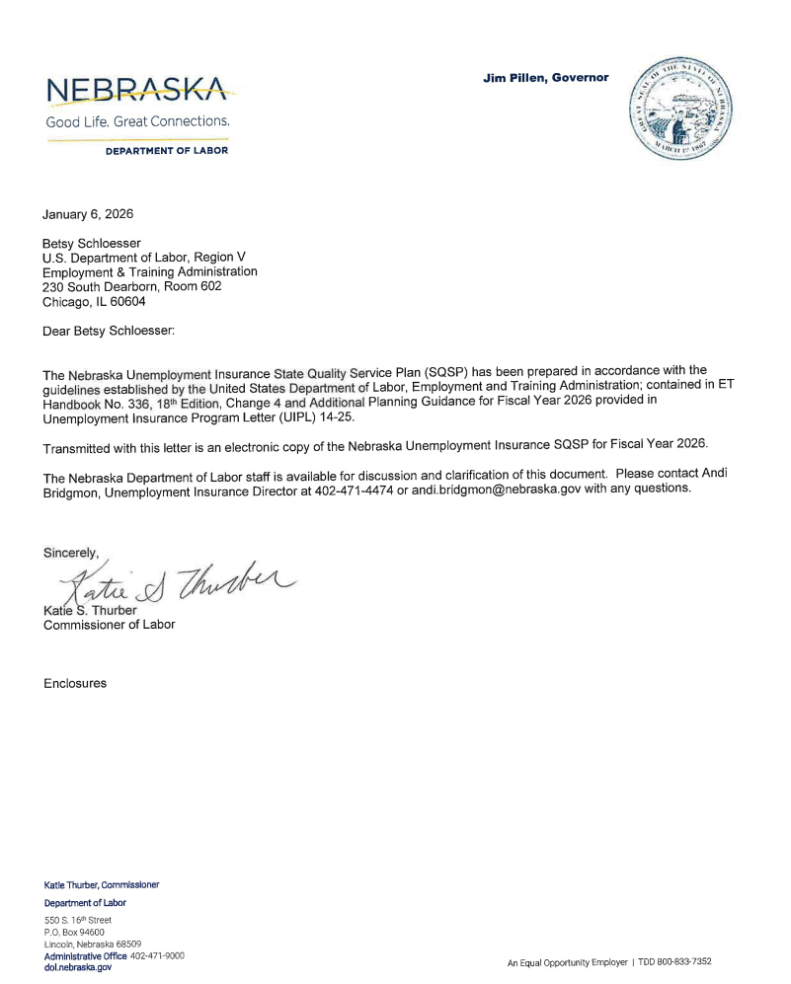

2. Budget Worksheets/Forms
Budget worksheets/forms and plan for program administration based on projected allocations received from the Federal partner. These forms include Worksheet UI-1 and SF 424, SF 424A and SF 424B. The SF 424A is only required if the State vary the quarterly distribution of base claims activity staff years.
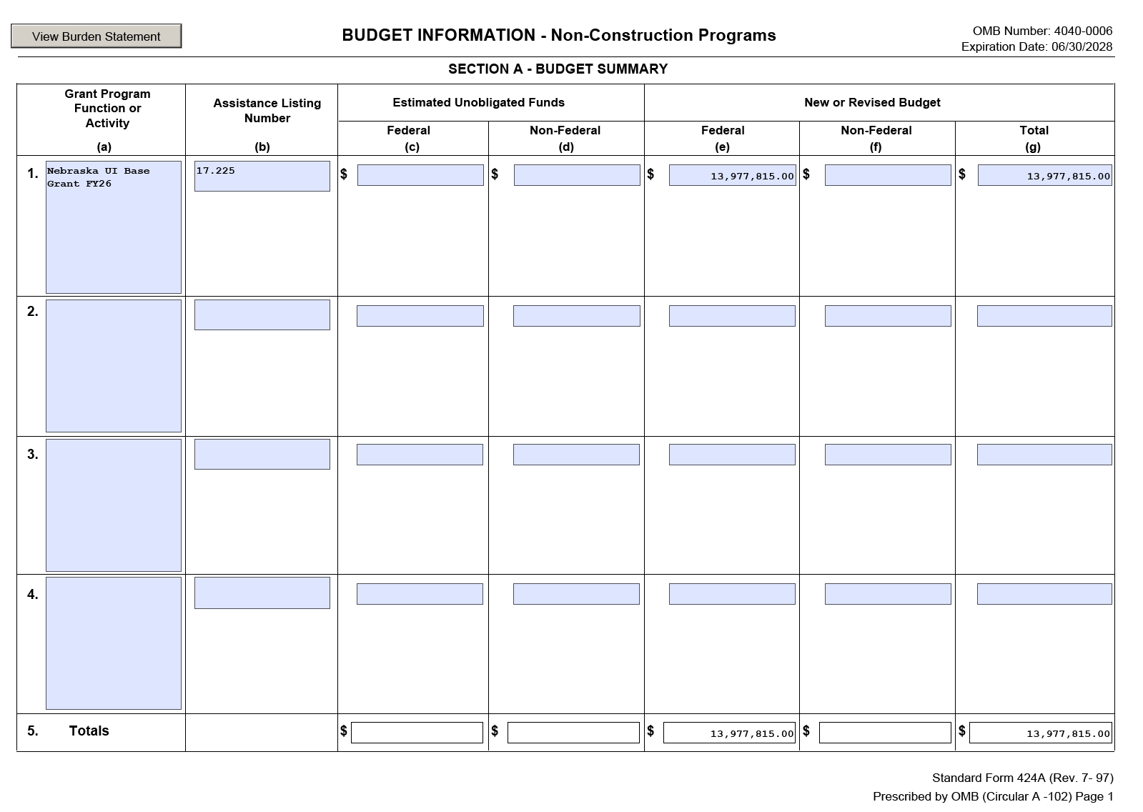
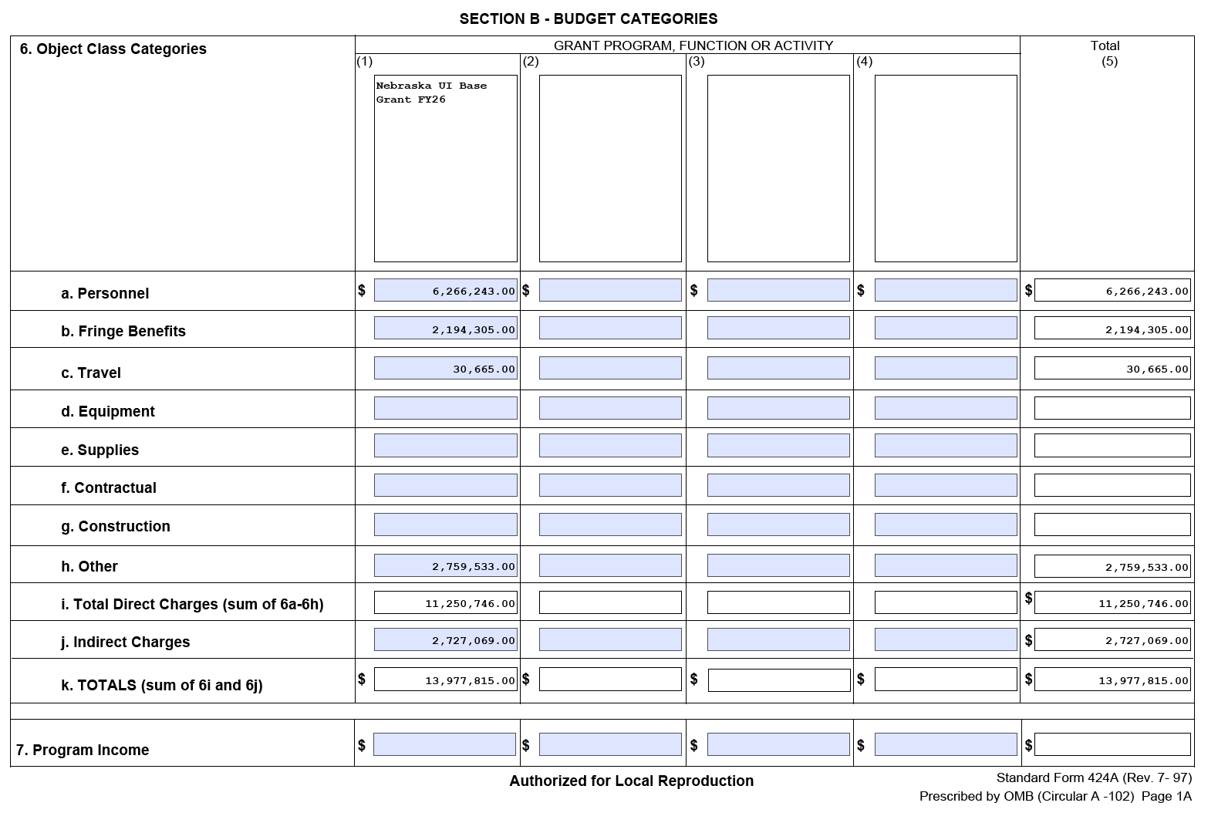
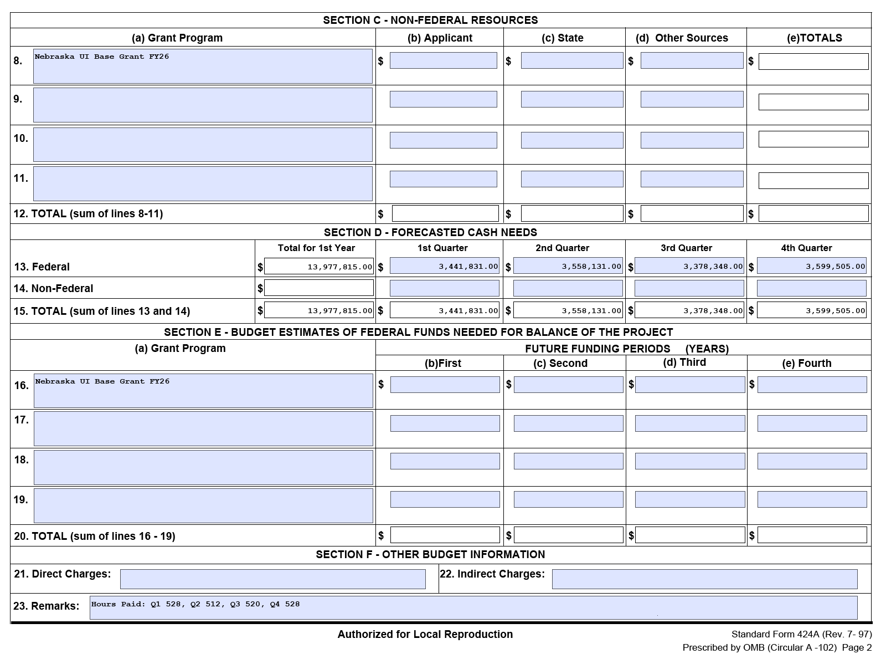

3. The State Plan Narrative
State Plan Narrative is a vital element of the SQSP that provides a vehicle for sharing with the Federal partner State-specific efforts that affect the administration of the UI Program. The State Plan Narrative allows the State to describe in a single narrative: a) State performance in comparison to the Government Performance Review Act goals; b) actions planned to correct deficiencies regarding UI programs, UI program reviews and reporting requirements; and c) results of customer satisfaction surveys (optional).
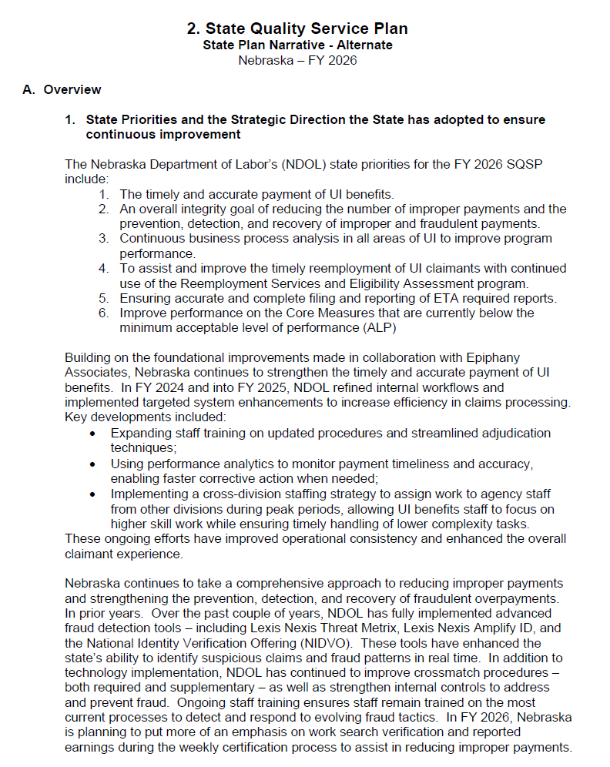
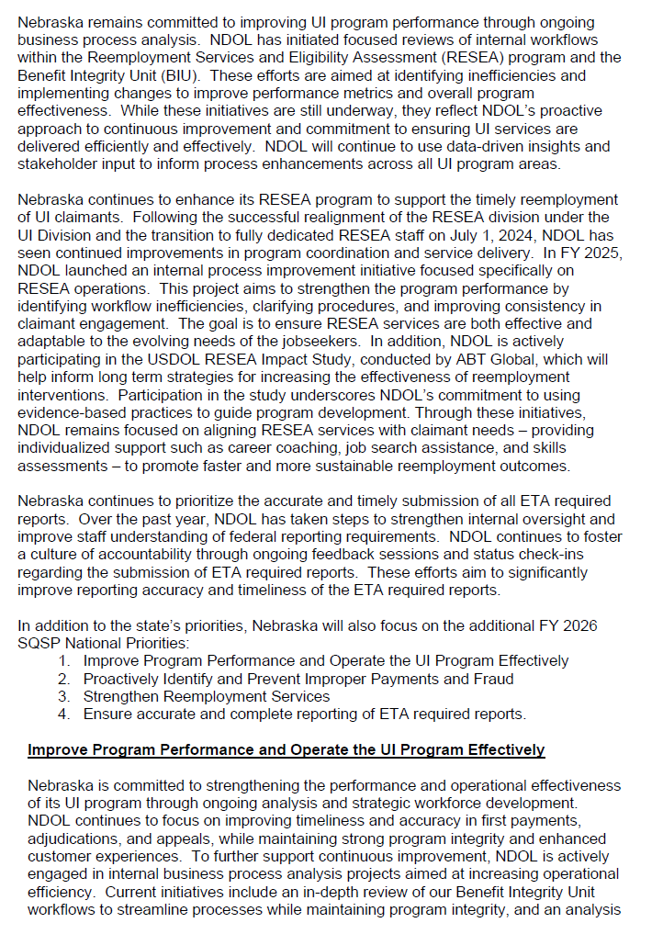
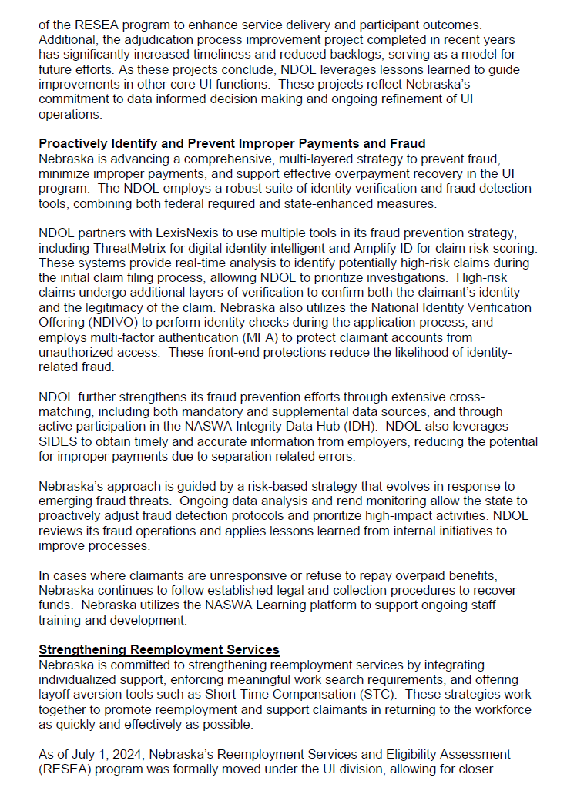
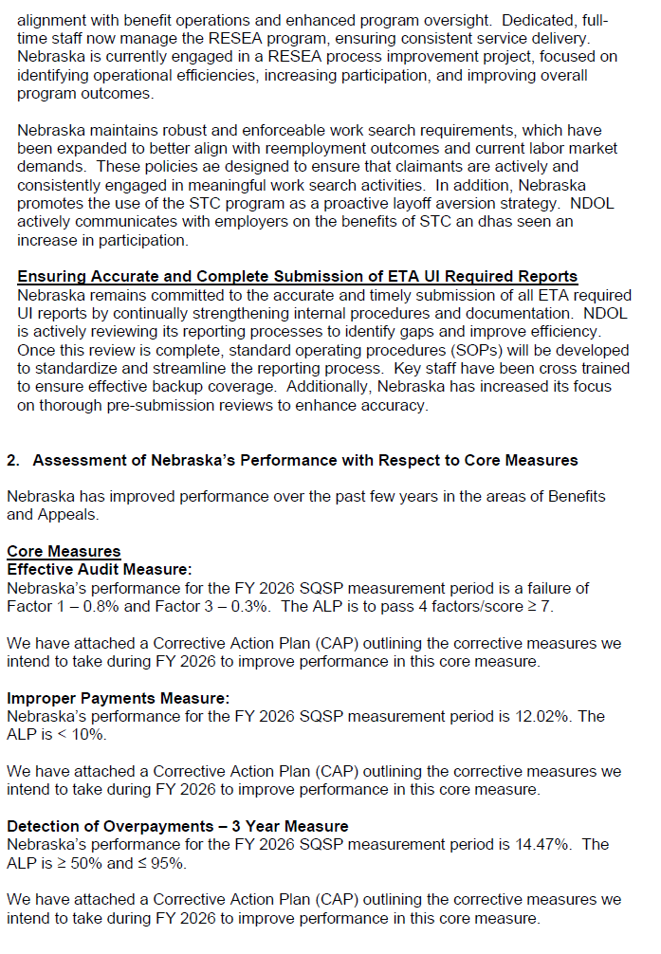
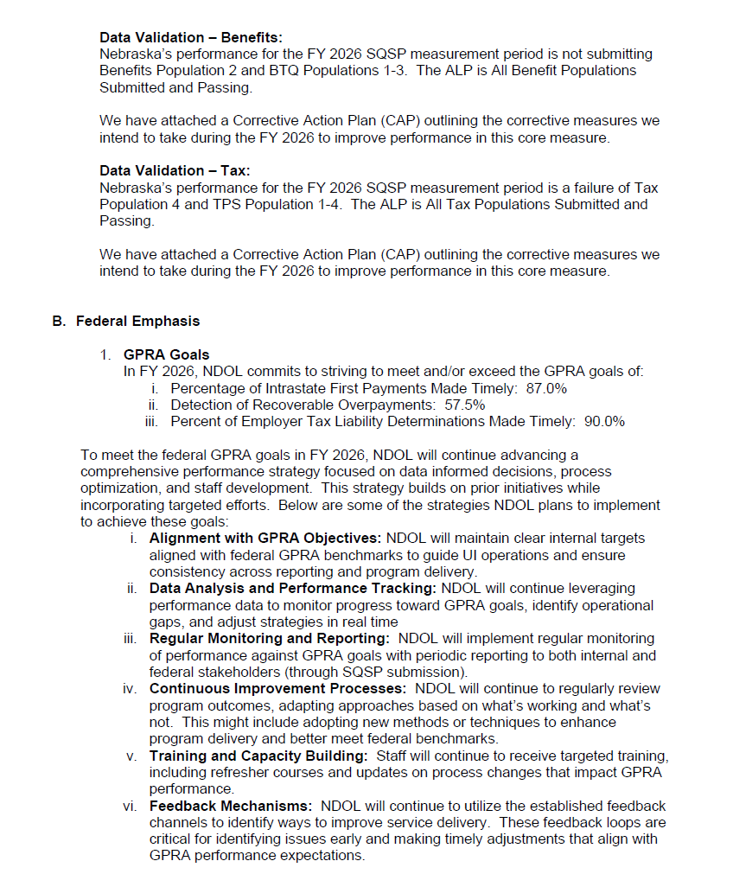
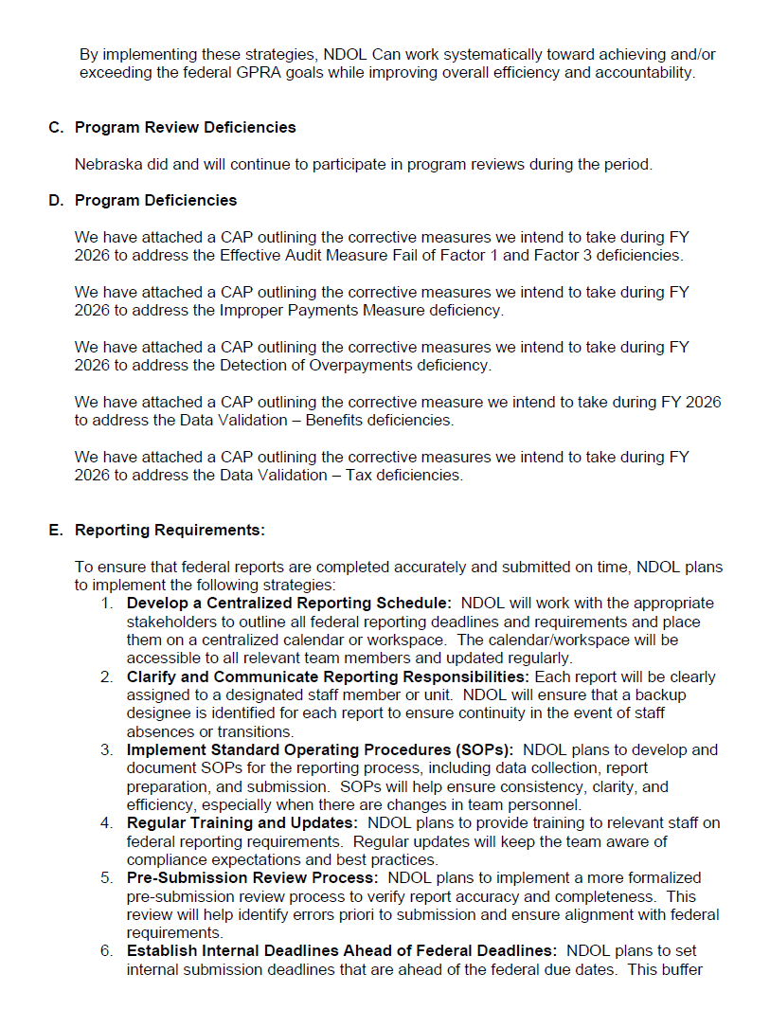
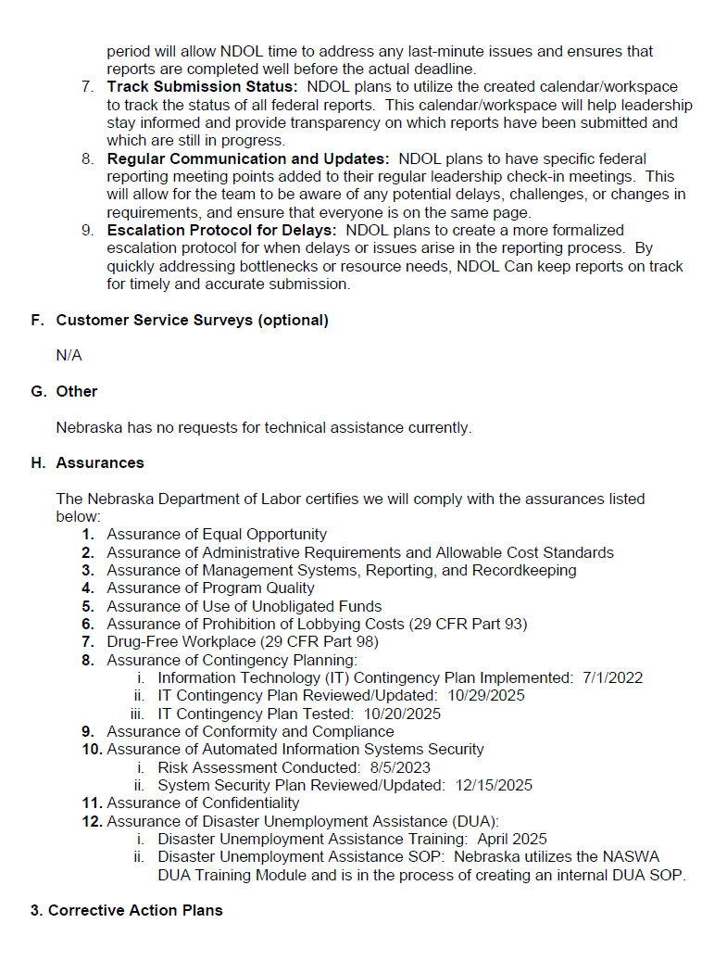
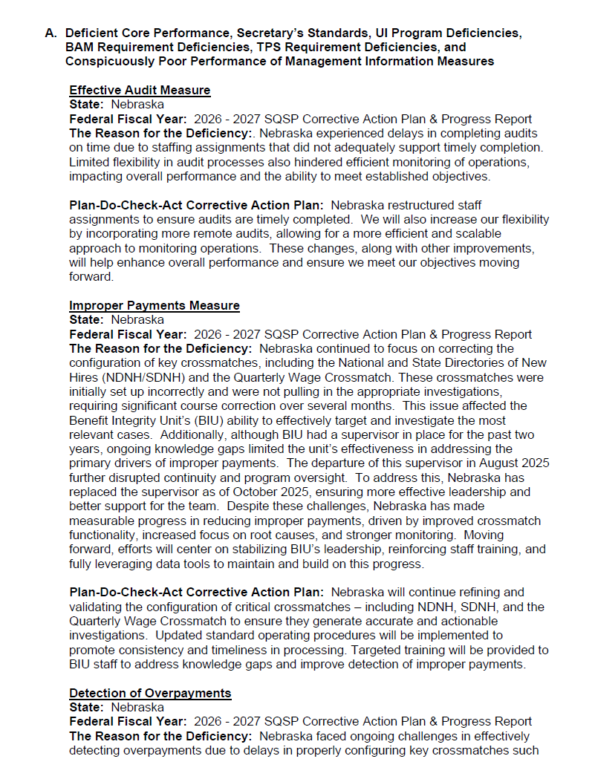
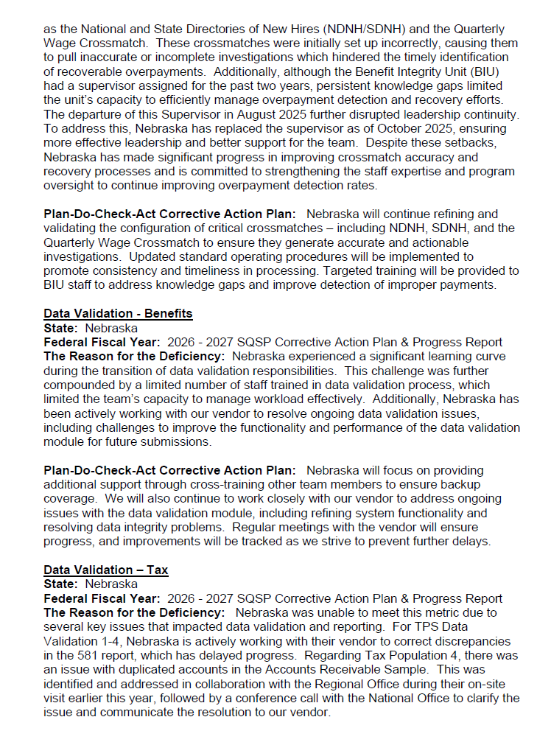
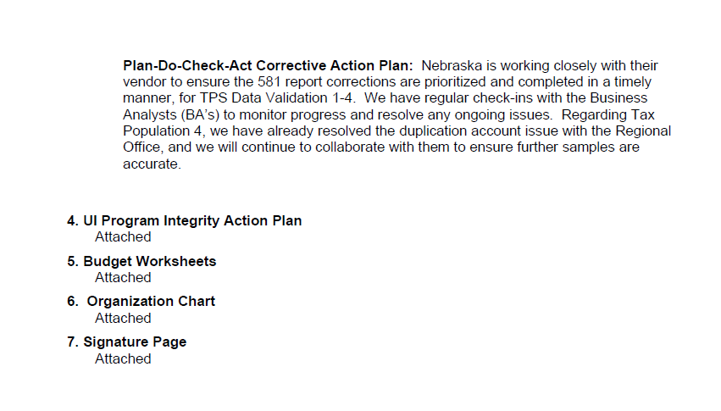
4. Corrective Action Plans (CAPs)
CAPs are expected as a part of the SQSP when State’s annual performance does not meet the established criteria for core measures, Secretary’s Standards, UI program, assurances, and other program deficiencies identified in the annual SQSP guidance provided by the Department. The CAP must list both specific milestones for key corrective actions or improvement activities, and the completion date for each milestone.

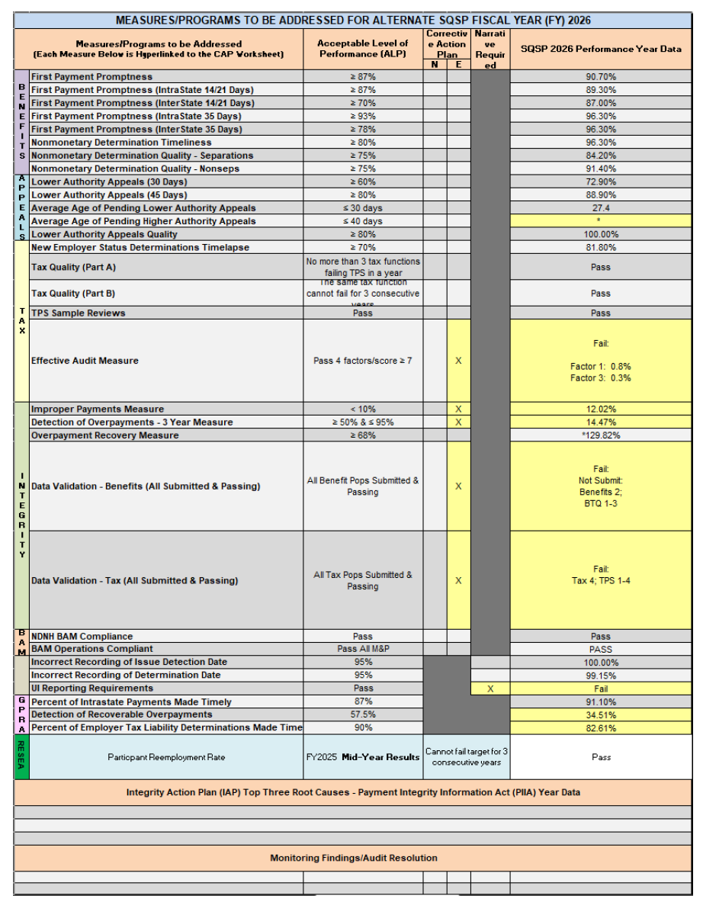
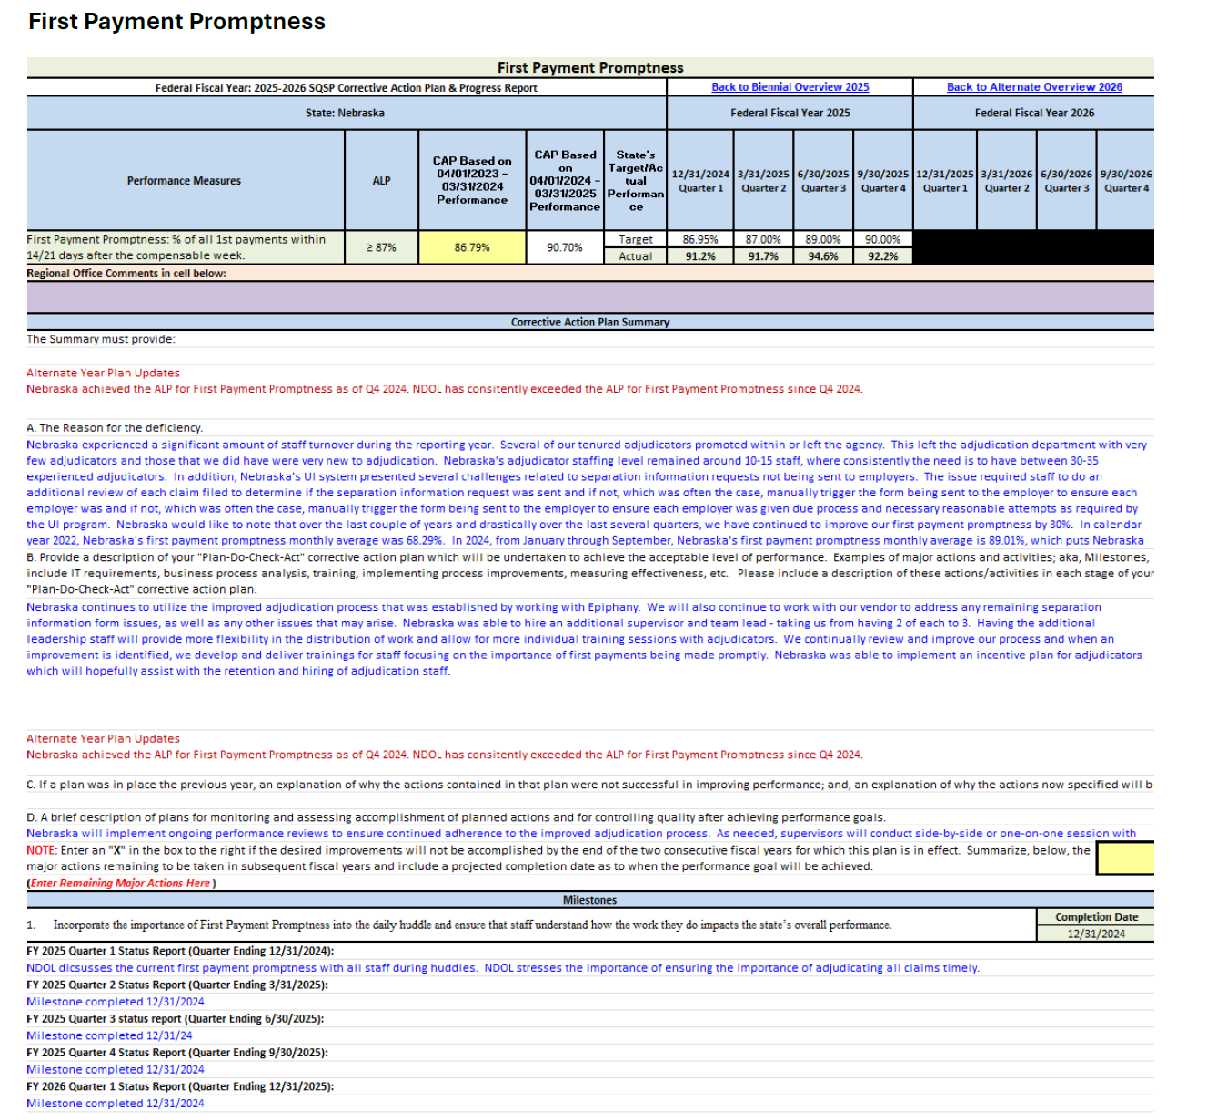
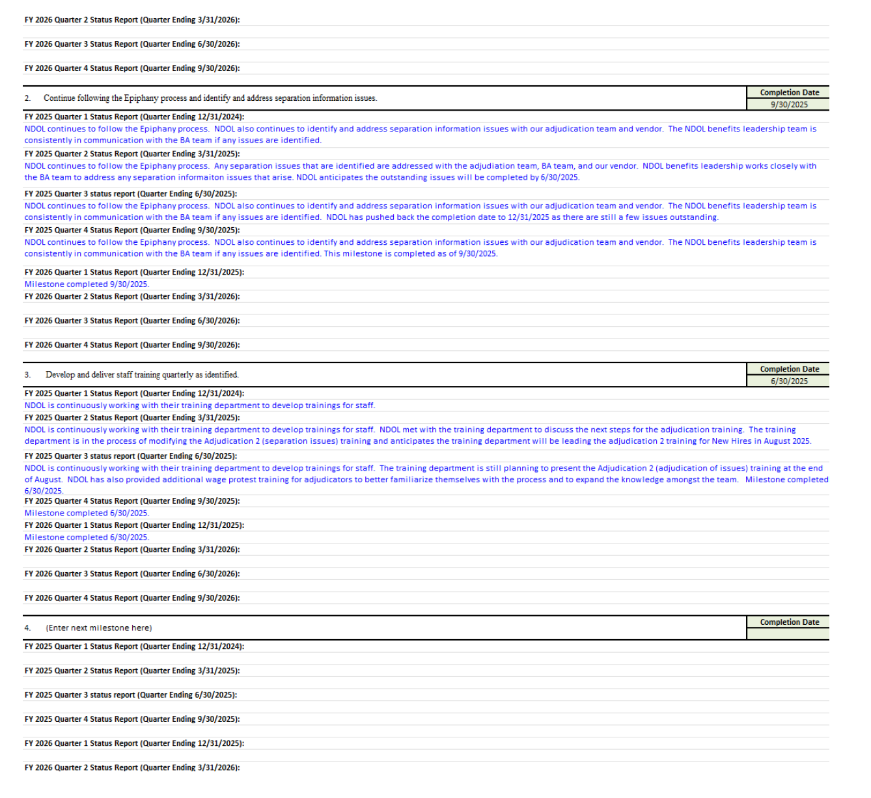
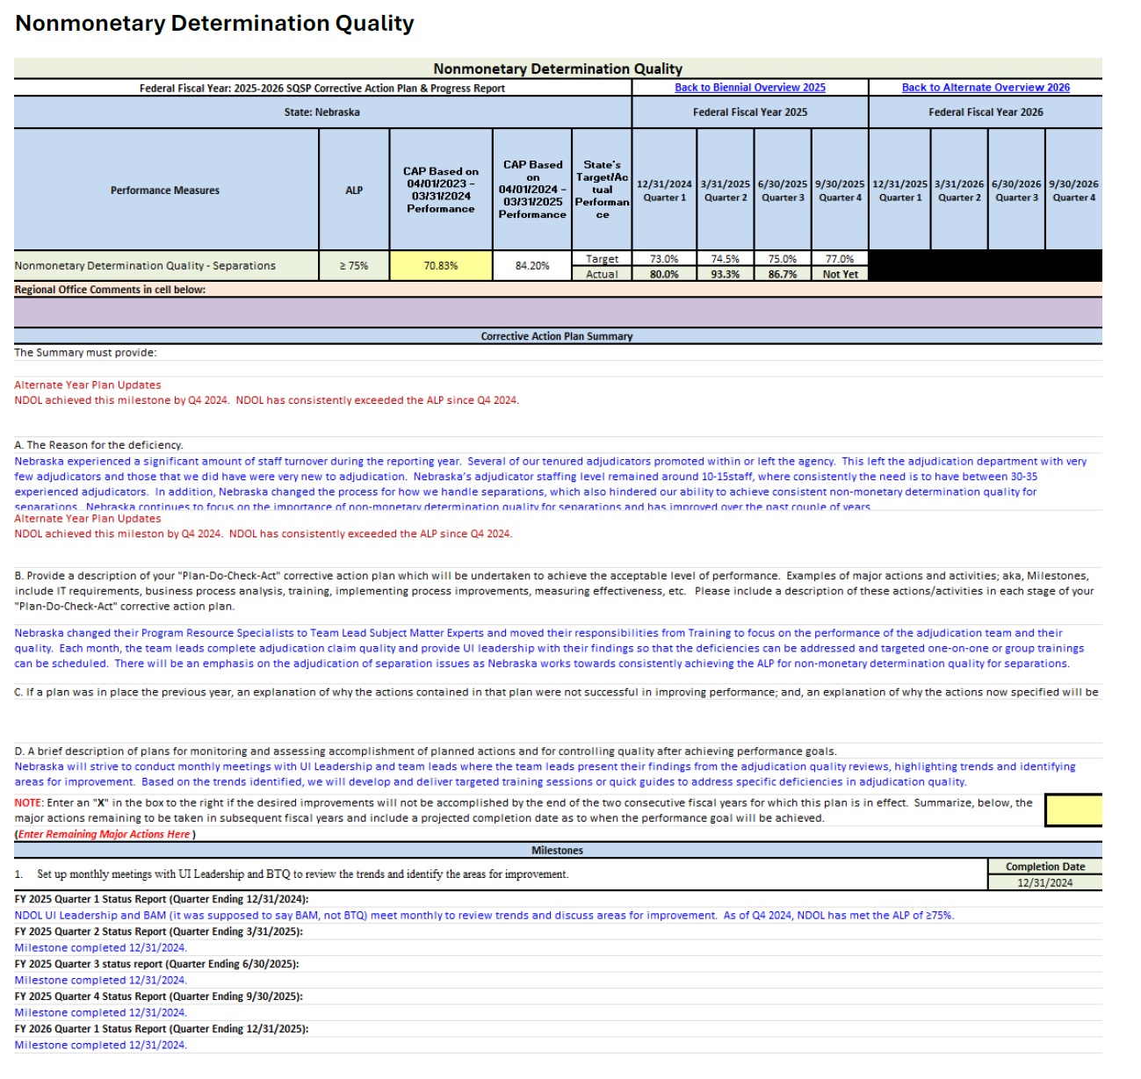
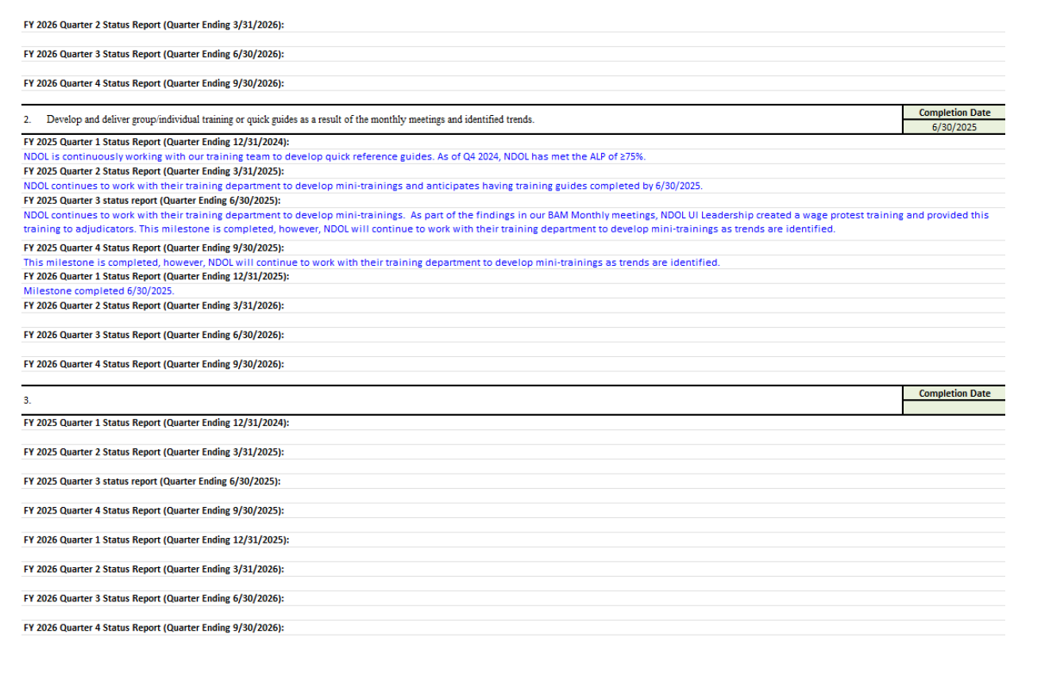
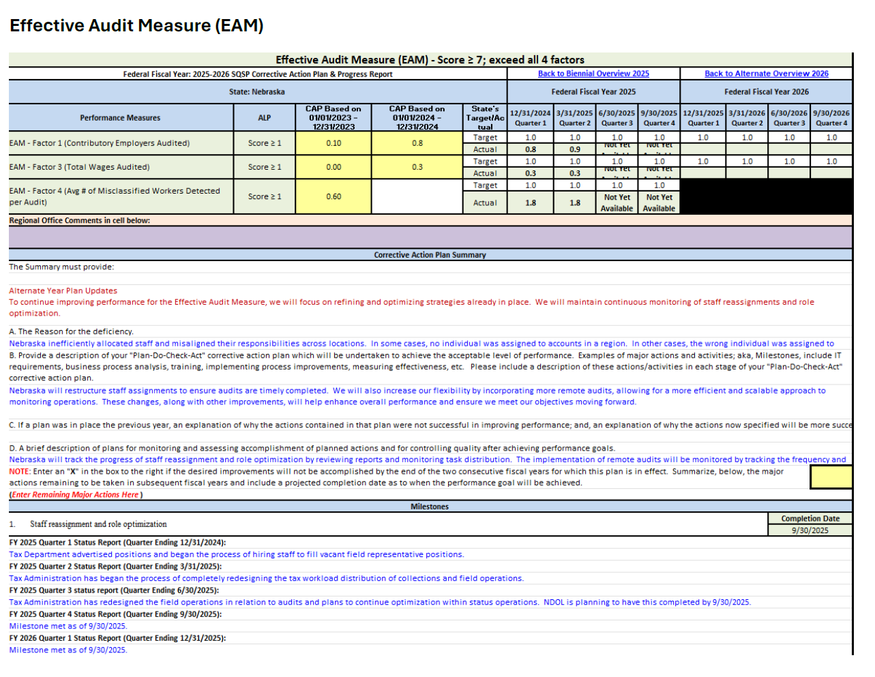
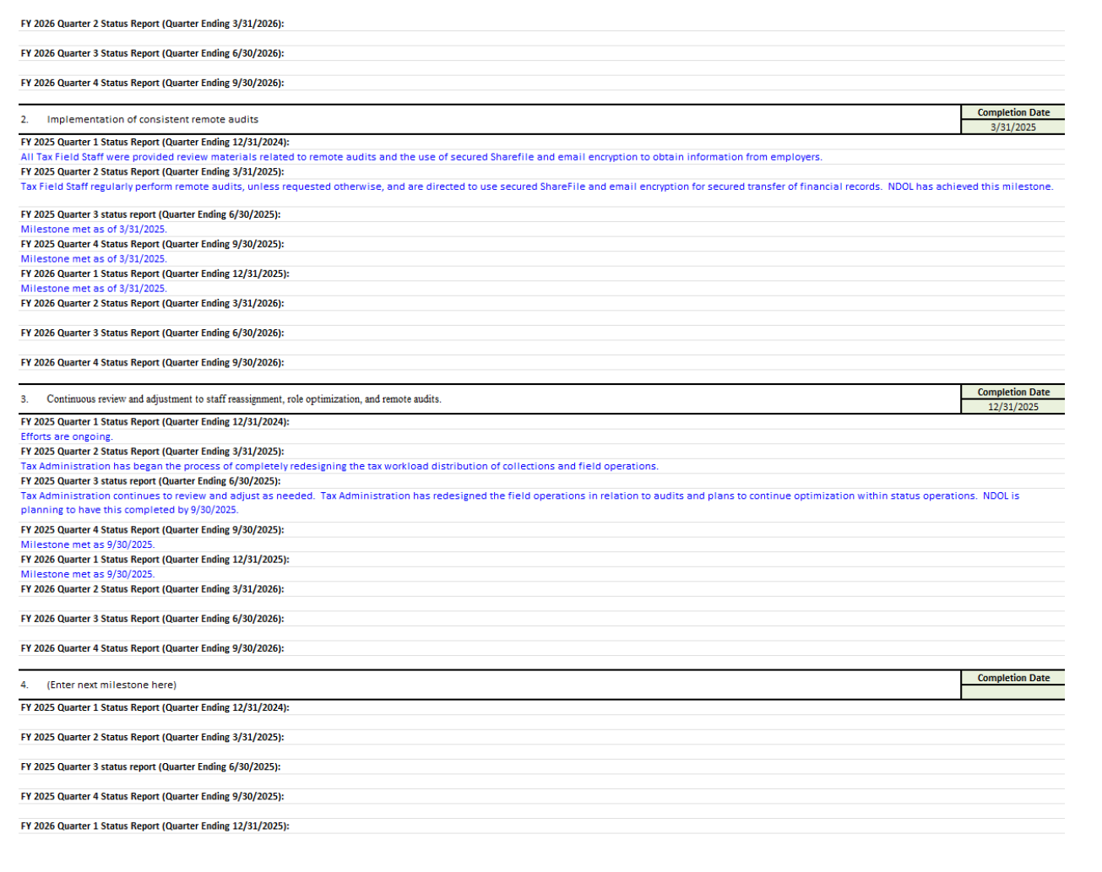
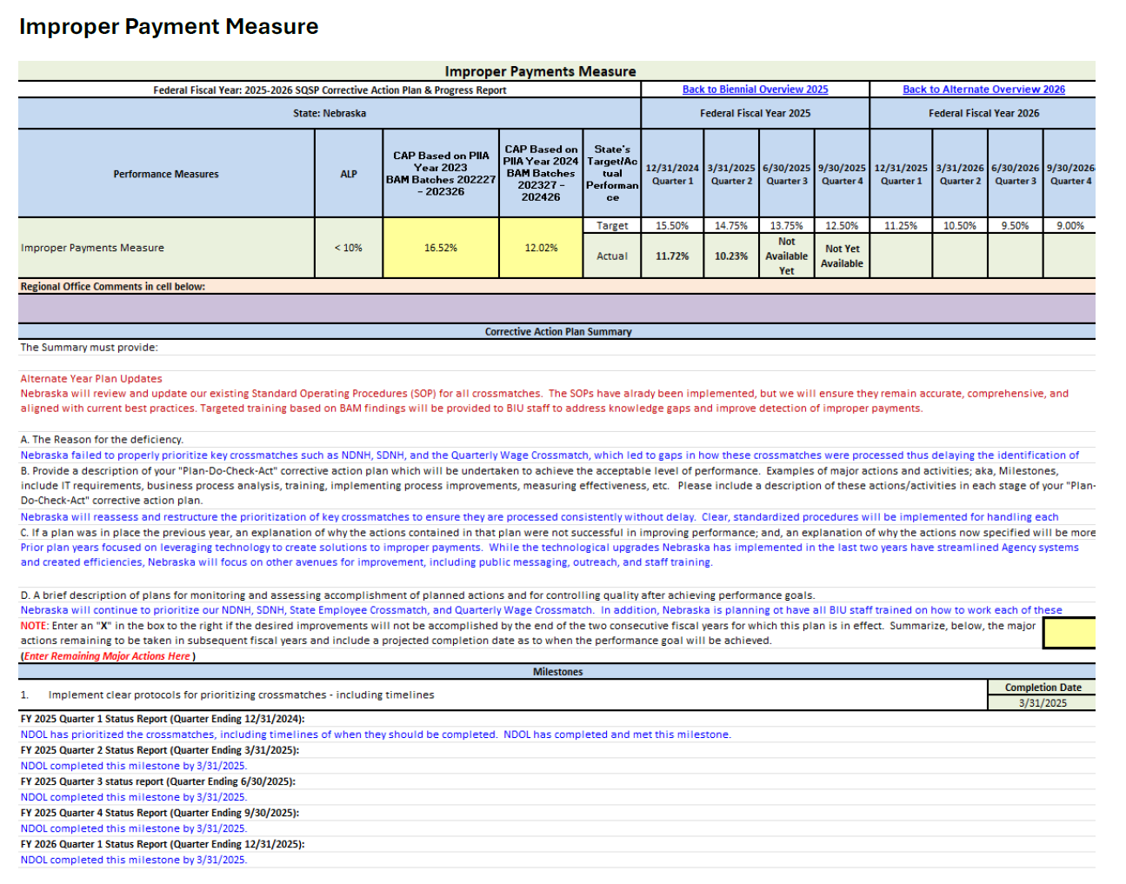
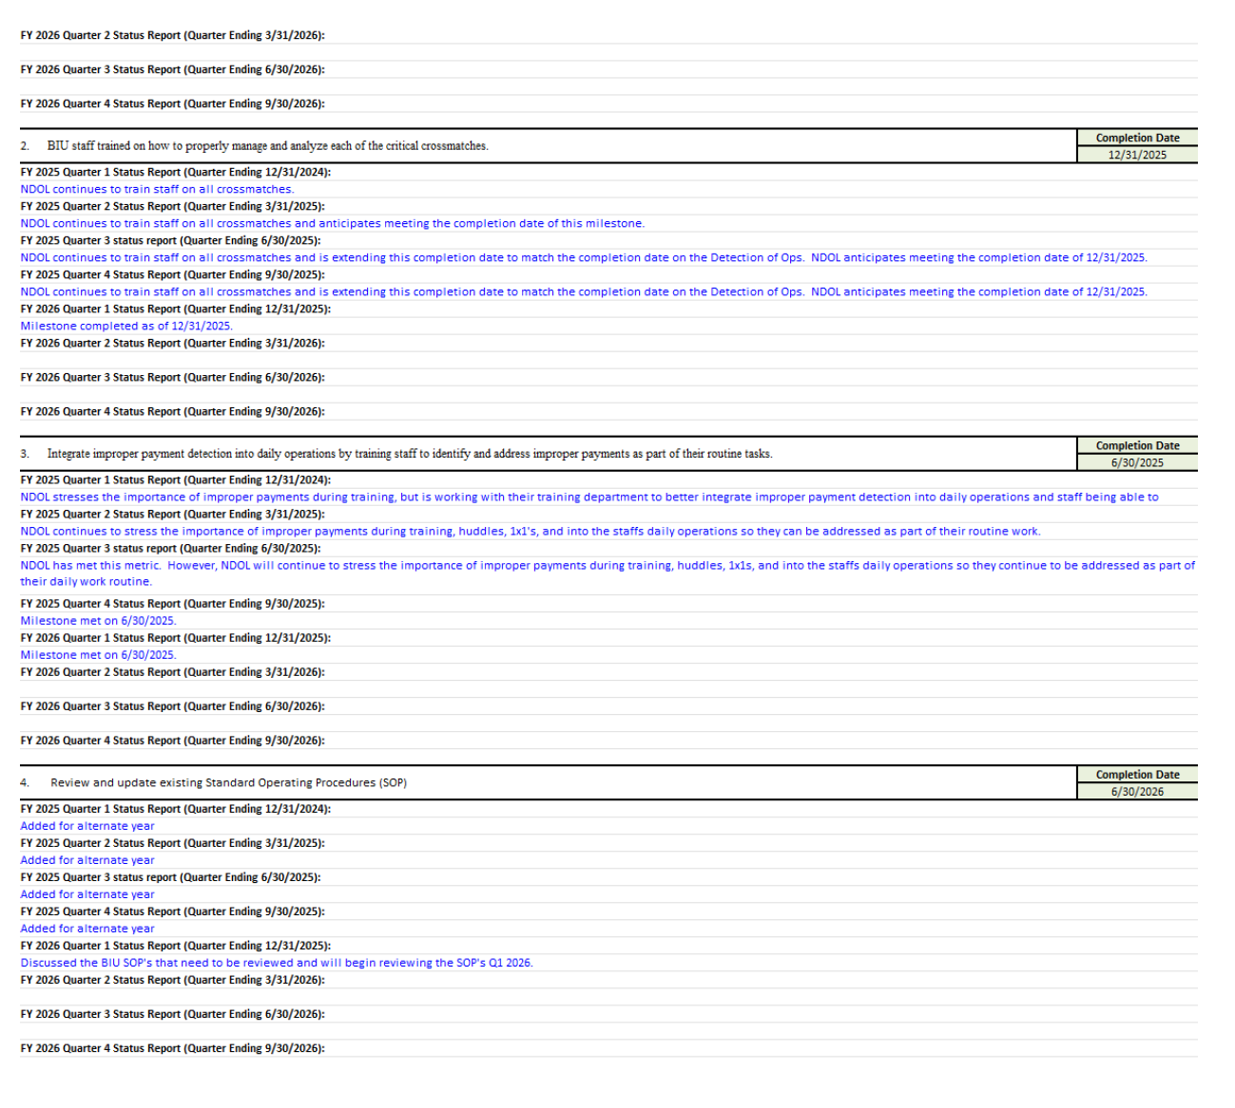
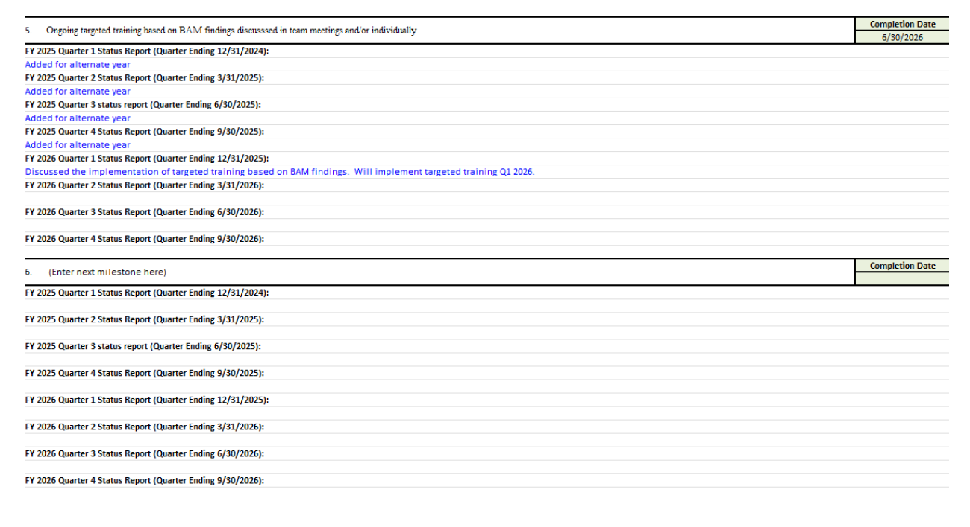
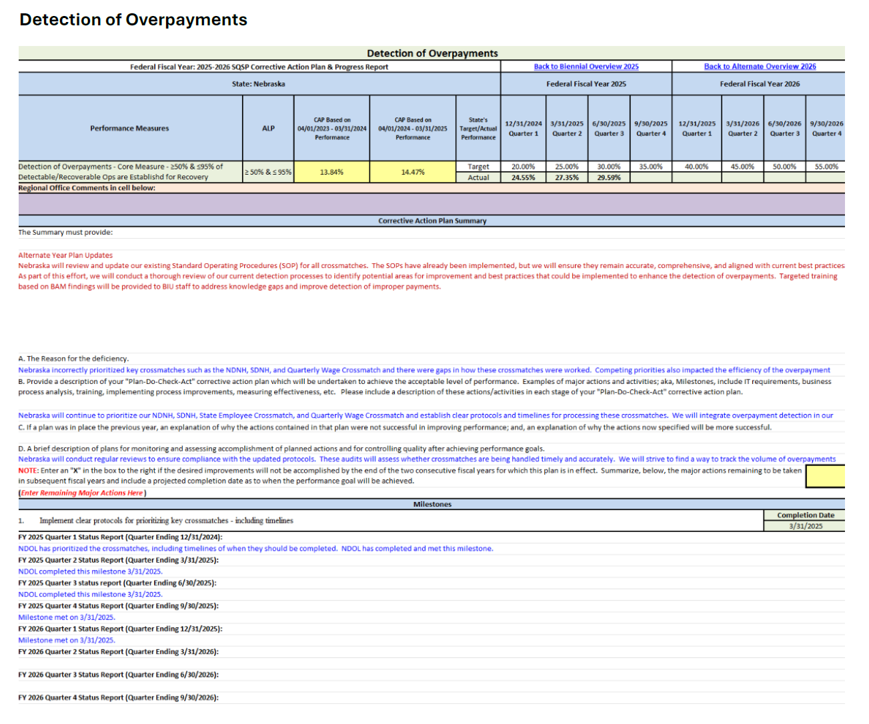
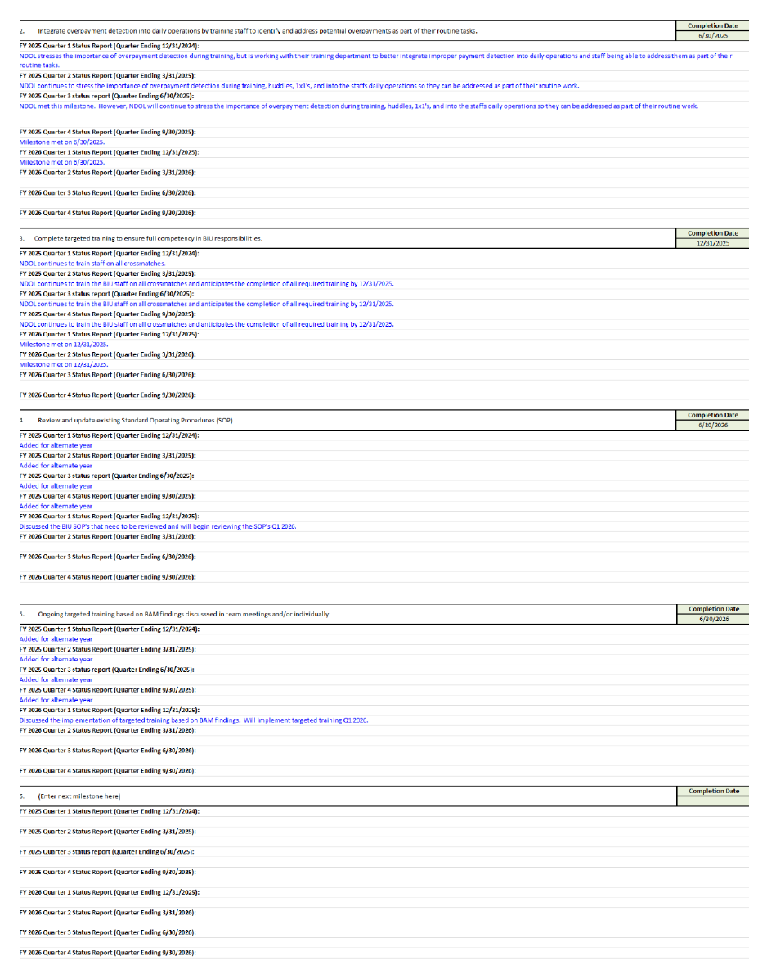
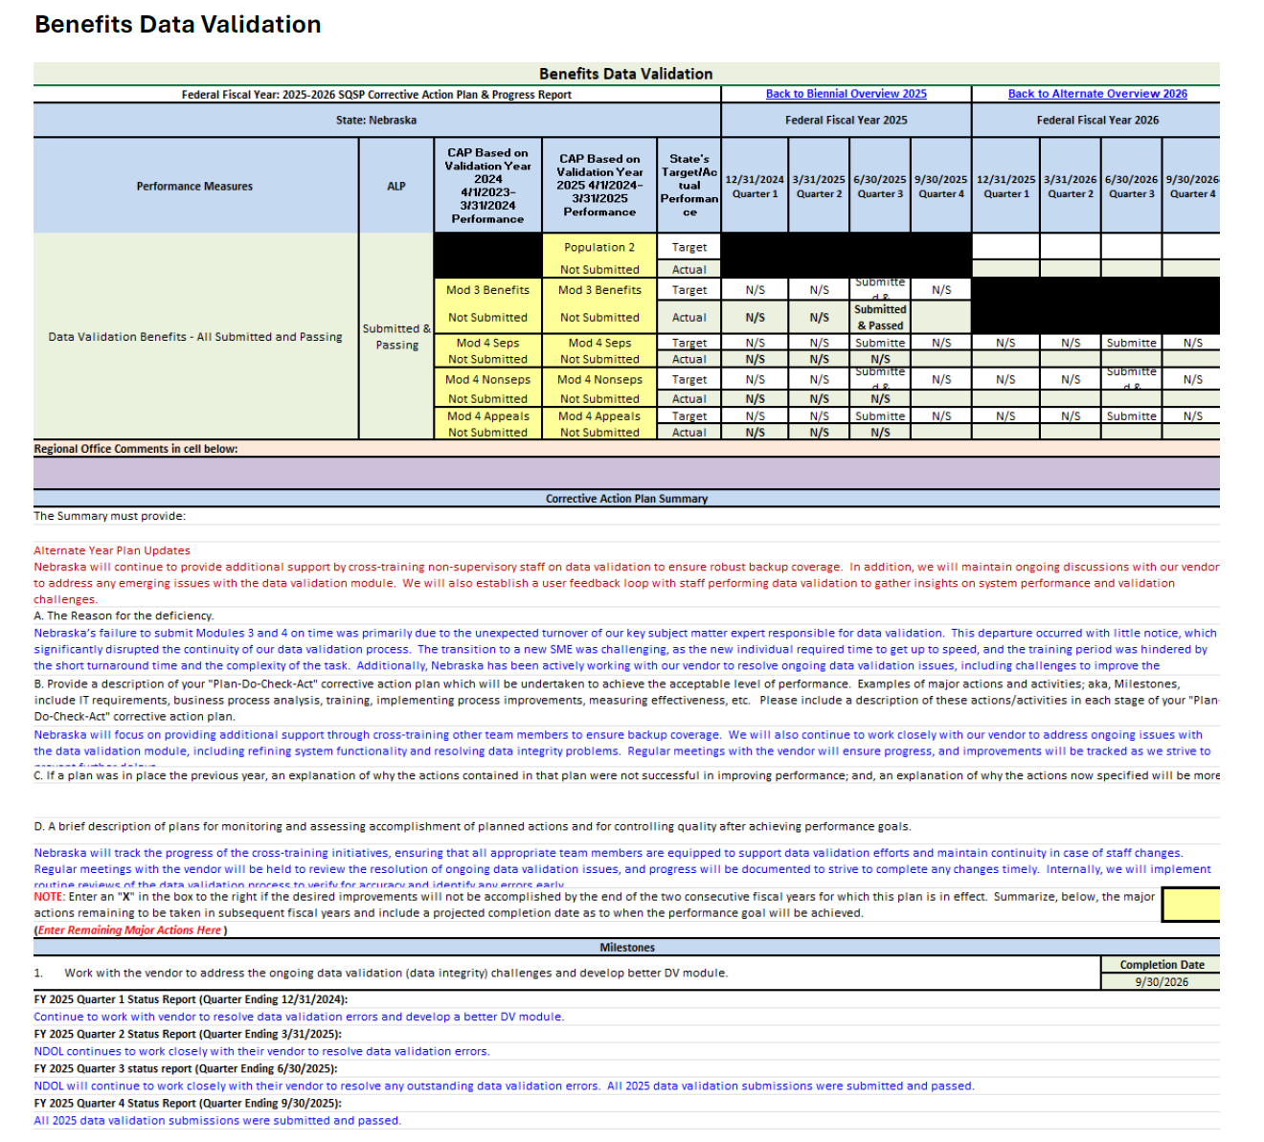
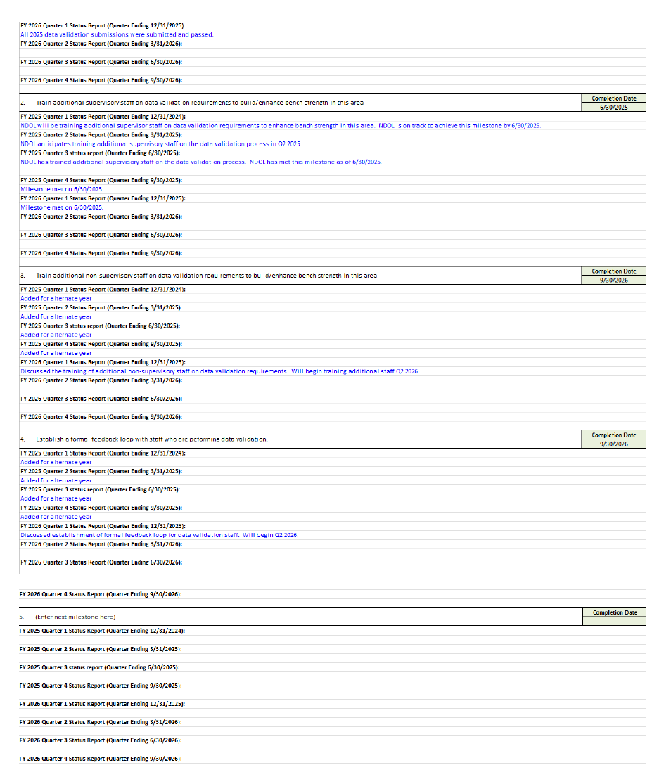
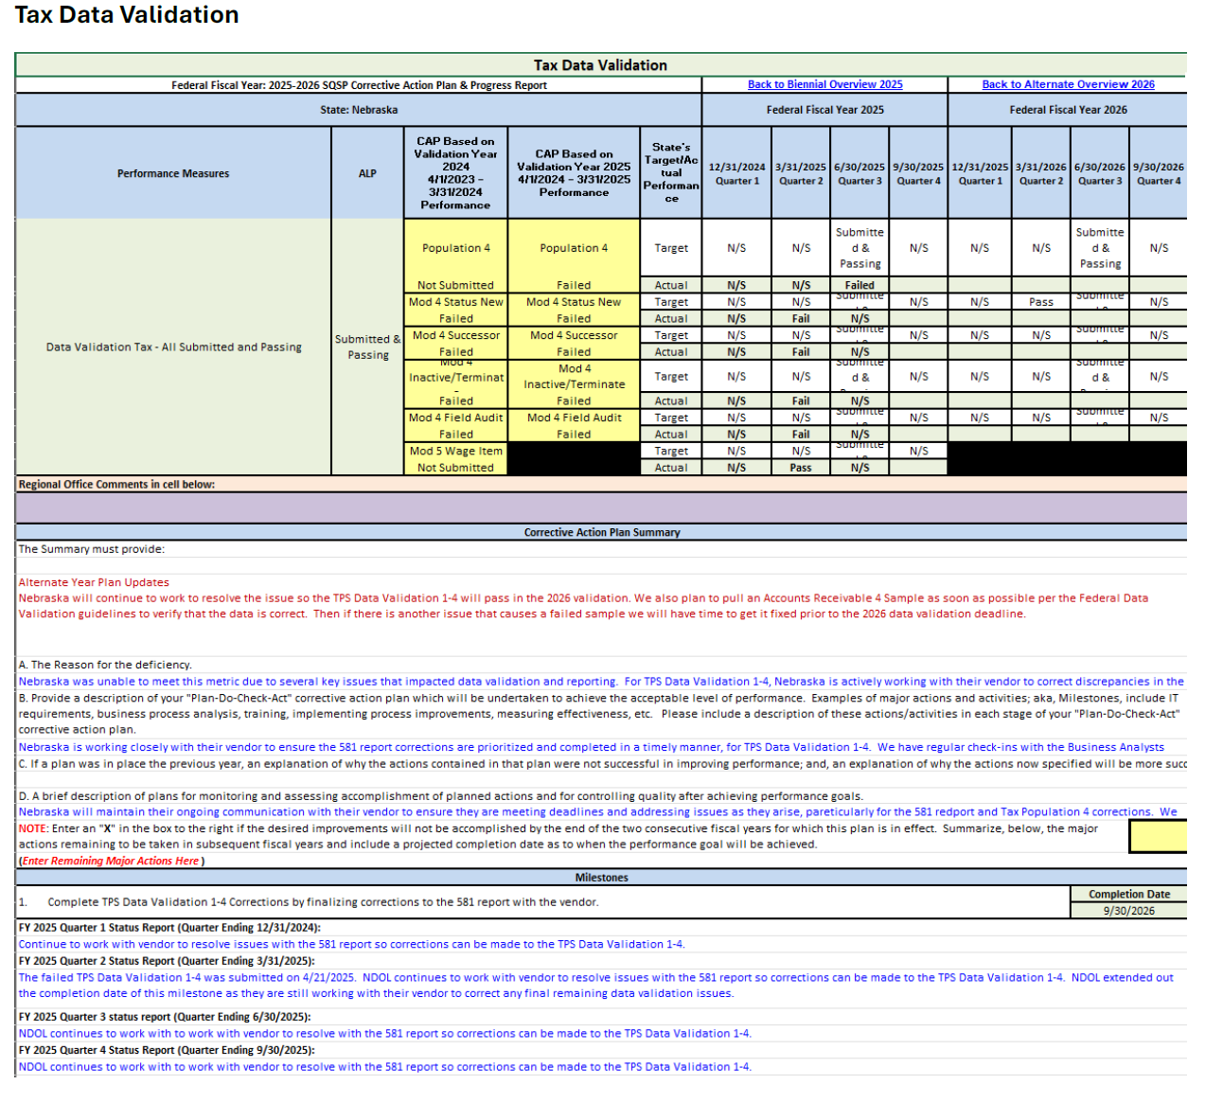
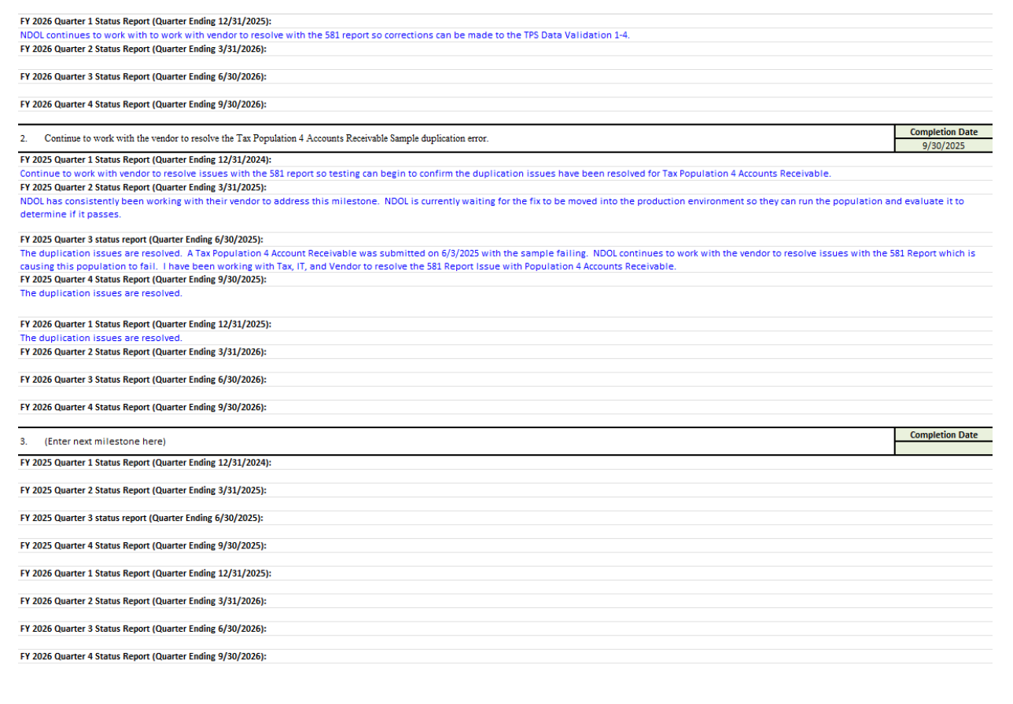
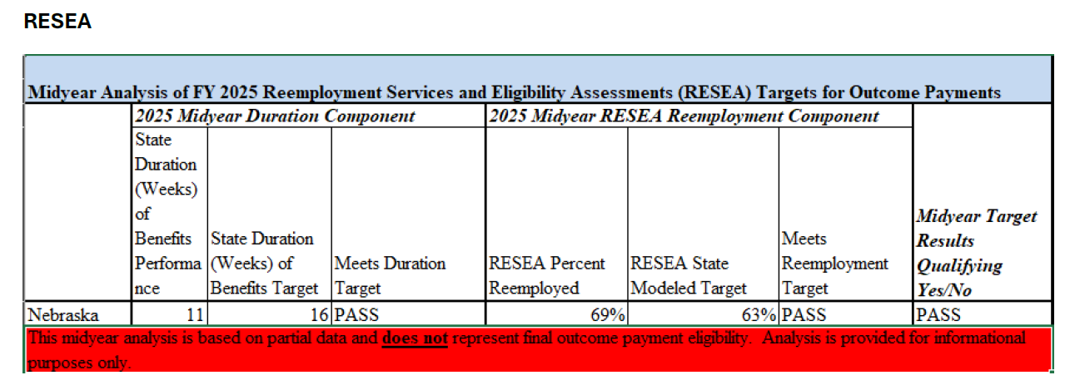
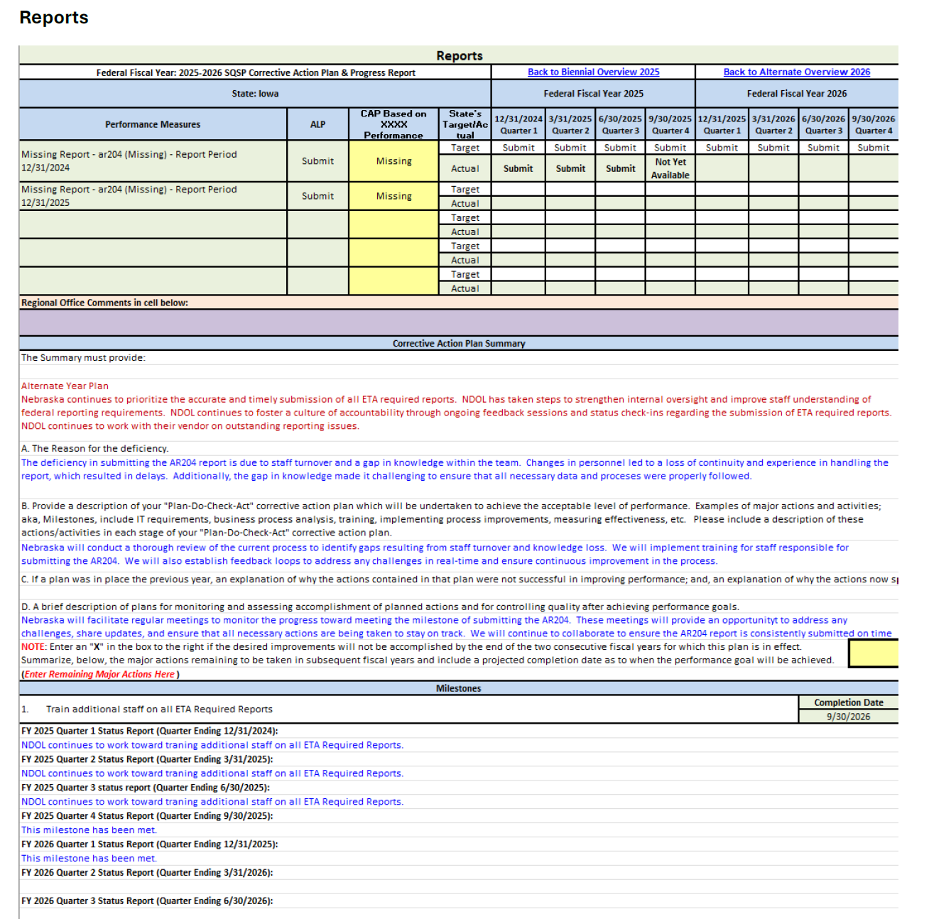
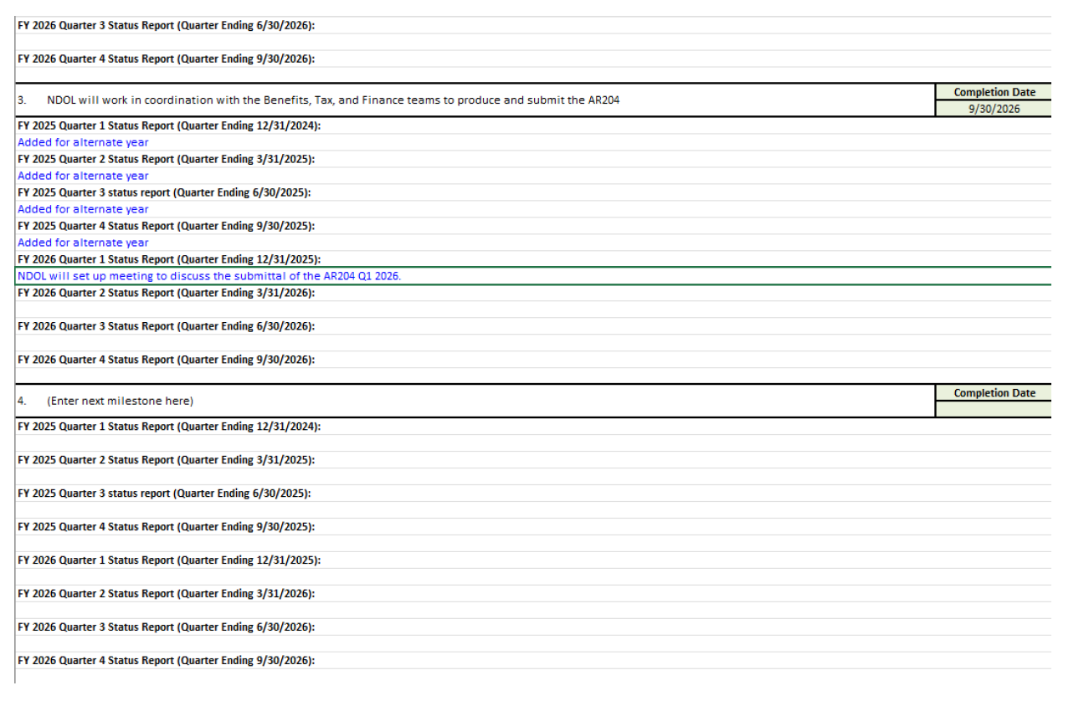
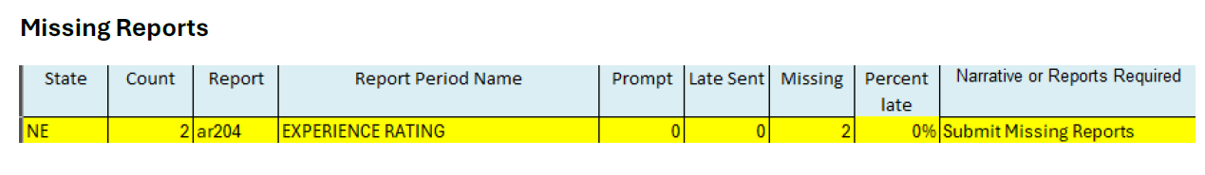

5. UI Program Integrity Action Plan (UI IAP)
The UI IAP outlines the strategies the State will undertake during the planning period regarding the prevention reduction and recovery of UI improper payments.
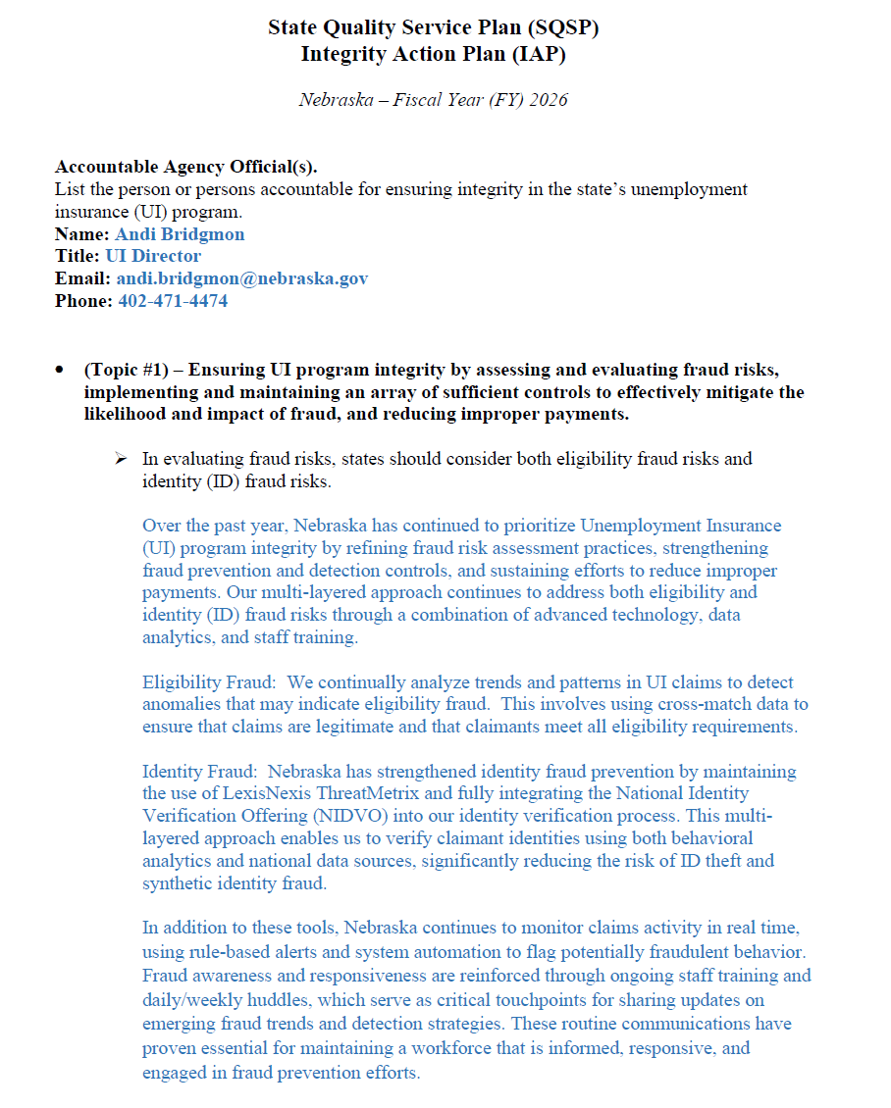
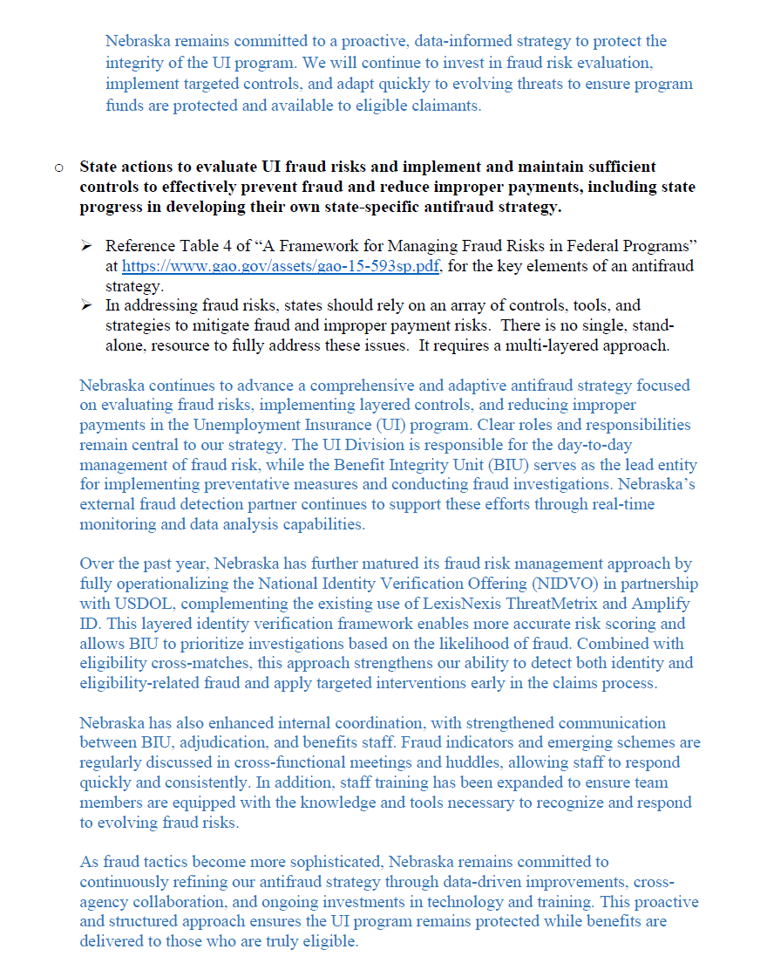
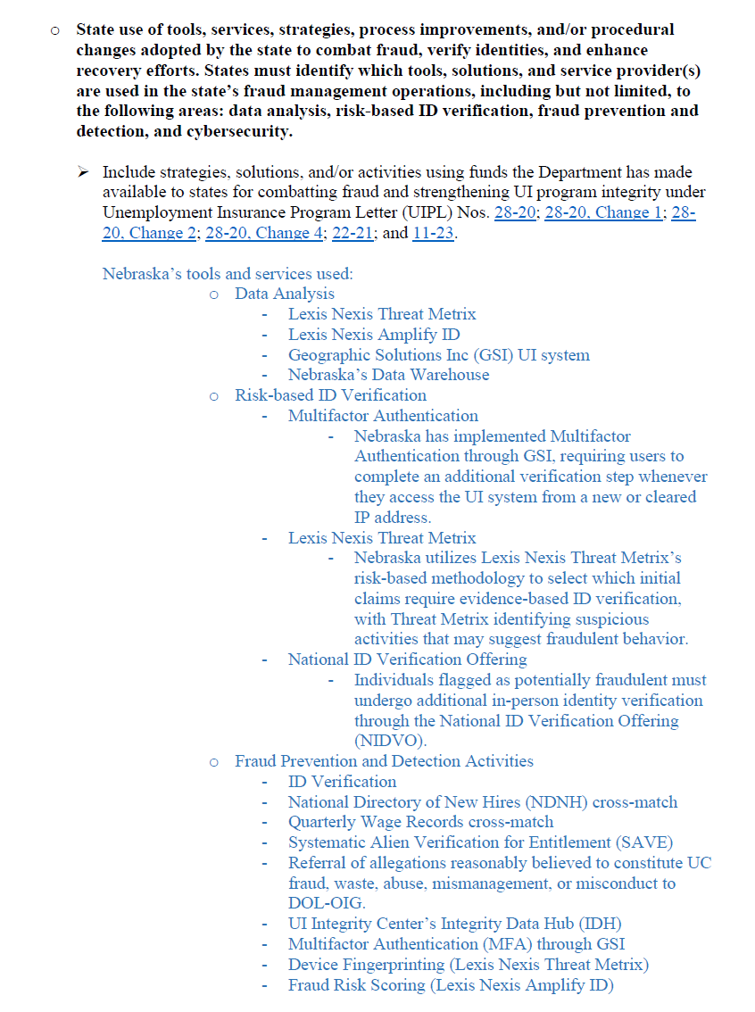
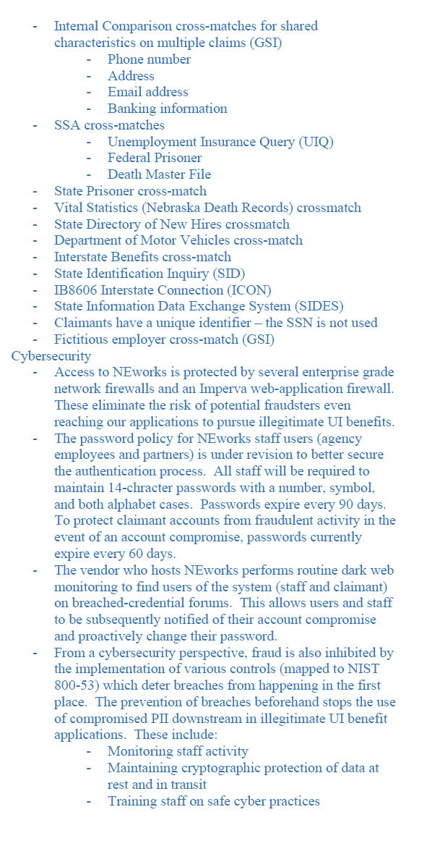
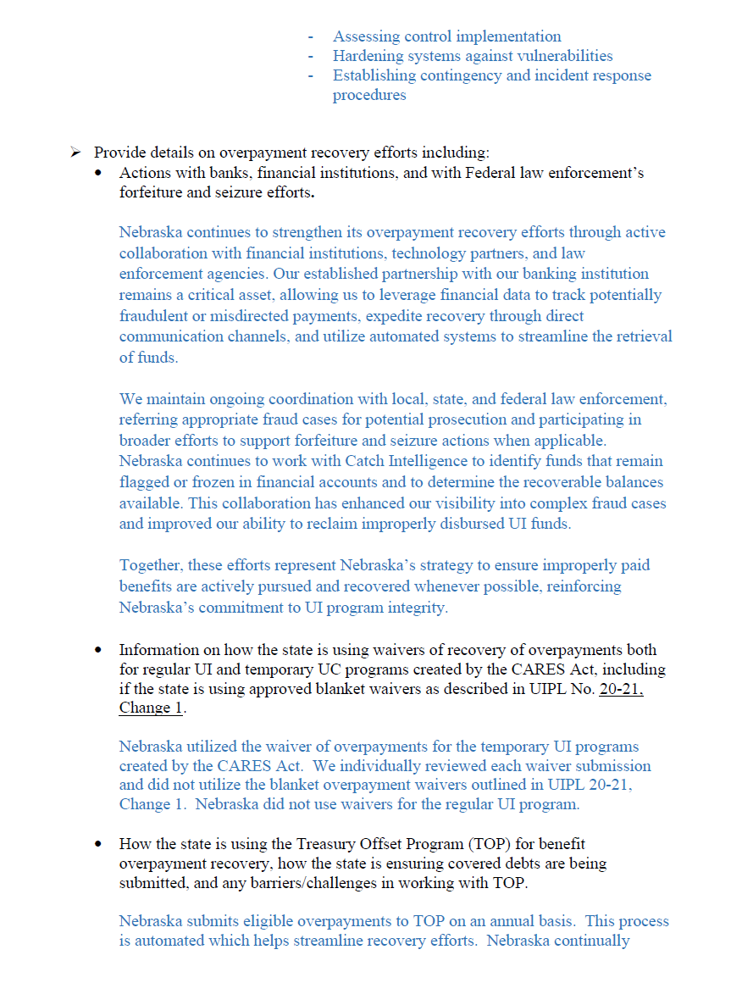
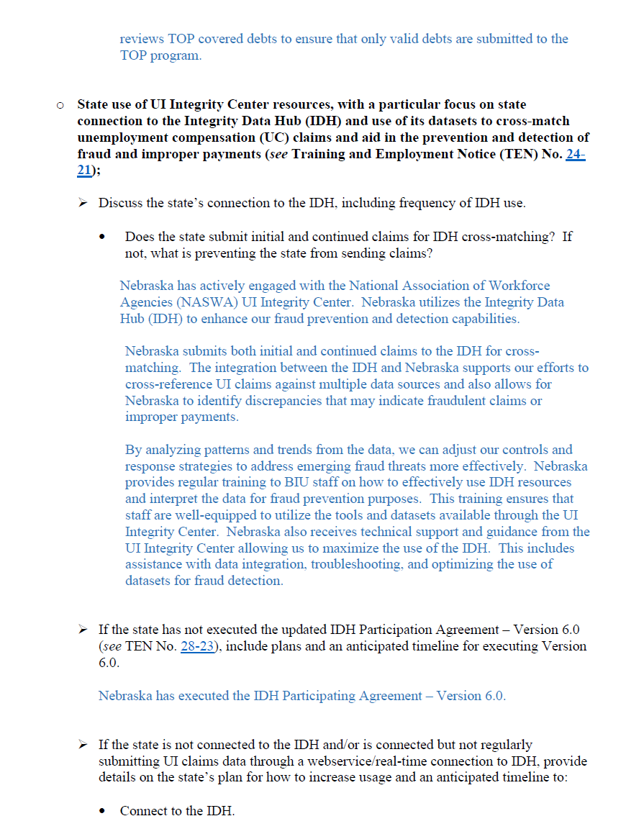
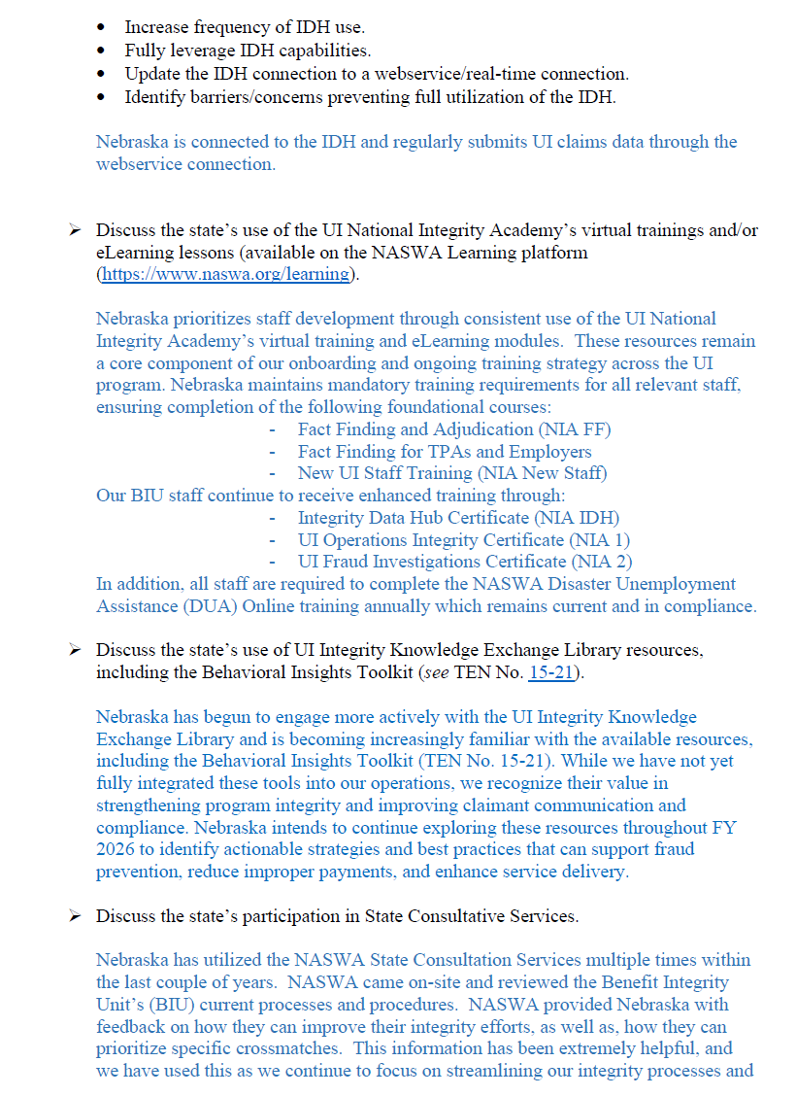
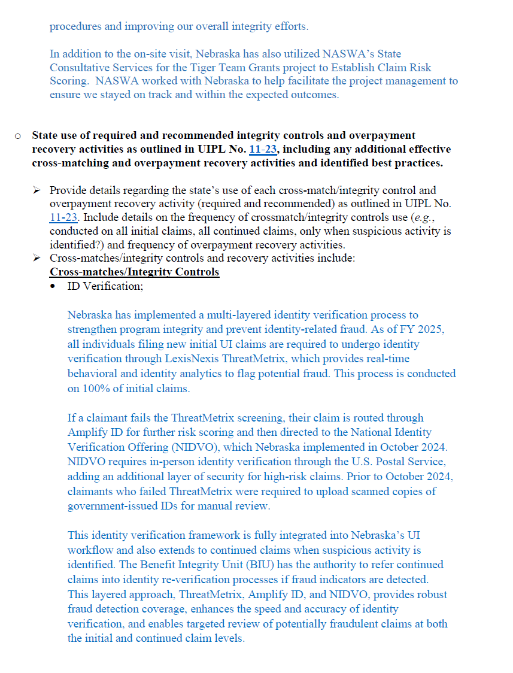

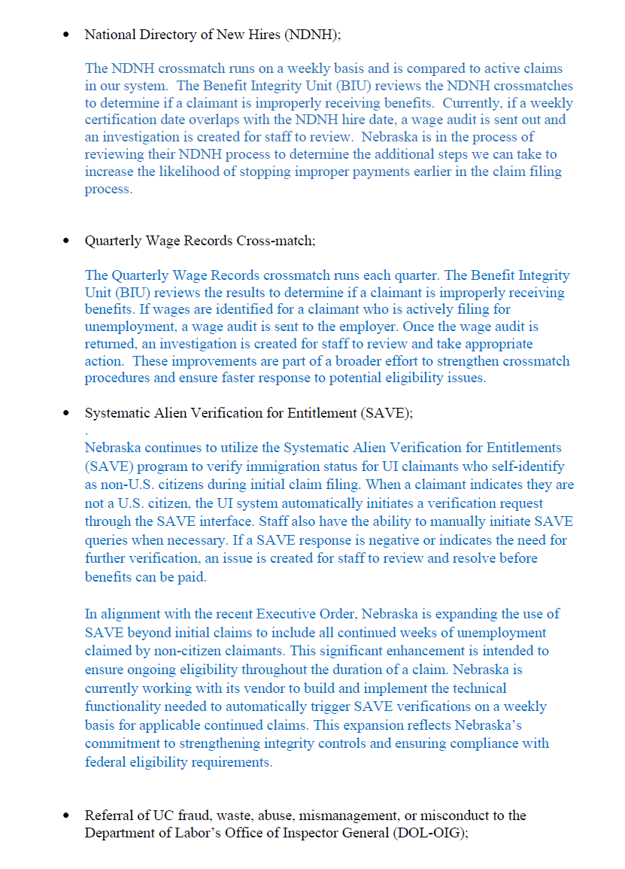

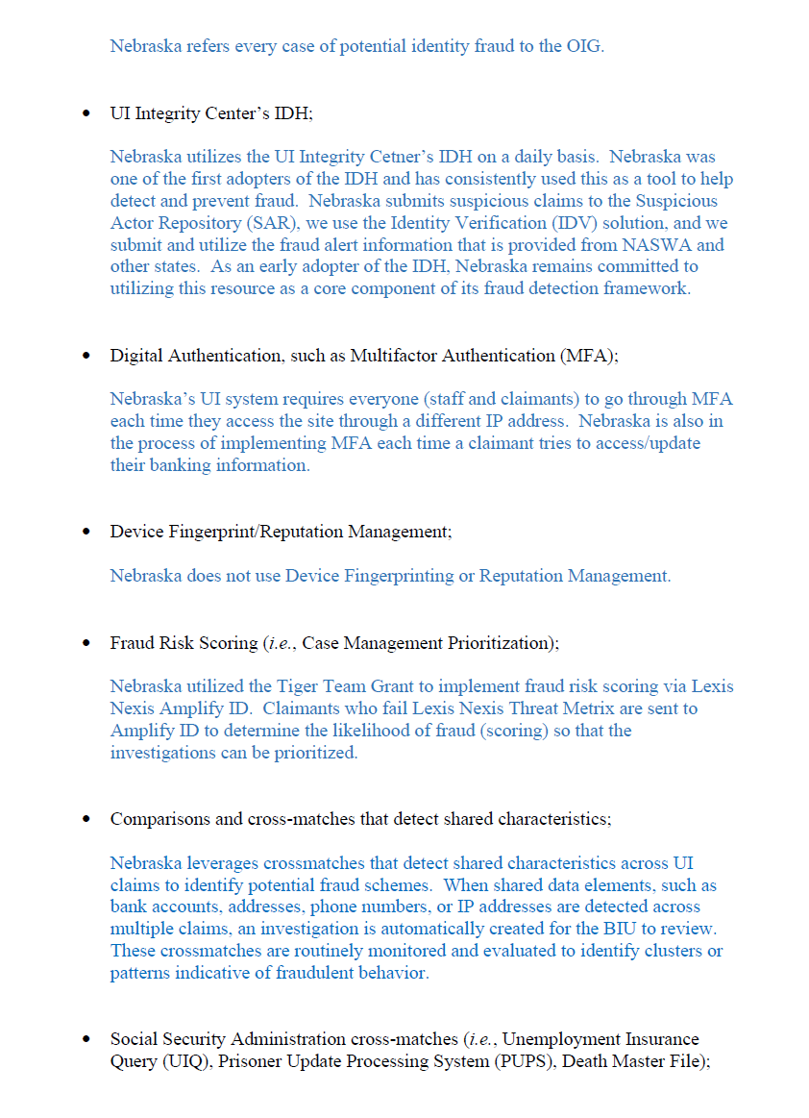
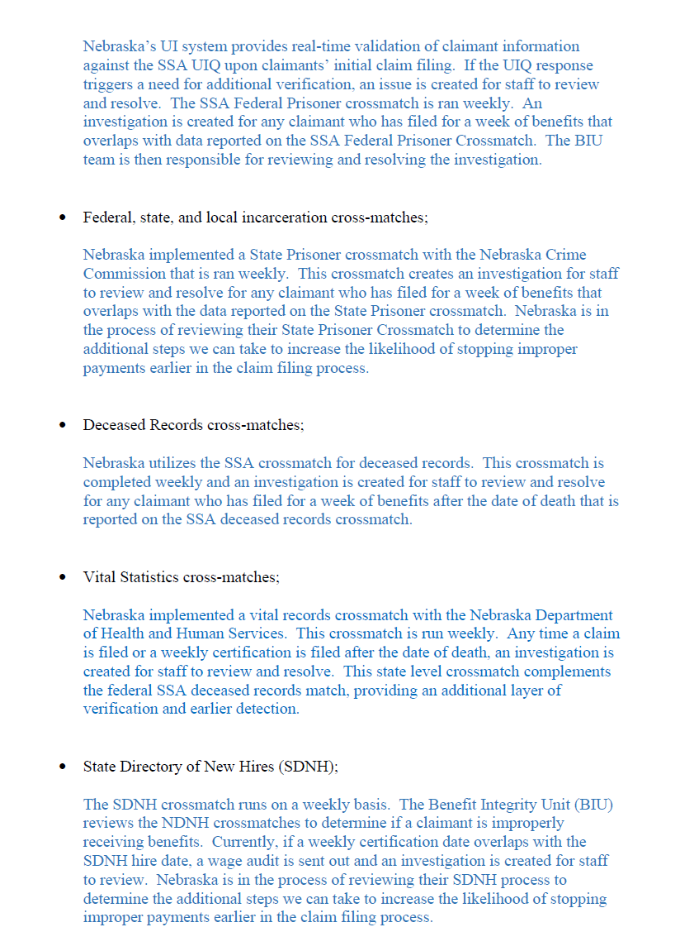
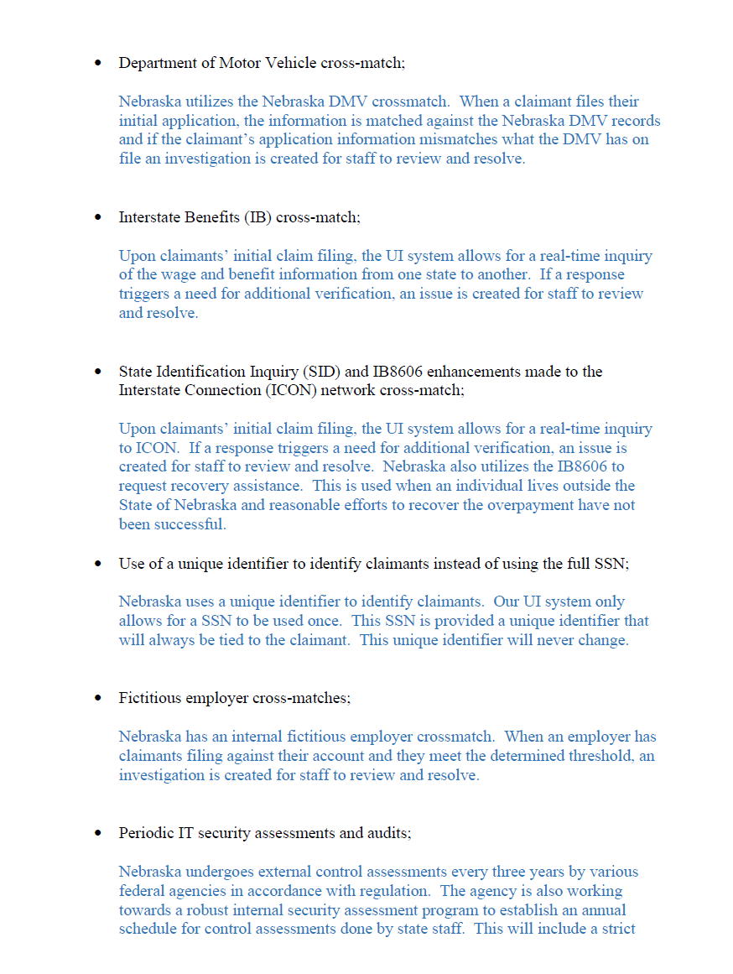
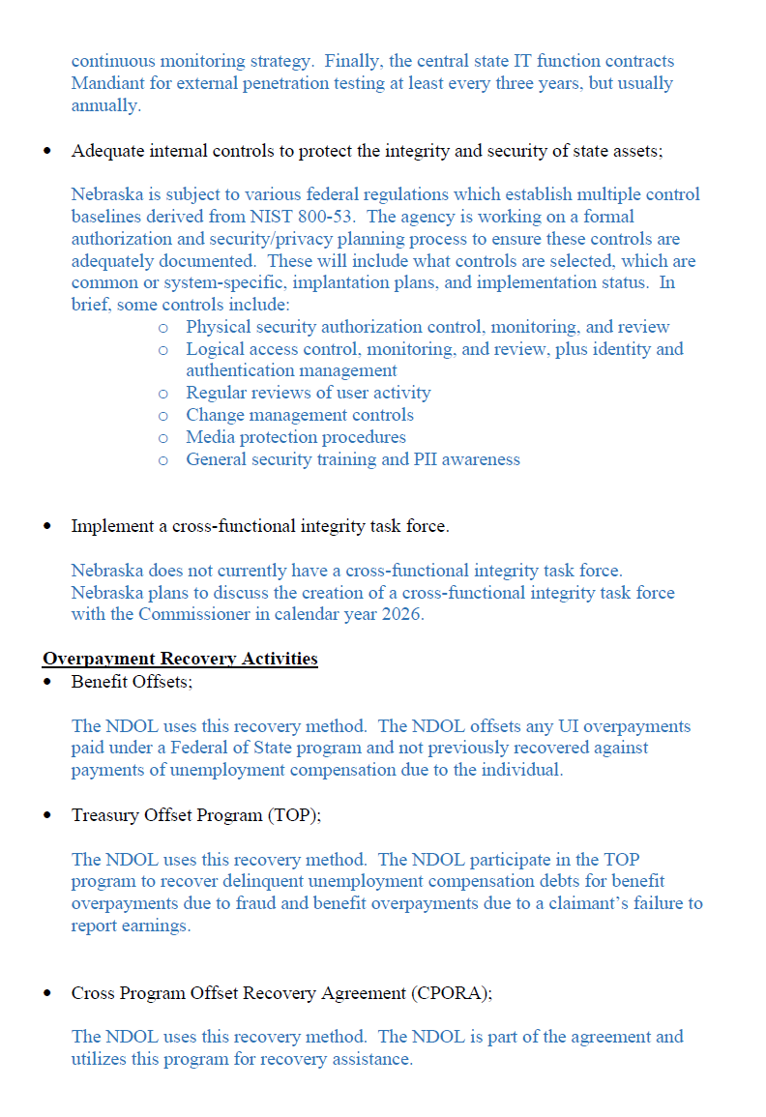
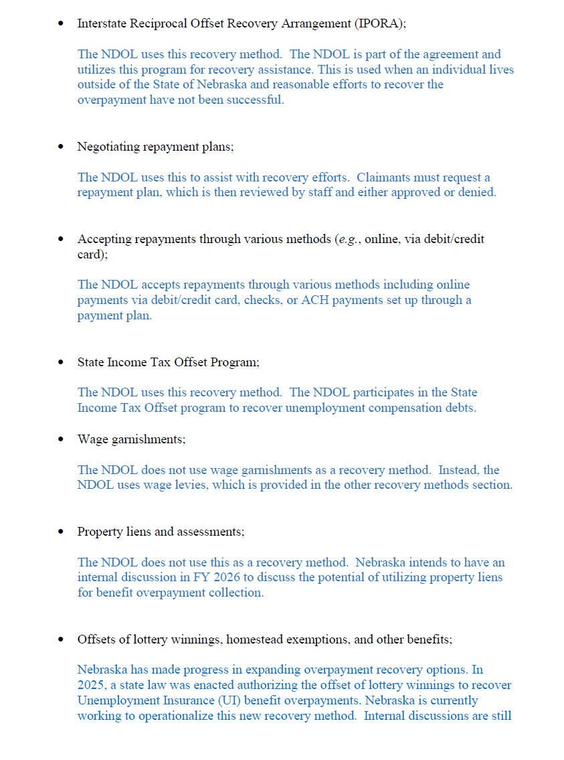
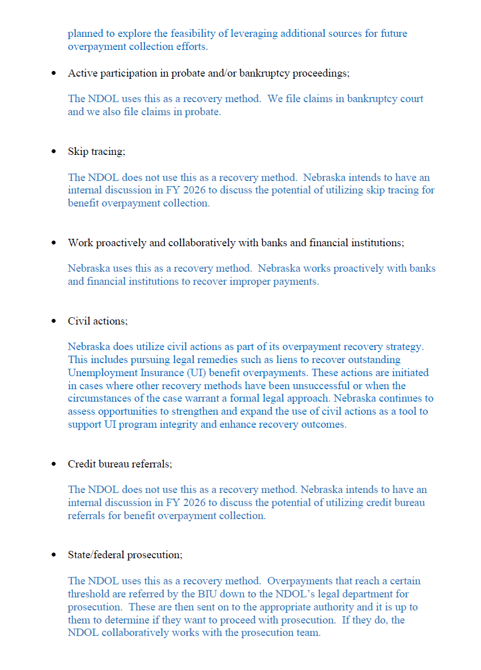
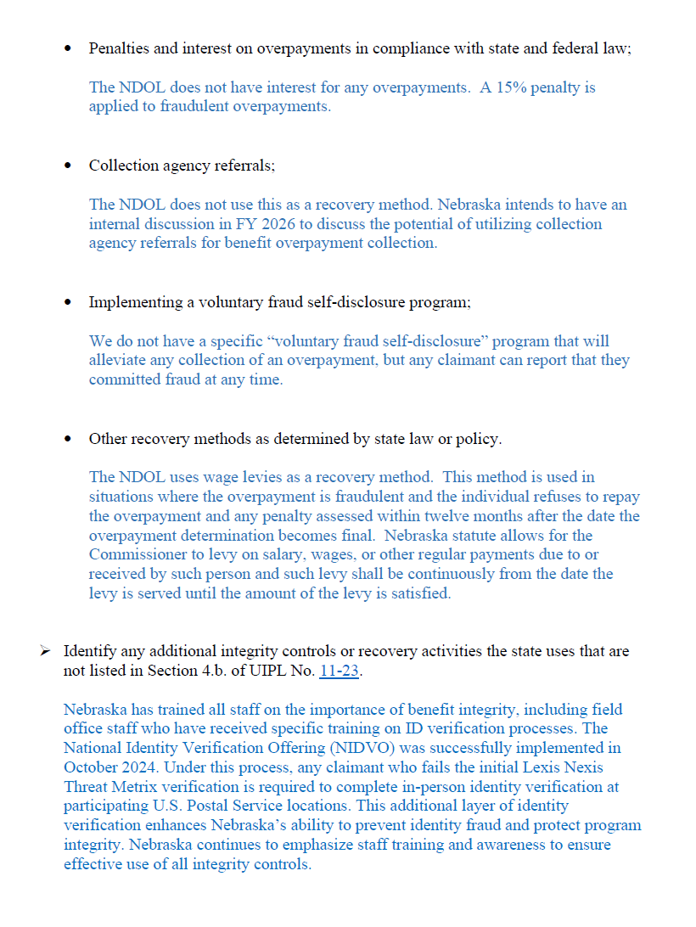
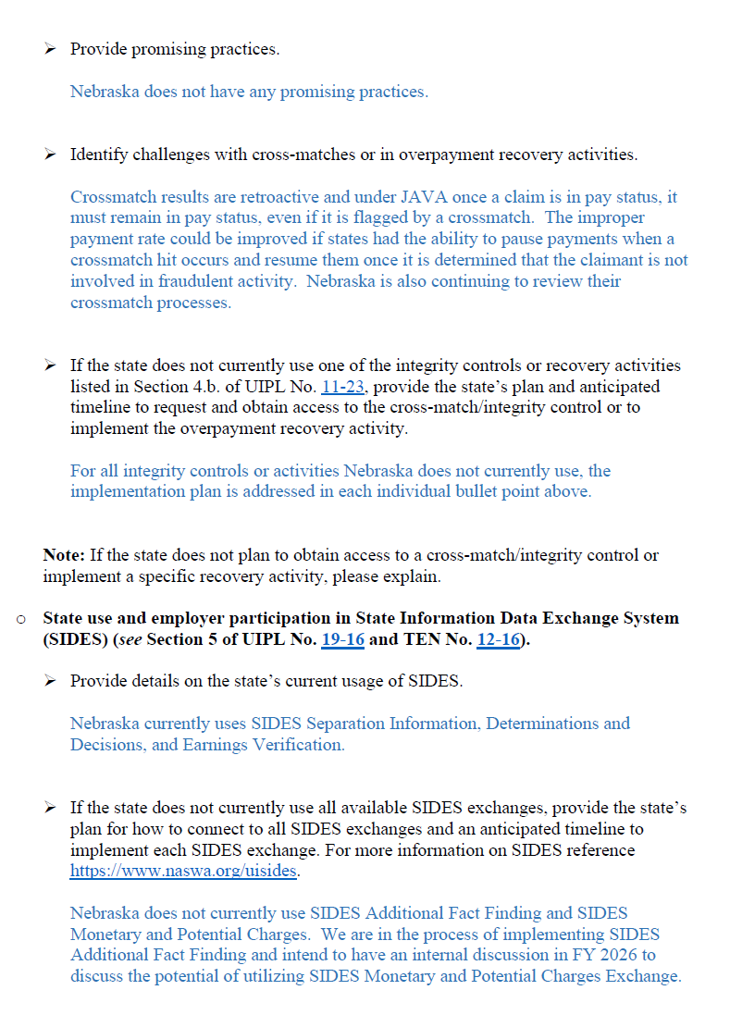

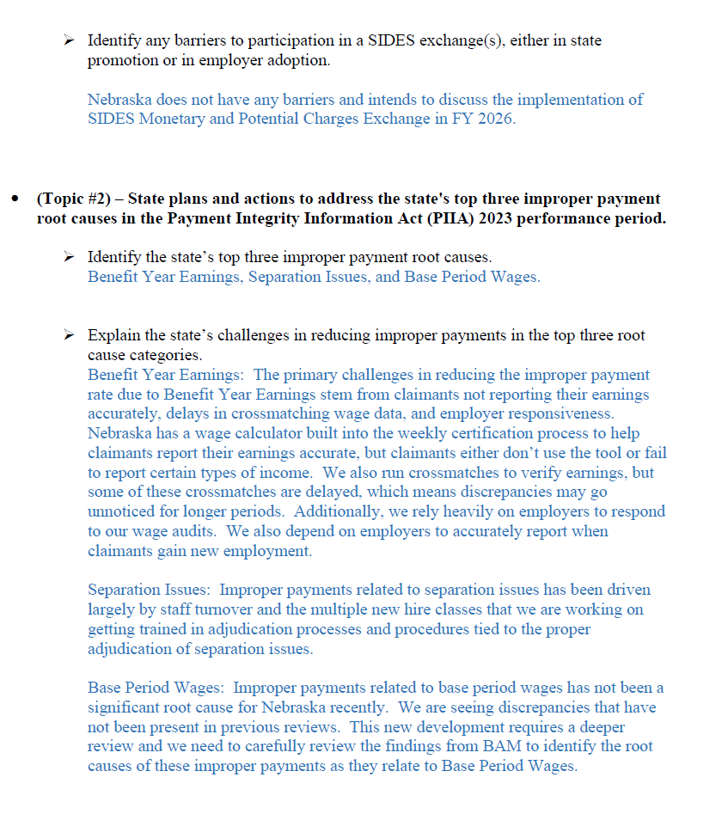
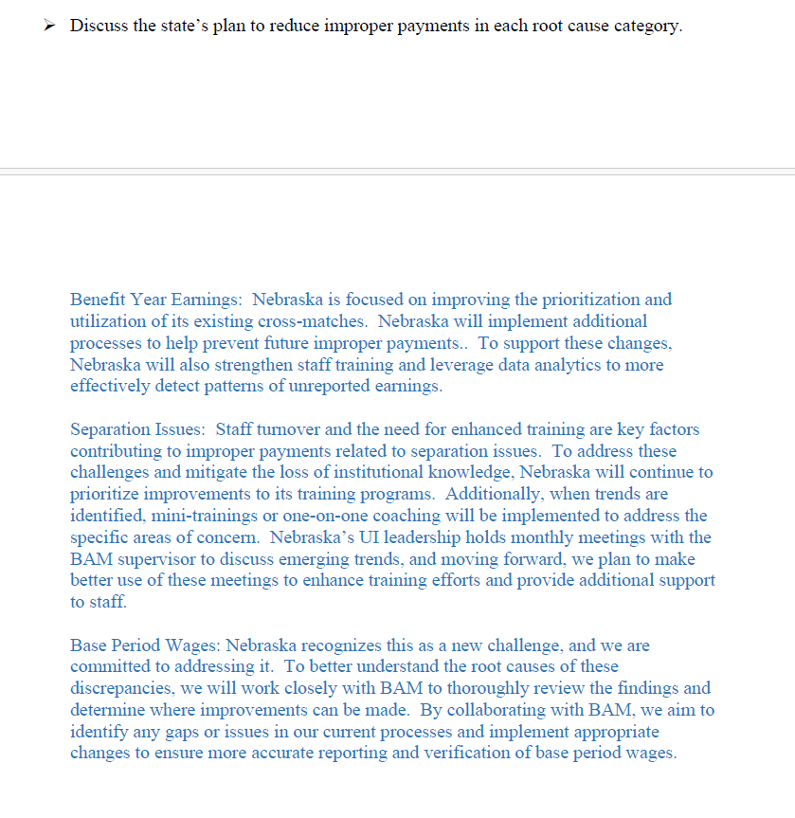
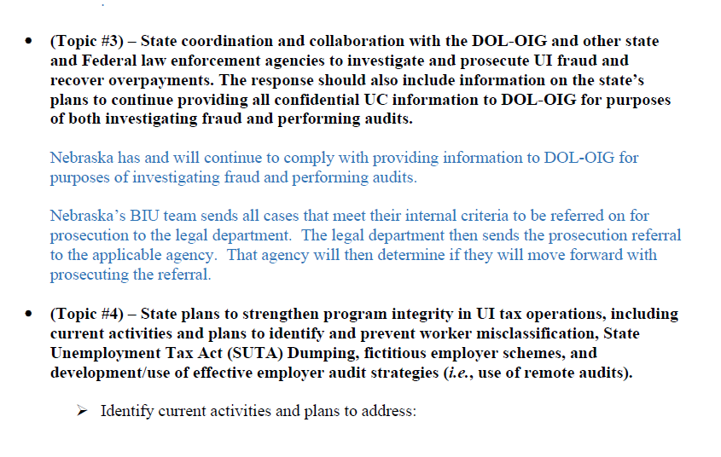
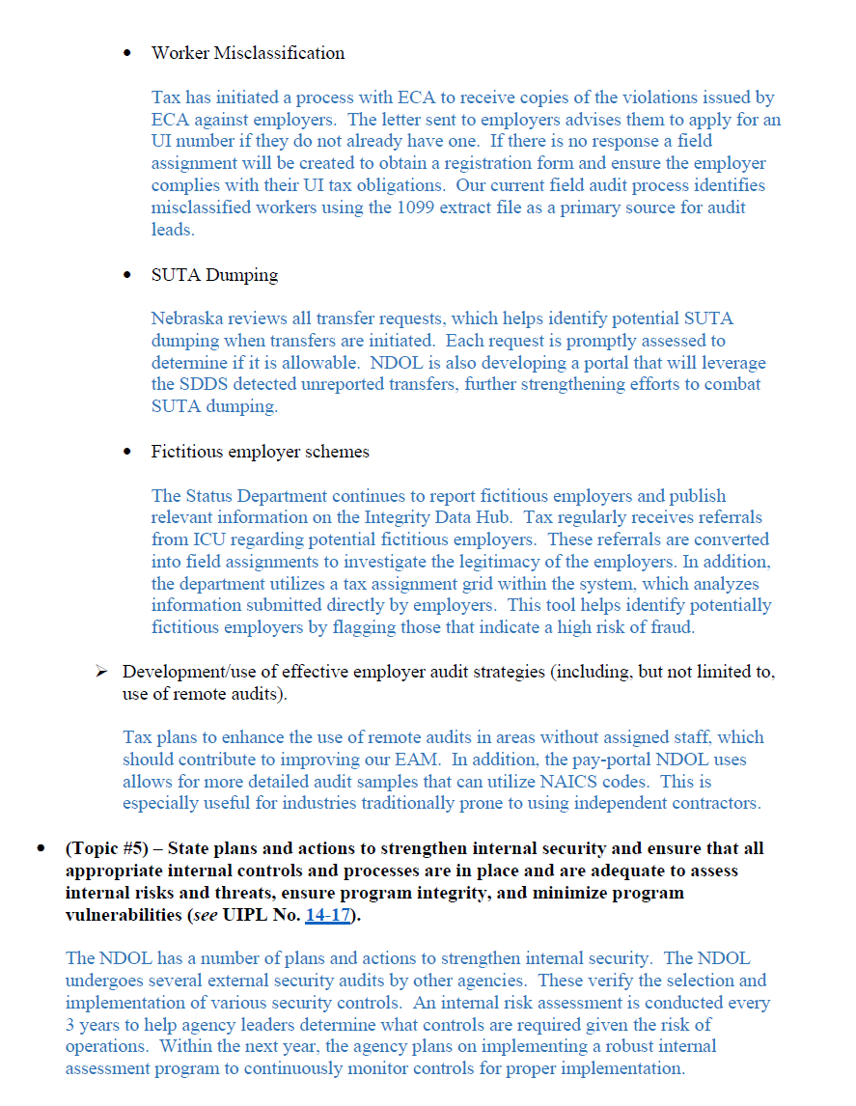
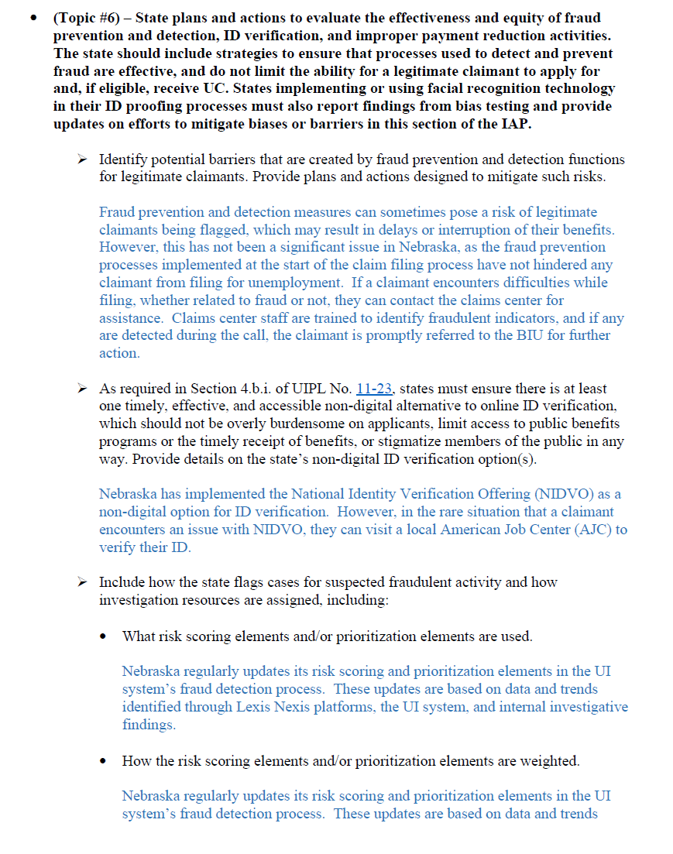
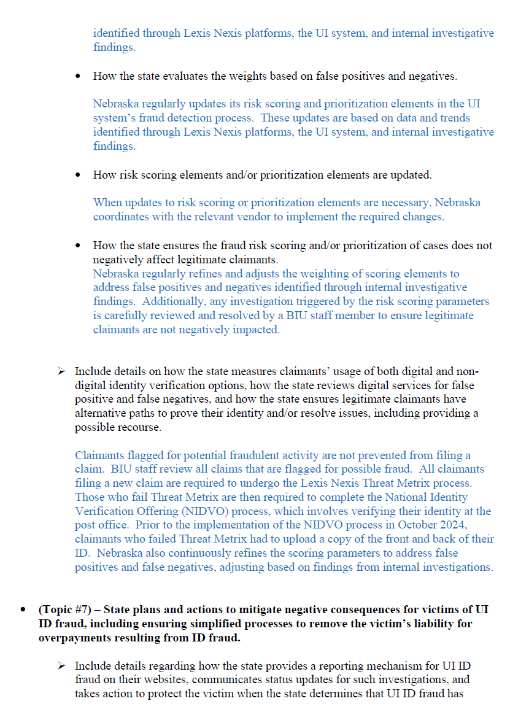
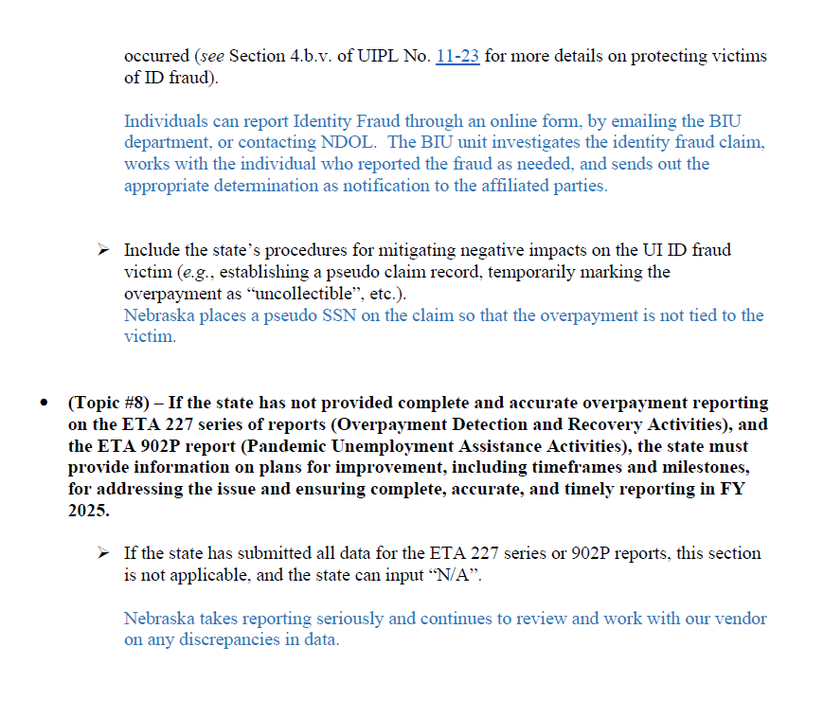

6. Organizational Chart
The organization chart must conform to the requirement for delivery of service through public employment offices, or such other designated providers as the Secretary may authorize; show the State's configuration from the Governor of the State down to the point of Employment Service and UI customer service delivery; and provide sufficient detail to show each organizational unit involved and the title of the unit manager.

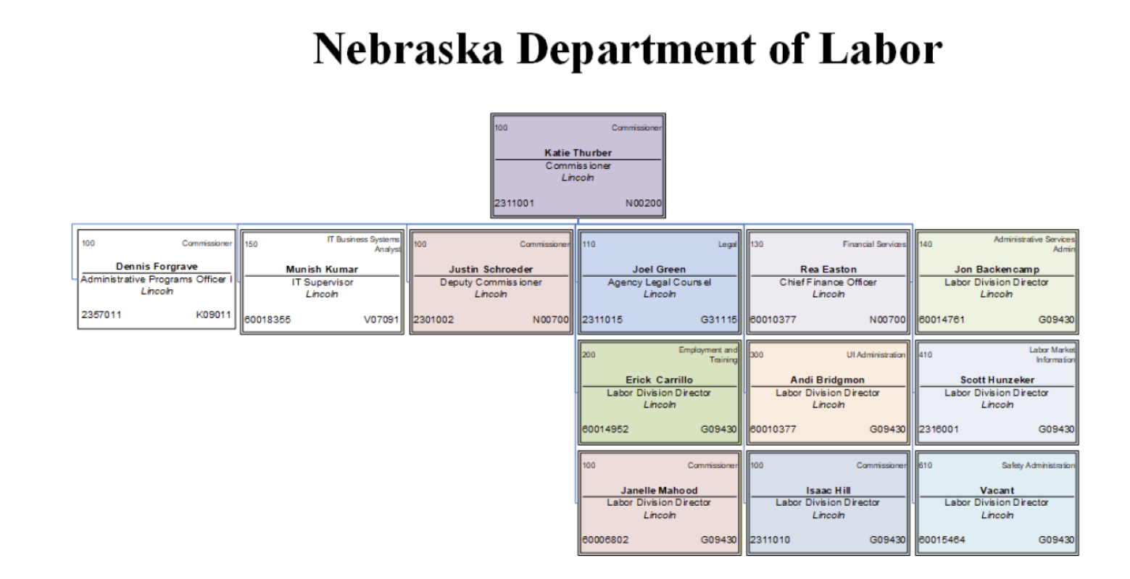
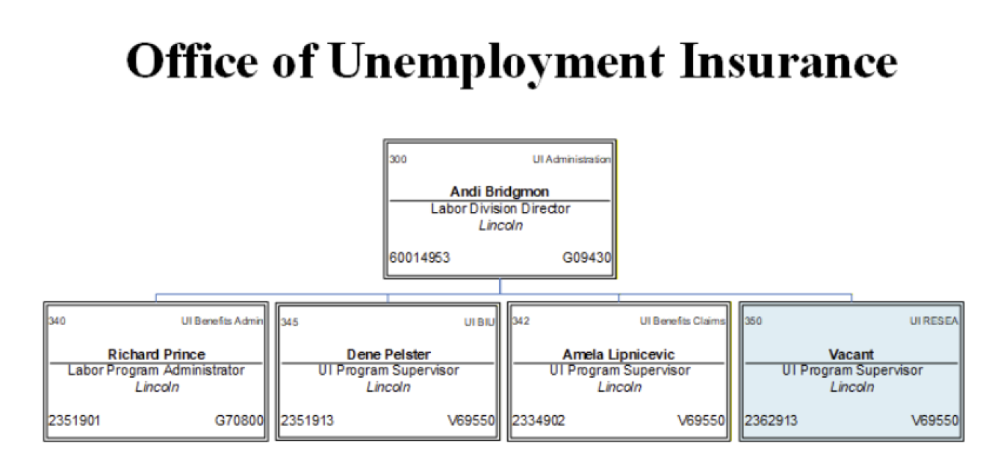
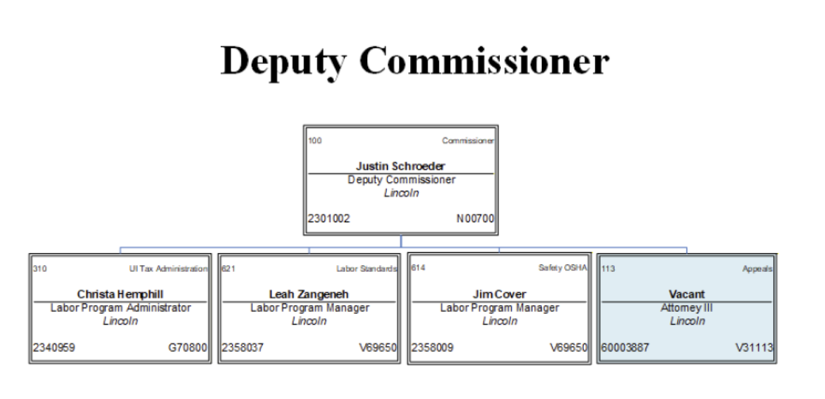
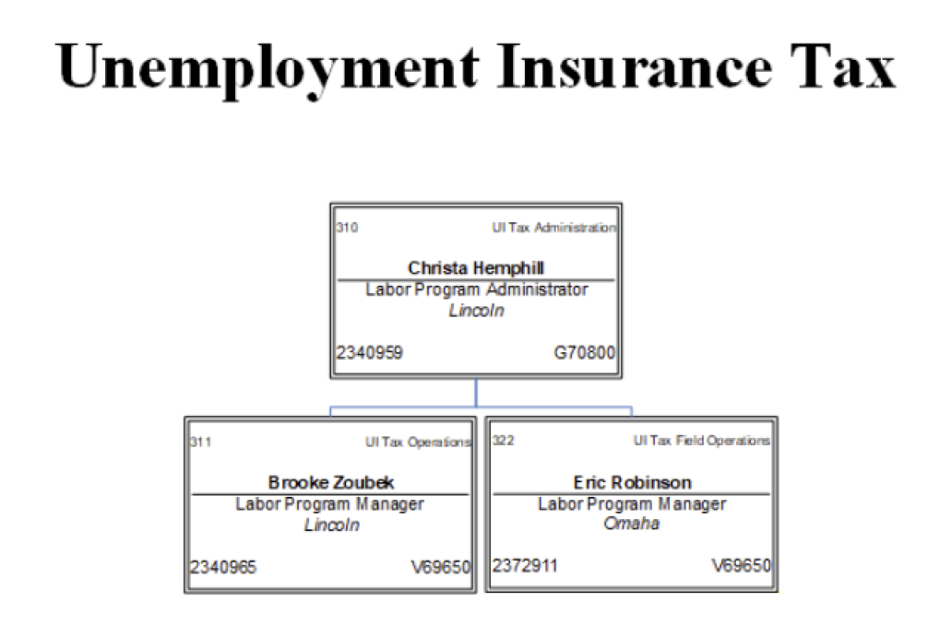

7. SQSP Signature Page
The State administrator must sign and date the SQSP Signature Page. By signing the Signature Page, the State administrator certifies that the State will comply with all the assurances and activities contained in the SQSP guidelines.
Though a State needs to submit the complete SQSP package on a 2-year cycle, there are certain documents contained in the SQSP package which are required to be submitted by States annually as part of the off-year submission. The documents which are required to be submitted annually are considered a modification to the complete SQSP submitted the previous year. Since funds for State UI operations are appropriated each year, each State is required to annually submit the transmittal letter, budget worksheets, organizational chart and the signature page. The modification may also include CAPs for new identified performance deficiencies, and any required modifications to existing CAPs.
Since the UI program is a required one-stop partner, States have the option of including UI in the Combined State Plan authorized by WIOA sec. 103.
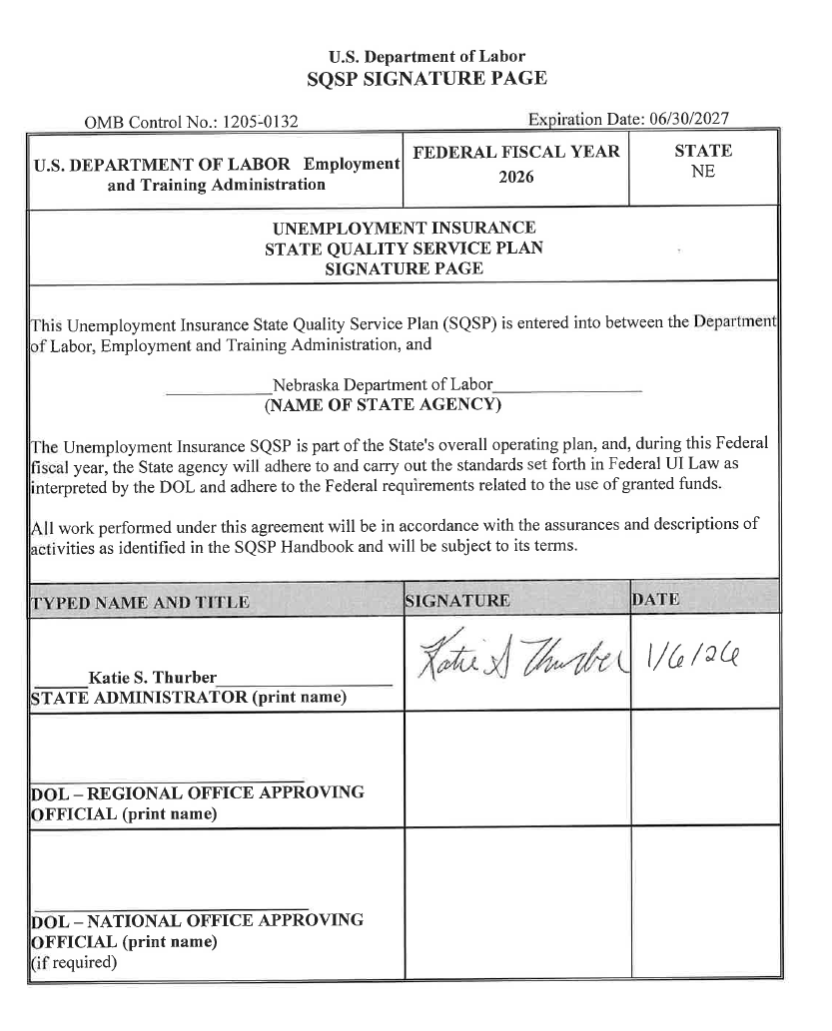
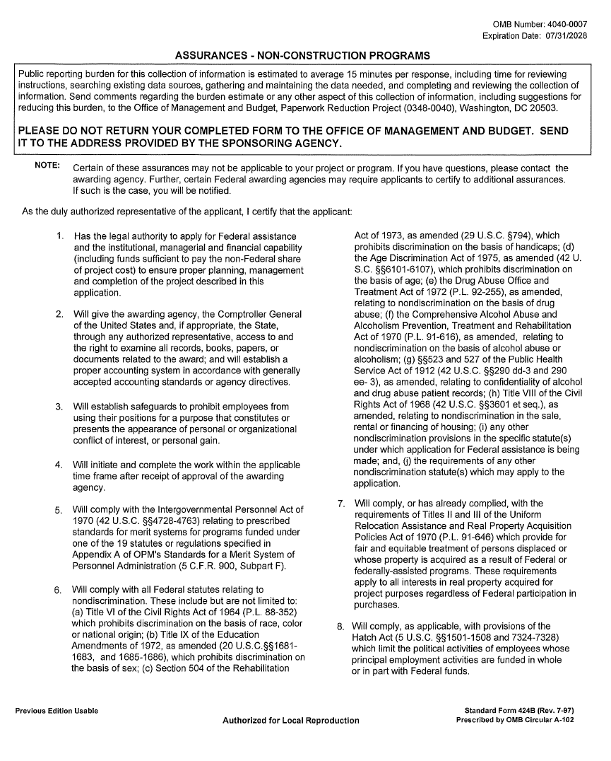
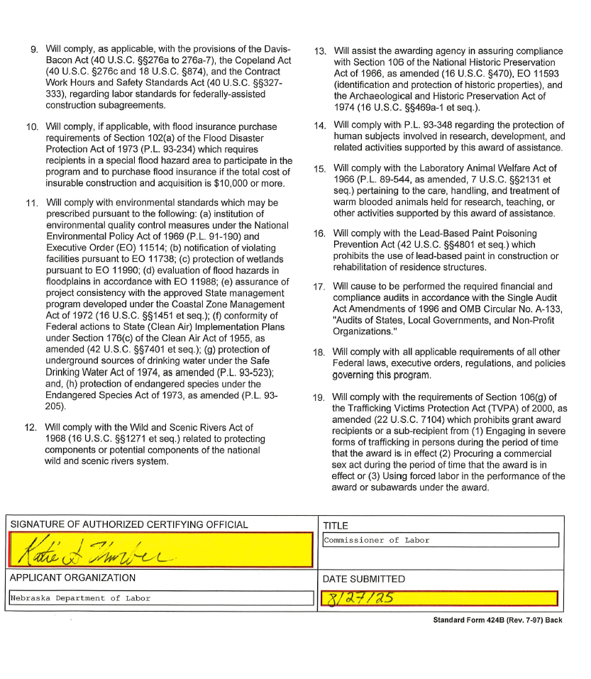

b. Requirements for States electing to include UI in the Combined State Plan
States that elect to include UI in the Combined State Plan must:

1. Submit an SQSP in the following manner depending on their timing in the SQSP cycle:

A. If a State is in the first year of their 2-year cycle, the State is required to submit the most recently approved complete SQSP package. A complete SQSP package will include the Transmittal Letter, Budget Worksheets/Forms, State Plan Narrative, CAPs (including the milestones and the completion date for each milestone), the UI IAP, Organizational Chart, and the SQSP Signature Page. One of the key goals for the UI program is to ensure that claimants are able to successfully return to work. As such, the SQSP State Plan Narrative must provide a discussion of the plan coordination with other WIOA Combined Plan programs to ensure a coordinated effort and integrated service delivery.
Nebraska is currently in the 2nd year of the two-year SQSP cycle. The modified and approved SQSP package has been uploaded.

B. If a State is in the second year of the 2-year cycle, the State is required to submit the most recently approved complete SQSP package with a modification that must include the Transmittal Letter, Budget Worksheets/Forms, Organizational Chart, and the SQSP Signature page. The modification may also include CAPs for new identified performance deficiencies, and any required modifications to existing CAPs. The CAP must list both specific milestones for key corrective actions or improvement activities, and the completion date for each milestone.
Approved submission has been uploaded.

2. Submit the required off-year SQSP components as a modification to the Combined State Plan on the same cycle as the regular SQSP process which must be approved by September 30th each year
Not applicable.

Senior Community Service Employment Program (SCSEP)

a. Economic Projections and Impact

1. Discuss long-term projections for jobs in industries and occupations in the State that may provide employment opportunities for older workers. (20 CFR 641.302(d)) (May alternatively be discussed in the economic analysis section of strategic plan.)
Section II.a. of this plan provides an overview of the long-term projections for jobs in industries and occupations with an analysis of the education, work experience, and training required. Industry sectors with the projected highest growth by numeric change include Health Care and Social Assistance; Retail Trade; Educational Services (including state and local government); Manufacturing; and Accommodation and Food Services. Table 1 below shows the top five industries in Nebraska by percent of the total workforce.
Table 1. 2022-2032 Industry Change in Employment by Percent of Total Workforce
Industry Title | 2022 Annual Employment | 2022 Percent  of Total Workforce | 2032 Projected Employment | 2032 Percent  of Total Workforce
Health Care and Social Assistance | 144,611 | 12.7% | 158,411 | 13.1%
Retail Trade | 104,927 | 9.2% | 106,806 | 8.9%
Educational Services (including state and local gov) | 103,586 | 9.1% | 106,981 | 8.9%
Manufacturing | 103,490 | 9.1% | 109,149 | 9.1%
Accommodation and Food Services | 77,630 | 6.8% | 83,848 | 7.0%
Source: Nebraska Department of Labor, NEworks, Labor Market Data
The top five occupation groups with the projected highest growth by numeric change include Office and Administrative Support Occupations, Sales and Related Occupations, Transportation and Material Moving Occupations, Management Occupations, Food Preparation and Serving Related Occupations. Table 2 below shows the top occupation groups in Nebraska by projected employment and percent of workforce.
Table 2. 2022-2032 Occupation Change in Employment by Percent of Total Workforce
Standard Occupation Classification Title | 2022 Estimated Employment | 2022 Percent of Total  Employment | 2032 Projected Employment | 2032 Percent  of Total Employment
Office and Administrative Support Occupations | 135,907 | 11.9% | 132,494 | 11.0%
Sales and Related Occupations | 100,256 | 8.8% | 102,281 | 8.5%
Transportation and Material Moving Occupations | 98,884 | 8.7% | 106,745 | 8.9%
Management Occupations | 97,164 | 8.5% | 105,284 | 8.7%
Food Preparation and Serving Related Occupations | 85,627 | 7.5% | 90,996 | 7.5%
Production Occupations | 72,271 | 6.3% | 74,630 | 6.2%
Healthcare Practitioners and Technical Occupations | 68,743 | 6.0% | 75,310 | 6.2%
Educational Instruction and Library Occupations | 64,493 | 5.6% | 66,787 | 5.5%
Business and Financial Operations Occupations | 62,386 | 5.5% | 66,675 | 5.5%
Construction and Extraction Occupations | 56,420 | 4.9% | 61,183 | 5.1%
Source: Nebraska Department of Labor, NEworks, Labor Market Data
Older Workers gain and update transferable skills for these top industries and occupations dependent upon their individual training position and any schooling or credential attainment while enrolled in SCSEP. Nebraska SCSEP host agencies provide hands-on skills training to support participants' development of job skills for meeting their goal of obtaining an unsubsidized position in the workforce. Nebraska strives to place participants in Community Service Assignments that will provide them with the skills needed for occupations with the highest percentages of the total workforce, notably, exposure to computers and software. Current placements include animal caretakers, cashiers, community and social services, data entry, food preparation, maintenance helper, janitorial, material mover/stocker, library assistant, office support/clerk and receptionist/secretary.

2. Discuss how the long-term job projections discussed in the economic analysis section of strategic plan relate to the types of unsubsidized jobs for which SCSEP participants will be trained and the types of skill training to be provided. (20 CFR 641.302(d))
Nebraska continues to see very low unemployment rates and very high labor force participation. However, businesses are still reporting difficulty recruiting and retaining quality workers. Labor shortages across the state in many industries have led businesses to expand their recruitment pools. Table 3 shows the top eight occupation groups experiencing labor shortages by comparing the number of job seekers to current openings. The majority of occupations available in Nebraska require a high school diploma or less, as shown in Table 4.
Table 3. Jobs and Candidates by Occupation Group
Occupation Group | Job Openings | Candidates | Potential Candidates Per Job Opening
Healthcare Practitioners and Technical | 6,971 | 873 | .13
Educational Instruction and Library | 1,575 | 597 | .38
Architecture and Engineering | 593 | 540 | .91
Life, Physical, and Social Science | 458 | 440 | .96
Installation, Maintenance, and Repair | 1,305 | 1,720 | 1.32
Food Preparation and Serving Related | 1,607 | 2,193 | 1.36
Farming, Fishing, and Forestry | 186 | 273 | 1.47
Healthcare Support | 1,071 | 1,440 | 1.34
Source: Nebraska Department of Labor, NEworks, Labor Market Data
Table 4. 2022-2032 Long-term Occupational Projections by Education--Nebraska Statewide
Education | 2022 Estimated Employment | 2022 Percentage of Total Workforce | 2032 Projected Employment | 2032 Percentage of Total Workforce
Doctoral or professional degree | 28,690 | 2.5% | 30,622 | 2.5%
Master's degree | 20,042 | 1.8% | 22,171 | 1.8%
Bachelor's degree | 259,525 | 22.7% | 280,952 | 23.3%
Associate's degree | 20,468 | 1.8% | 22,225 | 1.8%
Postsecondary non-degree award | 83,074 | 7.3% | 89,809 | 7.4%
Some college, no degree | 31,509 | 2.8% | 31,693 | 2.6%
High school diploma or equivalent | 421,746 | 36.9% | 439,756 | 36.5%
No formal educational credential | 277,046 | 24.3% | 288,734 | 23.9%
Source: Nebraska Department of Labor, Office of Labor Market Information, October 2025
Most occupations currently available in Nebraska require a working knowledge of computers. In an analysis of the top advertised tools and technology skills by region, Microsoft Office ranked in the top three for all regions except one, where it ranked sixth. Other skills listed included computer keyboarding, point of sale systems, HTML, and SQL. This technological experience is often underdeveloped in persons over 55 years of age. Nebraska SCSEP utilizes NEworks, which provides a number of self-paced trainings available through Alison. National Able, the National grantee operating in Nebraska, is currently utilizing the Additional Training and Supportive Services waiver to address this need through NorthStar to provide participants with digital literacy training. NorthStar provides ground up training for individuals, meeting them where they are in their learning process. Participants are also encouraged to participate in digital literacy classes in-person and online through local educational institutions and agencies. National Able is utilizing the NorthStar system delivered in the following ways:
- National Able has a pool of loaner laptops for participants to access the learning materials. Laptops will be sent to participants to complete the training and then sent back when they are done.
- Loaner laptops will be equipped with existing internet connectivity, or with a mobile hotspot to allow participants with no internet to access videos and/or live training sessions online. National Able will train some existing and hire new program aides to assist participants where it is geographically feasible to turn on the computer, access the trainings, etc. It is expected that participants will meet program aides and/or other staff in libraries where they can take advantage of the internet and potentially library computers.
- National Able will have participants go to a reserved American Job Centers computer lab(s) to participate in a scheduled live online class in a group setting where trainers can help participants get registered and access the classes they need. National Able is plotting out the AJCs in counties served.
- In locations where there are no program aides or AJCs, National Able will coordinate with local host agencies to determine if they can facilitate technology skills training for SCSEP participants.
Nebraska SCSEP host agencies provide hands-on skills training to support participants' development of job skills for meeting their goal of obtaining an unsubsidized position in the workforce. Nebraska strives to place participants in Community Service Assignments that will provide them with the skills needed for occupations with the highest percentages of the total workforce, notably, exposure to computers and software. Current placements include:
- animal caretakers
- cashiers
- community and social services
- customer service representatives
- data entry
- food preparation and service
- helpers – installation, maintenance, and repair
- janitors and cleaners
- laborers and freight, stock, and material movers
- library assistants
- office and administrative support workers
- office clerks
- receptionists
- retail
- sales and related
- secretary and administrative assistant
- stockers and order fillers
Most of the community service assignments fall within the top industries and occupations in Nebraska. Community Service assignments provide direct experience for participants to update and gain transferrable skills for employment opportunities in these leading industries and occupations. Nebraska SCSEP will continue to work towards aligning training with the top job openings in the state as much as possible.
Skills gained through Community Service Assignments may require supplementation by Nebraska SCSEP and WIOA partners to provide Nebraska employers with job-ready employees, which supports the career pathways goal and strategies described in Sections II.b.2. and II.c of this plan. Nebraska SCSEP will partner with local area WIOA partners to assist participants with credential attainment for in-demand occupations. These industries may not have comparable host agency assignments, but placements offering transferable skill gains will be sought and OJE placements will be promoted upon completion of the credential.

3. Discuss current and projected employment opportunities in the State (such as by providing information available under §15 of the Wagner-Peyser Act (29 U.S.C. 491-2) by occupation), and the types of skills possessed by eligible individuals. (20 CFR 641.325(c))
The current and projected employment opportunities in Nebraska are discussed in the economic analysis section of the strategic plan portion of the Nebraska Combined State Plan. Section II.a.1.A. of this plan identifies education and job training requirements for the top 20 emerging demand occupations in the state. This section breaks down the top five occupations of the top ten occupational groups by 2030 projected employment numbers.
Office and Administrative Support
This occupational group includes titles that fall under Office and Administrative Support Occupations; Supervisors of Office and Administrative Support Workers; Communications Equipment Operators; Financial Clerks; Information and Record Clerks; Material Recording, Scheduling, Dispatching, and Distributing Workers; Secretaries and Administrative Assistants; Other Office and Administrative Support Workers. Most of these titles require only a high school diploma or equivalent with two requiring some college (Bookkeeping, Accounting, and Auditing and Order Clerks), two requiring an Associate’s degree (Human Resources Assistants, Except Payroll and Timekeeping, and Desktop Publishers) and two required a Bachelor’s degree (Statistical Assistants and Proofreaders and Copy Markers). Most also require no work experience, with two requiring less than five years (First-Line Supervisors of Office and Administrative Support Workers and Executive Secretaries and Executive Administrative Assistants). Long-term on-the-job training is only required for one title (Court, Municipal, and License Clerks), with Moderate-term on-the-job training required for 15 titles, Short-term on-the-job training required for 33 titles, and no on-the-job training required for five titles. The top five occupations under this category with the highest projected employment and corresponding requirements are shown in Table 5. All of these occupations are well-suited for SCSEP participants interested in an office environment due to the education and work experience requirements.
Table 5. Education, Work Experience, and Job Training required for Top Five Occupations by Projected Employment for Office and Administrative Support occupational group
Standard Occupation Classification Title | 2032 Projected Employment | Education | Work Experience | Job Training
Secretaries and Administrative Assistants, Except Legal, Medical, and Executive | 17,981 | High school diploma or equivalent | None | Short-term on-the-job training
Customer Service Representatives | 17,608 | High school diploma or equivalent | None | Short-term on-the-job training
Office Clerks, General | 12,642 | High school diploma or equivalent | None | Short-term on-the-job training
Bookkeeping, Accounting, and Auditing Clerks | 12,575 | Some college, no degree | None | Moderate-term on-the-job training
First-Line Supervisors of Office and Administrative Support Workers | 10,060 | High school diploma or equivalent | Less than 5 years | None
Source: Nebraska Department of Labor, NEworks, Labor Market Data
Table 6 provides the top advertised personal skills, job skills, and tools and technology skills for the top five occupations in Office and Administrative Support. Active Listening and Speaking skills are the most prevalent personal (soft) skills required in postings listed on the Nebraska Labor Exchange site (NEworks), with Customer Service appearing first as an advertised job skill for all five occupations. These are typical skills gained during Community Services Assignments. Notably, Microsoft Office is among the top five advertised tools and technology skills for all five occupations. Nebraska SCSEP and National Able provide exposure to Microsoft Word through Alison courses and NorthStar.
Table 6. Top Personal Skills, Advertised Job Skills, and Advertised Tools and Technology Skills by Occupation for Office and Administrative Support occupational group
Occupation | Personal Skills | Advertised Job Skills | Advertised Tools and Technology
Secretaries and Administrative Assistants, Except Legal, Medical, and Executive | Speaking  Active Listening  Reading Comprehension  Writing  Service Orientation | Customer service  Word processing  Answer phone calls  Bookkeeping  Proofreading skills | Microsoft (MS) Office  Microsoft PowerPoint  Microsoft Word  Microsoft Excel  Hypertext markup language (HTML)
Customer Service Representatives | Active Listening  Service Orientation  Speaking  Reading Comprehension  Critical Thinking | Customer Service  Inventory control  Unloading trucks  Mops floors  Taking orders | Cash register  Microsoft (MS) Office  Canes  Microsoft Word  Microsoft PowerPoint
Office Clerks, General | Active listening  Reading comprehension  Speaking  Writing  Critical thinking | Customer service  Ensure customer satisfaction  Facilitate travel arrangements  Record keeping  Cleanliness of store | Cash register  Microsoft (MS) Office  Box Cutter  Cash drawers  Shrink wrap machine
Bookkeeping, Accounting, and Auditing Clerks | Mathematics  Critical Thinking  Reading Comprehension  Active Listening  Writing | Bookkeeping  Customer service  Purchase Orders  Account reconciliations  Process payments | Accounting software  Microsoft (MS) Office  Microsoft Excel  Contract Management software  Motor vehicles
First-Line Supervisors of Office and Administrative Support Workers | Coordination  Social Perceptiveness  Monitoring  Speaking  Active Listening | Customer service  Bookkeeping  Providing information  Inventory control  Performance appraisals | Microsoft (MS) Office  Microsoft PowerPoint  Microsoft Word  Balers  Fax Machine
Source: Nebraska Department of Labor, NEworks, Labor Market Data
Transportation and Material Moving
This occupational group includes titles that fall under Supervisors of Transportation and Material Moving Workers, Air Transportation Workers, Motor Vehicle Operators, Rail Transportation Workers, Water Transportation Workers, Other Transportation Workers, and Material Moving Workers. Most of these titles require no formal education or only a high school diploma or equivalent with two requiring a postsecondary non-degree award (Heavy and Tractor-Trailer Truck Drivers and Captains, Mates, and Pilots of Water Vessels), one requiring an Associate’s degree (Air Traffic Controllers) and one required a Bachelor’s degree (Airline Pilots, Copilots, and Flight Engineers). Most also require no work experience, with seven requiring less than five years. Long-term on-the-job training is only required for two titles (Air Traffic Controllers and Airfield Operations Specialists), with Moderate-term on-the-job training required for 15 titles, Short-term on-the-job training required for 19 titles, and no on-the-job training required for three titles (Aircraft Cargo Handling Supervisors; Firstline Supervisors of Transportation and Material Moving Workers, excluding Aircraft Cargo Handling Supervisors; and Captains, Mates, and Pilots of Water Vessels). The top five occupations under this category with the highest projected employment and corresponding requirements are shown in Table 7.
Table 7. Education, Work Experience, and Job Training required for Top Five Occupations by Projected Employment for Transportation and Material Moving occupational group
Standard Occupation Classification Title | 2032 Projected Employment | Education | Work Experience | Job Training
Heavy and Tractor-Trailer Truck Drivers | 28,848 | Postsecondary non-degree award | None | Short-term on-the-job training
Laborers and Freight, Stock, and Material Movers, Hand | 19,444 | No formal educational credential | None | Short-term on-the-job training
Stockers and Order Fillers | 16,067 | High school diploma or equivalent | None | Short-term on-the-job training
Light Truck Drivers | 5,865 | High school diploma or equivalent | None | Short-term on-the-job training
Cleaners of Vehicles and Equipment | 5,530 | No formal educational credential | None | Short-term on-the-job training
Source: Nebraska Department of Labor, NEworks, Labor Market Data
Table 8 provides the top advertised personal skills, job skills, tools and technology skills, and typical job skills for the top five occupations in Transportation and Material Moving. Operations and Control is the most prevalent personal (soft) skill required in postings listed on the Nebraska Labor Exchange site (NEworks), with Customer Service appearing first as an advertised job skill for all five occupations. These are typical skills gained during Community Services Assignments. Although many positions within this occupation group require physical labor, there are quite a few that are considered to be lighter duty, including driving only positions and positions that involve operation of equipment.
Table 8. Top Personal Skills, Advertised Job Skills, and Advertised Tools and Technology Skills by Occupation for Transportation and Material Moving occupational group
Occupation | Personal Skills | Advertised Job Skills | Advertised Tools and Technology
Heavy and Tractor-Trailer Truck Drivers | Operation and Control  Operations Monitoring  Monitoring  Critical Thinking  Speaking | Customer Service  Leadership development  Deliver Product  Deliver Product to customers  Repair maintenance | Motor Vehicles  Hand Truck  Forklift  Delivery Truck  Straight Truck
Laborers and Freight, Stock, and Material Movers, Hand | Coordination  Active Listening  Speaking  Reading Comprehension  Monitoring | Customer Service  Inventory Control  Operate Forklift  Preventative Maintenance  Regulatory Compliance | Forklift  Pallet Jack  Personal Protective equipment  Safety glasses  Face shield
Stockers and Order Fillers | Active listening  Reading comprehension  Service orientation  Speaking  monitoring | Customer service  Inventory management  Stocking shelves  Cycle counting  Inventory control | Forklift  Pallet Jack  Cash register  Point of Sale (POS) systems  Balers
Light Truck Drivers | Reading Comprehension  Active Listening  Speaking  Monitoring  Operation and Control | Customer service  Leadership development  Delivery merchandise  Fleet management  General maintenance | Delivery truck  Motor vehicles  Personal protective equipment  Hand truck  Hand cart
Cleaners of Vehicles and Equipment | Operation and control  Quality control analysis  Operations monitoring  Time management  Monitoring | Customer service  Vacuum floors  Pressure washing  Employee referrals  Dusting | Detail brushes  Pressure washer  Motor vehicles  Boats  Steam Cleaning Equipment
Source: Nebraska Department of Labor, NEworks, Labor Market Data
Sales and Related
This occupational group includes titles that fall under Supervisors of Sales Workers; Retail Sales Workers; Sales Representatives, Services; Sales Representatives, Wholesale and Manufacturing; Other Sales and Related Workers. Most of these titles require no formal education or only a high school diploma or equivalent with three requiring a Bachelor’s degree (Securities, Commodities, and Financial Services Sales Agents; Sales Representatives, Wholesale and Manufacturing, Technical and Scientific Products; Sales Engineers). Most also require no work experience, with three requiring less than five years (First-line Supervisors of Retail Sales Workers, First-line Supervisors of Non-Retail Sales Workers, Real Estate Brokers). Moderate-term on-the-job training is required for 10 titles, Short-term on-the-job training required for 7 titles, and no on-the-job training required for four titles (First-line Supervisors of Retail Sales Workers; First-line Supervisors of Non-Retail Sales Workers; Real Estate Brokers; and Sales and Related Workers, All Other). The top five occupations under this category with the highest projected employment and corresponding requirements are shown in Table 9.
Table 9. Education, Work Experience, and Job Training required for Top Five Occupations by Projected Employment for Sales and Related occupational group
Standard Occupation Classification Title | 2032 Projected Employment | Education | Work Experience | Job Training
Cashiers | 22,544 | No formal educational credential | None | Short-term on-the-job training
Retail Salespersons | 22,482 | No formal educational credential | None | Short-term on-the-job training
Sales Representatives, Wholesale and Manufacturing, Except Technical and Scientific Products | 10,434 | High school diploma or equivalent | None | Moderate-term on-the-job training
First-Line Supervisors of Retail Sales Workers | 8,639 | High school diploma or equivalent | Less than 5 years | None
Insurance Sales Agents | 8,355 | High school diploma or equivalent | None | Moderate-term on-the-job training
Source: Nebraska Department of Labor, NEworks, Labor Market Data
Table 10 provides the top advertised personal skills, job skills, tools and technology skills, and typical job skills for the top five occupations in Sales and Related. Active Listening and Speaking skills are the most prevalent personal (soft) skills required in postings listed on the Nebraska Labor Exchange site (NEworks), with Customer Service appearing first as an advertised job skill for all five occupations. These are typical skills gained during Community Services Assignments. While some of the requirements of these positions require physical capabilities such as standing for long periods of time, these requirements are easy to accommodate for most employers.
Table 10. Top Personal Skills, Advertised Job Skills, and Advertised Tools and Technology Skills by Occupation for Sales and Related occupational group
Occupation | Personal Skills | Advertised Job Skills | Advertised Tools and Technology
Cashiers | Service orientation  Social perceptiveness  Speaking  Active listening  Reading comprehension  Critical thinking | Customer service  Cash handling  Retirement planning  Taking orders  Inventory management | Cash register  Canes  Handheld scanners  Cash drawers  Automatic teller machine (ATM)
Retail Salespersons | Persuasion  Service Orientation  Active listening  Speaking  Negotiation | Customer service  Meet and exceed sales goals  Dusting  Mops floors  Stand for long periods of time | Cash register  Point of sale (POS) systems  Forklift  Pallet Jack  Balers
Sales Representatives, Wholesale and Manufacturing, Except Technical and Scientific Products | Active listening  Speaking  Social perceptiveness  Persuasion  Negotiation | Revenue growth  Strategic planning  Customer service  Interpreting the data  Product rotation | Funnels  Smart phones  Cell Phone  Microsoft (MS) Office  Center TRACON automation systems (CTAS)
First-Line Supervisors of Retail Sales Workers | Active listening  Speaking  Service orientation  Critical thinking  Monitoring | Customer service  Inventory control  Cash handling  Inventory management  Bookkeeping | Cash register  Point of sale (POS) systems  Microsoft (MS) Office  Cell phone  Forklift
Insurance Sales Agents | Reading comprehension  Active listening  Speaking  Critical thinking  Writing | Customer service  Recommend appropriate products  Risk management  Cold calling  Consultative selling | Microsoft (MS) Office  Microsoft PowerPoint  Microsoft Word  Zoom  Adobe Systems Adobe Acrobat software
Source: Nebraska Department of Labor, NEworks, Labor Market Data
Food Preparation and Serving Related
This occupational group includes titles that fall under Supervisors of Food Preparation and Serving Workers, Cooks and Food Preparation Workers, Food and Beverage Serving Workers, Other Food Preparation and Serving Related. Most of these titles require no formal education, with two requiring a high school diploma or equivalent (Chefs and Head Cooks and First-line Supervisors of Food Preparation and Serving Workers) and one requiring a postsecondary non-degree award (Cooks, Private Household). Most also require no work experience, with three requiring less than five years (First-line Supervisors of Food Preparation and Serving Workers; Cooks, Restaurant; and Cooks, Private Household) and one requiring five years (Chefs and Head Cooks). Moderate-term on-the-job training is only required for two titles (Cooks, Restaurant; Cooks, All Other), Short-term on-the-job training is required for 12 titles, and no on-the-job training is required for three titles (Chefs and Head Cooks; First-line Supervisors of Food Preparation and Serving Workers; and Cooks, Private Household). The top five occupations under this category with the highest projected employment and corresponding requirements are shown in Table 11.
Table 11. Education, Work Experience, and Job Training required for Top Five Occupations by Projected Employment for Food Preparation and Serving Related occupational group
Standard Occupation Classification Title | 2032 Projected Employment | Education | Work Experience | Job Training
Fast Food and Counter Workers | 28,119 | No formal educational credential | None | Short-term on-the-job training
Waiters and Waitresses | 13,779 | No formal educational credential | None | Short-term on-the-job training
Bartenders | 7,843 | No formal educational credential | None | Short-term on-the-job training
First-Line Supervisors of Food Preparation and Serving Workers | 7,879 | High school diploma or equivalent | Less than 5 years | None
Food Preparation Workers | 6,694 | No formal educational credential | None | Short-term on-the-job training
Source: Nebraska Department of Labor, NEworks, Labor Market Data
Table 12 provides the top advertised personal skills, job skills, tools and technology skills, and typical job skills for the top five occupations in Food Preparation & Serving Related. Active Listening is the most prevalent personal (soft) skill required in postings listed on the Nebraska Labor Exchange site (NEworks), with Customer Service appearing first or second as an advertised job skill for all five occupations. These are typical skills gained during Community Services Assignments.
Table 12. Top Personal Skills, Advertised Job Skills, and Advertised Tools and Technology Skills by Occupation for Food Preparation and Serving Related occupational group
Occupation | Personal Skills | Advertised Job Skills | Advertised Tools and Technology
Fast Food and Counter Workers | Active listening  Social perceptiveness  Coordination  Service orientation  Monitoring | Customer service  Food preparation  Leadership development  Empty trash  Vacuum floors | Cash Register  Freezers  Can openers  Slicers  Canes
Waiters and Waitresses | Service orientation  Active listening  Speaking  Social perceptiveness  Coordination | Customer service  Taking orders  Serving food  Process payments  Welcome patrons | Point of sale (POS) systems  Spray Bottle  Coffee Maker  Keyboard  Cash register
Bartenders | Active listening  Service orientation  Social perceptiveness  Coordination  Persuasion | Customer service  Welcome patrons  Stand for long periods of time  Cash handling  Guest service calls | Point of sale (POS) systems  Cash register  Freezers  Coffee Maker  Automatic teller machine (ATM)
First-Line Supervisors of Food Preparation and Serving Workers | Management of Personnel Resources  Coordination  Monitoring  Speaking  Active Listening | Customer service  Restaurant management  Inventory management  Cash handling  Food preparation | Microsoft (MS) Office  Point of sale (POS) systems  Personal protective equipment  Scoops  Balers
Food Preparation Workers | Active listening  Service orientation  Time management  Coordination  Speaking | Customer service  Divide in all units of measure  Record keeping  Financial management  Clean dishes | Slicers  Steamers  Can openers  Food processors  Brooms
Source: Nebraska Department of Labor, NEworks, Labor Market Data
Management Occupations
This occupational group includes titles that fall under Top Executives; Advertising, Marketing, Promotions, Public Relations, and Sales Managers; Operations Specialties Managers; and Other Management Occupations. Most of these titles require a Bachelor’s Degree, with seven requiring a High School Diploma or Equivalent, two requiring a Master’s Degree (Education Administrator, Elementary and Secondary School and Education Administrators, Postsecondary), and one requiring an Associate’s degree (Funeral Home Managers). Most require 5 years or more of work experience, with 17 requiring less than five years, and one requiring no work experience (Construction Managers). Most titles do not require job training. Moderate-term on-the-job training is only required for two titles (Postmasters and Mail Superintendents and Construction Managers). The top five occupations under this category with the highest projected employment and corresponding requirements are shown in Table 13.
Table 13. Education, Work Experience, and Job Training required for Top Five Occupations by Projected Employment for Management Occupations occupational group
Standard Occupation Classification Title | 2032 Projected Employment | Education | Work Experience | Job Training
General and Operations Managers | 23,995 | Bachelor's degree | 5 years or more | None
Farmers, Ranchers, and Other Agricultural Managers | 13,572 | High School Diploma or Equivalent | 5 years or more | None
Managers, All Other | 8,732 | Bachelor's degree | Less than 5 years | None
Financial Managers | 6,317 | Bachelor's degree | 5 years or more | None
Construction Managers | 5,247 | Bachelor's degree | None | Moderate-term on-the-job training
Source: Nebraska Department of Labor, NEworks, Labor Market Data
Table 14 provides the top advertised personal skills, job skills, tools and technology skills, and typical job skills for the top five occupations in Management Occupations. Crticial Thinking is the most prevalent personal (soft) skill required in postings listed on the Nebraska Labor Exchange site (NEworks). Notably, Microsoft Office is among the top five advertised tools and technology skills for all five occupations.
Table 14. Top Personal Skills, Advertised Job Skills, and Advertised Tools and Technology Skills by Occupation for Management Occupations occupational group
Occupation | Personal Skills | Advertised Job Skills | Advertised Tools and Technology
General and Operations Managers | Monitoring  Speaking  Active listening  Reading comprehension  Critical thinking | Customer service  Inventory management  Financial management  Expense control  Cash handling | Microsoft (MS) Office  Cash register  Dollies  Microsoft PowerPoint  Brooms
Farmers, Ranchers, and Other Agricultural Managers | Critical thinking  Active listening  Reading comprehension  Speaking  Management of personnel resources | Preventative maintenance  Business planning  Inventory management  Land management  Watering | Loaders  Sprayers  Tractors
Managers, All Other | There is no data available for Managers, All Other. | Customer Service  Retaining clients  Inventory control  Leadership development  Inventory management | Microsoft (MS) Office  Microsoft PowerPoint  Artificial Intelligence software  Forklift  Microsoft Word
Financial Managers | Reading comprehension  Active listening  Speaking  Critical thinking  Writing | Customer service  Developing new business  Inventory management  Cash handling  Business planning | Probes  Microsoft (MS) Office  Microsoft PowerPoint  Structured query language (SQL)  Automatic teller machine (ATM)
Construction Managers | Judgment and Decision Making  Management of Personnel Resources  Time Management  Active Listening  Critical Thinking | Customer service  Record keeping  Maintains records  Manage multiple projects  On-time delivery | Microsoft (MS) Office  Site Manager  Hard Hat  Goggles  Keyboard
Source: Nebraska Department of Labor, NEworks, Labor Market Data
Healthcare Practitioners and Technical
This occupational group includes titles that fall under Health Diagnosing and Treating Practitioners, Health Technologists and Technicians, and Other Healthcare Practitioners and Technical Occupations. Three of these titles require a high school diploma or equivalent (Pharmacy Technicians; Opticians, Dispensing; and Hearing Aid Specialists) with seven requiring a postsecondary non-degree award, ten requiring an Associate’s degree, seven requiring a Bachelor’s degree, nine requiring a Master’s degree and 19 requiring a Doctoral or professional degree. Most also require no work experience, with two requiring less than five years (Psychiatric Technicians and Magnetic Resonance Imaging Technologists). Long-term on-the-job training is only required for one title (Opticians, Dispensing), with moderate-term on-the-job training required for two titles (Pharmacy Technicians and Hearing Aid Specialists), short-term on-the-job training required for one title (Psychiatric Technicians), internship/residency for 15 titles, and no on-the-job training required for 36 titles. The top five occupations under this category with the highest projected employment and corresponding requirements are shown in Table 15.
Table 15. Education, Work Experience, and Job Training required for Top Five Occupations by Projected Employment for Healthcare Practitioners and Technical occupational group
Standard Occupation Classification Title | 2032 Projected Employment | Education | Work Experience | Job Training
Registered Nurses | 24,672 | Bachelor's degree | None | None
Licensed Practical and Licensed Vocational Nurses | 6,578 | Postsecondary non-degree award | None | None
Pharmacy Technicians | 2,920 | High school diploma or equivalent | None | Moderate-term on-the-job training
Pharmacists | 2,487 | Doctoral or professional degree | None | None
Medical Records Specialists | 2,234 | Postsecondary non-degree award | None | None
Source: Nebraska Department of Labor, NEworks, Labor Market Data
Table 16 provides the top advertised personal skills, job skills, tools and technology skills, and typical job skills for the top five occupations in Healthcare Practitioners & Technical. Active Listening, Speaking, and Service Orientation skills are the most prevalent personal (soft) skills required in postings listed on the Nebraska Labor Exchange site (NEworks), with Customer Service appearing first as an advertised job skill for four of the five occupations. These are typical skills gained during Community Services Assignments.
Table 16. Top Personal Skills, Advertised Job Skills, and Advertised Tools and Technology Skills by Occupation for Healthcare Practitioners and Technical occupational group
Occupation | Personal Skills | Advertised Job Skills | Advertised Tools and Technology
Registered Nurses | Social perceptiveness  Coordination  Critical thinking  Speaking  Active listening | Customer service  Discharge planning  Advanced cardiac life support  Supervises licensed practical nurses  Medication administration | Microsoft (MS) Office  Personal protective equipment  Microsoft PowerPoint  Catheters  Peripherally inserted central catheters (PICC)
Licensed Practical and Licensed Vocational Nurses | Service orientation  Coordination  Social perceptiveness  Monitoring  Speaking | Customer service  Medication administration  Administer medications  Assists physicians  Typing | Microsoft (MS) Office  Microsoft PowerPoint  Foley catheters  Wheelchair  Personal Computer (PC)
Pharmacy Technicians | Active listening  Speaking  Reading comprehension  Critical thinking  Active learning | Customer service  Fills orders for medications  Inventory control  Good computer skills  Inventory management | Cash register  Crash carts  Calculators  Microsoft outlook  Workstations
Pharmacists | Speaking  Active Listening  Reading Comprehension  Writing  Monitoring | Customer Service  Inventory management  Prescription filling  Distribution of medications  Fills orders for medications | Microsoft (MS) Office  Keyboard  Microsoft PowerPoint  Artificial Intelligence software  Calculators
Medical Records Specialists | There is no data available for Medical Records Specialists. | Cpt coding  Customer service  Inpatient coding  Knowledge of medical terminology  Knowledge of anatomy | 3M Encoder  Keyboard  Microsoft (MS) Office  Billing software  Personal Computer (PC)
Source: Nebraska Department of Labor, NEworks, Labor Market Data
Production
This occupational group includes titles that fall under Supervisors of Production Workers; Assemblers and Fabricators; Food Processing Workers; Metal Workers and Plastic Workers; Textile, Apparel, and Furnishings Workers; Woodworkers; Plant and System Operators; and Other Production Occupations. Most of these titles require only a high school diploma or equivalent with 13 requiring no formal education and three requiring a postsecondary non-degree credential (Tool and Die Makers, Prepress Technicians and Workers, and Computer Numerically Controlled Tool Programmers). Most also require no work experience, with one requiring less than five years (First-Line Supervisors of Production and Operating Workers). Long-term on-the-job training is required for 12 titles with Moderate-term on-the-job training required for 71 titles, Short-term on-the-job training required for 11 titles, and no on-the-job training required for two titles (First-Line Supervisors of Production and Operating Workers and Prepress Technicians and Workers). The top five occupations under this category with the highest projected employment and corresponding requirements are shown in Table 17.
Table 17. Education, Work Experience, and Job Training required for Top Five Occupations by Projected Employment for Production occupational group
Standard Occupation Classification Title | 2032 Projected Employment | Education | Work Experience | Job Training
Miscellaneous Assemblers and Fabricators | 5,939 | High school diploma or equivalent | None | Moderate-term on-the-job training
Meat, Poultry, and Fish Cutters and Trimmers | 6,092 | High school diploma or equivalent | None | Short-term on-the-job training
First-Line Supervisors of Production and Operating Workers | 5,896 | High school diploma or equivalent | Less than 5 years | None
Welders, Cutters, Solderers, and Brazers | 4,685 | High school diploma or equivalent | None | Moderate-term on-the-job training
Packaging and Filling Machine Operators and Tenders | 4,145 | High school diploma or equivalent | None | Moderate-term on-the-job training
Source: Nebraska Department of Labor, NEworks, Labor Market Data
Table 18 provides the top advertised personal skills, job skills, tools and technology skills, and typical job skills for the top five occupations in Production. Active Listening, Quality Control Analysis, and Critical Thinking skills are the most prevalent personal (soft) skills required in postings listed on the Nebraska Labor Exchange site (NEworks).
Table 18. Top Personal Skills, Advertised Job Skills, and Advertised Tools and Technology Skills by Occupation for Production occupational group
Occupation | Personal Skills | Advertised Job Skills | Advertised Tools and Technology
Miscellaneous Assemblers and Fabricators | There is no data available for Assemblers and Fabricators, All Other. | Welding  Read a tape measure  Stand for long periods of time | Generators  Plotters  Steel-toed boots  Workstations
Meat, Poultry, and Fish Cutters and Trimmers | Active listening  Speaking  Monitoring  Critical thinking  Judgment and Decision making | Following recipes | There is no data available for Meat, Poultry, and Fish Cutters and Trimmers in Nebraska.
First-Line Supervisors of Production and Operating Workers | Active listening  Speaking  Time management  Management of personnel resources  Monitoring | Customer service  Ensure accurate timekeeping  Tax preparation  Inventory management  Preventative maintenance | Microsoft (MS) Office  Cash Register  Forklift  Handheld scanners  Steam table
Welders, Cutters, Solderers, and Brazers | Quality control analysis  Monitoring  Critical thinking  Judgement and decision making  Time management | Welding  Gas metal arc welding (GMAW)  Arc welding  Mig welding  Work from blueprints | Welding equipment  Gas welding equipment  Forklift  Grinders  Overhead crane
Packaging and Filling Machine Operators and Tenders | Operations monitoring  Monitoring  Coordination  Active listening  Operation and control | Record keeping  Ability to compute  Comprehend simple instructions  Divide in all units of measure  Draw and interpret bar graphs | Personal protective equipment  Forklift  Safety shoes  Tape machines  Ear plugs
Source: Nebraska Department of Labor, NEworks, Labor Market Data
Education, Training, and Library
This occupational group includes titles that fall under Postsecondary Teachers; Preschool, Primary, Secondary, and Special Education School Teachers; Other Teachers and Instructors; Librarians, Curators, and Archivists; and Other Education, Training and Library Occupations. Most of these titles require a Doctoral or professional degree with six requiring a Master’s degree, 18 requiring a Bachelor’s degree, one requiring an Associate’s degree (Preschool Teachers, except special education), one requiring Postsecondary non-degree award (Library Technicians), one requiring some college, no degree (Teaching Assistants, Except Postsecondary), and one requiring a high school diploma or equivalent (Self-enrichment Education Teachers). Most also require no work experience, with eight requiring less than five years, and one requiring five years or more (Instructional Coordinators). There is no required on-the-job training for any of these titles. The top five occupations under this category with the highest projected employment and corresponding requirements are shown in Table 19.
Table 19. Education, Work Experience, and Job Training required for Top Five Occupations by Projected Employment for Education, Training, and Library occupational group
Standard Occupation Classification Title | 2032 Projected Employment | Education | Work Experience | Job Training
Teaching Assistants, Except Postsecondary | 11,920 | Some college, no degree | None | None
Elementary School Teachers, Except Special Education | 9,840 | Bachelor's degree | None | None
Secondary School Teachers, Except Special and Career/Technical Education | 8,438 | Bachelor's degree | None | None
Middle School Teachers, Except Special and Career/Technical Education | 4,714 | Bachelor's degree | None | None
Substitute Teachers, Short-Term | 4,125 | Bachelor's degree | None | None
Source: Nebraska Department of Labor, NEworks, Labor Market Data
Table 20 provides the top advertised personal skills, job skills, tools and technology skills, and typical job skills for the top five occupations in Education, Training, and Library. Instructing, Speaking, and Learning Strategies are the most prevalent personal (soft) skills required in postings listed on the Nebraska Labor Exchange site (NEworks). While most of these positions require a Bachelor’s degree, this occupational group shows a large need with .26 potential candidates per job opening. SCSEP participants are able to supplement this labor pool by helping to fill positions for teaching assistants, paraprofessionals, and library positions.
Table 20. Top Personal Skills, Advertised Job Skills, and Advertised Tools and Technology Skills by Occupation for Education, Training, and Library occupational group
Occupation | Personal Skills | Advertised Job Skills | Advertised Tools and Technology
Teaching Assistants, Except Postsecondary | Social perceptiveness  Active listening  Reading comprehension  Speaking  Service orientation | Helping students  Typing  Medication administration  Supervise students  Customer service | Microsoft (MS) Office  Fax Machine  Keyboard  Large trucks  Alarms
Elementary School Teachers, Except Special Education | Instructing  Learning strategies  Speaking  Critical thinking  Active listening | Student teaching  Typing  Communicate with childrens parents  Color hair  Build strong relationships | Restraints  Blowers  Fax machine  Large trucks  Motor vehicles
Secondary School Teachers, Except Special and Career/Technical Education | Instructing  Reading comprehension  Active listening  Speaking  Learning strategies | Scheduling interviews  Student teaching  Communicate with childrens parents  Curriculum development  Typing | Fax machines  Large trucks  Restraints
Middle School Teachers, Except Special and Career/Technical Education | Learning strategies  Instructing  Speaking  Active listening  Writing | Student teaching  Communicate with childrens parents  Scheduling interviews  Prepare lessons  Curriculum development | Fax machine  Presentation software
Substitute Teachers, Short-Term | Speaking  Active listening  Reading comprehension  Social perceptiveness  Monitoring | Typing  Curriculum development  Supervise students  Implement lesson plans  Maintain cooperative relationships | Large trucks  Copy machines  Keyboard  Walkers
Source: Nebraska Department of Labor, NEworks, Labor Market Data
Business and Financial Operations
This occupational group includes titles that fall under Business Operations Specialists and Financial Specialists. Most of these titles require a Bachelor’s degree, with two titles requiring only a high school diploma or equivalent (Claims Adjusters, Examiners, and Investigators, and Tax Preparers), one requiring no formal education (Farm Labor Contractors), and one requiring a postsecondary non-degree award (Insurance, Appraisers, Auto Damage). Most also require no work experience, with seven requiring less than five years. Long-term on-the-job training is only required for four titles (Property Appraisers and Assessors; Personal Financial Advisors; Financial Examiners; Claims Adjusters, Examiners, and Investigators), with Moderate-term on-the-job training required for nine titles, no on-the-job training required for 15 titles, and Short-term on-the-job training required for one title (Farm Labor Contractor). The top five occupations under this category with the highest projected employment and corresponding requirements are shown in Table 21.
Table 21. Education, Work Experience, and Job Training required for Top Five Occupations by Projected Employment for Business and Financial Operations occupational group
Standard Occupation Classification Title | 2032 Projected Employment | Education | Work Experience | Job Training
Accountants and Auditors | 11,072 | Bachelor's degree | None | None
Human Resources Specialists | 7,347 | Bachelor's degree | None | None
Market Research Analysts and Marketing Specialists | 4,869 | Bachelor's degree | None | None
Management Analysts | 4,642 | Bachelor's degree | Less than 5 years | None
Business Operations Specialists, All Other | 4,299 | Bachelor's degree | None | None
Source: Nebraska Department of Labor, NEworks, Labor Market Data
Table 22 provides the top advertised personal skills, job skills, tools and technology skills, and typical job skills for the top five occupations in Business and Financial Operations. Reading Comprehension is the most prevalent personal (soft) skills required in postings listed on the Nebraska Labor Exchange site (NEworks), with Customer Service appearing first as an advertised job skill for four of the five listed occupations. Notably, Microsoft Office is among the top five advertised tools and technology skills for all five occupations. Nebraska SCSEP and National Able provide exposure to Microsoft Word through Alison courses and NorthStar.
Table 22. Top Personal Skills, Advertised Job Skills, and Advertised Tools and Technology Skills by Occupation for Business and Financial Operations occupational group
Occupation | Personal Skills | Advertised Job Skills | Advertised Tools and Technology
Accountants and Auditors | Reading comprehension  Active listening  Speaking  Critical thinking  Writing | Tax planning  Journal entries  Financial reporting  Bookkeeping  Customer service | Microsoft (MS) Office  Microsoft Excel  Accounting software  Tax Preparation Software  Intuit TurboTax
Human Resources Specialists | Speaking  Active listening  Reading comprehension  Writing  Critical thinking | Background investigations  Customer service  New hire orientation  Build strong relationships  Typing | Microsoft (MS) Office  Microsoft PowerPoint  Can openers  Food processors  Scheduling software
Market Research Analysts and Marketing Specialists | Writing  Reading comprehension  Critical thinking  Active listening  Speaking | Customer service  Manage multiple projects  Market analysis  Product marketing  Report on web site traffic | Microsoft (MS) Office  Microsoft PowerPoint  Google Analytics  HubSpot  Artificial Intelligence software
Management Analysts | Critical thinking  Active listening  Reading comprehension  Speaking  Writing | Customer service  Dusting  Meet and exceed sales goals  Mops floors  Cash handling | Microsoft Excel  Structured query language (SQL)  Artificial Intelligence software  Cell phone  Microsoft PowerPoint
Business Operations Specialists, All Other | There is no data available for Business Operations Specialists, All Other. | Customer service  Record keeping  Developing new business  Instructional design  Program planning | Microsoft Word  Microsoft (MS) Office  Microsoft PowerPoint  Microsoft Excel  Structured query language (SQL)
Source: Nebraska Department of Labor, NEworks, Labor Market Data
Construction and Extraction
This occupational group includes titles that fall under Supervisors of Construction and Extraction; Construction Trades Workers; Helpers, Construction Workers; Other Construction and Related Workers; and Extraction Workers. Most (27) of these titles require only a high school diploma or equivalent with 24 titles requiring no formal education. Most also require no work experience, with two requiring more than five years (First-Line Supervisors of Construction Trades and Extraction Workers and Construction and Building Inspectors) and two requiring less than five years (Excavating and Loading Machine and Dragline Operators, Surface Mining and Earth Drillers, Except Oil and Gas; and Explosives Workers, Ordnance Handling Experts, and Blasters). Long-term on-the-job training is only required for three titles (Tile and Marble Setters; Plasterers and Stucco Masons; and Earth Drillers, Except Oil and Gas; and Explosives Workers, Ordnance Handling Experts, and Blasters), with Moderate-term on-the-job training required for 23 titles, Short-term on-the-job training required for 12 titles, Apprenticeship required for 12 titles and no on-the-job training required for one title (First-Line Supervisors of Construction Trades and Extraction Workers). The top five occupations under this category with the highest projected employment and corresponding requirements are shown in Table 23.
Table 23. Education, Work Experience, and Job Training required for Top Five Occupations by Projected Employment for Construction and Extraction occupational group
Standard Occupation Classification Title | 2032 Projected Employment | Education | Work Experience | Job Training
Construction Laborers | 9,206 | No formal educational credential | None | Short-term on-the-job training
Carpenters | 8,581 | High school diploma or equivalent | None | Apprenticeship
Electricians | 7,258 | High school diploma or equivalent | None | Apprenticeship
First-Line Supervisors of Construction Trades and Extraction Workers | 6,620 | High school diploma or equivalent | 5 years or more | None
Plumbers, Pipefitters, and Steamfitters | 4,642 | High school diploma or equivalent | None | Apprenticeship
Source: Nebraska Department of Labor, NEworks, Labor Market Data
Table 24 provides the top advertised personal skills, job skills, tools and technology skills, and typical job skills for the top five occupations in Construction and Extraction. Active Listening is the most prevalent personal (soft) skills required in postings listed on the Nebraska Labor Exchange site (NEworks), which is a typical skill gained during Community Service Assignments.
Table 24. Top Advertised Personal Skills, Job Skills, and Tools and Technology Skills by Occupation for Construction and Extraction occupational group
Occupation | Personal Skills | Job Skills | Tools and Technology
Construction Laborers | Speaking  Active listening  Coordination  Operation and control  Operations monitoring | Waterproofing  Customer service  General maintenance  Climbing ladders  Dismantle scaffolding | Loaders  Motor vehicles  Braces  Alarms  Personal protective equipment
Carpenters | Monitoring  Critical thinking  Active listening  Coordination  Reading comprehension | Customer service  Finish carpentry  Climbing ladders  Sort products  Caulking | Saws  Backhoe  Compactors  Construction Hoist  Drill presses
Electricians | Troubleshooting  Repairing  Active listening  Speaking  Critical thinking | Preventative maintenance  Install conduit  Pulling wire  Conduct regular inspections  Customer service | Alarm systems  Microsoft (MS) Office  Generators  Voltmeters  Alarms
First-Line Supervisors of Construction Trades and Extraction Workers | Coordination  Speaking  Active listening  Critical thinking  Management of personnel resources | Customer service  Identify opportunities  Risk management  Mathematical concepts  Mathematical skills | Microsoft (MS) Office  Personal protective equipment  Forklift  Calipers  Motor vehicles
Plumbers, Pipefitters, and Steamfitters | Critical thinking  Troubleshooting  Repairing  Judgment and Decision Making  Monitoring | Clears clogged drains  Customer service  Preventative maintenance  Welding  Maintains piping | Water heaters  Motor vehicles  Water softeners  Alarms  Disposal units
Source: Nebraska Department of Labor, NEworks, Labor Market Data
Skills gained during a participant’s prior work experience can be transferrable by placing the individual in a well-matched training assignment based on an assessment of their education and skills in reference to their interests and job goals. Nebraska SCSEP utilizes the Objective Assessment to conduct a thorough evaluation of each participant’s skills, work experience, and barriers to employment during the participant assessment. Individuals are also evaluated on soft skills such as dependability, work ethic, and communication. National Able utilizes a similar assessment to gather this information. The information is then used to develop an Individualized Employability Plan (IEP) with the participant to help guide job coaches in targeting the skills participants need to enhance to prepare for unsubsidized employment.
Table 25 summarizes SCSEP participant demographics for Nebraska for PY 2024, including the education skill level.
Table 25. SCSEP participant demographics for Nebraska for PY 2024 including the education skill level
Participant characteristics | State %
Male | 36
Female | 64
Age at enrollment: 55-59 | 15
Age at enrollment: 60-64 | 21
Age at enrollment: 65-69 | 30
Age at enrollment: 70-74 | 17
Age at enrollment: 75 and over | 17
Ethnicity: Hispanic, Latino or Spanish Origin | 8
Ethnicity: American Indian or Alaska Native | 0
Ethnicity: Asian | 0
Ethnicity: Black or African American | 6
Ethnicity: Native Hawaiian or Pacific Islander | 0
Ethnicity: White | 91
Ethnicity: Two or more races | 0
Education: 8th grace and under | 0
Education: 9th grade – 11th grade | 9
Education: Secondary school graduate or equivalent | 49
Education: Completed one or more years of postsecondary education | 23
Education: Postsecondary certificate | 4
Education: Associate degree | 9
Education: Bachelor’s degree or equivalent | 2
Education: Advanced degree beyond Bachelor’s degree | 4
Family income at or below the poverty level | 87
Individuals with disabilities | 19
Individuals with limited English proficiency | 0
Individuals with low literacy skills | 0
Individuals residing in rural areas | 87
Individuals with low employment prospects | 19
Veterans (or eligible spouse of veteran) | 13.04
Source: SCSEP Performance Status Report PY24 7/1/2024-6/30/2025

b. Service Delivery and Coordination

1. A description of actions to coordinate SCSEP with other programs. This may alternatively be discussed in the State strategies section of the strategic plan, but regardless of placement in document, must include:

A. Planned actions to coordinate activities of SCSEP grantees with WIOA title I programs, including plans for using the WIOA one-stop delivery system and its partners to serve individuals aged 55 and older. (20 CFR 641.302(g), 641.325(e))
Nebraska SCSEP operates as part of an integrated and coordinated team within the American Job Centers and affiliate sites Nebraska Department of Labor administers SCSEP and Wagner-Peyser Title III, as well as the Workforce Innovation and Opportunity Act (WIOA) Title IB grant and One-Stop operations in Greater Nebraska. The National provider, National Able, is concentrated in Greater Omaha, Greater Lincoln, and several Eastern counties in Greater Nebraska. These programs are all co-located at American Job Centers and affiliate sites and share similar values and the overall mission of leading job seekers to sustainable employment.
All participants are screened for partner program referrals and co-enrollment at SCSEP enrollment and throughout the person’s participation in the program to improve performance and outcomes across all populations. Nebraska Department of Labor will promote co-enrollment in applicable partner programs (Wagner-Peyser, WIOA, Veteran, Trade, Voc Rehab, SNAP Next Step, etc.) to ensure participants are receiving the services they need to address as many barriers as possible. Individuals ready for OJE are co-enrolled into WIOA Title IB to provide the participant and employer with additional services to improve the success of the placement. This co-enrollment will also increase the capacity of the SCSEP program through leveraging of WIOA funding and coordination of services. Case management will be coordinated so as to not to overwhelm the participant if enrolled in more than one program at the same time and to ensure no duplication of services or funding. Development of support networks will provide participants with increased support and opportunities.
Nebraska SCSEP will focus on populations in the priority of service areas:
- 65 years of age or older;
- have a disability;
- limited English proficiency or low literacy skills;
- reside in a rural area;
- Veterans (or, in some cases, spouses of Veterans) for the purposes of § 2(a) of the Jobs for Veterans Act, 38 USC 4215(a) as set forth in 20 CFR § 641.510(b);
- have low employment prospects;
- failed to find employment after using services provided through the One-Stop delivery system; under WIOA
- homeless or are at risk for homelessness. (OAA § 518(b)); or
- formerly incarcerated or on supervision following release from prison or jail within five years of the date of initial SCSEP eligibility determination.

B. Planned actions to coordinate activities of SCSEP grantees with the activities being carried out in the State under the other titles of the Older Americans Act (OAA). (20 CFR 641.302(h))
Nebraska SCSEP and National Able will increase coordination with area agencies on aging, senior centers, and other community organizations regarding activities carried out under other titles of the Older Americans Act (OAA). Nebraska has eight Area Agencies on Aging (AAA) and Aging & Disability Resource Centers (ADRC) which provide nutrition assistance, supportive services, volunteer opportunities, and other services. Collaboration with these agencies will include coordination of services to:
- better serve common participants;
- access supportive services needed by SCSEP participants;
- refer individuals seeking community engagement, but not eventual unsubsidized employment;
- outreach to and recruitment of new participants;
- establish host agency sites; and
- integrate SCSEP into the service-delivery models of these agencies.
Nebraska SCSEP and National Able Network will coordinate a meeting with the point of contact person overseeing the Nebraska AAA’s and Native Elder Service contacts for the Santee Sioux, Winnebago, and Omaha tribes. From that conversation, the corresponding SCSEP provider will meet with the local Area Agency on Aging office and follow up with each tribe in the Native Elder Service area, after which the corresponding SCSEP provider will conduct outreach to other agencies under the AAA and ADRC umbrella, including, but not limited to: League of Human Dignity (offices throughout NE), Munroe Mayer Institute (in Omaha), Easterseals NE (in Omaha), Brain Injury Alliance (in Lincoln).

C. Planned actions to coordinate SCSEP with other private and public entities and programs that provide services to older Americans, such as community and faith- based organizations, transportation programs, and programs for those with special needs or disabilities. (20 CFR 641.302(i))
Coordination with partner organizations is integral to meeting the basic support needs of SCSEP participants, which improves employment outcomes for individuals. The inadequacy of basic supports such as housing, transportation, and possible care needs of a frail spouse or parent will lower a SCSEP participant’s chances of completing training and finding and keeping a job. Human service organizations such as the Nebraska Aging & Disability Resource Centers, the Nebraska Department of Health and Human Services (NDHHS), and Area Agencies on Aging will be central to addressing these basic support needs. NDHHS offers a wide variety of supports to help maintain individuals within their community. A sampling of possible support services includes transportation, energy, housing, and telephone assistance, Supplemental Nutrition Assistance Program (SNAP), adult day care for caregivers, and programs covering Medicare premiums for eligible low-income beneficiaries. Specific programs that address common support needs include the Social Services Block Grant, Disabled Persons and Family Support, Lifespan Respite, and Medicaid Waivers. Program participants are often caregivers for a parent, spouse, or grandchild. The Nebraska Lifespan Respite Program, Care Management Program, and the Older Americans Act Caregiver Support Program assist these caregivers. These agencies also provide care management and operate caregiver support programs. Nebraska SCSEP will utilize 2-1-1 and other support organizations such as Easter Seals and Arc of Nebraska to identify support for individuals with disabilities.
Local area agencies on aging are familiar with the support needs of the elderly and are experienced in organizing community resources to address those needs. Nebraska SCSEP and National Able will arrange meetings at least annually with the staff of each of Nebraska’s eight area agencies on aging to build rapport and address non-employment support needs of SCSEP participants. This partnership will continue to provide participants with information to address a variety of needs as well as a referral link to local agencies that aid the targeted population. The ADRC website provides linkages to a wide variety of community resources for SCSEP participants.
Nebraska SCSEP and National Able Network will conduct targeted outreach efforts to both private and public entities and programs for their provider area. Each quarter the focus will shift to a different service category. Examples include but not limited to: Food resources, housing, transportation, and medical/disability. These efforts of targeted outreach may increase participant referrals, host agencies, supportive service referrals, and partnerships throughout the state. Nebraska SCSEP and National Able Network will also compile provider lists of these resources for their respective areas. These lists will aid all SCSEP Case Managers throughout NE to give appropriate referrals no matter where the participant resides or which provider oversees the county.

D. Planned actions to coordinate SCSEP with other labor market and job training initiatives. (20 CFR 641.302(j))
The Nebraska Workforce Development Board established the Career Pathways Workgroup focused on utilizing labor market information to identify and prioritize the development of Career Pathways based on industry-sector needs. This information is shared with local area Business Services Teams and businesses are engaged to learn about their needs and barriers. Nebraska SCSEP and National Able will coordinate with local area Business Services Teams in the state to promote SCSEP participants as an untapped labor pool in occupations that best fit participant needs, interests, and skill levels. For SCSEP participants wishing to investigate training options, Nebraska SCSEP staff have also received training on the labor market information available on NEworks and are equipped to assist SCSEP participants with interpreting the data available. This information is then utilized to develop an employment goal on the Individualized Employment Plan, with corresponding objectives to help the participant reach their goal.

E. Actions to ensure that SCSEP is an active partner in the one-stop delivery system and the steps the State will take to encourage and improve coordination with the one-stop delivery system. (20 CFR 641.335)
Local area One-Stop Operators assist in the promotion of SCSEP open positions and services available. This includes marketing through One-Stop partner networks and targeted NEworks messaging. SCSEP staff are also part of One-Stop teams, committees, and meetings, including, but not limited to:
- Limited English Proficiency Plan committee
- Business Service Teams
- Partner meetings
Local Title IB and other partner programs provide a wide variety of support services and employment and training activities, including work-based and occupational skills training. Nebraska SCSEP and National Able will coordinate development of OJEs with local Title IB programs and other One-Stop partner programs offering OJT to enhance job development initiatives with employers. This includes education of partner staff and Business Services Teams on the eligibility of SCSEP and services offered.

F. Efforts to work with local economic development offices in rural locations.
Nebraska has three local areas. Greater Omaha and Greater Lincoln are largely urban, with much of Nebraska’s rural areas falling in Greater Nebraska. The Regional Managers, and their respective teams, in each of the Greater Nebraska regions have developed a positive rapport with their local Economic Development partners, several serving on their local Economic Development boards. Each region has an Employ group focused on serving employers, which is made up of Nebraska Department of Labor, Economic Development, Department of Health and Human Services, and other partner staff.
Nebraska Department of Economic Development (DED) Field Representatives are working regionally with employers throughout Greater Nebraska to identify business barriers and refer businesses to appropriate resources. Workforce needs are among the top issues employers face, particularly in the rural areas. DED Field Staff have established relationships with NDOL staff and have been trained on recruitment, hiring, training, retraining, and retention services available at the local AJCs, career centers and other partner agencies throughout Greater Nebraska.
DED Field Staff work closely with local and regional economic development staff and partner agencies and have long standing working relationships that connect existing businesses, as well as startups and business recruitment prospects, to the local resources available. Many of these local resources include workforce development and training. Appropriate referrals or collaborations are made to assist businesses with workforce challenges.
Nebraska SCSEP will continue to build partnerships with local economic development offices in rural areas. Nebraska SCSEP will also support the economic development initiatives outlined in Sections II.a.2.C. (key strengths subsection) and III.2.I. of this plan.

2. The State’s long-term strategy for engaging employers to develop and promote opportunities for the placement of SCSEP participants in unsubsidized employment. (20 CFR 641.302(e)) (May alternatively be discussed in the State strategies section of strategic plan.)
Nebraska SCSEP and National Able have implemented new strategies for promoting the program through Business Services Teams. Business Service Teams have experience working with employers to address their hiring needs and connect them with qualified applicants through partnerships with programs serving job seeker participants. Business Service Consultants and Business Service Representatives are well-versed in providing advocacy for participants in untapped labor pools and developing service strategies based on needs identified during business consultations. This increases engagement of potential host agencies and businesses for unsubsidized employment placement, allowing case management staff to focus on the needs of the participant. SCSEP is promoted as an untapped labor pool which can help address labor shortages. Businesses are also educated on employer incentives, including OJE/OJT wage reimbursements, Work Opportunity Tax Credit, Fidelity Bonds, Customized Training, and other services. Case Managers and Business Services Teams work together to identify potential placements and then coordinate services post-placement to provide participants and employers services to address issues that may jeopardize the placement.

3. The State’s long-term strategy for serving minority older individuals under SCSEP. (20 CFR 641.302 (c))
Nebraska’s population was 1,956,966 per the 2024 American Community Survey 5-year estimate (DP05). Table 26 provides a comparison of the percent below poverty level in relation to the population percentage for those whom poverty status was determined in the “Poverty Status in the Past 12 Months” data set as part of the American Community Survey 5-year Estimates. A review of this data by race and ethnicity shows the disparity in income for minority populations in Nebraska. The poverty level rate is higher than the population percentage for all races/ethnicities but White alone, not Hispanic or Latino. This rate decreases for individuals 55 and older in all races/ethnicities but two or more races. However, these rates remain higher than the population percentage for all minority races/ethnicities.
Table 26. Population by race/ethnicity comparison to total below poverty level and 55 and older below poverty level
Race/Ethnicity | Population Number | Population Percentage | Total below poverty level | Percent below poverty level | 55 and older | 55 and older below poverty level | 55 and older percent below poverty level
Black or African American alone | 89,447 | 4.67% | 21,597 | 24.1% | 15,903 | 3,291 | 20.7%
American Indian/ Alaska Native alone | 18,391 | 0.96% | 4,245 | 23.1% | 2,817 | 584 | 20.7%
Asian alone | 48,049 | 2.51% | 4,574 | 9.5% | 7,381 | 573 | 7.8%
Native Hawaiian/ Other Pacific Islander alone | 885 | 0.05% | 209 | 23.6% | 147 | 0 | 0.0%
Some other race alone | 80,635 | 4.21% | 12,300 | 15.3% | 9,423 | 954 | 10.1%
Two or more races | 146,070 | 7.62% | 20,971 | 14.4% | 18,997 | 2,759 | 14.5%
Hispanic or Latino origin (of any race) | 236,496 | 12.34% | 37,267 | 15.8% | 26,396 | 3,428 | 13.0%
White alone, not Hispanic or Latino | 1,462,471 | 76.31% | 121,519 | 8.3% | 488,122 | 38,181 | 7.8%
Source: United States Census Bureau, 2023 American Community Survey 5-year Estimates (S1701 and B17001A-I)
Table 27. Nebraska State SCSEP PY24 Participation
Participation | SCSEP % | Census % | Percent Difference
Overall
Minority | 14 | 29 | 16
By Race/Ethnicity
Black or African American | 6 | 5 | -1
American Indian or Alaskan Native | 0 | 1 | 1
Asian | 0 | 3 | 3
Native Hawaiian or Pacific Islander | 0 | 0 | 0
More than one race | 0 | 8 | 8
Hispanic or Latino | 8 | 12 | 4
White | 91 | 76 | -15
Source: SCSEP Performance Status Report PY24 7/1/2024-6/30/2025
Nebraska’s PY24 participation rate for minorities overall was 14%, compared to 29% of the population. A review of the SCSEP participation rates by race and ethnicity shows that individuals of Asian descent and individuals who are Hispanic or Latino were slightly underserved, while individuals of more than one race were largely underserved and Native Hawaiian/Pacific Islander populations were not served at all during PY24. In reviewing these numbers, it is important to note the distribution of individuals, where possible, to better target outreach and marketing. Table 28 provides the breakdown of individuals 55 and older by race/ethnicity and poverty level in each of the local areas.
Table 28. 55 and older population and poverty rates by local area
Race/Ethnicity | 55 and older | 55 and older below poverty level | Greater Omaha 55 and older | Greater Omaha 55 and older below poverty level | Greater Lincoln 55 and older | Greater Lincoln 55 and older below poverty level | Greater Nebraska 55 and older | Greater Nebraska 55 and older below poverty level
Black or African American alone | 15,903 | 2,247 | 13,594 | 1961 | 1,647 | 152 | 662 | 134
American Indian/ Alaska Native alone | 2,817 | 584 | 675 | 101 | 298 | 68 | 1,844 | 415
Asian alone | 7,381 | 573 | 3,807 | 210 | 2,290 | 275 | 1,284 | 88
Native Hawaiian/ Other Pacific Islander alone | 147 | 0 | 116 | 0 | 6 | 0 | 25 | 0
Some other race alone | 9,423 | 954 | 3,237 | 240 | 1059 | 143 | 5,127 | 571
Two or more races | 18,997 | 2,759 | 7,873 | 984 | 2,450 | 627 | 8,674 | 1148
Hispanic or Latino origin (of any race) | 26,396 | 3,428 | 10,356 | 832 | 2,786 | 625 | 13,254 | 1,971
White alone, not Hispanic or Latino | 488,122 | 38,181 | 165,326 | 11,589 | 80,845 | 5218 | 241951 | 21374
Source: United States Census Bureau, 2023 American Community Survey 5-year Estimates (B17001A-I)
Nebraska SCSEP will focus heavily on outreach strategies and partnerships with other agencies to connect with the most vulnerable populations. Local area teams will increase efforts to further collaborate with cultural organizations, community-based organizations, and local area partners throughout Nebraska. To increase participation and services to minorities, Nebraska SCSEP will conduct outreach to various community-based organizations that provide services to minorities for training, translation assistance, referrals, and additional resources. These partners will also be engaged to become host agencies. Cultural organizations identified within Nebraska that serve targeted populations include, but are not limited to:
- Empowering Families (Scottsbluff)
- Immigrant Legal Center and Refugee Empowerment Center (Scottsbluff)
- Community Action Partnership of Western Nebraska Migrant and Seasonal Head Start (Scottsbluff)
- Guadalupe Center (Scottsbluff)
- Centro Hispano (Columbus)
- Hope-Esperanza (North Platte)
- Las Mananitas Community Advocates (North Platte)
- United by Culture Media (Lexington)
- Islamic Center of Lexington (Lexington)
- Multicultural Coalition of Grand Island (Grand Island)
- El Centro Hispano (Grand Island)
- Immigrant Legal Center + Refugee Empowerment Center (Nebraska City)
- Centro Hispano (Columbus)
Outreach strategies include the utilization of multi-lingual digital outreach tools including social media and the Nebraska Department of Labor website. Nebraska Department of Labor has formed a committee to address barriers to participation in the workforce experienced by individuals with limited English skills as identified in the Limited English Proficiency Plan. This committee is made up of State and local area staff from all three local areas (Greater Lincoln, Greater Nebraska, Greater Omaha) in Nebraska and includes the Nebraska SCSEP Program Coordinator. Staff are trained on resources available to assist in service provision to all individuals, including use of the Language Line and adaptive equipment in the American Job Centers and affiliate sites.
Nebraska SCSEP is committed not just to meeting the requirements of providing services to minorities as specified in the Older Americans Act (OAA) Title V, Section 511, but to ensuring the services provided to all populations are designed to best meet their individual needs. Nebraska SCSEP will work as part of an integrated and coordinated team within the American Job Centers and affiliate sites to improve performance and outcomes across all populations. Efforts will include co-enrollment with partner programs such as Nebraska VR, TANF, and SNAP Next Step Employment & Training. Individuals identified as Migrant and Seasonal Farmworkers will be co-enrolled with Proteus, the National Farmworker Jobs Program service provider in Nebraska.
Nebraska SCSEP will collaborate with One-Stop partners to provide multi-generational services. Outreach focused toward individuals 55 and older will be combined with outreach toward individuals ages 14 and up, particularly in high poverty areas. This approach will hopefully help families to reach sustainability more quickly. Increased collaboration and multi-generational engagement will also help to improve retention rates, thereby improving employment after exit performance measures.
Nebraska SCSEP will also seek to connect National Able to providers where a relationship has been developed. For example, during the screening process it was determined that an individual resided in a county served by National Able Network and not NE SCSEP. The individual interviewed at a Host Agency in a nearby county who partnered with NE SCSEP. NE SCSEP then sent information for both the participant and introduced the Host Agency Supervisor to National Able Network for participant enrollment.

4. A list of community services that are needed and the places where these services are most needed. Specifically, the plan must address the needs and location of those individuals most in need of community services and the groups working to meet their needs. (20 CFR 641.330)
Nebraska SCSEP and National Able SCSEP staff live and work in the communities they serve and have direct knowledge of community services available and gaps that create unmet needs. Nebraska is a largely rural state, with two-thirds of counties classified at rural and approximately 50% of residents living in rural areas. The needs and resource accessibility of each community vary widely. Community service needs addressed through SCSEP includes educational activities, environmental quality, health care, housing, employment assistance, cultural and recreational services, as well as senior services such as nutrition sites, outreach and referral, and transportation. Assistance with linkages, referrals, and accurate information about the availability of supportive service assistance includes, but is not limited to, WIOA Title IB programs, SNAP benefits, TANF, Community Action Partnerships, Nebraska VR, Veteran’s assistance funds, financial assistance for education, county public assistance funds, etc. When possible, SCSEP participants are co-enrolled into Title IB programs, SNAP Next Step E&T, dislocated worker programs, Nebraska VR, TANF, and other partner programs. Partnerships exist and continue to be developed in each area to coordinate service delivery and address gaps. Coordination of various supportive services includes housing assistance, transportation, tools, and dependent care. Through collaboration and ongoing partner meetings, workforce system partners receive updated information and cross training on available services. Partnerships with programs such as Families First Partnership in North Platte, Norfolk Family Coalition, and others throughout the state have been developed to coordinate provision of supportive services and ensure individuals requesting assistance from partner programs are connected with employment assistance to help them obtain self-sufficiency. Additionally, working with partners such as Vocational Rehabilitation allows Nebraska SCSEP and National Able to braid program and financial resources for individuals whose disability could be a barrier to employment.
The placement of Nebraskans who face barriers to employment present unique challenges in communicating and coordinating services to areas where these populations reside. This includes remote rural areas, where transportation can hinder service delivery and placement options. Nebraska does not have a robust public transportation system in most communities. The lack of a comprehensive and reliable transit system in all Nebraska communities is widely recognized. Nebraska Public Transit has been working on a multi-phase project to address this shortfall. Several studies have been completed and are awaiting funding for implementation of identified solutions. This includes a Grand Island, Kearney, Hastings flexible fixed-route service. Through a technology project, Nebraska Public Transit has developed a scheduling/dispatch system allowing providers to schedule trips and track vehicles completely online. In addition, Nebraska Public Transit offers a comprehensive list of intercity bus and rail options on their website. Intercity busses provides regularly scheduled public service with limited stops between two or more communities and which connects to other transit. Amtrak provides intercity passenger service on railroads. (Nebraska Public Transit | Map of Providers (nebraskatransit.com))
Greater Lincoln is served by StarTran and provides bus passes, mileage reimbursement to participants who have a vehicle or an approved driver/vehicle arrangement, Uber/Lyft credits, or assistance through the Ponca Express. Fourteen Greater Nebraska communities have public transit within city limits, such as NorthFork transit, which serves the Norfolk community. In early 2022, Norfolk Public Transit rebranded to North Fork Area Transit and, following the implementation plan from the Nebraska Public Transit feasibility study, began providing a new host of services including a scheduled flexroute with two routes called ForkLift and a 24 hour in advance demand response ride called TeleLift. Since then, the organization has also added regional routes extending south and west as well as a popular service called NiteLift, offering a late-night ride to Norfolk residents. Services are expected to expand and continue to serve the needs of the city of Norfolk as well as the surrounding areas. Greater Nebraska is also served by intercity routes connecting 30 Nebraska communities and four communities in neighboring states. Greater Omaha, which is served by Metro Transit, provides bus passes, gas cards, and Uber/Lyft credits. SCSEP participants in all three local areas are co-enrolled with partner programs, including WIOA and SNAP E&T, when possible to increase access to these supportive services.
Larger communities offer broader training options, which include health care, and a wider range of community service organizations. Lincoln and Omaha have the widest range of community service possibilities including government agencies (state, federal and local governments), hospitals (local, regional and university), cultural centers, ethnic, minority, and neighborhood organizations, and non-profits. One-Stop partners and Business Service Teams help with ongoing recruitment of host agency sites that offer varying work experience opportunities. Labor Market Information provided by Nebraska Department of Labor is integral to focusing strategies and outreach toward opportunities that will be a good fit for SCSEP participants. The statewide SCSEP network is continuously refining its strategies for job development and uses this information to guide employer outreach and participant job readiness.

5. The State’s long-term strategy to improve SCSEP services, including planned long-term changes to the design of the program within the State, and planned changes in the use of SCSEP grantees and program operators to better achieve the goals of the program. This may include recommendations to the Department as appropriate. (20 CFR 641.302(k))
Strategy for serving rural areas: With Nebraska Department of Labor having SCSEP representatives in all offices throughout Nebraska, rural communities can be served in a more effective and efficient manner. Participants in rural areas will receive in-person services and support. There will be continued collaboration with the National grantee on outreach, referrals, and enrollment activities to serve participants residing in areas with National positions.
The Nebraska SCSEP Case Managers will co-enroll eligible participants on a case-by-case basis. Nebraska State SCSEP staff will utilize NEworks for case management activities, as do other Reemployment programs. With the same staff overseeing multiple programs and utilizing the same case management system, this will minimize co-enrollment barriers and provide more support to the SCSEP participant. Nebraska State will continue to modify NEworks to reflect SCSEP requirements, case management, and cross-checking information in GPMS.
Program improvement will focus on growing industries, developing a closer working relationship with human service organizations, supporting employers, and equitably distributing SCSEP positions across our State. Plans include:
- Establishment of a Memorandum of Understanding between Nebraska SCSEP and National Able to strengthen the State and National partnership
- Collaboration with the Reentry program for co-enrollment and partnering with Host Agencies that serve the justice-involved population
- Increase co-enrollments with partner programs were beneficial to program participants.
- Improve relationships between Nebraska SCSEP, the Nebraska Aging Network (Aging and Disability Resource Centers and Area Agencies on Aging), and the State Department of Health and Human Services to address the multiple support needs common among SCSEP participants
- Both the National and State grantee will focus on “Zero” counties where counties are served but have no active participant enrollments to achieve the goal of equitable distribution
- Both grantees will have timely and accurate reporting of participant activity into the Grant Performance Management System (GPMS)
- Position modification due to increase in minimum wage may affect future SCSEP enrollments. Coordination of services and notification of any participants impacted will be handled in a timely manner by both grantees and co-enrollment in programs when applicable to provide seamless support.

6. The State’s strategy for continuous improvement in the level of performance for SCSEP participants’ entry into unsubsidized employment, and to achieve, at a minimum, the levels specified in OAA Section 513(a)(2)(E)(ii). (20 CFR 641.302(f))
Nebraska SCSEP has implemented required weekly job search activities that increase incrementally throughout the participant’s enrollment. Development of this requirement was carefully considered to ensure participants are becoming more comfortable with and gaining skills in job search techniques, but do not feel pressured to leave the program before they are ready. This requirement also allows for employment activities such as completion of Alison courses, attending hiring events, working on computers skills, etc. Case managers will work with participants to ensure time spent in other activities is reasonable and that skill progression is occurring. Case Managers also meet with participants on a routine basis to offer support and referrals in areas needed for them to be successful in gaining permanent employment. Participants are notified of job fairs and workshops that are specific to their interests and needs.
Nebraska SCSEP will pair participant interests, skills, and abilities to applicable training positions, based on availability, for each individual participant. Through appropriate Community Service Assignments, participants will gain confidence and achieve goals, preparing them for a transition to unsubsidized employment utilizing transferrable skills gained. Host agencies partnering with SCSEP may be more apt to hire a participant who has been training with them if budgetary funds will allow. Nebraska SCSEP and National Able will work with these host agencies to identify the best time to transition a participant to an unsubsidized position.
Strategies for Improvement
Nebraska SCSEP will continue to improve assessments and Individualized Employment Plans (IEP) to help identify participant strengths and job training needs to enhance their transferrable skills to obtain unsubsidized employment. Additionally, the team will:
- Work with Business Service Teams to identify On-the-Job Experience (OJEs) opportunities through targeted job development and employer outreach.
- Pursue joint employer outreach with WIOA partners in Greater Lincoln, Greater Nebraska, and Greater Omaha. Participate in monthly partner forums held in all three local areas. Increase co-enrollments with partner programs where beneficial to program participants. Nebraska SCSEP participants ready for OJE will be co-enrolled into Greater Nebraska Title IB WIOA for coordination of OJE/OJT services.
- Continue a certification program for customer service positions through the National grantee as Nebraska has a large number of employers with customer service/call center jobs.
- Utilize the ATSS waiver to provide NorthStar, a computer literacy program, provided by the National Grantee with curriculum, practice modules, job readiness and resume development
- Enhance job search opportunities provided at One-Stop centers through hiring events and workshops
- Provide continuous training to equip staff to discuss strategies with participants to help them overcome personal barriers
- Strengthen assessments of participant skills, knowledge, interests, and aptitudes to define career objectives that are relevant for the participant’s interests and abilities in relation to local business needs.
- Research labor market information and consult with Boards, economic development agencies, chambers of commerce, and local business partners to identify targeted industries and high growth occupations appropriate for seniors
- Monitor performance in the area of placement in unsubsidized employment through on-site visits, provision of technical assistance, and follow up activities
- Identify employers in industries where SCSEP participants seek employment that have successfully hired participants and/or are seeking older workers based on input from Boards, business organizations, and Business Service Representative communication
- Publicize the success stories of former participants during the National Employ Older Worker Week
- Remind participants and host agencies during orientations and throughout the training that SCSEP is a temporary training program and the goal is for participants to gain skills, obtain unsubsidized employment, and exit the program.
- Coordinate with providers of the Work Opportunity Tax Credit, Fidelity Bonds, Customized Training and other incentives to help increase the participant employment rate through benefits for the employer.
- As stated above, participants are required to conduct job search activities that increase incrementally while enrolled in SCSEP. Job search activities may include activities such as Alison courses, attendance at hiring events, development of computers skills, etc. Requirements are:
  - At six months of active participation in SCSEP, participants must begin job search activities at one hour per week
  - At one year, job search activity requirements increase to two hours per week
  - At two years, job search activity requirements increase to three hours per week
  - At three years, job search activity requirements increase to four hours per week
- Coordination with partner providers to ensure participants are provided both general and specific training to enhance their marketability to potential employers. Training and resources provided include but are not limited to the following:
  - Basic education skills (GED preparation and language skills classes)
  - Basic or advanced computer skills including web-based skills, Microsoft Office Suite, and others through Alison and NorthStar
  - Education in specialized fields the participant may be interested in
  - Soft skills training and self-improvement skills
  - Resources such as labor market information and approved training providers
Host agencies provide meaningful training for participants looking to refresh their skills to build on previous work experience. The most common occupations where host agencies help develop participant skills are administrative services, healthcare, retail, and food service. Several host agencies in Nebraska end up hiring the participant which makes the match between the participant and the host agency important in facilitating permanent employment. Nebraska SCSEP will utilize new avenues of reaching employers for job development and provide participants new tools to find employment. Collaborating with the Work Opportunity Tax Credit (WOTC) Program and the Federal Bonding Program going forward will be especially useful in helping participants who have a record of a felony prior to enrolling in SCSEP.

c. Location and Population Served, including Equitable Distribution

1. A description of the localities and populations for which projects of the type authorized by title V are most needed. (20 CFR 641.325 (d))
Two-thirds of Nebraska counties are not included in a Metropolitan Statistical Area (MSA) or a Micropolitan Statistical Area (MC). The distribution of Nebraska residents eligible for SCSEP is fairly equal between urban and rural areas. There are an estimated 48,726 eligible individuals in Nebraska, 23,025 of whom reside in urban areas, leaving 25,701 located in rural areas.
According to the US Census, the Nebraska population of those 55 years of age or above represents 569,186 individuals, or 29% of the state population. The Nebraska population age 55 and over includes 49,770 individuals with incomes below the poverty level. Douglas and Lancaster are the most populated counties, with 81 and 35 positions respectively. Individuals seeking SCSEP services do so because they are not able to cover all of their expenses on the income they have been receiving.
Nebraska’s overall population is projected to be 2,031,075 by 2050.
Nebraska as of February 2024 has a 2.5% Unemployment rate compared to the National Unemployment rate of 3.9%. and is ranked the as the 5th lowest state in the nation.

2. List the cities and counties where the project will be conducted. Include the number of SCSEP authorized positions and indicate where the positions changed from the prior year.
To enhance SCSEP service delivery in Nebraska, the Nebraska Department of Labor (NDOL) became the SCSEP service provider for the Greater Nebraska Workforce Development Area beginning July 1, 2023, as further described in section 7 below. (National Able continues to serve as SCSEP provider for the Greater Lincoln and Greater Omaha Workforce Development Areas.) NDOL has staff situated throughout the state, allowing for more efficient and effective outreach. NDOL and the National Grantee for Nebraska, National Able, negotiated redistribution of authorized positions throughout Nebraska. This negotiated redistribution will allow National Able to focus service delivery in the eastern portion of the state, where National Able staff are physically located. NDOL authorized positions are focused around office locations, near communities that would benefit from having SCSEP Workforce Navigators placed at local libraries, and in areas where outreach would be prohibitive for National Able staff. In areas where National Able staff are not able to provide regular in-person outreach and service provision, such as the counties further west from staff office locations, NDOL staff will connect individuals with National Able staff for enrollment and required activities.
Tables 29 and 30 below provide summary and detailed information for PY 2025 authorized positions and authorized-position swaps.
Table 29. Nebraska PY 2025 Authorized Positions
Type of Position | Number
National Able | 232
NDOL SCSEP | 62
Total | 294

Table 30. Nebraska Authorized-Position - From PY25 Equitable Distribution Report in GPMS
County | PY25 # Authorized Positions: State Grantee | PY25 # Authorized Positions: National Grantee
Adams County | 2 | 4
Antelope County | 0 | 1
Boone County | 0 | 1
Box Butte County | 3 | 0
Boyd County | 1 | 0
Brown County | 1 | 0
Buffalo County | 2 | 5
Burt County | 0 | 2
Butler County | 0 | 2
Cass County | 0 | 3
Cedar County | 0 | 1
Chase County | 1 | 0
Cherry County | 1 | 0
Cheyenne County | 2 | 0
Clay County | 0 | 1
Colfax County | 0 | 1
Cuming County | 0 | 2
Custer County | 0 | 2
Dakota County | 0 | 2
Dawes County | 1 | 0
Dawson County | 0 | 4
Deuel County | 0 | 1
Dixon County | 0 | 1
Dodge County | 0 | 7
Douglas County | 0 | 81
Fillmore County | 1 | 0
Franklin County | 0 | 1
Furnas County | 0 | 1
Gage County | 5 | 0
Gosper County | 0 | 1
Greeley County | 0 | 1
Hall County | 3 | 7
Hamilton County | 0 | 1
Harlan County | 0 | 1
Hitchcock County | 1 | 0
Holt County | 3 | 0
Howard County | 0 | 1
Jefferson County | 0 | 2
Johnson County | 0 | 1
Keith County | 2 | 0
Kimball County | 1 | 0
Knox County | 2 | 0
Lancaster County | 0 | 35
Lincoln County | 0 | 10
Madison County | 2 | 4
Merrick County | 0 | 2
Morrill County | 1 | 0
Nance County | 0 | 1
Nemaha County | 0 | 1
Nuckolls County | 0 | 1
Otoe County | 0 | 3
Pawnee County | 0 | 1
Perkins County | 0 | 1
Phelps County | 3 | 0
Pierce County | 0 | 1
Platte County | 5 | 0
Polk County | 0 | 1
Red Willow County | 2 | 0
Richardson County | 3 | 0
Saline County | 0 | 2
Sarpy County | 0 | 14
Saunders County | 0 | 4
Scotts Bluff County | 9 | 0
Seward County | 0 | 2
Sheridan County | 1 | 0
Sherman County | 0 | 1
Stanton County | 0 | 1
Thayer County | 1 | 0
Thurston County | 0 | 1
Valley County | 0 | 1
Washington County | 0 | 3
Wayne County | 0 | 3
Webster County | 0 | 1
York County | 3 | 0
TOTAL | 62 | 232

3. Describe current slot imbalances and proposed steps to correct inequities to achieve equitable distribution.
Program Year: 2025; Quarter: 2
Table 31. Average Percentage of Variance for NE State
Service status | Number of Counties | Percent of All Counties | Average Percentage of Variance
Under-service | 19 | 70.4 | 75.6
Over-service | 2 | 7.4 | 66.7
Combined Total Under- and Over-service | 21 | 77.8 | 58.1
Several counties where there is under-enrollment are extremely rural, which impacted the previous provider’s ability to enroll there easily. Nebraska Department of Labor has teams situated throughout the State, allowing for more efficient and effective outreach. Nebraska Department of Labor has negotiated the distribution of authorized positions throughout the State with the National Grantee (National Able) for Nebraska. This distribution will allow National Able to focus service delivery in the Eastern portion of the State, where their staff is located. Nebraska Department of Labor authorized positions are focused around office locations and in areas where outreach would be prohibitive for National Able. In areas where National Able is not able to provide regular in-person outreach and service provision, such as the counties further West from their staff office locations, Nebraska Department of Labor will assist individuals with connecting to National Able for enrollment and required activities.

4. The State’s long-term strategy for achieving an equitable distribution of SCSEP positions within the State that:

A. Moves positions from over-served to underserved locations within the State in compliance with 20 CFR 641.365.
The Nebraska Equitable Distribution (ED) Report provides a basis for determining a fair allocation of program positions with the State. This report is useful for determining where to locate new positions, fill vacant positions, or reduce positions, as necessary. The most recent Nebraska Equitable Distribution data is provided in Section c.2. and c.3. of this plan and is based on the latest Census data for distribution of the SCSEP-eligible population within each state. The PY 2022 modified positions for Nebraska is 40. Nebraska SCSEP will work with the National grantee operating in the state to coordinate equitable distribution of all modified positions.

B. Equitably serves rural and urban areas.
Nebraska SCSEP and National Able will work closely together to ensure rural and urban areas are served equitably. National Able is well-poised to serve the urban areas of Eastern Nebraska, having established a strong case management and Business Services team in Omaha. Nebraska Department of Labor is strategically located to serve rural areas throughout Nebraska and to support National Able in counties not situated near their staff. National Able has seen success in recruitment of host agencies and employers through the Chambers in other states. Nebraska SCSEP and National Able will collaborate on an outreach project focused on Nebraska Chambers to increase opportunities for participants in both rural and urban areas.

C. Serves individuals afforded priority for service under 20 CFR 641.520. (20 CFR 641.302(a), 641.365, 641.520)
Recruitment
Nebraska SCSEP and National Able are focused on several partnerships to recruit eligible individuals with factors such as greatest economic need, social need and/or limited English proficiency into SCSEP. WIOA and community partners such as Vocational Rehabilitation and the Nebraska Commission for the Blind and Visually Impaired, the Latino Commission, Asian Center, and the Intercultural Senior Center are key relationships in the recruitment of and service strategy for those with greatest economic and social needs and limited English Proficient. Partnerships are being developed with reentry program providers and State and local correctional facilities to connect with individuals over 55 who have been incarcerated or under supervision in the last five years.
The total number of participants assisted during PY 2022 was 45. Table 32 shows the percentage of eligible individuals that were assisted by the SCSEP program in PY 2022 that meet the criteria of greatest economic or social need, are limited English proficient, or were formerly incarcerated.
Table 32. Eligible individuals assisted by SCSEP in PY24 meeting greatest economic, social need, LEP criteria
Most in Need Measure | Percentage of SCSEP Participants
Minority Population | 9
Individuals with disabilities | 19
Individuals with limited English Proficiency | 0
Individuals with low literacy skills | 0
Individuals residing in rural areas | 87
Individuals with low employment prospects | 91
Individuals who fail to find employment after WIOA Title I | 0
Individuals aged 75 and over at date of report | 28
Individuals who are homeless or at risk of homelessness | 51
Displaced homemakers | 0
Veterans (or eligible spouses) | 19
Post 9/11 era veterans | 0
Individuals receiving public assistance | 43
Individuals with severe disability | 2
Individuals who are frail | 0
Individuals old enough for but not receiving SS Title II | 0
Individuals with severely limited employment prospects in areas of persistent unemployment | 0
Individuals formerly incarcerated | 6
Source: SCSEP Performance Status Report PY24 7/1/2024-6/30/2025

5. The ratio of eligible individuals in each service area to the total eligible population in the State. (20 CFR 641.325(a))
The ratio of eligible individuals in each service area to the total eligible population in the state is provided in Table 33. Top 4 counties with the highest percentages are in bold. There are only 8 counties with the eligible population being over 1,000.
Nebraska service areas | Eligible population | % of eligible-to-eligible population in the state
Adams | 1079 | 2.28%
Antelope | 286 | 0.60%
Arthur | 14 | 0.03%
Banner | 24 | 0.05%
Blaine | 27 | 0.06%
Boone | 208 | 0.44%
Box Butte | 431 | 0.91%
Boyd | 67 | 0.14%
Brown | 177 | 0.37%
Buffalo | 1078 | 2.28%
Burt | 260 | 0.55%
Butler | 266 | 0.56%
Cass | 464 | 0.98%
Cedar | 211 | 0.45%
Chase | 66 | 0.14%
Cherry | 199 | 0.42%
Cheyenne | 331 | 0.70%
Clay | 144 | 0.30%
Colfax | 218 | 0.46%
Cuming | 164 | 0.35%
Custer | 278 | 0.59%
Dakota | 295 | 0.62%
Dawes | 170 | 0.36%
Dawson | 735 | 1.55%
Deuel | 95 | 0.20%
Dixon | 151 | 0.32%
Dodge | 854 | 1.80%
Douglas | 13359 | 28.20%
Dundy | 51 | 0.11%
Fillmore | 211 | 0.45%
Franklin | 123 | 0.26%
Frontier | 115 | 0.24%
Furnas | 244 | 0.52%
Gage | 822 | 1.74%
Garden | 79 | 0.17%
Garfield | 74 | 0.16%
Gosper | 36 | 0.08%
Grant | 48 | 0.10%
Greeley | 68 | 0.14%
Hall | 1543 | 3.26%
Hamilton | 192 | 0.41%
Harlan | 92 | 0.19%
Hayes | 66 | 0.14%
Hitchcock | 117 | 0.25%
Holt | 426 | 0.90%
Hooker | 10 | 0.02%
Howard | 188 | 0.40%
Jefferson | 258 | 0.54%
Johnson | 112 | 0.24%
Kearney | 114 | 0.24%
Keith | 404 | 0.85%
Keya Paha | 45 | 0.10%
Kimball | 119 | 0.25%
Knox | 331 | 0.70%
Lancaster | 6248 | 13.19%
Lincoln | 1562 | 3.30%
Logan | 29 | 0.06%
Loup | 16 | 0.03%
McPherson | 7 | 0.01%
Madison | 948 | 2.00%
Merrick | 287 | 0.61%
Morrill | 219 | 0.46%
Nance | 139 | 0.29%
Nemaha | 237 | 0.50%
Nuckolls | 119 | 0.25%
Otoe | 438 | 0.92%
Pawnee | 135 | 0.29%
Perkins | 103 | 0.22%
Phelps | 387 | 0.82%
Pierce | 143 | 0.30%
Platte | 871 | 1.84%
Polk | 90 | 0.19%
Red Willow | 309 | 0.65%
Richardson | 345 | 0.73%
Rock | 58 | 0.12%
Saline | 300 | 0.63%
Sarpy | 2397 | 5.06%
Saunders | 545 | 1.15%
Scotts Bluff | 1370 | 2.89%
Seward | 248 | 0.52%
Sheridan | 127 | 0.27%
Sherman | 110 | 0.23%
Sioux | 34 | 0.07%
Stanton | 214 | 0.45%
Thayer | 175 | 0.37%
Thomas | 21 | 0.04%
Thurston | 212 | 0.45%
Valley | 141 | 0.30%
Washington | 365 | 0.77%
Wayne | 344 | 0.73%
Webster | 116 | 0.24%
Wheeler | 23 | 0.05%
York | 396 | 0.84%

6. The relative distribution of eligible individuals who:

A. Reside in urban and rural areas within the State
The distribution of Nebraska residents eligible for SCSEP is fairly equal between urban and rural areas. There are an estimated 48,726 eligible individuals in Nebraska, 23,025 of whom reside in urban areas, leaving 25,701 located in rural areas.

B. Have the greatest economic need
The Nebraska population age 55 and over includes 48,726 individuals with incomes below the poverty level. Nebraska has 53 counties with poverty rates at or higher than the National average (11.5%). For individuals 55 and older, poverty rates are higher than the National average in three counties (Douglas County, 27.7% and Lancaster County, 12.2%). Douglas and Lancaster are the most populated counties, with 83 and 37 positions respectively. Individuals seeking SCSEP services do so because they are not able to cover all of their expenses on the income they have been receiving. During PY22, 73.91% of participants had family incomes at or below poverty level and 63.04% were receiving public assistance.
Table 34. Participant percentage with greatest economic need
Population Description | NE State % | NE Able %
Individuals with low employment prospects | 78.13 | 90.09
Individuals who fail to find employment after WIOA Title I | 0 | 31.53
Displaced Homemakers | 0 | 0.9
Individuals Receiving Public Assistance | 40.63 | 52.25
Individuals old enough for but not receiving SS Title II | 0 | 0
Individuals with severely limited employment prospects in areas of persistent unemployment | 0 | 0
Family income at or below the poverty level | 75 | 63.96
Source: SCSEP Performance Report PY23Q3

C. Are minorities
Table 35 provides a breakdown of Nebraska’s population by race and ethnicity.
Table 35. Nebraska population by race and ethnicity
Race/Ethnicity | Population Number | Population Percentage | Percent Below Poverty Level
Black or African American alone | 89,447 | 4.67 | 24.1
American Indian/Alaska Native alone | 18,391 | .96 | 23.1
Asian alone | 48,049 | 2.51 | 9.5
Native Hawaiian/Other Pacific Islander alone | 885 | 0.05 | 23.6
Some other race alone | 80,635 | 4.21 | 15.3
Two or more races | 146,070 | 7.62 | 14.4
Hispanic or Latino origin (of any race) | 236,496 | 12.34 | 15.8
White alone, not Hispanic or Latino | 1,462,471 | 76.31 | 8.3
Source: United State Census Bureau, 2023 American Community Survey 5-year Estimates (S1701)

D. Are Limited English Proficient
In Nebraska, there are an estimated 94,109 individuals or 5.1 percent of the population age 5 years and older who speak a language other than English and speak English less than very well according to the 2023 American Community Survey.
Nebraska has established a Limited English Proficiency (LEP) Plan, which ensures that individuals with limited English proficiency are able to access programs and services provided through the One-Stop delivery system on an equitable basis. The Nebraska SCSEP Program Coordinator is a member of the committee tasked with addressing service gaps and limitations to ensure access is equitable for all.

E. Have the greatest social need. (20 CFR 641.325(b))
Table 36 provides PY24 data for individuals with the greatest social need. Nebraska SCSEP and National Able partner with community agencies to connect with individuals experiencing these barriers for potential enrollment into the program. Partnerships are also developed to address barriers identified.
Table 36. Participant percentage with greatest social need
Greatest Social Need | % of participants
Severe Disability | 2
Age 75 and Over at Date of Report | 28
Old Enough but Not Receiving SS Title II | 0
Rural | 87
Frail | 0
Homeless or At Risk of Homelessness | 51
Failed to Find Employment After Using WIOA Title I | 0
Disabilities | 19
Limited English Proficiency | 0
Low Employment Prospects | 91
Low Literacy Skills | 0
Severely Limited Employment Prospects in Areas of Persistent Unemployment | 0
Formerly Incarcerated | 6
Veterans (or Eligible Spouse of Veteran) | 19
5n(1). Post 9/11 Era Veterans | 0
Source: SCSEP Performance Status Report PY24

F. Formerly incarcerated individuals, as defined in TEGL 17-20
Per Nebraska Department of Correctional Services, 1,975 people were released from NDCS custody in calendar year 2023. Table 37 below provides a breakdown of the population of individuals who were incarcerated or under supervision in 2023. While data is not currently available regarding the number of individuals over 55 who have been or will be released to the community, applying the currently percentage of Nebraska residents aged 55 and older (27.3%) it can be estimated that approximately 539 individuals released annually may be eligible for SCSEP services.
Table 37. Populations of Individuals Incarcerated or Under Supervision, 2023
- | Population,  January 1, 2023 | Entries | Exits | Population,  December 31, 2023 | Number Change
State and Federal facilities | 5,216 | 2,235 | 1,975 | 5,886 | 670
Community Supervision | 12,400 | 10,100 | 9,900 | 12,400 | 0
Probation | 11,510 | 9,270 | 9,000 | 11,510 | 0
Parole | 890 | 830 | 870 | 860 | -30
Sources: https://bjs.ojp.gov/document/p23st.pdf, https://bjs.ojp.gov/document/ppus23.pdf

7. A description of the steps taken to avoid disruptions to the greatest extent possible, when positions are redistributed, as provided in 20 CFR 641.365; when new Census or other reliable data become available; or when there is over-enrollment for any other reason. (20 CFR 641.325(i), 641.302(b))
The Nebraska Department of Labor (NDOL) became the SCSEP service provider for the Greater Nebraska Workforce Development Area beginning July 1, 2023. National Able continues to serve as SCSEP provider for the Greater Lincoln and Greater Omaha Workforce Development Areas.
- NDOL and National Able underwent negotiations for position swaps as part of this change.
- Both providers worked to ensure positions were served by staff in the area, or easily accessible by staff.
- Full county swaps resulted in a minimal number of shared counties.
- NDOL and National Able negotiated the distribution of authorized positions throughout the state.
- The negotiated distribution allows National Able to focus service delivery in the eastern portion of the state, where its staff are located.
- In areas where National Able staff are not able to provide regular in-person outreach and service provision, such as the counties further west from their office locations, NDOL will assist individuals with connecting to National Able for enrollment and required activities.
- National Able is heavily present in Greater Omaha and is working to establish a greater presence in Greater Lincoln. For this reason, the majority of National Able positions are located in the eastern portion of the State, near these predominantly metropolitan areas.
- NDOL is the WIOA Title I service provider and One-stop Operator in Greater Nebraska; therefore, NDOL has staff throughout the local area and is well-poised to serve individuals in more rural areas.
- Identifying these strengths prior to identifying position locations was key to a smooth and efficient negotiation process.
Following completion of the negotiation process, communication proved to be vital for a smooth transition from one provider to another. As the new SCSEP provider, NDOL reached out to participants who were transitioning, as well as their host agencies, 30 days prior to the transition to provide information and set expectations. Case management staff met with participants and host agencies prior to the transition date (July 1, 2023) to complete new hire paperwork, orientations, recertifications, and IEP reviews and updates. This allowed all participants to continue to receive program support during the program transition period. NDOL’s SCSEP Program Coordinator also maintained close and frequent communication with the National Able team to identify and address issues quickly and efficiently.
During the transition period, several SCSEP Grant Performance Management System (GPMS) issues were identified. Tickets were submitted to the SCSEP Zendesk and were quickly addressed by the Help team. NDOL SCSEP was able to utilize NEworks for all data collection and tracking purposes while awaiting GPMS issue resolution. Despite some issues, this process was successful and was an excellent learning experience and will be developed into a Standard Operating Procedure should there be any future changes to the service provider or position allocations.

