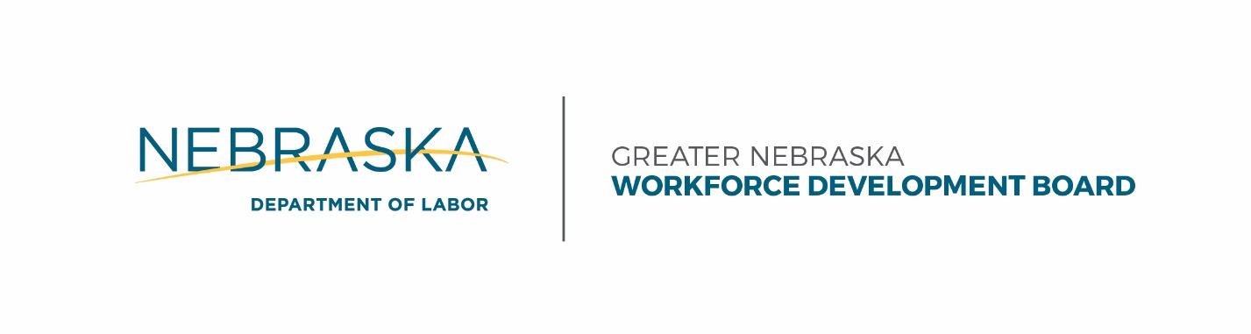

Lisa Wilson Pamela Lancaster Chair CEOB Chair

Youth Incentive Policy | Policy No. | 24
Greater Nebraska Workforce Development Area  550 South 16th Street  Lincoln, NE 68508  402.471.9878  ndol.greaternebraska@nebraska.gov | Effective Date | 5/25/2017
 | Supersedes
 | Revision Date
 | Revision No.
 | Approval | GNWDB

Youth Program Incentive Policy

Only eligible Youth Program participants may receive monetary stipends as incentive for recognition and achievement directly tied to training activities and work experiences. Incentives may be awarded for:

Credential Attainment (Degree/Certificate)

The goal for this incentive is to encourage participants to obtain a WIOA-recognized credential.

Credential Completion Incentive

$200 will be paid for credential completion. The participant must produce a certificate of completion, diploma, or other related documentation.

GED Completion Incentive
$200 will be paid upon attainment of the GED. The participant must produce a certificate of completion, diploma or other related documentation.

Credential Incentive Limit: Greater Nebraska will only provide one Credential Incentive per participant. If a participant achieves more than one credential while enrolled in the WIOA program, they are only eligible to receive one Credential Incentive. GED is considered a credential.

GPA Incentive

The goal for this incentive is to encourage participants to make an effort in their academic endeavors.

ELIGIBLE: To be eligible to receive a GPA incentive, participants must participate in training with an Eligible Training Provider or approved institution for which they receive a Grade Point
Average (GPA).

INELIGIBLE: Youth participating in training programs that do not earn a GPA are not eligible for this incentive. This included Pass-Fail, Satisfactory-Unsatisfactory, etc., type programs of study.

The amount of the incentive will correspond to the cumulative GPA at the end of the training program (not quarterly or per semester) as follows:

Based on a 4.0 GPA system

$125 = 2.5 Final GPA
$150 = 3.0 Final GPA
$175 = 3.5 Final GPA
$200 = 4.0 Final GPA

GPA Incentive Limit: Greater Nebraska will only provide one GPA Incentive per participant. If a participant participates in more than one program that utilizes a GPA, they are only eligible to receive one GPA Incentive.

Work Experience Incentive

The goal for this incentive is to encourage participants to successfully complete 500 hours of Work Experience.

$200 will be paid for the successful completion of a work experience as outlined in ISS. The participant must produce a signed letter of reference from the supervisor/worksite stating that the participant met all required attendance, work duties, and professional conduct standards.

The letter must include the following information:

- Where the job was performed, the letter should include the company letterhead.
- Supervisor’s name and signature.
- Employee’s name and signature
- The time period that the work occurred.

Work Experience (WE) Incentive Limit: Greater Nebraska will only provide one WE incentive per participant. Participants may be eligible to receive either a GPA or credential incentive in addition to the WE incentive.

All incentives must be outlined in the Individual Service Strategy before beginning a program that may provide incentive payments.

