Worker Training Program Guidelines
Purpose:
In accordance with Nebraska Revised Statutes §48-622.02 and 48-622.03 The Nebraska Worker Training and Support Cash Fund may be used to provide training opportunities that:
- expand the Nebraska workforce by increasing the pool of highly skilled workers in Nebraska;
- support public and private job training programs designed to train, retrain, or upgrade work skills of existing Nebraska workers of for-profit and not-for-profit businesses;
- recruit workers to Nebraska; and
- train new employees of expanding Nebraska businesses.
Employers, labor organizations, or other entities providing an apprenticeship training program may apply for a worker training grant.
Eligibility requirements:
- Employer must be current on all combined taxes and quarterly wage reports with the Nebraska Department of Labor under the Nebraska Employment Security Law. Failure to pay taxes or report wages may result in revocation of an award.
- Training must be for a high wage, high skill and high demand (H3) occupation in the employer’s Nebraska Economic Development Region (Panhandle, Sandhills, Northeast, Mid Plains, Central, Grand Island MSA, Southeast, Lincoln MSA, and Omaha Consortium).
  - H3 occupation status must be confirmed by the H3 Report generator available at H3.ne.gov.
Special Training and Commissioner Designated Grants:
- Up to 20 percent of grant funds available for award each year may be for special employment training projects and apprenticeship training programs that:

  - Support training in occupations that pay 100 percent of the regional average hourly wage, but not less than 95 percent of the state average hourly wage; and

  - One or more of the following:

    - Encourage the development of the new industries, including advanced technology industries, that contribute to high-skilled, high-wage, high demand employment and economic vitality of Nebraska by supporting training programs advancing the development of new industries in the state resulting from the grant applicant’s training and/or retraining programs;
    - Support efforts that address the training and employment of workers affected by industry downsizing;

    - Help stabilize employment in fields where there is a demonstrated deficit of trained employees and clear career advancement opportunities;

    - Support small business entrepreneurial training in business management and related skills for workers to enhance the competitive position of business with at least one full-time but fewer than 10 full- time employees that are registered with the Department and have paid unemployment insurance taxes for at least six months prior to grant award;

    - Support apprenticeship training programs by paying training stipends to participants in apprenticeship training programs;

      - Training stipends shall be distributed directly to the apprenticeship training provider for distribution to participants who successfully complete the apprenticeship training;

      - The apprenticeship training provider shall send a claim for reimbursement to the Commissioner for training stipends paid by the provider, but not more often than monthly;

    - Support training programs for workers of reimbursable employers when the training involves high skill, high wage, or high demand positions.

- 20 percent of the annually available training funds for funding grant awards shall be reserved for training initiatives designated by the Commissioner that provide significant economic benefits to a region or the state.

- The Commissioner may recommend award of more than 20% in either of these categories as long as the total amount awarded under this section does not exceed 40% of the grant funds available for award.

Grant Application Process:

- Any eligible employer or apprenticeship training program requesting funds for training purposes shall complete a grant application.

- All applications must be submitted electronically through the Worker Training Application Portal – https://ecmp.nebraska.gov/ndol-wtp). The date and time on the Portals’ submission record system will be used as the application received date.

- The Portal will not allow the submission of incomplete applications. The Portal will specify, on-screen, the additional information required to complete the application. In the event of system difficulties, the applicant shall immediately notify the Department. The Department shall identify a contact person on its staff who is available to assist the applicant in completing the application.

- An employer may apply for more than one grant during a quarter, but must create a separate application for each training program. If multiple projects are included on the same application, the application will be denied.

- Pursuant to Neb. Rev. Stat. §§4-108 through 4-114, each person or entity making application for a training grant shall certify in a format approved by the Department of Administrative Services that he/ she is a citizen of the United States or a qualified alien and that all workers to be trained under the grant are citizens of the United States or qualified aliens.

- Applications shall clearly state the goal of the training, the expected outcome of the training, and what measurements will be used to determine the success of the training. This section shall include the following:

  - Type of training;
  - Reason for training must clearly state employer need;
  - Specific, measurable, achievable, relevant, and time-bound goal(s) for training;
  - Geographic location of training;
  - Who is being trained
    - Position/Job title;
    - Employer (if other than applicant); and
    - Current wage rate for trainee(s);
  - Proposed dates for training;
  - Anticipated outcome of training

- Applications shall clearly describe how the training will assist the employer and promote the goals of the board.

- Applications must provide an estimate of the training and administrative expenses including:

  - specification of costs related to direct training;

  - specification of administrative costs;

  - specification of any matching contributions. Participating businesses must provide matching funds toward Program costs. The Department will assist in identifying appropriate matching contributions. Apprenticeship training programs shall not require a specific employer match; and

  - A breakdown of what the grant funds, if awarded, will pay for.

- Any employer awarded a grant shall provide the name and full social security number for every person participating in the awarded training with its request for reimbursement of training costs.

Training Requirements:

1. Training providers may be required to demonstrate to the Commissioner, upon request, satisfactory evidence that the training provider has sufficient competencies to provide the training that it proposes to provide through either professional credentials or an established history of providing training and placement services to the public.

2. Training providers must maintain and make available:

a. records that clearly document all aspects of training and retention related to the training,

b. applicable financial records which document funds received and disbursed,

c. records of attendance of training recipients, and

d. any certificate or documentation of completed training.

3. All classroom/laboratory training records shall be completed daily and shall contain the following elements:

a. Date training occurred.

b. Type of training.

c. Subject(s) covered.

d. Number of hours’ trainee was in attendance.

e. Instructor(s) name(s) typed or clearly printed.

f. Instructor(s) daily signature.

g. Trainees name(s) typed or clearly printed.

h. Make-up classes identified as “Make-up”.

All training records shall be retained no less than three years after final payment is made under the grant. If the project is partially or completely terminated, records shall be preserved and made available to the Department for a period of three years from the date of any resulting final settlement. Records which relate to litigation or settlement of claims arising out of the performance of an awarded grant shall be retained by the grant recipient and made available to the Department for a period of three years after the final disposition of such appeals, audits, claims, exceptions, or litigation.

All records shall be retained within the control of the grant recipient and shall be open to inspection by the Department at any time during normal business hours of the grant recipient. In absence of records or supporting documentation necessary to substantiate performance of the grant project, the grant recipient may be required to return Program funds, plus interest. NDOL will keep any personally identifiable information it receives as a part of the program confidential in accordance with Neb. Rev. Stat. §§48-612, 48-612.01, and 20 CFR §603.9.

Grant Award and Performance:

The board shall review grant applications recommended by the commissioner for compliance with these guidelines. The grant award must specify those skills and competencies to be gained as a result of the project. Grant applications and awards will provide that reimbursement for training will not be made for trainees who complete less than eighty percent (80%) of the required classroom and laboratory training hours.

The grant award reimbursement request shall be submitted to the Department within 45 days after the date of completion of the project, or an identifiable, separate and divisible portion of the training program is completed. With the reimbursement request, the employer or apprenticeship-training provider shall submit to the Department for verification the employment records for each trainee including name, dates of employment, and full SSN. If the number of trainees completing training during the life of the grant is less than 85% of the number identified to be trained in the grant application, the amount of the grant awarded will be as follows:

(Number of Trainees Trained /Number of Trainees proposed) * Grant Award

In the case of apprenticeship training programs eligibility for referral by a union hall shall be considered retention in employment.

Amendments to the grant must be requested in writing at least 30 days prior to the proposed changes and must be executed before changes are implemented. Acceptance of the requested amendment is within the discretion of the Commissioner. Amendments will be executed by the authorized employer’s representative and the Commissioner, or his or her designee.

All awardees are subject to potential audit by the Commissioner.

Grant Closeout Requirements

At the completion of a grant, the following documentation must be provided:

- Completed Grant Closeout Form provided by the Nebraska Department of Labor;

- All training records including but not limited to class roster, social security number of individuals for which training cost reimbursement is sought, attendance records, and billing invoices;

- Training outcomes; and

- Evaluation of stated training goal(s) including supporting material to establish if goal(s) was met

- Supporting material to establish what was accomplished if goal(s) was not met, an evaluation as to whether the goal(s) is still achievable in the future, and reason(s) for not meeting the stated goal(s).

Deobligation of Unearned Funds

The Commissioner may deobligate any unearned funds remaining under a grant award no later than six months after the termination date grant project. Funds which have not been claimed within one year after the termination date of the grant project may be deobligated and made available for subsequent grant applications.

Project Review; Monitoring and Auditing:

1. The Commissioner may conduct pre-award audits of training awards to determine whether the grant recipient can perform the planned training.

2. The Department may review performance every six months after the start of a project and continue to audit for up to three years after the close of any grant. Such reviews shall contain:

- Grantee’s actual enrollments compared with planned enrollments at that stage of the training project.

- Assessment of the likelihood that the full amount of the award will be earned.

- Recommendations to the Commissioner for amendments to the grant award or to deobligate funds. In these cases, the Department shall notify the grant recipient of the Commissioner’s intention to de-obligate funds and the grant recipient shall have the opportunity to make a presentation before the Commissioner prior to any final action.

3. The Department may schedule periodic on-site visits to the grantee’s place of business or the location of the training program funded by the Commissioner for the purpose of reviewing training activities for compliance with the Program guidelines and grant award specifications. During the on-site visit, the Department may perform any or all of the following:

- Review the number of trainees entering, progressing through or completing training,

- Review the training schedule,

- Review the curricula,

- Observe classroom, laboratory or on-site training in session,

- Assure that budgeted and required training staff, equipment, supplies or materials are available,

- Interview trainers or trainees,

- Review record keeping and daily documentation of training; Review invoices,

- Review agreements and determine if all specified services are being delivered as provided for in the grant award,

- The results of the visit shall be documented in a report covering all areas reviewed, and include an assessment whether the training is meeting the Program guidelines and grant award specifications. If the training activities are out of compliance, recommendations for adjustment shall be made. If corrective action must be taken by the training provider or employer, a report documenting the requirements will be prepared and given to the grantee. Failure to take corrective action may result in loss of grant funding.

5. The Commissioner may, on a quarterly basis, provide for audits of a representative sample of completed grant awards. These audits shall determine whether certification of eligibility for training, enrollment in training, training, status of individuals trained – including wage changes, if any, placement of a job, retention in that job at the specified wage and payments were done in accordance with the grant award.

6. The Commissioner may request any documentation necessary for completion of the audit. The grant recipient shall provide all requested documentation. This may include payroll records and social security numbers for training participants.

Allowable Costs
- Costs related to direct training may include:
  - Tuition and Fees,
  - Books and classroom materials,
  - Rental costs during the term of the project,
  - Reasonable pre- and post-training participant costs for the purchase of approved curricula specified in the applicant’s training plan if there is not already a course offering at a convenient public education institution for which the grant is paying tuition and fees,

  - Costs of curriculum design,
  - Wages, salaries and reasonable benefits of instructors and instructional aides,
  - The purchase or construction of a specialized facility or equipment for use in the training specified in the grant application,

  - In the case of apprenticeship training programs provided by a labor organization to its members, if the training program involves at least six hours of training in a single calendar day, a training stipend for each trainee in an amount not to exceed one-fifth of the maximum weekly unemployment benefit amount available on the date of application (as determined in accordance with Neb. Rev. Stat. §48-624) for each day the worker attends the apprenticeship training program, and

  - Other reasonable cost related directly to the training provided.
- Except as provided in Paragraph 1 (H) above or for good cause shown as determined by the Commissioner, reimbursement for costs related to direct training may not include:

  - The lease, rental, purchase or construction of facilities;
  - The purchase of capital equipment;
  - Salaries, wages, or benefits paid to personnel trained, or personnel assigned to manage or report on the project or grant award;

  - Costs incurred for the preparation of an application;
  - Costs incurred prior to the submission of the application.
Availability

Training grants are awarded subject to the availability of funds appropriated by the Legislature and the discretion of the Commissioner. There is no minimum threshold amount that must be awarded each quarter.

Scoring Criteria:

Set Points:

- Economic Development Impact:

  - Job Creation (20 points for first net new job, 5 additional points for each net new job after that)

  - Increased Wages because of training; must show not just an annual raise or bonus (20 points for a wage increase due to training, 5 additional points for each job that sees a wage increase due to training, and additional 20 points if wage increase is more than 5%)

  - Retention (20 points for training new skill to retain workforce, 5 additional points for each job not eliminated because of training)

  - Required training (10 points for training required for employees to continue working in their designated field)

- Job Trained:
  - High Wage
    - Hourly wage is 95% to 99% of the state average hourly wage – 20 points
    - Hourly wage is 100% to 104% of the state average hourly wage – 25 points
    - Hourly wage is 105% to 109% of the state average hourly wage – 30 points
    - Hourly wage is 110% or more of the state average hourly wage – 35 points
- Grantee
  - 1st time awardee – 25 points
  - 2-5 time awardee – 10 points
- Likelihood of Completion
  - (-10) points for every grant an applicant still has open
    - No deduction if the open grant is a multiple year grant and the timeframe for the multiple year grant award has not run.
- Employer Match
  - Points:
    - Employer Match at least 2:1– 20 points
    - Employer Match >=3:1– 30 points
    - Employer Match of >= 4:1 – 40 points
    - Employer Match of >= 5:1 – 50 points
  - In-kind contributions:
    - Documented in-kind contributions may be considered as part of the employer match. Documentation of in-kind contributions, which are submitted as part of the employers’ match must specify the dollar value of facilities; equipment, wages paid to the trainees during training, and consumable supplies submitted to the project.
    - New equipment utilized only in the project will be valued at cost. Other equipment and facilities will be valued on a pro rata basis for the time used for training consistent with the U.S. Internal Revenue Service depreciation schedules for such assets based on data provided by the employer.
- Cost Per Participant
  - $100 or less – 25 points
  - $101 to $500 – 15 points
  - $501 to $1,000 – 10 points
Discretionary Points:
Measure | 0 Points | 1 – 10 Points | 11 – 20 Points
1. Statement of Need | Missing, unclear, or not related to grant purpose | Need expressed does not match grant purpose; not tied to relevant industry needs | Need is clearly stated and tied to area industry needs strongly
Measure | 0 Points | 1 – 15 Points | 16 – 30 Points
2. Goals and corresponding outcomes | Missing, unclear, or not related to grant purpose | Goals and/or outcomes are included, but they are stated vaguely/inconclusively and/or their correlation is weak | Goals and outcomes are clearly stated, and their correlation is evident/strong
Measure | 0 Points | 1 – 10 Points | 11 – 20 Points
4. Budget | Missing, unclear, or incomplete | Budget lacks details | Budget is clearly detailed
Measure | 0 Points | 1 – 30 Points | 31 – 50 Points
- Impact | Missing, unclear, or incomplete | Somewhat innovative, more traditional approach with average potential for impact on trainees | Innovative approach with potential for significant impact on large number of trainees

Location Factor:
It is the intent of the Nebraska Worker Training Board that grants be awarded across the entire State of Nebraska. For this purpose, once scored, applications will be grouped by Congressional District. No Congressional District will be eligible for a fourth grant per quarter until each Congressional District has received at least three grants. Once each Congressional District has been awarded three grants, grants may be awarded regardless of location.

Business Size
It is the intent of the Nebraska Worker Training Board that grants be awarded to businesses of all sizes. Once scored and grouped by Congressional District applications will be subdivided by business size. Bonus points will be awarded based on business size as follows:

- Small employer (0 – 50 employees) – 25 points
- Mid-Small employer (51 – 100 employees) – 20 points
- Mid employer (101 – 250 employees) – 15 points
- Mid-large employer (250 – 400 employees) – 10 points
- Large employer (401 or more employees) – 5 points

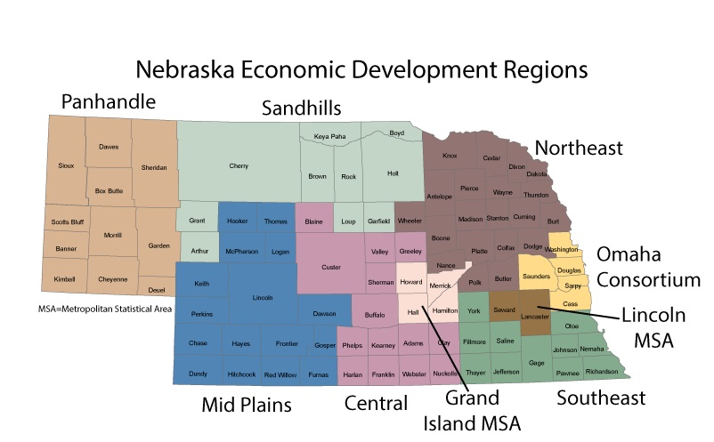

Nebraska Congressional Districts:

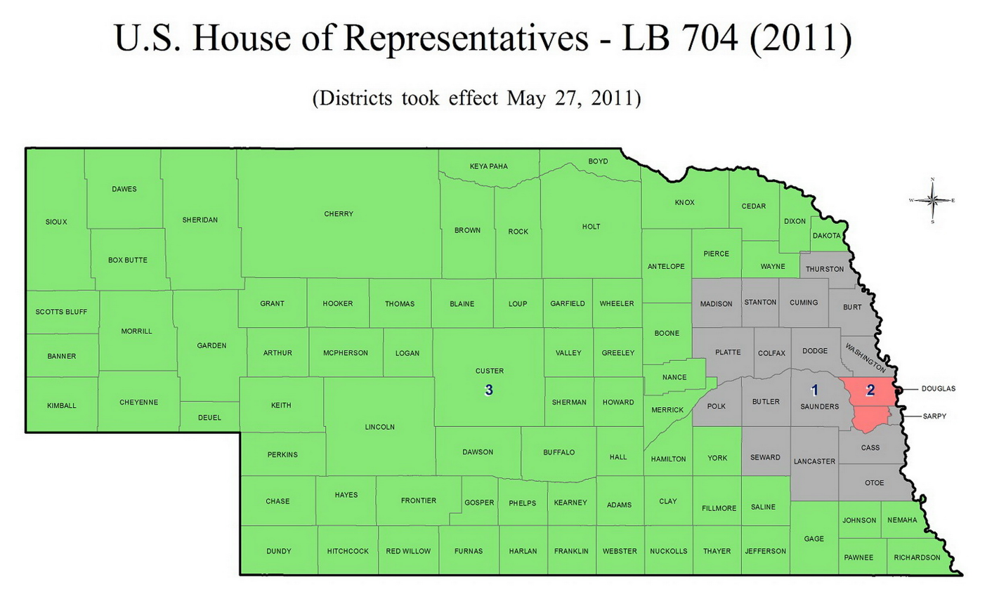

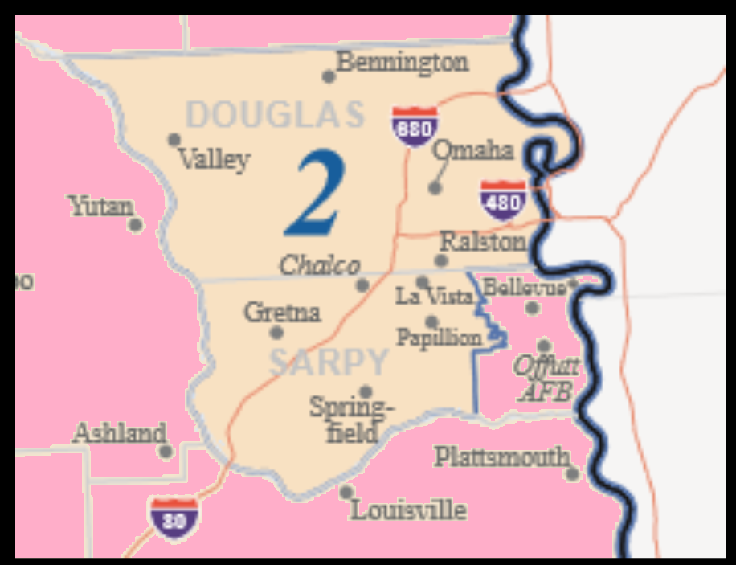

Scoring is not required for Special Training and Commissioner Designated grants

