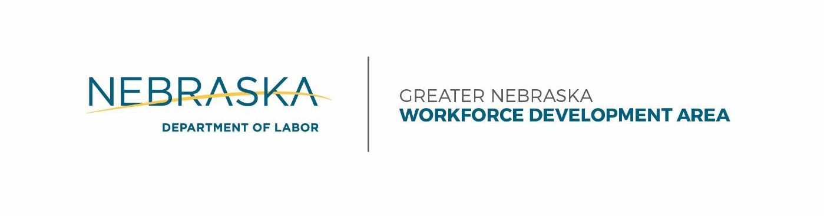

Lisa Wilson Pamela Lancaster
Chair CEOB Chair

Agenda – Executive Committee

Thursday, 2/2/2016
10:30 – 12:00 p.m. (CT)
Grand Island City Library, 211 N Washington St. Grand Island, NE 68801

- Call to Order
- Roll Call
- Notice of Publication
- Old Business
- New Business
  - Local and Regional Plan*
  - Issue RFP for One-Stop Operator*
  - Guiding Principles
- Public Comment
- Adjournment

*Requires a Motion & Vote

Department of Labor | ADMINISTRATIVE ENTITY
A proud partner of the American Job Center network
(402) 471-9878
ndol.greaternebraska@nebraska.gov
P.O. Box 9460, Lincoln, Nebraska 68509 An Equal Opportunity Employer | TDD 800-833-7352

dol.nebraska.gov

