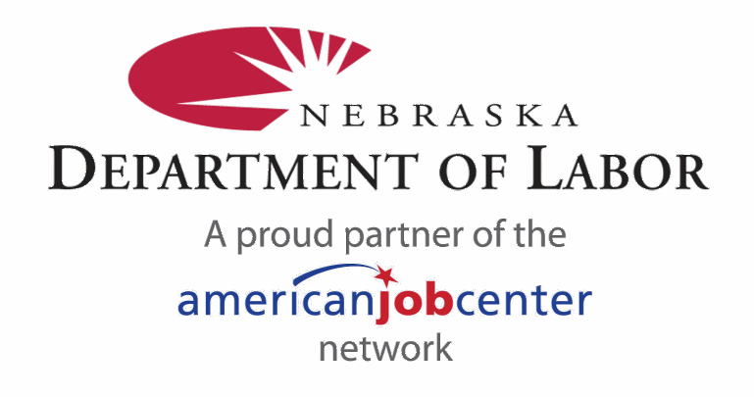

Office of Employment and Training Limited English Proficiency Plan

February 2016

Contents
I. Executive Summary: 3
II. Introduction/Background 3
a. Planning Committee 3
b. Purpose 3
c. Title VI of Civil Rights Act of 1964 4
d. Executive Order No. 13166 4
e. United States Department of Labor Guidance 5
III. The Four-Factor Analysis 6
IV. Identifying Individuals with Limited English Proficiency: 7
a. Greater Nebraska Workforce Development Area: 10
b. Omaha Workforce Development Area: 15
c. Lincoln Workforce Development Area: 16
V. Individuals Self-Identifying as Hispanic, Latino, or of Spanish origin in Nebraska: 17
VI. Local Office Language Assistance Measures: 17
VII. Accessibility of Information Online to LEP Individuals 21
a. NEworks 21
b. NDOL Website 21
c. Social Media 22
VIII. Accessibility of Rapid Response Information to LEP Individuals 22
IX. Training Staff: 22
X. Dissemination of OET’s LEP Plan 23
XI. LEP Complaint Procedures 23
XII. Appendices Error! Bookmark not defined.

- Executive Summary:

Individuals who do not speak English as their primary language and who have limited ability to read, write, speak, or understand English may incur a barrier to employment and are entitled to language assistance in their effort to enter the workforce. The quality and accuracy of the language is critical to these efforts and shall be provided in a timely manner to ensure maximum access to services. This plan provides individuals with Limited English Proficiency (LEP) access to programs and services provided by the American Job Centers and Nebraska Department of Labor (NDOL) offices on an equitable basis. This plan is applicable to all entities in the NDOL Office of Employment and Training (OET) that receive federal financial assistance, and any subrecipients of such funds. This plan reflects the LEP needs of Wagner-Peyser and Veterans operations statewide and in all local offices.

- Introduction/Background

- Planning Committee

In an effort to provide equitable services to individuals with Limited English Proficiency the OET has established a planning committee consisting of the following team members:

2016 LEP Planning Committee
Mary Hinojosa, Scottsbluff (bilingual) | Jose Palacios, Omaha
Steph Den Besten, North Platte | Pablo Colindres-Moreno, Virtual Services Unit (bilingual)
Randy Kissinger, Grand Island | Mary Findlay, LMI
Kari Janssen, Beatrice | Deb Andersen, OET
Ada Sanchez, Columbus (bilingual) | Lorena Hernandez, OET
Sayaka Sato-Mumm, Lincoln (bilingual)

- Purpose

The planning committee is responsible for: identifying major concentrations of ethnic groups with Limited English Proficiency in each region; staff training needs; inventorying and identifying language assistance aids such as posters, handbooks, forms, handouts, etc.; and making recommendations to OET for development of other language assistance aids to assist with service delivery.

The OET LEP Plan is reviewed and updated on an annual basis with the exception of any major changes in demographics, types of services, program changes, or other factors affecting a specific geographic location. Should any of these changes occur, an immediate review of the situation, and plan update will be completed. The annual review, as well as any necessary modifications, will be conducted by the LEP committee members. The LEP committee schedules meetings on a quarterly basis to review any issues or concerns potentially affecting the LEP plan or LEP populations.

The Wagner-Peyser Governor’s Reserve funds (10% set aside) may be used to support procurement of language assistance materials and to support costs associated with group language assistance training. Individual clients who require language assistance training and are eligible for Workforce Innovation and Opportunities Act (WIOA) programs and services may be funded from the specific program area funds (Adult, Dislocated Worker, and Youth). These determinations will be left to the Workforce Development Areas. Language assistance tools will also be utilized on an as needed basis for the State Rapid Response Activities and the Trade Adjustment Assistant Assistance (TAA) Program.

The goal of this plan is to function as a tool used to assess the effectiveness of OET’s service delivery to LEP individuals.

- Title VI of Civil Rights Act of 1964

Section 601 of Title VI of the Civil Rights Act of 1964 provides that no person shall "on the ground of race, color, or national origin, be excluded from participation in, be denied the benefits of, or be subjected to discrimination under any program or activity receiving Federal financial assistance." The requirement to provide meaningful access under Title VI applies beyond the education context to include all of the programs and activities of all recipients of Federal financial assistance.

- Executive Order No. 13166

On Aug. 11, 2000, President Clinton issued Executive Order No. 13166, entitled “Improving Access to Service for Persons with Limited English Proficiency” (available electronically at http://www.dol.gov/oasam/regs/statutes/Eo13166.pdf). This executive order was meant to clarify Title VI of the Civil Rights Act of 1964. The executive order was issued to ensure equal accessibility to federally funded programs and services to otherwise eligible individuals not proficient in the English language. The executive order states that:

Each federal agency shall prepare a plan to improve access to its federally conducted programs and activities by eligible LEP persons. Each plan shall be consistent with the standards set forth in the LEP Guidance, and shall include the steps the agency will take to ensure that eligible LEP persons can meaningfully access the agency’s programs and activities.

Executive Order No. 13166 ensures that in addition to federal agencies, recipients of federal financial assistance funds must also comply with Title VI and the LEP guidelines of the agency from which the funds are received. In addition, each agency subject to the requirements of Title VI must publish guidance to its respective recipients clarifying its obligation. As a recipient of federal funding, this requirement applies to all programs and services offered by OET.

- United States Department of Labor Guidance

The United States Department of Labor (DOL) has provided policy guidance to federal financial assistance recipients regarding the Title VI prohibition against national origin discrimination affecting LEP persons. The DOL has created a webpage entitled “LEP Toolkit” which provides numerous resources for recipient agencies to utilize as they create LEP Plans. This webpage is accessible at http://www.dol.gov/oasam/programs/crc/lepcnt.htm.

Among the available LEP planning resources provided by DOL, is the “Policy Guidance on the Prohibition of National Origin Discrimination as it Affect Person with Limited English.” This guidance policy was published in the Federal Register on May 29, 2003. The DOL policy guidance states:

Language for LEP individuals can be a barrier to accessing important benefits or services, understanding and exercising important rights, complying with applicable responsibilities, or understanding other information provided by federally assisted programs and activities.

The DOL policy guidance helps to ensure “that federally assisted programs aimed at the American public do not leave some behind simply because they face challenges communicating in English.” Subrecipients likewise are held to the same standards when federal funds are passed through from one recipient to a subrecipient.

29 CFR part 37 provides regulations for the implementation of policies and procedures that provide equal opportunity and equal access in a nondiscriminatory manner. 29 CFR § 37.35(a) states that where “a significant number or proportion of the population eligible to be served, or likely to be directly affected, by a [WIOA] Title I – [financially] assisted program or activity may need services or information in a language other than English in order to be effectively informed about, or able to participate in, the program or activity”.

The Section 188 regulations require recipients ‘‘to take reasonable steps to provide services and information in appropriate languages’’ [29 CFR 37.35(a)(2)]. Even where there is not a significant number or proportion of LEP persons in the community serviced by the recipient, recipients nonetheless are required to ‘‘make reasonable efforts to meet the particularized language needs of limited-English speaking individuals who seek services or information from the recipient’’ [29 CFR 37.35(b)].

- The Four-Factor Analysis

Recipients and subrecipients are required to take reasonable steps to ensure meaningful access to their programs and activities by LEP persons. While designed to be a flexible and fact-dependent standard, the DOL has stated that the starting point is an individualized assessment that balances the following four factors:

Factor 1: The Number or Proportion of LEP Persons Served or Encountered in the Eligible Service Population

The U.S. Census Bureau has a range of four classifications of how well people speak English. The classifications are (1) ‘Very Well,’ (2) ‘Well,’ (3) ‘Not Well,’ and (4) ‘Not At All.’ For planning and statistical purposes, we are considering individuals who speak English at any level below “Very Well” as Limited English Proficient (LEP).

As part of this planning process, we have included statistics from the 2012 U.S. Census Bureau American Community Survey 5-Year Estimates Table to illustrate the number of individuals living in the state of Nebraska who speak English less than “Very Well.” In addition, this U.S. Census survey indicates the number of individuals in each language group among the total population of individuals who speak English less than “Very Well.” These statistics help to identify prominent and/or growing language groups for planning purposes at a state level, region level, and by Workforce Development Area.

Factor 2: The Frequency With Which LEP Individuals Come in Contact With the Program

The program must be evaluated in relationship to the number of LEP persons who are within the program area and the number of times those persons have frequented the program or activity. NDOL utilizes the NEworks system, the state’s public labor exchange system, to provide information to job seekers, to register program applicants and participants, and to list available jobs throughout Nebraska. User statistics have been pulled from NEworks Registered Individuals, which indicate voluntary self-identification information which may help to indicate a potential need for language assistance among individuals.

To help indicate the frequency with which LEP individuals come in contact with NDOL programs, NEworks data for Program Year 2012 (June 30, 2012 to July 1, 2013) has been used. The NEworks data has been localized to each individual office.

Factor 3: The Nature and Importance of the Program, Activity, or Service Provided by the Recipient

The OET provides a wide range of programs, activities and services. The OET provides Veterans Services, Job Seeker Services, Business Services, Labor Market Information, and a multitude of other services. The OET is responsible for administering numerous programs that receive federal funding, including: Workforce Innovation and Opportunities Act, Wagner-Peyser, Veterans, Trade Adjustment Assistance, Rapid Response, Work Opportunity Tax Credit (WOTC), and many other programs receiving federal funding or grants.

Factor 4: The Resources Available to the Recipient and Costs

OET serves the entire state of Nebraska and is required by federal law to provide access to LEP persons, and to ensure that its sub-recipients also provide such access. The Wagner-Peyser Governor’s Reserve funds (10% set aside) may be used to support procurement of language assistance materials and to support costs associated with group language assistance training.

- Identifying Individuals with Limited English Proficiency:

To achieve equal access to all programs offered by OET, it is essential to conduct a thorough assessment of the language needs of the populations served by attempting to identify LEP individuals. In order to identify language needs, the LEP committee has reviewed available language data from the U.S. Census American Community Survey and from self-identifying information from NEworks registrants.

In Nebraska, there are an estimated 83,597 individuals or 4.8 percent of the population age 5 years and older speak a language other than English and speak English less than very well according to the 2010-2014 American Community Survey estimates in Table B16001. The highest numbers of people with limited English proficiency reside in the most populous counties in the state with Douglas (32,962), Lancaster (12,863), Hall (6,388) and Sarpy (5,066) counties topping the list.

The majority of the state’s limited English speakers speak Spanish or Spanish Creole with nearly seven in 10 or 68.9 percent followed by Vietnamese with 5.9 percent. The top eight categories below account for 90.2 percent of all limited English speakers in Nebraska.

2014 Number and Percent of Individuals Age 5 and Older Who Speak English Less than "Very Well" by Language or Language Group in Nebraska
Language/Language Group | Number of Individuals 5 Years and Older Who Speak English Less than "Very Well" | Percent of Limited English Speakers Who Speak English Less than "Very Well"
Spanish or Spanish Creole | 57,612 | 68.9%
Vietnamese | 4,973 | 5.9%
Other Asian languages | 3,182 | 3.8%
African languages | 2,738 | 3.3%
Chinese | 2,504 | 3.0%
Arabic | 2,161 | 2.6%
French (incl. Patois, Cajun) | 1,244 | 1.5%
Other Indic languages | 1,001 | 1.2%
All Other Languages | 8,182 | 9.8%
Total | 83,597 | 100.0%
Examples of Other Asian languages include: Malayalam, Telugu, Tamil, and Turkish. Examples of African Languages include: Amharic, Ibo, Yoruba, Bantu, Swahili, and Somali. Other Indic languages include: Bengali, Marathi, Punjabi, and Romany. 2010-2014 American Community Survey estimates in Table B16001

Linguistically isolated individuals account for a significant proportion of the population in several counties when the percent of the total population is considered. In Colfax County more than a quarter (26.0 percent) of the population speak limited English. This is followed by Dawson County with 17.9 percent, Dakota with 17.1 percent, Hall with 11.5 percent and Saline with 11.1 percent. A second group including Chase, Douglas, Platte, Dodge, Madison, Dixon and Johnson counties range from five percent to 6.9 percent, all above the statewide average. This group of 11 counties comprises more than two-thirds (68.0 percent) of all the limited English speakers in the state. Northeast Nebraska has the highest concentration of linguistically isolated individuals with six of the 11 counties listed above.

Number of Individuals Age 5 and Older Who Speak English Less Than Very Well
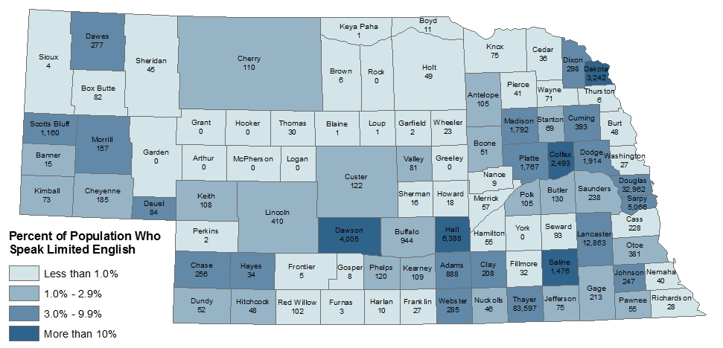
Shading displays the percentage of each county’s population age 5 and older who speak English less than very well.

The American Community Survey 2010-2014 estimates in Table B16004 have more detailed information on Spanish language speakers between the ages of 18 and 64. It has the categories: “Speak Spanish,” “Speak Spanish - Speak English Very Well,” “Speak Spanish - Speak English Well,” “Speak Spanish – Speak English Not Well,” and “Speak Spanish – Speak English Not At All.” There are an estimated 83,021 people in the state who speak Spanish and of those, 25.9 percent speak English “Not Well” and 11.4 percent do not speak English at all. Unfortunately, Spanish is the only language with these detailed categories by the working age population available.

Over the past five years, when comparing the 2005-2009 American Community Survey estimates to the current 2009-2014 estimates there have been shifts in the number of linguistically isolated individuals by language spoken. Of those individuals who don’t speak English very well, African language speakers have increased 74.4 percent, Arabic speakers have increased 58.2 percent, Chinese speakers 31.4 percent, Vietnamese 27.0 percent and Spanish speakers 10.0 percent.
The number of languages or language groups with limited English speakers varies by Workforce Areas within the state. Greater Nebraska has six language or language groups with one percent or more of limited English speakers with Spanish or Spanish Creole topping the list 86.2 percent. Within Greater Nebraska there are marked differences between regions in the linguistically isolated populations. Greater Omaha has 10 language or language groups with one percent or more limited English speakers with Spanish or Spanish Creole with 67.0 percent. The Greater Lincoln area has the highest number (13) of language or language groups with one percent or more limited English speakers. Spanish or Spanish Creole with 31.7 percent followed by Vietnamese with 22.5 percent have the highest percentage of linguistically isolated individuals.

Greater Nebraska Workforce Development Area:

The U. S. Census American Community Survey 2010-2014 estimates, the most recent data available for county level data, show that there were 32,397 individuals in Greater Nebraska age five years and older who speak a language other than English at home and speak English less than “Very Well.” Among individuals who speak English less than “Very Well,” 86.2 percent speak Spanish.

2014 Number and Percent of Individuals Age 5 and Older Who Speak English Less than "Very Well" by Language or Language Group in Greater Nebraska
Language/Language Group | Number of Individuals 5 Years and Older Who Speak English Less than "Very Well" | Percent of Limited English Speakers Who Speak English Less than "Very Well"
Spanish or Spanish Creole | 27,928 | 86.2%
African languages | 1,073 | 3.3%
Vietnamese | 549 | 1.7%
Laotian | 433 | 1.3%
German | 365 | 1.1%
Chinese | 357 | 1.1%
All Other Languages | 1,692 | 5.2%
Total | 32,397 | 100.0%
Examples of African Languages include: Amharic, Ibo, Yoruba, Bantu, Swahili, and Somali. 2010-2014 American Community Survey estimates in Table B16001
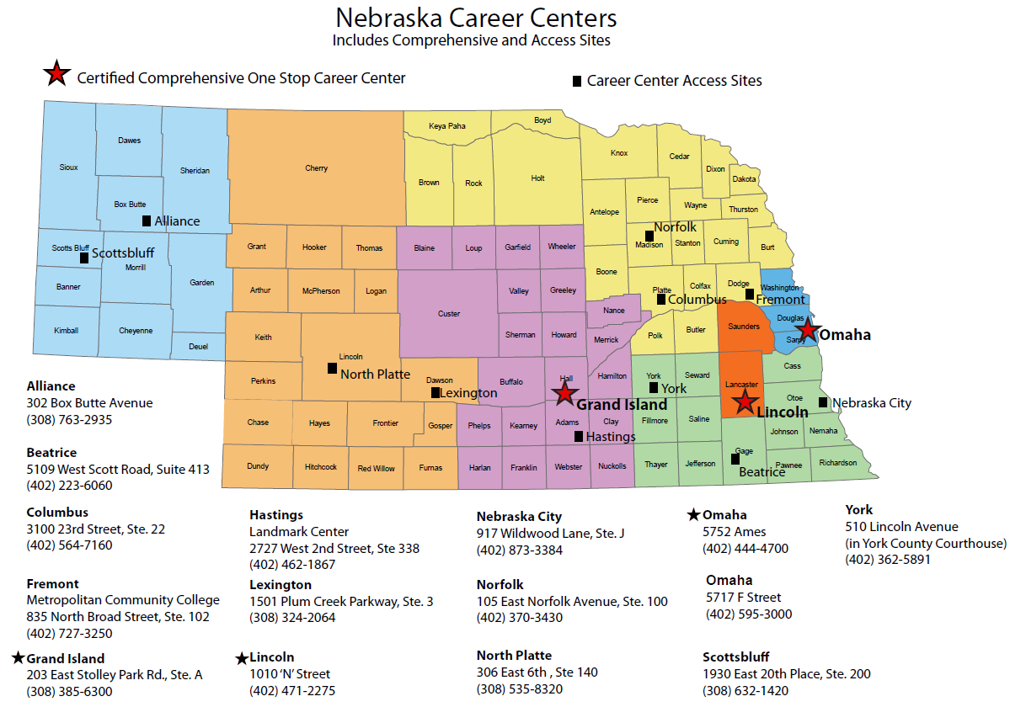

- Greater Nebraska Region 1

2014 Number and Percent of Individuals Age 5 and Older Who Speak English Less than "Very Well" by Language or Language Group in Greater Nebraska Region 1
Language/Language Group | Number of Individuals 5 Years and Older Who Speak English Less than "Very Well" | Percent of Limited English Speakers Who Speak English Less than "Very Well"
Spanish or Spanish Creole | 1,654 | 79.4%
Other Pacific Island languages | 83 | 4.0%
Chinese | 80 | 3.8%
German | 50 | 2.4%
Thai | 49 | 2.4%
Korean | 34 | 1.6%
Tagalog | 31 | 1.5%
Other Native North American languages | 23 | 1.1%
Other Asian languages | 22 | 1.1%
All Other Languages | 56 | 2.7%
Total | 2,082 | 100.0%
Examples of Other Pacific Island languages include: Chamorro, Hawaiian, Ilocano, Indonesian, and Samoan. Other Native North American languages include: Apache, Cherokee, Dakota, Pima, and Yupik. Examples of Other Asian languages include: Malayalam, Telugu, Tamil, and Turkish. 2010-2014 American Community Survey estimates in Table B16001

 | % Hispanic Ethnicity
Region 1 Offices | Registered Individuals | WIOA Enrollments
Scottsbluff | 18.65% | 8.11%
Alliance | 12.14% | 0.00%
Information from NEworks: self-identified as Hispanic/Latino during Program Year 2014 (7/1/14-6/30/15).

- Greater Nebraska Region 2

2014 Number and Percent of Individuals Age 5 and Older Who Speak English Less than "Very Well" by Language or Language Group in Greater Nebraska Region 2
Language/Language Group | Number of Individuals 5 Years and Older Who Speak English Less than "Very Well" | Percent of Limited English Speakers Who Speak English Less than "Very Well"
Spanish or Spanish Creole | 4,522 | 87.8%
African languages | 465 | 9.0%
Chinese | 85 | 1.7%
All Other Languages | 77 | 1.5%
Total | 5,149 | 100.0%
Examples of African Languages include: Amharic, Ibo, Yoruba, Bantu, Swahili, and Somali. 2010-2014 American Community Survey estimates in Table B16001

 | % Hispanic Ethnicity
Region 2 Offices | Registered Individuals | WIOA Enrollments
North Platte | 7.49% | 7.14%
Lexington | 25.45% | 100.00%
Information from NEworks: self-identified as Hispanic/Latino during Program Year 2014 (7/1/14-6/30/15).

- Greater Nebraska Region 3

2014 Number and Percent of Individuals Age 5 and Older Who Speak English Less than "Very Well" by Language or Language Group in Greater Nebraska Region 3
Language/Language Group | Number of Individuals 5 Years and Older Who Speak English Less than "Very Well" | Percent of Limited English Speakers Who Speak English Less than "Very Well"
Spanish or Spanish Creole | 7,747 | 85.4%
Laotian | 199 | 2.2%
African languages | 193 | 2.1%
Vietnamese | 179 | 2.0%
German | 165 | 1.8%
Arabic | 121 | 1.3%
All Other Languages | 467 | 5.1%
Total | 9,071 | 100.0%
Examples of African Languages include: Amharic, Ibo, Yoruba, Bantu, Swahili, and Somali. 2010-2014 American Community Survey estimates in Table B16001

 | % Hispanic Ethnicity
Region 3 Offices | Registered Individuals | WIOA Enrollments
Grand Island | 20.07% | 13.51%
Hastings | 9.43% | 2.94%
Information from NEworks: self-identified as Hispanic/Latino during Program Year 2014 (7/1/14-6/30/15).

- Greater Nebraska Region 4

2014 Number and Percent of Individuals Age 5 and Older Who Speak English Less than "Very Well" by Language or Language Group in Greater Nebraska Region 4
Language/Language Group | Number of Individuals 5 Years and Older Who Speak English Less than "Very Well" | Percent of Limited English Speakers Who Speak English Less than "Very Well"
Spanish or Spanish Creole | 2,378 | 76.6%
Vietnamese | 170 | 5.5%
Laotian | 149 | 4.8%
German | 98 | 3.2%
Chinese | 51 | 1.6%
Other West Germanic languages | 46 | 1.5%
Other Pacific Island languages | 40 | 1.3%
Other Slavic languages | 39 | 1.3%
Other Indic languages | 33 | 1.1%
French (incl. Patois, Cajun) | 30 | 1.0%
All Other Languages | 69 | 2.2%
Total | 3,103 | 100.0%
Examples of Other West Germanic languages include: Dutch, Pennsylvania Dutch and Afrikaans. Examples of Other Pacific Island languages include: Chamorro, Hawaiian, Ilocano, Indonesian, and Samoan. Examples of Other Slavic languages include: Czech, Slovak, and Ukrainian. Examples of Other Indic languages include: Bengali, Marathi, Punjabi, and Romany. 2010-2014 American Community Survey estimates in Table B16001

 | % Hispanic Ethnicity
Region 4 Offices | Registered Individuals | WIOA Enrollments
Beatrice | 4.96% | 4.24%
Nebraska City | 7.43% | 0.00%
York | 4.76% | 0.00%
Information from NEworks: self-identified as Hispanic/Latino during Program Year 2014 (7/1/14-6/30/15).

- Greater Nebraska Region 5

2014 Number and Percent of Individuals Age 5 and Older Who Speak English Less than "Very Well" by Language or Language Group in Greater Nebraska Region 5
Language/Language Group | Number of Individuals 5 Years and Older Who Speak English Less than "Very Well" | Percent of Limited English Speakers Who Speak English Less than "Very Well"
Spanish or Spanish Creole | 11,627 | 89.5%
African languages | 410 | 3.2%
Vietnamese | 190 | 1.5%
All Other Languages | 765 | 5.9%
Total | 12,992 | 100.0%
Examples of African Languages include: Amharic, Ibo, Yoruba, Bantu, Swahili, and Somali. 2010-2014 American Community Survey estimates in Table B16001

 | % Hispanic Ethnicity
Region 5 Offices | Registered Individuals | WIOA Enrollments
Columbus | 34.29% | 46.15%
Norfolk | 11.83% | 20.51%
Information from NEworks: self-identified as Hispanic/Latino during Program Year 2014 (7/1/14-6/30/15).

Omaha Workforce Development Area:

The U. S. Census American Community Survey 2010-2014 estimates show that the Omaha Workforce Development Area has a total of 38,099 individuals that speak English less than “Very Well.” The table below displays the top 10 languages or language groups of people who spoke English less than “Very Well.” Spanish speakers top the ranking with 67.0% of the population among individuals who speak English less than “Very Well.”

2014 Number and Percent of Individuals Age 5 and Older Who Speak English Less than "Very Well" by Language or Language Group in Greater Omaha
Language/Language Group | Number of Individuals 5 Years and Older Who Speak English Less than "Very Well" | Percent of Limited English Speakers Who Speak English Less than "Very Well"
Spanish or Spanish Creole | 25,530 | 67.0%
Other Asian languages | 2,406 | 6.3%
African languages | 1,505 | 4.0%
Vietnamese | 1,470 | 3.9%
Chinese | 1,076 | 2.8%
Arabic | 836 | 2.2%
Other Indic languages | 834 | 2.2%
French (incl. Patois, Cajun) | 768 | 2.0%
Other and unspecified languages | 499 | 1.3%
Korean | 397 | 1.0%
All Other Languages | 2,778 | 7.3%
Total | 38,099 | 100.0%
Examples of Other Asian languages include: Malayalam, Telugu, Tamil, and Turkish. Examples of African Languages include: Amharic, Ibo, Yoruba, Bantu, Swahili, and Somali. Other Indic languages include: Bengali, Marathi, Punjabi, and Romany. 2010-2014 American Community Survey estimates in Table B16001

 | % Hispanic Ethnicity
Omaha Region | Registered Individuals | WIOA Enrollments
Omaha | 9.36% | 9.62%
Information from NEworks: self-identified as Hispanic/Latino during Program Year 2014 (7/1/14-6/30/15).

Lincoln Workforce Development Area:

The U. S. Census American Community Survey 2010 - 2014 estimates show that Lincoln Workforce Area has a total of 13,101 individuals who speak English less than “Very Well.” The table below displays the languages or language groups of people who spoke English less than “Very Well.” Individuals speaking Spanish and Vietnamese are the two most prevalent language groups served by the NDOL Lincoln office.

2014 Number and Percent of Individuals Age 5 and Older Who Speak English Less than "Very Well" by Language or Language Group in Greater Lincoln
Language/Language Group | Number of Individuals 5 Years and Older Who Speak English Less than "Very Well" | Percent of Limited English Speakers Who Speak English Less than "Very Well"
Spanish or Spanish Creole | 4,154 | 31.7%
Vietnamese | 2,954 | 22.5%
Arabic | 1,171 | 8.9%
Chinese | 1,071 | 8.2%
Other Asian languages | 736 | 5.6%
Other Indo-European languages | 549 | 4.2%
Russian | 401 | 3.1%
Other Slavic languages | 387 | 3.0%
French (incl. Patois, Cajun) | 331 | 2.5%
Korean | 238 | 1.8%
Serbo-Croatian | 172 | 1.3%
African languages | 160 | 1.2%
German | 133 | 1.0%
All Other Languages | 644 | 4.9%
Total | 13,101 | 100.0%
Examples of Other Asian languages include: Malayalam, Telugu, Tamil, and Turkish. Examples of Other Indo-European languages include: Albanian, Gaelic, Lithuanian, and Romanian. Examples of Other Slavic languages include: Czech, Slovak, and Ukrainian. Examples of African Languages include: Amharic, Ibo, Yoruba, Bantu, Swahili, and Somali. 2010-2014 American Community Survey estimates in Table B16001

 | % Hispanic Ethnicity
Lincoln Region | Registered Individuals | WIOA Enrollments
Lincoln | 5.85% | 10.34%
Information from NEworks: self-identified as Hispanic/Latino during Program Year 2014 (7/1/14-6/30/15).

Individuals Self-Identifying as Hispanic, Latino, or of Spanish origin in Nebraska:

Because the majority of limited English speakers speak Spanish, it may be helpful for planning purposes to look at the change in the number of individuals who self-identify as Hispanic, Latino, or of Spanish origin in the state. Overall, the state saw a 77% increase in the number of individuals in this self-identifying category from 2000 to 2010. Since then, according to Census American Community Survey 2010, 2011 and 2012 5-year estimates, the population of individuals who self-identify as Hispanic, Latino, or of Spanish origin has continued to increase, with a 7,579 increase between 2010 and 2011 and a 7,605 increase between 2011 and 2012.

- Local Office Language Assistance Measures:

Language assistance services are available throughout the State for many languages. NDOL field staff may access these services through coordination with Adult Basic Education English as a Second Language providers (statewide list is attached), local literacy councils, community action agencies, community based organizations (CBOs), and private providers of language assistance which provide specific language assistance such as Spanish, Southeast Asian, African, Sudanese, etc.

Likewise, if a customer enters an NDOL field office with their own interpreter, the OET is accommodating to the customer’s desire for their own language interpreter. LEP individuals served by OET staff are responded to in a manner that is respectful and courteous. Staff persons who are contacted either by telephone, written communication, or personal contact will make every effort to provide the necessary language assistance that is required. LEP individuals will receive the same level of service as all customers served by OET.

Brochures, signage, and complaint forms are available in multiple languages in all offices throughout the State. The OET has created an inventory of language assistance resources that are available to NDOL field offices and their customers. Use of these resources ensures that LEP individuals have equitable access to programs operated by the Office of Employment and Training. The OET maintains ongoing efforts to create and provide translation of Equal Employment Opportunity (EEO) brochures, posters, and customer materials.

Assistance may include interpreters, translated versions of NDOL documents/information, referral to English as a Second Language courses, or other appropriate services, which will enable the individual to enter the workforce. Additionally, the OET utilizes web-based translation applications, the Language Line and services. Access to the Language Line resource allows for guaranteed translation services if other, on-site resources are not available.

Specific language assistance available at each NDOL local office or American Job Center is as follows:
- Omaha Local Offices
Currently the F Street office has two bilingual (Spanish) employment services staff member and one bilingual (Spanish) Disabled Veterans Outreach Program (DVOP) representative to serve veterans. Interpreting services for other languages are available through the Language Line phone service and other community resources. Written material such as application forms, job seeker brochures, and assessment forms are also available in Spanish.

- Lincoln Local Office
The Lincoln office utilizes the Language Line in situations where translation assistance is needed. Individuals are welcome to bring in personal translators, such as family members or friends, to assist them in communicating with staff. Staff members also utilizes Google Translate to address the language barriers, especially when individuals are comfortable with typing their inquiries and concerns and reading staff members’ responses on staff members’ computer screens. Staff members also practice basic intercultural communication strategies, including frequently asking individuals if they understood, encouraging them to articulate their interpretation, paraphrasing, and actively choosing simpler words in communication. Additional Spanish resources are available through Virtual Service Unit staff members.

- Region 1 Local Offices
Scottsbluff, Alliance Offices:
The Scottsbluff and Alliance offices utilize bilingual staff (Spanish) from the Scottsbluff office for language assistance. Staff may be contacted by telephone, written communication or personal contact. Assistance includes interpretation, translation of NDOL information and referral to ESL. The Language Line is also an available resource as needed.

- Region 2 Local Offices
North Platte Office: The North Platte office has access to the Language Line services. Spanish resources and on-line translation tools, such as Google Translate, are available to assist staff in communicating with non-English speakers.

Lexington Office:
The Lexington office maintains a list of community resources that provide language assistance. A Minority Health Center is co-located within the resource center and available to assist the Spanish-speaking customers when needed. Spanish-speaking individuals represent the majority of LEP individuals seeking employment as walk-in customers at the Lexington office. Often, LEP individuals in this area bring their own interpreter for assistance. In addition, the language interpretation assistance, Language Line, is used regularly at this office. Spanish-speaking individuals represent the majority of LEP individuals and the Samolian population in the area is vastly growing. Often the LEP individuals bring in their own interpreter. However, the Language Line is used regularly, and on-line translation tools such as Google Translate are available to assist staff in communicating with non-English speakers

- Region 3 American Job Center and Local Office
Grand Island American Job Center: Utilizes community resources to assist with interpretations and has access to Language Line services as LEP resources when needed. In addition, Google Translate is used to assist individuals. The Central Region’s major language barrier is Spanish. Many of the individuals bring in translators, family members, or friends to assist. In addition, the Grand Island American Job Center works with the local Multi-Cultural Coalition office to assist seekers with job posting information, application completion, and information on local job fairs and hiring opportunities. All documents are available in English and Spanish related to NDOL programs. In addition, referrals are made to the local ESL classes in coordination with Central Community College. As of February 2016, The NDOL has added a bi-lingual English\Spanish staff member that will assist with Unemployment Insurance, Filing of initial claims and weekly claims in the resource room. In addition, this individual will provide assistance with individuals needing other work search activities. This is a new partnership between the Unemployment Insurance Division and Employment and Training to provide needed bi-lingual assistance in the American Job Center in Grand Island.

Hastings Office: Utilizes community resources to assist with interpretations and has access to Language Line services as LEP resources when needed. In addition, Google Translate is used to assist individuals. The Central Region’s major language barrier is Spanish. Many of the individuals bring in translators, family members, or friends to assist. All documents are available in English and Spanish related to DOL programs. In addition, referrals are made to the local ESL classes in coordination with Central Community College.

- Region 4 Local Offices
Beatrice, York, Nebraska City Offices: Staff members utilize the Language Line services as LEP resources when needed. Staff may also use free translation websites such as, freetranslation.com and translate.google.com, when face-to-face with a non-English speaking customer. Beatrice, Nebraska City and York staff members refer customers to local ESL classes. Nebraska City has access to bilingual partner staff working at the Nebraska City Center for Children and Families. The Director for Nebraska City Center for Children and Families may assist with interpreting if necessary.

- Region 5 Local Offices

Norfolk Office: On a limited basis, the Norfolk office utilizes bilingual staff from the Columbus office when interpretation services are needed. The Language Line services are used when a translator is not available. NDOL staff refers job seekers to ESL classes, which are held at NECC in Norfolk & O’Neill, at the South Sioux City Library, Student Center at Wayne State, and at area faith-based organizations. Staff also utilize free translation websites such as BabelFish.com & translate.google.com.

Columbus Office: The Columbus office has a staff person who is bilingual in Spanish/English and provides interpretation and/or translation services related to employment services on a daily basis. The Language Line services along with Proteus, Inc. are used when a translator is not available. NDOL staff refers job seekers and applicants to Platte Valley Literacy Association (PVLA), a nonprofit organization which offers ESL classes in coordination with Central Community College (CCC), and the on-site learning center at Cargill Meat Solutions for ESL, GED, computer classes and tutoring programs in an effort to help LEP individuals increase their English language skills. In addition to the learning center, there are bi-lingual services available at the Homestead Center in downtown Schuyler for job seekers. The Columbus Office also works with Centro Hispano Comunitario, which offers computer, ESL and citizenship classes. English classes are also offered at local faith-based organizations.

Both the Norfolk and Columbus offices have multiple brochures explaining services available, along with materials and applications available in Spanish.

- Virtual Services Unit
The Virtual Services Unit (VSU) provides email and telephone assistance to LEP job seekers, including assistance with website navigation, password changes, and contact information for the Unemployment Insurance call center. The VSU has bilingual staff members who speak Spanish, Serbo-Croatian, Bosnian, Kurdish, and Arabic. Requests are generated from helpdesk referrals and other internal sources.

The Virtual Services Unit (VSU) provides email and telephone assistance to LEP job seekers, including assistance with website navigation, password changes, and contact information for the Unemployment Insurance call center. The VSU has bilingual staff members who speak Spanish and Vietnamese. Requests are generated from helpdesk referrals and other internal sources. When assisting an LEP individual, the VSU uses (restricted to availability) co-workers or individual’s associates able to assist. Services from El Centro De Las Americas can be accessed to assist individuals and also to gain new NEworks customers. Technology assistance comes from linguee.com for professional uses and Google translate for a starting point.

- Accessibility of Information Online to LEP Individuals

- NEworks

NEworks is the labor exchange, case management and reporting site for the OET programs. At this time, the only available language for NEworks is English. NEworks is accessible at https://neworks.nebraska.gov/vosnet/Default.aspx.

- NDOL Website

The NDOL public website provides information for workers and employers. This includes information about job searching, training, the Workforce Innovation and Opportunities Act, and many additional programs and services. The NDOL site is accessible at http://www.dol.nebraska.gov/index.cfm.

The site features the option of selecting language translation services provided via Google Language Tools. The translation through Google utilizes an automated/computerized translation which serves as an approximation for the site’s original content. NDOL has provided a Translation Disclaimer Statement indicating potential issues with the automated translation process. Available languages listed on the NDOL site include: Spanish, Chinese, French, German, Italian, Korean, Russian, Polish, Arabic, Portuguese, Japanese, and Norwegian. The NDOL website provides information on how to contact local field staff for additional assistance.

- Social Media

OET utilizes multiple social media platforms in order to improve and increase its public outreach. The social media platforms used include Facebook (http://www.facebook.com/Nebraska.DOL), Twitter (http://twitter.com/NE_DOL), and YouTube (http://www.youtube.com/user/NEDeptOfLabor).

At this time, all information published to social media platforms is published exclusively in English.

- Accessibility of Rapid Response Information to LEP Individuals

OET manages Nebraska’s Rapid Response activities as the designated Dislocated Worker Unit. Rapid Response provides assistance to workers who are dislocated due to plant closures and substantial layoffs, and is a required activity under the Workforce Innovation and Opportunities Act (WIOA).

Rapid Response meetings provide information to dislocated workers about American Job Center services, WIOA training activities, Trade Adjustment Assistance, Unemployment Insurance benefits, LMI, financial counseling, federal financial assistance, and many other job-seeker services and programs. Many of the printed information guides disseminated during Rapid Response meetings are available in Spanish. Rapid Response staff include a bilingual Spanish speaker. Interpreter/translation assistance is provided at Rapid Response events upon request.

- Training Staff:

Training on serving individuals with LEP needs will be conducted by the OET for staff. The OET LEP Coordinator, in conjunction with the agency monitor and the Equal Opportunity (EO) Officer or designee will coordinate, schedule and implement statewide training. LEP training will be conducted every two years, with the training materials and topics being coordinated with the EO Officer or designee. Additional training sessions will be conducted via video conference alerting staff to any major changes necessitating alterations to the LEP plan that would directly influence daily activities. Likewise, training materials and tools are shared with staff through meetings and emails as the OET or the LEP committee becomes aware of them. Some of these items include but are not limited to resources such as, I Speak Cards, free website translations services, federal initiatives and tools, Nebraska’s Non-English Speaking Worker’s Protection Act (Neb. Rev. Stat. § 48-2207 to 48-2214), U.S. Census data, and a translatable glossary of workforce terms.

The content, details and topics of training will be determined based upon the need across the state, recommendations by staff and also by the EO officer, as well as budget constraints.

The OET continues to implement the practice of promoting bilingual skills as part of the hiring practice. This has become a desired skill listed on most OET job announcements across the state. Applicants are not screened out if they do not have bilingual skills; however, it is desirable if bilingual skills are present in an applicant, as the OET strives to hire qualified candidates who possess bilingual skills in order to ensure access to services for LEP customers.

- Dissemination of OET’s LEP Plan

The OET LEP Plan may be assessed on the NDOL website, under the State of Nebraska Five-Year Integrated Workforce Plan, accessible at http://www.dol.nebraska.gov/center.cfm?PRICAT=3&SUBCAT=8F.

- LEP Complaint Procedures

If you think you have been subjected to discrimination involving LEP, Title VI, and related statutes please contact the Nebraska Equal Opportunity Commission at (402) 471-2024 or 1 (800) 642-6112. If you think that you have been subjected to discrimination under a WIOA Title I financially-assisted program or activity, you may file a complaint within 180 days from the date of the alleged violation with:

Terri Slone, EO Officer
Nebraska Department of Labor
550 S. 16th Street
P.O. Box 94600
Lincoln, NE 68509-4600
(402) 471-8358
TDD (800) 833-7352

For Assistance with Unemployment Insurance
TTY (402)471-0016
Auxiliary aids and services are available upon request to individuals with disabilities.

