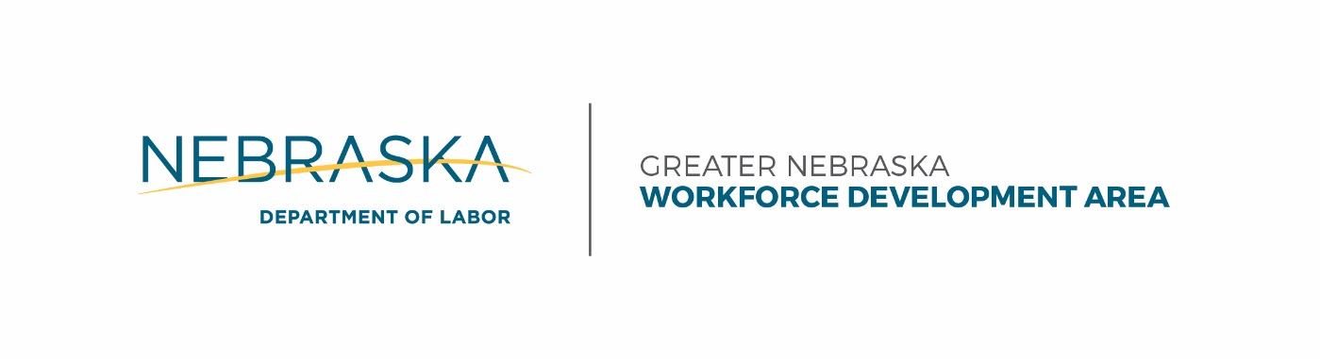
9:15 – 9:30 | Chief Elected Officials Board Registration
9:30 – 11:15 | Chief Elected Officials Board Meeting
11:15 – 11:30 | Workforce Development Board Registration
11:30 – 12:30 | Working Lunch
1:00 – 2:00 | System Coordination
1:00 – 2:00 | Strategic Planning
2:00 – 2:15 | Break
2:15 – 3:30 | Workforce Development Board
Pamela Lancaster Lisa Wilson CEOB Chair GNWDB Chair

Agenda
Greater Nebraska Workforce Development Board and Chief Elected Officials Board Meetings
May 25, 2017
LOCATION Fairfield Inn & Suites, 805 Allen Drive, Grand Island, Nebraska 68803

