Attachment O

May 8, 2015

beatrice.legals@beatricedailysun.com  (402) 223-5233  Beatrice Daily Sun  200 North Seventh Street  Beatrice, NE 68310 | col.clerk@lee.net  (402) 564-2741  Columbus Telegram  1254 17th Avenue  Columbus, NE | legals@theindependent.com  (308) 382-1000  Grand Island Independent  422 W. First  Grand Island, NE
legals@hastingstribune.com  (402) 462-2131  Hastings Tribune  908 W 2nd  Hastings, NE | legals@kearneyhub.com  (308) 233-9707  Kearney Hub  13 E 22nd St  Kearney, NE | legals@norfolkdailynews.com  (402) 371-1020  Norfolk Daily News  PO Box 977  Norfolk, NE 68702
jmurrish@nptelegraph.com  (308) 535-4731  North Platte Telegraph  621 N Chestnut St.  North Platte, NE | casey.harvey@starherald.com  (308) 632-9000  Scottsbluff Star-Herald  1405 Broadway  Scottsbluff, NE | legals@suntelegraph.com  (308) 254-2818  Sidney Sun-Telegraph  817 12th Ave  Sidney, NE 69162

Please publish the following Notice of Meeting as a public notice once on the next possible publication date.

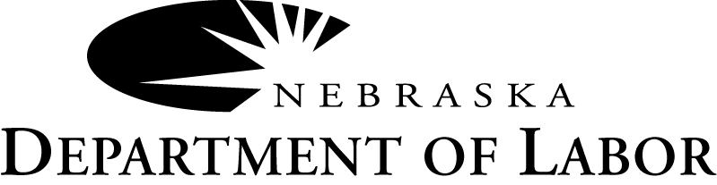

NOTICE OF MEETING
Greater Nebraska Workforce Development Board

The Greater Nebraska Workforce Development Board has scheduled a meeting for 1:30 p.m. to 3:30 p.m. (Central) on Wednesday, May 27, 2015 at the Holiday Inn Express and Suites located at 300 Holiday Frontage Road, North Platte, NE.
The proposed agenda will be available seven (7) working days prior to the meeting and include items regarding the Workforce Innovation and Opportunity Act, fiscal and performance reports, appointing new Workforce Development Board representatives and local plan modifications. For more information contact the Nebraska Department of Labor at 402-471-9828.

If auxiliary aids or reasonable accommodations are needed, please call Yvette Montes at 402-471-9828. An Equal Opportunity Employer/Program • TDD: 800.833.7352

M. L. MARTIN, Chair
Greater Nebraska Workforce Development Board
Please include the logo if you charge a line by line fee, but do NOT include the logo if you charge advertising fees. If you need a TIF of the logo or if you have any questions concerning this notice, please contact Yvette Montes at (402) 471-9828.
Your proof of publication and statement of charges should be forwarded to Nebraska Department of Labor, Attn: Yvette Montes, 550 South 16th Street, PO BOX 94600, Lincoln, NE 68509-4600. Please include your Federal Tax identification number on your statement of charges.

Sincerely,
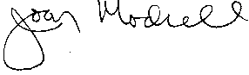
Joan Modrell, Director, Office of Employment & Training

CC: John Albin, Joan Modrell, Seth Fager, Pam Lancaster, M.L. Martin, Jean Mertz, Ann Tillery, Denise Schroder, Thomas Ukinski, Malek-Madani, Terri, Schuster, Elizabeth

May 8, 2015

beatrice.legals@beatricedailysun.com  (402) 223-5233  Beatrice Daily Sun  200 North Seventh Street  Beatrice, NE 68310 | col.clerk@lee.net  (402) 564-2741  Columbus Telegram  1254 17th Avenue  Columbus, NE | legals@theindependent.com  (308) 382-1000  Grand Island Independent  422 W. First  Grand Island, NE
legals@hastingstribune.com  (402) 462-2131  Hastings Tribune  908 W 2nd  Hastings, NE | legals@kearneyhub.com  (308) 233-9707  Kearney Hub  13 E 22nd St  Kearney, NE | legals@norfolkdailynews.com  (402) 371-1020  Norfolk Daily News  PO Box 977  Norfolk, NE 68702
jmurrish@nptelegraph.com  (308) 535-4731  North Platte Telegraph  621 N Chestnut St.  North Platte, NE | casey.harvey@starherald.com  (308) 632-9000  Star-Herald  1405 Broadway  Scottsbluff, NE | legals@suntelegraph.com  (308) 254-2818  Sidney Sun-Telegraph  817 12th Ave  Sidney, NE 69162

Please publish the following Notice of Meeting as a public notice once on the next possible publication date.

NOTICE OF MEETING
Greater Nebraska Chief Elected Officials Board

The Greater Nebraska Chief Elected Officials Board has scheduled a meeting for 12:30 p.m. thru 1:15 p.m. (Central) on Wednesday, May 27, 2015 at the Holiday Inn Express and Suites, located at 300 Holiday Frontage Road, North Platte, NE.
The proposed agenda will be available seven (7) working days prior to the meeting and include items regarding the Agreement between the Greater Nebraska Chief Elected Officials Board and the Greater Nebraska Workforce Development Board, Local Plan Modifications and motions to approve GNWDB representatives. For more information contact the Nebraska Department of Labor at 402-471-9828.

If auxiliary aids or reasonable accommodations are needed, please call Yvette Montes at 402-471-9828.
An Equal Opportunity Employer/Program • TDD: 800.833.7352

M. L. MARTIN, Chair
Greater Nebraska Workforce Development Board
Please include the logo if you charge a line by line fee, but do NOT include the logo if you charge advertising fees. If you need a TIF of the logo or if you have any questions concerning this notice, please contact Yvette Montes at (402) 471-9828.
Your proof of publication and statement of charges should be forwarded to Nebraska Department of Labor, Attn: Yvette Montes, 550 South 16th Street, PO BOX 94600, Lincoln, NE 68509-4600. Please include your Federal Tax identification number on your statement of charges.

Sincerely,
Joan Modrell, Director, Office of Employment & Training

CC: John Albin, Seth Fager, Pam Lancaster, M.L. Martin, Jean Mertz, Joan Modrell, Denise Schroder, Thomas Ukinski; Ann Tillery; Malek-Madani, Terri; Schuster, Elizabeth

